Employee Engagement

Student Name:
Huzaira Shafqat
Student ID Number:
2128180
Module title:
Personnel Resourcing and Development
Module Code:
BMIH5005
Lecturer’s Name:
Helen Lee
Words Count:
2000
Deadline:
20/11/2023

Table of Contents

Introduction: 3
The Role of Human Resources in Engaging Employees: 3
How to Engage Employees and Advantages of Engagement: 5
Advantages of Employee Engagement: 6
The Employee Lifecycle: 7
1. Attraction: 7
2. Recruitment: 8
3. Onboarding: 8
4. Development: 9
5. Retention: 9
6. Separation: 10
Employee Engagement Model and Implementation: 11
Conclusion: 11
References 12

Introduction:
Human resources (HR) have become increasingly important in the fast-paced, cutthroat corporate environment of today. Human resources experts are no longer just administrative assistants; they play a crucial role in navigating the modern management and corporate landscape. Internal and external factors drive a company's need to not only meet but exceed its objectives while maintaining a competitive advantage, and their influence extends across a number of different dimensions, including resourcing, recruitment, selection, socialization, performance management, and talent mobilization.
With an emphasis on the hotel sector, this essay examines the critical knowledge of the complex management and corporate environment in which HR practitioners work. We examine the techniques and practices that allow human resources to effectively engage workers across the spectrum of their employment lifecycle using the world-famous hotel the Grand Brighton as a case study. This article discusses how human resources plays a crucial role in the success of a large hotel by attracting, hiring, training, and releasing employees who have the right mindset, knowledge, and experience to ensure the hotel has a competitive edge for the long haul (Sharma, 2018).

The Role of Human Resources in Engaging Employees:
Human Resources (HR) plays a crucial role at The Grand Brighton, as in any other major hotel, in the effort to maintain employee engagement over their entire tenure with the company. Human resources (HR) is in charge of designing and enforcing policies that foster an atmosphere that encourages employees to feel valued and invested in their job.
Human resources experts perform a number of crucial functions in the context of employee engagement (Salas, 2021).
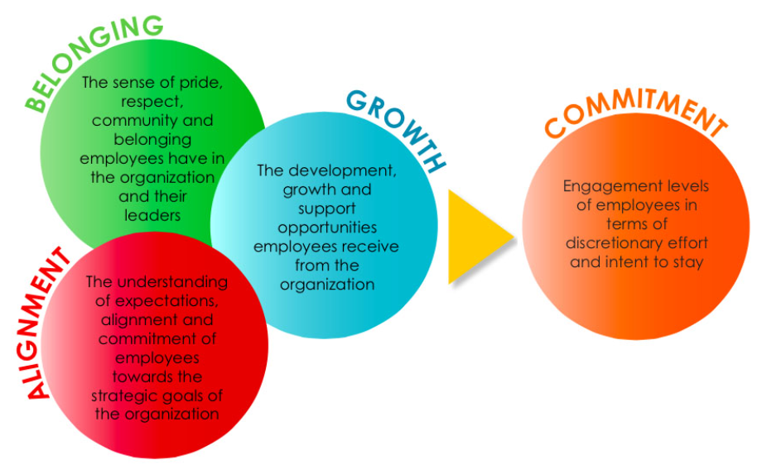
Policy Formulation:
Human resources is in charge of crafting hotel-wide policies and processes that reflect the establishment's guiding principles. Compensation, perks, performance evaluations, and opportunities for professional growth are all components that need to be addressed by these guidelines. Fair and open rules instill confidence in employees and motivate them to do their best (Gupta, 2018).
Recruitment and Selection:
Human resources is responsible for finding and hiring employees that are a good fit for the hotel's values and mission. Human resources may increase employee dedication from the get-go by picking suitable applicants.
Human resources plays a crucial part in the onboarding process, ensuring that new hires fit in well with the rest of the company. New employees' early involvement with the hotel depends on an effective onboarding program that familiarizes them with the hotel's culture, values, and expectations (Tucker, 2017).
Training and Development:
Human resources is in charge of creating and delivering initiatives for staff members to learn new skills and improve in their professions. These actions not only show that the company cares about its workers' development, but also increase their level of enjoyment at work.
Conflict Resolution and Support:
Human resources is there for workers to go to if they have questions, disagreements, or complaints. Their fast and equitable handling of these concerns is crucial to preserving a productive workplace.
Performance Management:
Goal-setting, feedback, and evaluations are all part of performance management, which HR controls. This makes it so workers know what is expected of them and where they stand in terms of growth (Lockwood, 2007).
Recognition and Rewards:
Human resources may help show appreciation for employees by creating and implementing reward and recognition programs. Employees who feel appreciated are more likely to put forth extra effort.
Human resources, in essence, is responsible for creating and sustaining The Grand Brighton's enthusiastic and dedicated staff. Their job is crucial in shaping an environment where hotel goals are met, competitive advantage is maintained, and workers are content at all stages of their employment (Masih, 2013).

How to Engage Employees and Advantages of Engagement:
Engaging employees inside The Grand Brighton means establishing an environment where they feel driven, dedicated, and appreciated, which, in turn, contributes to a more productive and peaceful work climate. The positive effects of employee involvement on both the company and its bottom line are numerous.
Engagement Strategies:
The success of an organization depends on its ability to effectively communicate its mission, values, and objectives to its members. One-on-one meetings, group meetings, and suggestion boxes are all examples of regular feedback methods that provide workers a chance to share their opinions and suggestions to management (Soupata, 2005).
Career Development:
Employees are more invested in their work when they see a clear route for professional development and promotion. Mentoring, coaching, and other forms of training can provide workers the tools they need to reach their full potential in the workplace.
Recognition and Rewards:
When employees' hard work and dedication are recognized and rewarded, it does more than just boost morale. Programs that reward success with incentives, trophies, or public acclaim increase participation (Macey, 2008).
Team Building:
Team-building activities, trips, or cross-functional initiatives that foster team cohesiveness and a sense of belonging among employees have been shown to increase engagement.

Advantages of Employee Engagement:
Increased Productivity:
Employees that are invested in their work are more likely to be enthusiastic about it and stick to it until completion. As a result, they are more inclined to go above and beyond what is required of them to achieve success for the company.
Reduced Turnover:
Employees who are invested in their work are more likely to be content in their positions and less likely to look elsewhere for employment. Because of this, the expenses and interruptions associated with hiring and training new employees are reduced (Kumar, 2016).
Improved Customer Satisfaction:
Customers are more likely to be satisfied and loyal to a company whose staff is enthusiastic and invested in its success. Guests who had a positive experience are more likely to return and tell others about their stay (Markos, 2010).
Positive Workplace Environment:
Employees that are invested in their job create an environment where employees are comfortable working together and helping one another. This, in turn, helps to entice and keep the best employees.
Enhanced Employee Well-Being:
Employee engagement typically goes hand in hand with better well-being, both psychologically and physically. In a nutshell, a healthier and more productive workforce is one in which workers are less likely to become sick or miss work due to stress (Albrecht, 2015).

The Employee Lifecycle:
Each phase of an employee's lifecycle at a major hotel like The Grand Brighton is essential to the development of the employee's journey and to the success of the hotel as a whole. Keeping a competent and engaged staff requires an in-depth understanding of and skill in managing these phases (Cattermole, 2019).
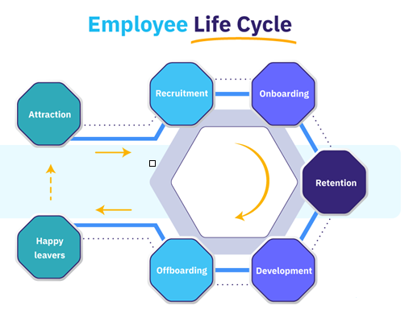

1. Attraction:
Attracting possible applicants to the hotel is the first step in the employee lifecycle. The Grand Brighton needs to portray itself as an appealing employer in order to attract and retain top personnel in this highly competitive business. Important factors include:
Employer Branding:
The hotel has to build an employer brand that reflects its values, culture, and dedication to its staff members' personal and professional growth. People who share your values will be drawn to a well-defined brand (Gladka, 2022).
Recruitment Marketing:
The Grand Brighton is able to advertise available positions in a number of ways. These include social media, job sites, and in-person events. Attracting potential employees to work at the hotel requires detailed job descriptions, eye-catching images, and positive feedback from present workers (Thompsen, 2009).
Employee Value Proposition (EVP):
The Grand Brighton offers competitive salaries, excellent benefits, and a welcoming work environment, all of which are highlighted in a compelling employee value proposition (EVP). It needs to highlight the hotel's special qualities that set it apart from the competition (Cherep, 2019).
Culture Showcasing:
To demonstrate its welcoming work atmosphere, the hotel can host open houses, provide virtual tours, or conduct interviews with current staff members. Candidates might get a feel for the position from this personal account (Nosratabadi, 2022).

2. Recruitment:
The purpose of recruitment is to find and hire the best possible people to fill open positions at the hotel. The following procedures are necessary for The Grand Brighton to hire people who are not just capable of doing their jobs but who also share the hotel's core values:
Competency-Based Selection: Human resources may gauge a candidate's knowledge, experience, and potential cultural fit with the use of competency-based interviews and tests.
Inclusive Recruitment Practices: The hotel can better serve its guests by eliminating discrimination in hiring. This may be done by using recruitment strategies that promote diversity, such as using blind applications and interview panels.
Clear Communication: It is important that candidates know where they stand in the hiring process at all times. When employees are able to express their ideas and concerns openly and courteously, the business as a whole benefits.

3. Onboarding:
New hires have the best chance of settling in quickly and contributing to the hotel's success if they are properly on boarded:
Orientation Programs: New hires are given a thorough overview of the hotel's goals, beliefs, and standards in an organized orientation session. Taking this first step is critical for establishing a sense of community and significance.
Buddy or Mentor Systems: Newcomers benefit greatly from having an experienced coworker act as a mentor or buddy while they adjust to their new position, team, and overall work environment. This facilitates a network of help and quickens the pace of adaptation.
Training and Development: Employees should be given the opportunity to learn the fundamentals of their positions throughout the onboarding process. The hotel may provide either virtual or in-person training options.

4. Development:
At The Grand Brighton, training and education are never-ending processes. Through participation in ongoing training and development programs, workers' skills are enhanced and their professional aspirations are brought into line with those of the hotel. The following are examples of development strategies:
Reviewing an employee's performance on a regular basis allows for the open discussion of their accomplishments, future objectives, and problem areas. Employee growth is aided by both positive criticism and well-defined objectives (Xiang, 2023).
Skill Enhancement:
The hotel can provide training programs, workshops, and coaching to develop workers' skills and competence. The hotel benefits from a more trained and flexible staff thanks to these options.
The Grand Brighton should make it easy for workers to see where they fit in the company's structure and how they may advance in their careers. Giving employees a clear path to promotion boosts motivation and loyalty.
Mentorship and coaching programs enable seasoned workers to give back to the workforce by helping others just starting out. Relationships like this may be extremely beneficial to progress.

5. Retention:
The phase of an employee's career in which they are retained is crucial. Staff turnover is expensive and causes disruptions in hotel operations. The Grand Brighton's methods of maintaining its staff include:
Rewards and Acknowledgement: Boosting morale and loyalty may be achieved by the implementation of reward programs such as "Employee of the Month" or bonuses for great performance. When employees feel appreciated, they are more likely to put up extra effort (Sonenshein, 2012).
Work-Life Balance:
Work-life balance and employee happiness may be improved by providing for work-from-home options, paid time off, and other family-friendly policies.
Wellness Initiatives: The hotel may aid its staff in both body and mind by providing wellness programs, health benefits, and stress management tools.
Constant Feedback: Holding regular feedback meetings where staff may vent problems and share suggestions encourages free flow of information. A positive work environment requires that problems be addressed quickly and openly.
Professional Development:
The hotel's dedication to its workers' development may be seen in its provision of educational assistance and funding for attendance at relevant conferences.

6. Separation:
Employees at The Grand Brighton might depart for various reasons.
Key practices include:
Exit interviews are a great way to get honest feedback from departing employees about their experiences and motivations for leaving a company. Employers may utilize this data to make their workplaces better and attract and retain more employees.
Alumni Networks:
The hotel may create alumni networks to remain in touch with past workers, benefit from their knowledge, and possibly hire them again in the future.
Positive Departure Experience: Ensuring that departing workers get professional and courteous treatment, irrespective of their reasons for leaving, may create a great image that lasts a lifetime.
In summary, The Grand Brighton's approach to the employee lifecycle is critical to encouraging engagement and preserving a team of driven, competent, and devoted workers. A hotel's competitive edge in the hospitality sector is derived from effective management at every level, which fosters a work environment where staff members feel appreciated and motivated to contribute to the company's success.
Examples of Employee Engagement:
Regular feedback meetings, recognition programs, career development plans, team-building exercises, and wellness initiatives are a few instances of employee engagement at The Grand Brighton. These programs may foster a sense of worth, community, and motivation among staff members.
The Grand Brighton's unique culture and requirements may be catered for in these employee engagement campaign examples. Combining these tactics can result in a work environment where staff members are driven, content, and dedicated to doing all in their power to support the hotel's success (Catteeuw, 2007).

Employee Engagement Model and Implementation:
Assessing existing engagement levels, establishing clear goals and expectations, allocating the required resources, and routinely monitoring and tweaking the engagement tactics might all be part of an effective employee engagement plan for The Grand Brighton. For this strategy to be successfully implemented, HR and upper-level management must actively support and promote engagement efforts (Glavas, 2012).
Industry Examples:
The hotel industry is very competitive, and many successful hotels encourage employee engagement. The Ritz-Carlton Hotel Company, for instance, is well-known for its Gold Standards, which place a premium on employee autonomy and participation. As part of the company's "Daily Line-Up" meetings, staff members present examples of their outstanding service to customers.

Conclusion:
Ultimately, The Grand Brighton's continued success in the highly competitive hospitality business is dependent on the hotel's dedication to promoting employee engagement over the entire employee lifecycle. Attracting, hiring, orienting, training, retaining, and eventually parting ways with employees all play a part in creating a staff that is not only competent but also dedicated to the hotel's goals.
The hotel will have a far better chance of creating and implementing strategies that resonate with workers if it acknowledges the critical role that Human Resources plays in this process. The capacity of human resources to provide an atmosphere of open communication, ample opportunity for growth, and consistent acknowledgement is crucial to a highly engaged workforce.
The positive effects of this kind of participation extend well beyond the hotel's bottom line and into the lives of the staff members who work there. Employees that are invested in their work are more likely to go above and beyond for both the company and its clients.
The Grand Brighton's commitment in staff engagement is proof that the hotel is serious about creating excellent guest experiences and staying ahead of the competition in a world where service quality is vital. This dedication not only helps the hotel, but also sets a precedent for the rest of the business world when it comes to employee involvement.

References

Albrecht, S.L., Bakker, A.B., Gruman, J.A., Macey, W.H. and Saks, A.M., 2015. Employee engagement, human resource management practices and competitive advantage: An integrated approach. Journal of organizational effectiveness: People and performance, 2(1), pp.7-35.
Cherep, A.V., Helman, V.М. and Rybalko, O.M., 2019. Management employee life cycle of higher education. Вісник Запорізького національного університету. Економічні науки, (4), pp.160-164.
Cattermole, G., 2019. Developing the employee lifecycle to keep top talent. Strategic HR review, 18(6), pp.258-262.
Catteeuw, F., Flynn, E. and Vonderhorst, J., 2007. Employee engagement: Boosting productivity in turbulent times. Organization development journal, 25(2).
Gladka, O., Fedorova, V. and Dohadailo, Y., 2022. Development of conceptual bases of the employee life cycle within an organization. Business: Theory and Practice, 23(1), pp.39-52.
Gupta, M., 2018. Engaging employees at work: Insights from India. Advances in Developing Human Resources, 20(1), pp.3-10.
Glavas, A., 2012. Employee engagement and sustainability: A model for implementing meaningfulness at and in work. Journal of Corporate Citizenship, (46), pp.13-29.
Kumar, V. and Pansari, A., 2016. Competitive advantage through engagement. Journal of marketing research, 53(4), pp.497-514.
Lockwood, N.R., 2007. Leveraging employee engagement for competitive advantage: HR’s strategic role. HR magazine, 52(3), pp.1-11.
Markos, S. and Sridevi, M.S., 2010. Employee engagement: The key to improving performance. International journal of business and management, 5(12), p.89.
Masih, E., Singh, V.P. and Tirkey, M.R., 2013. Employee engagement: Engaging employees at work place. International Journal of Management, 4(5), pp.69-77.
Macey, W.H. and Schneider, B., 2008. Engaged in engagement: We are delighted we did it. Industrial and Organizational psychology, 1(1), pp.76-83.
Nosratabadi, S., Zahed, R.K., Ponkratov, V.V. and Kostyrin, E.V., 2022. Artificial Intelligence models and employee lifecycle management: A systematic literature review. Organizacija, 55(3), pp.181-198.
Sharma, E. and Tewari, R., 2018. Engaging employee perception for effective corporate social responsibility: Role of human resource professionals. Global Business Review, 19(1), pp.111-130.
Salas‐Vallina, A., Alegre, J. and López‐Cabrales, Á., 2021. The challenge of increasing employees' well‐being and performance: How human resource management practices and engaging leadership work together toward reaching this goal. Human Resource Management, 60(3), pp.333-347.
Soupata, L., 2005. Engaging employees in company success: The UPS approach to a winning team. Human Resource Management, 44(1), pp.95-98.
Sonenshein, S. and Dholakia, U., 2012. Explaining employee engagement with strategic change implementation: A meaning-making approach. Organization Science, 23(1), pp.1-23.
Tucker, E., 2017. Engaging employees: Three critical roles for managers. Strategic HR Review, 16(3), pp.107-111.
Thompsen, J.A. ed., 2009. Achieving a triple win: Human capital management of the employee lifecycle. Routledge.
Xiang, H., Lu, J., Kosov, M.E., Volkova, M.V., Ponkratov, V.V., Masterov, A.I., Elyakova, I.D., Popkov, S.Y., Taburov, D.Y., Lazareva, N.V. and Muda, I., 2023. Sustainable Development of Employee Lifecycle Management in the Age of Global Challenges: Evidence from China, Russia, and Indonesia. Sustainability, 15(6), p.4987.

