Task Two – Essentials of People Practice

(AC 3.1)
A work-life balance refers to the balance an individual has between their work and their personal time. It is important for employees to maintain a healthy work-life balance as it protects individuals’ health, safety, physical and mental wellbeing (ACAS, 2025).

Waite et al (2021) found that if employees have a poor balance, they can become overworked and burnt out. Employers must look for signs of employees being overworked as tired employees are more likely to make mistakes, which could be detrimental to the company. Having clear policies supporting work-life balance highlights to the employees that the company cares. This makes the organisation one people want to associate with and supports a positive reputation.

The Flexible Working Regulations 2014 supports employees to maintain a good work-life balance that suits their needs while continuing to meet the needs of the employer. CIPD (2024) outlines the recent changes to legislation giving employees the right to request a flexible working request from day one of their employment. Employees can request changes to their hours, shift patterns, work location and shift times. (Gov, no date) outlines the steps employers need to take to deal with request in a reasonable manner. Employers must look at the circumstances for each request and assess advantages and disadvantages. Alternatives for the request must also be explored. If employers decline the request the employee has the right to appeal.

Wood (2018) explored the benefits of flexible working arrangements and research found these arrangements do improve wellbeing. They also increase job autonomy for employees enhancing their perception of their managements support. This can promote a positive relationship between employer and employee.

ACAS (2025) outline The Working Time Regulation Act 1998 and what employers need to implement to support employees work-life balance. Employees must not work more than 48 hours per week unless they sign the opt out agreement allowing them to legally work above these hours. Employers must also provide regular breaks in the workday, a minimum of 11 hours off between shifts or compensatory rest if doing shift work, and a minimum annual leave entitlement of 5.6 weeks per year.

(AC 3.2)
Waite et al (2021) defines wellbeing as how people feel both physically and mentally and how positively individuals feel on our outlook on daily life. Wellbeing in work is the safety and quality of the environment employees are in when they are working. Health is important to wellbeing and the work environment should promote good physical and mental health. Factors such as financial wellbeing, good work, principles/values, personal growth, social and good lifestyle choices all contribute to an individual’s wellbeing.

Employee wellbeing can have a direct impact on the organisation. CIPD (2024) held
a 2023 Health and Wellbeing in Work survey and discovered that some of the
benefits of focusing on their employee’s wellbeing increased employee
engagement and moral and created a more inclusive and healthier workplace.
Statistics show that in 2022 in the UK mental health was the 5th most common
reason for sickness in the workplace accounting for 7.9%, with an estimated 15% of
the UK workforce having an existing mental health condition (Mental Health
Foundation, n.d). By adopting a proactive and positive approach to employee
wellbeing we can encourage a better workplace culture where staff are more
reliable and productive.

AC 3.3
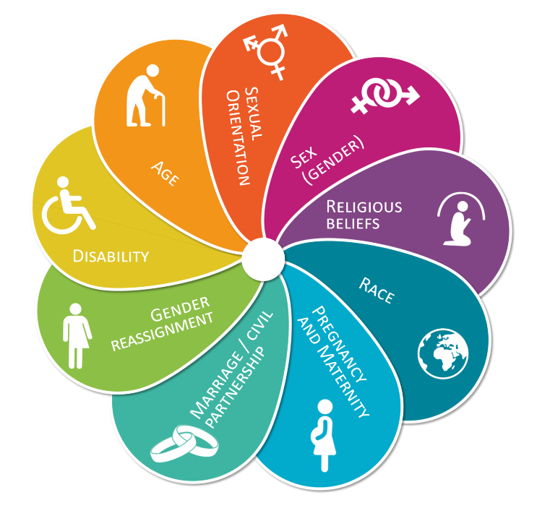
There is legislation in the UK to protect individuals from discrimination. The main legislation is the Equality Act 2010. This legislation ensures fair and transparent processes within all aspects of the workplace. The act has 9 main characteristics that are protected from being discriminated against, shown in the diagram below (School, n.d).

Figure 1.

Waite et al (2021) explains The Equality Act 2010 outlining types of discrimination. Direct discrimination is when someone has unfair treatment due to a protected characteristic. Indirect Discrimination is when there are policies and procedures that are equal for all staff but put employees with a protected characteristic at a disadvantage. Harassment is unwanted behaviour which can present numerous ways such as sexual, offensive banter or bullying. Victimisation is when someone is treated less favourably for carrying out or intending to carry out a ‘protected act’ such as raising a grievance.

Discrimination within the workplace can have a negative impact on the organisation. Employees who feel discriminated against are likely to be less motivated and show lower productivity. Staff turnover is likely to be higher. Some staff may take the company to Employment Tribunal which can damage the company brand with negative publicity and cause large financial damage (Karolina, 2022).

The Human Rights Act 1998 requires all employers to consider reasonable adjustments for any disabled workers such as work patterns or changes to equipment. Factors to consider include cost, the ease of the change, the difference it would make the worker and if the change is achievable within their role (Clyde and Co, 2024). This allows for equity within the workforce over equality providing all employees with the same opportunity to thrive.

(AC 3.4)
Inclusion and diversity often go hand in hand and are discussed together but they have their own meanings. Diversity is recognising the differences such as colour, race, gender, beliefs, opinions and other differences and that they are respected (CIPD, 2024). Inclusion is embracing the differences people have while allowing them to feel they belong without having to conform to others and their contributions, opinions and views will be valued (Waite et al, 2021).

Diversity within the workplace is important as it allows a range of experiences and opinions to be shared and the CIPD (2024) highlights the benefits to innovation, decision making and problem solving. People need to feel empowered and respected for their differences for them to be able to provide benefit to the company.

Inclusion allows individuals to feel respected and treated fairly regardless of their race, age or background. Employees are likely to have a higher job satisfaction when they feel included in their employment supporting a positive work culture.

(AC 3.5)
If employers want to dismiss an employee, they must ensure a fair process is followed within legislation, the ACAS Code of Practice and the company policy. A fair investigation should be carried out and the employee given the chance to explain their actions. The dismissal should be kept confidential from other parties and settlement agreements may sometimes be used (ACAS, 2024). There are five reasons listed in the Employee Rights Act 1996 for fair dismissal: capability or qualification; conduct; redundancy; legal restriction or statutory ban; some other substantial reason (Waite et al, 2021).

The Employment Rights Act 1996 gives employees the right to not be unfairly dismissed. Unfair dismissal can be claimed by an employee who has had continuous employment for 2 years or longer. If it is felt the dismissal had no fair ground, their actions did not warrant dismissal, or the employer did not follow a fair process the employee may take the organisation to Employment Tribunal (Waite et al, 2021).

BHS V Burchell is a case of unfair dismissal that was brought to Employment Tribunal in 1979. During this case, Lord Denning outlined a three-step process to determine whether a dismissal is fair or unfair. Employers should: believe there is genuine guilt; have reasonable grounds for this belief; act reasonably in all circumstances. This is now known as the ‘Burchell test’ and has helped to shape UK law (Oakwood, 2023).

Reference

ACAS (2024) Dismissals. Available at What dismissal is - Dismissals - Acas (Accessed: 17 May 2025)

ACAS (2025) Working Time Rules. Available at Understanding the Working Time Regulations - Working time rules - Acas. (Accessed: 17 May 2025)

ACAS (n.d) Equality, diversity and inclusion. Available at What they are - Equality, diversity and inclusion - Acas (Accessed: 17 May 2025)

Amber Needham (2023) Why Equality, Diversity and Inclusion Matters in The Workplace. Available at Why Equality, Diversity and Inclusion Matters in the Workplace | SPD | University of Salford. (Accessed: 17 May 2025)

CIPD (2024) Equality, diversity and inclusion (EDI) in the workplace. Available at: Equality, diversity and inclusion in the Workplace | Factsheets | CIPD (Accessed: 17 May 2025)

CIPD (2024) New rights around flexible working requests stand to benefit millions of workers, says the CIPD. Available at: “New rights around flexible working requests stand to benefit millions of workers”, says the CIPD | CIPD (Accessed: 31 May 2025)

CIPD (2024) Wellbeing at work. Available at: Wellbeing at Work | Factsheets | CIPD (Accessed: 17 May 2025)

Clyde and Co (2024) Anti-Discrimination Laws in the UK. Available at Anti-discrimination laws & legislation in the UK (Accessed: 17 May 2025)

Gov (n.d) Flexible Working. Available at Flexible working: Overview - GOV.UK. (Accessed: 17 May 2025)

Karolina (2022) Tackling Discrimination – Why is it important? Available at: Tackling Discrimination – Why is it important? - Diversiti UK. (Accessed: 31 May 2025)

Oakwood Solicitors (2023) Legal Landmark Case – British Home Stores Ltd v Burchell: An Essential Milestone in Employment Law. Available at: Legal Landmark Case - British Home Stores Ltd v Burchell. (Accessed May 2023)

Professor Stephen Wood (2018). CIPD Applied Research Conference 2018. Available at https://www.cipd.org/globalassets/media/comms/get-involved/events/work-life-balance-supports_tcm18-57294.pdf. (Accessed: 17 May 2025)

Waite, K. et al. (2021) People Practice A Complete Guide. London: Kogan Page.

Wolsingdale School (n.d) Protected Characteristics. Available at: Protected Characteristics. (Accessed: 17 May 2025)

