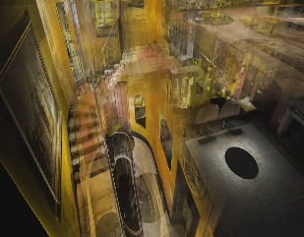
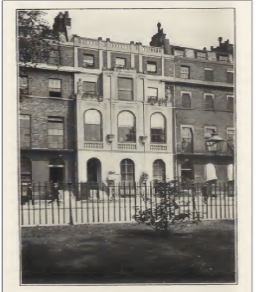
VIRTUAL VISIT OF THE SIR JOHN SOANE’S MUSEUM AND REFLECTION ON HOW THE MUSEUM PROVIDES PUBLIC UNDERSTANDING OF THE ARCHAEOLOGICAL RECORD
Image 2. Virtual tour (soanes.org, 2024)
Image 1. Sir John Soane Museum (1905)

Background of the Sir John Soane’s Museum, Lincoln’s Inn Fields, London
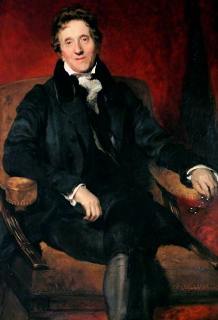
Sir John Soane was an established 19th century architect who secured positions of repute as architect for the Bank of England, and Professor at the Royal Academy of Architecture in 1906. Soanes fascination with the classical Mediterranean influenced not only his work but collection of ‘architectural fragments and models, plaster casts, classical statuary, natural curiosities, paintings, and a library of thousands of volumes’ (Romano, 2021:2) which at the present time consists of over 40,000 objects (ibid). At the time of his death in 1836, Sir John Soane bequeathed ‘that his collection remains intact and be exhibited as he left it for the public’ (Elliot & Kennedy, 2006:2). To this day the museum is a memorial to Soane and his achievements, regarded as ‘an illustration of early 19th century domestic architecture’ (Adams, 2013:71), and a home where the collector lived with his objects.
Image 3. Sir John Soane

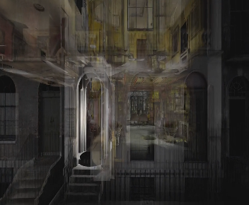
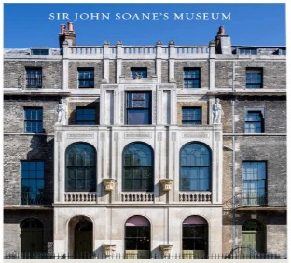
As a visitor to the museum some years ago I thought it would be fascinating to re visit the site through the medium of digital technology, so that I could experience once again, the glorious visuals of the house, and maybe encapsulate similar emotions to that which I experienced on my preliminary outing. Soane’s house museum has a large physical presence in as much as ‘content and container are one’ (Young, 2007:60), and I envisaged seeing narratives that would evidence the acclaimed architect, the collections, and the splendour of the building. Under the heading of plan your visit, the virtual tour was listed approximately halfway through the options which may suggest that marketing of the activity is not as essential as getting visitors through the door or attracting people to attend a variety of exhibitions in the building. Comfortably sitting in front of my laptop, with a cup of tea, the virtual experience stated it used ‘the latest photogrammetry technology’ (soane.org, 2024), which meant little to an unexperienced I.T. novice such as myself. The link to the tour was accessed through a digital image of the house, which appeared ethereal and atmospherically dark, with whisps of grey and white, evoking a haunted house image. This contrasts with the formal pictures of the exterior of the museum that fronts the web site, depicting the premises basking in sunlight. As the building itself is part of the archaeological record there appears to be disparity between the images, which plausibly is connected to wanting to appeal to a variety of people.
Image 4. Virtual tour (soanes.org, 2024)
Image 5. Façade of museum (soanes.org, 2024)
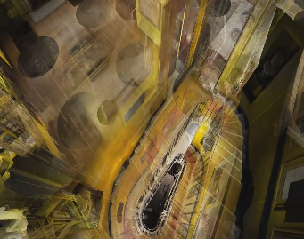
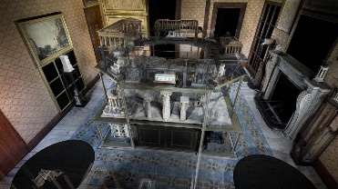
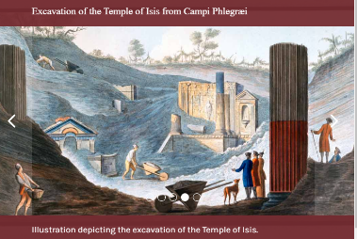
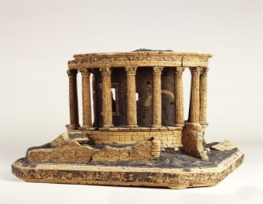
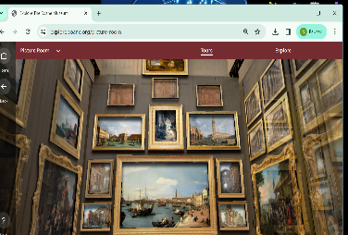
Moving slowly through the door, the experience continued with a swirling transportation through the house, penetrated by colours of mustard yellows and browns. The technology cut through layers of the house haphazardly and there was no option to stop the ascent to the chosen room and look around. I felt as though I were taking part in a hidden object game (play.google.com, 2024), which could be an intentional graphic design, given the vast, eclectic volume of objects housed in the museum. Choosing to enter the Model Room, one is drawn to the large display cabinet containing objects. Only three artifacts were given prominence, these being Cork Model of the Temple of Vesta, Tivoli, Model of Pompeii in 1820, and Temple of Vesta (Plaster). Each artifact can be seen individually using VR, and the viewer can closely examine and navigate the object, via three dimensional visuals. Accompanying narratives support the images accounting for the reasons pertaining to why the objects were collected and in the context of the era. The data provided for Soane’s ‘favourite classical building, The Temple of Vesta’(soanes.org,2024) introduces the public not only to Sir John Soane as a person, but to a world that he and his contemporaries inhabited.
Image 7. Virtual tour (soanes.org, 2024)
Image 6. Model Room (soanes.org, 2024)
Image 8. (soanes.org, 2024)
Image 9 Temple of Vesta. (sianes.org, 2024)
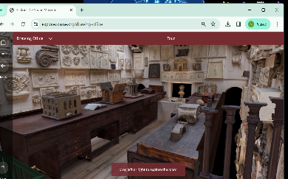
Physically the virtual tour worked responsively and smoothly, however the downwards looking view in the model room felt a little constrained, as also in the tour of the Sepulchral chamber. The Picture room and Drawing Office presented a more upward looking aspect, and somehow felt more real, as opposed to just viewing on a screen. Vivacious and perspicacious detail could be observed which, when placed in context with the narratives presented, though these being at the discretion of those who permitted the activity, make accessibility to the museum possible. Without being able to experience the physicality of being in the building and with a silent background, the experience somehow feels a little sterile and stilted.
Image 11. (soanes.org, 2024)
Image 10. (soanes.org, 2024)
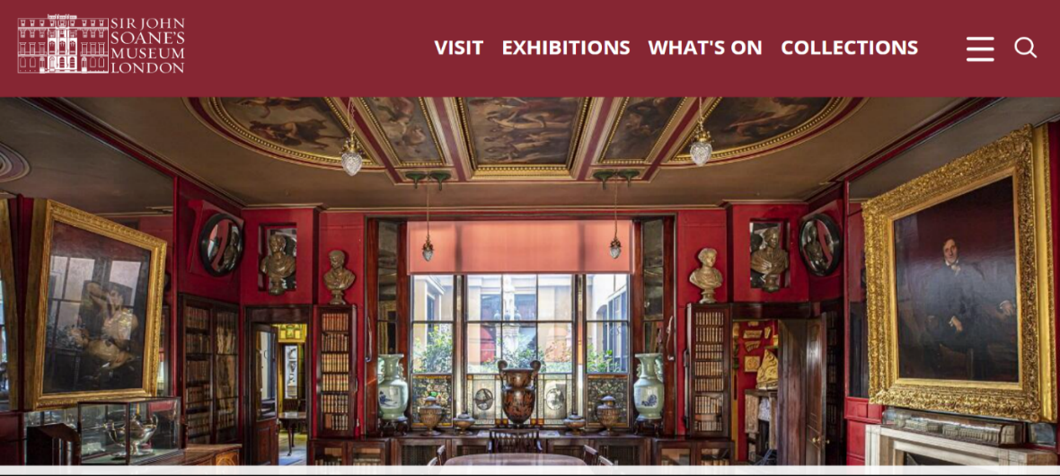
However, as a museum that has been made digital, the Sir John Soane’s has captured elements of Soane’s ambitious, eclectic collections and explores his character and life for the ‘publics inspiration and education’ (soanes.org, 2024). The museums web page contains an alluring blend of information and visual sources which allow the visitor to explore exhibitions, what’s on activities, collections, learning, the Soane Medal, and access to online shopping. Being an extension of the physical museum, the Soanes appears more than a ‘brochure museum’ to be used primarily as a marketing strategy containing content and learning material to encourage the virtual visitor to return and ‘establish a personal relationship with the online collection’ (Styliani, Fotis, Kostas, Petros, 2009:521). However, there are drawbacks with virtual museums, and research suggests advanced graphics do not always represent a true image, and in reconstructing items, remove the ethno-historical, imaginative of former practices and impress upon the viewer ‘museologists know more than they actually do’ (ibid). For the computer illiterate virtual museums can be difficult to navigate with the ever-increasing sophistication of the Internet. As can be seen in the virtual tour of the Soane’s Museum, the virtual reconstructions of the objects offer one aspect only, and do not provide alternative views, which contradicts the ‘fact there are many ways to examine the Past (ibid). Considering the Soane’s Museum and possibly other virtual sites, the viewer maybe entranced by impressive visualisations but should be aware that the purpose of such material is ultimately to ‘serve public consumption’(ibid:522). Reflecting on my own experience, the Soane’s virtual experience was enjoyable, however at times I failed to successfully navigate the site and found the narratives connected to the object I viewed somewhat disjointed, and authored in a way that the viewer would have previous knowledge of the architect and the museum. Not inaccessible for the first-time observer, I felt the experience was suited more to the regular visitor of the Soane, who would like to dip in and out online, when a physical visit was unavailable.
Image 12. (soanes.org, 2024)
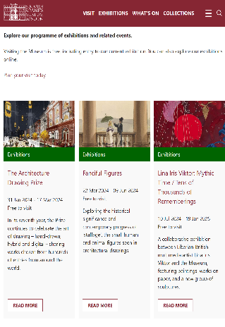
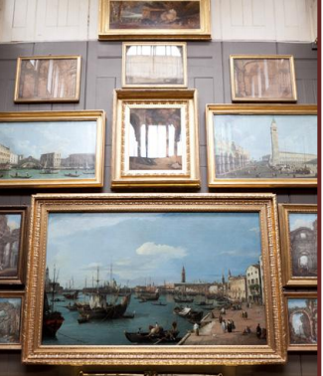
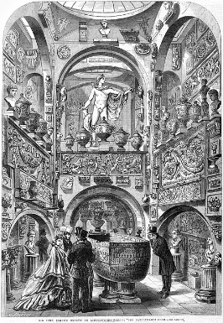
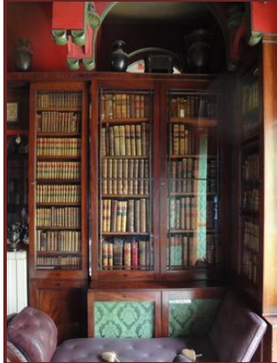
How then does the museum provide for the public an understanding of the archaeological record of Soane’s collection when few artefacts have contextual labelling or panels to describe the objects; the emphasis being on ‘aesthetics, use of space and visual impact’ (Adams, 2013:69). The interior has little changed since Soane’s occupied the premises, being described by one 19th century observer as ‘labyrinth stuffed full of fragments in the most tasteless arrangement that can be seen; it has the same kind of perplexing and oppressive effect on the spectator as if squeezed into a doll’s house’ (Michaelis, 1882:64). Fowler and Givens describe the archaeological record as ‘the database of the of the discipline, in which alongside the objects themselves, archaeological contexts and written and visual sources function as sources to document ‘three dimensional contextual relationships and environmental matrices’ (1995:2). Given the minimal written narratives to coincide with the collections, the visitor may engage with a tour of the building, guided by a volunteer, to discover various parts of the house. Alternatively, there is an option to use the free digital guide (headphones with commentary and visuals) which offers insights into the exhibitions and collections (soanes.org, 2024). In the virtual shop there is a small selection of books which, relevant to the theme of architecture, do not seem to address the collections themselves. From an online perspective there are numerous links to different access areas which inform the viewer of archaeological records. The online bibliography covering the museum is free to use comprising ‘the museum and its contents, and works dedicated to other Soane buildings’ (soane.org, 2024), as well as being able to view previous exhibition catalogues. The literature also recommends to the reader that an ‘understanding of the wider societal context in which Soane’s lived and practised’ (soane.org, 2024) to trace his connections with aspects of empire and the East India Company. This may not illustrate the origins of many of the artifacts but serves as useful tool to begin interpretating the beliefs and perceptions of persons in social positions such as Soane’s.
Image 13. The Sarcophagus of Seti 1, Sepulchral Chamber (1864)

Image 14. (soanes.org, 2024)
Image 15. Art collections soanes.org, (2024)
Image 16. Private room (soanes.org, 2024)
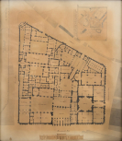
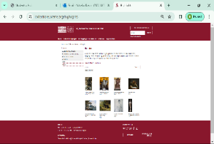
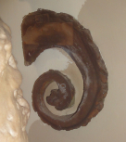
The museum houses a Research Library and Archive which is a collection of Sir John Soane’s’30,000 architectural drawings and 7,000 books and a small working library of modern books and information files’ (soanes.org, 2024). Personal and business papers belonging to Soane’s can be accessed in the archive. Pre booking is advertised as essential to visit both areas, and spaces are limited. A free, online bibliography ‘covering the Museum, its collections and Sir John Soane’s life and architecture’(soanes.org,2024) can be utilised. For online visitors interested in the career of Soane’s a dedicated link takes you to a list of his major architectural works ‘including their current status where known or relevant’ (soanes.org, 2024). This vast selection of literature and imagery provided by the museum encourages the public to examine the records, work, and life of Sir John Soane’s and places into context the physical structure of the museum and those that lived and visited Lincoln’s Inn Fields. Yet it is the online cataloguing page of the museum which aims to provide archaeological records for the public to benefit from. As a relatively new migration into web-hosted databases, the museum describes the task as ‘large and complex but one that continues to be tackled behind the scenes’ (soanes.org, 2024).
Image 17. Fragment of elm tree (soanes.org, 2024)
Image 19. Plan of the Bank of England with an elevation of the South Front, 1831 (soanes.org, 2024)
Image 18. (soanes.org, 2024)
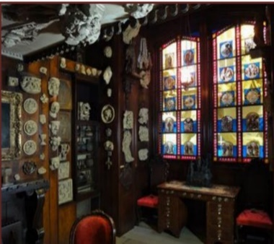
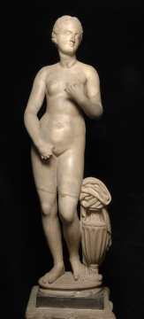
Using the object of a ‘Graeco-Roam head of Aphrodite’ as an example (image 20), the archaeological record of this item commences with a physical description of the artefact, along with the museum catalogue and Vermeulen numbers. The Curatorial note adds detailed description of piece and ‘excavations at Knidos have produced the site of the temple and scraps of the original statue, together with an inscription referring to the masterpiece and to Praxiteles’ (soanes.org, 2024). The figure has been reconstructed figure from ‘two fragmentary antique copies joined together’ (soanes.org, 2024). The provenance and supplementary literature also add to the archaeological record and through written and visible means the public can appreciate the origins of the object but are able to trace a history. Amongst this literature the related files can offer value in terms of ‘understanding the collections per se, bibliographical material on collectors and excavators as well as reflecting ownership and custodianship’ (Fowler & Givens, 1995:3).
Image 20. (soanes.org, 2024)
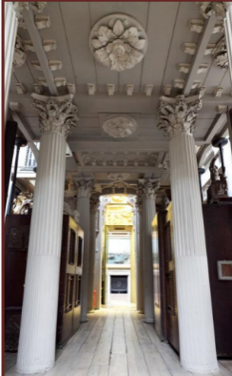
The Sir John Soane’s building as both museum and house that displays a ‘riot of architectural pieces, busts, and urns’ (Geibelhausen, 2006:5) which is at once a ‘self-portrait and autobiography where history is conceived as story, public and private, factual and fictional’ (ibid). The museum goes beyond the period of its creation and the creator, providing an opportunity to study and learn, not only from the changed value of the building as a document, but to ‘utilize the archive beyond Soane to better understand the evolution of architectural history and the times the museum has passed through’ (Blount, 2005:35). This small museum provides opportunities in understanding the ‘mechanisms of conservation and change’ (ibid) in collections of archived, detailed records and publications. To merely focus on Sloane alone distracts from a rich heritage of the museum’s contents and architecture. To uphold the public’s understanding of the archaeological record continuing studies and promotion of the hidden archival records could well ‘give us all a much richer understanding and appreciation of the past and its histories’ (Blount, 2005:35).
Image 22. Hallway (soanes.org, 2024)
Image 21. (saones.org, 2024)
Image 18. Hallway on first floor (soanes, 2024)
Image 19. The Grand Tour (soanes.org, 2024)
Image 17. Private room (soanes.org, 2024)
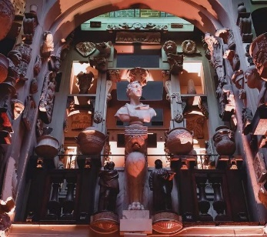

Image 23. The Grand Tour (soanes.org, 2024)

The online visitation to the Sir John Soane Museum did not disappoint, though the sensory elements of vision and hearing that can be stimulated in person, were depleted when viewing through a flat screen. However, as a technological vehicle, the site presents a large amount of historical data, both from the age of antiquity to current scholarship, that ensures the archaeological records of objects inside the building are accessible to members of the public, without incurring costs and at a mere touch of a button.

Bibliography
Adams, E (2013) Shaping, collecting, and displaying medicine and architecture: A comparison of the Hunterian and Soane museums., Journal of the History of Collections vol.25 no.1 pp. 59-75
Blount, A.R., 2005. Sir John Soane’s Museum: Changelessness and change. University of London, University College London (United Kingdom).
Elliott, B. and Kennedy, J., (2006). Haunting the Artist’s House: Sir John Soane’s Museum and Isaac Julien’s Vagabondia. Image and Narrative.
Fowler, D. & Givens D., (1995) The Records of Archaeology., Council for the Preservation of Anthropological Records., 2., [online @copar.umd.edu]
Giebelhausen, M., (2006). Lost worlds: How the museum remembers. In Working Papers in Art and Design.
Michaelis, A., (1882). Ancient Marbles in Great Britain., trans C.A.M. Fennell Cambridge University Press. p.164
www.play.google.com
Sir John Soane Museum (2024) https://www.soane.org
sir-john-soanes-museum-easy-read-guide.pdf [accessed online 2024)
Styliani, S., Fotis, L., Kostas, K. and Petros, P., 2009. Virtual museums, asurvey and some issues for consideration. Journal of cultural Heritage, 10(4), pp.520-528.
Young, L., 2007. Is there a museum in the house? Historic houses as a species of museum. Museum management and curatorship, 22(1), pp.59-77.

List of illustrations
- A photograph of Sir John Soane's Museum as seen from within the gates of Lincoln's Inn Fields. From Spiers (1905: Plate I)
- Virtual tour of Sir John Soane Museum (2024) [accessed www.soanes.org]
- Portrait of Sir John Soane, 1753 by Thomas Lawrence [accessed www.wikicommons, 2024]
- Virtual tour of Sir John Saone Museum (2024) [accessed www.soanes.org]
- Façade of Sir John Museum (2024) [accessed www.soanes.org]
- Virtual tour of The Model Room (2024) [accessed www.soanes.org]
- Virtual tour of museum (2024) [accessed www.soanes.org]
8. Excavation of the Temple of Isis from Campi Phlegræi by Sir William Hamilton This hand-coloured illustration depicts the excavation of the Temple of Isis in Pompeii. It may also depict the creators, Sir William Hamilton (in the red coat) and Pietro Fabris (in the blue), as part of the crowd who have gathered eagerly to watch. The illustration is from Campi Phlegræi, Hamilton’s pioneering 1776 work on volcanology.
- Temple of Vesta, 2024 [accessed www.soanes.org]
10. Virtual of The Picture Room (2024) [accessed www.soanes.org]
- Virtual tour of The Drawing Room (2024) [accessed www.soanes.org]
- Online home page of the museum (2024) [accessed www.soanes.org]
- The Sarcophagus of Seti I in the Sepulchral Chamber in the centre of the 'Museum' at the back of the house, as shown in the Illustrated London News in 1864.
- Exhibition page for Sir John Soane Museum [www.soanes.org] 2024
- Image of part of John Soane art collection (2024) [accessed www.soanes.org]
- Private room in the museum (2024) [accessed www.soanes.org.pdf]
- A fragment of an elm tree, Museum number: M584 on display: Museum South Passage
- Collections online at the John Soane Museum [accessed www.soanes.org] 2024
- Plan of the Bank of England with an elevation of the South front, 1831 [accessed soanes.org] 2024
20. A Graeco-Roman head of Aphrodite on a much restored and overworked body which may be an ancient fragment or could be entirely a neoclassical restoration. Grained Greek marble. Height (statuette): 69cm. Height (head): 9.5cm. Museum number: M566. Vermeule catalogue number: Vermeule 387 (2024) [accessed www.soanes.og]
21. Stained glass in private room (2024) [accessed www.soanes.org.pdf]
22. Hallway in Sir John Soane Museum (2024) [accessed www.soanes.org]
23. The Grand Tour, 2024 [accessed www.soanes.org]

