Ways of Perceiving

The Sublime of Street Photography

Kelsee Gwyther
STUDENT NUMBER: 1702748
BA COURSE TITLE: PHOTOGRAPHY IN THE ARTS
WORD COUNT: 1195
The Sublime of Street Photography

This exhibition will follow some well-known black and white and colour street photography over four decades, the 40’s to the mid 80’s. I am exploring how street photography has developed and why the following photographs are still relevant when creating our own styles and techniques. I plan to look at the compositions of each photograph as we go through the years, how the sublime can affect how a photograph is perceived and why street photography is so important. Lastly, I will deliberate my theory that colour film changed street photography, giving new depth to each image.

This exhibition will be held at the Tate Modern in the Boiler House, the photographs are mounted to the wall around the room in date order. Starting at the entrance near the shop, the photographs start with the 40’s working their way around to the exit at the 80’s. The aim of displaying them this way was to show the progression in street photography, being able to travel through time with each image, all photographs shall be displayed with a spotlight illuminating them. I want the photographs to be displayed on a bright white wall with the writing under each image to the left, I would like the statement on the empty wall between the entrance and the exit displayed clearly in black.

When I think of street photography I imagine photographers like Charles. H. Traub, Joel Meyerowitz and Ansel Adams, each had their own style but all focused around documenting the streets, one of their differences was the film they used. Street photography started as black and white film or slides, photographers that started doing street photography before Kodak created Kodachrome in 1936, thought that colour photography was vile. Colour film was originally used for advertising and branding, so they thought there wasn’t a place for it in fine art photography, most weren’t adventurous and wanted to stick to what they knew. Photographers such as Ansel Adams and Robert Frank continued using black and white photography and didn’t use colour film until later in their careers. It was photographers like Joel Meyerowitz, Fred Herzog and Charles. H. Traub who embraced colour earlier than some for what it was, something that could bring new depth and meaning to an image.
This is where the sublime comes into play, we look at both colour and black and white only to see the beauty alongside the repulsion to find that the image is perceived differently. The beauty of black and white is the raw image it produces, the repulsion means that we can only get so involved, I think that black and white photography doesn’t have the ability to connect the audience to certain subjects. I believe colour changed that for street photography, it gives the photograph more depth to tell a story. Colour film changed street photography for the better, the changes in subject matter and style is evident when looking at multiple works by photographers.
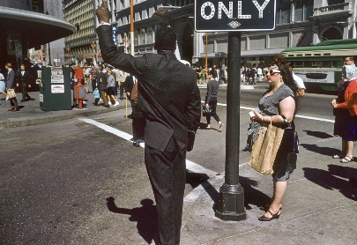
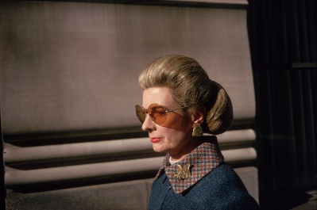
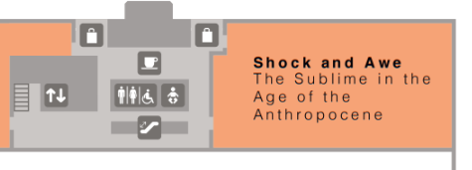
Tate Modern Exhibition Floor Plans
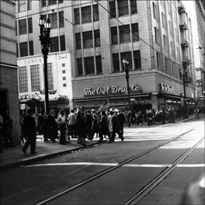
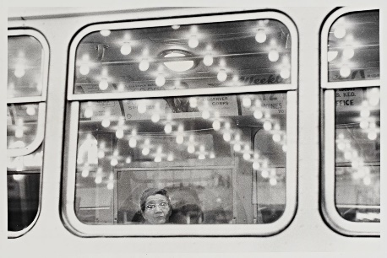

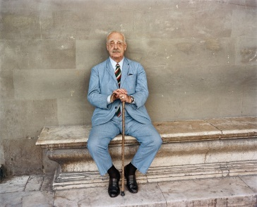

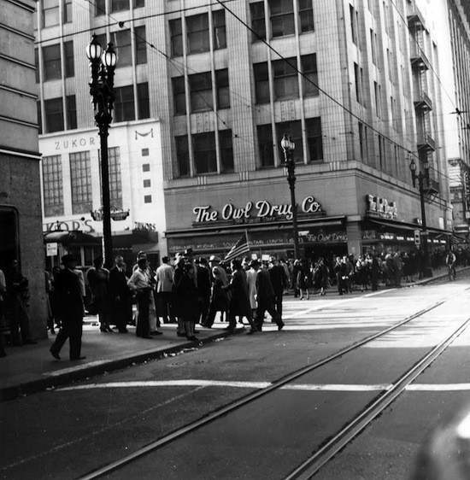
Adams (1940)
The first photograph represents the 1940’s, by Ansel Adams, titled ‘Fifth and Broadway, Los Angeles 1940’. Immediately we are met by crowds of people surrounded by tall buildings in the streets of Los Angeles, a flat image with lots of depth. The composition of this photograph is amazing, multiple telephone lines in the sky, the throng of people along with the tram rails carefully move our gaze to the other side of the image. This photograph is the type of street photography that was extremely popular after the great depression, the documentation of life was important.
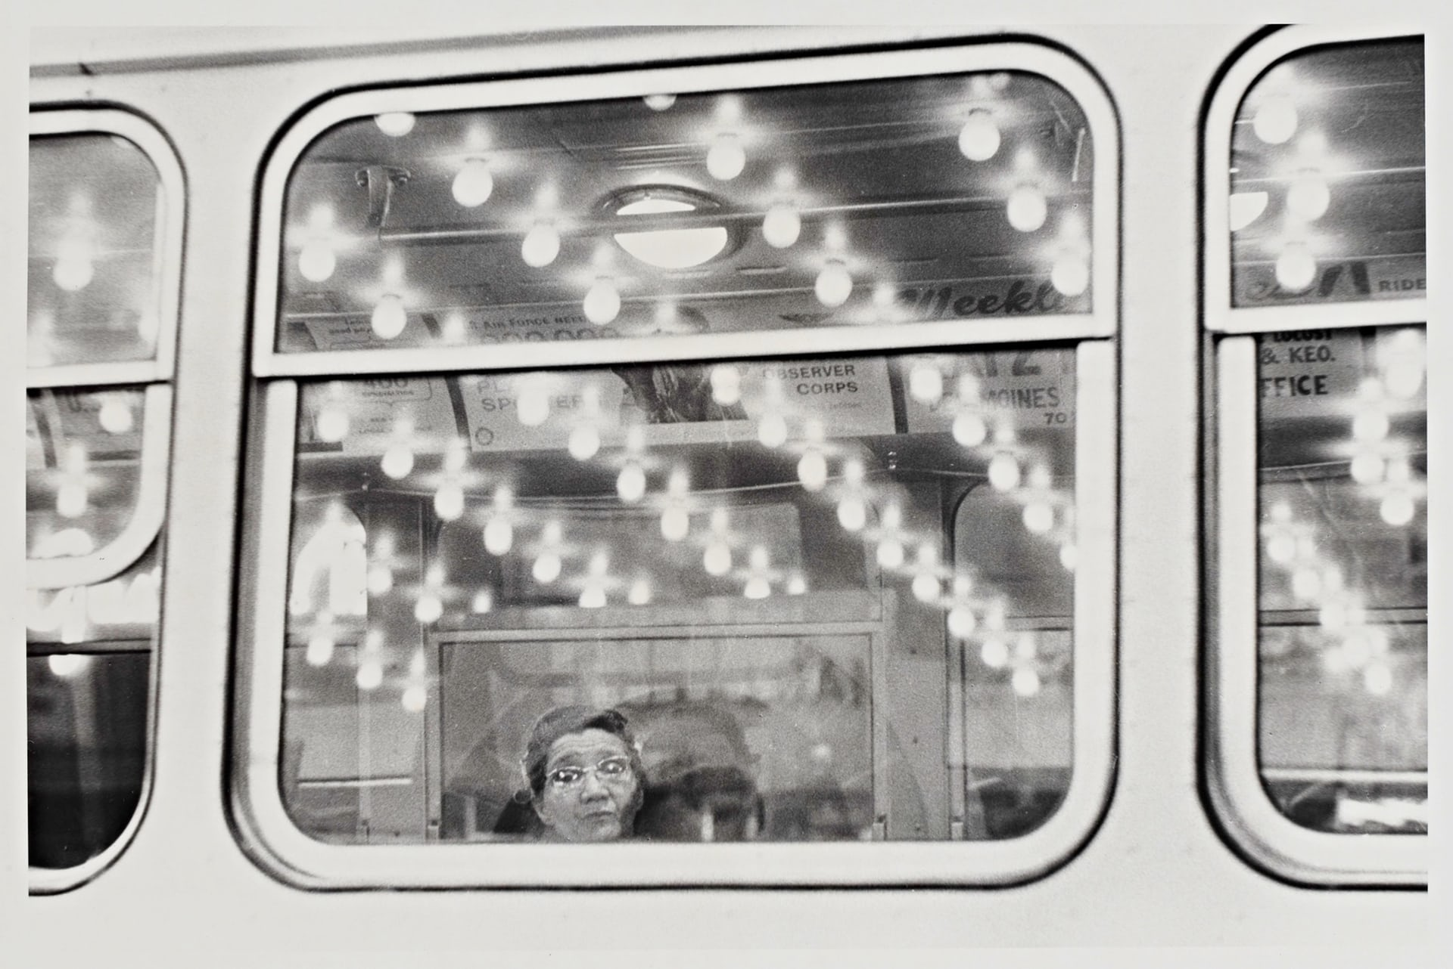
Frank (1956)
The second image is titled ‘Iowa 1956’ by Robert Frank. The photograph includes a lady sat on a bus with the reflections of lights that surround her, the image was taken from the outside looking in. It’s the lights that grab the attention of viewers, the lines of the lights cancel out the bus adverts and make the woman the only thing we see. The photographers of that time were experimenting with composition, using the mirror self to make up a story about the woman and where she was going helps connect us to the subject. However, we are only peering in through the window means we can’t produce a full story, we can’t fully connect with the image – the sublime is at work.

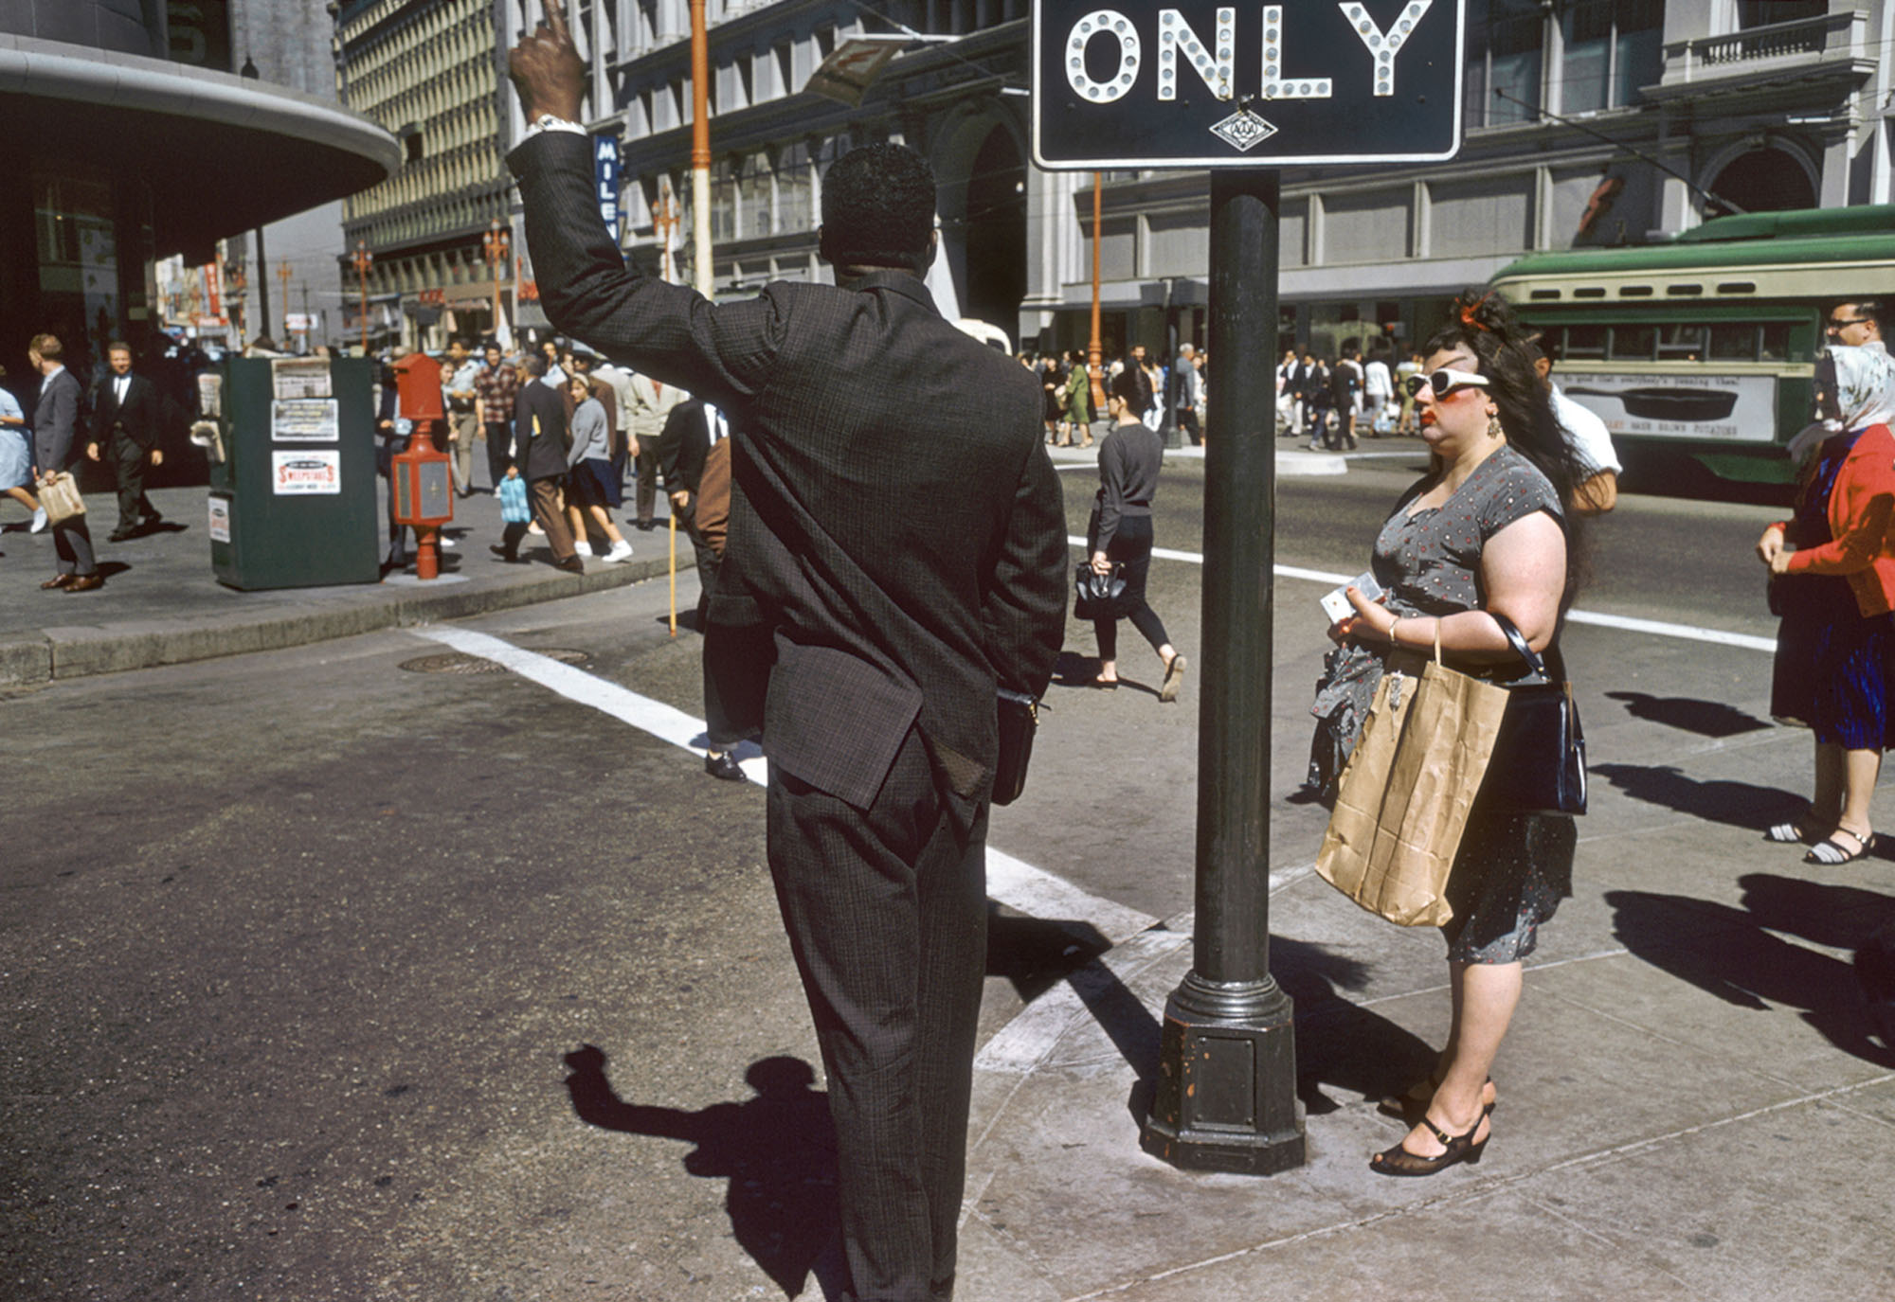
Herzog (1962)
My next image is one of colour, ‘San Francisco 1962’ by Fred Herzog. A photograph of a man stood on a street corner next to a woman with a questionable look he stands tall beside the street sign. The composition is interesting and symbolises a new age for street photography, colour was explored in previous decades but really started picking up in the 60’s. As we know, the sublime and beautiful work side by side, it is the beautiful that really shows us the depth within the image and portrays the 60’s well.

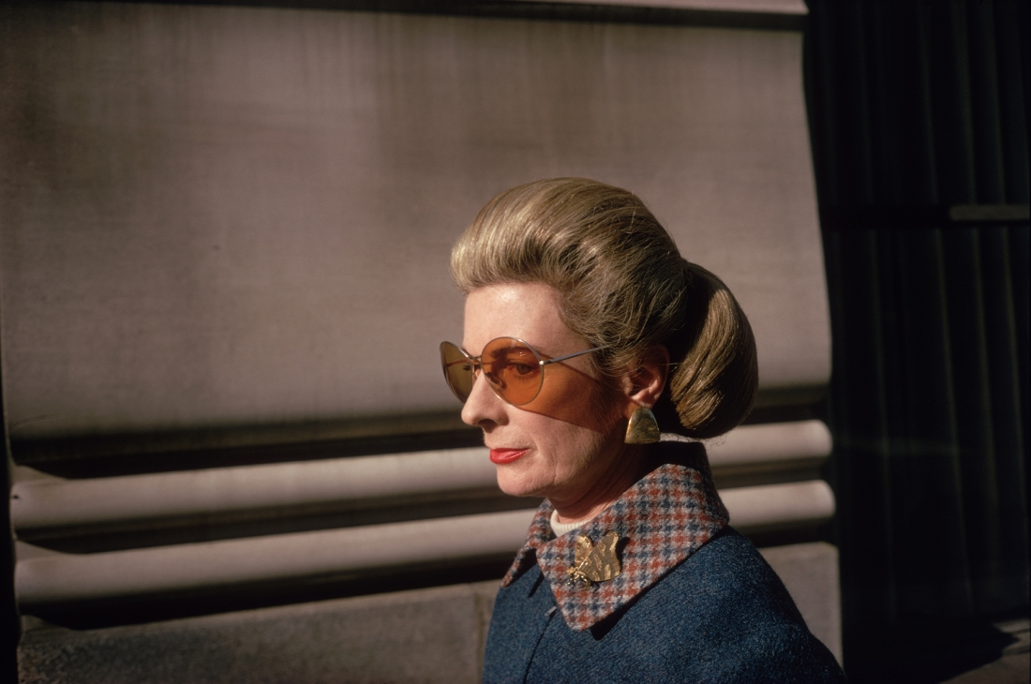
Meyerowitz (1973)
I chose this image to represent the 1970’s, by Joel Meyerowitz titled ‘New York City 1973’. The subject is a woman, smartly dressed with her hair done to match, walking down the street. We can see that she is watching Meyerowitz (1973) from the corner of her eye, she knows that he is taking her photograph but doesn’t pose for the camera. Her waspy sunglasses cast shadows across her face, she is the only focus in the image. This photograph is one of beauty, the photographer captures the woman perfectly, letting us create our own narrative about the woman.

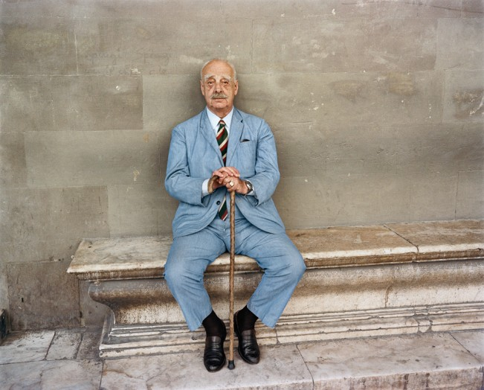
Traub (1982)
My final photograph in the exhibition is by Charles. H. Traub, the photograph is titled ‘Verona 1982’. A man is sat on a dirty marble bench, dressed in a blue suit, he holds his walking stick between his feet. The man seems to be taking a break, he stands out against the dull brick but the sublime starts altering the image, the subject falling flat. Through each image the sublime and beautiful work together giving us changed images, we no longer see the image we first saw but an entirely new results.
It was Burke (1757) that asked, “If the qualities of the sublime and beautiful are sometimes found united, does this prove that they are the same; does it prove that they are any way allied; does it prove even that they are not opposite and contradictory?”. These questions ask if the sublime and the beautiful can exist in the same image, they are one and the same in their meanings by cancelling each other out. In conclusion, the sublime has the power to change an image, it alters our perception of it and shows us something we don’t always want to see, the photographs in the exhibition have also been affected. The sublime is why these images and street photography is still relevant to my work today, these photographs are what have helped develop my own styles and techniques. The sublime creates an opportunity to break down the image to make it more relatable for the mirror self, giving us chance to project our own experiences into each image to please ourselves. The sublime and beautiful will continue to alter works for years to come.

References

Burke E (1757). A Philosophical Enquiry into the Origin of Our Ideas of the Sublime and Beautiful. [online] Available at: https://archive.org/details/philosophicalinq00burk Accessed on: 14/4/18
Bibliography

Valerie Jardin (2015). Colour or Black and White for Street Photography. [online] https://digital-photography-school.com/color-or-black-and-white-for-street-photography/ Accessed on: 26/4/18

