Analysis of a Significant Programme of Work Developed by the Student

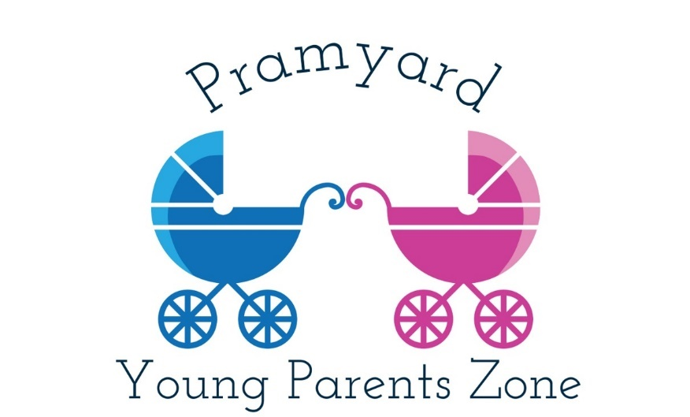

Introduction and Scope
Now more than ever we all understand what it is like to be socially isolated. This analysis describes the Pramyard project that was developed by the author in response to findings from research into the loneliness and social isolation faced by young parents.
Five reflective journals have been presented that review the planning and preparation for the project, how it was funded, preparing to launch the new group, promoting it in the local community and the actual launch day. This analysis aims not to reproduce the material presented in those accounts.
As the project was interrupted in March 2020 by the coronavirus pandemic, the scope of this analysis is limited to where the project is today. The project did not conclude and no measures of overall success can be gathered. However, positive conclusions can be drawn from the work that was undertaken and lessons have been learned that can lead to improvement in the future.
Background and Identification of Need
The Tanyard’s charitable objects (see Appendix 1) are to educate and assist young people and to improve their lives. In order to fulfil these aims we must understand how we can help young people and what it is that they want, but more importantly what it is that they need.
The author undertook a variety of research from primary and secondary sources to establish and validate the needs of young parents (under 25) locally and generally (see Reflective Journal 1).
It is well established that teenage pregnancy and early motherhood are associated with poor achievement, poverty, social isolation and poorer physical and mental health (Witcombe-Hayes et al., 2018) and it is estimated that 27% of women suffer perinatal mental health problems each year (ibid.).
In a study into loneliness in the UK, and looking at young mothers, it was stated that
even where their initial social connections were strong, either before or shortly after the birth of their baby, they had experienced diminishing support from friends and family as the months went on. (Kantar Public, 2016)

This is reinforced by research conducted by the Co-op and the British Red Cross. Smith (2018) states that ‘49 per cent of mothers aged between 18 and 25 are often or always lonely’ and that over 80 per cent of them ‘meet their friends less often after having their child’.
Therefore, it is essential that we cater for young parents who are more isolated than their peers who do not have children. This is especially true since there are still concerns about the availability of mental health services for young people in Wales; despite improvement ‘health boards are still not meeting the Welsh Government's target for 80% of children requiring routine assessments to be seen by CAMHS within 28 days of referral’ (Patel, 2019).
The children of young parents tend to experience poorer health and social outcomes too (Witcombe-Hayes et al., 2018), and the emphasis is usually on them. However, the author wished to focus on improving the lives of the young parents themselves. The project would not replicate the parenting classes or other ‘interventions’ offered in a school or a health centre, it would provide a social space where young parents could meet to experience valuable peer support and ‘me time’ in an informal setting.
‘Constructing a programme is the art of the possible’ (Harris & Ingram, 2001, p36) and this is how the Pramyard project came to be. It was intended to be a ‘widening of the net’ to welcome and support more young people under 25 in the community, fully in line with the charitable aims of the organisation, and it would provide better equality of opportunity and less social isolation for young parents.
Aims and Objectives of the Programme
The aim of the Pramyard project is to provide local young parents under the age of 25 with equality of access to support, skills and, most importantly, a social life, as experienced by those in their age group who are without parental responsibilities, and to make positive changes to their mental health and wellbeing.
Socialising is important for young people’s wellbeing (PCC, 2017 Wellbeing Assessment), and this is especially true for those young people under 25 who find themselves isolated at home as new parents. Pramyard aims to help these young parents to feel more supported and more connected to their local community.
The outcomes for young parents through joining Pramyard are that they will feel:
- More optimistic about the future
- More relaxed
- More able to deal with problems
- More confident as a parent
- Closer to other people and to have a sense of belonging
These outcomes are to be achieved through the following programme objectives.
- Early intervention – Making contact with young parents and young parents-to-be through existing social networks. We promote the project via community-based partners (e.g. health visitors, community connectors) and in community settings such as schools, shops, churches and health centres.
- Establishing peer support – Using Mind’s peer support group development tools that were used in the creation of the BESPOKE group at the Tanyard, so that empathy and trust are built quickly between participants and facilitating staff. Members will be able to help each other adjust to parenthood and learn from each other. Members will feel able to express their concerns knowing that these will stay within the group, unless external help is specifically requested.
- Keeping it informal – Doing what the young parents want to do. Having fun and time to relax. Not delivering formal interventions. Using a non-judgemental youth work approach that is inclusive and empowering. Avoiding the fear of social services that can prevent young people from expressing themselves (Mental Health Foundation, 2013, p9).
To summarise, our aim is to build a social network that supports confidence and self-esteem in these young people, to reduce the isolation caused by young parenthood and to establish them as a valued group in our community with better mental health and wellbeing, for their sakes and for their children.
Delivery Methods
Pramyard is a targeted youth work provision that benefits young parents ‘by providing activities through which young people can develop new relationships, skills and knowledge’ and ‘particularly to [experience] enjoyment and achievement’ (Lahal, 2010, p101).
Pramyard operates a weekly open access drop-in session on a Monday afternoon for all young parents locally. It has the flexibility to offer both group work and one to one interactions. An example session Plan is provided in Appendix 4.
It is staffed by two support workers who are helping to establish the group, organising and facilitating a variety of activities, ensuring that attendance is recorded and that evaluation measures are in place so that we can report on the positive changes that result.
Activities include cooking, arts, crafts, sports, games, music and of course socialising, all aimed at helping members to make new friends, try new things and establish a peer support network.
We can provide signposting, mentoring, advice and advocacy on a range of issues such as housing, money and benefits as required. We can also work with the Garth Youth & Community Project who can provide a young person’s one-to-one counselling service at our premises if needed.
We are offering free access to courses (such as Food Safety & Hygiene and First Aid) for those who wish to improve their skills, as well as helping with CVs and employability skills if required.
When members join they are asked to complete a GDPR compliant Membership Form (see Appendix 2) and also a short Wellbeing Self-Assessment Form (see Appendix 3), which is used for evaluation purposes later in the project.
Monitoring and Evaluation
In applying for grant funding the author necessarily had to consider how to measure success of the project against its objectives and whether the outcomes for young people had been achieved.
The author researched how best to measure the mental health and wellbeing of young people (Public Health England, 2015) and registered the Tanyard Youth Project as a licensed user of the Short Warwick Edinburgh Mental Wellbeing Scale (SWEMWBS), which seemed to be a useful and straight-forward tool to use for collating data. The plan was to use this in conjunction with the Wellbeing Self-Assessment Form (Appendix 3).
It was intended to use the Self-Assessment Forms when members first join and at quarterly intervals to measure improvements (or otherwise) in mental wellbeing. This would provide our main method of evaluation for the project, ‘the process of reviewing movement towards achieving the objectives’ (Harris & Ingram, 2001).
It was also planned to record how members came to hear about the group, so that we would know where and how best to promote the project.
In all sessions members were to be encouraged to provide feedback to us about the group and to provide suggestions for activities they would like to do or resources they thought might be needed. This would be a type of formative evaluation (Harris & Ingram, 2001, p51).
The author planned to develop anonymised case studies later in the project, as these could support applications for continuation funding.
Overall, the approach to monitoring and evaluation was well planned in advance and ready to go when the project launched.
Contribution to High Quality Youth Work
As well as contributing to three of the tenets of the Well-being of Future Generations Act (2015), ‘a healthier Wales’, ‘a more equal Wales’ and ‘a Wales of cohesive communities’, the Pramyard project also supports current youth work strategy (Welsh Government, 2019). It is accessible and inclusive of young people who are socially isolated and it provides them with opportunities and experiences to help them thrive. It is informed by the young people themselves (i.e. through feedback and suggestions) and supported by both skilled and junior staff who themselves benefit from the learning experience offered by the new provision (ref. Signpost No. 39, LSIS, 2012).
One of the purposes of youth work in Wales is to ‘support young people through significant changes in their lives’ (YWWRG, 2018) and becoming a parent is a life-changing transition at any age. Another purpose is to ‘promote opportunities and access for all young people whatever their… personal circumstances’ (YWWRG, 2018) and Pramyard does this by providing a new daytime open access provision specifically for young parents.
Underpinning the Pramyard project are the youth work values (LSIS, 2012) of participation and active involvement, equity, diversity and inclusion, working in partnership with young people and others and enabling the personal and social development of young people.

Summary Analysis
In the author’s experience projects are often assessed against three main variables, also known as the triple constraints: time, quality and cost. If time or cost are constrained, quality will be reduced, if time or quality are increased, cost will increase too, and so on.
Thinking about the timeline, the budget and the quality of the Pramyard project, it is reasonable to say that the original timeline of 48 weeks over one year was interrupted, the budget (see Appendix 5) was largely set aside for later, only a few resources having been purchased so far, and the quality of the project can only be assessed as far as the beginning of March.
However, the analysis of a programme of work with and for young people can take a different approach. Smith (2001, 2006) states that ‘evaluation if it is to have any meaning must look at the people involved, the processes and any outcomes we can identify’. In saying this Smith is adding a human dimension to the approach and thus incorporating an element of ‘practice evaluation’ too.
With this in mind, the author decided to obtain some qualitative feedback on the project from the people who had been involved with the project from the beginning.
The member of staff who was working on the project said:
Pramyard is unique because it focuses on the parent rather than their children, unlike other parent groups. I think it’s a much needed provision within Pembroke and the Dock, as far as I’m aware there isn’t anywhere else that offers the same for young parents. I think Pramyard gives young parents somewhere they can go to be supported but also gain new life skills, confidence, self-esteem etc. Also, young parents have the opportunity to meet other young parents so they can build friendships, enables them not to be isolated and overall will help improve young parents’ mental health and well-being.
(Project staff member, 2020)

This response is positive and demonstrates the staff member’s ‘buy-in’ to the project as they can articulate the need for the project as well as how young parents can benefit from it (the outcomes).
This reflects well on the author as the creator of the project and is an example of:
Enabling workers both to build on their strengths, but also encouraging them to develop new skills and enthusiasms so that they, like the young people, get the ‘buzz’ of achievement and creativity.
(Lahal, 2010, p102)

A young person helping with the project was also asked for their thoughts, and they said:
I think Pramyard is a really good idea as it would help a lot of people as it would give them a chance to meet people of a similar age and they could have the chance to meet with new people.
(Young person on project, age 17, 2020)
This young person knows of others in their own age group who have become young parents or are expecting babies and would have been instrumental in encouraging them to join the group. It is hoped that this young person will have that opportunity again soon.
From the author’s own point of view the project has been successful to date and has every chance of proving successful with young parents in the future. It has been a learning experience in a ‘real world’ situation that has provided opportunities to try new things, take some risks and reflect on personal strengths and weaknesses (NOS ref. YW30, LSIS, 2012).
No summative evaluation (Smith, 2001, 2006) can be made as the Pramyard project remains open ended. However, it is possible to look at another framework for evaluation (The Centre for Youth Impact, 2018), which poses some key questions that can be used to evaluate the Pramyard project to date and over a period of time in the future.
That framework (ibid.) asks ‘Why do you do what you do?’ and the answer lies in both the charitable aims of our organisation and the needs of young people. It asks ‘What exactly are you doing?’ and this relates to the delivery methods we have chosen to use and the detail of the sessions that we are running (see Appendix 4 - Sample Session Plan) and how these relate back to the objectives of the project and the intended outcomes for young people. When asked ‘Are you doing it consistently well?’, the response at present is that everything is on hold and that we can not answer this. Later questions such as ‘What do young people think about what you do?’ and ‘Are you achieving your aims?’ can only be posed again and answered when we are further into the Pramyard programme.
Concluding Remarks
As the author considers the current situation during the coronavirus pandemic, it is clear that the needs underlying the Pramyard project remain. Indeed, these needs may grow as a result of imposed isolation. There is currently (May 2020) a lot of advice online for parents about how to help their children cope with ‘lockdown’: their loss of interaction with friends and wider family, the new hygiene rules and home schooling. However, there is nothing that the author could find specifically to help young parents.
As restrictions lift and we begin to move forward we aim to relaunch the Pramyard project. We will grow our presence on Instagram to find more young parents, run competitions to celebrate ‘lockdown babies’, perhaps meet outdoors on the Commons at a distance. The project may not be delivered in the way it was originally intended, but it will still aim to meet the same outcomes for young parents: that they feel more optimistic about the future, more relaxed, more able to deal with problems, more confident as a parent and closer to other people again.
Appendix 1 – Tanyard Youth Project Ltd – Charitable Aims
“The charity's objects are to educate and assist young persons through their leisure time activities so as to develop their physical, mental, and social capacities that they may grow to full maturity as individuals and members of society and their conditions of life may be improved and in furtherance of that object to provide in Pembroke a centre for meeting sessions and other forms of leisure time occupation for the benefit of young persons.”

(Tanyard Youth Project Ltd., Memorandum of Association, 2005)

Appendix 2 – Membership Form
Appendix 3 – Wellbeing Self-Assessment Form

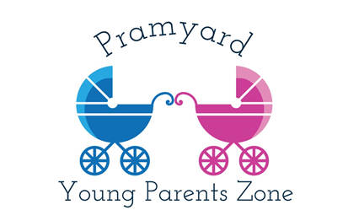
Initials:
Date:

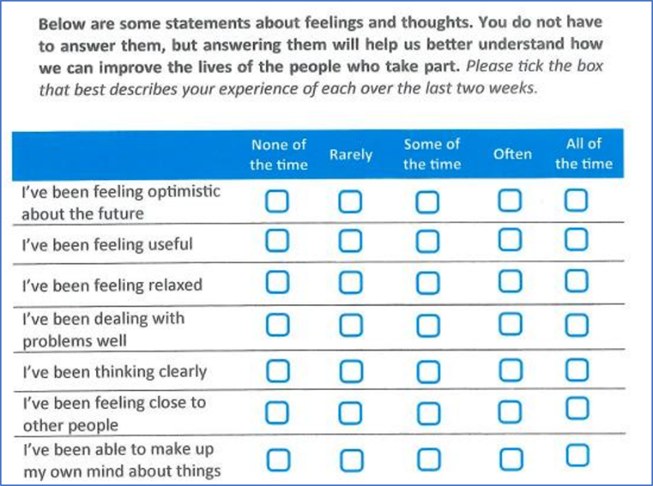

Appendix 4 – Sample Session Plan
Appendix 5 – Project Budget

2 project workers @ £10/hour (£11.68 including NI and 3% pension) x 4 hours/week x 48 weeks = £2,243 each = £4,486

1 laptop with office software to organise, communicate, promote, hold records etc. - £420

Resources and refreshments for sessions @ £20/session x 48 weeks = £960

Garth Youth & Community Project (for youth counselling services) = £500

Access to work relevant courses for participants if desired (10 each of Food Safety & Hygiene, Health & Safety Basics, Equality & Diversity, Tier 1 Safeguarding, First Aid) = £850

Large 8-sided playpen with soft play matting = £85

Total - £7,301 (including VAT)

Reference List
Harris, J. & Ingram, G. (2001) Delivering Good Youth Work: A Working Guide to Surviving and Thriving. Lyme Regis: Russell House Publishing
Kantar Public (2016) Trapped in a bubble: An investigation into triggers for loneliness in the UK. [Online]. Available at: https://assets.ctfassets.net/5ywmq66472jr/5tKumBSlO0suKwiWO6KmaM/230366b0171541781a0cd98fa80fdc6e/Coop_Trapped_in_a_bubble_report.pdf Accessed 11th February 2020.
Lahal, R. (2010) Targeting for Youth Workers in Batsleer, J & Davies, B. (Eds.) What is Youth Work? Exeter: Learning Matters
Learning and Skills Improvement Service. (2012) National Occupational Standards for Youth Work. Coventry: LSIS.
Mental Health Foundation (2013) Young Mums Together: Promoting young mothers’ wellbeing. [Online]. Available at: https://www.mentalhealth.org.uk/sites/default/files/young-mums-together-report.pdf Accessed: 5th February 2020.
Mind (2019) Five Ways to Wellbeing. Online. Available at: https://www.mind.org.uk/workplace/mental-health-at-work/taking-care-of-yourself/five-ways-to-wellbeing/ Accessed 13/10/2019.

Patel, A. (2019) CAMHS referral waiting times in Wales improved by 13% in a month. [Online]. Available at: http://www.pulsetoday.co.uk/clinical/clinical-specialties/mental-health/camhs-referral-waiting-times-in-wales-improved-by-13-in-a-month/20039758.article Accessed 25th April 2020.

Pembrokeshire Public Services Board (2017) Well-being Assessment. [Online]. Available to download from: https://www.pembrokeshire.gov.uk/public-services-board/well-being-assessment Accessed 5th February 2020.
Public Health England (2015) Measuring Mental Wellbeing in Children and Young People. [Online]. Available at: https://assets.publishing.service.gov.uk/government/uploads/system/uploads/attachment_data/file/768983/Measuring_mental_wellbeing_in_children_and_young_people.pdf Accessed 25th April 2020.
Smith, D. (2018) Shocking extent of loneliness faced by young mothers revealed. [Online]. Available at: https://www.co-operative.coop/media/news-releases/shocking-extent-of-loneliness-faced-by-young-mothers-revealed Accessed 25th April 2020.
Smith, Mark K. (2001, 2006) ‘Evaluation for education, learning and change: theory and practice’ in The encyclopedia of pedagogy and informal education. [Online]. Available at: https://infed.org/mobi/evaluation-theory-and-practice/ Accessed 25th April 2020.
The Centre for Youth Impact (2018) Asking good questions: a framework to support evaluation. [Online]. Available at: https://www.youthimpact.uk/uploads/1/1/4/1/114154335/asking_good_questions_-_a_framework_to_support_evaluation__.pdf Accessed 20th May 2020.
Welsh Government. (2015) Well-being of Future Generations (Wales) Act 2015, Cardiff: Welsh Government.
Welsh Government. (2019) Youth Work Strategy for Wales, Cardiff: Welsh Government. [Online]. Available at: https://gov.wales/sites/default/files/publications/2019-06/youth-work-strategy-for-wales.pdf Accessed 16th March 2020
Witcombe-Hayes, S. et. al (2018) From bumps to babies: perinatal mental health care in Wales. [Online]. Available at: https://learning.nspcc.org.uk/research-resources/2018/from-bumps-to-babies-perinatal-mental-health-care-in-wales/ Accessed: 5th Feb 2020.
Youth Work in Wales Review Group, (2018) Youth Work in Wales: Principles and Purposes. Welsh Assembly Government.

