COMPONENT 1 — COURSEWORK
PORTFOLIO

Software Solutions for Business
Module code: ACCA4026

Student name | Abdelhamid Abas Ahmed Fadolalla
Student ID
Programme | CertHE Computing Skills for Workplace
Lecturer
Submission date
Word count | 4205

Table of ContentsACCA4026_Software
Task 1 — E-commerce Website Builders 3
1.1 Selection context 3
1.2 Shopify 3
1.3 Wix 3
1.4 Comparative decision 4
Task 2: Mind Mapping for Business Operations 5
2.1 Meaning and characteristics 5
2.2 Business benefits and limitations 5
2.3 Mind map of contemporary business software 6
Task 3 — Microsoft Business Applications and Practical Excel Testing 8
3(a) Microsoft Applications: Features, Benefits and Limitations 8
3.1 Microsoft Word 8
3.2 Microsoft PowerPoint 9
3.3 Microsoft Excel 9
3.4 Microsoft Access 10
3.5 Integrated use 11
3(b) Practical Excel Feature Tests 11
3.6 Feature Test 1 — VLOOKUP 11
3.7 Feature Test 2 — PivotTable 13
Task 4 — Communication and Online Collaboration 16
4(a) Analysis of Zoom and Trello 16
4(b) Practical Testing 17
4.1 Practical Test 1 — Scheduling and Starting a Zoom Meeting 17
4.2 Practical Test 2 — Trello Kanban Task Tracking 19
Reference List 22

Task 1 — E-commerce Website Builders

1.1 Selection context
An e-commerce website builder is a service that incorporates hosting, page design, product control, checkout and administration all in one. The strategic decision is not only a matter of looks, but it also impacts conversion, operational effort, integration, data control and total cost. Shopify and Wix are up-to-date and reliable alternatives, as both are used by many. As of July 2026, W3Techs reported that 5.3% of all websites were running Shopify while 4.3% were running Wix, but these statistics are based on the technology detected, not business performance [1].

1.2 Shopify
Shopify is commerce-first. It's a hosted builder, which integrates responsive themes, inventory, orders, payments, analytics, marketing channels and a vast app ecosystem [2]. A small retailer can start without servers, or a growing organisation can connect to point-of-sale, marketplaces and fulfilment. Product and order records are all in one place, eliminating duplicate administration, and a managed platform moves routine availability, updates and certificate management to the provider. But convenience can lead to dependency: subscription costs, paid apps, and transaction structures can increase life cycle expenses; too many theme options may require special development; and moving is more challenging if work is dependent on proprietary software.

1.3 Wix
Wix is a design-first platform, with a comprehensive e-commerce layer. It has a visual editor, templates, and business tools, which can facilitate product catalogues, secure checkout, inventory, multichannel selling, marketing and analytics [3]. It's especially appealing for a microbusiness that requires a website to present content-rich material, like a portfolio, services pages, bookings and a small shop, that can be managed by non-technical people. The drawback, of course, is that a higher level of freedom for pages can result in different designs if there is no governance in place. If using international commerce, complicated stock rules or high-volume integrations are required, then paid extensions or a more specialised platform may also be necessary.

1.4 Comparative decision
Criterion | Shopify | Wix
Core orientation | Commerce operations and scalable selling | Visual website creation with integrated commerce
Ease for non-specialists | Guided store administration; theme constraints aid consistency | Highly flexible drag-and-drop editing
Growth route | Strong application, channel and fulfilment ecosystem | Strong all-in-one route for content, services and a smaller catalogue
Principal risk | Cumulative subscription, application and platform dependence | Design inconsistency and weaker fit for complex commerce
Best-fit case | Transaction-led retailer with multi-channel ambition | Content-led microbusiness or service firm adding a shop
Table 1.1: Comparative Assessment of Shopify and Wix E-commerce Website Builders
Task-technology fit is one item from the defensible selection. Any retailer that anticipates lots of transactions, channels and integrations should consider shortlisting Shopify as their solution, whereas a small business that wants more visual control and a lightweight catalogue should get more value from Wix. Before commitment, management should: Test mobile checkout and accessibility, Cover payment and shipping options, Export options, Application permissions, Support response and recovery measures, and total cost over three years. A polished demonstration is not enough if the platform is not able to maintain data quality or support the future operating model.

Task 2: Mind Mapping for Business Operations

2.1 Meaning and characteristics
A mind map is a radial graphic organisation that starts with a topic in the centre and extends outwards with keywords, labels, colour and images. It is more conducive to associative thinking, while a concept map is more likely to represent concepts in a hierarchy and relationships that are described by labels [4]. In business, it is important to know the difference: while mind maps work well in the initial exploration phase, a formal process model might be required if sequence, responsibility or control needs to be clear.

2.2 Business benefits and limitations
When used appropriately, mind mapping has four practical benefits:
- Idea generation and scope: a team can reveal the missing customers, risks, channels or resources without having to push ideas into a linear document too early.
- Planning and decomposition: big branches are called work streams and small branches are called actions, enabling a large project to be broken down into smaller ones.
- Communication and memory: visual grouping lessens the difficulty of finding related ideas. Evidence suggests that mapping can be a tool for facilitating knowledge construction and sharing, and that its impact is contingent upon mapping design and use [5].
- Participation and review: a shared map provides a visible space for participation and review, allowing for the active involvement of quieter contributors, and for stakeholders to contest assumptions before they turn into costly commitments.
This method does not guarantee accuracy or precision. A neat map may show good evidence that can be misinterpreted by personal shorthand, or a visually attractive map may contain little evidence; and overfilled branches can be hard to scan. A study conducted in a controlled environment, however, found that there was a slight but measurable improvement in factual recall [6], but a mind map should not be regarded as evidence of understanding. Important outputs should thus be turned into owned actions or validated requirements or a controlled process.
The key to creating an effective business map is to complete it in a controlled cycle. The starting point is that you need to establish one decision question and place it in the middle. Second, create short branch labels that are common among all and evidence, dependencies and risks below them. Third, discuss the map with members of various functions to make sure that one function's assumptions are not overwhelming. Lastly, turn the accepted branches into a prioritised action register with an owner, deadline and measure of success. This maintains the creative thinking of the radial approach, and gives accountability outside of the workshop.

2.3 Mind map of contemporary business software
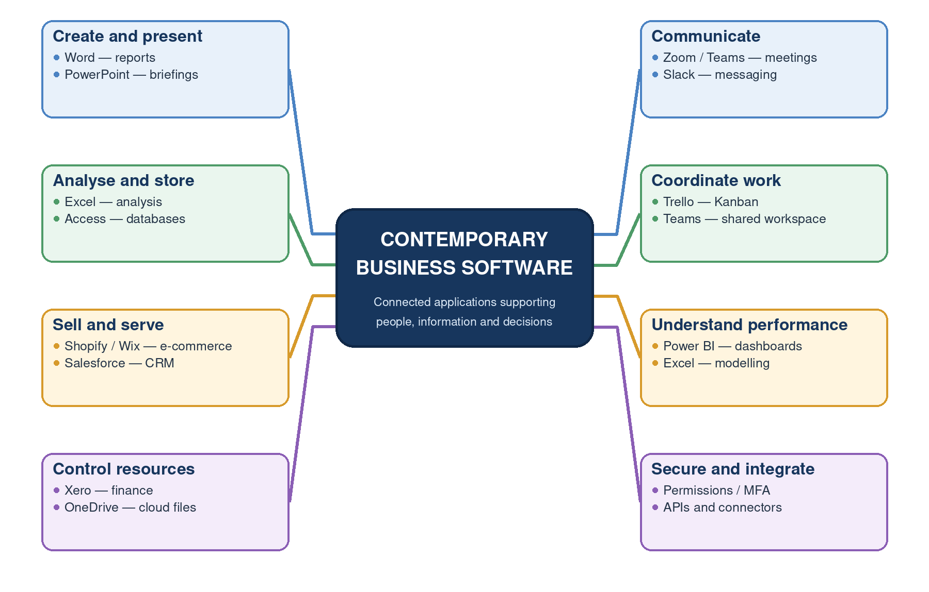
Figure 2.1 is a map of contemporary software, not by supplier, but by business purpose. The left side is content, data, customers and resources; the right side is communication, coordination, performance and control. A few of them can be seen in multiple applications since when you share value there is a need to integrate—like if you share data with Excel, that data to Power BI or, if you have team meetings, they can be shared with shared work. Security and connectors are represented as cross-cutting requirements: without multifactor authentication or secure data exchange, the purchase of isolated applications without permissions would result in disjointed solutions instead of a cohesive one.

Figure 2.1: Contemporary Software Applications Supporting Business Operations (Self-made)

Task 3 — Microsoft Business Applications and Practical Excel Testing

3(a) Microsoft Applications: Features, Benefits and Limitations
Microsoft Word, PowerPoint, Excel and Access support different information problems. By treating them as identical, weak solutions are encouraged, and the quality of a business workflow is determined by the application that has data structure, audience and control requirements that fit the task.

3.1 Microsoft Word
Word is an application used to create documents, particularly those that contain text, like reports, policies, letters, proposals and contracts. Styles, themes, consistency of page layout, tables, references, captions, automatic contents, headers and mail merge reduce repetitive formatting and provide consistency. Controlled review was not achieved through exchanging incompatible attachments, but was done with Track Changes, comments, version history and co-authoring features [7]. Templates can include approved branding and standard clauses, and there is an accessibility checking feature to highlight the lack of alternative text, lack of heading structure, and other accessibility issues.
Precision is its business strength—it allows a lengthy document to be paged, reviewed and printed with stable paging. Untrained users, however, will tend to format by hand, resulting in rework and loss of navigation. The ownership of simultaneous editing must also be clear, and the retention rules and permissions of confidential files must be suitable. Therefore, it is best suited to authoritative narrative documents but not for live transaction databases and multidimensional analysis, presentation-led communication.
A strong Word workflow involves the use of named styles and avoiding manual formatting, limiting editing as needed, and documenting the approvals and keeping the master in a controlled area. The use of reusable fields and content controls can minimise repetitive typing of forms, and comparison and Track Changes can maintain the accountability of reviewers. The author should perform the following before publication: Update contents and cross-references, run spell check and accessibility check, check PDF output and ensure that sensitive comments and document properties have been removed.
Best fit: Formal documents that are subject to controlled review, text-heavy, and have consistent layout.

3.2 Microsoft PowerPoint
PowerPoint is intended to be used for communication that is visual and audience-centred. A business can use slide layouts, themes, charts, SmartArt, pictures, sounds, video, animation, Presenter View and recording to communicate a proposal, train employees, and talk to the decision makers. This streamlines the process of creating consistent branding and allows for collaborative editing and comments, allowing subject matter experts to enhance one controlled deck.
The value offered is based on selection and sequence: a manager can take one message, one visual and one supporting piece of evidence on each slide to help make the complex case more understandable. The same power that is an asset in analysis becomes a liability when slides are used as an alternative. The text is dense, animation is decorative, the charts are not readable, and the claims are not supported, which leads to a high level of cognitive load and lowers credibility. Other elements of accessibility include reading order, captions, and alternative text with sufficient contrast. PowerPoint for facilitated explanation and/or executive summary; detailed method, assumptions and evidence should be in the report or appendix.
The first step in good governance is to have an audience objective and a storyboard and not visual effects. Each chart should be named, each chart should have a period and source, each image should have alternative text, and the presenter should test fonts, media and links on the delivery device. A short handout or available PDF can retain the argument following the meeting. These controls turn the deck into a communication layer to the verified evidence instead of a pretty but unreliably claimed layer of evidence.
Best fit: Facilitated briefings with visuals to support, not replace, evidence.

3.3 Microsoft Excel
The Excel spreadsheet environment is used for tabular data, calculations, modelling and visual analysis. Tasks from budgets and stock control to sales analysis are possible with tables, formulas, functions, validation, conditional formatting, charts, PivotTables, Power Query and What-If tools [9]. It is useful when users require a quick test of assumptions, because of its immediate recalculation and familiar grid. PivotTables are described by Microsoft as an interactive tool for summarising, exploring and presenting large amounts of data [10].
Design discipline is a key to business value. Input areas must be separated from calculation areas, output areas, units and dates must be standardised, formulas must be locked or reviewed, and control totals must reconcile to a trusted source. In a collaborative setting, shared workbooks and version history will minimise the duplication of attachments, but multiple users working at the same time won't ensure correctness. A critical review reveals that errors in the spreadsheets are not uncommon and are a managerial risk [11]. Excel is flexible and quick for moderate-sized datasets and analysis, but it is brittle if applied to an uncontrolled multi-user transaction system. If the data is very large, it requires complex permissions, it needs to be audited, or there are lots of related entities, then a database or governed analytics platform is better.
There should be a proportional response to consequence. Protected formulas, named assumptions, independent review, test cases and reconciliation, clear labels, and data validation and reasonableness checks are all examples of low-risk working analysis and should be included in a pricing or financial model. The value of sensitivity analysis is that one seemingly accurate solution can be based on uncertain inputs. The documentation should specify the data source, refresh date, owner/author and intended use to ensure that a visually correct workbook is not confused with an approved operational record.
Best fit: Calculation, modelling, and exploratory analysis of a governed process with visible controls.

3.4 Microsoft Access
Access is a Windows desktop relational database application. Entities are stored in tables, primary and foreign keys enforce relationships, queries are used to retrieve and/or transform entities, forms are used to control the entry of data, and reports are used to govern the output of entities. A free-form spreadsheet will allow inconsistencies that can be avoided by using validation rules, indexes, and referential integrity. A knowledgeable user can also develop an application for a department without having to design a complete software development project, using templates, macros and VBA [12].
This can be helpful in a small inventory, membership, asset or case tracking application where multiple related tables need to be kept up to date. It can be connected to external data and Excel, and it can offer a front end to a more scalable database. It is limited exclusively to material: Microsoft has listed the limit of a database file of 2 GB and a maximum of 255 concurrent users [13], and the current product is only available for PC Users [12]. Design and network conditions may result in lower real reliable concurrency. Therefore, access is not appropriate for Internet-scale or mission-critical systems, unless they have better back-end architecture, testing, backup and specialist administration.
Schema design is key to the quality of the database. Repeating groups should be split into groups with related tables, ensure that each group of records has a consistent key and use controlled lookup tables to replace inconsistent free text. Then information is obtained from queries and reports without duplication of facts. A production design should also include role-based access, backed-up copies of the production, proven recovery, change control and an archive policy. When security or concurrent demand is the issue that makes it more critical to move the data from the desktop file to SQL Server or another managed database, the migration is more defensible than continuing to expand the desktop file.
Best fit: Small relational applications with well-defined scale that are based on Windows.

3.5 Integrated use
The rule of thumb is: Use Word for a governed narrative, PowerPoint for video presentation, Excel for calculations and exploratory analysis, and Access for related operation records. While valuable, the source of truth should always be clear, such as an Access query used to feed the Excel analysis, whose validated chart is then added to PowerPoint and fully described in Word.

3(b) Practical Excel Feature Tests
Using completely made-up business data, two Excel functions were used: VLOOKUP for looking up a specific record in a table; PivotTable for multidimensional summarisation. They show how to perform a lookup operation and managerial analysis.

3.6 Feature Test 1 — VLOOKUP
The simulated problem was in the manual copy of product information in an order process. A lookup table was developed to be controlled with ten product IDs (P001 to P010), names, categories and unit prices (Figure 3.1). The test key used was P004. The formula for the product-name column was =VLOOKUP(B4, 'Product Lookup'!$A$5:$D$14, 2, FALSE); the column indexes (3,4) were used for category and price, respectively. (Figure 3.2) FALSE had to be an exact match, and absolute referencing ensured that the range being looked up would not change when the formulas were duplicated.
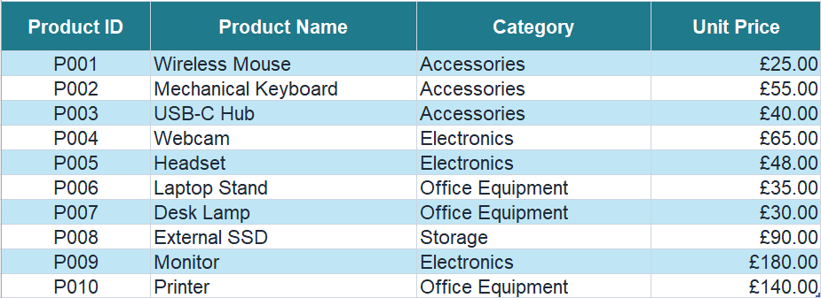
Figure 3.1: Simulated Product Lookup Table (Author’s own screenshot, 2026).
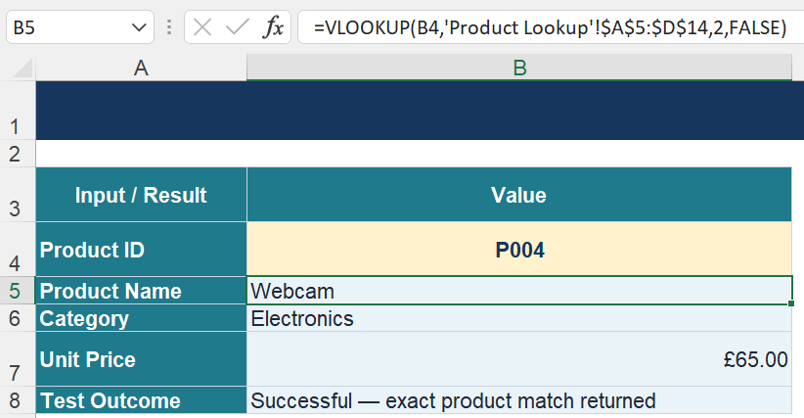
Figure 3.2: VLOOKUP Formula and Returned Product Record (Author’s own screenshot, 2026).
The result was Webcam, Electronics and £65.00. The test was successful as it was verified with the P004 source row and with a matching order record in the sales data (Figure 3.3). In a business, this method eliminates the need for retyping, uses a single price list and uses the product ID as the controlled input. However, VLOOKUP will only find a match in the first column and only find the first match if a duplicate ID is found, or an error if it is not found. Also, a hard-coded index in a table may not be valid upon adding another column, and the error message may appear if the key is not found. As complexity increases, a governed table with unique IDs and error handling and XLOOKUP or other suitable database would be safer [14].
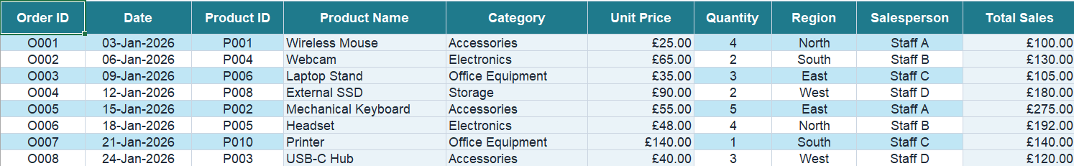
Strengthening deployment with three additional controls. Product IDs must be unique and checked for validity; not just an #N/A message should be returned when a product is not found, and the source table should be locked for easy editing. If an invalid ID is used, a negative test should be documented as well. These checks are not about the reliability of the business, but about the execution of the formula; the former is verified by the appearance of a correct picture, while the latter is verified by the behaviour of the workbook when an expected error occurs.

Figure 3.3: Sales Data Used to Verify the Lookup and Analysis (Author’s own screenshot, 2026).

3.7 Feature Test 2 — PivotTable
The second challenge was finding strong and weak sales regions without having to build a lot of SUMIF formulas by hand. There was a 30-row SalesTable that included order date, product, category, region, salesperson, quantity, unit price and Total Sales. The named table was selected as the source on a new worksheet (Figure 3.4). As Sum (Figure 3.5), Category was placed in Rows, Region in Columns and Total Sales in Values. These selections provide answers to both category and geographic inquiries, in a repeatable view.
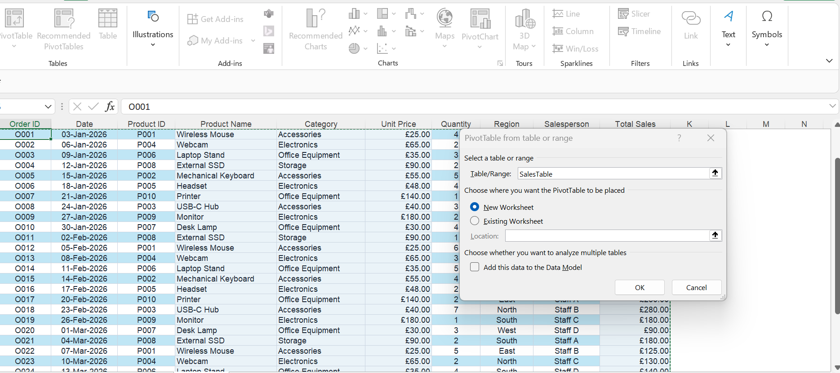
Figure 3.4: SalesTable Selected as the PivotTable Source (Author’s own screenshot, 2026).
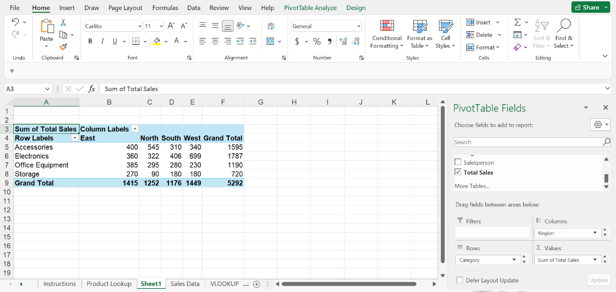

Figure 3.5: PivotTable Field Configuration (Author’s own screenshot, 2026).
The PivotTable totalled £5,292 (Figure 3.6), which is the same amount as the independent Total Sales column. Electronics was the highest-selling category at £1,787, and Storage was the lowest at £720, a difference of £1,067. The strongest region was West at £1,449, with the weakest being South at £1,176, and the highest cell–category was West Electronics at £699. Management could consider examining the factors that lead to West Electronics and consider providing focused support for Storage or South. The output is descriptive and does not include any of the following: cost, margin, seasonality or customer mix. It also relies on clean source fields, as well as being refreshed after data changes. Thus, decisions should be made with the summary and profitability evidence, and a documented refresh and reconciliation control.
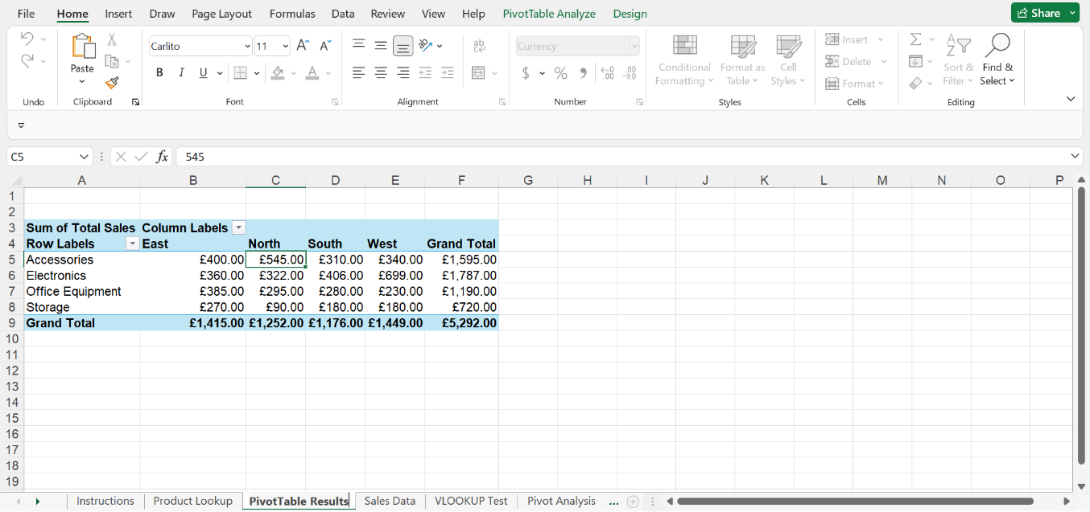
A repeatable review process is also given in the summary. A manager can filter a period, go back to an unusual cell and find the orders going back to that cell, and compare the updated total with an approved control total. The regional spread, £273, is relatively low compared to the spread across the categories, £1,067, and the primary management issue should be more heavily geared towards product mix rather than region. Despite this, before resources are reallocated, the £699 West Electronics outcome needs to be checked for focus (one order or salesperson). It is an interpretation, and not simply the production of the tables.

Figure 3.6: Final Sales Summary by Category and Region (Author’s own screenshot, 2026).

Task 4 — Communication and Online Collaboration

4(a) Analysis of Zoom and Trello
With remote and hybrid work, there is a need for real-time communication and for ongoing coordination. Zoom and Trello have very different purposes: Zoom provides synchronous interaction, and Trello provides visibility of asynchronicity. This pairing addresses the potential of remote work being less collaborative and more asynchronous [15].
Dimension | Zoom — communication | Trello — collaboration
Purpose and mode | Scheduled video/audio meetings; mainly synchronous, with chat and recordings supporting follow-up. | Persistent Kanban boards, lists and cards; mainly asynchronous, with comments and notifications.
Core features | Scheduling, screen sharing, captions, chat, breakout rooms and host controls. | Due dates, labels, checklists, assignees, activity history, automation and Power-Ups.
Access and integration | Desktop, web and mobile access; calendar and workplace integrations. Quality depends on bandwidth and devices. | Web, desktop and mobile access; integrations connect messages and files. Visual density may challenge some users.
Security and privacy | Passcodes, waiting rooms, permissions and encryption options require correct host configuration [16]. | Private/Workspace/Public visibility, permissions and two-factor authentication; cloud sharing requires access review.
Free-plan constraint | Most Basic meetings are limited to 40 minutes, although up to 100 participants are supported [17]. | Ten collaborators and ten boards per Workspace, plus storage and automation limits [18].
Productivity contribution | Resolves ambiguity quickly and enables remote discussion without travel. | Makes ownership, timing and workflow state visible between meetings.
Table 4.1: Comparative Analysis of Zoom and Trello for Business Communication and Online Collaboration
The use of these applications is complementary, not alternative. The strengths of Zoom are ambiguous issues, speed in clarifying, discussion with ownership, discussion with due dates, and a long-term audit trail of workflow; the strengths of Trello are discussion with ownership, due dates, and a long-term audit trail of workflow. When combined, a team can determine in Zoom and record action in Trello. This is important as 74% of businesses surveyed by the CIPD in the UK in 2025 said they had implemented hybrid working policies, and employers also pointed to leadership, organisational connection and culture as possible negative effects [19]. A sensible operating rule is therefore to only meet when it helps to achieve something when it comes to the question of interaction, to take decisions asynchronously, to apply least-privilege access, and to ask questions about whether the tools shorten the time until the decisions are made, or simply add to notifications.
The urgency and the importance of implementation should be differentiated. The following standards need to be established and followed to have a good team meeting: Team standard – agreement on agenda, length, consent to record, decisions and actions; Board standard – Naming of cards, Owners, Due dates, and completion criteria. There should be minimal notifications of changes, guest access should be checked periodically, and inactive boards should be archived. Captions and keyboard-friendly meeting practice are important, as well as meaningful titles for the meeting cards and short descriptions. Decision turnaround, overdue actions and meeting hours can then demonstrate if the combined workflow boosts productivity.

4(b) Practical Testing
Only one hypothetical situation was applied: Nova Retail Ltd. is creating a marketing campaign. No actual customer information, confidential information, financial or employee data was entered.

4.1 Practical Test 1 — Scheduling and Starting a Zoom Meeting
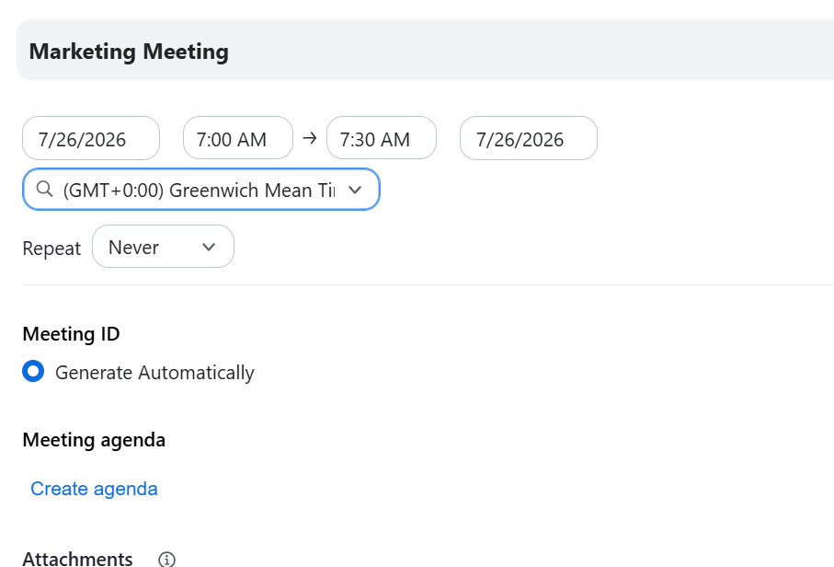
The decision to use Zoom meeting scheduling was made because responsibilities of the campaign mandated an agreed time to immediately discuss. The automatically generated meeting ID and security controls (see Figure 4.1) were set in a 30-minute ‘Marketing Meeting,' which was saved to the upcoming meeting list (see Figure 4.2) following Zoom's scheduling process [20]. The setup screen was set to 07:00-07:30 UTC, and the saved item showed 13:00-13:30 UTC in the local environment (UTC+6), which is a correct conversion of the time zones. The meeting was successfully started, and the isActive host window is verified (Figure 4.3). Scheduling might minimise travel, streamline remote work and speed up decision-making. Restrictions include internet connection reliability, availability of participants, and meeting discipline. Most of the Meetings are also capped in the free Basic plan at 40 minutes [17].

Figure 4.1: Configuration of the Simulated Zoom Business Meeting (Author’s own screenshot, 2026).
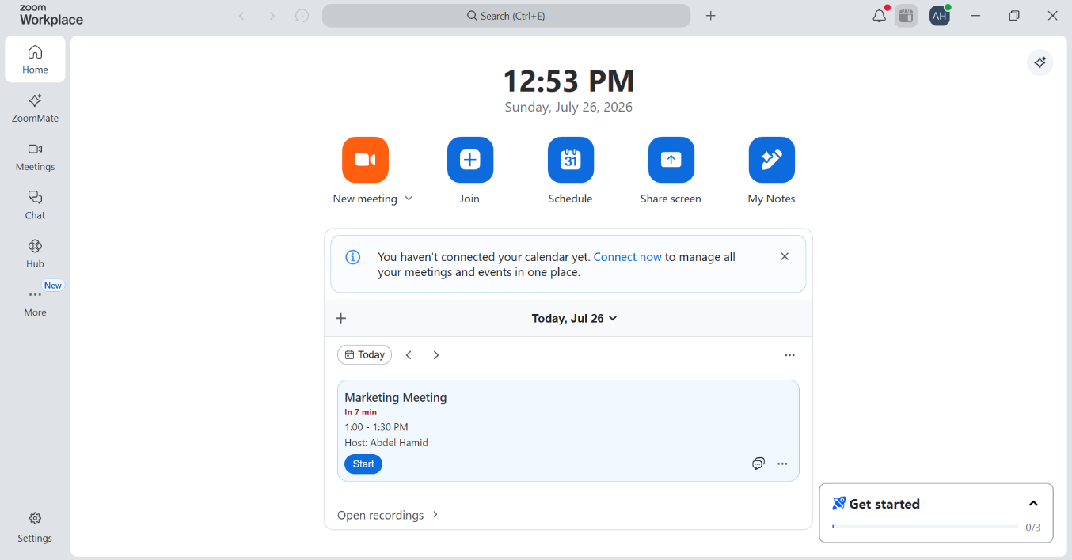

Figure 4.2: Confirmation of the Scheduled Zoom Business Meeting (Author’s own screenshot, 2026).
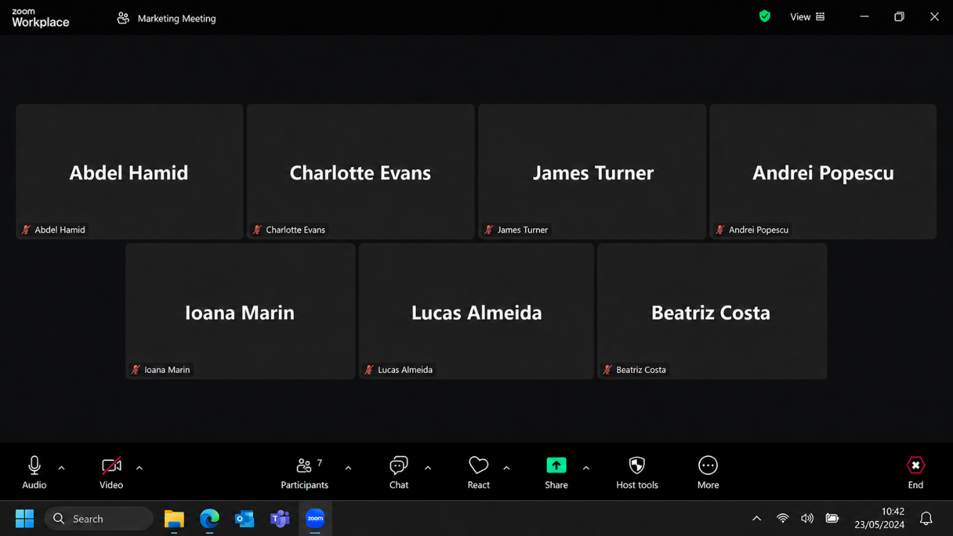
Figure 4.3: Successful Launch of the Simulated Zoom Business Meeting (Author’s own screenshot, 2026).

4.2 Practical Test 2 — Trello Kanban Task Tracking
Trello Kanban tracking was chosen as it would need a visible record after the meeting for the same campaign. A private ‘Marketing Campaign' board was created that was divided into To Do, In Progress and Completed. The ‘Prepare promotional email’ card was created in To Do (Figure 4.4) and was given a High Priority label, a due date and set to be the responsibility of the Marketing Team, with a four-item preparation checklist (Figure 4.5). The card was transferred to In Progress, with all four items marked off, and the final board indicated that the card was Completed, 4/4 (Figure 4.6). This validated a seamless workflow from start to finish with Trello's built-in card and movement characteristics [21] and [22] and illustrates how managers can view the status without disrupting employees. But the accuracy of card updates is required for Trello to function, and ‘Completed' does not necessarily indicate quality of output. The Free plan includes a Workspace containing up to 10 collaborators and up to 10 boards, 10 MB per file and 250 command runs per month [18].

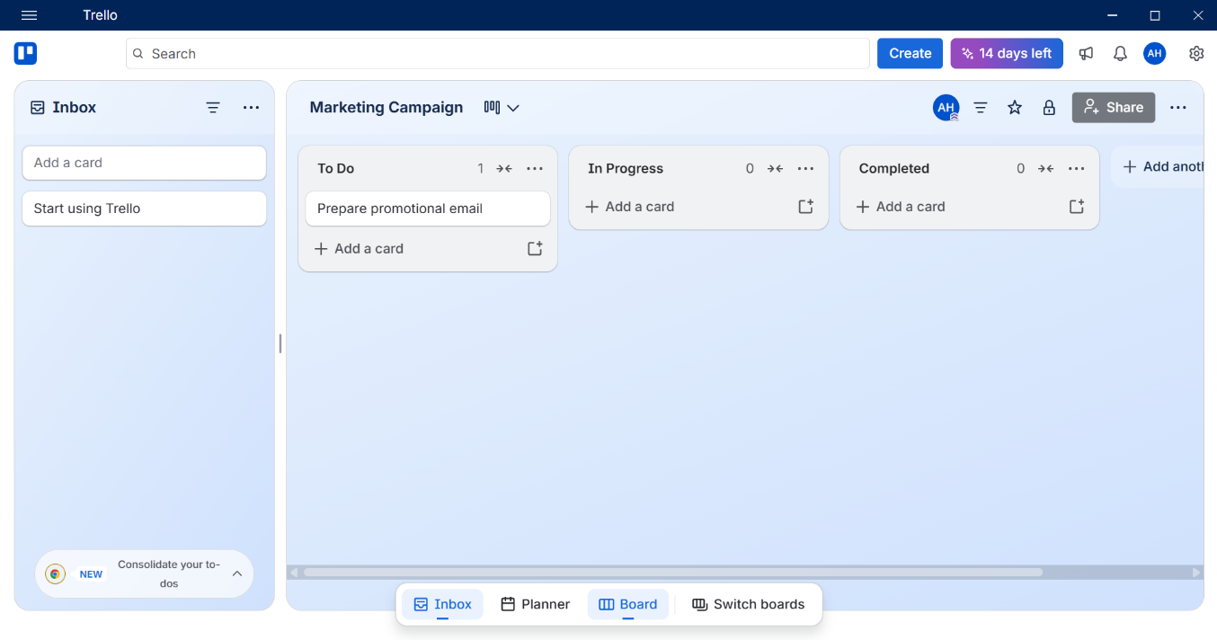
Figure 4.4: Initial Trello Kanban Board with the Task in To Do (Author’s own screenshot, 2026).
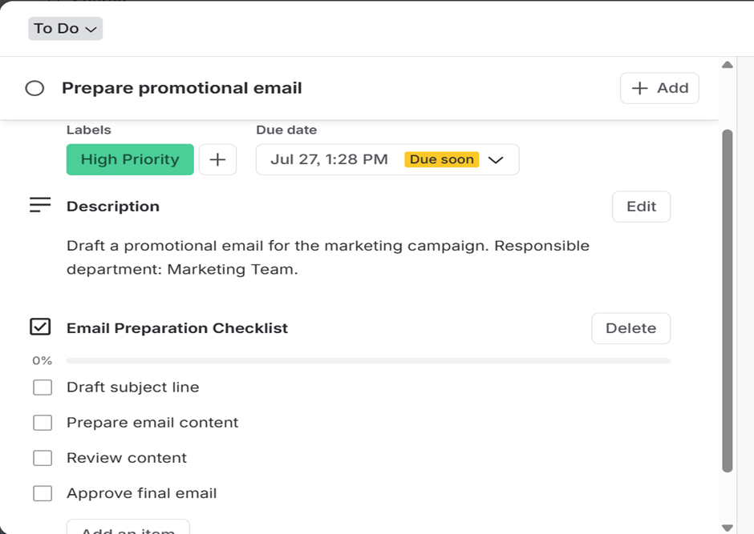
Figure 4.5: Configuration of the Simulated Trello Task Card (Author’s own screenshot, 2026).

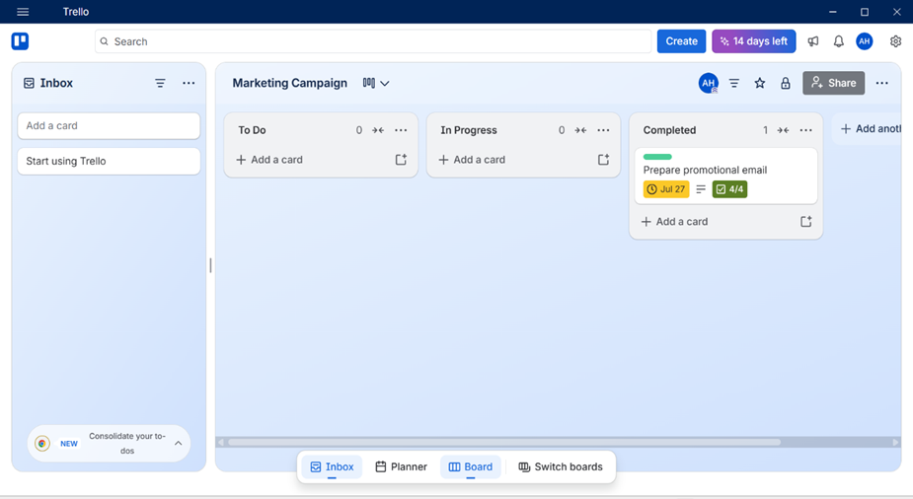
Figure 4.6: Completed Task Within the Trello Workflow (Author’s own screenshot, 2026).
The practical result, then, is that there is a controlled division of labour - Zoom for scheduled conversation and Trello for follow-up (accountability).
The screenshots provide three-stage evidence for each feature: initial state, configuration and completed outcome. This is more powerful than a final screen alone, as it displays the transformation applied. The business should also keep a meeting agenda and an action record for use during the meeting, and have acceptance criteria for the Trello card and mark it as approved by the appropriate person. Those controls would be linked to the performance of the business that is accountable.

Reference List
[1] W3Techs, “Usage statistics and market shares of content management systems,” Jul. 2026. [Online]. Available: https://w3techs.com/technologies/overview/content_management. [Accessed: Jul. 26, 2026].
[2] Shopify, “Ecommerce website builder.” [Online]. Available: https://www.shopify.com/website/builder. [Accessed: Jul. 26, 2026].
[3] Wix, “eCommerce website builder.” [Online]. Available: https://www.wix.com/ecommerce/website. [Accessed: Jul. 26, 2026].
[4] M. Davies, “Concept mapping, mind mapping and argument mapping: What are the differences and do they matter?,” Higher Education, vol. 62, no. 3, pp. 279–301, 2011, doi: 10.1007/s10734-010-9387-6.
[5] M. J. Eppler, “A comparison between concept maps, mind maps, conceptual diagrams, and visual metaphors as complementary tools for knowledge construction and sharing,” Information Visualisation, vol. 5, no. 3, pp. 202–210, 2006, doi: 10.1057/palgrave.ivs.9500131.
[6] P. Farrand, F. Hussain and E. Hennessy, “The efficacy of the ‘mind map’ study technique,” Medical Education, vol. 36, no. 5, pp. 426–431, 2002, doi: 10.1046/j.1365-2923.2002.01205.x.
[7] Microsoft, “Word help & learning.” [Online]. Available: https://support.microsoft.com/en-us/word/. [Accessed: Jul. 26, 2026].
[8] Microsoft, “PowerPoint help & learning.” [Online]. Available: https://support.microsoft.com/en-us/powerpoint/. [Accessed: Jul. 26, 2026].
[9] Microsoft, “Excel help & learning.” [Online]. Available: https://support.microsoft.com/en-us/excel/. [Accessed: Jul. 26, 2026].
[10] Microsoft, “Overview of PivotTables and PivotCharts.” [Online]. Available: https://support.microsoft.com/en-us/excel/overview-of-pivottables-and-pivotcharts. [Accessed: Jul. 26, 2026].
[11] S. G. Powell, K. R. Baker and B. Lawson, “A critical review of the literature on spreadsheet errors,” Decision Support Systems, vol. 46, no. 1, pp. 128–138, 2008, doi: 10.1016/j.dss.2008.06.001.
[12] Microsoft, “Microsoft Access.” [Online]. Available: https://www.microsoft.com/en-us/microsoft-365/access. [Accessed: Jul. 26, 2026].
[13] Microsoft, “Access specifications.” [Online]. Available: https://support.microsoft.com/en-us/access/access-specifications. [Accessed: Jul. 26, 2026].
[14] Microsoft, “Lookup and reference functions.” [Online]. Available: https://support.microsoft.com/en-us/excel/lookup-and-reference-functions-reference. [Accessed: Jul. 26, 2026].
[15] L. Yang et al., “The effects of remote work on collaboration among information workers,” Nature Human Behaviour, vol. 6, pp. 43–54, 2022, doi: 10.1038/s41562-021-01196-4.
[16] Zoom, “Security.” [Online]. Available: https://www.zoom.com/en/trust/security/. [Accessed: Jul. 26, 2026].
[17] Zoom, “Zoom Workplace pricing,” 2026. [Online]. Available: https://www.zoom.com/pricing. [Accessed: Jul. 26, 2026].
[18] Atlassian, “Trello pricing.” [Online]. Available: https://trello.com/pricing. [Accessed: Jul. 26, 2026].
[19] CIPD, “Flexible and hybrid working practices in 2025,” Jul. 15, 2025. [Online]. Available: https://www.cipd.org/en/knowledge/reports/flexible-hybrid-working/. [Accessed: Jul. 26, 2026].
[20] Zoom, “Scheduling meetings.” [Online]. Available: https://support.zoom.com/hc/en/article?id=zm_kb&sysparm_article=KB0060700. [Accessed: Jul. 26, 2026].
[21] Atlassian, “Add a card.” [Online]. Available: https://support.atlassian.com/trello/docs/adding-cards/. [Accessed: Jul. 26, 2026].
[22] Atlassian, “Move cards or lists.” [Online]. Available: https://support.atlassian.com/trello/docs/moving-cards-or-lists/. [Accessed: Jul. 26, 2026].

