University of Wales
Trinity Saint David
Name: Maria Daniela Enache Student number:1916676
Prrograme :BA Business Management
Level 4/Term 2/Group 2
Module name: The Global Businss Enviroment
Assignment 2: Global Business Environment
Title assignment: Electric Car Production of Tesla
Lecturer: Syed Jaffer

Table of Contents

1.0 Introduction 3
2.0 Findings and Analysis 4
2.1 Porter's value chain for Tesla 4
a. Primary Activities 5
b. Secondary Activities 6
2.2 PESTEL Analysis 6
2.3 Porter’s five forces framework on Tesla 8
2.4 Benefits and Challenges in producing Electric Vehicles for Tesla 9
2.5 How natural resources are extracted for the electric car and how it is disposed of 10
2.6 Critical analysis and recommendations 10
3.0 Conclusion 11
Reference List 12

1.0 Introduction
The automotive industry over the past few years have observed a prodigious change in terms of its impact on the users as well as in the industry. The study set forth to predict the restructuring process of the automobile industry in terms of volume and complexity. The future of car companies strongly relies on an "electrified, autonomous, shared, connected and yearly updated” process, or “eascy” in short. First; the autonomy of cars takes less space and time to move, second; the electrification emits minimal noise and exhaust fumes, third; sharing ideas makes the travel more affordable, fourth; yearly updates help to restrain issues that cause accidents. The US, Europe, and China are the most significant car industries in the globe and have already started to apply "eascy” in their production. The forecast predicts that within 2030, the number of autonomous vehicles will be 40% in Europe and the US. Similarly, the report also predicts that within 2030, 55% of cars in the world will be electrified (pwc.com, 2018).
The auto manufacturers navigated three salient parameters in the complex market landscape. First; rapid development and execution of ICE (Internal Combustion Engine) technology, Second; the urge of mobility for urbanization and Third; constantly changing government regulatory framework and technology (cdn.ihs.com, 2015).
The study is going to focus on Tesla Motors Inc., the superior electric vehicle producer from the US whose estimated net worth is $34.3 billion. Electric cars are cost-efficient in comparison to conventional vehicles as the electric vehicles do not require gas, oil, smog tests, prices of which are increasing each passing day. Besides, electric cars save the environment by releasing low air pollutants and greenhouse gases. The essay is expecting to analyze different aspects of Tesla in international trading through the academic framework. It is also going to acknowledge different phases of the electric car production of Tesla and relate it with automotive industry trends. The study will comprehend the value chain analysis of Tesla as this is an effective analytical framework to acknowledge the business activities of the company for developing concentric value and competitive edge in the market (tesla.com, 2020).
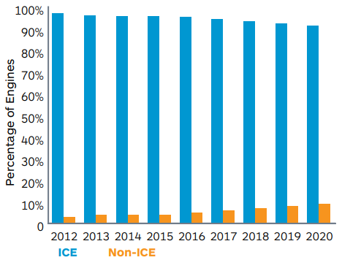
Figure 1: The use of ICE vs Non-ICE engines in the US
(Source: cdn.ihs.com, 2015)

2.0 Findings and Analysis

2.1 Porter's value chain for Tesla
Value Chain Analysis is a compelling academic framework to quickly acknowledge the activities where cost reduction, waste elimination, work optimization, and profit escalation could have been made. The value chain analysis of Tesla is done below;
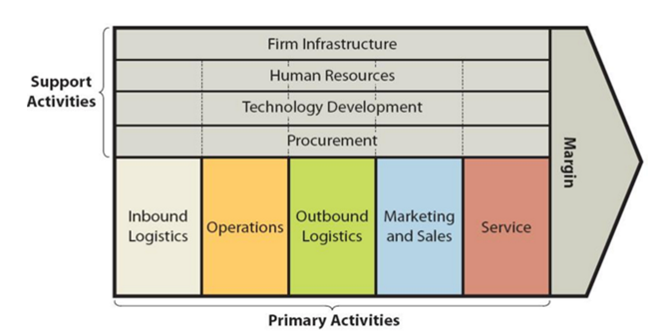
Figure 2: Porter's Value Chain Analysis of Tesla
(Source: research-methodology.net, 2020)

a.Primary Activities
Inbound Logistics
Inbound logistics of Tesla includes the sourcing of raw materials required for electric cars, solar panels, and energy systems. Apart from the raw materials, Tesla sources other scarce materials like steel, nickel, copper, and aluminium as well (Gianesello et al. 2017). The company has 1.3 million sq. Feet warehouse in the Oaks Logistics Centre, Calif. Advanced logistics services are still not valued by many electric car manufacturers. Tesla currently follows the “build-to-order” process, which sources the materials from suppliers in the short-term or part process. They need to build a long-term relationship with the suppliers.
Operations
The operations of Tesla are divided into two sections. “Automotive”; this section deals with the design, production, and sales of the "electric cars". In 2017, the company manufactured 1764 vehicles of Model 3 and 101,420 of Model X and Model S. “Energy generation and storage”; this section comprises the design, production, and installation of energy storage items and solar panels. Tesla installed 523 MW solar energy panels in 2017. The use of robots in the manufacturing process is the strength of Tesla, which offers excellent value to the company. As per the engineers of the company, “up to eight robots at a time work on a single Model S in a choreographed routine”.
Outbound Logistics
The outbound logistics of Tesla includes the depository and distribution of electric cars, solar panels, and energy storage systems. The company sells its electric vehicles through its own stores situated in the US and other 29 countries (Kalaitzi et al. 2019). The company maintains a limited inventory of cars in its stores as most of the customers prefer online booking to get customized cars. Tesla's outbound logistics is highly valuable as it delivers the car directly to the customer without assessing any middleman, which decreases the delivery time and cost.
Marketing and Sales
According to the CEO of Tesla, Elon Musk, the brand does believe in virtual promotion or endorsements. Instead, they believe in word of mouth for sales. The brand attracts the attention of the global media through the inauguration of its technologically upgraded electric cars. Along with the new cars, it sells the old and used cars as well. The online selling website of Tesla is enough for the brand to make customers aware of the products (Aaij et al. 2016). However, they sell via third-party auctions as well.
Services
Tesla, in recent times, has undergone a series of complaints about their services where most of the customers accused that the customer executives of the company do not respond to their vehicle issues appropriately. In 2016, many customers complained about waiting for weeks to repair their Model X electric cars (Kim, 2020). In order to mitigate the issues, the company now allows its customers to contact the company executives directly for their problems. Besides, they offer "post-sales services" at the local service centres. They currently have 250 service centres and 350 on-demand service cars across the US (research-methodology.net, 2020).

b.Secondary Activities

Infrastructure | Effective leadership, potential managing team, clear and horizontal infrastructure
Technology | Massive investment in R&D, cost leadership and superiority in technology
Procurement | Short agreements with suppliers, partnerships
HRM | The effective relationship among the employees, outsourced recruitment

2.2PESTEL Analysis
The PESTEL analysis of Tesla is given below;
Political
The major political factor that influences the industry is the "Environmental Protection Law" to produce eco-friendly cars with minimal exhaust gas emission levels. Secondly, the “Energy loan programs” of the US government are attracting new companies to enter into vehicle technology which is a challenge for Tesla.
Economic
Economic growth towards the use of alternative energies is increasing the sales of electric vehicles. Drop at the electric battery price is making electric cars more affordable.
Social
Buyers are shifting towards the “eco-friendly” cars with the increasing concern for the environment and decreasing trust in gasoline fuel. Besides, people consider electric cars as a status symbol (Gafarov, 2019). The ageing population of the US and Europe are also in favour of autonomous electric cars.
Technological
The introduction of technology in electric cars decreased the chance of accidents. Technology in the automobile sector has developed enormously leaving a trace of reduced carbon footprint.
Environmental
Environmental concerns are forcing the manufacturers more to produce eco-friendly electric cars. Thus companies like Tesla have an added benefit here.
Legal
Tesla sells its cars in 28 countries, and each country has different trading regulations which change continuously. Besides, the regulations are strict for the automobile industry.

Figure 3: PESTEL Analysis of Tesla
(Source: Self-created)

2.3 Porter’s five forces framework on Tesla
Porter's Five Forces is an academic framework to analyze the competitive statics of the company and below is the same done for Tesla;
Threats of New Entrance
Tesla is already operating from the leading edge in the electric vehicles industry. The threat of new entrants is a weak force here as the automotive industry has a high entry barrier. Besides, it requires massive investments and the existing producers like Tesla are already improving their production capacities.
Supplier’s bargaining power
The bargaining power of suppliers is a moderate force as the electric vehicle industry has limited suppliers who are well knowledgeable about the latest technology and matches the company standard. This escalated the bargaining power of suppliers. However, organizations like Tesla already have a huge supplier base which makes the power moderate for them.
Buyer’s bargaining power
The bargaining power of the buyers is a moderate force as they can switch to another company with zero switching cost, which increases the chance of bargaining. However, the customers do not have too many quality alternate options available for them in the electric vehicle industry which lowers the force (researchgate.net, 2020).
Threat of substitution
This is a moderate force as Tesla already sits in the list of top three electric car sellar of the world. Customers these days are either considering public transport or eco-friendly vehicles than the conventional one. But some major automobile manufacturers are also providing excellent electric cars.
Rivalry
The rivalry has a strong force as there exist strong competitors like General Motors, Volkswagen, and Nissan, who also produce cost-efficient yet high-quality EV. Besides, people are considering hybrid car makers as well.

Figure 4: Porter’s five force analysis of Tesla
(Source: Self-created)

2.4 Benefits and Challenges in producing Electric Vehicles for Tesla
Since electric vehicles (EV) do not use the traditional ICE, it reacts quickly to the instructions and has a good amount of torque. EVs can connect digitally, which allows the drivers to operate it from their smartphones. They can charge the car from any nearby electric grid. Apart from personal benefit, EV provides an alternative option of fuel to the world. The US nearly uses 9 billion barrels of petroleum, which is a limited source, and 2/3rd of it goes to transportation. Thus, EV is a great source to save petroleum as it uses renewable energy (Malmgren, 2016). Such positive signs are increasing the demand for EV across the world, especially in the US, which is a good sign as Tesla generates 60% of its total revenue from the US.
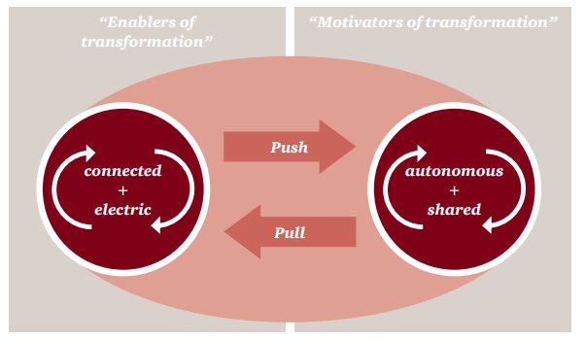
Figure 5: Motivation of users for electric mobility
(Source: pwc.com, 2018)
However, there exist some challenges as well for Tesla to operate in the market. The rapid change in battery technology is causing uncertainty in maintaining the standard. Electric vehicles are still unable to provide a 100% solution for carbon emission. So there always remains a chance of replacement by a new invention (Noel et al. 2018). As per the survey, the drivers of the UK will not prefer EVs completely within the next 15 years or so rather light vehicles are gaining more popularity there.

2.5 How natural resources are extracted for the electric car and how it is disposed
The body and chassis of the electric vehicles are prepared by aluminium where in some parts boron-steel is also used. The underbody is constructed by titanium while the other components use rare-earth materials like neodymium magnets. However, it uses plastics and silicon as well. Tesla started sourcing recycled batteries from the suppliers. They also recycle raw materials.

2.6 Critical analysis and recommendations
The automotive industry is a wide region, and Tesla is definitely a strong player in the field. The company has a limited network as most of its international trading is done via its online and offline stores. However, the competitive nature of the market demands cost-effective products. Apart from Tesla, there already exist big players like BMW and Toyota in the industry. Under such competitive pressure, Tesla is recommended to develop their brand value more by introducing value-added services to the customers. Additionally, customers have the power to switch to ICE-powered vehicles at any moment from EVs. Tesla is suggested to develop its global store and network services. They have to support the customers in decision making.
The growing internationalization of the automotive industry is asking the companies to introduce technologically upgraded products. As observed earlier, the governments of almost every country are also in favour of hybrid, autonomous, and electric vehicles to protect the environment. Thus, Tesla needs to invest more in its R&D and international operations to develop highly effective powertrain engineering for the EVs. They have to develop the energy storage capacity of the engines and also need to introduce software to limit the obsolescence.

3.0 Conclusion
The paper has undertaken Tesla as the concerned organization for further investigation. Tesla Motors has successfully operated in the competitive automobile industry from 2003 with their electric vehicles. With the help of multiple academic frameworks and tools like Porter's value chain analysis, PESTLE analysis, and Porter's Five forces analysis, the study outlined different aspects of Tesla and its present status in the industry. The frameworks helped the study in identifying the macro and microeconomic parameters that can affect the performance of the company as well as its competition. The study strongly suggests the company invest more in its R&D department to introduce technologically improved vehicles. They are also suggested to look for greater production of hybrid vehicles as well, which is soon going to be in demand list of the customers.

Reference List
Journals
Aaij, R., Amato, S., Anderlini, L., Benson, S., Cattaneo, M., Clemencic, M., Couturier, B., Frank, M., Gligorov, V.V., Head, T. and Jones, C., 2016. Tesla: an application for real-time data analysis in High Energy Physics. Computer Physics Communications, 208, pp.35-42. Available at:https://arxiv.org/pdf/1604.05596.pdf [Accessed on: 05:08:2020]
Gafarov, R., 2019. Evaluation of the financial position and the performance of Tesla, Inc (Doctoral dissertation, Masarykova univerzita, Ekonomicko-správní fakulta). Available at:https://is.muni.cz/th/iphw4/Gafarov.pdf [Accessed on: 05:08:2020]
Gianesello, P., Ivanov, D. and Battini, D., 2017. Closed-loop supply chain simulation with disruption considerations: A case-study on Tesla. International Journal of Inventory Research, 4(4), pp.257-280. Available at:https://www.anylogistix.ru/upload/iblock/910/91063dfe903a73dcdfbf1da5cacf4fe4.pdf [Accessed on: 05:08:2020]
Kalaitzi, D., Matopoulos, A. and Clegg, B., 2019. Managing resource dependencies in electric vehicle supply chains: a multi-tier case study. Supply Chain Management: An International Journal. Available at:https://publications.aston.ac.uk/id/eprint/37313/1/electric_vehicle_supply_chains.pdf [Accessed on: 05:08:2020]
Kim, H., 2020. Analysis of how Tesla Creating Core Innovation Capability. International Journal of Business and Management, 15(6). Available at:https://www.researchgate.net/profile/Hyeonjoo_Kim2/publication/341323098_Analysis_of_how_Tesla_Creating_Core_Innovation_Capability/links/5ebb5c13299bf1c09ab933e5/Analysis-of-how-Tesla-Creating-Core-Innovation-Capability.pdf [Accessed on: 05:08:2020]
Malmgren, I., 2016. Quantifying the societal benefits of electric vehicles. World Electric Vehicle Journal, 8(4), pp.996-1007. Available at:https://www.mdpi.com/2032-6653/8/4/996/pdf[Accessed on: 05:08:2020]
Noel, L., de Rubens, G.Z., Kester, J. and Sovacool, B.K., 2018. Beyond emissions and economics: Rethinking the co-benefits of electric vehicles (EVs) and vehicle-to-grid (V2G). Transport Policy, 71, pp.130-137. Available at:http://www.academia.edu/download/60463499/Noel-et-al-TP-Co-benefits20190902-80534-133577e.pdf [Accessed on: 05:08:2020]
Online articles
cdn.ihs.com, (2015), about Top five challenges faced by the automotive industry, Available at:http://cdn.ihs.com/www/pdf/AUT-TL-WhitePaper-5.pdf [Accessed on 05:08:2020]
pwc.com, (2018), about five trends transforming the Automotive Industry, Available at:https://www.pwc.com/hu/hu/kiadvanyok/assets/pdf/five_trends_transforming_the_automotive_industry.pdf [Accessed on 05:08:2020]
Websites
researchgate.net, (2020), about Porter’s five force analysis of Tesla, Available at:https://www.researchgate.net/publication/325746551_Tesla_-_Porter_Five_Forces_Analysis_Harvard [Accessed on 05:08:2020]
research-methodology.net, (2020), about value chain analysis of Tesla, Available at https://research-methodology.net/tesla-value-chain-analysis-2/[Accessed on 05:08:2020]
tesla.com, (2020), about Tesla Motors, Available at https://www.tesla.com/ [Accessed on 05:08:2020]

