Activity Plan

The activity will take place in Penllergaer Valley Woods which is a woodland where there are plenty of opportunity to discover natural elements. It is a public area in which people use to walk dogs, walk and explore. The terrain is uneven and there are little rivers and ponds around too. The area is vast so the children will be given an area with boundaries in which they will have to stay within. It is owned by the Forestry Commission Wales. (penllergare.org.uk, 2019)
I will be taking 5 children in a reception class so their ages will vary between 4 and 5. NSPCC.org (2019) makes the recommendation that there should be at least one adult to every six children for the age category 4-8. For the purposes of safety and monitoring there will be two adults present. The experience will be 2 hours long, including a picnic.
An appropriate risk assessment will be conducted before the activity. The possible risks will be noted and appropriate resources to help prevent any risk will be brought along and provided for the children. There are also plenty of risks around that will provide beneficial experiences for the children. For example, there are lots of trees around that the children can climb. There are obvious risks with children climbing trees but there are many benefits including physical development. Such risks will be an opportunity for the children to make their own decisions about what they perceive to be a risk and what they are comfortable doing, all with an adult on hand to monitor.
The adult’s role during this experience will be to observe and monitor activity, to give suggestions but no direct instruction on what is expected from the children. The adults can explain the potential risks that can occur during the activity and give instruction of boundaries in which the children must stick to. Given that this experience will be undertaken in a public area an environmental audit will be carried out and the adults will talk to the children about the importance of the natural world around them. The children will not be told what they are expected to do with the resources provided but told they are in charge of their learning and that they can make the decisions of how they use the resources and what they use them for.
Education for Sustainable Development and Global Citizenship (ESDGC) (2008) is about the things that we do every day. The framework sets out to teach children about the big issues that are facing their world. Things such as; climate change, trade, resources and many other things. Furthermore, it’s aim is to get children to understand how these issues relate to each other and them as an individual. The ESDGC (2008) sets out to explain to children how important it is to treat the earth with respect and to treat each other in equal measure. This experience will support the ESDGC (2008) aims by teaching the children lessons about the environment that they have been taken to.
The adult will explain to the children that any natural resources they find, any woodland creatures they come across can be explored but that we have to look after the environment around us. Children should be reminded to be gentle with any creatures that they find but not to be deterred from exploring said creatures and asking important questions about them. If children come across litter due to it being a public area, they are to notify an adult, and this will provide an opportunity to discuss the importance of littering and recycling at any opportunity. As well as the resources listed, there will be bags provided to pick up any plastic and litter that is seen during our time in the woods.
I will provide a variety of open-ended resources to best enhance the experience for the children. The children will be provided with a blanket with the following resources:
- Magnifying glasses x 5
- Water jugs x 5
- Spades x 5
- Rope
- Ribbons
- Small match boxes x 5
- Paper
- Crayons
- Wildlife books
Resources that will be provided for safety reasons will be:
- Protective gloves
- First aid kit
- Sunscreen
- Water
- Tarpaulin for somewhere to sit
- Picnic
This experience supports the Framework for Children’s Learning for 3 to 7-year-olds in Wales (2015). The framework states that the Foundation Phase environment should promote discovery and independence with a greater emphasis on using the outdoor environment as a resource for children’s learning. The areas of learning that this experience will enhance according to the Foundation Phase curriculum are as followed:
- Personal, Social Development, Well-being and Cultural Diversity -
Allowed to explore with their peers, use resources to explore. Allows an enriched experience outdoors, letting off steam in the wild to contribute to the well-being of the child.
- Language, Literacy and Communication Skills –
Communicating with their peers and discussing what they would want to do using resources and the area they have been given. Being able to explain what they would want to do and using their imagination to create different things using boxes and ribbon provided.
- Mathematical Development –
Counting creatures, the distances and areas in which the natural habitat have grown. How close are the trees and how many specific flowers can they count in one area?
- Knowledge and Understanding of the World –
Developing an understanding of nature. Discovering different creatures that the children may not have seen before. Seeing how the natural world has developed and learning what makes things grow the way they do and how important these elements are to their lives.
- Physical Development –
Allowing the children to run around freely. Being given the opportunity to climb trees and really use their gross motor skills. Walking and exploring over different floor surfaces.
- Creative Development –
Tree markings and being able to interpret the outdoors in their own way exactly how they see and feel it. Opportunities for a discussion on how they feel about their environment.

Risk Assessment – Element 2
Name of activity: | Penllergaer Valley Woods Outdoor Experience
Description of activity | An open-ended outdoor experience in which children will be allowed to explore freely and provided with resources to enhance their outdoor learning and discovery of their surroundings. Children are in charge of their own learning using the outdoors as a ‘classroom’ to allow lessons on what they want to learn.
Appropriate for which ages and abilities | This activity is appropriate for a wide variety of ages, but specifically for this experience there will be five children between the ages of 4 and 5. All children will from a mainstream reception class and of similar ability.
Equipment or resources needed | Resources provided for the children to include; magnifying glasses, water jugs, spades, rope, ribbons, small match boxes, paper, crayons, wildlife books. Children will be dressed appropriately including appropriate footwear. Waterproof clothing and wellies. Resources provided for the safety of the children will include; sunscreen, water, first aid kit and snacks.  Snacks to be cross reference with any allergies that have been identified with parents.
Any special adaptations for different needs | As children are of similar abilities there will be no requirements for different needs. However, adults are to be aware that despite being of similar abilities, there may be things that some children will need additional help with.
Benefits  e.g. Soft/Hard outcomes, Early learning outcomes, Key stage outcomes | According to the ESDGC framework for Foundation Phase (2008), children should be given the opportunity to explore and learn about the natural environment, consumption and waste, and climate change. This experience provides the opportunity for the children to ask the adults questions that support this learning. It provides the adult to teach the children about the importance of looking after their environment and to discuss current issues that are affecting our environment and potentially their future.  According to the Foundation Phase framework, children should be given a chance to challenge themselves and understand what their limits are and learn how to manage risk. Adults need to facilitate this opportunity but make sure that there are no unacceptable hazards and risks by checking the grounds before-hand.  Throughout this experience it is important that risk is apparent in context. Managed and purposeful risk is key in children’s development. (learning.gov.wales, 2019)
Risk-benefit assessment

Activity | Hazard  (potentially  dangerous activity,  occurrence or  physical item) | Risk  (incident / accident that MAY happen) | Likelihood  +  Severity | Benefit | Action to remove or reduce risk  (The whole group can learn to take their own precautions guided by the forest school leader) | Who? | When? | Risk  Level (when actions observed)
Independent exploration in a public area | The risk of strangers, dogs and harmful litter | Dogs may bite, suspicious adults, cuts on glass | 4  5 | To allow the children to practice their independence and listening skills | Explain very clearly to the children that if a stranger approaches them to tell a teacher and not to engage. Do not approach animals that they do not know and If they see any harmful litter to immediately tell a teacher. | Teacher | Before experience | L
Climbing trees | The risk of falling from the tree | Broken bones, head injuries, general injury | 2  5 | To allow the children to push their limits and decide on what they are comfortable with and with not doing | Explain to the children that they are welcome to climb the trees. Choose a sturdy tree that won’t be damaged and monitor the usage of the tree. | Teacher | Before experience | L
Mud | Mud getting into any open cuts or grazes | Infections | 4  3 | Exploring mud, finding worms. Wildlife searching | Provide protective gloves for the children (if needed). Anti-bacterial gel to use. | Teacher | Continuous | L
Playing with sticks | Sticks can cause splinters | Splinters | 2  1 | Use of imagination and creativity with sticks | First aid kit on hand | Teacher | Continuous | L
Uneven terrain | Trip hazards | General injury | 5  3 | Gross motor skills, stamina and balance | Make the children aware that the terrain is uneven and to take caution | Teacher | Continuous | L
Likelihood | X | severity | risk level and acceptability
Likelihood | X | severity | Low – L | medium – m | high – H
1-5 | X | 1-5 | 1-5  acceptable risk level | 5-12  acceptable with precautions | 12+  unacceptable risk level - find ways to reduce risk.

Mater / Nodwedd amgylcheddol Issue / environmental feature | Niwed allai ddigwydd  Damage that could occur | Sut i leihau y effaith negyddol How to lessen negative impact | Adnoddau sydd angen  Resources needed | Pwy sy’n gyfrifol  Who is responsible
Rare flowers | Children may pick or trample on flowers | Explain to children the importance of looking after the flowers and the benefits they have to nature and bees. | Wildlife book that explains different flowers | Everyone
Birds nests/burrows | Children may disturb birds nests, rabbit holes and burrows | Tell the children how the natural world and animals especially rely on their nests to protect their young and how important it is not to disturb these things. | Look for examples in the space provided to start a dialogue in which the children can learn from the examples. | Everyone
Trees | Children may choose to climb a tree that is not sturdy and stable enough and damage it | Observe the tree before allowing the children to climb it to ensure it is stable enough to stand the weight of children climbing it. | Explain that trees get old and different parts of the tree can die. Natural effects can cause damage to trees such as wind and rain. | Everyone
Litter | Children may drop litter or food waste after they have had their lunch | Use lunchtime as an opportunity to discuss how important it is to recycle and dispose of food waste appropriately.  Provide a bin for waste and remind children to put their rubbish in the bin. | A bin.  Appropriate bags for different types of recyclable material that may be found | Everyone
Natural resources | Disturbing or taking natural resources away from the environment | Remind the children that they are welcome to play with the natural resources that they come across, but they must put things back how they found them | N/A | Everyone
Creatures | Unintentionally hurting animals and creatures and taking them away from their nests | Emphasise the importance of keeping our animals and creatures safe and explaining that the outside environment is where they live and to be gentle with them. | Wildlife book that shows different creatures that live in the wildlife. | Everyone
Environmental Audit

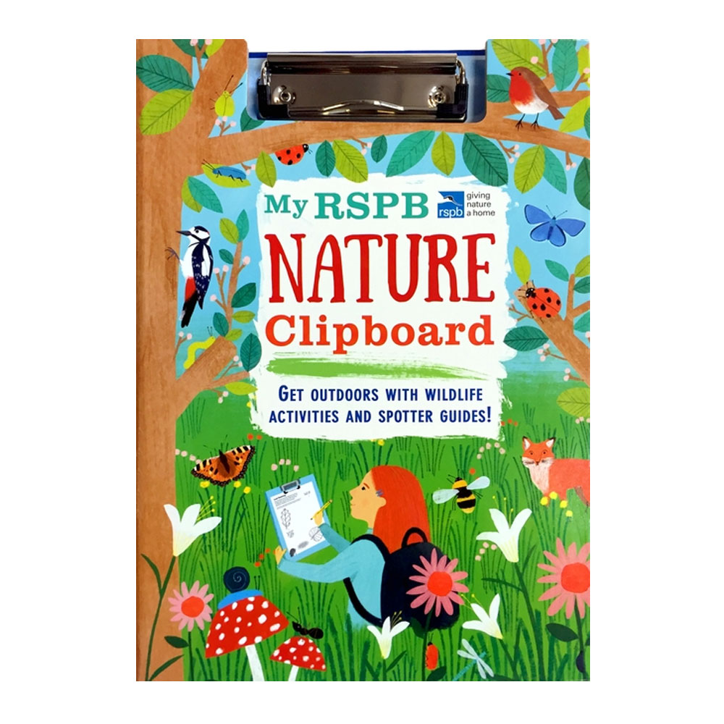
Evaluation


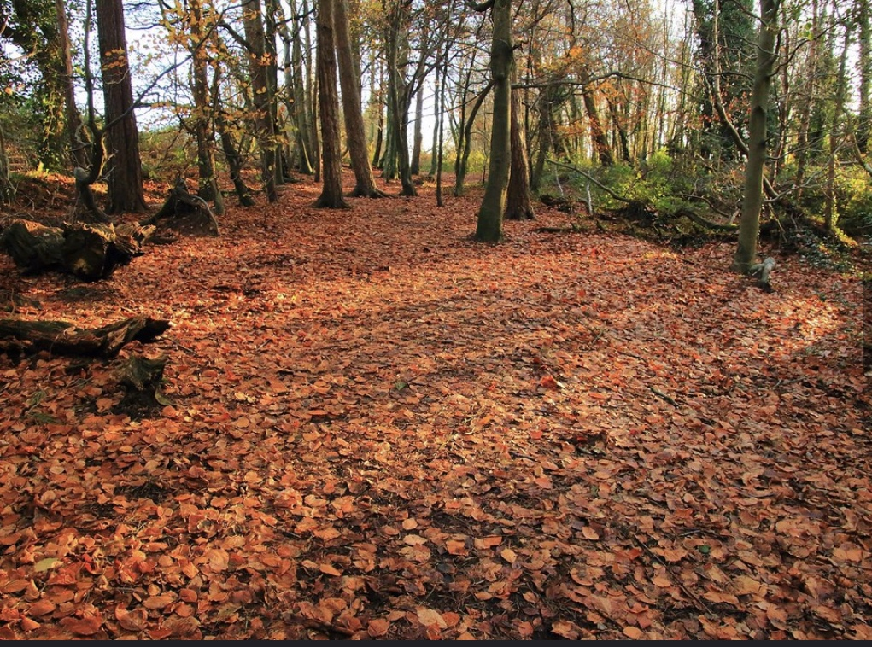

(Source: shutterstock.con, 2019)
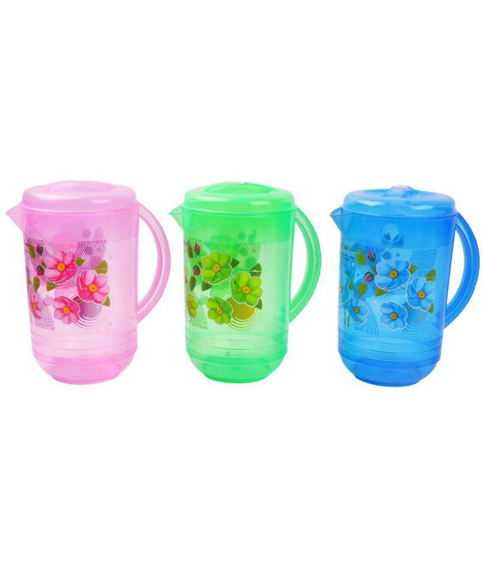
(Source: shopping.rspb.org.uk, no date)
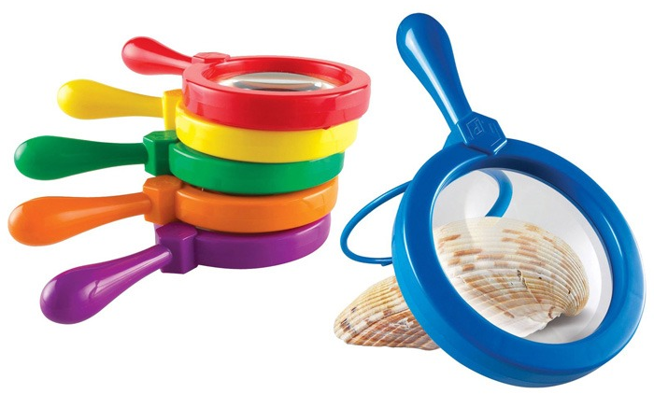

(Source: snapdeal.com, 2019)



(Source: Funlearning.co.uk, 2019)


(Source: thebigbottleco.co.uk, 2016) (Source: bylassen.com, no date)

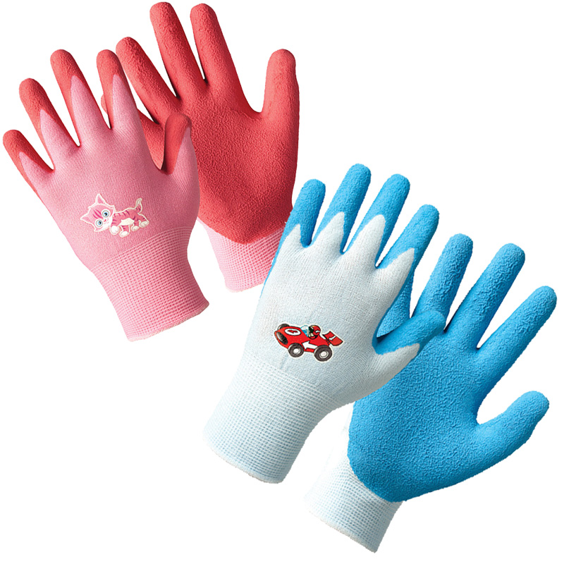



(Source: Justgloves.co.uk, 2019)

(Source: screwfix.com, 2019)



(Source: Penllergare.org.uk, 2019) (Source: ebay.co.uk, 2019)

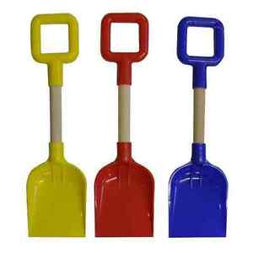


(Source: Sainsburys.co.uk, 2019)



(Source: Ebay.co.uk, 2019)

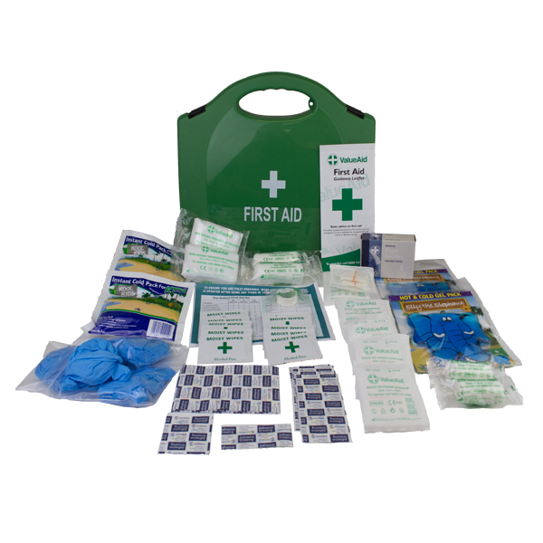

(Source: Headsprung,co.uk, 2019)

(Source: Firstaid4less.co.uk, 2019)

This outdoor experience provided many opportunities to explore the outdoor environment. The resources that were provided allowed for different independent activities to take place. Bilton (2010) states that many outdoor activities and experiences can involve whatever resources that are available at the time. If children are not given actual tools, they will make use of their natural environment such as leaves and twigs. Furthermore, Bilton (2010) suggests that children invent experiences using the natural resources and these experiences contribute to many different aspects of their development.
Some of the tools that were provided such as magnifying glasses and wildlife books allow for children to look for particular creatures and wildlife that are out in the wild and identify them and expand on their knowledge. In addition, resources such as the spade could be considered the most specific resource as the children would automatically use it to dig as opposed to picking up the resource like ribbon and using their imagination and thinking of what they wanted to use that for.
Santi and Purboningrum (2004) discuss Piaget in a paper. They state that Piaget was an emerging figure in recognising that children’s interactions with their environment was a key factor in their development. Furthermore, Piaget coined four developmental stages that children go through in response to things that happen around them. Piaget stated that learning does not just happen, but we create our own lessons by responding to things that happen.
The experience provided to the children allowed for independent activity and learning. The resources were open-ended and not expected to be used in any way. This approach supports Piaget view of how children “accommodate” themselves to the environment and “assimilate” the environment to themselves. In addition, Piaget states that a child’s interaction with the environment improves cognitive development, such as the structure, chemistry and function of the brain.
Similarly, the Foundation Phase Framework (2015) would agree that outdoor activity and spending more time in natural environment has a positive effect on a child’s cognitive development. They go on to say that children should have access to an environment that promotes discovery and independence and that there should be a greater emphasis on that environment should be outdoors and that the natural environment should be used as a resource for children’s learning.
The resources that were provided for this activity were multi-sensory. Oxforddictionary.com (2019) defines multi-sensory as involving or using more than one of the senses. Piaget (1972) discusses that there are four stages of cognitive development; sensorimotor, pre-operational, concrete operational and formal operational. The sensorimotor stage is said to take place between the ages of 0-2. Although, the children taking part in this activity were older and more into the pre-operational stage of their cognitive development, the resources that were provided relied on their holistic development being nurtured to be able to enjoy and use the resources to their full extent. The jugs of water were poured into the soil and was absorbed allowed them to see science in front of their eyes, the very environment itself had different smells of wildlife growing. Provided was paper and crayons and many children did tree markings which got them using their touch to explore different surface types.
It was very important during this experience that the adults who were conducting the activity knew what their role was. As in the description of the activity, it was explained that this would be a child-centred experience and that the children involved were in charge of their own. Learning. The children were not to be given cues as to what they were expected to do other than clear safety instructions to ensure the well-being of not only the children but also the public that also had access to this particular area. Davies (1977) discuss the teacher’s role in outdoor play. Davies states that overall, teachers believed their role to be setting an appropriate environment to play and to observe the children to monitor safety, and only intervening when the children’s behaviour had become inappropriate. Davies states that teachers supported the minimal intervention as a way to encourage child-centred learning and how the lack of intervention placed emphasis on the importance of using the outdoors as resource for learning.
Similarly, Bredekamp and Rosegrant (1992) suggest that in early childhood education, in which it is the general expectation is to support and promote holistic development within a child, the role of the adult is to encourage exploration and social interaction and rather than instruct, the adult should respond to the initiatives and imagination of the child. Furthermore, Jones and Reynolds (1992) state that rather than imparting information or instructing children directly, the teacher creates settings for child-initiated play and adopts particular strategies to support this play. In contrast, Morrongiello and Dawber (1999, 2000) state that their studies had shown that parent socialisation played a key role in influencing a child’s independent decision making. This is apparent in situations like the activity, when observing different children and what they perceived to be a risk and what was not a risk.

Maynard and Waters (2007) state that in 2001 the Welsh Assembly Government announced a play-based approach for the curriculum for children aged 3-7 years old. Many Scandinavian countries use the outdoors as a main resource for the development of their children. Maynard and Waters (2007) discuss that the natural environment can be used as a playground for children. Similarly, Fjørtoft (2004) suggest that children who play in the outdoors appear to be healthier, with more developed motor skills, including an enhanced development in creative skills. During the activity, the children were given the opportunity to play in a flexible and natural landscape. This contributes to the development of the Vestibular System as the children were able to run around and spin around in the open space. According to Motorstory.org (2014) the “Sense Organ” for the Vestibular System can be found in the inner ear. The Vestibular System is what helps develop balance and can also help children to acknowledge speed and motion. The vestibular system has key roles in letting a child not only balance, but to know whether they are moving or standing still. Moving around helps the vestibular system influence a child’s sensory processing and impacts on respiration and heart rate. The vestibular system impacts on muscle tone, most importantly the muscles that are in the back. Spinning, rocking and moving fast are all way to start the vestibular system.
In addition to this, Fjørtoft and Sageje (2000) suggest that the natural environment, like they use for the Scandinavian curriculum, has the qualities needed for stimulation. The environment that the children had during this activity was an open space and Fjørtoft and Sageje (2000) state that these types of spaces were used mainly for running and catching games. The children did enjoy the freedom and opportunity to utilise the space by running around, but also put the resources they were provided to good use. Furthermore, Fjørtoft and Sageje (2000) state that it is specifically the natural environment that is beneficial to learning, and their research suggested that children that used outdoor environments like forests to play showed better motor skills than those children who played in playgrounds. The use of the motor skills can stimulate the proprioceptors which are joint nerves. Motorstory.org (no date) state that a message gets sent to specific nerve cells in the brain called “Inhibitory Neurons.” These nerve cells eliminate unnecessary information in the brain and help the child to determine what is important and then helps get rid of the information that is unimportant. The “proprioceptors” are what start the filtering system in the brain and help block out the unimportant information. As a result, when children are active and are able to move around the proprioception system activates the nerves which helps the child to focus and pay attention.
Maynard and Waters (2007) go on to state that experiences in natural environments provide opportunities for effective and important environmental education. The issue of the environment and the issues that the environment is facing has been enhanced by the belief that children using the outdoors as a resource for learning can result in an understanding of the importance of caring for the environment around them. These lessons that are learnt in the Scandinavian curriculum links with the aims of the ESDGC (2008). The main aims are an emphasis on the natural environment, where learners should be given opportunities to develop a sense of their surroundings including landscapes, living things, taking care of the earth and developing an understanding of how other people’s actions can do both good and bad for the environment. There is also an emphasis on consumption and waste. The ESDGC (2008) state that people must take care of their belongings, recycle and dispose of resources and make use of the natural resources we have been provided with. Another aim of the ESDGC is climate change. It is believed that learners should be given opportunities to understand the importance of saving energy, and how different behaviours can affect the climate. Furthermore, the weather changes that occur are as a direct result of climate change and that can affect the way people live.
Maynard and Waters (2007) state that environments that provide children with enriched sensory experiences not only contribute to children’s own curiosity and imagination, but it also contributes to a wider social context. This experience allows for social development of the children and helps develop many aspects of social competency by allowing the children to work within a group. Group activities allow for many parts of the Foundation Phase (2008) curriculum to be achieved, such as lessons about themselves, their relationships with other children and adults both within and beyond the family. Social development and group work help encourage and develop their self-esteem, their personal beliefs and moral values. This activity provided plenty of group task activities such as helping each other build dens, working as team to find different wildlife using the books and magnifying glasses given and racing each other. Similarly, Harland (2003) who cites Vygotsky (1978) zone of proximal development discusses the way children can model and imitate other children’s behaviour that are within the same area of development as them and then using that newly found knowledge to further enhance their individual capabilities. The use of group work and the social interaction this activity provides children allows for them to work alongside their peers but also make decisions independent of their peers such as risk-taking and exploring.
If the activity were to be undertaken again, the children could be given a vaster space with more areas to explore and independently risk-assess. The activity did encourage exploration as the children were given plenty of opportunities to find out and look at things that they wanted to. According to Ord and Leather (2011) in order to understand how experiential learning contributes to the development of a child we must look at Dewey (1938). Dewey believed that the learning from an experience is a transaction between the child and their environment. Furthermore, Dewey stated that the lesson is ultimately a consequence from trying different things within that experience until the individual achieves the desired result. In addition to this, Dewey put emphasis on meaning to experiential learning, and using Dewey’s understanding the experience of outdoor education can be used to its full potential. Using this approach, the children used their experience during this activity to build upon the skills they already had by trying out different things. For example, the children initially were not using the magnifying glass for its intended purpose, but after much trial and error they realised how to use it.
To conclude, the outdoor activity provided the children with an enriched experience in which they could become at one with nature. They discovered many different aspects that the natural world has to offer them and opened up dialogue on how to best protect the earth that they will one day be responsible for.

Reference List
Bilton, H. (2010) Outdoor Learning in the Early Years. London: Routledge.
Bredekamp, S., & Rosegrant, T. (1992). Reaching potentials: Appropriate curriculum and assessment for young children, volume 1. Washington, DC: NAEYC.
byLasson. (no date) Matchbox. [On-line]. Available at: https://bylassen.com/collection/living-room/matchbox-green/c-1212/p-20296/ [Accessed: 19th May 2019].

Davies, M. (1997) The Teacher’s Role in Outdoor Play: Preschool Teachers’ Beliefs and Practices. Journal of Australian Research in Early Childhood Education, 1, 10-20.
Department for Children, Education, Lifelong Learning and Skills. (2008) ESDGC: A Common Understanding for Schools. Cardiff: Welsh Assembly Government. https://learning.gov.wales/docs/learningwales/publications/081204commonunderstschoolsen.pdf [Accessed: 15th May 2019].
Department for Children, Education, Lifelong Learning and Skills. (2008) ESDGC: Information for Teacher Trainees and New Teachers in Wales. Cardiff: Welsh Assembly Government. https://learning.gov.wales/docs/learningwales/publications/081204infoteachertraineesen.pdf [Accessed: 15th May 2019].
eBay.co.uk. (2019) Tarpaulin. [On-line]. Available at: https://www.ebay.co.uk/p/Heavy-Duty-Tarpaulin-Plastic-Canopy-Tarp-PVC-Sheet-Waterproof-Cover-S95-1-8-X-2-4m/6003409265 [Accessed: 19th May 2019].

eBay.co.uk. (2019) Square End Plastic Spades. [On-line]. Available at: https://www.ebay.co.uk/itm/Pack-Of-3-35cm-Square-End-Plastic-Spades-With-Wooden-Shaft-Sandpit-Beach-Toy-/202351567753 [Accessed: 19th May 2019].

Eery, J. (December 2017) Autumn Carpet. [On-line]. Available at: http://penllergare.org/photo-gallery/ [Accessed: 19th May 2019].

English Oxford Dictionary. (2019) Multisensory. https://en.oxforddictionaries.com/definition/multisensory [Accessed 12th May 2019].

Firstaid4less.co.uk. (2019) PreSchool First Aid. [On-line]. Available at: https://www.firstaid4less.co.uk/First-Aid-Kits-Refills/School-and-Childcare-First-Aid-Kits/PreSchool-First-Aid-Kit?utm_source=google&utm_medium=product_feed_or_listings&pl=STD&ccv=Y&gclid=EAIaIQobChMI2uTJ1-Oo4gIVQbTtCh0D_wvxEAQYAiABEgJhbPD_BwE [Accessed: 19th May 2019].

Fjortoft, I. (2004) Landscape as playscape: the effects of natural environments on children's play and motor development. Children, Youth and Environments, 14(2), 21–44.

Fjortoft, I. and Sageie, J. (2000) The natural environment as a playground for children. Landscape and Urban Planning, pp. 83–97.
Forestry Commission England. (2012) A marvellous opportunity for children to learn: A participatory evaluation of Forest School in England and Wales. Available on-line: https://www.forestschooltraining.co.uk/_webedit/uploaded-files/All%20Files/Research%20papers/Marvellous%20opportunity.pdf [Accessed: 18th May 2019]
FunLearning.co.uk. (2019) Jumbo Magnifying Glass. [On-line]. Available at: https://www.funlearning.co.uk/product/science/natural-world/jumbo-magnifying-glass/ [Accessed: 19th May 2019].

Harland, T. (2003) Vygotsky’s Zone of Proximal Development and Problem-based Learning: Linking a theoretical concept with practice through action research. Teaching in Higher Education, 8(2), 263-272.

HeadSprung. (2019) Ribbon. [On-line]. Available at: https://www.headsprung.co.uk/products/ribbon-coat-rack [Accessed: 19th May 2019].
Jones, E., and Reynolds, G. (1992) The Play’s the Thing: Teachers’ Roles in Children’s Play. New York: Teachers College Press.
Justgloves.co.uk. (2019) Work Gloves for Children. [On-line]. Available at: https://www.justgloves.co.uk/Work-Gloves/Gardening-Gloves/Play-and-Work-Gloves-for-Children?utm_source=google&utm_medium=product_feed_or_listings&pl=STD&ccv=Y&gclid=EAIaIQobChMI29TcxuOo4gIVzZ3tCh2ToQ4jEAQYASABEgIyi_D_BwE [Accessed: 19th May 2019].

Little, H. (2010) Relationship between parents’ beliefs and their responses to children’s risk-taking behaviour during outdoor play. Journal of Early Childhood Research, 8(3), 315-330.

Maynard, T. and Waters, J. (2007) Learning in the outdoor environment: a missed opportunity? An International Research Journal, 27(3), 255-265.

Morrongiello, B. A., & Dawber, T. (1999). Parental influences on toddlers' injury-risk behaviors: Are sons and daughters socialized differently? Journal of Applied Developmental Psychology, 20(2), 227-251.

NSPCC. (2018) Recommended adult to child ratios for working with children. https://learning.nspcc.org.uk/research-resources/briefings/recommended-adult-child-ratios-working-with-children/ [Accessed: 18th May 2019].
Ord, J. and Leather, M. (2011) The Substance Beneath the Labels of Experiential Learning: The Importance of John Dewey for Outdoor Educators. Journal of Outdoor and Environmental Education, 15(2), 13-23.

RSPB.org. (2019) My nature clipboard. [On-line]. Available at: https://shopping.rspb.org.uk/children-books/rspb-nature-clipboard.html?ClickType=Image&ListType=&ListName=&Position=22 [Accessed: 19th May 2019].

Sainsburys.co.uk. (2019) Nivea Sun Spray. [On-line]. Available at: https://www.sainsburys.co.uk/webapp/wcs/stores/servlet/gb/groceries/nivea-sun-spray--spf-30-200ml?langId=44&gclid=EAIaIQobChMIguvVhvCo4gIVzLvtCh1XmQpEEAQYASABEgKKtfD_BwE&storeId=10151&krypto=xWmZi8xOZpQHSrqQiUONsHDXBF28EEZwUJvIZFH5x%2BikBTZk5AtlPBlpR%2FtpfLHFCZ58drfX81dM2icIR%2FeAXzCf8MOQiYkJkpByL6T8xlV%2FNoE6jK78gzXSSvbx1AFxOugSU%2BuNph8zP%2BfSW8yz1nR1o3tz4f6PMvtHSdmxmZknmRPfqAyLkWjCol9MtgiQh0PuEPs4fNqd%2F95UHlB4DzfbuleDRXhts%2FPbleXWpDq8RbxD1MNbaSq1LdwlqGyjJOB%2BtDIWXu0I8YAo61R0kkQwQg4N8EaVAy7yZzd11uNDVDfUM6LuTbQPtqXVm%2F4wGKv5VyVIblHEAOXE5yMXcr7Xyx4MIOIJPftQm2SNO%2B0%3D&ddkey=https%3Agb%2Fgroceries%2Fnivea-sun-spray--spf-30-200ml [Accessed: 19th May 2019].

Santi, NKS. and Purboningrum, MM. (2004) The Necessary Role of Outdoor Education in Education Process. Outdoor Education conference.

Screwfix.com. (2019) Polypropylene rope. [On-line]. Available at: https://www.screwfix.com/p/stranded-polypropylene-rope-blue-6mm-x-30m/98570 [Accessed: 19th May 2019].

Shutterstock. (2019) Paper and Crayon. [On-line]. Available at: https://www.shutterstock.com/search/crayon+paper [Accessed: 19th May 2019].

Snapdeal.com. (2019) Plastic Water Jug. [On-line]. Available at: https://www.snapdeal.com/product/nahata-micro-plastic-water-jug/637996770598 [Accessed: 19th May 2019].

Thebigbottle.co.uk. (2019) Big Blue. [On-line]. Available at: https://www.thebigbottleco.co.uk/product/big-blue/ [Accessed: 19th May 2019].

The Motor Story. (no date) Proprioception. http://themotorstory.org/sensory-processing/proprioception/ [Accessed: 16th May 2019].

The Motor Story. (2014) The Vestibular System. http://themotorstory.org/sensory-processing/the-vestibular-system/ [Accessed: 16th May 2019].

Welsh Government. (2013) First Steps Outdoors. Available on-line: https://learning.gov.wales/docs/learningwales/publications/141013-first-steps-outdoors-en.pdf [Accessed: 10th May 2019].

Welsh Government. (2015) Foundation Phase Framework. Available on-line: https://gov.wales/sites/default/files/publications/2018-02/foundation-phase-framework-revised-2015.pdf [Accessed: 19th May 2019]

