The Impact of Stigma on
those with Bipolar Disorder

Social Interactions and Family Life

What is Stigma?

- Stigma can be defined as a reflection of a populations responses to an individual who may have unusual or unwanted traits.

- Stigma can be communicated through several ways, including through prejudice and discrimination.
(Vázquez, Kapczinski, Magalhaes, Córdoba, Jaramillo, Rosa, 2011).

(Vázquez, Kapczinski, Magalhaes, Córdoba, Jaramillo, Rosa, 2011)

Bipolar Disorder can lead to disruptions to an individual’s…
Stigma surrounding mental health problems can impact several aspects of an individual’s life and the lives of their families.
For example, stigma can cause increased stress, problems with relationships and social restrictions.

Social Interactions
Firstly, several studies have revealed the impact that stigma has on the social lives of those with Bipolar Disorder.

Shamsaei, Kermanshahi, Vanaki, & Holtforth (2013) noted that a study looking at eighteen people with Bipolar Disorder, showed that they felt as though stigma negatively affected the way they viewed themselves within society.

Facts and Figures

Research –
Vazquez, Kapczinski, Magalhaes, Cordoba, Jaramillo & Rosa (2011)
AIM – To explore to impact of stigma on the social experiences of those with Bipolar Disorder
PARTICIPANTS – 241 Latin American participants
HOW? – Interviews and questionnaires
FINDINGS – Those with Bipolar Disorder reported significantly less interpersonal relationships which lead to feelings of embarrassment.
Stigma caused individuals to adapt their social behaviour to avoid discrimination and public rejection.
These findings support the view stigma has an impact of the social interactions of those with bipolar.

Further Research Support -
Lazowski, Koller, Stuart & Miley (2012)


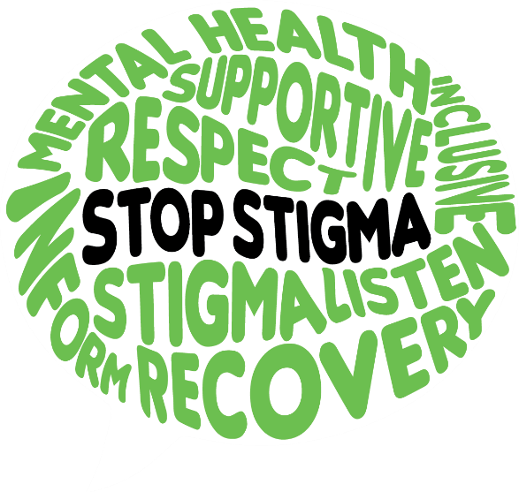

Bipolar Disorder sufferers are
often faced with 2 challenges –
(Shamsaei, Kermanshahi, Vanaki, & Holtforth, 2013)

The Impact of Stigma on Family Members

References

All images were obtained from Bing 2019.
Brohan, E., Gauci, D., Sartorius, N., Thornicroft, G., & GAMIAN–Europe Study Group. (2011). Self-stigma, empowerment and perceived discrimination among people with bipolar disorder or depression in 13 European countries: The GAMIAN–Europe study. Journal of affective disorders, 129(1-3), 56-63.
Lazowski, L., Koller, M., Stuart, H., & Milev, R. (2012). Stigma and discrimination in people suffering with a mood disorder: a cross-sectional study. Depression research and treatment, 2012.
Shamsaei, F., Kermanshahi, S. M. K., Vanaki, Z., & Holtforth, M. G. (2013). Family care giving in bipolar disorder: experiences of stigma. Iranian journal of psychiatry, 8(4), 188.
Stip, E., Caron, J., & Mancini-Marïe, A. (2006). General population perceptions and attitudes towards schizophrenia and bipolar disorder. Primary Care and Community Psychiatry, 11(4), 157.
Vázquez, G. H., Kapczinski, F., Magalhaes, P. V., Córdoba, R., Jaramillo, C. L., Rosa, A. R., ... & on Bipolar, T. I. A. N. (2011). Stigma and functioning in patients with bipolar disorder. Journal of Affective Disorders, 130(1-2), 323-327.

