Human Resource Management – LCMB7000
Assessment 2

Shirina Begum
Student ID 1709360
MBA- Masters of Business Administration
Human Resource Management – Assessment 2
University of Wales Trinity Saint David

Table of Contents
Introduction 3
Company Background 3
The 5Ps Model 4
Compensation 5
Scientific Management (Taylor and Gilbreth) 6
Relevance and Application in HR Practice and Policy 7
Change Management 7
Motivation Theories 9
Relevance and Application in HR Practice and Policy. 9
Staffing: Retention 10
Vision and mission 11
Conclusion 11
Recommendations 12
References 13

Introduction

The Human Resource (HR) department is the cornerstone of any business setup, therefore prioritization of employees is key for any organisational setting to achieve its corporate strategic objectives. HR departments must formulate and implement practices and policies that can trigger growth and sustainability while giving a business a competitive advantage over its rival companies. Management theories have played a pivotal role in laying the foundation for today's modern concepts of management. Performance appraisals, organisational charts, and corporate strategic goals are key managerial principles utilised in today's business world courtesy of Taylor and Gilbreth's scientific management theory. Furthermore, motivational theories have significantly assisted employers to put in place measures that can make employees happy and motivated. Serving as Apple's Human Resource Director, several management strategies significantly borrow from HRM theories that I would employ to enhance efficiency in the company’s HR practices like compensation, staffing, and change management.

Company Background

Apple Inc. is a U.S.-based technology firm that deals in computer software and electronics founded in 1976 by Steve Jobs, Ronald Wayne, and Steve Wozniak. The company has its headquarters in California, United States, and owns more than five hundred stores spread across the globe. Statistical evidence reveals that Apple is considered the most valuable information technology company worldwide. For that reason, it continues to realise more significant revenues than its rival companies like Amazon, Microsoft, Facebook, and Google (Green, 2015). It is worth noting that currently, Apple is the world's fourth-largest smartphone producer and one of the globe's leading vendors of computers. The company has more than one hundred and fifty thousand employees working in various departments such as Design, Communications, Finance, Engineering, Community Operations, Launch, Marketing, Legal, Public Policy, People and Places, Product, Safety, Security and Insurance, Business Development and Sales, and Data Science and Analytics (Johnson et al., 2012). These departments comprise a team of employees with varying careers and, therefore, performing different duties and responsibilities to enable the company to realise its mission and vision statements.
The company's net income in the 2021 fiscal year was nearly $94 billion, and in the same year, it attained revenue of over $350 billion, indicating growth (Chen et al., 2021 p.74). The company has experienced immense transformation in almost every aspect through the hands of various CEOs. For instance, its products have significantly evolved courtesy of its innovative manufacturing techniques. Likewise, Apple is one of the top employers owing to its excellent HR practices, and policies go a long way to enhance job satisfaction and fulfillment. Compared with decades ago, the tech giant is enjoying increased profitability, expanded market share of its products, and a positive brand image. In many cases, the company has reaffirmed its commitment to environmental conservation and business ethics, contributing tremendously to its ever-present success.

Fig 1 Apple Inc.

The 5Ps Model

Both the external and internal environment of an enterprise influences its strategies. Any organization seeking to increase its profitability and market share of its products must take into consideration the Five Ps model. This concept harmonises the various strategic human resources activities to assist the company realise its corporate strategic objectives. The model comprises people, processes, principles, purpose, and performance. As the head of the human resource department in Apple Inc., I would apply managerial theories revolving around these 5Ps such as behaviour theories, values and culture theories, system theories, measurement and feedback theories, and strategic theories to enable me to put in place the most appropriate HR practices and policies. These five areas are key in human resource management and therefore an HR department of any organization must strive to create a balance among them to achieve overall success. For example, I would motivate employees by issuing financial rewards and recognitions. I would put in place performance appraisal systems to fulfill performance aspects within the company. I would ensure the company's principles resonates with employees' values and cultures.
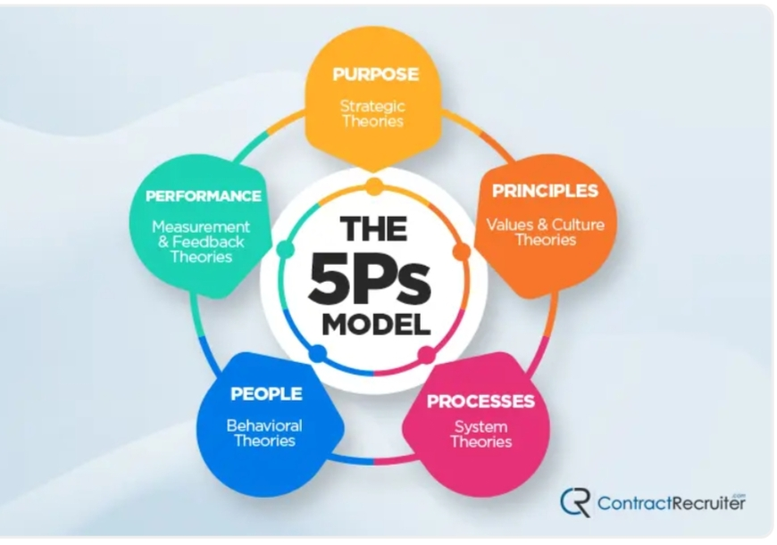
- Fig 3: The 5 Ps Model source: Contract Recruiter 2021

Compensation

As the Human Resource Director of Apple Inc. I will be keen to put attractive compensation strategies in place, considering that compensation is vital when hiring and retaining employees. For example, I would offer compensation strategies such as overtime pay, profit-sharing schemes, employee perks, adjustable salaries depending on longevity or experience, and paid leaves, including vacation and personal days off. These strategies would significantly motivate employees, attaining job satisfaction and fulfillment. In the end run, the organisation would realise increased profitability since motivated employees are more productive and perform better. Also, solid compensation strategies would enhance employee loyalty prompting the workforce to continue offering services to the company and not shift to another one. Circumstances can sometimes demand that employees work extra hours to satisfy customers' needs. Paying them for the extra hours would motivate them to be more willing to work extra hours next time without any complaints. This has an impact on the company's short-term and long-term goals.
My office would be committed to ensuring that these compensation strategies apply to all Apple employees without any form of prejudice or discrimination. Workplace discrimination can negatively impact an employee's input which can trigger losses within the firm. Irrespective of one's religious or political affiliation, race, colour, origin, sex, sexual orientation, or financial status, all employees would receive equal treatment in not only the compensation area but also other HR aspects. I would introduce bonuses to employees who have worked with the company for at least five years. This would compel recruits to continue working with the company. Rewards would be issued based on performance metrics periodically. Also, the more an employee has stayed in the company, the more they will qualify for a vacation of a longer duration. I would grant two years old employees paid three weeks vacation while employees who have served for more than five years would enjoy paid five weeks vacation. Rewards are vital in achieving compensation within a workplace, and they possess the ability to influence employees to perform better.

Scientific Management (Taylor and Gilbreth)

Science Management consists of assessing the workflows in an organization to ensure maximum economic efficiency and labor productivity. According to (Armstrong and Taylor, 2020), Taylor and Gilbreth's scientific management concept was introduced when managers faced inefficiencies and delayed work within their organizations.
Scientific Management Theory was conceived by Taylor and Gilbreth during the industrialisation era. Several factories were cropping up in Europe and they largely utilised various raw materials in making several goods. Several individuals were hired to work as labourers in these factories. However, managers of these factories could face economic inefficiencies brought by lazy labourers and system inefficiencies. It is worth noting that many workers could intentionally work at a much slower pace to safeguard their jobs. They knew that the factory managers could not substitute them since there were no supernatural beings. This situation of inefficiencies brought by lazy workers and system inefficiencies gave rise to the scientific management theory.

Relevance and Application in HR Practice and Policy

Considering that the world is experiencing technological evolution, scientific management theory has evolved over time to suit the needs of today's modern business settings. The concept of scientific management has found its way into current business world and mainly it strives to ensure that employees fully utilise their potential. Also, it seeks to enhance system efficiency within a business. For example, performance evaluations, corporate strategic objectives, teamwork, and organisational charts are managerial practices and policies in the current business world geared towards enhancing system efficiency and employee productivity. These concepts trace their origin to scientific management theory by Taylor and Gilbreth.
Several researchers have adapted Taylor and Gilbreth's notion throughout the years to make it more relevant to today's technology world. Businesses exist in a technologically driven environment, which forces them to adapt to social trends and ever-changing technology. Scholars have developed concepts such as performance appraisals, organizational charts, production and sales objectives, and quality indicators, all of which are based on Taylor and Gilbreth's concept of scientific management (Watson and Derouin, 2020).

Also, the scientific management theory has shaped the way current enterprises go about doing their operations. It also laid a foundation for various managerial concepts that are currently vital in today's business management. For instance, the scientific management theory by Taylor and Gilbreth relied on the use of statistics. As a result, concepts of quality assurance and control emerged, which are vital in positioning a business to gauge it with respect to its key competitors. Other concepts like re-engineering and management cybernetics greatly borrows from Taylor and Gilbreth's scientific management theory. They are crucial in ensuring that the business remains sustainable and lives up to its occasion of generating desirable profits.

Change Management

Having acquainted myself with the necessary knowledge of various management theories and their significance in today's business management, I would be keen to adopt and implement practices and policies that reflect these concepts. Apple Inc. is a multinational firm that strives to offer costumer satisfaction while realising increased profitability and market share. Also, the HR department of the tech giant is committed towards enhancing job satisfaction and fulfillment among the employees. Therefore, to achieve these and Apple's strategic corporate objectives, I would adopt practices like performance evaluations, teamwork, and organisational charts. Organisational charts are fundamental in relaying the workplace structure. It plays a vital role in showing employees direction to assist them follow protocols. Performance evaluation would enable the company to gauge each employee's input to the company. It also provides avenues for the company to figure out productive and unproductive employees. Training and development programs would be available for employees to enable them grow their professional lives that goes a long way to contribute positively to the company's growth and brand image. (Hassan et al., 2021, pp.287-296). It would be my responsibility to encourage and nurture the spirit of teamwork among the employees by assigning different employees to perform some essential tasks jointly.
Change management involves assessing previous HR practices and policies of the company. I would examine past activities that my organisation has undertaken to establish Apple's strengths and weaknesses. This would also assist the HR department in adopting beneficial practices. Other activities done in the past but proved not to be significant would be dropped moving into the future. To realise change development, a firm must be ready first to change itself. It cannot continue to operate in the same fashion as before. I would consider several new practices, and if needs be, I will streamline the existing ones that are viable. I would pay much attention to quality control and quality assessment, fundamental aspects of scientific management.

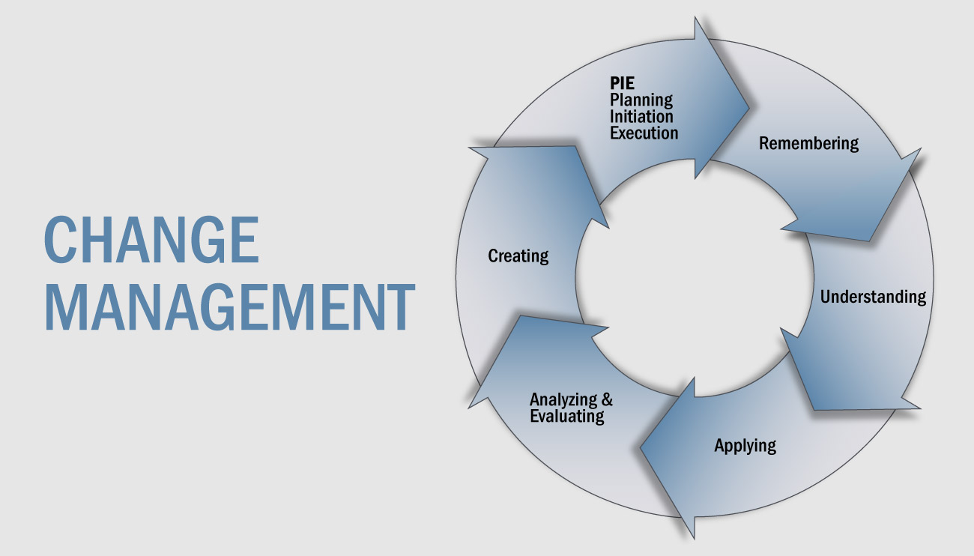
Fig 3: Change Management Model Source: Strategy Associates

Motivation Theories

Researchers conceived motivational theories after realising that there exists certain factors that can compel working human beings to attain job satisfaction and fulfillment. Theorists noticed that managers who caters for the needs of their employees enjoy more productivity and eventually increased profitability (De Winter and Hancock, 2021, p. 9). Meeting employees needs gives the latter joy making them to go extra mile while discharging their duties. Therefore, the concept of motivation is vital in business and management setup. Research has revealed that an enterprise that motivates its employees is likely to attain an increment of 12 per cent in its profitability. Theorists realise that when employees are encouraged, they become happy, promoting them to give their best in the workplace (Armstrong and Taylor, 2020).

Relevance and Application in HR Practice and Policy.

An example of motivational theories is the Theory of Human Relations advanced by Mayo that put forwards extrinsic and intrinsic factors that can motivate an employee. Extrinsic factors are mainly organisational initiatives such as bonuses, recognition, rewards, greater authority, and status geared towards making an employee happy and motivated. Intrinsic factors refer to inborn qualities such as a desire to accomplish various goals. Someone's desire for something can motivate them to go extra mile to attain their goals. For that reason, both extrinsic and intrinsic factors need to be considered by managers aiming to motivate their employees. For example, an HR department of a company can introduce bonuses and sanctions (Armstrong and Taylor, 2020). A bonus is an additional reward to rewards the employees for their hard work. Employees receive bonuses when they surpass a firm's set out targets. Profit margins, sales volume, and the number of consumers served by personnel can all be targeted by businesses. Employees earn bonuses from their employers if these goals are met. Employees who fail to reach targets can also be sanctioned by their employers. Companies can impose fines such as additional unpaid work hours, reduced paid leave periods, and wage deductions of a certain proportion. Extrinsic elements such as sanctions and bonuses can encourage staff. Intrinsic elements, on the other hand, rely on individual characteristics and personalities to motivate people (Armstrong and Taylor, 2020). For example, when an individual wants to please their managers or wants to achieve their personal goals. These goals and desires motivate an individual to do their best and work hard within their workplace. It is vital for employers to assess and understand the factors that motivates their employees fully.
Abraham Maslow's theory of hierarchy of needs can also explain the concept of motivation. He put forward various needs in a hierarchical manner that compels individuals to work towards achieving them. Starting from the bottom of the pyramid going upward to the top are physiological needs, safety needs, love needs, esteem needs, and self-actualisation respectively. Maslow believed that after an individual is motivated to accomplish a given level of needs that they lack. Maslow suggested physiological needs like hunger and sleep (Turner, 2021, pp. 5-16). After achieving one level of needs at the pyramid, one gets motivated to achieve the other needs on the next levels of the pyramid. Employees will only work for organisations that take into account their needs. If a firm cannot be sensitive to employees' needs, it will lose productive employees and suffer losses ultimately. Therefore, firms that considers their employees' needs can retain them for a longer period and realise their full potentials.
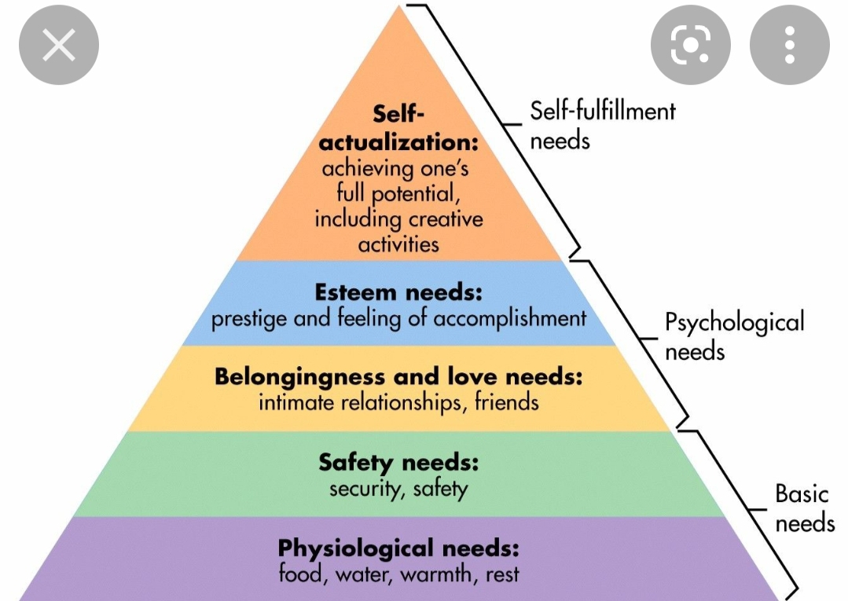
Fig 4: Maslow's hierarchy Model source: Simply Psychology

Staffing: Retention

Apple Inc. finds value in employee satisfaction and fulfillment. The company appreciates its continuous growth to human resources and for that reason, it constantly strives to formulate and implement HR practices and policies that can prompt employees to go extra mile and utilise their maximum potentials. Serving as the HR director of Apple Inc. I would avail financial rewards to employees exhibiting outstanding performance in their various departments. Also, bonuses would be available for employees who are working extra hours. Because of the pandemic, several employees are currently working remotely. I would ensure they are provided with the necessary resources such as internet connectivity fees to ensure that they are having a conducive work environment. I would also avail ranking of employees to recognize colleagues who are performing way better than other employees. I would ensure that majority of employees can access basic needs such as housing within the company's environs. Depending on the amount of profits realised, the company would offer its employees paid extra days vacations. These measures would significantly motivate Apple's employees making them more productive.
Catering for employees' basic social needs like housing coupled with financial rewards would make them attain job satisfaction and fulfillment (Mathis et al., 2015). It's worth emphasizing that I'd get to know the majority of the employees on a personal level. This would help me find factors that, when put into practice, can immediately motivate them.

Vision and mission

My vision and mission for Apple Inc. is to unify employees around shared goals and ideal and instill within the employees a sense of having a purpose. A recent study found that American employees will be willing to trade 23% of their lifetime income in exchange for a job that is has a purpose and is fulfilling. My mission will be my actions that drive me towards the future. To do this as a manager I must have a long term and short-term goals set. As an HR Manager I need to ensure that my mission and vision give a clear powerful and purposeful message to my employees through clear communication. I need to ensure that all my employees clearly understand me and they should have a self-worth and should feel fired up about working towards my mission and vision they should feel like a team not just employees. The final result of my mission and vision should be to make team members valued, appreciated, and
develop a sense of belonging to Apple Inc.

Conclusion

In summary, managers need to be conscious of the fact that today's business greatly relies on technology. Courtesy of technology, century old management theories such as scientific management theory advanced by Gilbreth and Taylor have evolved to modern concepts. For example, organisational charts and performance appraisals are modern managerial principles founded on Taylor and Gilbreth's scientific management theory. Moreover, motivation theories have seen HR departments of various enterprises adopt practices and policies such as rewards and recognitions of employees to make them more productive since their beliefs, needs, and attitudes are considered. When employees are more productive, a firm realises increased profitability and market share.

Recommendations

- Human Resource Managers should utilise a wide range of tools to gauge employees' capabilities. Companies need to pay employees based on their performance to achieve maximum productivity from employees. Tools such as performance appraisals are crucial in establishing employees' inputs.
- HR leaders need to evaluate training before executing them to ascertain it will result in desired outcomes. Training plays a key role in achieving change management within an organisational setup.
- III.Proactiveness. HR departments must be adaptive and flexible to quickly adopt emerging trends before other companies realise their existence. This will make an organization always stay ahead giving it a competitive advantage over other companies.
- Employers need to harmonize their strategic plans with their companies' internal and external factors. They should conduct a comprehensive analysis of the external and internal environments of their enterprises before drafting strategies.

References

Armstrong, M. and Taylor, S., 2020. Armstrong's handbook of human resource management practice.
Chen, B., Lu, W. and Wang, S., 2021. The Valuation and Analysis of Apple Inc. BCP Business & Management, 13, pp.72-75.
De Winter, J.C.F. and Hancock, P.A., 2021. Why human factors science is demonstrably necessary: historical and evolutionary foundations. Ergonomics, pp.1-17.
Green, S., 2015. Apple. Bellwether Media.
Guillén, L., Mayo, M. and Korotov, K., 2015. Is leadership a part of me? A leader identity approach to understanding the motivation to lead. The Leadership Quarterly, 26(5), pp.802-820.
Hassan, H.A., Zhang, X., Ahmad, A.B., and Liu, B., 2021. Public service motivation and employee change-supportive intention: Utilising the theory of planned behaviour. Public Personnel Management, 50(2), pp.283-304.
Johnson, K., Li, Y., Phan, H., Singer, J., and Trinh, H., 2012. The Innovative Success that is Apple, Inc.
Mathis, R.L., Jackson, J.H. and Valentine, S.R., 2015. Human resource management: Essential perspectives. Cengage Learning.
Turner, P., 2021. What Is Management; What Do Managers Do?. In The Making of the Modern Manager (pp. 1-32). Palgrave Macmillan, Cham.
Watson, G.J. and Derouin, J.J., 2020. Critical Thinking: Learning from Mistakes and how to Prevent Them. CRC Press.

