Strategic Management for SMEs

“BISTECH PLC”

Ricardo Alexandre
2025546

BMSW6104
Strategic Management for SMEs

Lecturer: Miss Bente Fatem
November 6th, 2023

Table of Contents
1. Introduction 3
1.1 Business Overview 3
2 Critical of Bistech Strategic Direction Appraisal 4
3 Analysis - Macro or External Environment 8
3.1 PESTLE Environment Analysis 8
3.2 Micro or Internal Environment 9
3.3 SWOT Analysis 9
3.4 Advance SWOT Analysis 11
3.5 Porter’s Five Forces Model 12
3.6 Value Chain Analysis 14
3.7 VRIO Analysis 14
4 Stakeholders 15
4.1 Stakeholder’s Mapping 16
5 The discussion of new strategies for sustainable growth 18
5.1 Business strategy: 19
5.2 Selection of Strategies (SAF) Framework 20
5.3 SFA Matrix 23
6 Provide key strategic recommendations. 24
7 Conclusion 26
8 Reference List 27
9 Appendix A 31
10 Appendix B 32
11 Porter 34

Table of Figures and Tables

Figure 1.Source: According to Kieser (1994. P.1). 12
Figure 2:Source: Porter’s Five Forces Model. According to Heubel (2021). 13
Figure 4. Source: Value Chain Model. According to Hart (2022). 15
Figure 5. Source:Stakeholder according to (Salonen, 2010). 17
Figure 6. Source: Power/Interest Matrix. According to Salonen (2010). 17
Figure 7. Source: Power/Interest Matrix According to Chen (2017). 19
Figure 8. Source: According to Botsford et al. (2019). 25

Table 1. Source: According to Marvilano (2020). 5
Table 2. Source: According by Al-Masri and Curran (2019). 6
Table 3. Source: According to) Bocij et al. (2005). 8
Table 4. Source: According to Fahy and Jobber (2019) 10
Table 5. Source: SWOT Analysis Speth and Probert (2015). 11
Table 6. Source: Advance SWOT. According to Kieser (1994). 12
Table 7. Source: According to Heubel (2021, p.1). 15
Table 8. Source: According to Kimmy (2022). 17
Table 10. source: SFA Matrix According to the research by Benson and Bugnitz (2004, p.2). 24
Table 11. Source: SFA Matrix According to research by Botsford et al. (2019). 26
Table 12. Source: Kurt Lewin's Three-Step Model according to Cummings et at. (2017) 27
Considering the barriers and challenges outlined earlier (Table 13), Bistech should prepare for: 28
Table 13. Source: Barriers and challenges. According to Krüger and Stumpf (2013). 28

Introduction
This academic report focuses on small and medium-sized companies (SMEs) and their role in socioeconomic growth and economic expansion. It begins by evaluating Bistech's current strategic direction, assessing its mission, vision, objectives, and existing approaches. The report uses environmental scanning tools like PESTLE and SWOT analysis to analyse Bistech's external and internal environment, identifying potential opportunities and threats. By employing a variety of methods such as the Five Porter's theories, VMOST, PESTLE analysis, SWOT analysis, Value Chain, and VRIO framework. In their analysis by Matt et al. (2021). It also conducts a stakeholder analysis to evaluate stakeholder expectations and their influence within the organisation.
The research proposes a new strategy for Bistech, highlighting its sustainability for the organization's long-term future. The report concludes with key strategic recommendations, considering common challenges faced by SMEs when implementing strategic direction (Fernández and Nieto, 2006). These recommendations offer actionable guidance for future developments and the implementation of the chosen strategy.
The report uses various academic models, methods and theories to develop a sustainable business strategy tailored to Bistech's context. The research aims to provide valuable insights and recommendations to help Bistech achieve its strategic objectives and ensure long-term growth and viability within the SME landscape.
  - Business Overview
Bistech is a privately-owned IT services provider with over 30 years of experience. They work closely with clients to develop and implement intelligent technological solutions to address business challenges. Their team of specialists includes experts in cyber security, remote work solutions, and public cloud technologies. Bistech's expertise spans various domains, helping clients achieve their business objectives. With a workforce of 76, Bistech is an asset for small and medium-sized enterprises (SMEs) in a competitive environment, promoting innovation and economic growth. The Main officer is IT Consulting, Ferndown, Dorset (Appendix A).
- Critical of Bistech Strategic Direction Appraisal
Bistech's strategic direction is based on its mission and objectives, which are not explicitly stated.
The company's strengths lie in its comprehensive IT services and solutions, including professional services, managed services, and technology products. Their commitment to proactive, preventative, and cost-effective managed services aligns with the growing demand for reliable IT support. Bistech's strategic partnerships with industry-leading vendors and emerging innovators demonstrate their commitment to staying at the forefront of technology. However, the lack of explicit mission and objectives may lead to a lack of clarity among employees, clients and stakeholders. The absence of specific information about their target market or segments may indicate a potential weakness in market focus. Additionally, the absence of financial performance, market share or competitive positioning makes it challenging to assess their financial health and market standing.
To improve, Bistech should clearly define its mission and objectives to research by Rafay (2019), conduct a thorough market analysis, and provide financial information and performance metrics. Additionally, the company should align its strategic actions and investments with its long-term vision, which is unclear due to the absence of an explicitly stated vision.
VMOST Analysis for Bistech (Table 1):

Table 1. Source: According to Marvilano (2020).
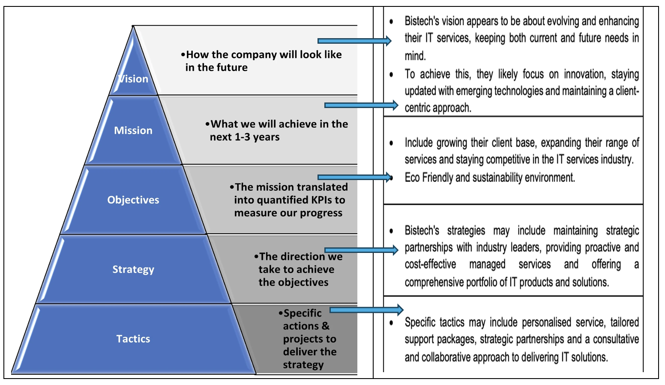
Bistech, a leading IT services provider, should focus on improving its mission and objectives to align with its long-term vision. This can be achieved through various strategies from the perspectives of operations, marketing, and human resources.
Operations can provide training support to research by Barney and Hesterly (2019) such as flexible work hours and access to relevant courses and materials for civil service exams and desired job roles. They can also manage workloads by redistributing tasks or temporarily reassigning responsibilities to other team members. Networking opportunities can be fostered by attending relevant industry events, conferences or workshops, providing insights into civil service job openings.
Marketing can assist goal setters in creating a strong personal brand that aligns with their career goals, such as optimising LinkedIn profiles and sharing relevant content. Market research can identify trends, job openings and requirements in the environment and sustainability field within the civil service sector, guiding the job application and exam preparation process.
Resume and cover letter support can be provided by marketing professionals, helping goal setters craft compelling resumes and cover letters tailored to the civil service sector. Human resources can provide strategic guidance on the civil service recruitment process, including job listings, exam navigation, and application tailoring. Mentorship and coaching can also be provided by HR, who can offer valuable insights and advice on the application process and interviews (Olson, 2018).
Performance evaluations can be conducted periodically to track progress towards obtaining a civil service job. By involving operations, marketing, and human resources in pursuing this career goal, Bistech can benefit from a comprehensive and well-rounded approach.
Each department plays a crucial role in providing support, guidance, and resources to achieve the specific, measurable, achievable, relevant and time-bound (SMART) objectives within the set timeframe of six months (Table 2).
Given example in number in real scenario by text above: Bistech IT Business service with innovation technologies:
Bistech IT Business Services with Innovation Technologies - SMART Objectives:
Table 2. Source: According by Al-Masri and Curran (2019).
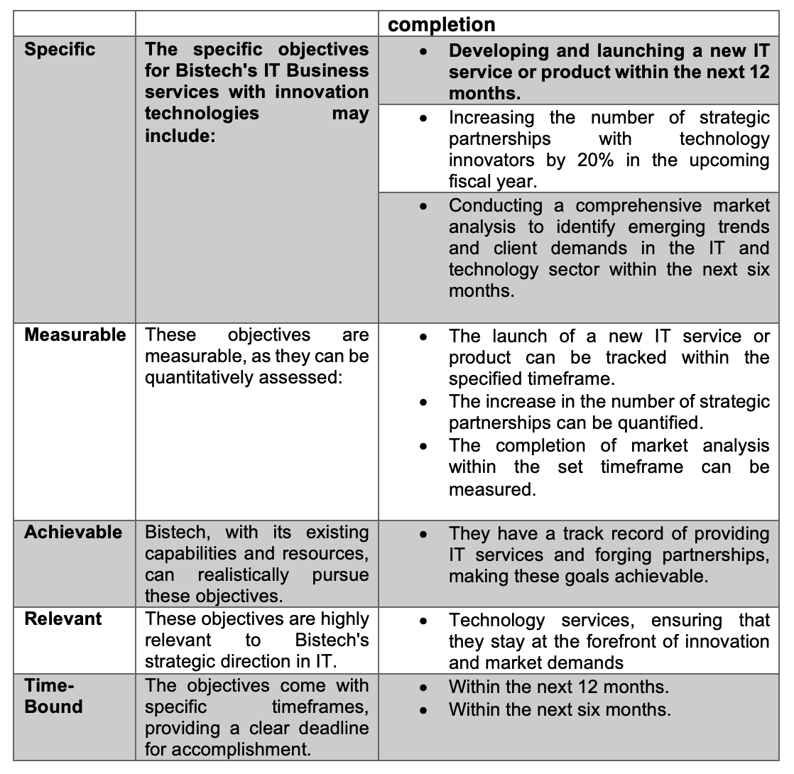
According to research (Al-Masri and Curran, 2019, p.1). By applying the SMART framework, Bistech can systematically work towards these specific objectives in IT Business services with innovation technologies, track progress, and ensure that their actions align with their strategic direction.
These example categorising decisions in this way, Bistech can better allocate resources and ensure that the appropriate level of expertise and attention is given to each type of decision.
key information characteristics for different management levels (Table 3):
Table 3. Source: According to) Bocij et al. (2005).
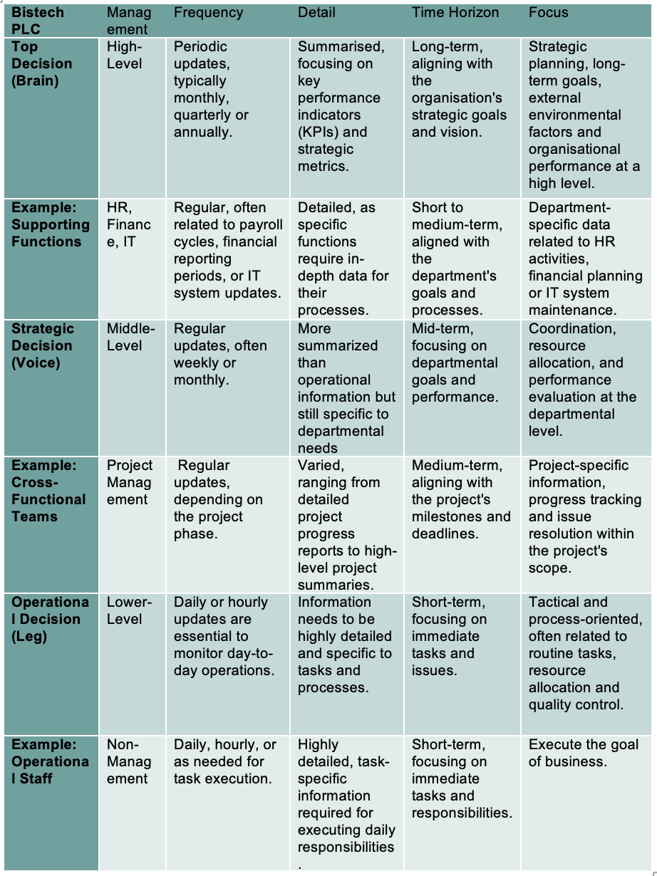
This information characteristics required by management levels differ in terms of frequency (Johnson et al., 2017), detail, time horizon and focus, reflecting the distinct roles and responsibilities of each management level within an organisation. Tailoring information to these characteristics ensures that decision-makers have the right data to make informed choices at their respective levels.
Research found that suggested by Bhagwat and Sharma (2007) The Balanced Scorecard (BSC) is a strategic management tool used by organisations like BISTECH PLC to assess their performance from various angles (Appendix B).
- Analysis - Macro or External Environment
  - PESTLE Environment Analysis
This PESTLE analysis provides an overview of the external factors affecting Bistech PLC's operations and growth prospects on the concept by Haberberg and Rieple (2008). Understanding these macro-environmental factors is crucial for developing a sustainable business strategy and ensuring that Bistech can navigate potential challenges while capitalising on emerging opportunities, it has been suggested that Lynch (2021).
Bistech faces significant external environmental factors such as Brexit according to Hantrais (2019), demographic changes and the COVID-19 pandemic according to the research Neeta Baporikar (2021).
Brexit may introduce trade barriers, customs checks and tariffs, increasing costs and logistics complexity. Post-Brexit, regulatory frameworks may diverge between the UK and EU, requiring legal and regulatory adjustments. Currency fluctuations can affect Bistech's international transactions, impacting import costs and export revenue. Market access to the EU may require a reassessment of Bistech's market strategy. Demographic changes can affect consumer behavior, labour force availability, and market opportunities. The COVID-19 pandemic has disrupted global supply chains, leading to delays and increased costs (Kumar et al., 2020). The pandemic has accelerated remote work and digital transformation, necessitating investments in digital transformation initiatives argues by Rajaram (2023). Demand fluctuations have led to agility in responding to changing customer needs and market conditions. Financial challenges resulting from the pandemic may impact Bistech's financial stability, necessitating revisiting financial strategies and cost-saving measures. To manage these external environmental factors, Bistech should conduct a comprehensive risk assessment, develop adaptive strategies, and closely monitor consumer trends (Long, 2019).

There are six macroenvironmental components to consider (Table 4):
Table 4. Source: According to Fahy and Jobber (2019)
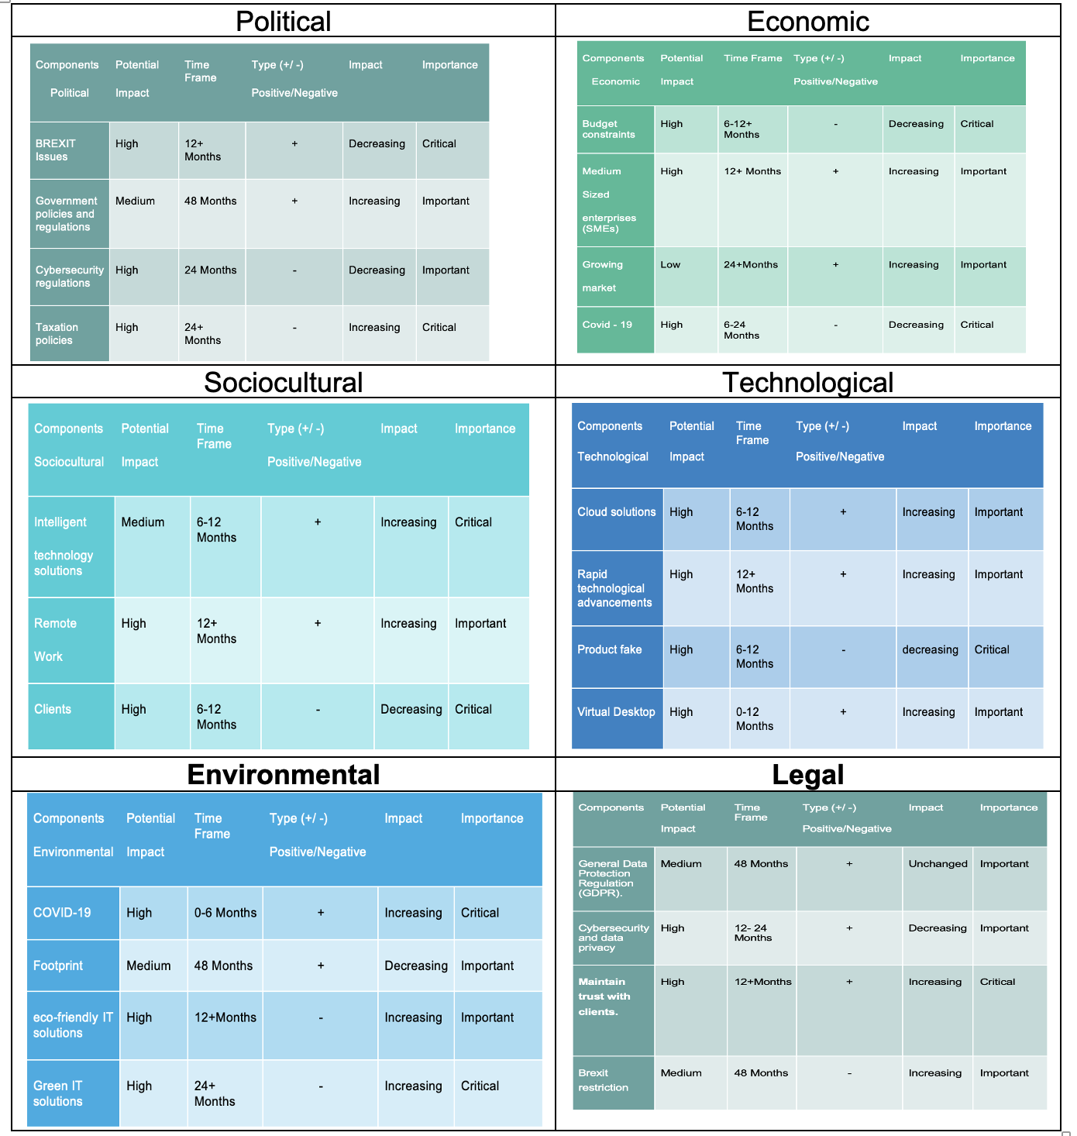

  - Micro or Internal Environment
Bistech's microenvironment comprises immediate forces affecting its performance, decision-making, and customer service, including customers, employees, suppliers and stakeholders Lessig et al. (2002)
  - SWOT Analysis
This analysis will help identify the company's internal strengths and weaknesses and external opportunities and threats:

SWOT Analysis (TABLE 5):
Table 5. Source: SWOT Analysis Speth and Probert (2015).
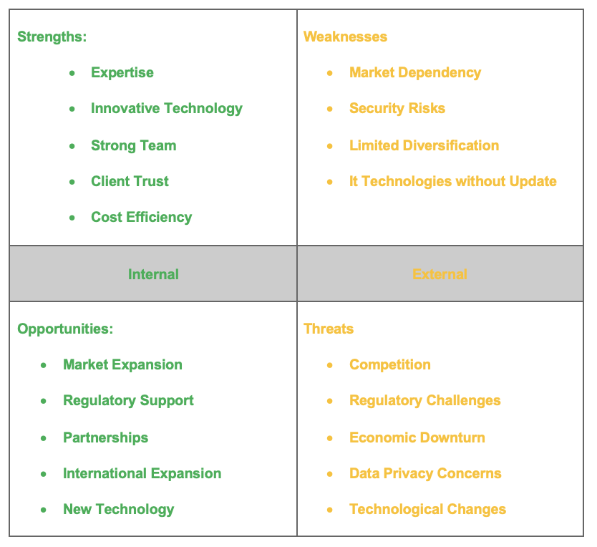
Bistech's success will depend on its ability to leverage its strengths to meet opportunities while mitigating its weaknesses and addressing threats effectively. Regular SWOT analysis can help the company adapt to the ever-changing business landscape (Speth and Probert, 2015, p.1).
This thorough SWOT analysis reveals the interconnected web of factors shaping Bistech 's operational environment. The organisation's strategies and sustainability are contingent on its ability to navigate and harness the identified opportunities while mitigating the potential threats within this dynamic IT industry landscape.

  - Advance SWOT Analysis
The Rating relating with factors of SWOT (Table 6).
Table 6. Source: Advance SWOT. According to Kieser (1994).
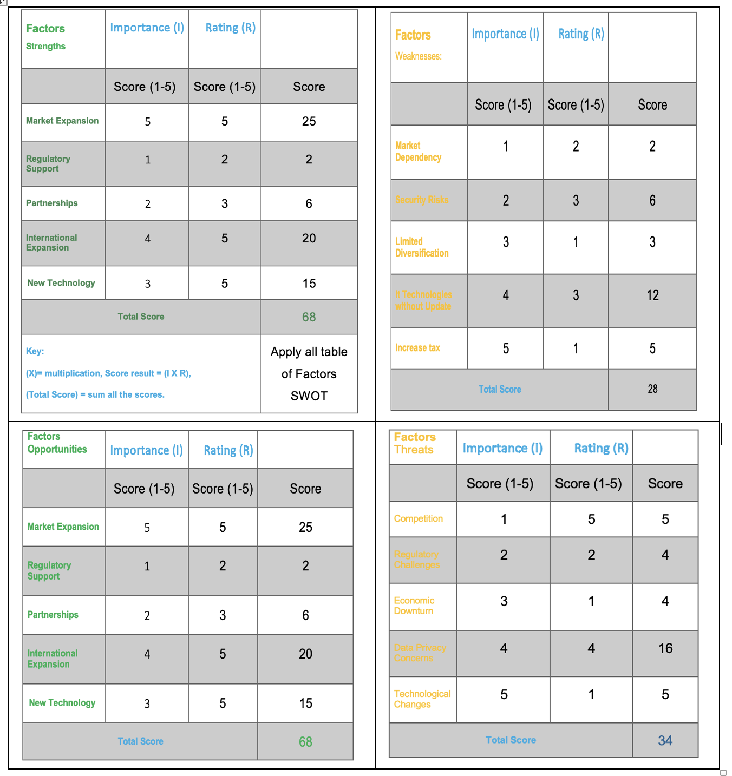
The scores provide a comprehensive analysis of Bistech's internal strengths, weaknesses, opportunities, and threats according to the research by Watkins (2007). They can be utilised to devise strategies that capitalise on strengths, address weaknesses, capitalise on opportunities, and mitigate threats to achieve Bistech's objectives. The positive sign suggests that strengths and opportunities outweigh weaknesses and threats, but it's crucial to consider the specifics of the organisation and industry.
Graphic SWOT Analysis (Figure 1):

Figure 1.Source: According to Kieser (1994. P.1).

Porter’s Five Forces Model
Porter's Generic Strategies: The choice of generic strategy (cost leadership, differentiation, or focus) can significantly impact Bistech's competitive positioning and profitability.
Porter’s Five Forces Model (Figure 2):
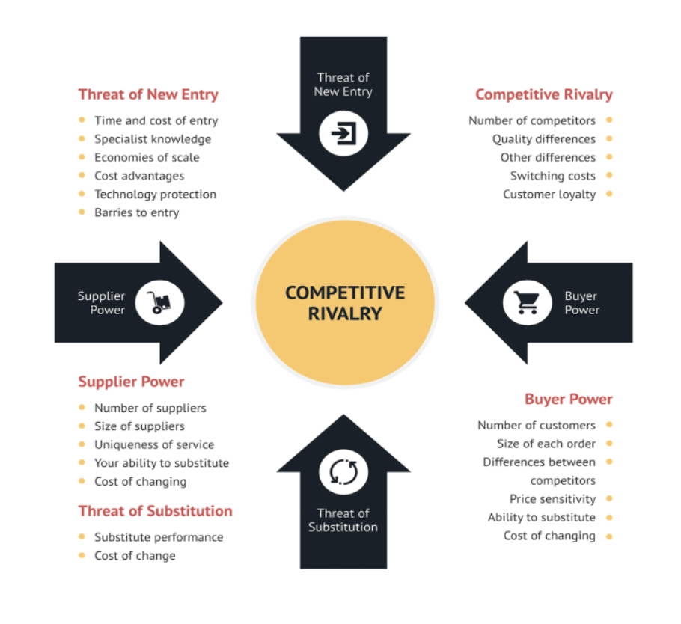
Figure 2:Source: Porter’s Five Forces Model. According to Heubel (2021).

The implications of these findings can inform Bistech's strategic decision-making (Table 7). For instance, if supplier power is high, Bistech might work on diversifying its supplier base or negotiating more favourable terms. If competitive rivalry is intense, differentiation strategies could be a key focus to stand out in the market.
(Table 7): Bistech's strategic decision-making:
Table 7. Source: According to Heubel (2021, p.1).
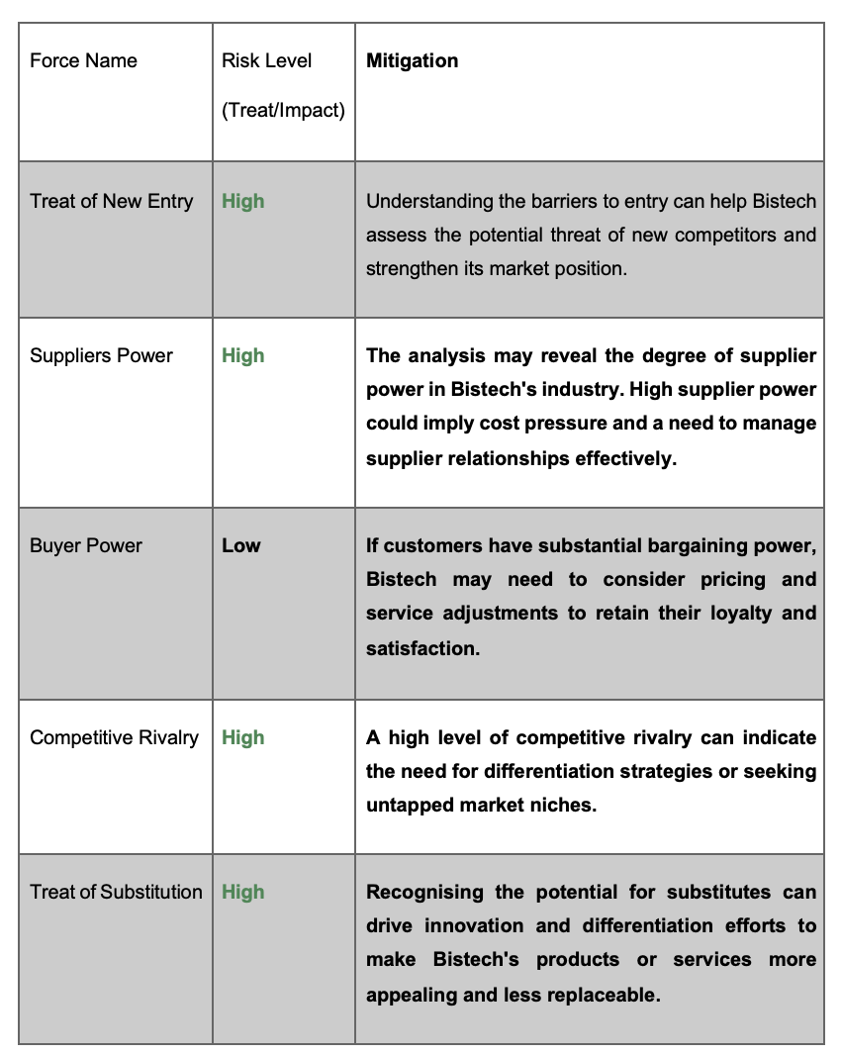
Ultimately, this analysis serves as a foundational step for Bistech to develop and refine its strategic plans, considering both the competitive landscape and the company's internal operations (Heubel, 2021).

  - Value Chain Analysis
Evaluating the value chain can identify areas for cost reduction, quality improvement and overall operational efficiency.
Value Chain Model (Figure 4):
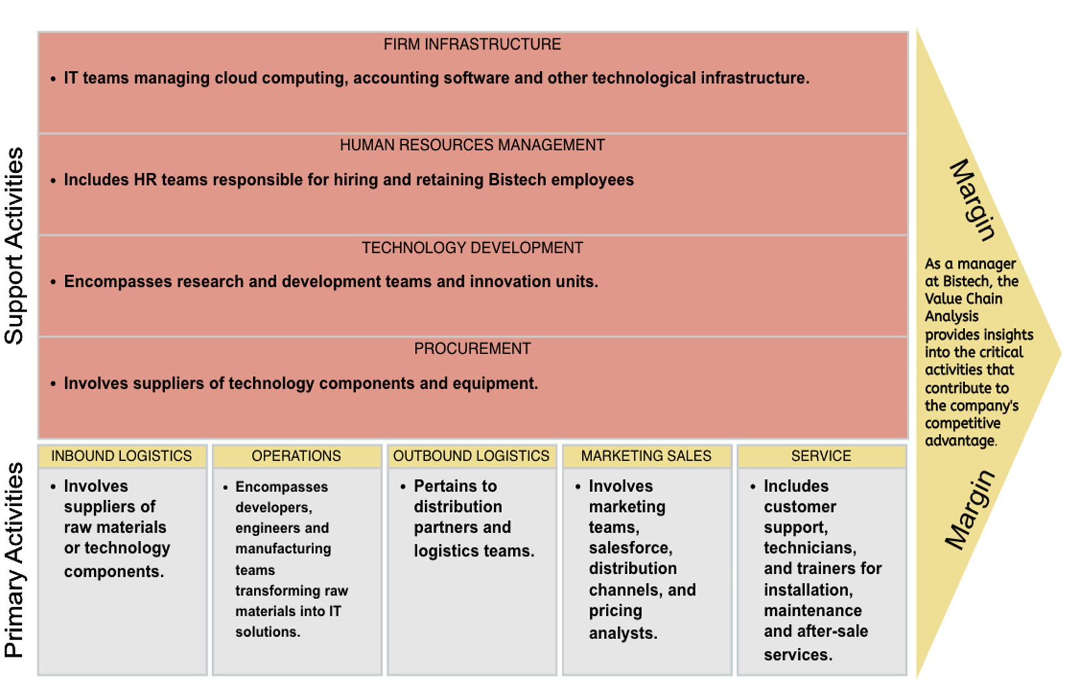
Figure 4. Source: Value Chain Model. According to Hart (2022).
The managerial perspective on Value Chain Analysis at Bistech is crucial for understanding the company's strategic planning, resource allocation, and process optimisation. It helps create value for customers by enhancing efficiency, delivering high-quality IT solutions and reducing costs argues by (Hart, 2022, p.1) The perspective focuses on consistently improving and innovating in areas crucial to the company's clients and business success.
  - VRIO Analysis
The VRIO analysis for Bistech categorises its resources and capabilities as Valuable, Rare, Inimitable and Organised, assessing its potential effectiveness and viability within its strategic framework.
VRIO analysis (Table 8):
Table 8. Source: According to Kimmy (2022).
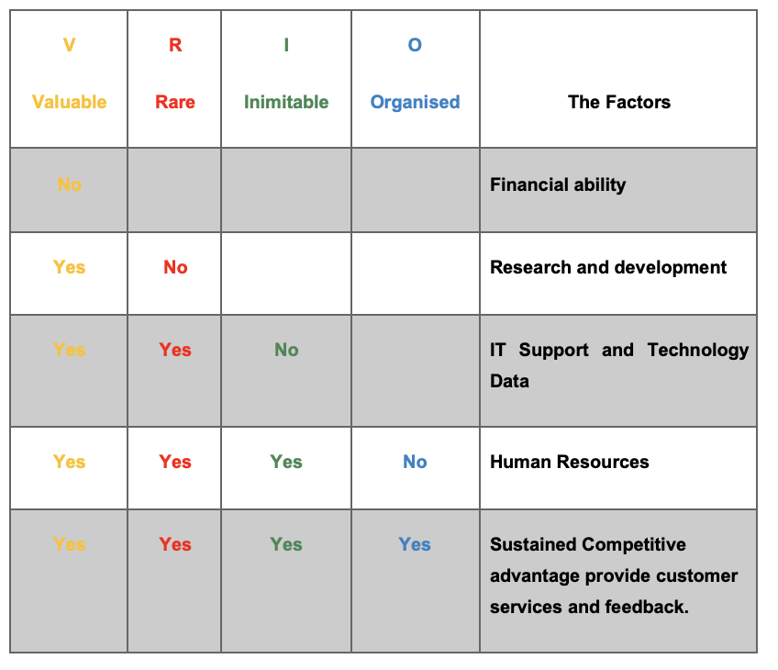
The analysis reveals that financial ability is not a significant factor in Bistech's success, but research and development are valuable but not rare. IT support and technology data are valuable but not inimitable and Bistech should protect their technology to prevent imitation. Human resources are valuable but not organised and Bistech should ensure an effective organisational structure to fully leverage this resource. The sustained competitive advantage providing customer services and feedback is valuable, rare, inimitable, and organised. To evaluate the effectiveness and viability of these resources, Bistech should assess their suitability, acceptability, feasibility, cost-effectiveness, ethical considerations and capabilities. This analysis can guide decision-making and resource allocation to enhance Bistech's long-term viability and success (Kimmy, 2022, p.1).

Stakeholders
The stakeholders are divided into internal and external (Figure 5):

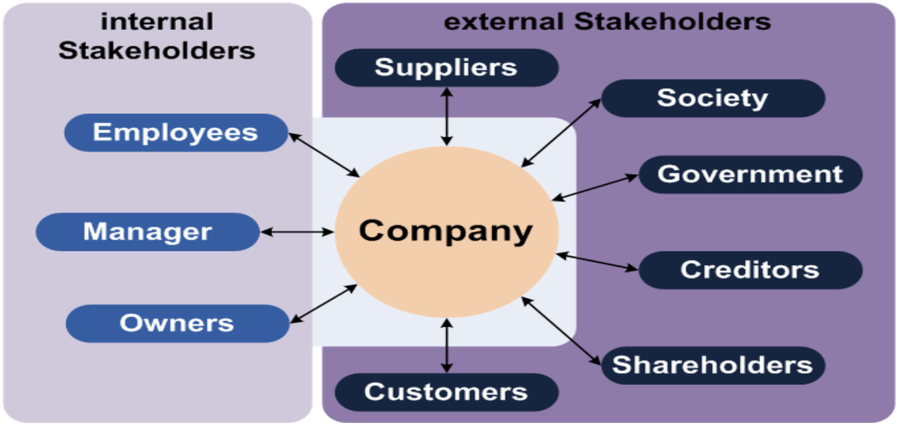
Figure 5. Source:Stakeholder according to (Salonen, 2010).

Stakeholder’s Mapping
Power/Interest Matrix

Figure 6: Power/Interest Matrix

A Power/Interest Matrix is a tool used to categorize stakeholders based on their level of power and their level of interest in a company or its activities (Salonen, 2010). This matrix helps organizations determine how to engage and manage relationships with various stakeholder groups. Here's a Power/Interest Matrix for Bistech:
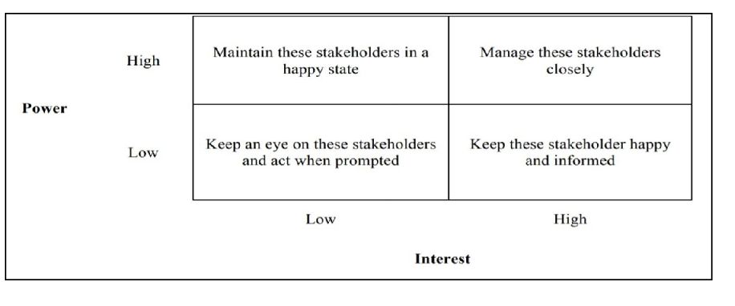
Figure 6. Source: Power/Interest Matrix. According to Salonen (2010).

High Power, High Interest (Manage Closely):
Customers
Customers have a high interest in Bistech's services and the power to influence the company's reputation and success. Managing and satisfying their needs is critical.
Suppliers
Bistech's workforce is highly interested in the company's operations and has the power to impact its daily functioning. Ensuring their engagement and satisfaction is important.
High Power, Low Interest (Keep Informed):
Government
Suppliers have the power to affect Bistech's supply chain, but their primary interest is transactional. Keeping them informed about changes in demand or requirements is crucial.
Media
While the media and the public can have an impact through coverage or perception, their interest in Bistech's operations may be relatively low. Monitoring their sentiments and addressing any significant issues is necessary.
Low Power, High Interest (Keep Satisfied):
Employees
The local community may have a high interest in Bistech's impact on the environment and society.
Shareholders
Maintaining a positive image and addressing concerns is important.
Low Power, Low Interest (Monitor):
General Public
Bistech operates within a local community, and its activities can have social and environmental impacts. Maintaining a positive relationship with the community is important.
Competitors
Industry associations have limited power over Bistech but can provide valuable insights and networking opportunities. Monitoring their activities and engagement is beneficial.

Figure 7: Power/Interest Matrix of Bistech

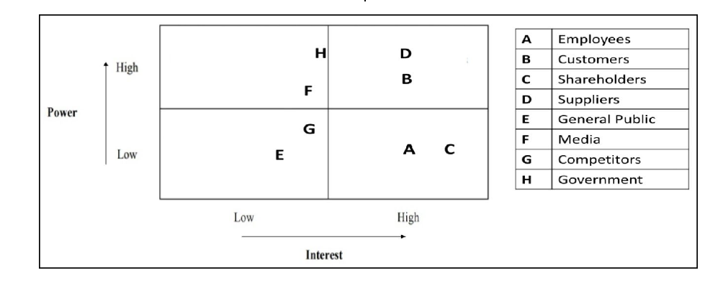
Figure 7. Source: Power/Interest Matrix According to Chen (2017).
This Power/Interest Matrix provides a visual representation of how Bistech should approach different stakeholder groups. It helps the company tailor its communication and engagement strategies to effectively manage relationships and ensure alignment with the interests and expectations of each group.
- The discussion of new strategies for sustainable growth
Bistech's Market Development strategy is a comprehensive approach aimed at expanding its market presence and increasing its market share.
It comprises key elements such as market analysis, competitive analysis, customer segmentation, pricing strategies, product and service enhancements, distribution channels, marketing and promotion, sales force optimisation, customer loyalty programs, quality assurance, competitive pricing analysis, innovation and differentiation, Key Performance Indicators (KPIs) and customer feedback and communication Szulanski (1996).
Market analysis helps Bistech understand the competitive landscape, customer behavior, and demand for its products or services. Competitive analysis helps identify weaknesses in competitors' offerings, allowing Bistech to differentiate itself and gain a competitive edge. Customer segmentation helps identify target groups with the most potential for increased sales. Pricing strategies can include discounts, bundles or other incentives to attract new customers or encourage existing ones to make additional purchases (Soyka, 2013).
Product and service enhancements are crucial for driving increased demand, and Bistech can improve its products or services by adding new features, enhancing quality, or expanding product lines. Distribution channels should be reviewed to ensure efficient product delivery and explore new markets or customer segments. Marketing and promotion are essential for creating awareness and generating interest in Bistech's products. Competitive pricing analysis monitors and adjusts pricing while protecting profitability. Innovation and differentiation are crucial for Bistech to stay ahead in a competitive market Lefebvre (2011).
  - Business strategy:
Three Plan A, B and B:
Plan A - Work from Home Strategy
This plan targets the market of businesses and organisations transitioning to work-from-home and remote work setups. Bistech can encourage the adoption of its chain-based digital record solutions by offering promotional deals and pricing incentives. This approach capitalises on the growing trend of remote work and addresses the increased demand for secure and efficient data management in such environments. By focusing on the work-from-home segment, Bistech can gain a competitive edge and expand its market share in a rapidly evolving business landscape (Benson and Bugnitz, 2004).

Plan B - Eco-Friendly
This plan emphasises Bistech's eco-friendly and cost-efficient products and services. It highlights the environmental benefits of Bistech's technology and the cost savings it offers. This approach can not only attract new clients but also reinforce relationships with existing ones by demonstrating how Bistech's solutions align with sustainability objectives and reduce operational expenses. In an era where environmental consciousness is on the rise, promoting the eco-friendliness of products can be a compelling market penetration strategy.
Plan C - Sustainability in the Cloud
Cloud infrastructure has emerged as an environmentally friendly alternative to traditional on-premises counterparts. Studies indicate that cloud datacentre’s can be up to 80% more energy efficient. Moreover, by shifting on-premises applications to renewable-powered public clouds, businesses can further reduce their carbon footprint. The cloud's shared services model enhances computing efficiency and provides access to greater computing power, supporting critical sustainability objectives such as improving business efficiency through machine learning and automation, reducing travel through hybrid work models and virtual collaboration, and minimising real-world waste through advanced visualisation, simulation and modelling techniques.
Bistech's business strategy options include the Work from Home Strategy, which focuses on attracting businesses transitioning to remote work and promoting the adoption of chain-based digital record solutions Benson and Bugnitz (2004, p.1). However, this strategy may face challenges such as the highly competitive remote work market and the need to differentiate its offerings in terms of security, efficiency, and cost-effectiveness. The Eco-Friendly Strategy emphasises the eco-friendly and cost-efficient nature of Bistech's products and services, which can attract new clients and enhance existing ones. However, it may require concrete evidence and certifications to support its environmental claims. Transparency and clear communication about the eco-friendliness of products are crucial for gaining client trust. This is contrasts. The Sustainability in the Cloud Strategy leverages cloud infrastructure's environmental benefits and energy efficiency (Buyya et al., 2009), offering reduced carbon footprint and enhanced computing efficiency. However, this strategy may require significant investment in infrastructure and expertise to migrate on-premises applications to the cloud. Addressing security and privacy concerns associated with cloud technology is also essential.

In result, Bistech's success depends on its ability to address challenges, adapt to market dynamics, and communicate its value proposition clearly to its target audience. Aligning these strategies with Bistech's long-term goals and values is essential for sustainable growth and success.
  - Selection of Strategies (SAF) Framework
The suitability, (Table 10) acceptability, and feasibility (SAF) framework for strategic analysis and decision-making, particularly in the context of Bistech. This Tables elaborate on these considerations criteria and questions for each aspect:
Table 10: (SAF) framework
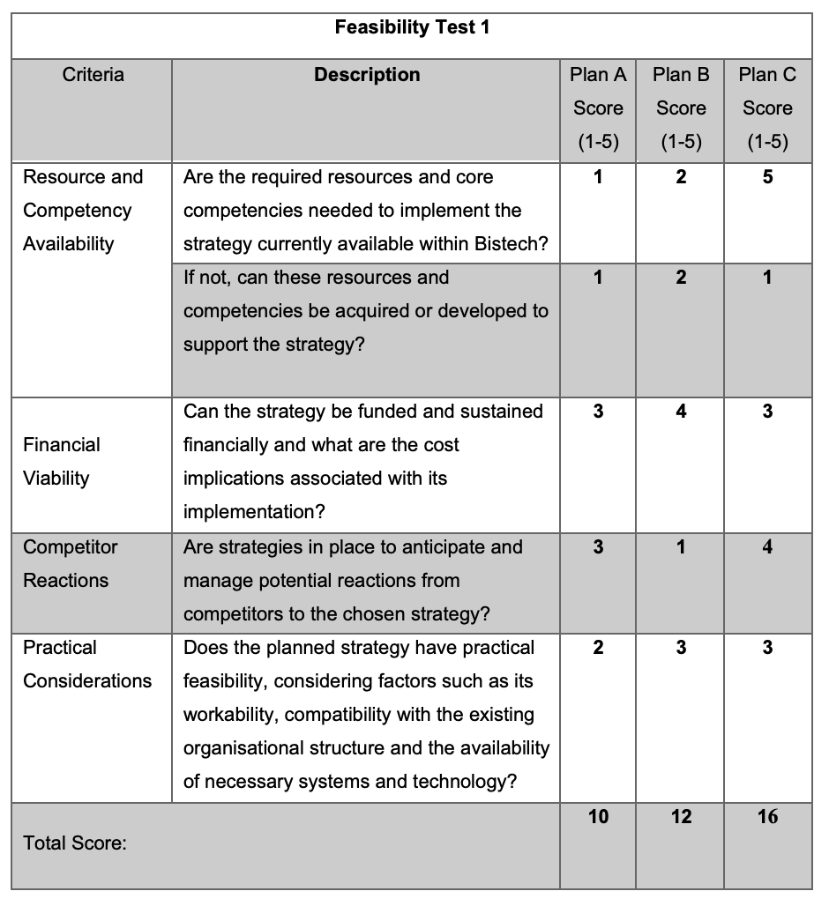
Table 10. source: SFA Matrix According to the research by Benson and Bugnitz (2004, p.2).

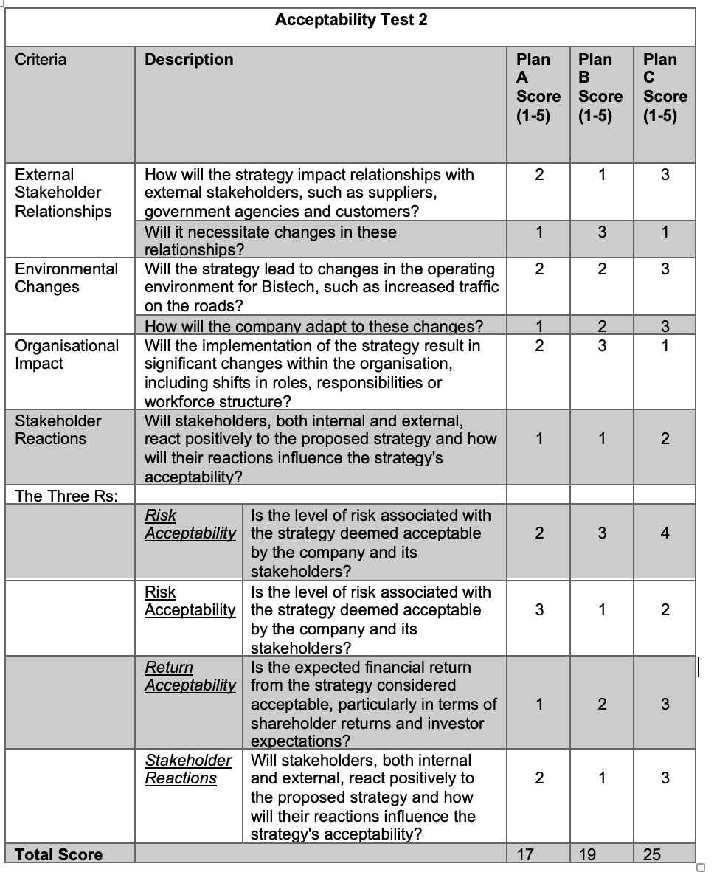

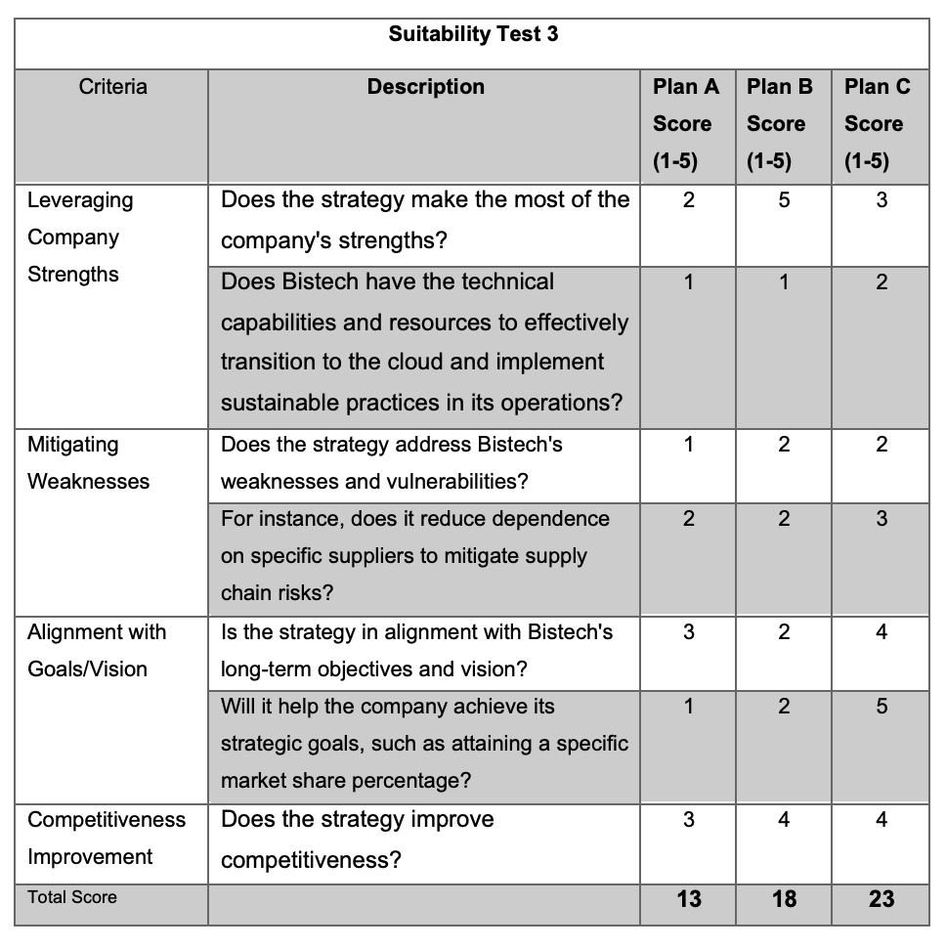

An agreement, Plan C, which focuses on sustainability in the cloud, emerges as the most feasible and acceptable strategy for Bistech, with a total score of 25. However, it's essential to consider other factors and conduct a more comprehensive analysis before making a final decision. Plan B also shows promise, especially in terms of leveraging the company's strengths and competitiveness improvement. Plan A, while viable, may require further consideration and adjustments to fully align with the company's goals and vision (Yue et al., 2015).
  - SFA Matrix
SFA MATRIX (Table 11):
Table 11. Source: SFA Matrix According to research by Botsford et al. (2019).
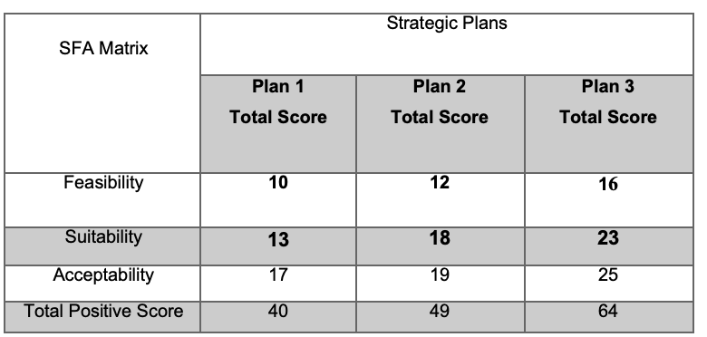
In this SFA Matrix analysis, higher scores indicate better suitability, feasibility and acceptability of the plans. Plan 3 has the highest total positive score of 64, making it the most favourable option among the three plans. Plan 2 comes second with a total positive score of 49 and Plan 1 is the least favourable with a total positive score of 40.

Figure 8. Source: According to Botsford et al. (2019).
The SFA Matrix suggests that Plan 3 is the most suitable, feasible, and acceptable option among the three, making it the recommended choice based on this evaluation. However, it's important to consider other factors and conduct a more comprehensive analysis before making a final decision.
- Provide key strategic recommendations.
Bistech's "Sustainability in the Cloud" strategy should align with Ansoff's model and Kurt Lewin's three-step organisational change model for effective change management and transformation.
Kurt Lewin's Three-Step Model (Table 12): Emphasises three key stages for successful change:
Table 12. Source: Kurt Lewin's Three-Step Model according to Cummings et at. (2017)
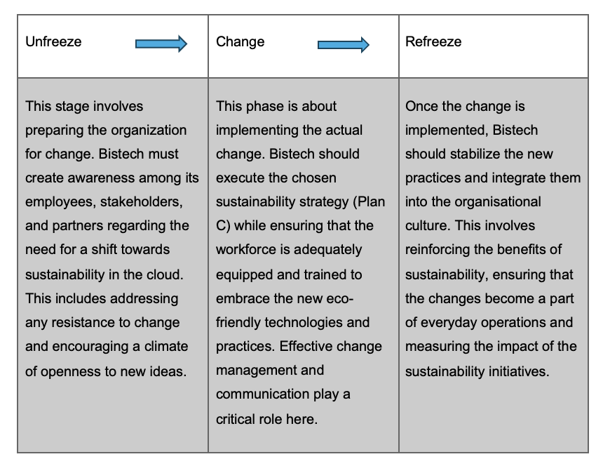
Ansoff's Model (Market Development and Product Development): Applying Ansoff's model to Bistech's sustainability strategy (Peterdy, 2022):
Market Development
Bistech is venturing into new markets by educating clients about the benefits of sustainable cloud solutions. To succeed, they should conduct thorough market research, understand the unique needs and concerns of these new markets and tailor their approach accordingly. Providing educational resources and support to clients will be crucial.
Product Development
Transitioning to eco-friendly cloud solutions represents a significant product development effort. Bistech should focus on innovation and technical capabilities to ensure a seamless transition. This includes investing in sustainable infrastructure, adopting new technologies and maintaining product quality and reliability throughout the transition.
Considering the barriers and challenges outlined earlier (Table 13), Bistech should prepare for:
Table 13. Source: Barriers and challenges. According to Krüger and Stumpf (2013).
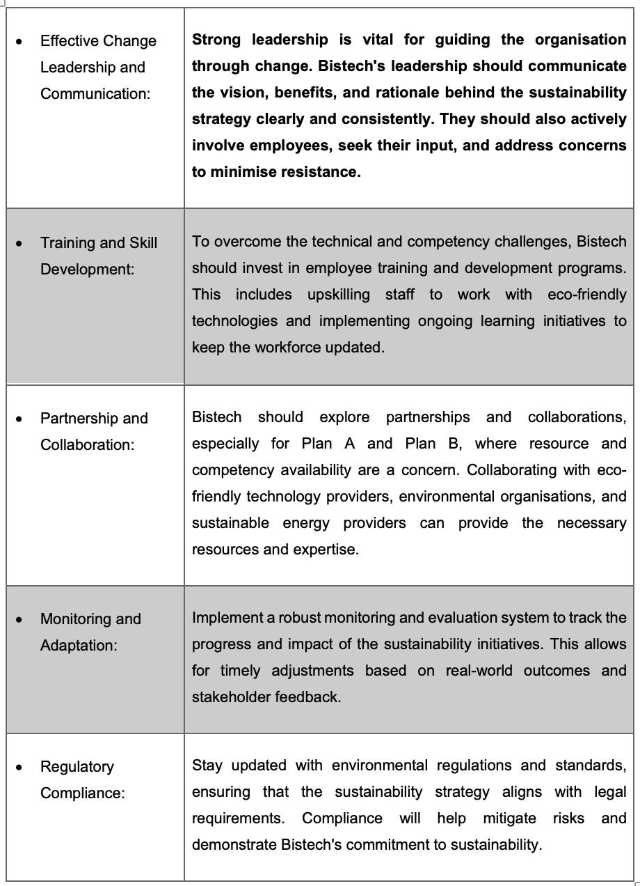
In result, aligning Ansoff's model with Kurt Lewin's change management model, Bistech should focus on effective communication, employee training, strategic partnerships, continuous monitoring and regulatory compliance to overcome the barriers and successfully implement its "Sustainability in the Cloud" strategy similarly by Godbole and Lamb (2018), whether it involves market development or product development. The choice of Plan C, with its strong feasibility and alignment with long-term goals, offers a solid foundation for these efforts.
- Conclusion
Bistech's transition towards eco-friendly cloud solutions requires alignment with Ansoff's growth model and Kurt Lewin's three-step change model. Ansoff's model focuses on market development and product development by Cadle, et al, (2010), while Lewin's model emphasises unfreezing the existing state, implementing change, and refreezing new practices into the culture. This approach ensures Bistech manages the transition effectively, addresses resistance and sustains eco-friendly practices. To overcome challenges, Bistech must prioritise effective leadership, employee training, partnerships, monitoring and regulatory compliance. These measures will mitigate risks and reinforce Bistech's commitment to sustainability and environmental responsibility. The strategic recommendations for Bistech include a holistic approach that integrates market development, product development, change management and eco-friendliness for sustainable growth and success. Aligning these strategies with Bistech's long-term vision and values is crucial for continued prosperity.

- Reference List
Al-Masri, A. and Curran, K. (2019). Smart Technologies and Innovation for a Sustainable Future: Proceedings of the 1st American University in the Emirates International Research Conference - Dubai, UAE 2017. Cham Springer International Publishing Imprint, Springer.
Barney, J.B. and Hesterly, W.S. (2019). Strategic Management and Competitive Advantage. Harlow, United Kingdom: Pearson Education, Limited.
Benson, R.J. and Bugnitz, T. (2004). From Business Strategy to IT Action. John Wiley & Sons.
Botsford, L.W., J Wilson White and Hastings, A. (2019). Population dynamics for conservation. Oxford: Oxford University Press.
Buyya, R., Yeo, C.S., Venugopal, S., Broberg, J. and Brandic, I. (2009). Cloud computing and emerging IT platforms: Vision, hype, and reality for delivering computing as the 5th utility. Future Generation Computer Systems, 25(6), pp.599–616. doi: https://doi.org/10.1016/j.future.2008.12.001.
Cadle, J., Paul, D. and Turner, P. (2010). Business analysis techniques 72 essential tools for success. Swindon British Informatics Society Limited.
Chen, C. (2017). Science Mapping: A Systematic Review of the Literature. Journal of Data and Information Science, 2(2), pp.1–40. doi: https://doi.org/10.1515/jdis-2017-0006.
Cummings, S., Bridgman, T. and Hassard, J. (2017). A new history of management. Cambridge, United Kingdom; New York, Ny: Cambridge University Press.
Fahy, J. and Jobber, D. (2019). Foundations of marketing. 6th ed. New York: Mcgraw-Hill Education.
Fernández, Z. and Nieto, M.J. (2006). Impact of ownership on the international involvement of SMEs. Journal of International Business Studies, [online] 37(3), pp.340–351. doi: https://doi.org/10.1057/palgrave.jibs.8400196.
Godbole, N.S. and Lamb, J.P. (2018). Making healthcare green: the role of Cloud, green IT, and data science to reduce healthcare costs and combat climate change. Cham, Switzerland: Springer.
Hantrais, L. (2019). What Brexit means for EU and UK social policy. Bristol: Policy Press.
Hart, M. (2022). The Straightforward Guide to Value Chain Analysis. [online] Hubspot.com. Available at: https://blog.hubspot.com/sales/value-chain-analysis.
Heubel, M. (2021). Porter’s Five Forces Analysis: Definition, Model & Examples Explained. [online] Consulterce. Available at: https://consulterce.com/five-forces-analysis/.
Johnson, G., Angwin, D., Regner, P., Kevan Scholes and Whittington, R. (2017). Exploring strategy. Harlow, England: Pearson.
Kieser, A. (1994). Why Organization Theory Needs Historical Analyses—And How This Should Be Performed. Organization Science, 5(4), pp.608–620. doi: https://doi.org/10.1287/orsc.5.4.608.
Kimmy (2022). The VRIO Model: A Framework for Assessing a Company’s Competitiveness and Potential for Long-term Profitability | kyinbridges.com. [online] www.kyinbridges.com. Available at: https://www.kyinbridges.com/the-vrio-model-a-framework-for-assessing-a-companys-competitiveness-and-potential-for-long-term-profitability/.
Krüger, R. and Stumpf, A. (2013). Brand Growth Barriers. Springer Science & Business Media.
Kumar, A., Luthra, S., Kumar Mangla, S. and Kazancoglu, Y. (2020). COVID-19 impact on sustainable production and operations management. Sustainable Operations and Computers, 1(1), pp.1–7. doi:https://doi.org/10.1016/j.susoc.2020.06.001.
Lefebvre, R.C. (2011). An integrative model for social marketing. Journal of Social Marketing, 1(1), pp.54–72. doi:https://doi.org/10.1108/20426761111104437.
Lessig, L., Sekula, A., Stein, S. and S. (2002). The future of ideas: the fate of the commons in a connected world. New York: Vintage Books.
Long, J.M. (2019). Management and leadership skills that affect small business survival: a resource guide for small businesses everywhere. London: Anthem Press.
Lynch, R. (2021). Strategic Management. SAGE.
Marvilano, D. (2020). Overview of Strategy Tools: VMOST. [online] GOSPEL of Strategy. Available at: https://www.marvilano.com/post/tools-vmost.
Matt, D.T., Modrák, Vladimír and Zsifkovits, H. (2021). Implementing Industry 4.0 in SMEs: Concepts, Examples and Applications. Cham: Springer International Publishing: Imprint: Palgrave Macmillan.
Neeta Baporikar (2021). Handbook of research on sustaining SMEs and entrepreneurial innovation in the post-COVID-19 era. Hershey, Pa: Business Science Reference, An Imprint of Ige Global.
Olson, D. (2018). VMOST Analysis | Wiki | BAwiki. [online] Bawiki.com. Available at: http://www.bawiki.com/wiki/vmost-analysis.html.
Peterdy, K. (2022). Ansoff Matrix - Overview, Strategies and Practical Examples. [online] Corporate Finance Institute. Available at: https://corporatefinanceinstitute.com/resources/knowledge/strategy/ansoff-matrix/.
Rafay, A. (2019). FinTech as a Disruptive Technology for Financial Institutions. IGI Global.
Rajaram, K. (2023). Leading and Transforming Organizations. Taylor & Francis.
Salonen, T. (2010). Strategies, Structures, and Processes for Network and Resources Management in Industrial Parks. BoD – Books on Demand.
Soyka, K. (2013). Drive Growth Through Sustainable Business Practices (Collection). S.L.: Addison Wesley.
Sparviero, S. (2019). The Case for a Socially Oriented Business Model Canvas: The Social Enterprise Model Canvas. Journal of Social Entrepreneurship, 10(2), pp.1–20. doi: https://doi.org/10.1080/19420676.2018.1541011.
Speth, C. and Probert, C. (2015). The SWOT analysis develop strengths to decrease the weaknesses of your business. Namur 50Minutes.
Szulanski, G. (1996). Exploring internal stickiness: Impediments to the transfer of best practice within the firm. Strategic Management Journal, 17(S2), pp.27–43. doi: https://doi.org/10.1002/smj.4250171105.
Watkins, R. (2007). Performance by design: the systematic selection, design, and development of performance technologies that produce useful results. Amherst, Mass.: Hdr Press; Silver Spring, Md.
Yue, X., Cai, H., Yan, H., Zou, C. and Zhou, K. (2015). Cloud-assisted industrial cyber-physical systems: An insight. Microprocessors and Microsystems, 39(8), pp.1262–1270. doi: https://doi.org/10.1016/j.micpro.2015.08.013

- Appendix A

Annual Report: For the year ended 31 July (2022, p.22).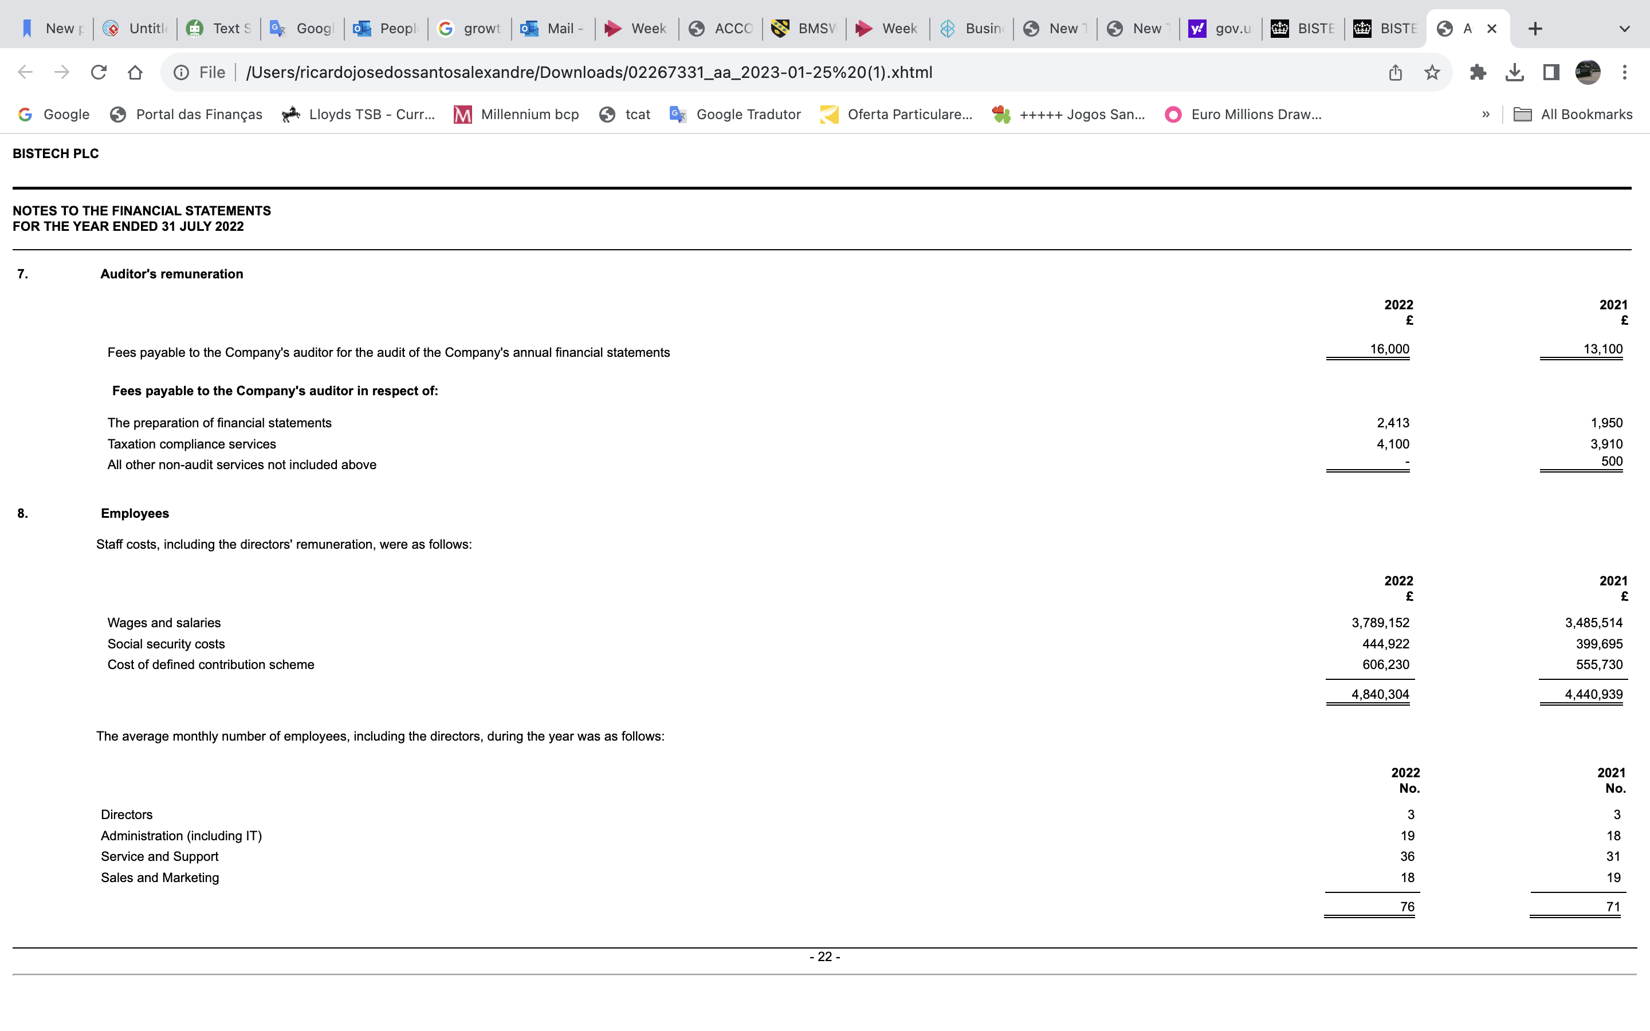
Source: https://find-and-update.company-information.service.gov.uk/company/02267331/filing-history

- Appendix B

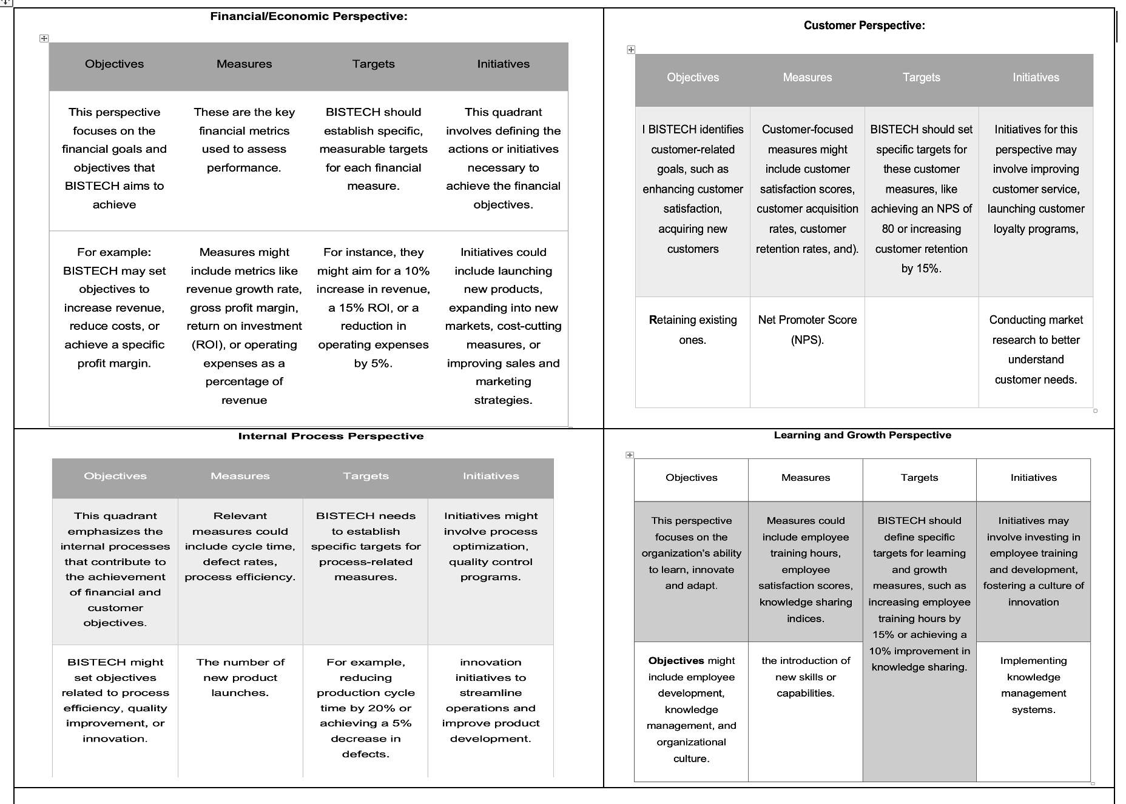
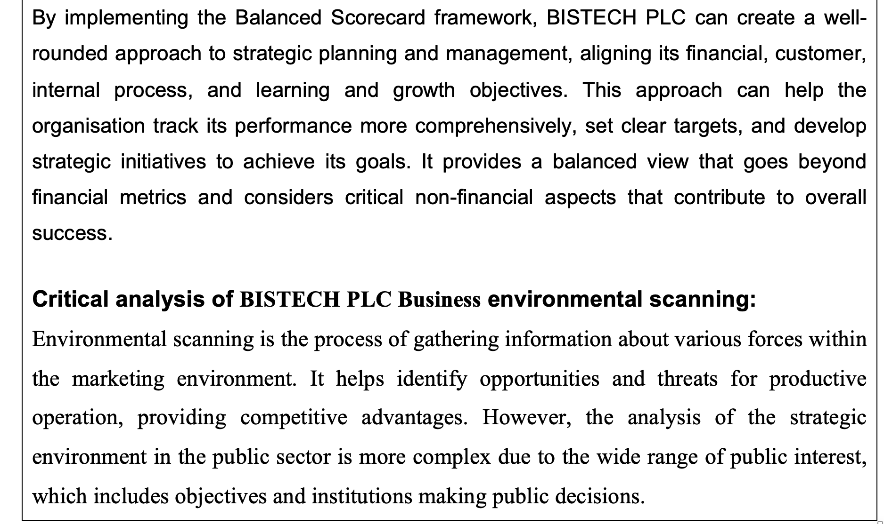

- Porter

Strategic Management for SMEs

“BISTECH PLC”


