Emma Jane Vaughan
1703817
Keywords
Word Count 2580

This investigation is carried through three keywords Sustainability, Maker and Emotion. Sustainability is such an extensive and current topic that the British Government has called for a Climate Change Emergency to tackle it. However do we know what the term really means, and what we should be concerned about as a consumer. Carrying these concerns over to a Makers point of view also, how can we include sustainability into our produce whilst still satisfying the needs of today`s consumer. Synthesise Emotion, Maker and Sustainable into design may prove difficult and how does this translate into consumer`s satisfaction and decision making.
According to the Oxford Dictionary term Sustainability is described as “the ability to be maintained at a certain rate or level”, also the “avoidance of the depletion of natural resources in order to maintain an ecological balance” (Dictionary,2018). In 1972, it was the first time for us to see a photo of Earth from outer space, see figure 1. The reality of this image sent shockwaves as it showed us all the reality of what we have, a closed circle, all the resources we need to maintain life are on this planet and once they are gone, they cannot be replaced our resources are finite (Chapman,2005,p.1).

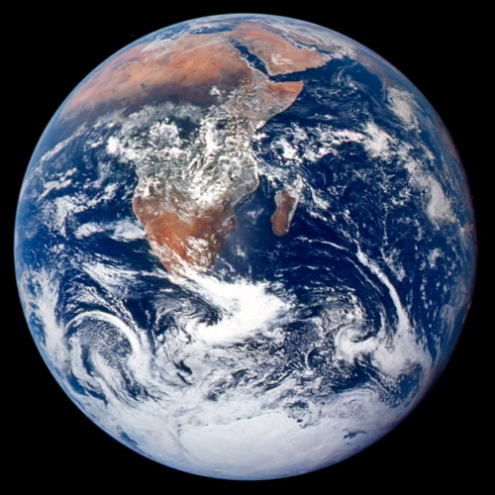

Figure 1

Until recently we had become disconnected with the term sustainable, it has been over used. We have been stripping the world of natural resources without any regard to the effects caused. Currently we are leading “a resource-hungry existence, taking out a great deal more from the Earth than we put back in” (Chapman,2005,p.5). Studies have shown that “In total, one third of all the planets resources have been consumed within the past four decades” (Burnie,1999,p.40). This rate of growth is so unstainable.
We have become a nation that is obsessed with keeping up with the latest trend or having the latest fashion piece, with no thought to the environmental consequences and no regard for how it was made, or the cost to the planet. “It can`t be sustainable if those making it are at risk” (Shedroff,2009,p.15). Everyone is disgusted with the thought that something they have purchased been made by child and slave labour, but this still happens. “Consumers are becoming increasingly aware of both the social, environmental and personal implications of their purchasing decisions” (Chapman,2005,p.176). People are beginning to ask questions like how is it made/where it has come from and act accordingly when choosing a particular object or fashion piece. People are trying to find alternatives and there are companies such as Ellen McArthur foundation, Stella McCartney, Faber Futures and Atelier Lumer are leading the way in developing new opportunities for sustainable production and manufacturing.
Shocking figures like, “90 per cent of the resources taken out of the ground today become waste within three months” (Chapman,2005,p.8), it is no wonder that our landfills are overloaded as we have been discarding products/objects before there life span, so how can sustainability fit in with our increasing demand for everyday products. Elvis and Kresse are a company in Kent which create a luxury range of lifestyle accessories. Only using waste materials destined for landfills, one of the materials used in their range are decommissioned fire hoses supplied from the London Fire Brigade, over the past decade have reclaimed over 175 tones destined for landfill, see figure 2. They transform this waste into a variety of products from bags to wallets to belts to name a few.

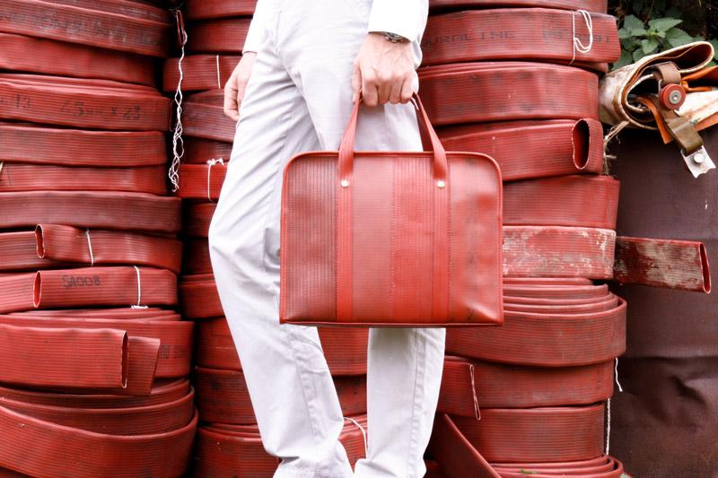
Figure 2.

They love the challenge of creating and discovering new solutions, asking themselves each time they work on something “what can we do to prove value, change perception, and respect these resources (Elvis & Kresse,2019). With their innovated ways of thinking and design they use very skilled craftsmen’s and though their products maybe expensive “A survey by Gallup found that nine out of ten consumers would make a special effort to buy products from companies trying to protect the environment (Chapman,2005,p.176). This innovative company is defiantly doing that, and also, they are educating the consumers as well as new designers to look for more ethnic pieces not just mass-produced items.
Within my own practice of Surface Pattern Design, I have been fortunate to work in collaboration with OrangeBox to produce innovative textile designs and solution that respond to the concepts of “circular economy” which also meet the needs of contemporary office spaces. Orangebox produce approximately a tonne of waste material weekly during their manufacturing process and sadly the majority is sent to be incinerated. According to Circular fibres initiative 2015, the greenhouse gas emissions from the production of textiles globally totalled 1.2 billion tonnes of CO2, more than all international flights and maritime shipping combined (The Guardian, 2019). The waste we were given to work with consisted of 46 different high value substrates, how can they be simply discarded. Each of these fabrics have gone through multiple processes which have consumed valuable planetary resources from being grown, harvested, washed, carded, dyed, woven and shipped to the factory. My work demonstrated independent investigation of materiality and the ideals of the Circular Economy; I was able to utilize all the waste material, by layering and fusing the offcuts together. This created a high-density fabric on to which I was able to emboss surface designs. This waste material is of such a high quality that it can command a premium price, whilst still being sustainable. The reason I have added this is because it might carry into a case study for my dissertation.
Leading on from sustainability I want to look at the process of making and how practices and processes can maximise the suitability’s.
According to the Oxford dictionary a Maker is described as “a person or thing that makes or produces something” (Dictionary,2018). Making in its most basic form is just playing, expressing yourself using different materials, childlike. From here you start to get a feel for the materials, their capabilities, how they join, move and form new pieces, “problem solving and problem finding” (Sennett,2008,p.9) it is just a fascinating process. Making is a way of escapism, there is nothing better going into a studio when you have no deadlines no pressure. I have seen the pleasure children have when they are making, they don’t care what they are creating, it is them just having fun. Another example of this in practice is art therapy, this “is the deliberate use of art making to address psychological and emotional needs” (Cognitive Dynamics, 2019)). Anybody can make something, it doesn`t matter what other people think, it is just a way of you expressing yourself.
In order to make something to a certain standard you need to possess a level of skill. Sennett refers to skill as a trained practiced (Sennett,2008,p.37). To become established in carrying out a skill, it takes endless hours of repeating the same task, you can almost say it gets boring. “However, the gradual improvement of performance, combined with dedication, keeps the negative sense of boredom at bay” (Pallasmaa, 2009,p.81) This is also backed up by Malcom Gladlwell “10,000 Hour Rule”, who also believed in endless practicing in order to be successful in something (Gladwell,2009). This is true, everyone would use the more skilled worker over a novice because they want the work carried out to a high standard and also, they know everything there is to know within the field of work so if anything does go wrong they are able to rectify this straight away. To become a skilled in anything you need impeccable hand, eye and mind coordination. “While drawing, a mature student and architect is not focused on the lines of the drawing, as he is envisioning the object itself and in his mind holding the object in his hand or occupying the space being designed” (Pallasmaa, 2009,p.59). This same principle happens when a skilled crafter makes something, even though they are physically handing it, they are also using tools to carry out a variety of process, while envisioning the piece complete.
Sennett says “All Craftsmanship is founded on skill developed to a high degree (Sennett, 2008,p.20). A good example of Craftsmanship at is best is at Elvis and kresse (as mentioned previously). They source only the best highly skilled crafts persons to work within their team because they want to maintain a high standard of authenticity, also they wouldn’t have their luxury brand if their work wasn’t carried out to a high level.

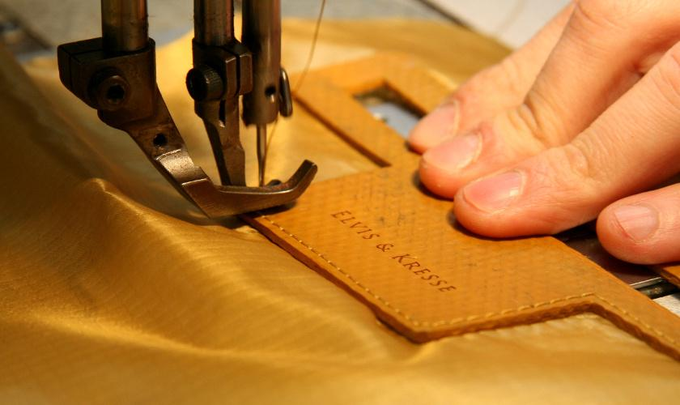
Figure 3

When a craftsman carries out certain tasks or skills, he can do them without even thinking about them. For him the “tool as an extension and specialisation of the hand that alters the hands natural powers and capacities” (Pallasmaa2009,p.47)), this is just an automatic response when he is in his workshop surrounded by machines and equipment while working on different projects. This knowledge can be attained and is accountable because of our tacit knowing, “we can know more than we can tell” (Polanyi,2009,p.4) also “our body is involved in the perception of objects, it participates thereby in our knowing of all other things outside” (Polanyi,2009,p.29). We can spend time developing skills but our personal knowledge we have gained throughout our development, comes into play whilst making. A craftsman can carry out multiple tasks without even thinking of them, they just have an automatic response, he/she cannot explain how it is done, it is the inbuilt knowledge which they have developed, known as tacit knowledge.
Sometimes a Craftsman can come across a problem and not being able to solve it straight away. When this happens, they normally divert there attention somewhere else, then their answer just comes to them. This can be referred to as waking incubation (Kounios and Beeman,2015,p.97). Similarly, “many people have reported waking up with an idea or the solution to a problem that they incubated during sleep” (Kounios and Beeman,2015:,p.92) and as soon as they are awake they are able to write it down on a note pad that is next to their bed. This is something that I have experienced, I find that a lot of solutions come to me during sleep or upon waking.
The action of making may have many benefits to the individual including, a sense of wellbeing, renewal or confidence, or a combination of all leading to a feeling of improved quality of life. This emotional response can transfer into an enhanced end product which arguably may influenced those looking for a hand crafted or unique product.
Emotion can be defined as “a strong feeling deriving from one`s circumstances, mood, or relationships with others” or “instinctive or intuitive feeling as distinguished from reasoning or knowledge” (Dictionary,2018). We can show what emotions we are feeling by physical gestures. Paul Ekman “identified seven emotions that seem to be universal: joy, sadness, contempt, fear, disgust, surprise and anger” (Weinschenk,2011,p.164). It is important to watch people’s reactions closely as this can give you a good indication to how they are really feeling, some people might say they like something but upon looking at their body language you can see that they are not connected.
When we look at consumers “emotions are powerful mechanisms…they…connect and build relationships with (or revulsions to) products, services, events, brands, or organizations (Shedroff,2009,p.111). Customers tend to stick to the same brand because they are loyal and also because they are familiar with the design or quality of the product. “Every customer wants to be a loyal customer. But first you have to enchant them.” (Lockwood,2010,p.257). You have to ensure that your customer has a positive experience from the start, be that in a shop or over the internet. People are impulsive, so first impression count and you also have to make sure you are appealing to the correct customer base.
We can feel an emotional connection when we are purchasing a new material object. We like to surround ourselves with objects both new and old, they tell a story about us. “Material possessions are used as symbols of what we are, what we have been, and what we are attempting to be” (Chapman,2005,p.118). Old family heirlooms which have been passed down from generation to generation have a sentimental value, an emotional attachment to the past. Or it could be the latest must have, that you desire in order to fulfil your need. Whatever the reason some people “have to fill that void of emptiness within their souls by spending on themselves” (Chapman,2005,p.61) or like most we can be literally be “seduced by a newer and shiner version of the predecessor” (Chapman, 2005,p.65). Most of the time we are buying things that we don’t really need or want, it is just a way of us dealing with an emotion we are feeling at the time.
As previously mentioned, while talking about sustainability we are continually discarding items before the end of their use. In today’s society we discard of things to easily, “everything is designed for you to throw away when you are finished with it. Cradle to grave designs dominate modern manufacturing” (Braungart and McDonough,2009,p.27). The days of fixing things have long gone, it is cheaper in most cases to buy new. It is very rare these days for us the consumer to engage in a long-lasting relationship to an object, for “most emotional attachments are withdrawn once the honeymoon period draws to a close” (Chapman,2005,p.66). The consumer generally falls out of love with that particular object just because it no longer fits in their life style or they are already desiring the next best thing. There is a “relentless cycle of desire and disappointment” (Chapman,2005,p.66). Instead of designers just continuously churning out new products, with no consideration to what the modern-day consumer actually wants or the environment, they need to sit back and “provide material artefacts that provoke some kind of emotional response from the user” (Chapman,2005,p.101), this will allow the consumer to connect with the object as it is, continually stimulating a response from them (Chapman,2005,p.101). This will eventually improve the longevity of the product and save it from the ever-impending landfill.
Connecting with the items we hold dear enrich our daily life, and being able to tell a story about them is important, it increases our emotional attachment. “Most consumer products are like stories with an incredible opening line”(Chapman,2005,p.120) by having something which is beautifully hand made by a skilled craftsman, which is unique and personal to the individual, enhances the value of the object and therefore carry on the story for future generations.
I feel that this investigation has lead me in many different pathways which I can continue to research to further my studies. We have all been guilty of disconnecting with the term sustainability, wanting the latest item/trend at whatever cost to fulfil our emotional desires. Many companies have been churning out goods just to keep up with the demand at whatever cost to the workforce and environment. The consumer is the main driving force behind everything, we choose were to spend the money, be it something mass produced (less sustainable) or personalised by a skilled craftsman. Consumers are definitely becoming aware of this and are asking questions like how it is made/ is it sustainable. Through my investigation it has been noted that people are prepared to pay more for items that are sustainable and that have more of an emotional attachment with. This leads me to my question of:- How can the consumer drive change within the attitudes of mass market industries in envisage a more designer friendly, sustainable future?

Bibliography
Websites
Cognitive Dynamics (2019). Bringing Art to Life.
Available at: https://www.cognitivedynamics.org/therapy/
(Accessed: 20th March 2019)
Elvis & Kresse (2019). Sustainable and Ethical Luxury.
Available at: https://www.elvisandkresse.com/
(Accessed: 20th April 2019)
Oxford Dictionary. (2018). Sustainability, Maker, Emotion.
Available at: https://en.oxforddictionaries.com/definition/sustainability
(Accessed: 4th April 2019)
The Guardian (2019). Is fast fashion giving way to the sustainable wardrobe?
Available at: https://www.theguardian.com/business/2018/dec/29/fast-fashion-giving-way-sustainable-...
(Accessed: 16th March 2019).

Books
Braungart, M. and McDonough, W. (2009) Cradle to Cradle. London: Vintage.
Burnie, D. (1999) Get a Grip on Ecology. Lewes: The ivy Press.
Chapman, J. (2005) Emotionally Durable Design. London: Earthscan.
Gladwell, M. (2009) Outliers. London: Penguin Books.
Kounios, J. and Beeman, M. (2015) The Eureka Factor. London: Penguin Books.
Lockwood, T. (2010) Design Thinking. New York: Allworth Press
Pallasmaa, J. (2009) The Thinking Hand. Sussex: John Wiley & Sons Ltd.
Polanyi, M. (2009) The Tacit Dimension. London: The University of Chicago Press.
Sennett, R. (2008) The Craftsman. London: Penguin Books
Shedroff, N. (2009) Design is the problem. London: Rosenfeld.
Weinschenk, S, M. (2011) 100 Things Every Designer Needs To Know About People. Berkeley: New Riders.

Images
Figure 1
NASA (2017) Apollo 17: Blue Marble
Available at: https://www.nasa.gov/image-feature/apollo-17-blue-marble
(Accessed: 19th March 2019)
Figure 2
Elvis & Kresse (2019) Sustainable and Ethical Luxury.
Available at: https://www.elvisandkresse.com/
(Accessed: 29th April 2019)
Figure 3
Elvis & Kresse (2019) Sustainable and Ethical Luxury.
Available at: https://www.elvisandkresse.com/
(Accessed: 29th April 2019)

