


Security analysis techniques and procedures

Computer Networks and Cyber Security

Aida Luca Lamer

1706552

ACCA7030

January 2022

Table of Contents
Abstract 5
Chapter 1-Penetration testing on a live website (Task 1) 6
1.1 Introduction 6
1.2 Contingency Policy 6
1.3 Contingency Plan 6
1.4 Penetration Test Framework 7
1.4.1 OWASP 7
1.4.2 Framework 8
1.4.3 Penetration Test Methodology 9
1.5 Types of Attacks 9
1.5.1 Injection-1 9
1.5.2 SQL Attacks Vulnerabilities 9
1.5.3 Broken Authentication-2 10
1.5.4 Sensitive Data Exposure-3 10
1.5.5 XML External Entities-4 10
1.5.6 Broken Access Control-5 10
1.5.7 Security Misconfiguration-6 10
1.5.8 Cross-Site Scripting-7 11
1.5.9 Insecure Deserialization-8 11
1.5.10 Using Components With Known Vulnerabilities-9 11
1.5.11 Insufficient Logging and Monitoring-10 11
1.6 Penetration Testing Tool 11
1.6.1 Nessus Essentials Vulnerability Scanner 11
1.6.2 Burp Suite 12
1.6.3 Kali Linux 12
1.7 Black Box Penetration Test 12
1.7.1 Testing 13
1.8 Comprehensive Technical Report 17
1.9 Recommended Solutions 18
1.10 Cost of Solution 18
1.11 Conclusion 19
Chapter 2-Research into cyber security incident and defensive technique 21
2.1 Introduction 21
2.2 Research 21
2.2.1 Methodology 21
2.2.2 Forensic Investigation Process 22
2.3 Professional Report 23
2.4 Invoice 24
2.5 Report 24
2.6 Conclusion 25
References 26

Table of figure
Figure 1-Contingency Plan 7
Figure 2-Framework Lifecycle 8
Figure 3-Penetration Test Methodology 9
Figure 4-Registrar's data 14
Figure 5-DNS records for healios-pharma.com 15
Figure 6-Threats and vulnerabilities found during scan 15
Figure 7-PHP vulnerability 15
Figure 8-Other vulnerabilities from HPC's website 16
Figure 9-Overall vulnerability report 16
Figure 10-Forensics Methodology 21
Figure 11-Forensic investigation process 22

Table of tables
Table 1-Types of vulnerabilities and attack tools 12
Table 2-Types of vulnerabilities and Nessus Essential tests 13
Table 3--Live website vulnerability test invoice 19
Table 4-Professionally restoring data files invoice 24
Table 5-Professional forensics incident report 25

Abstract
A pharmaceutical company wishes to ensure that their systems are not compromised or hacked into. Therefore, a real-life penetration test is carried out by a professional hacker on a live website. Detailed contingency plan and policy set put in place priority conducting the penetration testing. Research is carried out on different types of potential attacks that could be used to carry out the penetration testing. Suitable penetration testing framework and penetration testing tools are selected that are suitable for the researched types of attacks.
Following the research, a black box penetration test on the live website is carried out using Nessus Essentials vulnerability scanner. Vulnerabilities identified and how they are exploitable are outlined. A comprehensive technical report of the penetration test findings from the live website is produced and is compared with the findings from the researched carried out prior to testing. Recommended solutions for the threats discovered on the website are listed including configuration changes, defence strategy and software and hardware recommendations. A professional cost of solution is produced including the cost of implementing the facts and hourly rates. A timetable for the execution of the solution is set up and provided for the client.
In the second chapter of the research, a scientist working for Healios Pharmaceutical Company (HPC) was involved in research for six months and carried out over 270 pages of sensitive formulae working towards a human vaccine for Covid-19. Following the dispute of promotional management decisions, the scientist erased the research data before resigning from the position. Research is carried out to perform a forensics methodology for the purpose of investigating and restoring the erased files. The erased filed were stored in MS Word, Rich Text and PDF format. A professional forensics report is provided for HPC to portray the actions taken to restore the erased data. An invoice and a written professional forensics report is provided to demonstrate the professional service carried out to restore the erased files for HPC.

Chapter 1-Penetration testing on a live website (Task 1)

1.1 Introduction
Healios Pharmaceutical Company (HPC) is working towards producing a Covid-19 vaccine and wants to ensure that the system is not compromised or hacked into. A real-life penetration testing is carried out on HPC’s website by a professional ethical hacker. The penetration test type is a black-box test as prior knowledge of the company network is unknown and only the URL of https://healios-pharma.com is supplied to the professional ethical hacker. The purpose of this test is to attempt for the professional ethical hacker to break into the website simulating as if a real-life malicious attack took place.

1.2 Contingency Policy
Detailed contingency policy in place to use as guidance for the penetration testing.
- Content of the website is not to be modified.
- Vulnerability and exploit identified must provide details including information required to reduce and resolve the identified vulnerability.
- Efforts must be taken to avoid privacy violations, destruction of data and interruptions or deprivation of the services.
- No third-party data is to be modified or accessed during the penetration testing.
- Vulnerabilities identified to bring the testing must not be further hinged to discover additional vulnerabilities.
- Penetration tester is not permitted to access, download, or modify data that does not belong to them.
- Denial of service attacks are not permitted to be executed or attempted to be executed.
- Malicious software must not be intentionally distributed to cause harm.
- Unsolicited and duplicated messages must not be received by users in the result of testing in such manner.
- It is not prohibited to test in a manner that would cause the operation of the service to degrade.
- It is not prohibited to carry out tests on third-party application, websites or services that share an interest to the service outside.
- Regular backups of data must be carried out prior to the testing.

1.3 Contingency Plan
A contingency plan has been created in preparation if the expected outcome is not what was expected as the plan prior to testing. This plan is in place to respond to emergencies that could arise during the penetration testing of the live website.
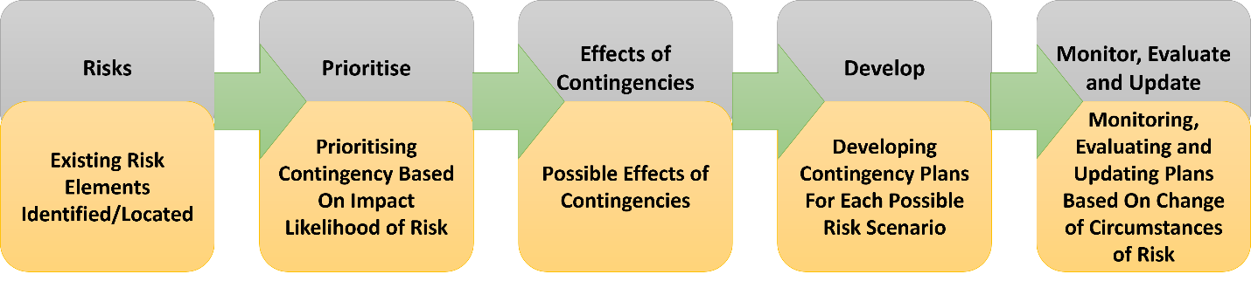
Figure 1-Contingency Plan
Figure 1 represents the contingency plan. In the first stage of the contingency plan, the existing risk elements are identified and located. Following this, in the second stage the contingency is prioritised based on the impact likelihood of the risk. The third step is effects of contingencies which outlines possible effects that could occur from the risks identified if they were to exploit. the effects are planned out including outlining early warning signs and minor effects that would occur at the beginning stages of the risk identified. The next step is developing contingency plans for each possible scenarios and executing these plans created. The final step is monitoring, evaluating, and updating plans based on changes of circumstances of the risk. In this stage the risk is continuously reviewed.

1.4 Penetration Test Framework
A suitable penetration testing framework selected to cater for the testing of the live website.

1.4.1 OWASP
The Open Web Application Security Project (OWASP) is the most widely recognised security standard in the industry. [1] This framework is mainly used for application penetration testing as it can identify vulnerabilities within web and mobile applications and complicated logic flaws that stem from unsafe development practices can also be identified. The framework includes comprehensive guidelines for the penetration testing methods and includes over 66 controls to assess which allows penetration testers to identify vulnerabilities across a variety of functionalities that are found in modern web applications. [1] The most known project of OWASP is the Top 10 which outlines security concerns for web application security focusing on the top 10 most critical security risks. [2] OWASP penetration testing contributes towards achieving security standards including HIPPA, PCI DSS and SOC2. [4]

1.4.2 Framework
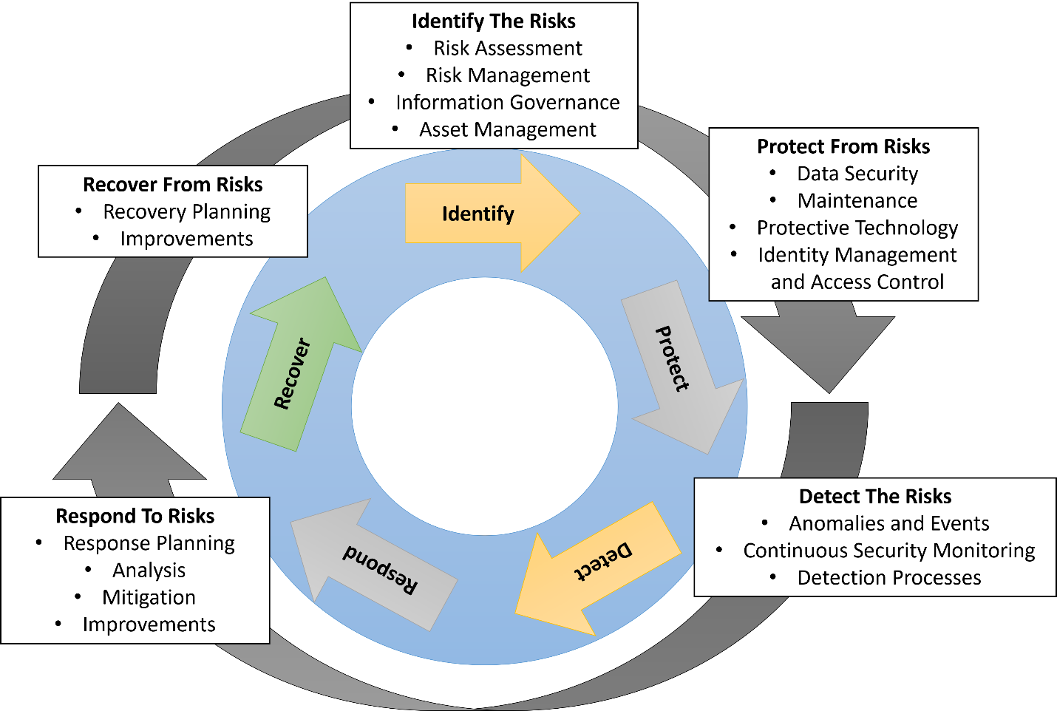
Figure 2-Framework Lifecycle
Figure 2 represents the framework lifecycle used for the penetration testing. This framework is used as a guideline for a successful penetration test completion.

1.4.3 Penetration Test Methodology
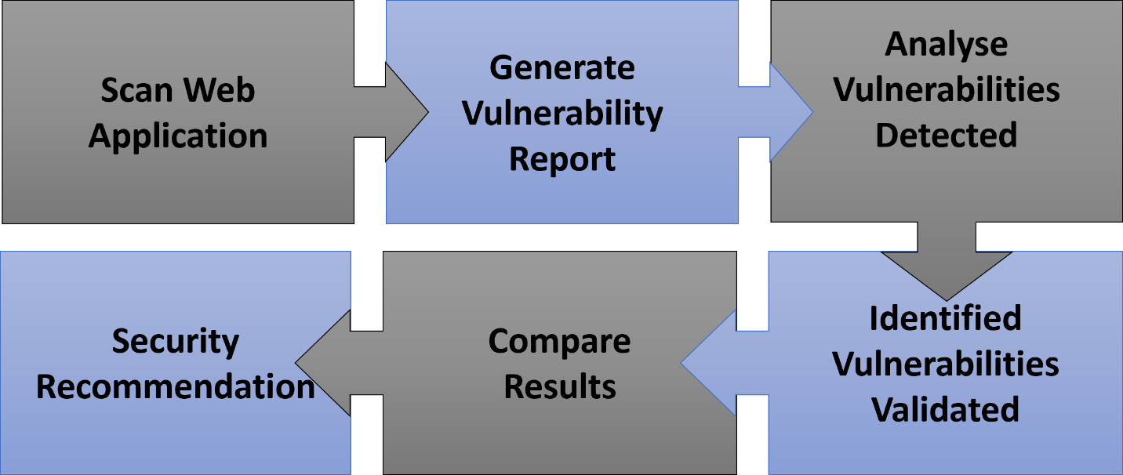
Figure 3-Penetration Test Methodology
Figure 3 demonstrated the penetration test methodology used to carry out the penetration test on HPC live website.

1.5 Types of Attacks
Following the research carried out on OWASP framework, the best-known project of OWASP is the Top 10 which outlines the top 10 most critical security risks focusing on web applications. OWASP Top 10 project is suitable for HPC black-box test with the most common risks outlines that affect web applications. The types of attacks OWASP top 10 2017 report covers include injection, broken authentication, sensitive data exposure, XML external entities (XEE), broken access control, security misconfiguration, cross-site scripting, insecure deserialization, using components with known vulnerabilities, and insufficient logging and monitoring. [2] These types of attacks are desired to carry out the penetration testing against. OWASP top 10 2021 report include minor changes in the types of attacks, however not major and for the purpose of HPC’s website penetration test the 2017 report is suitable. The changed in the 2021 report include cryptographic failures, insecure design, software and data integrity failures, and server-side request forgery.

1.5.1 Injection-1
SQL Injection is an attack where attackers can interfere with queries that the web application takes to the database. This can result in unauthorised access to sensitive data including passwords, credit card details, and other personal information. [3] There are several types of SQL injection attacks that can be performed. Some of these include retrieving hidden data, subverting application logic and examining the database. [3] Other type of SQL injections include injection flaws, bypassing authentication, detecting SQL specific parameter manipulation flaws, and detecting and exploiting blind SQL injection bugs.

1.5.2 SQL Attacks Vulnerabilities
Retrieving hidden data- WHERE clause allows hidden data to be retrieved by SQL injection. [3]
Subverting application logic- Removes the password from the WHERE clause of the query allowing login bypass to any user without a password. [3]
Examining the database- Depending on the type of database attack, the attack can list the database contents or query the database types. [3]

1.5.3 Broken Authentication-2
Authentication systems can potentially provide attackers with access to user accounts and to compromise entire systems using admin accounts. With having flaws in the authentication system an attacker could use a script including user authentication obtained in a data breach to attempt access to large number of accounts. [2] In order to avoid such scenario, two-factor authentication and login attempts rate limiting is used. Broken authentication attack methods include brute force login, testing for sensitive data exposure weaknesses and bypassing authentication.

1.5.4 Sensitive Data Exposure-3
Attackers can gain access to sensitive data including financial information and passwords if the web application is not protected. This data can be gained access to or be utilised for nefarious purposes. A method for stealing such information is using on path attacks. [2] This risk can be minimised by encrypting all the sensitive data and disabling the caching of sensitive information. The method of testing this vulnerability is through testing sensitive data exposure issues.

1.5.5 XML External Entities-4
XEE is an attack against web application that parses Extensive Markup Language (XML) input. This input can represent an external entity that attempts to exploit vulnerabilities in the parser. [2]

1.5.6 Broken Access Control-5
The access control system controls the access to the information and functionality but if the access control is broken it allows attackers to bypass authorization and perform tasks that privileged users including administrators are authorized to. This could be exploited if a web application allows for change of user account by modifying part of a URL without further verifications required. To minimize such vulnerability, authorization tokens are used for web applications when the users login. [2] To visualise if the vulnerability if effecting the website penetration tests including missing function level access control and test access control issues can be performed.

1.5.7 Security Misconfiguration-6
The most common vulnerability on the list is security misconfiguration which is often the result of using default configurations or displaying excessively verbose errors. [2] A web application that demonstrates to user very descriptive errors could reveal vulnerabilities in the application. To minimise such risk, unused features in the code are removed and error messages that users receive are more general. [2] To perform penetration test on vulnerability, tools can be used to test for security misconfiguration issues.

1.5.8 Cross-Site Scripting-7
Cross-site scripting allows users to add custom code into a URL path or onto a website to be visible by other users. Such vulnerability can be exploited to distribute malicious JavaScript code on the victim’s browser. [2] To minimise the risk of cross-site scripting, untrusted HTTP requests and user generated consent validating should be avoided. [2] Methods to exploit this vulnerability include locating cross-site scripting issues, testing for reflected and stored XSS, and exploiting XSS by injecting directly into HTML.

1.5.9 Insecure Deserialization-8
This vulnerability targets web applications that frequently serialise and deserialize data. The result of deserializing data from untrusted sources is an insecure deserialization exploit which could lead to serious consequences such as DDoS attacks and remote code execution attacks. [2] DDoS attacks are not permitted to be tested on the HPC’s website in line with the contingency policy.

1.5.10 Using Components With Known Vulnerabilities-9
Components used in modern web development including libraries and frameworks in web applications that are used to provide needed functionality can be used as vulnerabilities by attackers. An attacker can locate the vulnerability in the component and orchestrate attack. [2] These components are used widely across web applications meaning if an attacker identified a vulnerability in the used components, all sites using the same component would be let vulnerable to the exploit similar to the log4j incident of 2021. A method to check if the vulnerability if targeting the website is by testing for components with known vulnerabilities.

1.5.11 Insufficient Logging and Monitoring-10
The average discovery time for a data breach to be detected is estimated around 200 days after the breach took place. This shows that web applications are not taking enough steps to detect data breaches, providing the attacker with plenty of time for damage to be caused before being noticed and responded to. To minimise such risk, it is recommended that web developers implement logging and monitoring to ensure they are aware of attacks taking place on their web applications. [2]

1.6 Penetration Testing Tool
The penetration tool selected to use and the purpose it serves towards the penetration testing of the live website.

1.6.1 Nessus Essentials Vulnerability Scanner
The Penetration testing tool selected for penetration testing HPC’s live website is Nessus Essentials vulnerability scanner. Nessus vulnerability scanner is one of the largest knowledge bases for security vulnerabilities and include various plugins to conduct detailed customised scans. [5] Nessus is a commercial tool that is compatible with windows operating system, MAC operating system, and Linux. [5] Nessus detects vulnerabilities in the operating system of targeted hosts, services and patches. Nessus vulnerability scan also provides proposals for solutions to combat security vulnerabilities. [5] Some research found that when Nessus Essentials and Burp Suite vulnerability scanner’s vulnerability count is compared against true and false positives that Burp Suite has 50% accuracy and Nessus has 90% accuracy in reporting true positive vulnerabilities. [5]

1.6.2 Burp Suite
An alternative penetration testing tool suitable to use for penetration testing HPC’s live website is Burp Suite. This is an integrated platform that is used for security testing of web applications with an advanced web application scanner that is used for the automated detection of numerous types of vulnerabilities. [5] The alternative tool offers penetration testing methods in line with the OWASP penetration testing framework. Burp Suite is installed by default on Kali Linux which is open source and is set up to conduct various information security tasks including penetration testing. Research shows that when Burp Suite is compared against other tools such as Acunetix, NetSparker, Nessus and ZAP, it can detect one of the largest number of high severity vulnerabilities. [5] However, as research found when the total vulnerability count of true and false positives are compared, Burp Suite reports 50% true positives. [5]

1.6.3 Kali Linux
Kali Linux is a penetration testing platform that contains variety of tools and utilities to be used for information gathering and final reporting, enabling professionals to assess system security. Some of the tools Kali Linux contains by default include Nmap, Metasploit Framework, John the Ripper, sqlmap, Wireshark, Burp Suite and Maltego. [6]

1.7 Black Box Penetration Test
A black box penetration test is required to be carried out on the live website. A black box penetration test is a penetration test carried out on a live website without any prior vulnerability knowledge provided of the website. The targeted website is https://healios-pharma.com. The following section is demonstrating the attacks carried out on the live website. The types of attacks set up are explained with diagrams.

Types of vulnerabilities targeted at the website | Attack tool used
Injection | Nessus Essentials Vulnerability Scanner
Broken Authentication | Nessus Essentials Vulnerability Scanner
Cross-Site Scripting | Nessus Essentials Vulnerability Scanner
Sensitive Data Exposure | Nessus Essentials Vulnerability Scanner
Security Misconfiguration | Nessus Essentials Vulnerability Scanner
Components With Known Vulnerabilities | Nessus Essentials Vulnerability Scanner
Table 1-Types of vulnerabilities and attack tools
Table 1 lists the types of vulnerabilities targeted at the live website and the attack tools used to conduct the penetration testing on HPC’s website to meet the OWASP top 10 vulnerability guidelines.

For the purpose of this penetration test, the following attacks have been selected from the top 10 OWASP vulnerabilities:
Vulnerability | Nessus Essentials Vulnerability Scanner Penetration Test
Injection | Test for injection flaws, bypassing authentication, detecting SQL specific parameter manipulation flaws, and detecting and exploiting blind SQL injection bugs
Broken Authentication | Brute force login page, testing for sensitive data exposure weaknesses and bypassing authentication.
Cross-Site Scripting (XSS) | Locate cross-site scripting issues, test for reflected and stored XSS, exploit XSS by injecting directly into HTML.
Sensitive Data Exposure | Testing sensitive data exposure issues.
Security Misconfiguration | Testing for security misconfiguration issues.
Components With Known Vulnerabilities | Testing for components with known vulnerabilities.
Table 2-Types of vulnerabilities and Nessus Essential tests
Table 2 lists the types of vulnerabilities and the Nessus Essentials penetration tests carried out on them to test for such vulnerabilities.

1.7.1 Testing
Investigation of HPC’s live website using Nessus Essentials. The screenshots in the following section represent the process and feedback of the testing. During the testing, the registrar is used to provide information of the domain that contains all information regarding the DNS name servers that provides the information of the contact and the registered address of the domain. Utilising this information, the IP address can be located which can be inserted into Nessus Essentials tool to begin a vulnerability scan of the website. Nessus is ideal to locate vulnerabilities listed within the website, and additional tool Burp Suite would be used to attack and exploit the vulnerabilities identified. Nessus uses an advanced scan that is predominantly used to locate and identify a majority of vulnerabilities.

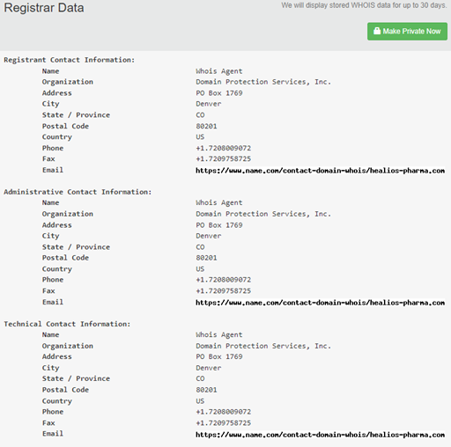
Figure 4-Registrar's data
Figure 4 above shows the registrar's data, and from this screenshot it can be seen that the owner of the domain hidden the address details and contact information and kept it hidden to the domain registrar’s information.

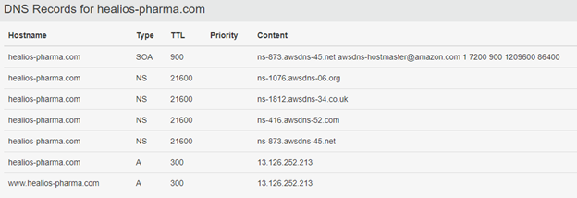
Figure 5-DNS records for healios-pharma.com
Figure 5 shows that the IP address is located within the DNS records, this allowing further exploring by inserting this information into Nessus scanner. With this information gathered and found, vulnerabilities can be located and exploited within the website. This is to be carried out using Nessus with an aggressive scan.

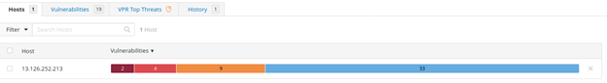
Figure 6-Threats and vulnerabilities found during scan
Figure 6 shows the results once the scan is completed. Once the scan is complete, a chart is produced to portray the number of threats and vulnerabilities that have been located. Blue represents the information, orange represents the medium threats, red represents high vulnerabilities and dark red is representing critical.

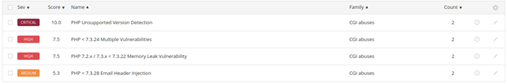
Figure 7-PHP vulnerability
Figure 7 shows more details about the types of threats, and it is evident that PHP consist to be the number one issue around as the site is orienting around predominantly outdated versions of PHP causing different types of vulnerabilities on the website. These vulnerabilities include memory leaks, email header injections (XSS) and many other issues due to unsupported versions.

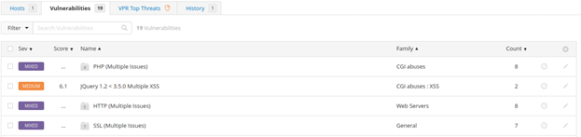
Figure 8-Other vulnerabilities from HPC's website
Figure 8 shows the other vulnerabilities found on HPC’s website include more PHP web server and SSL issues. Both these vulnerabilities are easy and quick to patch, however they do pose a medium size threat that requires further investigating into.

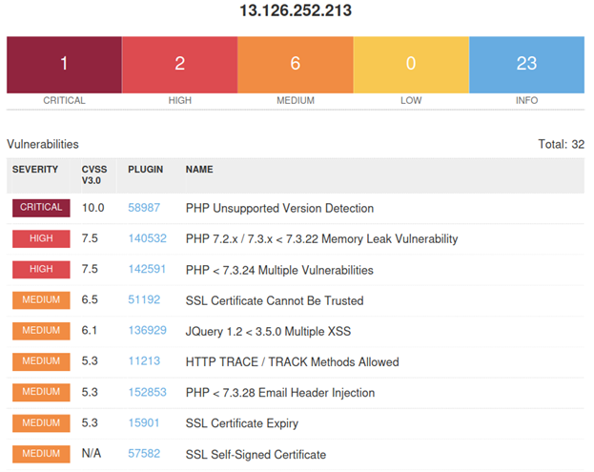
Figure 9-Overall vulnerability report
Figure 9 demonstrates the overall report that is generated to show the most vulnerable security threats found scoring them in the order of highest to lowest. The information at the top right corner indicates the amount of vulnerabilities located.

1.8 Comprehensive Technical Report
Comprehensive technical report produced to showcase the findings of the penetration test from the website. The research carried out earlier in the report is compared and discussed with the findings of the penetrations test. The penetration test carried out following the top 10 vulnerability guidelines found several vulnerabilities identified on the OWASP top 10 list.
Injection- The test results found that both port 80 and 443 are at a medium risk of email header injection due to a version of PHP running on the web server that is vulnerable to email header injection vulnerability. The results show that the web server is running on a PHP version prior to 7.3.28 which is effected by email header injection vulnerability in result of inappropriate handling of CR-LF sequences in header fields. This vulnerability can be exploited by remote attackers by inserting line feed characters into email headers to access gain full control to email header content. To minimalize the risk, upgrade to PHP version 7.3.28 or later.
Broken Authentication- The vulnerability test performed show small risk vulnerability on port 80 that the web servers are using basic authentication without HTTPS. This means that the web server contains pages that are protected with basic authentication over clear text that is resulting in transmitting credentials in clear text where an attacker could eavesdrop in the traffic to obtain login and password credentials of valid users. This vulnerability can be resolved by transmitting authentication over HTTPS instead of HTTP.
Cross-Site Scripting- The test results found that both port 80 and port 443 are missing or permissive content-security-policy frame-ancestors response header meaning that the web server does not take steps to mitigate a class for web application vulnerabilities. This vulnerability is opposing a very small risk.
Sensitive Data Exposure- The test results found no risk level of sensitive data exposure during the vulnerability assessment however on port 80 and 443 it is evident that the web application could potentially contain sensitive CGI parameters to control sensitive information. To avoid such vulnerability, ensure that sensitive data is not disclosed using CGI parameters and do not use CGI parameters to control access to resources and privileges.
Security Misconfiguration- during the penetration test no security misconfiguration vulnerabilities have been identified.
Components With Known Vulnerabilities- A high risk vulnerability identified during the penetration testing on both port 80 and 443 is memory leak vulnerability in the version of PHP running on the remote web server. The test results suggest that the version of PHP running on the remote web server is 7.2x or 7.3x prior to 7.3.21. Due to this, both ports are affected by a memory leak in the LDAP component. This could be exploited by a remote attacker to cause a denial-of-service attack when authenticated.
Both port 80 and port 443 are using unsupported versions of PHP on the remote host which is no longer supported. This means there is lack of support and no new security patched to be released by the vendor which would result in security vulnerabilities. This vulnerability is critical and to combat the risk it is required to upgrade to a supported version of PHP.

1.9 Recommended Solutions
The following section provides recommended solutions towards defence strategies to avoid identified attacks from succeeding in the future on the live website. Suitable recommendations on new software and hardware that could be purchased to enhance HPC’s website security and configuration changes that could be made to the web server are made.
Injection- vulnerable for SQL attack. Advisable remediation is to limit and validate the user input length to avoid being vulnerable to malicious code injections. [8] Other solutions to minimise the vulnerability are using appropriate privileges by using limit access account instead of administrative privileges. [9] Both post 80 and 443 are at risk of email header injection due to running outdated PHP version. To minimalize the risk, upgrade to PHP version 7.3.28 or later.
Broken authentication- The vulnerability test results show authentication flaws discovered on port 80 that opposes a low risk where the web server is using basic authentication without HTTPS which is resulting in the remote web server transmitting credentials in clear text. HPC’s website contains pages that use basic authentication over clear text which attackers eavesdropping in traffic could potentially obtain logins and passwords of the users. To resolve the vulnerability, HPC’s website authentication must be transmitted over HTTPS not HTTP.
Cross-site scripting- Website discovered to be vulnerable to XSS. JQuery hosted on remote web server is outdated and is advised to be upgraded to JQuery version 3.5.0 or later. A vulnerability that opposes no risk that was located is that both port 80 and port 443 are missing or permissive content-security-policy frame-ancestors response header. This vulnerability can be solved by setting a non-permissive content-security-policy frame-ancestors header for all the requested resources.
Sensitive data exposure- no vulnerability discovered that opposes a valid risk. No action needed to enhance security measures.
Security misconfiguration- no vulnerability discovered. No further actions advised to take to enhance security measures.
Components with known vulnerabilities-Test identified high risk vulnerability on both port 80 and 443. The PHP running on the remote web server is 7.2x or 7.3x prior to 7.3.21. This is causing both ports to be affected by a memory leak in the LDAP component. This could be exploited by a remote attacker to cause a denial-of-service attack when authenticated. To minimalize the risk, upgrade to PHP version 7.3.22 or later.

1.10 Cost of Solution
The following invoice provides the cost of replacing the software or hardware, cost of implementing the solution and hourly rates.
Forensic Invoice
Invoice From Ceac Cybersecurity and Forensics Ltd (CCPL) | Billing To Healios Pharmaceutical Company (HPC) | Date 03/01/2022 | Due Date 17/01/2022
Item | Quantity | Rate | Amount
Vulnerability Test-Injection | 1 | £125 | £125
Vulnerability Test-Broken Authentication | 1 | £125 | £125
Vulnerability Test-Cross-Site Scripting | 1 | £125 | £125
Vulnerability Test-Sensitive Data Exposure | 1 | £125 | £125
Vulnerability Test-Security Misconfiguration | 1 | £125 | £125
Vulnerability Test-Components With Known Vulnerabilities | 1 | £125 | £125
Comprehensive Technical Report | 1 | £450 | £450
Recommended Solutions For Vulnerabilities | 1 | £1500 | £1500
Consultation Fee | 1 | £150 | £150
Hourly Rate | 48 | £50 | £2400
 |  | Subtotal | £5,250.00
 |  | Tax | 20%
 |  | Total | £6,300.00
 |  | Balance Due | £6,300.00
Table 3--Live website vulnerability test invoice
Table 3 represents the forensic invoice provided to HPC for the professional work carried out.

1.11 Conclusion
In conclusion, research has been carried out on suitable contingency policy and plan to use as a guide prior to penetration testing. Further research carried out on OWASP penetration test framework and the top 10 vulnerability risks listed. The penetration test used the 2017 top 10 vulnerability risks, as the vulnerabilities that oppose common threats to web applications and websites remained very similar with minimal modifications made to the list. The black box penetration test on the HPC’s live website was carried out following the contingency plan and policy set in place. The penetration test carried out compared HPC’s website against the vulnerabilities outlined in the top 10 website vulnerabilities. These vulnerabilities include injection, broken authentication, cross-site scripting, sensitive data exposure, security misconfiguration and components with known vulnerabilities. The tool used to conduct the black box penetration test is Nessus Essentials Vulnerability Scanner.
The vulnerabilities identified during the black box penetration test found that HPC’s website is vulnerable to SQL attacks. Furthermore, authentication flaws have been discovered on port 80, and cross site scripting vulnerability been identified due to outdated JQuery hosted on remote web server. Another vulnerability found that both port 80 and 443 are using unsupported versions of PHP which is no longer supported. Recommended remediation solutions to combat the identified vulnerabilities have been outlined. Furthermore, appropriate cost of solutions invoice is provided detailing the forensic work carried out on HPC’s live website.

Chapter 2-Research into cyber security incident and defensive technique

2.1 Introduction
A research scientist working for Helios Pharmaceutical Company (HPC) was working on a vaccine for Covid-19 treatment. Six months of research has been carried out and in line with company policy, the research documents needed to be stored on MS Word of Rich Text Format and the more critical documents are stored as PDF to prevent tampering. Following a disagreement in management promotional decisions, the scientist quit working for the company and deleted all the critical research documents that have been carried out in the last 6 months. The employee’s data has not been backed up and if the data is not retrieved it will cost the company $3 Million in various contracts with the suppliers. HPC’s IT department failed to retrieve the data and requested Ceac Cybersecurity and Forensics Ltd (CCPL) to assign a Computer Forensics Investigator to investigate the incident and recover the deleted files including the research.

2.2 Research
Carrying out research and gathering knowledge to document the forensics methodology used to investigate and restore the deleted files.

2.2.1 Methodology
The following methodology outlines the various stages of gathering and handling digital evidence. The purpose of this is to provide a guide for professionals to follow prior, during and after a forensic investigation.
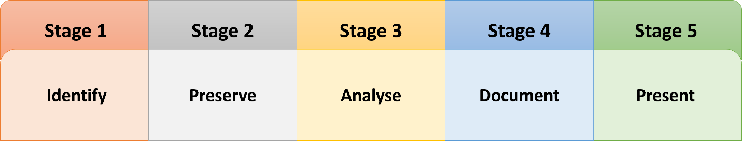
Figure 10-Forensics Methodology
Figure 10 shows the 5 stages of forensic methodology. The way these stages are utilised for evidence collection in cyber security is:
- Identify - Recognising the purpose of the investigation, identifying and collecting the resources require for the investigation. [7]
- Preserve is isolating and preserving the data. - Isolating the data files and devices for examination, securing the files to inspect the data and preserving the data for investigation. [7]
- Analyse is analysing the data and running analytics on the data to gather required files/evidence. – Identifying the techniques and tools used for the analysation of digital evidence and processing and interpreting the data and possible results. [7]
- Document is documenting findings including data analysed and information gathered during forensics investigation. – Preparation of documentation from the entire crime scene. [7]
- Present is the presentation of summarization of findings and facts. – Gathering conclusion with aid of facts gathered during investigation and summarise and explain the process taken. [7]

2.2.2 Forensic Investigation Process

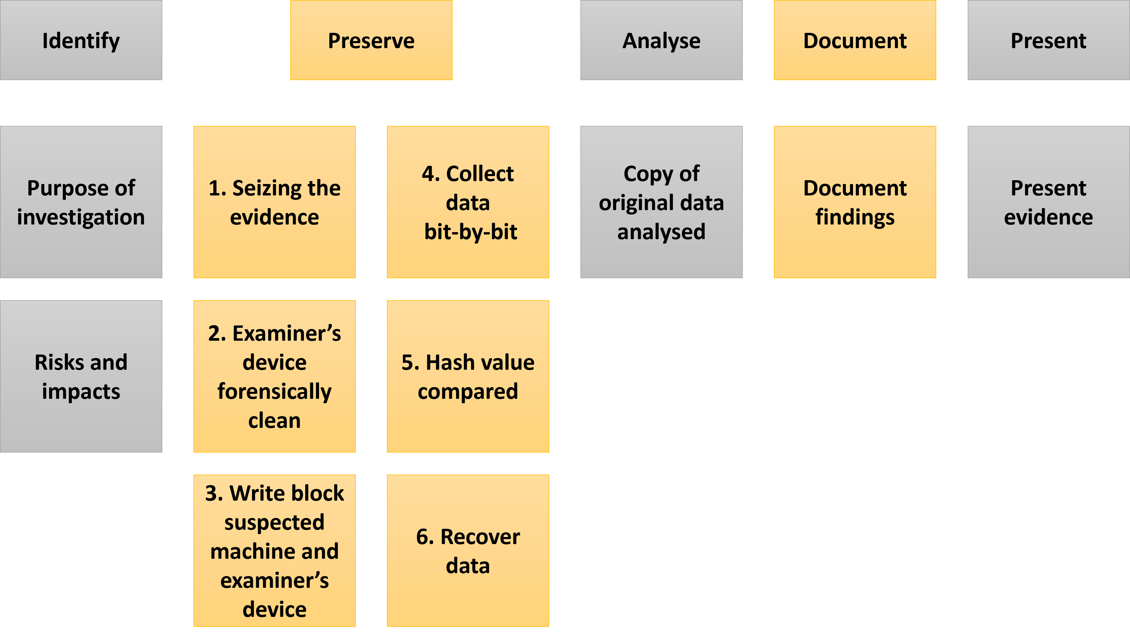
Figure 11-Forensic investigation process
Figure 11 demonstrates the forensic investigation process stages.

Identify- The purpose of the investigation is to restore deleted files including 270 pages of sensitive research formulae. If deleted files are not recovered, it will cost the firm $3 Million in various contracts with suppliers. Machine in subject failed to be backed up during the regular backup cycle due to enterprise central backup machine being under repair. The data deleted was stored in MS Word, Rich Text and DPF format. The tools used to retrieve deleted data from the identified formats is FTK Imager.
Preserve- The data files and devices used by the scientist are isolated for examination. The machine used by the scientist must not be powered off when seizing the evidence. The professional investigator’s storage device must be forensically clean to gather and preserve the evidence. The evidence must be write block protected using write blocker tools to permit read-only access to the data that is being used as evidence. This prevents the data from being tampered with and safeguards integrity of the data. Write blocking hardware ensures that the digital evidence is not changed or tampered with during the data extraction phase. This ensures the integrity of digital evidence and provides protection of the data chain of custody. [10] Once the target machine is write blocked, the external drive used for the purpose of copying the suspected machine’s content also must be write blocked to prevent data modification. Once both suspect’s machine and forensics external drive has been write blocked, a complete copy of the suspect’s hard drive is to be made. [11] The data is to be collected bit-by-bit to represent the original data from the suspect’s machine.
Analyse- The data collected using the appropriate tools is analysed. The copy of the original data is analysed to ensure the forensic image is an exact replica of the original data using hash value calculating tool, Forensic Toolkit (FTK) Imager. Software is used to recover the data including FTK Imager, a tool that can be used to recover corrupted and deleted files and photos. FTK is also a data carving tool that provides the ability to recover pictures and data from the suspect’s machine. [12] The data recovered from the suspect’s machine is analysed using FTK Imager to locate and recover the relevant files of research that have been deleted by the scientist.
Document- The data collected and analysed using FTK Imager is documented and presented in a formal manner that is acceptable to be presented in front of the court of law. The crime scene in this case being the machine used by the scientist is investigated and during the investigation process, the electronic crime scene is documented to permanently record the scene of crime.
Present- Presenting the evidence found in the analysis and documented from the findings of the data recovery process.

2.3 Professional Report
Providing HPC with professional forensics report based on actions taken to restore the data lost.
Purpose of the report
The report prepared following the incident in HPC where a member of staff erased 270 pages of sensitive research formulae and CCPL forensic investigator was assigned to recover deleted files saved in MS Word, Rich Text and PDF formats.
Author of report
The author of the report is CCPL Computer Forensic Investigator and referenced articles. The responsibility of the Computer Forensics Investigator was to recover deleted files saved in MS Word, Rich Text and PDF format for HPC.
Incident summary
The incident occurred with HPC employee following a disagreement over company promotional disputes where the scientist working for HPC in anger deleted 270 pages of sensitive research formulae that contributed towards a vaccine for COVID-19 Treatment before resigning from HPC. The data from the scientist's machine was not backed up in 6 months and if the data deleted is not retrieved it will cost HPC $3 Million in various contracts with suppliers.
Evidence
During the investigation, the data files and devices used by the scientist are isolated and the professional investigator's storage device is forensically cleaned. Both the investigator storage device and machine used for evidence are write blocked. Once both subsects machine and the investigator storage device are write blocked, a complete copy of the suspect hard drive is made. The data is collected bit by bit and analysed using FTK Imager to compare hash value of data collected. FTK Imager is used to locate erased files in MS Word, Rich Text and PDF format and restore the located erased files.

2.4 Invoice
Providing an invoice for the professional service carried out to restore the deleted files.
Forensic Invoice
Invoice From Ceac Cybersecurity and Forensics Ltd (CCPL) | Billing To Healios Pharmaceutical Company (HPC) | Date 03/01/2022 | Due Date 17/01/2022
Item | Quantity | Rate | Amount
Consultation Fee | 1 | £150 | £150
Professional Report | 1 | £250 | £250
Hourly Rate | 58 | £50 | £2,900.00
Risks and Impacts Identification | 1 | £75 | £75
Investigation Purpose Identification | 1 | £75 | £75
Evidence Seized | 1 | £125 | £125
Forensically Clean Device Usage | 1 | £125 | £125
Write Block Suspected Machine | 1 | £65 | £65
Write Block Examiner's Machine | 1 | £65 | £65
Duplicate Data Bit-By-Bit | 1 | £150 | £150
Hash Value Comparison | 1 | £80 | £80
Data Recovery | 1 | £320 | £320
Analysation of Original Data | 1 | £150 | £150
Documenting | 1 | £200 | £200
Forensic Report | 1 | £270 | £270
 |  | Subtotal | £5,000.00
 |  | Tax | 20%
 |  | Total | £6,000.00
 |  | Balance Due | £6,000.00
Table 4-Professionally restoring data files invoice
Table 4 represents the forensic invoice provided for HPC for the professional work carried out.

2.5 Report
Professional forensics report on the incident developed.
Forensic Report
Purpose of Investigation | Recover deleted MS Word, Rich Text and PDF file formats of 270 pages of sensitive data deleted by scientist working for HPC following dispute an resigning.
Risks and impact | If data not recovered it will cost HPC $3 Million in various contracts with suppliers.
Seizing the evidence | Machine used by scientist must not be powered off, data duplicated from suspect’s device.
Forensically clean work | Professional investigator’s device is forensically cleaned prior to investigation.
Preserve evidence | Write block to preserve the evidence. Write block both suspected machine and hardware used to duplicate data.
Duplicate data | Duplicate forensic data used as evidence bit-by-bit.
Data collected analysed | Copy of data collected from scientist’s device is analysed.
Original data analysed | Hash value calculating tool using FTK Imager is used to compare data evidence gathered.
Data recovery | FTK Imager is used to recover deleted MS Word, Rich Text and PDF format documents.
Data location and restoration | The data recovered from the scientist’s machine is analysed to locate and restore the deleted files using FTK Imager.
Recovery documentation | Data recovery process recorded of crime scene and steps taken to retrieve data to contribute towards electronic evidence.
Documenting events | Data recovered using FTK Imager is documented and presented in acceptable manner to contribute towards digital evidence of the crime.
Presenting evidence | Presenting the evidence collected during the forensic investigation on the scientist’s machine.
Table 5-Professional forensics incident report
Table 5 represents the professional forensics incident report produced for HPC regarding the steps taken to retrieve the deleted files.

2.6 Conclusion
In conclusion, research has been carried out on forensic methodologies used to investigate and restore the files deleted by the scientist. A methodology has been created that outlines various stages of gathering and handling forensic evidence. These stages are identify, preserve, analyse, document and present. Using this methodology, a forensic investigation process has been created to use as a guide when handling evidence, processing the data gathered and documenting and producing a forensic report. The hypothetical investigation was carried out using forensic tool FTK Imager which is well recognised tool used is forensic investigations. The stages of the investigation that the professional takes to locate and to retrieve deleted files have been documented. The professional report provides HPC what professional forensic actions were taken to restore the data. An invoice is produced for HPC of the total cost of fees the professional forensic tasks cost. Last, a professional forensic report on the incident is developed to be used in the court of law.

References
[1]"Top 5 Penetration Testing Methodologies and Standards | Vumetric", Vumetric.com, 2022. [Online]. Available: https://www.vumetric.com/blog/top-penetration-testing-methodologies/#:~:text=%20Top%205%20Penetration%20Testing%20Methodologies%20and%20Standards,Standards%20%29%20highlights%20the%20most%20recommended...%20More%20. [Accessed: 02- Jan- 2022].
[2]"What is OWASP? What is the OWASP Top 10?", Cloudflare, 2022. [Online]. Available: https://www.cloudflare.com/learning/security/threats/owasp-top-10/. [Accessed: 02- Jan- 2022].
[3]W. Academy and S. injection, "What is SQL Injection? Tutorial & Examples | Web Security Academy", Portswigger.net, 2022. [Online]. Available: https://portswigger.net/web-security/sql-injection. [Accessed: 02- Jan- 2022].
[4]K. Malik, "A Comprehensive Guide to OWASP Penetration Testing", Astra Security Blog, 2022. [Online]. Available: https://www.getastra.com/blog/security-audit/owasp-penetration-testing/#:~:text=Penetration%20testing%20framework%20is%20a%20guide%20to%20perform,with%20free%20online%20educational%20content%20and%20community%20tools. [Accessed: 02- Jan- 2022].
[5]M. Qasaimeh, A. Shamlawi and T. Khairallah, "BLACK BOX EVALUATION OF WEB APPLICATION SCANNERS: STANDARDS MAPPING APPROACH", Journal of Theoretical and Applied Information Technology, vol. 22, no. 1817-3195, pp. 4584-4596, 2018. Available: https://www.researchgate.net/publication/329990368_BLACK_BOX_EVALUATION_OF_WEB_APPLICATION_SCANNERS_STANDARDS_MAPPING_APPROACH. [Accessed 2 January 2022].
[6]"The most advanced Penetration Testing Distribution. Ever.", Kali Linux, 2022. [Online]. Available: https://www.kali.org/. [Accessed: 02- Jan- 2022].
[7]"Tactics for Digital Evidence Collection in Cyber Security", Official Blog of E-mail Examiner Software, 2022. [Online]. Available: https://www.mailxaminer.com/blog/digital-evidence-collection-in-cyber-security/. [Accessed: 03- Jan- 2022].
[8]"How to Prevent SQL Injection Attacks in 2022 | eSecurity Planet", eSecurityPlanet, 2022. [Online]. Available: https://www.esecurityplanet.com/threats/how-to-prevent-sql-injection-attacks/. [Accessed: 03- Jan- 2022].
[9]N. Sharma, M. Alam and M. Singh, "Web Based XSS and SQL Attacks on Cloud and Mitigation", Journal of Computer Science Engineering and Software Testing, vol. 1, no. 2, 2015. Available: https://www.researchgate.net/publication/296561649_Web_Based_XSS_and_SQL_Attacks_on_Cloud_and_Mitigation. [Accessed 3 January 2022].
[10]M. Shah, S. Saleem and R. Zulqarnain, "Protecting Digital Evidence Integrity and Preserving Chain of Custody", The Journal of Digital Forensics, Security and Law, 2017. Available: 10.15394/jdfsl.2017.1478 [Accessed 3 January 2022].
[11]M. Lessing and B. Solms, "Live forensic acquisition as alternative to traditional forensic processes", MF 2008 – IT Incident Management & IT Forensics, pp. 107-124, 2008. Available: https://dl.gi.de/bitstream/handle/20.500.12116/23601/gi-proc-140-009.pdf?sequence=1&isAllowed=y. [Accessed 3 January 2022].
[12]"Hello, I’m a Digital Hoarder", AccessData, 2022. [Online]. Available: https://accessdata.com/blog/hello-im-a-digital-hoarder#:~:text=FTK%C2%AE%20Imager%20can%20recover,to%20recover%20pictures%20and%20data. [Accessed: 03- Jan- 2022].

marking criteria and Student FEEDBACK

This section details the assessment criteria. The extent to which these are demonstrated by you determines your mark. The marks available for each criterion are shown. Lecturers will use the space provided to comment on the achievement of the task(s), including those areas in which you have performed well and areas that would benefit from development/improvement.

Common Assessment Criteria Applied (Assignment 1) | Marks available | Marks  awarded
1. Engagement with Literature Skills
Extent of research and/or own reading, selection of credible sources, application of appropriate referencing conventions.
You have engaged with the literature using relevant sources and materials. Appropriate referencing convention used. However, it would be good to use more updated peer reviewed articles. (Grade mark: 73.33%) | 15 | 11
2. Knowledge and Understanding Skills
Extent of knowledge and understanding of concepts and underlying principles associated with the discipline.
You have provided the relevant knowledge but provide too much on the research aspect. This demonstrates some lack of understanding. The research focus should mainly be on both tasks and not giving an epistle on the concepts. (Grade mark: 66.67%) | 15 | 10
3. Cognitive and Intellectual Skills
Analysis, evaluation and synthesis; logic, argument and judgement; analytical reflection; organisation of ideas and evidence
You have explained application of the methods, tools and technique used to carry out your tests. Moore critical analysis would enhance this section and limit the amount of research on the concepts. You have done penetration testing on the live website you have used appropriate penetration testing tools including Nessus. Screenshots and short explanation of these provided. You have done recommendation for the threats discovered. Note if you had use this tool https://tools.kali.org/web-applications/dirbuster you had opportunity to get to the portal and this portal would take you to the backend and you could try to dig it for more information.  Part 2 could do with more work and list the methodology steps that need to carry out the investigation. Note, the first procedure should be:  • All the ceased devices carefully placed in anti-static bags and transported them to a forensics laboratory.  The schedule to execute the potential solution done, cost solutions done, recommended solution given and invoice for the forensics investigation portion. No Chain of custody document and sample generated report done (Grade mark: 80.00%) | 40 | 32
4. Practical Application Skills
Deployment of methods, materials, tools and techniques; application of concepts; formulation of innovative and creative solutions to solve problems.
Evidence of practical/hands-on penetration testing done. Some screenshots provided and the relevant tools used (Grade mark: 72.00%) | 25 | 18
5. Transferable Skills for Life and Professional Practice
Attributes in professional practice: individual and collaborative working; deployment of appropriate media; presentation and organisation.
Your work could do with some formatting and alignment. (Grade mark: 68.00%) | 5 | 3.4

Assignment Mark (Assessment marks are subject to ratification at the Exam Board. These comments and marks are to give feedback on module work and are for guidance only until they are confirmed. ) | Late Submission Penalties (tick if appropriate) |  | 74%
 | Up to four weeks late |  | 74%
 | First Attempt? |  | 74%

