
Wednesdays Wheelers and Walkers
Marketing Strategy
Prepared by:
Mrs Sarah Hillam
P137987
Submitted to:
Jacqui Jones

Acknowledgements
A great thank you and appreciation to Carol Sayce-Wilkins of Wednesdays wheelers and walkers who conceived of this project and provided advice and encouragement throughout. A special thank you to everyone completing the online questionnaire. Without their response, this report would not be able to complete. Thank you to Michael Davies, Senior Lecturer at University of Wales Trinity Saint David for ongoing support, feedback and encouragement to do this project
Executive Summary
This marketing plan was created on behalf of Wednesday’s Wheelers and Walkers day centre who are a non-government funded disabled club based in Swansea, the management team asked for a consultant to revamp the business and try to gain more clients by doing various advertising strategies and asking current members what they wanted from the day centre.
The marketing plan has been successfully completed through using empirical and qualitivie research methods to gain statistics to be able to complete this marketing plan with the business in mind and implement the marketing plan to devise the best way forward to make the business a success after covid-19 restrictions are lifted by the government.
So far, the marketing plan and online advertising strategies seem to have proven successful as the business management team has received 15 enquiries from prospective clients wanting to attend the day centre in the future and the social media pages are now receiving enquiries as well from other prospective clients.
The tasks that were asked off by the management team have all now been successfully completed and with in the set time frame that is specified on the Gantt chart (see section 2.3 and the project has now been signed off by management.

Contents
1.0 Introduction 4
1.1 Terms of Reference 4
1.2 Project Justification 4
1.3 Aims and Objectives 4
1.4 Tables and Figures 5
    - Table 1 - Measurements of Success 5
    - Figure 1 - Depreciation 6
1.4.3 Figure 2 - Appreciation 7
2.0 Project parameters 8
2.1 What is the budget for? 8
2.2 How is the budget broken down? 8
2.3 Gantt Chart 8
2.4 How to envision the communication strategy with the client? 9
2.5 What is the first target that the team will work towards? 9
3.0 Define the Project Management Structure 10
4.0 Define the Specifics 11
5.0 Identify the Risks 12
6.0 Market Research 13
6.1 Competitors 13
7.0 Methods used and data collection 14
7.1 Marketing Plan 15
7.2 Potential funding sources 16
8.0 Conclusion 17
9.0 Limitations and suggestions 17
10.0 Recommendations 18
11.0 References 19
12.0 Works Cited 20
13.0 Appendix 22

- Introduction
The purpose of this consultancy project is to independently investigate why certain day centres have rapidly declined over the past few years, with the aim of structuring a suitable method to revamp the organisations after the effects of Covid-19. The focus of this project will be based on Wednesdays Wheelers and Walker’s day centre in Swansea. This will be done through liaising with the current management team and old management team if possible.
1.1 Terms of Reference
This report is written for Wednesdays wheelers and Walkers and University of Wales Trinity Saint David by Sarah Hillam Events Management Student. The report will assess the current needs and wants of the business with the aim to provide a marketing strategy for them.
1.2 Project Justification
The management team from Wednesday’s Wheelers and Walkers have approached and specified a requirement for an independent marketing consultant to restore their business Wednesdays Wheelers and Walkers back to good health as the business is declining in members and they cannot remain open due to the lack of funding. The business was formally known as ‘First Steps Forward’ from 2009 to 2017 when the management team decided to re-brand the day centre to its current name of Wednesday’s Wheelers and Walkers and this is when the main issue with declining members started. The re-brand was not a huge success and the day centre has depreciated year by year to the point where the day centre only has 15 members down from 45.
  - Aims & Objectives.
SMART goals and objectives for this marketing plan, include but are not limited to the following, increasing revenue by a specific amount, increasing the number of clients. SMART is an acronym that describes a management-enhancement system, standing for specific, measurable, achievable, realistic and timely goals. The specific details for exactly what need to be done for this marketing plan are the following, which have been specified by the management team. Also, to structure a suitable method to revamp the day centre and research the Effects of Covid-19 on the business.
- Social media
- Online advertising
- Website creation
- Email creation
- Set up of new business phone
- Increase number of clients
- Increase revenue for the business
- Work towards achievable and realistic goals and use time management efficiently
1.4.0 Tables and Figures
1.4.1 Table 1 – Measurement of Success
Change in Client Numbers | GROWTH | YR1 | YR2 | YR3
Clients -3 | -20% | £4200 | £3500 | £2450
Clients +5 | 33% | £7000 | £8750 | £10500
Clients +10 | 67% | £8750 | £24500 | £31500
Clients +15 | 100% | £21000 | £31500 | £63000
Clients +20 | 133% | £24500 | £57750 | £78750
Table 1: Measurement of success
For the first row on the graph above it shows that if no intervention was taking the business would severely decline and loose members to the point where the day centre would have to cease trading on the third year due to lack of funding and members. From line 2 onwards it focuses more on gaining new members, there is 2 measurements of success which both contribute to the businesses success, the first is to gain members and the second Is to improve the opening days and times and activities. From table 1 it is possible to see an increase of 15 members then it shows the day centre would be in a position to host annual holidays, day trips and in house activities, by increasing to an extra 30 members this could potentially allow the day centre to open for a third day and improve on its activities etc.

1.4.2 Figure 1 – Depreciation

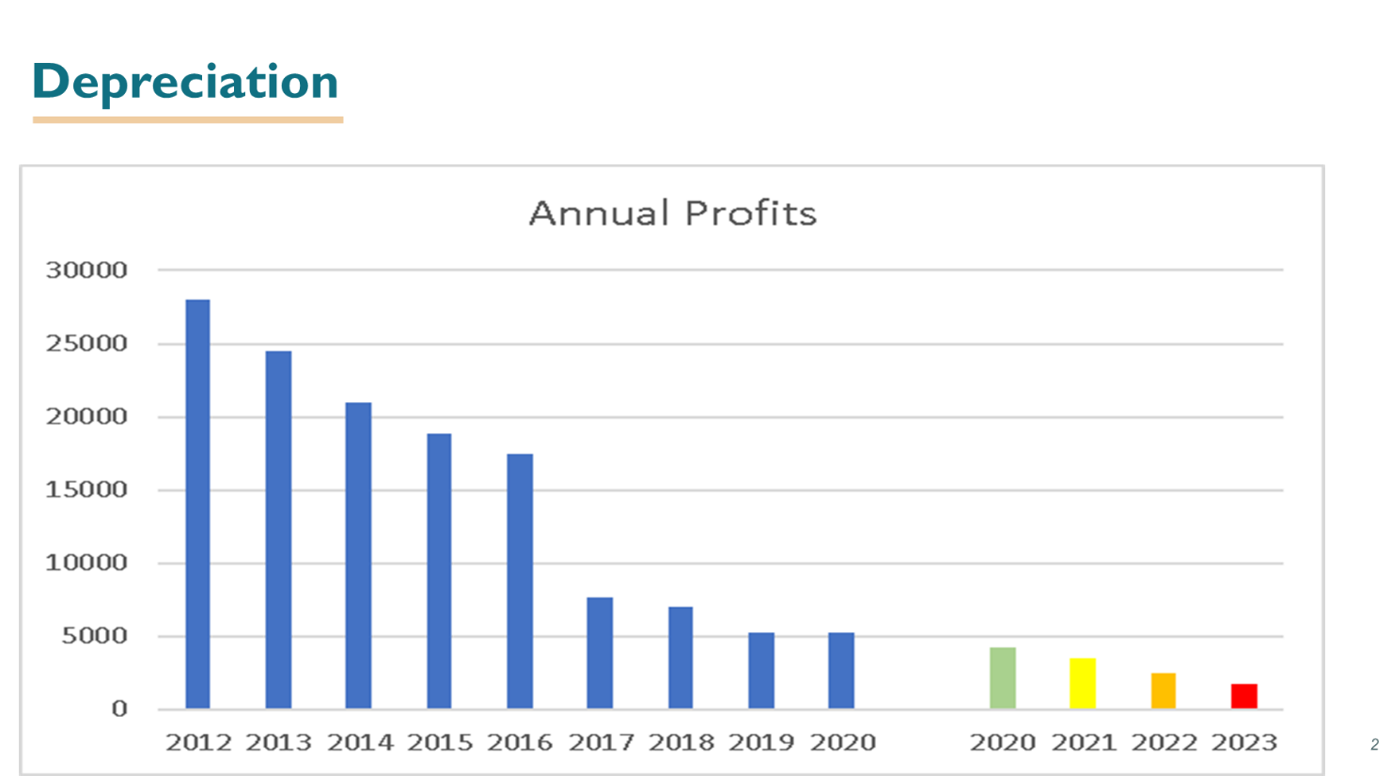
From figure 1, it is possible to see that since 2012 the business has rapidly declined in members due to changes in management, in 2017 the client numbers seemed to stay steady then in 2019 it declined again this was due to members leaving and some passing away but now the day centre only has 13-15 members who only attend one day per week on a regular basis. The graph has been continued until 2023 which shows the effects of depreciation continuing and resulting in the day centre having to close down.
Figure 1 – Depreciation

1.4.3 Figure 2 – Appreciation
Figure 2, depicts the appreciation for the number of clients, ultimately any profit above the 20k region allows the business to become financially stable and open on multiple days, as shown by the graph, 10 new members per month is heading in the right direction but it could take approximately 2 years to reach its safety net, however this is still a suitable rate of success for the business.
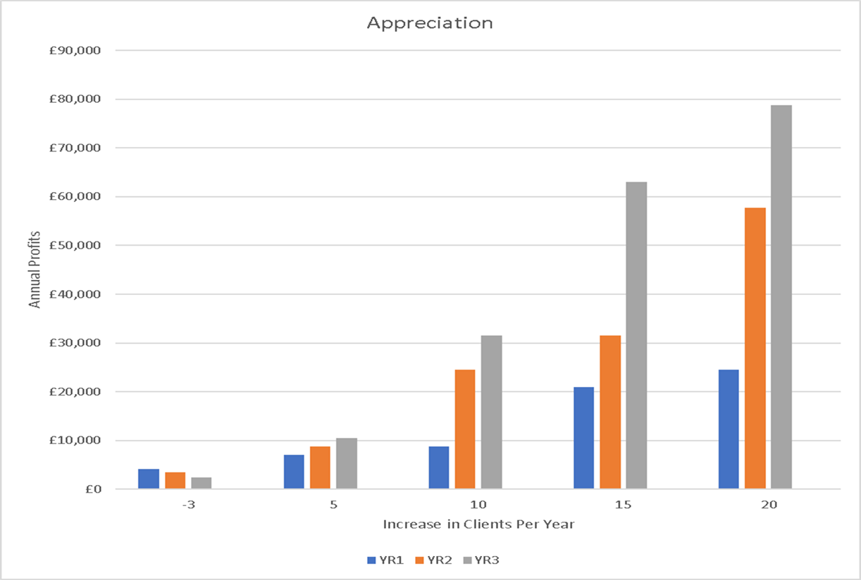
Figure 2: Appreciation
- Project Parameters
2.1 What is the budget for this project?
The budget that has been set by the management team is £5000

  - How is the budget broken down?
The budget will be shared between the following methods of marketing, providing the budget and plan are agreed with management and the marketing consultant. This must be related to the re-opening after Covid-19. All of these relate to funding for the plan of action for re-launch of Wednesdays walkers and wheelers post covid -19 restrictions, these methods will be implemented when an agreed date of reopening happens and the government lift restrictions.
  - Social media £ 400
  - Online advertising £ 1000
  - Website creation £ 1500
  - Email creation – free
  - Set up of new business phone £190
  - Consultants fee - £ 1000
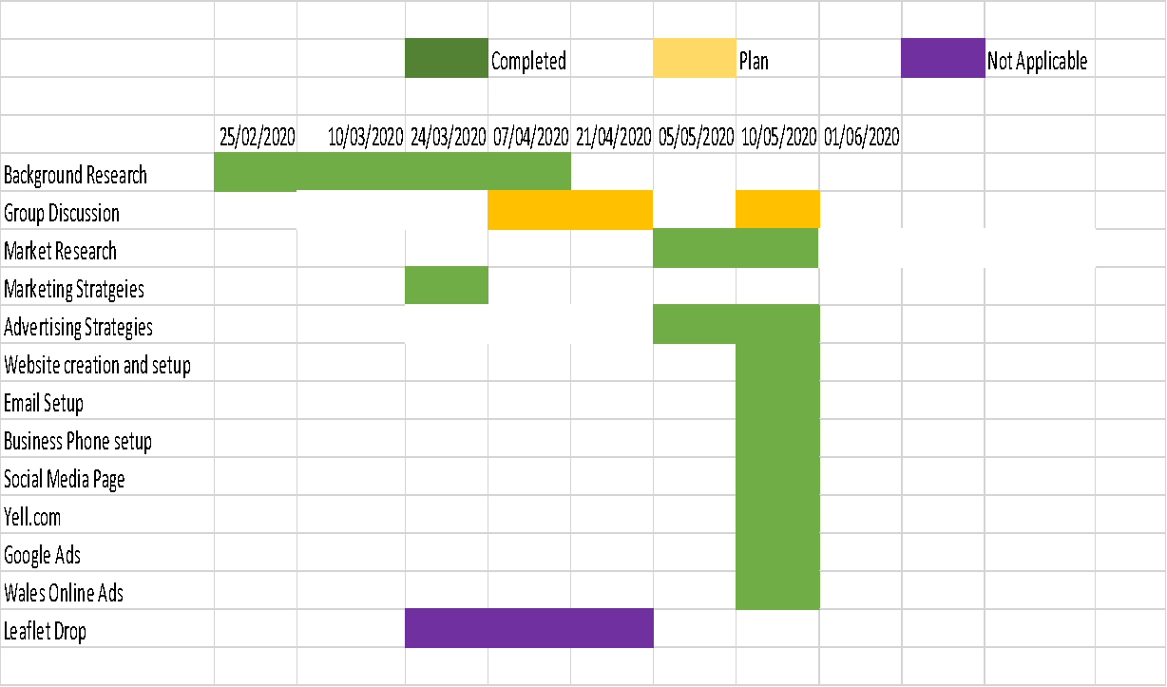
2.3 Gannt Chart
The Gannt chart above shows the timeline for the marketing plan and sets out clear time frames to succeed in the success of the business, this was based on the original goals to complete all the above tasks by the target date specified.
2.4 How to envision the communication strategy with the client?
Unfortunately, due to the outbreak of the coronavirus/covid-19 in March 2020, the communication strategies have now been revised and changed accordingly, to manage the implications it may have on the day centre Wednesday’s Wheelers and Walkers. The daycentre management team and the marketing consultant will communicate from now on during lockdown, this will only be via email, social media and phone. This could include the marketing plan and any proposals that arise for them regarding advertising.
2.5 What is the first target that the team will work towards?
The first target that the consultant team will work towards is deciding a strategy that works well for both of them and more importantly the business itself. The strategy will have a clear set of aims and objectives for the business and a clear set of project scopes and exclusions.

3.0 Define the Project Management Structure
Responsible – Who gets the job done? Marketing Consultant – Sarah Hillam
The role of an independent marketing consultant is to create a desirable marketing plan for the day centre known as Wednesday’s wheelers and walkers, this will be done through various strategies and to relay any proposals to the committee members through the chairlady Carol Sayce-Wilkins.
Accountable – Who is the decision maker? Chairlady of business –Carol Sayce-Wilkins
Mrs Sayce-Wilkins role in this project will be to take part as a consultant on behalf of the members and their family members who already attend the day centre and as the official chairlady of Wednesdays walkers and wheelers.
Consulted? Who needs to be asked before proceeding? Before proceeding with any of the marketing plan and advertising, carol needs to be consulted before anything is undertook
Informed – Who needs to be kept in the loop? Carol needs to be kept in the loop on a regular basis via the preferred communication plan of phone, email, social media.

4.0 Define the Specifics
What is in scope and out of scope?
The Scope and Exclusions for this project are as follows: Included in the project are the following:
- Marketing plan/ strategy
- Promote awareness of the day centre and to gain new members.
- Set up social media, Email and Website for the day centre
- Organise small events to gain members
- Advertisements through Yell.com, Google Ads, Facebook, Swansea Free Ads.
- Exclusions include the following:
- Not organising Holidays or events outside of what is stated above
- No other duties such as administration
- Are there some initial project requirements that are already defined?
The initial project requirements that have been discussed are:
- How best to promote and raise awareness of the day centre once lock down is lifted after the covid-19 restrictions
- What marketing would the client like to be implemented into the marketing plan.
- How to create a website and email address for the business reopening after covid -19.

What are the project boundaries that the team shall not cross?
The boundaries of this project have been set by the management team and consist of the following:

- Do not undertake any marketing plan without prior consent of management
- Discuss all marketing strategies with management before any research is undertook
- Consult with the management before implementing any advertising
- Gain permission from management before using questionnaires on clients

5.0 Identify the Risks
Timelines that are too short or too long
- The timelines that were set out for this marketing plan, were agreed by the management team and the marketing consultant, they are reasonable timelines and do not seem to be posing a problem at present even with the covid -19 restrictions as most of the work is undertook online via websites.
Budget constraints
- The budget of £5000 that has been set by the company will allow everything to be completed and the actual total comes in at under budget at £4090 for this project.
Technical issues
- The technical issues that could be a problem whilst completing this marketing strategy, is that the online advertising companies are not working due to covid-19 restrictions, so this would pose a problem whilst trying to complete the website and social media page and online advertising with yell.com and google ads.

6.0 Market Research
From the challenges presented to relaunch the adult day centre, Wednesdays walkers and wheelers, the following need to be taken into consideration while compiling market research.
- Target Audience:
Unfortunately, the marketing research plan cannot afford to target everyone. Knowing who the target audience is will help to craft relevant messages that resonate them. By focusing on those who are most likely to purchase a service from the business, so it is possible to prioritize the marketing spend and get the best possible ROI.
- Customer Acquisition:
To acquire new customers, as a marketing consultant, an understanding of what makes them tick helps a lot. Surveying clients can be a great way to learn how and why they chose a specific brand so is possible to acquire more customers like them and strive to make the business succeed.
- Customer Retention:
As marketers, its well known that it is cheaper to retain current customers than acquire new ones. Conduct market research to measure customer satisfaction, increase customer loyalty, and drive up retention numbers.
6.1 Competitors
The local competitors that would be competition for the day centre but most of these are government funded. To name a few of them would be the following
- Rose cross house – penlan
- The squirrel club – Townhill
- Friends of the young disabled – Cwmbrula

All these clubs offer similar facilities to Wednesday’s wheelers and walkers and offer more activities for their clients.

7.0 Research Methods Used and Data Collection

Whilst there are many other research methods available as a consultant the ones that will be focused on are, Empirical and Qualitive method, this research will involve taking questionnaires, and observations if possible. It aims at getting reasons for social behaviour, and to try to ascertain likely future behaviour. It will involve the members and their families, plus speaking with the relevant local authorities it will make it possible to understand what people would like to see at the day centre and what support these organizations can provide to aid in the success of the day centre in the future.

During the covid-19 lockdown communications have been undertaken with each member from the day centre via phone or Facebook or email, regarding what the day centre needs and what members want to see the day centre achieve( please see appendix for details on questionnaires that were undertook), below is some of the common answers from the questionnaires that were conducted. Common answers consist of: they enjoy the day centre and like to come here to socialise with each other; they attend each week to give them a sense of independence and some social time; they all said they would love for the day centre to run holidays again as it relieves stress and pressure on family members who care for them on a regular basis; they would like better facilities in the building they rent for the day centre as its lacking cleanliness and some of the facilities are out of date such as the heating; they also said that they would like to see regular entertainment such as singers (Wilkins, 2020).

All of the members agree that a website and social media page is needed to gain new members and boost profits for the day centre, so they can return the business to how it used to be, they have also agreed with the proposal of re-branding the day centre back to first steps forward (Wilkins, 2020).Qualitative methods were used, and data collected through structured Questionnaires with a sample size of eight service users. the voices of older people are essential for shaping services (McCormick, Clifton, Sachrajda, Cherti, & McDowell, 2009) and the ASCOF guidance emphasises the importance of gathering the perspectives of individuals using the service in order to improve overall quality (DH, 2014c). This approach was ideal for obtaining rich and detailed information from those accessing the day centre.

Through the market research that has been completed during the coronavirus lock down, yell.com have agreed free advertisement for the business has been secured for one year (Yell.com, 2020) until the company starts to see a gain in profits and members, these adverts have proven very successful up to now and hopefully will continue to benefit the business in the foreseeable future and help the business expand to be very successful, currently through yell.com advertising the business has received 15 emails from people that are interested in joining the day centre, this cannot take place until after Covid-19 restrictions have been removed completely by the government to allow social groups to get back together on a regular basis.

7.1 Marketing Plan

The marketing plan will be implemented by completing the following tasks for the business over a period. Throughout the project various methods of research have been carried out to find the best plan to revamp the business after covid-19 restrictions have been lifted, working out these strategies and implementing them will be the best way forward for the business to get back on their feet after covid-19 pandemic.

The following tasks have now successfully been complete and implemented for the business, so far, a Facebook Social media page has been created for the business to help gain new members through social media as this is an effective way of customer acquisition. Online advertising has also been implemented through yell.com and Swansea free ads, which have proving successful at present as over 50 people have viewed the yell.com advertisement which has resulted in 15 new members wanting have to join after restrictions are lifted, the Swansea free ad that was placed has gained 90 views. A Website has also been created via webs.com for the business where all the activities that are hoping to be available are listed and also a contact page for potential clients to contact the management team directly. A google email address has also been created for the management team to be able to contact new and old clients and able them to make contact with potential funding sources for the business. Set up of new business phone has been created via o2 online and this has now been successfully completed.

7.2 funding Sources
There are a lot of potential funding sources available for business such as the day centre, these sources offer small Grant’s to businesses who need that little bit of extra funding to enhance their business to potential clients. These sources include
- Princess trust
- National Lottery Community Fund.
- The National Emergencies Trust.
- Welcome Trust.
- £1m Money Saving Expert fund.
- The Indigo Trust
- Funding Cymru
- Community Foundation Wales
(WCVA, 2020)
They can offer potential grants of up to £25,000 for charities and small businesses to be able to revamp the following and provide financial flexibility to businesses who are suffering financial hardship.
- Adapting activities– we recognise that you may experience difficulties achieving some of the outputs or outcomes we agreed for your grant during the outbreak, and would like to be able to maintain our grant payments to you at originally-agreed levels during this period, so please have a conversation with us if you are affected in this way.
- Financial flexibility– we know you may need to use your funding to help cover sickness, purchase equipment, or deliver services differently, and we will be reasonable if you need to move money between budget headings to ensure your work can continue. (WCVA, 2020)

8.0 Conclusion
It can be concluded that most of the participants are happy with the experience of having a marketing consultant revamp their business to make it better overall. some feel they do not receive good value for the money at the day centre due to lack of activities and entertainment that is available to them on a weekly basis. As mentioned, it is difficult to accommodate all needs, but by listening to the clients, it is possible to make a change that will benefit not only the clients and management, but also the business and the overall client experience and satisfaction when they attend. The overall price to attend the day centre is averaging around £8.00 per week, which is a lot of money for some clients but it is the only socialising they get to do on a weekly basis so they feel that they have to pay it to be part of social cohesion. Arguably other day centres that are local maybe cheaper and offer better facilities and activities than Wednesdays wheelers and walkers. Another important focus the participants pointed out during the questionnaires was that most of them would like to see some form of hired entertainment to attend once per month or even a cinema day and meal. It is very important that the management take this into consideration when the relaunch is complete after the Covid-19 restrictions are lifted fully, they need to constantly gather information and monitor what clients want by asking if they are happy on a regular basis. By experience it has been noticed that most client’s complaints are regarding facilities and lack of activities and entertainment. This is where clients’ feel they have not received value for money due to the high cost of the attending per week.

9.0 Limitations and suggestions
The overall result of this consultancy project is to revamp the business Wednesday’s Wheelers and Walkers, however, due to the limitations of this questionnaire there might be some inconsistencies due to the lack of clients wanting to participate in this due to the coronavirus and their disabilities and that this case study incorporate all clients and not the just the ones who have taken place specifically. This may leave the possibility of future research within the business for clients who did not participate this time.

10.0 Recommendations
The strategic recommendations that need to be implemented for the day centre to continue in business are as follows:
- Continue with marketing that has been implemented
- Improve facilities at the daycentre
- Improve services offered to clients such as, arts and crafts, bingo, raffles, cake stalls and tombola and have a yearly fate to raise money for the business.
- Offer entertainment from a local singer or band once a month
- Cinema day and lunch out once per month at the Odeon Parc Tawe and nearby restaurant on wind street.
- Reorganise yearly holidays
- Reorganise various day trips for clients

The management team need to adhere to the guidelines set out for the recommendations the business will continue to succeed and provide a service to current and new perspective clients that may be interested in joining in the near future, these recommendations have set out as based on the questionnaires that have been received from current members and their families on what they would like to see at the day centre on a weekly or monthly basis.

11.0 References
Academy, P., 2019. Maslow's Mareting Theory. [Online]
Available at: https://www.professionalacademy.com/blogs-and-advice/marketing-theories-maslows-hierarchy-of-needs
[Accessed 3rd May 2020].
Ads, G., 2020. Local Disabled day centres. [Online]
Available at: https://www.google.co.uk/search?sxsrf=ALeKk01heleMGldLHFo7uLg_yEZaJxpdkg%3A1586100816552&source=hp&ei=UPqJXorIH4zjgwfRn7v4Cw&q=disabled+day+centres+near+me&oq=disabled+day+cen&gs_lcp=CgZwc3ktYWIQARgBMgIIADICCAAyCAgAEBYQChAeMgYIABAWEB4yBQgAEM0COgcIIxDqAhAn
[Accessed 5th April 2020].
Clark, C. L., 2001. Adult Day Services and Social Inclusion. Better Days, pp. 104- 110.
Company, T. S., 2019. Disabled grants for non profit organisations. [Online]
Available at: https://www.thestablecompany.com/sources-of-funding/charities-voluntary-organisations
[Accessed 5th April 2020].
Fifield, P., 2007. Marketing Strategy. 3RD ed. Burlington: Elsevier.
Kingsnorth, S., 2019. Digital Marketing Strategy. 2nd ed. London: Kogan page limited.
Mcguire, K. J., 2009. Maslow's Hierachy. [Online]
Available at: https://books.google.co.uk/books?id=_qw6LvpknKkC&printsec=frontcover&dq=maslow%27s+hierarchy+of+needs&hl=en&sa=X&ved=0ahUKEwjNi8GdhZjpAhUKO8AKHa8XDvoQ6AEIMTAB#v=onepage&q=maslow's%20hierarchy%20of%20needs&f=false
[Accessed 3rd May 2020].
Sridhar, R. W. P. a. S., 2017. Marketing Strategy Data Analytics. 1ST ed. London: Macmillan .
Swansea.gov.uk, 2019. Disabled Day Centres. [Online]
Available at: https://www.swansea.gov.uk/article/5458/Information-resources-for-disabled-people
[Accessed 5th April 2020].
Swansea.gov.uk, 2020. Swansea Population and Demographics. [Online]
Available at: https://worldpopulationreview.com/world-cities/swansea-population/
[Accessed 7th May 2020].
Wilkins, C. S., 2020. Wednesdays Walkers and Wheelers [Interview] (5th April 2020).
Yell.com, 2020. Disability Services. [Online]
Available at: www.yell.com/disabilityservicesswansea
[Accessed 5th April 2020].

12.0 Works Cited

Academy, P., 2019. Maslow's Mareting Theory. [Online]
Available at: https://www.professionalacademy.com/blogs-and-advice/marketing-theories-maslows-hierarchy-of-needs
[Accessed 3rd May 2020].
Ads, G., 2020. Local Disabled day centres. [Online]
Available at: https://www.google.co.uk/search?sxsrf=ALeKk01heleMGldLHFo7uLg_yEZaJxpdkg%3A1586100816552&source=hp&ei=UPqJXorIH4zjgwfRn7v4Cw&q=disabled+day+centres+near+me&oq=disabled+day+cen&gs_lcp=CgZwc3ktYWIQARgBMgIIADICCAAyCAgAEBYQChAeMgYIABAWEB4yBQgAEM0COgcIIxDqAhAn
[Accessed 5th April 2020].
Clark, C. L., 2001. Adult Day Services and Social Inclusion. Better Days, pp. 104- 110.
Company, T. S., 2019. Disabled grants for non profit organisations. [Online]
Available at: https://www.thestablecompany.com/sources-of-funding/charities-voluntary-organisations
[Accessed 5th April 2020].
Fifield, P., 2007. Marketing Strategy. 3RD ed. Burlington: Elsevier.
Kingsnorth, S., 2019. Digital Marketing Strategy. 2nd ed. London: Kogan page limited.
Mcguire, K. J., 2009. Maslow's Hierachy. [Online]
Available at: https://books.google.co.uk/books?id=_qw6LvpknKkC&printsec=frontcover&dq=maslow%27s+hierarchy+of+needs&hl=en&sa=X&ved=0ahUKEwjNi8GdhZjpAhUKO8AKHa8XDvoQ6AEIMTAB#v=onepage&q=maslow's%20hierarchy%20of%20needs&f=false
[Accessed 3rd May 2020].
Sridhar, R. W. P. a. S., 2017. Marketing Strategy Data Analytics. 1ST ed. London: Macmillan .
Swansea.gov.uk, 2019. Disabled Day Centres. [Online]
Available at: https://www.swansea.gov.uk/article/5458/Information-resources-for-disabled-people
[Accessed 5th April 2020].
Swansea.gov.uk, 2020. Swansea Population and Demographics. [Online]
Available at: https://worldpopulationreview.com/world-cities/swansea-population/
[Accessed 7th May 2020].
Wilkins, C. S., 2020. Wednesdays Walkers and Wheelers [Interview] (5th April 2020).
Yell.com, 2020. Disability Services. [Online]
Available at: www.yell.com/disabilityservicesswansea
[Accessed 5th April 2020].

11.0 Appendices

First Steps forward
Formally known as Wednesday’s Walkers and Wheelers
Mansleton Community Centre,
Elgin Street
Mansleton
Swansea
SA5 8QE
Firststepsforward2020@gmail.com
WWW.firststepsforward2020.webs.com
University of Wales Trinity Saint David
School of Tourism and Hospitality
Swansea Business Campus
Powell St
Swansea
SA1 1NE

To whom it may concern,
I am writing to confirm that Mrs. Sarah Louise Hillam, has successfully completed her consultancy project marketing plan for our Day Centre Wednesday’s walkers and wheelers. Sarah has worked very hard and tirelessly on this project during hard times for her and her family, but she has not lost focus on the project and has followed our guidelines very strictly during the Covid-19 pandemic.
Sarah has completed all tasks we asked off her in a timely manner and has successfully rebranded our Day Centre back to its former name of First steps forward, also she has created a website and email address to which I have provided links for at the top of the letter if you wish to take a look at the excellent work she has done.
We are very pleased to sign off Sarah’s work as complete as of the 23rd May 2020 and wish her all the very best for her master’s degree in September.
Warm regards,
Mrs. Carol Sayce Wilkins
Manager

