Student no 2223739

Case study report

This case study explores the physiological needs of a male football centre midfielder who is 21 years old. It focuses on the athlete's actual experiences who aspires to progress from a semi-professional to professional level in this role. We learn a great deal about complexed physiological demands made on the players' advantages in this position by investigating various tests. Ensuring a comparison to other participants will help give a Z value and normative data, which can help determine where paritipant ranks amongst others.
Andrzejewski et al. (2015) shows that on average professional football players run an average of 10-13.5km per match showing that a central midfielder's physiological make-up includes endurance. Effective oxygen transport to working muscles is ensured by a robust cardiovascular system, which postpones exhaustion and sustains performance levels throughout the game (Adib Febrianta and Imam Nurseto, 2022).
Central midfielders averagely made 23.5 sprints per game during Champions league (Ferro et al., 2014). Sprinting in short spurts, making abrupt direction changes, and forceful tackles require quick energy production independent of oxygen (Alghannam, 2012).
Powerful passes, shots, ball shielding, and winning physical contests depend on strong muscles. Major muscle groups are the focus of strength training regimens, which improve a player's ability to exert power and sustain physical dominance on the field (Paul and Nassis, 2015).
Agility and adaptability are essential qualities. CM’s game revolves around quick changes of direction, fast turns, and quick footwork. Sustaining high degrees of flexibility and agility throughout matches helps improve the player's capacity manouvering in confined places, sidestep obstacles, and accurately carry out complex moves (Goral, 2015).
Proper fuelling guarantees enough energy stores for prolonged, high-intensity activities during the game, while proper hydration promotes effective thermoregulation and guards against cramps and tiredness (Stables et al., 2022).
63 interceptions in the 22/23 premier league season was the best of all positions coming from a central midfielder, this equates too an average of 1.65 per game (Premier league, 2024). Reading the game, predicting plays, and acting quickly to intercept passes from the opposition or distribute the ball wisely (Ricotti et al., 2013).

Method
Ensuring that all tests were interlinked to the performance of a centre midfielder was vital. Understanding what physiological demands are put on centre midfielders during matches was the first step, and then finding testing that supports the demands while also executing these tests correctly was the next step.
Height weight and age were all recorded pre testing.

Reaction time tests were performed on the Blaze Pod 30s reaction test, tthe individual was instructed to stand facing the wall's buttons. The visual stimuli were activated and the app's timer was set to start. The participant pressed the button that matched the location of the visual stimulus as soon as they saw it, and they did this for 30 seconds. The programme counted the exact number of buttons that were pressed in the thirty seconds that were given. The best outcome from the three repetitions of this was recorded.

Maximal sprint efforts were done on performed with timing gates. The start and finish lines were then appropriately demarcated with cones or markers after the timing gates were placed 30 metres apart in a straight line. Ensuring accurate timing and assessing the timing gates' operation. To make sure they weren't in front of the first timing gate, the study was placed at the beginning.The athlete bolted through the first timing gate. It was made sure the participant continued to sprint through the last gate at full speed. The best result was reported after three iterations (Waldron et al., 2011).

VO2 max using douglas bags were done to evaluate the subjects aerobic capacity. The subject's height, weight, and resting heart rate were recorded. After the heart rate monitor was connected, the individual was instructed to wear it during the exam. The bike was riding at a reasonable speed. The training was progressively intensified at predetermined intervals every one to three minutes. The participant's heart rate and subjective exertion level were continually recorded using the Borg Rating of Perceived Exertion (RPE) scale. Regularly, expired air samples were collected with a Douglas bag. The participant persisted until they could no longer go at the desired pace or until they became volitionally exhausted (Beltz et al. (2016).

Agility was measured via the T-test. A T-shape, with a base of ten metres and a top width of five, was delineated by cones. The athlete started the T-shaped course at the beginning. The contestant shot through the time gate and reached for the farthest cone in front, touching it with their hand. The person then touched the cone by side-shuffle walking along the top of the T to the left. After touching the farthest right cone with a side shuffle, the subject moved back to the top cone in the middle. When the subject withdrew through the timing gate, the test was declared over (Pauole et al., 2000). After three repetitions, the best outcome was noted.

Vertical jump was used to analyse the subjects maximal jump height. Using the hip harness, the wire attachment was secured to the participant's hip. Ensuring that both the measuring gadget and the hip harness were properly attached to the wire. The participant was placed on an even surface with their hip firmly secured too the wire attachment. The participant then placed their feet shoulder-width apart. When they were ready, the participant launched themselves into a vertical leap with maximum effort, keeping their hands on hips.
The wire attachment extended to its full length to measure the height of the jump (McMaster et al., 2020). The best outcome was taken after three repetitions.

Watt bike PP was done to evaluate a maximal power effort. The seat height on the Watt bike was adjusted to be about hip height. The participant chose the 6-second Peak Power (PP) test and input their height and weight to determine the Watt bike's suitable resistance level. The subject was warmed up with a light cycle before the test. By choosing "Begin test," a 3-second countdown was activated, starting the test. The athlete started pedalling as soon as they reached 1, and they kept going for the entire six seconds. The Watt bike produced findings that were noted. To obtain the optimal outcome, this method was carried out three times (Herbert, Sculthorpe, and Grace, 2015).

Force platform PP was used to assess the subjects maximal power. The platform was positioned level, measurements were accurate and stable. The participants was told to place their feet shoulder-width apart and stand on the platform. Depending on the needs of the study, they were then asked to carry out a variety of exercises, including dynamic motions, jumping, and static standing. To ascertain variables such as peak force, rate of force development, and centre of pressure displacement, data from the force platform was gathered and examined. Regular calibration tests were carried out in order to ensure accuracy. The force platform's results provide important information about the participants' maximum leap power and the best result after 3 was noted (Prosperini and Pozzilli, 2013).

Results
James's athletic evaluation will be compared and analysed to how his performance compares to normative data and James Z’s score in comparison to a group of participants. This will help with identifying their strengths and weaknesses, how they compare to others and how the results influence their performance as a central midfielder.
To calculate an effective z score, the individual’s score in a data set must be subtracted from the mean of the data of the overall data set, the value of that result must then be divided by the data set’s standard deviation (Andrade, 2021).

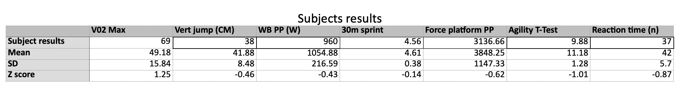
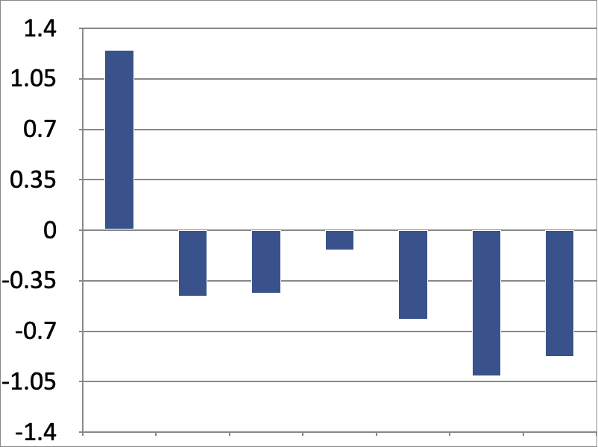
James Z score

Reaction time

T-test

VO2 max

30m sprint

Vert jump

Force platform PP

WB PP

Normative data
VO2 max | 65.7ml/kg/min
Verical jump | 56.4cm
Conducted on 17 elite footballers playing for Rosenborg F.C these were the average results for both tests (Wisloff et al., 2004).

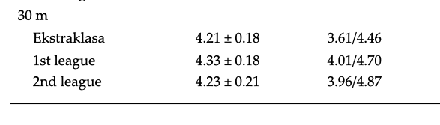

30 metre sprint (Drozd et al., 2017)

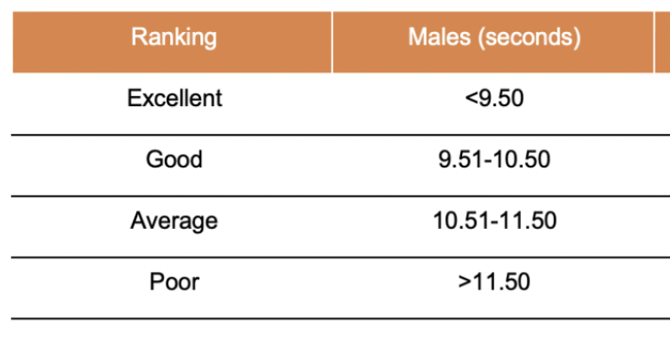

T-test (Hoffman, 2006)

Conclusion/ Discussion

The subject benefits greatly from having a high VO2 max score as a central midfielder. A central midfielder, is essential to the team's attacking and defensive strategies and must constantly travel throughout the pitch (Abbott, Brickley and Smeeton, 2018). The clients outstanding aerobic capacity is indicated by their high VO2 max score and his Z score of 1.2 showing he is above average compared to the data. Supporting this their score is better than elite level footballers (Wisloff et al., 2004), indicating that their use of aerobic capacity is at a high standard, using oxygen to produce energy throughout extended periods through the game (Buttar, Saboo and Kacker, 2020). A Z score of -1.01 for the agility T-test shows that they’re above average in accordance to the data set as the - is a positive as the lower the value the quicker the time, their score of 9.88 in comparison to the normative data shows that they’re in the “good” region supporting the evidence of the Z score being above average and that their score is good compared to others.

Although, when it comes to the more explosive tests the subjects results are not as good, a central midfielder needs to be explosive in order to change play rapidly between defence and attack, dodge opponents quickly, make accurate passes or shots when under pressure. A Z score of -0.45 of the vertical jump shows that they’re -0.45 standard deviations below the mean average. Furthermore, they are significantly below the average score of elite level footballers (Wisloff et al., 2004).
Watt Bike PP and Force platform PP was more examples of maximal effort tests where the clients Z score was -0.43 for Watt Bike PP and -0.62 for the Force platform PP thus showing they’re below average in both. For the 30 metre sprint the client once again achieved a negative score of -0.14 however, as this is sprint time this data must be interpreted differently, as the faster times are put into - as they are the lowest valued data.
Therefore showing that the subject is still in the average zone but 0.14 standard deviations above average which needs improving to progress as a footballer. The normative data from Drozd et al, 2017 shows professional scores in the Football Polish 1st to 3rd division, from the data it shows that the score of 4.56 would be suitable for the 2nd and 3rd division which is beneficial as they’re hoping to achieve playing at a professional level. These results shows that the client is predominantly slow twitch fibres by doing well in the VO2 max is evident of this. Achieving below average or average in explsoive tests also demonstrates that they’re predominately slow twitch fibres.

To improve the clients performances in explsovie movements the focuses must be on, muscle strength as that is the fundamental base before building power, energy systems are another focus as your main focus on the ATP-PC system and muscle fibre composition trying to achieve greater fast twitch fibres (Cronin, McNair and Marshall, 2001).
For muscle strength improvements, complexed exercises that focus on explosive movements and target numerous muscle groups are great. Exercises like bench presses, power cleans, deadlifts, and squats can aid in building general strength and power (Suchomel, Nimphius and Stone, 2016). Increasing explosive power and speed with plyometric exercises are essential. As strength increases, increase the volume, exercises like medicine ball tosses, box jumps, plyometric push-ups, and jumping lunges are all examples of plymoetric exercises (Pandoyo et al., 2020). Agility ladders, ladder drills, sprint intervals, and shuttle runs can help build fast-twitch muscle fibres and increase power production (Fajrin, Kusnanik and Wijono, 2018).
The studies reaction time test Z score of -0.87 suggests that their reaction time was slower than that of his peers, indicating that their performance was below the dataset average. This is another area that needs improving as a centre midfielder's ability to react rapidly to changes in play is essential since it enables them to make accurate and efficient interceptions, passes, and defensive or attacking transitions (Zhang, 2020). Improving proprioception and neuromuscular coordination via plyometric, agility ladder, and balancing drills, among other workouts. These aid in reaction speed and enhance the body's capacity to react swiftly and effectively to outside stimuli (Aman et al., 2015).

The subjects remarkable aerobic ability is an important asset for their position as a central midfielder in the game of football. It it admirable that they can maintain strong runs throughout games. But in order for them to perform even better in this role, they need to increase their anaerobic ability. Being able to undertake short, intense bursts of activity with increased anaerobic capacity, which is essential for quickening play transitions and producing decisive plays on the pitch. The study may improve their effectiveness and influence as a centre midfielder by adding focused anaerobic training to his current aerobic regimen. This will give the client a more well-rounded physical profile.

WORD COUNT-2162
References
Abbott, W., Brickley, G. and Smeeton, N.J. (2018) ‘Physical demands of playing position within English Premier League academy soccer’, Journal of Human Sport and Exercise, 13(2). Available at: https://doi.org/10.14198/jhse.2018.132.04.
Adib Febrianta and Imam Nurseto (2022) ‘Development of Football Conditioning Exercise Model for Cardiorespiratory Endurance of Football Players’, Advances in health sciences research, 43(4). Available at: https://doi.org/10.2991/ahsr.k.220106.058.
Alghannam, A.F. (2012) ‘Metabolic Limitations of Performance and Fatigue in Football’, Asian Journal of Sports Medicine, 3(2). Available at: https://doi.org/10.5812/asjsm.34699.
Aman, J.E. et al. (2015) ‘The effectiveness of proprioceptive training for improving motor function: a systematic review’, Frontiers in human neuroscience, 8(1075), p. 1075. Available at: https://doi.org/10.3389/fnhum.2014.01075.
Andrade, C. (2021) ‘Z Scores, Standard Scores, and Composite Test Scores Explained’, Indian Journal of Psychological Medicine, 43(6), p. 025371762110465. Available at: https://doi.org/10.1177/02537176211046525.
Andrzejewski, M. et al. (2015) ‘Sprinting Activities and Distance Covered by Top Level Europa League Soccer Players’, International Journal of Sports Science & Coaching, 10(1), pp. 39–50. Available at: https://doi.org/10.1260/1747-9541.10.1.39.
Beltz, N.M. et al. (2016) ‘Graded Exercise Testing Protocols for the Determination of VO2max: Historical Perspectives, Progress, and Future Considerations’, Journal of Sports Medicine, 2016(3968393), pp. 1–12. Available at: https://doi.org/10.1155/2016/3968393.
Buttar, K.K., Saboo, N. and Kacker, S. (2020) ‘Maximum Oxygen Consumption (VO2 max) Estimation using Direct and Indirect Method in Indian Population: A Pilot Study’, JOURNAL OF CLINICAL AND DIAGNOSTIC RESEARCH, 6(6). Available at: https://doi.org/10.7860/jcdr/2020/43225.13524.
Cronin, J., McNair, P.J. and Marshall, R.N. (2001) ‘Developing explosive power: A comparison of technique and training’, Journal of Science and Medicine in Sport, 4(1), pp. 59–70. Available at: https://doi.org/10.1016/s1440-2440(01)80008-6.
Drozd, M. et al. (2017) ‘Analysis of the 30-m running speed test results in soccer players in third soccer leagues’, DOAJ (DOAJ: Directory of Open Access Journals), 3(1-5).
Fajrin, F., Kusnanik, N.W. and Wijono (2018) ‘Effects of High Intensity Interval Training on Increasing Explosive Power, Speed, and Agility’, Journal of Physics: Conference Series, 947(12045), p. 012045. Available at: https://doi.org/10.1088/1742-6596/947/1/012045.
Ferro, A. et al. (2014) ‘Analysis of Speed Performance In Soccer by a Playing Position and a Sports Level Using a Laser System’, Journal of Human Kinetics, 44(1), pp. 143–153. Available at: https://doi.org/10.2478/hukin-2014-0120.
Goral, K. (2015) ‘Examination of agility performances of soccer players according to their playing positions’, The Sport Journal [Preprint], (1543-9518). Available at: https://doi.org/10.17682/sportjournal/2015.004.
Herbert, P., Sculthorpe, N. and Grace, F. (2015) ‘Validation of a 6 Second Cycle Test for the Determination of Peak Power Output (PPO) Using Wattbike Cycle Ergometer’, Medicine & Science in Sports & Exercise, 47(933-933), p. 933. Available at: https://doi.org/10.1249/01.mss.0000479266.13042.84.
Hoffman, J. (2006) Norms for fitness, performance, and health. Champaign: Human Kinetics, pp. 1–113.
McMaster, D.T. et al. (2020) ‘Validity of Vertical Jump Measurement Systems’, Measurement in Physical Education and Exercise Science, 25(3), pp. 1–6. Available at: https://doi.org/10.1080/1091367x.2020.1835664.
Pandoyo, P.A.S. et al. (2020) ‘THE EFFECT OF PLYOMETRICS TRAINING ON EXPLOSIVE POWER OF MEDICAL STUDENTS IN DIPONEGORO UNIVERSITY’, DIPONEGORO MEDICAL JOURNAL (JURNAL KEDOKTERAN DIPONEGORO), 9(3), pp. 213–219. Available at: https://doi.org/10.14710/dmj.v9i3.27495.
Paul, D.J. and Nassis, G.P. (2015) ‘Testing Strength and Power in Soccer Players’, Journal of Strength and Conditioning Research, 29(6), pp. 1748–1758. Available at: https://doi.org/10.1519/jsc.0000000000000807.
PAUOLE, K. et al. (2000) ‘Reliability and Validity of the T-Test as a Measure of Agility, Leg Power, and Leg Speed in College-Aged Men and Women’, The Journal of Strength and Conditioning Research, 14(4), p. 443. Available at: https://doi.org/10.1519/1533-4287(2000)014%3C0443:ravott%3E2.0.co;2.
Premier league (2024) Premier League Player Stats - Interceptions, www.premierleague.com. Available at: https://www.premierleague.com/stats/top/players/interception.
Prosperini, L. and Pozzilli, C. (2013) ‘The Clinical Relevance of Force Platform Measures in Multiple Sclerosis: A Review’, Multiple Sclerosis International, 2013(3671534), pp. 1–9. Available at: https://doi.org/10.1155/2013/756564.
Ricotti, L. et al. (2013) ‘Analysis of Balance, Rapidity, Force and Reaction Times of Soccer Players at Different Levels of Competition’, PLoS ONE. Edited by B. Ermentrout, 8(10), p. e77264. Available at: https://doi.org/10.1371/journal.pone.0077264.
Stables, R.G. et al. (2022) ‘Acute fuelling and recovery practices of academy soccer players: implications for growth, maturation, and physical performance’, Science and Medicine in Football, 8(1), pp. 1–15. Available at: https://doi.org/10.1080/24733938.2022.2146178.
Suchomel, T.J., Nimphius, S. and Stone, M.H. (2016) ‘The Importance of Muscular Strength in Athletic Performance’, Sports Medicine, 46(10), pp. 1419–1449. Available at: https://link.springer.com/article/10.1007/s40279-016-0486-0.
Waldron, M. et al. (2011) ‘Concurrent validity and test-retest reliability of a global positioning system (GPS) and timing gates to assess sprint performance variables’, Journal of Sports Sciences, 29(15), pp. 1613–1619. Available at: https://doi.org/10.1080/02640414.2011.608703.
Wisloff, U. et al. (2004) ‘Strong correlation of maximal squat strength with sprint performance and vertical jump height in elite soccer players’, British Journal of Sports Medicine, 38(3), pp. 285–288. Available at: https://bjsm.bmj.com/content/38/3/285.short.
Zhang, J. (2020) ‘A Study of the Reaction and Performance of Elite Athletes’, Frontiers in Sport Research, 2(6), pp. 130–136. Available at: https://doi.org/10.25236/FSR.2020.020617.

