

Module Name: learning in the digital era
Module Code: BMBM4008
Assignment Name: Evidence of learning (e-portfolio)
Topic: The role of influencers in modern marketing
Student Name: Omrakha Hassan Idrees Ali
Student Number:2500918
Lecturer: Ffion Cumberpatch
Deadline: 24/11/2025
Wordcount: 2000

AI Acknowledgement
Examples of AI statements if you have used AI
Example 1:
I acknowledge the use of Grammarly (https://www.grammarly.com/) on Date to check my work using the prompt(s):

Contents
Task 1 synthesis
Task 2 essay
Task 3 presentation

Task 1 synthesis

Evaluating both sources using the CRAAP test
The first source has great currency because it shows current trends in the field of digital marketing. The discussion of modern platforms like Instagram and TikTok, together with the increasing significance of micro-influencers, demonstrates that the content is current and in line with business practices. Because it specifically discusses how influencers impact consumer behaviour and brand tactics, the source is particularly relevant to anyone studying or working in marketing. Although the author seems informed, there is no obvious sign of professional expertise or institutional backing, which significantly diminishes its trustworthiness. As a result, its authority is moderate. While credibility is weakened by the lack of empirical evidence or citations, accuracy is reasonably maintained because the arguments are logical and consistent with observable trends. The source’s main goals are to educate and analyse, providing readers with methodical comprehension of influencer marketing without overt promotional bias (Catch Mark, 2024).
The second source demonstrates relevance since it refers to contemporary influencer strategies and the cultural effect of social media personalities. Its relevance, however, is rather different: although it is still related to the subject of influencer marketing, it takes on a more imaginative and playful tone, making it more appropriate for general audiences or creative entrepreneurs than for academic readers. Because Pauly’s Playhouse suggested a personal blog or informal platform rather than a professional or scholarly journal, its authority is weaker than that of the first source. Accuracy is limited because the source mostly depends on stories and metaphorical language rather than facts or research. Nevertheless, it captures the emotional and cultural dimensions of influencer marketing in a way that resonates with readers; the goal here is more persuasion and inspiration, with the intention of entertaining and showcasing the magic of influencers (Pauly’s Playhouse, 2025).
According to these sources, influencers are essential to contemporary marketing because they shape consumer perceptions, foster trust, and increase engagement. They draw attention to the transition from traditional advertising to influencer-driven strategies, where reliability and authenticity are more important than polished corporate campaigns. Both emphasise how crucial social media platforms are as the primary platform for influencer activity. However, they follow different approaches and have different tones. The first source has a more analytical approach, concentrating on useful elements like the rise of micro-influencers, measurable impacts on consumer behaviour, and strategic brand partnership. Paul’s Playhouse on the other hand, takes a more creative approach, presenting influencers as ‘‘magicians’’ who weave narrative and create emotional connections with the audience.
The sources work well together. The analytical perspective offers a structured understanding of influencer marketing mechanics. While the creative approach emphasises its intangible, emotional impact. According to this synthesis, effective influencer marketing involves both an understanding of the magic influencers offer in forming brand identity and customer loyalty as well as a strategic, data-driven approach to influencer selection and measurement.

The role of influencers in modern marketing

This essay will examine a number of important elements of influencers’ impact, such as how they cultivate strong online communities that affect customer behaviour, how they utilise creative storytelling to promote products, and the way they establish trust and authenticity. Along with the ethical issues that come up as the sector expands. When taken as a whole, these arguments show why influencers are now crucial brand partners in today’s marketing environment.
Influencers now are an essential component in contemporary marketing, changing how customers interact with brands and make decisions about what to buy. Social media sites like Instagram, YouTube, and TikTok have elevated regular individuals into influential voices that can reach millions of people during the last decade. The fundamentals of advertising have changed as a result, shifting from general, impersonal messaging to more focused, personal, and dialogue-based communication. Today’s customers want to hear from people they can trust, and influencers fill that role by acting as relatable intermediaries between companies and audiences (Forbes Council, 2025).
The sense of authenticity influencers project is one of the main reasons they have grown so important. In contrast to traditional celebrities, who are frequently seen as distant and staged, influencers grow their fan bases by providing insights into their actual lives, morals, and life experiences. Because of this, followers experience a kind of virtual connection where they feel they are deeply connected with the influencer. Given this, audiences typically see product recommendations from influencers as sincere advice rather than traditional advertising. Trust, which is more valuable in a crowded media environment, becomes a type of currency that influencers may utilise to alter consumer behaviour. This dynamic is best illustrated by micro-and nano-influencers, who have smaller but more active followings (Research Gate, 2023).
Influencers are excellent storytellers and content creators who go beyond trust. Presenting a product is no longer the only goal of modern marketing; it also involves creating an emotional story that people can relate to. Influencers are free to include products effortlessly into their everyday lives through vlog-style films, tutorials, and lifestyle photos. In addition to showcasing a product’s advantages, this type of content allows users to visualise how it may work in their own lives. When a product is shown in a real-world setting and discussed by a relatable person, its persuasive power exceeds that of traditional static advertising (Influencity, 2025).
Community development is another key aspect of influencer marketing. Social media is inherently interactive, allowing instant communication between influencers and their followers. Influencers take polls, reply to comments, ask questions, and have discussions to better understand the preferences of their audience. This two-way communication builds loyal communities where followers feel valued and included. Reaching an audience that is not only active but also emotionally invested. Whether in the areas of fashion, fitness, gaming, sustainability, or parenting, influencers serve as cultural leaders in their respective fields, setting trends and influencing what their followers consider essential or desirable. Influencer partnerships provide brands access to this cultural impact, which frequently results in increased customer engagement and brand loyalty (IZEA, 2024).
Additionally, influencers are crucial in shaping choices made by customers. Social media is a major source of product reviews, product glimpses, and product discovery for modern consumers. A product can be introduced to millions of people and generate a lot of interest with only one influencer post, like a promotional video, a day-in-the-life vlog, or a viral TikTok. Unplanned influencer endorsements have caused unexpected sales boosts for numerous firms, demonstrating the power and swiftness of social influence. Influencers are frequently the first to adopt new ideas or products, and their input can help brands enhance their products and services, tactics, and target audiences. Influencers work as freelance market researchers in this way, giving brands insights based on audience responses in real time (Mastroke, 2024).
Influencer marketing has substantial monetary consequences. Influencers monetise their platforms through sponsored content, marketing collaborations, and long-term brand agreements in this multibillion-dollar industry that launched out a niche profession. Because influencer marketing regularly provides measurable benefits, brands continue to invest heavily in it. Clear indicators of a campaign’s effectiveness include engagement rates, clicks, conversations, and user-generated content. Influencer marketing provides flexibility and openness in contrast to traditional advertising, which may be costly and challenging to measure. It enables companies to try out various producers, formats, and communication methods to see what people appeals to their target market the most.
However, the rise of influencer marketing has brought additional challenges and ethical considerations. If influencers do not clearly disclose their affiliations, the line between genuine recommendations and paid advertising may get blurred. Misleading claims, over-commercialisation, and inflated following counts have encouraged regulatory organisations to implement more restrictive standards. Transparency has become critical not simply for ethical reasons, but also for building trust with customers. Influencers that promote too many items or endorse brands that do not reflect their principles risk losing credibility. As the business evolves, both brands and influencers must handle these obstacles responsibly to maintain the authenticity that made influencer marketing so powerful in the first place (Journalism, 2023).
To conclude, influencers are now a crucial component of contemporary marketing. In an era where traditional advertising frequently falls short, they provide brands with an effective way of connecting with customers by combining authenticity, creativity, community involvement, and compelling storytelling. They are essential collaborators in the marketing industry because of their capacity to influence behaviours, establish trends, and impact customers’ choices. Influencers undoubtedly play a huge role as social media platforms develop and customer expectations continue to place a premium on reliability and trust, despite the industry’s continuous ethical and legal issues. Influencers stand out as voices that people choose to listen to in a busy digital environment, which is precisely why they have such a significant impact on contemporary marketing.

Presentation
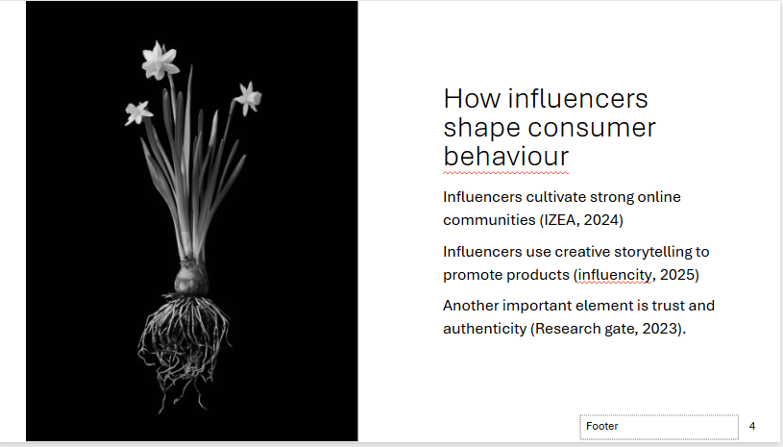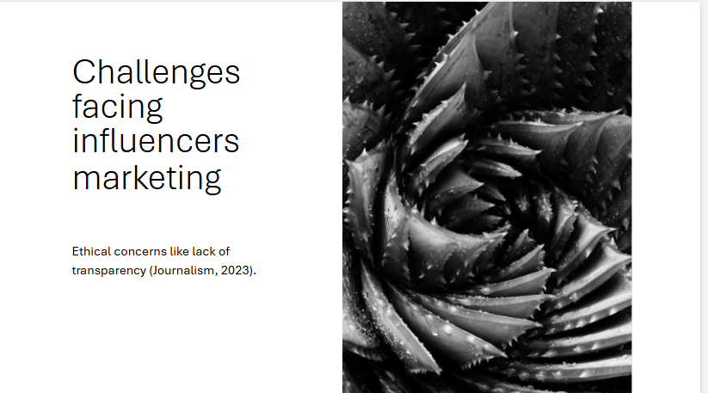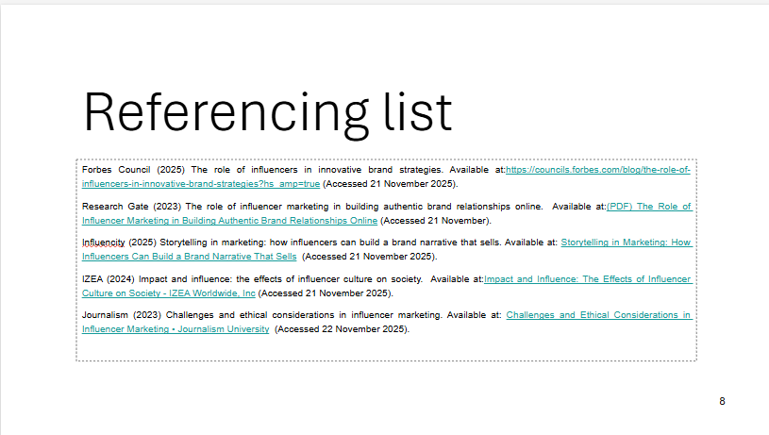

References
Catch Mark (2024) The role of influencers in modern marketing. Available at:The Role of Influencers in Modern Marketing (Accessed 20 November 2025).
Pauly’s Playhouse (2025) The role of influencers in modern marketing magic. Available at:The Role of Influencers in Modern Marketing Magic - Pauly's Playhouse (Accessed 20 November 2025).
Forbes Council (2025) The role of influencers in innovative brand strategies. Available at:https://councils.forbes.com/blog/the-role-of-influencers-in-innovative-brand-strategies?hs_amp=true (Accessed 21 November 2025).
Research Gate (2023) The role of influencer marketing in building authentic brand relationships online. Available at:(PDF) The Role of Influencer Marketing in Building Authentic Brand Relationships Online (Accessed 21 November).
Influencity (2025) Storytelling in marketing: how influencers can build a brand narrative that sells. Available at: Storytelling in Marketing: How Influencers Can Build a Brand Narrative That Sells (Accessed 21 November 2025).
IZEA (2024) Impact and influence: the effects of influencer culture on society. Available at:Impact and Influence: The Effects of Influencer Culture on Society - IZEA Worldwide, Inc (Accessed 21 November 2025).
Mastroke (2024) influencer marketing: shaping consumer choices in the digital age. Available at: Influencer Marketing: Shaping Consumer Choices in the Digital Age (Accessed 22 November 2025).
Journalism (2023) Challenges and ethical considerations in influencer marketing. Available at: Challenges and Ethical Considerations in Influencer Marketing • Journalism University (Accessed 22 November 2025).

