A Report Focussing on:

a single, two storey detached domestic building with a loft room.

Produced for – Debbie Hughes

Produced by – Ryan Evans (1910852)

Date of Completion:
28th April 2020

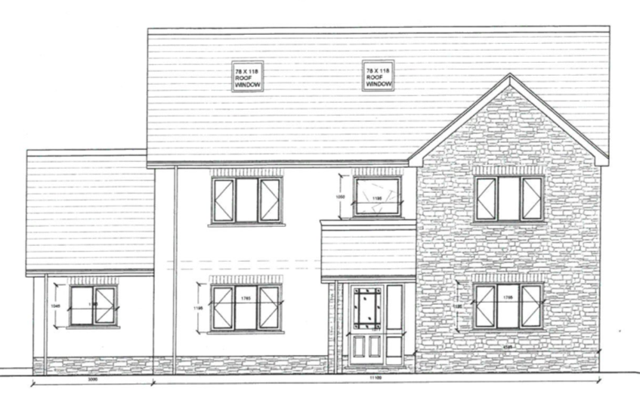

Contents Page
Page 1 – Front Cover
Page 2 – Contents page
Page 3 to 6 – Introduction and Construction Phase Plan
Page 6 – Risk Assessment, manual Handling
Page 7 – working at height, slips trips and falls, asbestos
Page 8 and 9 – Method Statement
Page 10 – References
Page 11- appendices Fig 1 (Manual Handling risk assessment)
Page 12 – appendices Fig 2 (Working at Height risk assessment)
Page 13 – appendices Fig 3 (Slips, Trips and Falls

Introduction
During this report I will be showing the Construction Phase Plan, required Risk Assessments and the required Method Statements I will be implementing in the construction of the domestic dwelling as requested by University of Wales Trinity of Saint David (UWTSD). The dwelling is a single, two storey domestic dwelling which will be used to house the Universities full time Caretaker and their family. Whilst doing this I will be including the relevant Health and Safety issues, the Legislation associated with these issues and who is responsible for implementing them.
CPP
- – Your Name/ Company
R.M Evans Building Services
1.1 – Name/Address of Client
UWTSD - 1 Kings Rd, Swansea SA1 8PH
1.2 – Contact Details of Principle Designer
Jeff Evans – 18 Merthyr Road, Gellideg, Merthyr Tydfil. CF47 8WE
1.3 – What is the job
To build a single, two-storey domestic dwelling with loft space. “The University want to build it adjacent to the new student accommodation on the SA1 site with access directly on to a public highway. This will be accommodation for a full-time caretaker and their family. The proposed foundations are concrete strip to a depth of 1m with standard cavity wall construction, block and block with partial fill cavity insulation and a smooth render externally. Plinths, soldier courses over all openings and porch pillars are to be natural sandstone. There is to be a suspended concrete beam and block ground floor and upper floors are to be traditional solid timber with plasterboard sheet covering. Doors and windows are to be light oak wood effect uPVC with sealed Double-glazed units. Roof structure is to be trussed rafters at a 40⁰ pitch with a natural slate covering and closed eaves.” (D.Hughes 2020)
1.4 – Start/Finish Dates
Start date – 6th May 2020
Finish date – 1st September 2020
1.5 – Where are your toilet/wash and rest facilities.
It has been agreed with the university that all site workers have allowed access to the ‘Technium 2’ building which is part of the University and is situated directly opposite our site. this was deemed beneficial as it will allow extra space on site as it will now not need to house welfare facilities on its grounds. This can help free up space for material storage or delivery spaces etc.
1.6 – Insurances
All contractors to be on site must produce evidence of relevant insurance documents to ensure correct insurance policies are in use.
1.7 – Training
Site managers are to be SMSTS approved and Site Foremen are to be SSSTS approved. All workers on site are to hold CSCS Cards. “The CSCS helps keep workers in the UK's construction industry safe – and therefore sites running smoothly.” (litrg 2020)
1.8 – Access
Due to our site being on the road-side access will be quite simple. We will have signs present stating that there may be works vehicles turning in the road and works site access signs to alert the public using the road to try and maintain a low risk level regarding these issues. Below is an image showing where the site access is situated:
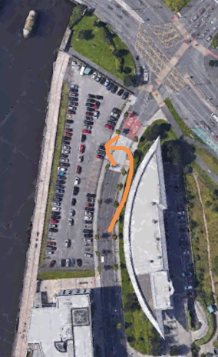
(Google Earth 2020)
1.9 – Security
There is to be a fence surrounding our site to try and secure the area. This is essential not only to avoid theft but also from a Health and Safety standpoint. If there are members of the public trespassing on our site, then they are at risk of injury. Also, there may be some materials on site that are harmful without correct PPE and again this may cause injury. Any materials being left on site shall also be stored out of sight where possible to avoid the risk of opportunists trying to take them off site.
- – Health and Safety Principles
“Managing Director: The managing director is responsible for this policy and its implementation, through senior management.
Project Manager: The project manager is responsible for ensuring this policy follows through on individual projects
Site Manager: The site manager will be responsible for establishing and maintaining safety standards and instructions on the site detailed herein, in compliance with applicable regulations and codes of practice. Safety Reviews: Safety reviews are an ongoing procedure. The safety committee will be responsible for reviewing such procedures and for the implementation of these standards and for updating of safety training requirements for staff and its operatives.
Training: We will provide the necessary training for its own staff to enable everyone to carry out his or her responsibilities in accordance with the act.
Safety Equipment: All safety equipment is to be worn as deemed necessary in accordance with the statutory regulations by all its operatives and sub-contractors (HandsHQ 2016)
2.1- Site Meetings
There will be a site meeting every Friday to discuss site progress of the work with all relevant people. Any contractual issues and any issues with Health and Safety can also be addressed. Obviously if anything needs to be discussed urgently then contact can be made via telephone or email.
2.2 Site Rules
1) Statutory site notices must be erected and displayed within the workspace.
2) Hard Hats must always be worn whilst around areas where people are working at height.
3) Steel Toe capped boots must always be worn.
4) Relative PPE to be worn whilst completing any tasks that require them. i.e. safety goggles etc
5) Run through site specific documentation and any emergency procedures that are site specific during induction. All individuals working on the site are to partake in site induction before they can carry out any work.
2.3 – RIDDOR
RIDDOR puts duties on employers, the self-employed and people in control of work premises (the Responsible Person) to report certain serious workplace accidents, occupational diseases and specified dangerous occurrences (near misses). (HSE 2020)
There will be a file on site to record any accidents and near misses that occur on site during the entirety of construction.
2.4 Health and Safety File.
A health and safety file will be located on site. It will contain:
- Construction Phase Plan
- Risk Assessments for all aspects of work
- Site Drawings
- Site induction forms
- Site forms for visitation
- COSHH register

2.5 COSHH
All work involving the use of substances which are hazardous to health must be completed by a person who is competent in the use of said substances. A COSHH register will be kept in the health and safety file.
Risk Assessment.
Risk assessments are a vital tool and essential for all aspects of construction. Every site will have hazards that have the potential to cause risk to human health. Risk assessments allow us to try and decrease the level of risk to a level where it is deemed safe to work. Legislation requires that we use ‘ALARP’. ““ALARP” is short for “as low as reasonably practicable. The core of the concept of “reasonably practicable”; involves weighing a risk against the trouble, time and money needed to control it. Thus, ALARP describes the level to which we expect to see workplace risks controlled.” (HSE 2020). The HSE has stated that the risk that is deemed acceptable in modern day construction is one in a thousand. The most common form of risk assessment is the Quantitative risk rating method. This is when you have a scale of one to five for the severity of injury if it were to happen multiplied by the one to five scale of the likelihood of that happening. On the scale five would be death or loss of limbs etc and very good chance of it happening and one would be the reverse of this. When multiplying these together it gives you a value and you can see where it lays on the scale. If it is above the green level, then control measures are introduced and the scale is re-evaluated. One of these scales are shown in the image below:
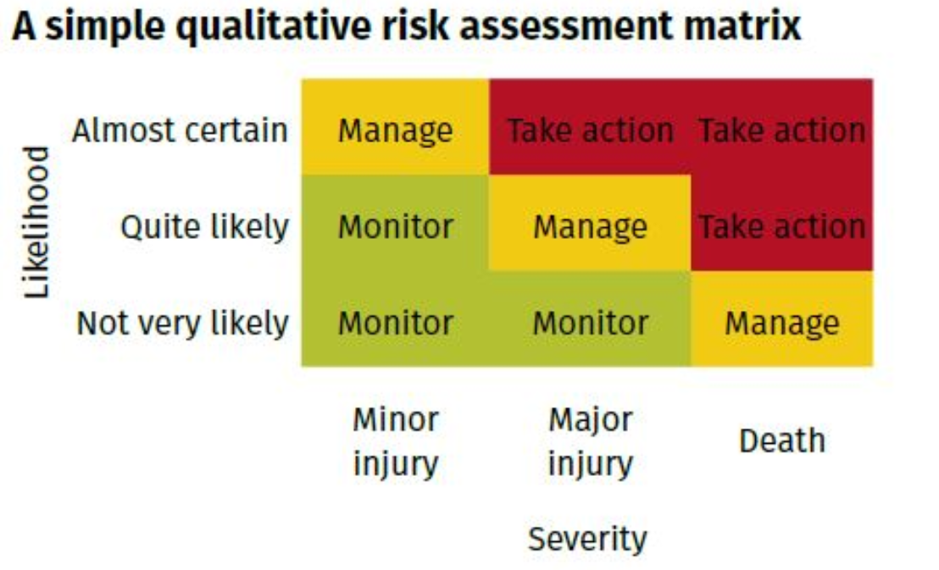
(IOSHMagazine 2020)
As conditions change regularly on a construction site it is vital that these risk assessments are continually revised and altered to suit.
Manual Handling
One of the most basic forms of risk assessment on any site is manual handling. Manual handling injuries can occur very easily and just from lifting something the wrong way even though it is light in weight. This could result in injury which in turn can result in an employee having time off work which could lead to a delay on the completion of work. Manual Handling guidelines can be found in Manual Handling Operations Regulations 1992. “This guidance aims to help employers comply with the Manual Handling Operations Regulations 1992, as amended by the Health and Safety (Miscellaneous Amendments) Regulations 2002. It will help employers – and managers, safety representatives and employees – to control and reduce the risk of injury from manual handling.” (HSE 2020) The Risk Assessment form for Manual Handling can be found in appendices labelled Fig 1.

Working at Height
Working at height is determined when you are working at a height that if you fell from there is a possibility of injury. This can happen even below ground level. There are many different risks involved with working at height. Some of these can include falling through roofs, dropping tools from height or having unstable access equipment. It is important to ensure that as much as possible is done to ensure the safety of people working at height as well as any people that are working around that working area. Working at height is regulated by The Working at Height Regulations 2005. “The purpose of The Work at Height Regulations 2005 is to prevent death and injury caused by a fall from height. If you are an employer or you control work at height, the Regulations apply to you. Employers and those in control of any work at height activity must make sure work is properly planned, supervised and carried out by competent people. This includes using the right type of equipment for working at height. Low-risk, relatively straightforward tasks will require less effort when it comes to planning” (HSE 2020). A Risk Assessment for Working at Height can be found in appendices labelled Fig 2.

Slips, Trips and Falls
Slips, Trips and Falls are probably the most common form of accident in the construction industry. There are many obstacles, uneven surfaces and slippery surfaces on all sites that contribute to the risk of injury. Everyone on site is responsible for the risk of slips, trips and falls. If you are on site and you see a potential hazard, then it is your duty to remove that hazard or to inform somebody who can. All walkways should be made clears, any trailing leads should be covered over, and any appropriate warning signs should be on show. There is no Regulation regarding Slips, Trips and Falls but common sense plays a big part in decreasing the risk. A risk assessment for Slips, Trips and Falls can be found in appendices labelled Fig 3.
Asbestos
Although asbestos is usually a major concern in the construction industry in this occasion it is probably not going to be an issue. The reason for this is that the building is a new build so no asbestos will be in use. However, some sites have asbestos in the land fill so when digging for foundations it is important to do relevant checks for any evidence of asbestos in the ground.

Method Statement for Electrical Installation.
All work must be carried out in strict accordance to the below method statement. If for some reason you cannot carry out any of the steps as stated in the method statement, then contact relevant people to make them aware of any issues.
- – Planned Task
The task is to carry out new electrical installation in a single, two storey new build with loft space. All work should be carried out following any wiring diagrams provided and should adhere to the Electrical Regulations BS7671. Again, any issues with following diagrams should be reported to site supervisor.
1.1 – Access
Access to site is to be gained at front of site of main road as shown in the Construction Phase Plan. All relative signage will be placed on road to show entry into site. However, parking, site office and welfare facilities are located at the opposite side of the road at the Technium 2 building. On arrival please report to site office where induction will take place.
1.2 – Installation
All workers on site require CSCS card. Electricians will be given a time scale of three days to complete first fix electrics and another three days to complete second fix electrics when the build is at that stage. All work is to be carried out in accordance to the BS7671 Electrical Regulations.
1.3 – Protection of others
Electricians on site must ensure that they keep site clean and tidy. All tools must be put away whilst not in use and all debris must be cleaned up as they go. Only 110v power tools to be used on site if needed but battery-operated tools are preferred, all electricians must adhere to control measures implemented after risk assessments have taken place.
1.4 – Emergency Procedures
All emergency procedure and meeting points will be discussed during site induction. Information will also be kept in the Health and Safety File located at the site office for any additional reading required on site procedures.
1.5 – PPE
All electricians shall wear:
Safety boots
High vis vests
Hard hats
Safety goggles when using power tools
Safety gloves to be used
1.6 – Plant
Electricians are only to use 110v power tools, must use insulated tools and can only use fibreglass step ladders.
1.7 Critical Stages
- Arrive at site office for induction
- Install electrical wiring in accordance with site plans and BS7671
- Fix back boxes on walls where required and ‘cap’ cables going down walls.
- Ensure site is clean and tidy
- When ready, second fix property using accessories stipulated on plans.
- Carry out ‘dead’ tests.
- Carry out ‘live’ tests
- Produce test certificate and hand over to site manager.

References
Hughes, D (2020) Task Description
Available at: https://moodle.uwtsd.ac.uk/course/view.php?id=6445
Accessed: 2nd April 2020
Litrg (2020) I am a construction worker: how do I get a CSCS card?
Available at: https://www.litrg.org.uk/tax-guides/migrants/other-migrant-issues/i-am-construction-worker-how-do-i-get-cscs-card
Accessed: 2nd April 2020
HandsHQ (2016) The Construction Phase Health & Safety Plan for Commercial Refurbishment - 21 Example Street
Available at: https://www.handshq.com/assets/example-cpp.pdf
Accessed: 2nd April 2020
HSE (2020) RIDDOR-Reporting of injuries, diseases and dangerous occurrences Regulations 2013
Available at: https://www.hse.gov.uk/riddor/
Accessed: 3rd April 2020
HSE (2020) Manual Handling Operation Regulations 1992.
Available at: https://www.hse.gov.uk/pUbns/priced/l23.pdf
Accessed: 3rd April 2020
HSE (2020) The Law
Available at: https://www.hse.gov.uk/work-at-height/the-law.htm
Accessed: 5th April 2020
HSE (2020) ALARP at a glance
Available at: https://www.hse.gov.uk/risk/theory/alarpglance.htm
Accessed: 5th April 2020
IOSHMagazine (2020) Q is for quantitative risk assessment.
Available at: https://www.ioshmagazine.com/q-quantitative-risk-assessment
Accessed: 7th April 2020

Appendices
Fig 1
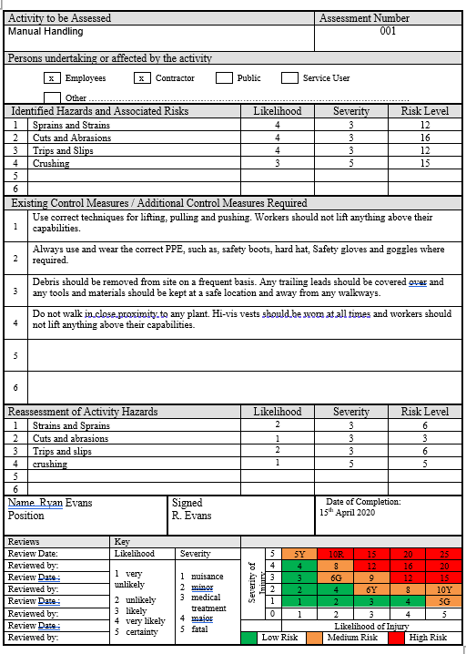
Fig 2
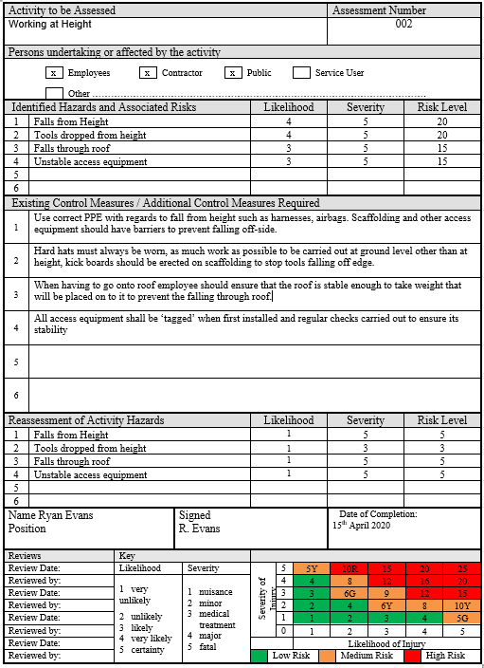
Fig 3


