Synthesize a solution to a potential real life scenario

Author: Ethan Colbeck 2007076
Network & Cybersecurity essentials ACCA 4024
School of Applied Computing
Wales Institute of Science and Art
Submission: 1600hrs, 23rd December 2020
Abstract
This report talks about the current cyber security to threat, how easy it is for a network breach to occur with a demonstrated example, along with how best to combat such an attack along with the implementation of an update cyber security policy.

Today everything is interconnected, whether it is family home network that allows the household to simultaneously use streaming services and talk to one another, or a multi-national business that hosts a continent spanning network to effectively communicate 24 hours a day, it is an essential part of our lives.
But that comes at a cost, with virtually everybody owning a personal device such a smartphone, that can connect to a host of networks, the risk of a cyber security breach increases drastically.
Such cyber security attacks are surprisingly common, with little in the way of hardware or training even required to carry out devastating attacks in an alarmingly short space of time. [1]
In order to combat that this, organisations and their personnel need to develop cyber resilience. In essence this can be distilled down to an intelligent multi layered approach to manage security risks quickly and being able to learn quickly from previous mistakes in a high-risk environment. [2]
This report will cover the networks chiefly used in Che-Si, and how these can be entry points for security breaches with a lack of defensive measures in place, as well the potential attacks that can occur and how to mitigate these risks with appropriate tools, methods and security policies.
Once the weak points of Che-Si’s networks have been pointed out, I will then demonstrate how an attack could occur and what sort of mechanism we can put in place to prevent this, and just how we can implement this into the security policy with the desired outcome accordingly.
Finally, this report will top off with highlighting the importance of updating existing security policy, training methods, etc and any recommendations on making immediate changes.
So, in order to understand how cyber threats can materialise, we need to have a basic understanding of networks; those relevant to Che-Si’s operations.
The definition of a network is as Technopedia puts it “A network, in computing, is a group of two or more devices or nodes that can communicate. The devices or nodes in question can be connected by physical or wireless connections. The key is that there are at least two separate components, and they are connected [3].”
The definition includes networks that can vary from a simple LAN connection from one PC to another, to sharing data on 1,000s of computers and smartphones via cloud storage. [3]
Whilst wired network connections presented their own security risk, the mass exodus to WLAN (Wireless Local area networks, used by just about every type of personal device in modern day) opened a whole host of vulnerabilities and weaknesses within networks, this type of cyber threat will be our focus within this report, simply through the sheer amount of reliance we place on a stable, secure wireless network.
The first inherent risk of WLANs is the signal leakage, as the data is not confined to a physical connection, it can be accessed by third parties without even connecting to the network itself. [4]
One of the first security protocols developed to combat this was WEP (Wired Equivalent Privacy), as defined by Karygiannis and Owens (2003), the security goals of WEP were “Authentication, Confidentiality, Integrity [4]”.
It was designed to provide encryption to protect against eavesdropping “packet sniffing” by making data transmitted unreadable by a third party without the relevant WEP key to decrypt data. [4]
This does not mean WEP was without weaknesses, as stated by Fortress Technologies, and developer of wireless and fixed VPN solutions noted:
“WEP uses one shared static key, which is stored on the user's computer. This enables an intruder to easily obtain the common key and gain full access into the protected network. Intruders can then use LAN equipment to permanently create a new access point on the network. The Media Access Control (MAC) address is communicated in the clear. This is a risk because part of the security information for encryption is stored on the MAC. An intruder can easily obtain this information and use it to break the encryption [5]”.
On top of this, the permanent access point can be created entirely undetected, meaning a breach in the WEP protocol especially dangerous. [5]
From the back of this, WPA2 (wi-fi protected access) was born, as an improvement to the WEP standard across the industry, using a stronger encryption method known as AES (Advanced Encryption Standard) that provides end to end encryption between devices communicating over a network.
According to a report published by Glin and Stasiak-Betlejewska at the Czestochowa University of Technology of Poland, data on a survey posed to 154 companies on the most significant types of cyber threats, showed the following results:
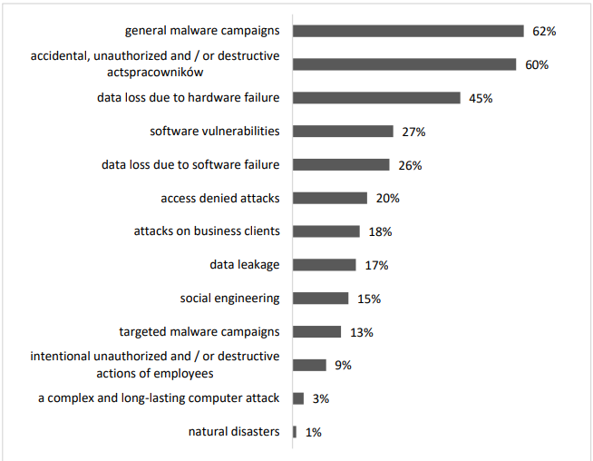[6]
This clearly shows that the cyber threat is a diverse subject, with a myriad avenue of attack and thus, we are presented with a multitude of vulnerabilities to consider.
One of the most basic security changes made industry wide was the switch from WEP to WPA2 connections, but of course WPA2 is not the end-all answer to cyber security, it does not protect from threats from trojan horse malware and viruses that can enter via normal user activities such as opening zipped attachments, clicking links that claim to be the next security patch and so on. [7]
To illustrate my point above, this diagram, from Schneidewind and Normans article on Metrics for Mitigating cybersecurity networks, presents multiple avenues of attack through a US substation network (though many other networks could provide an ample example).
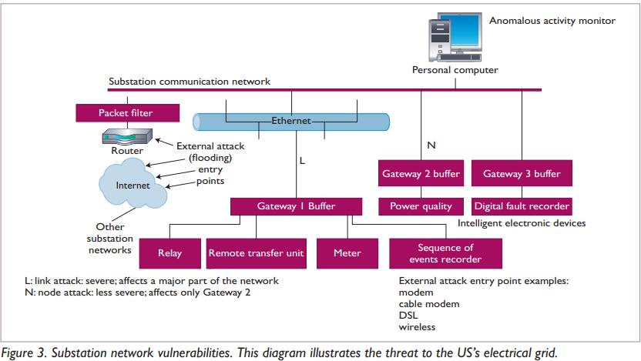[8]
Along with this, in the same article, Schneidewind and Norman showed findings of vulnerabilities through human error based on their survey of US companies, and basic countermeasures to prevent this.
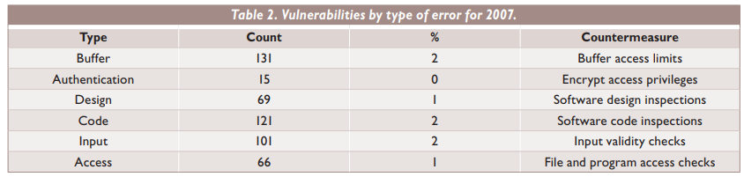[8]
How is all this relevant to Che-Si? Well, Che-Si’s infrastructure has been developed to enable it’s employees to connect into it’s vast network via any personal device with internet capability, and as I stated earlier in the report, this opens up the company to a wide range of attacks.
One of the main issues identified as a vulnerability in Che-Si network infrastructure is that there is no policy on securing a user’s home network whilst they connect to the Che-Si network, and thus open the door for hackers using packet sniffing tools to gain unauthorized access to Che-Si systems.
If Employee A for example, has not set his home router to WPA2 whilst he connects up to the network, he will be an easy target for anyone with even a basic knowledge on how to operate packet sniffing software to access network traffic, I shouldn’t need to explain the disastrous consequences that could occur.
This is a dual pronged failure in Che-Si security policy, and also failure in how the network is set up, to highlight this, I’ll be demonstrating how easy to is to use a packet sniffer tool to gain unauthorized access to an undefended network.
As Miller and Stanley for the Milwaukee Sentinel Journal states “E-mail can travel through a variety of computers over several networks before it reaches its destination. During its journey, anyone can read the message, which is stored in a plain text file that can be opened in several programs.
One quick and easy way for cyber-villains to intercept e-mail, for example, is by "packet-sniffing," using software to watch all of the local traffic on a network. By packet-sniffing, sophisticated hackers not only can acquire e-mail, but also can look in on all of the communication between a computer user and the server, the large network computer that allows access to the rest of the Internet [10]”.
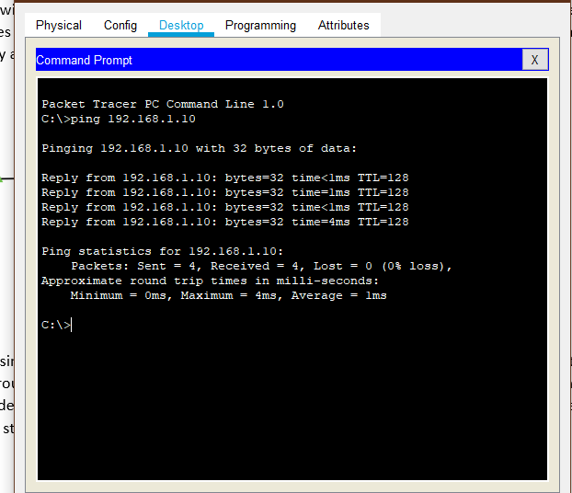
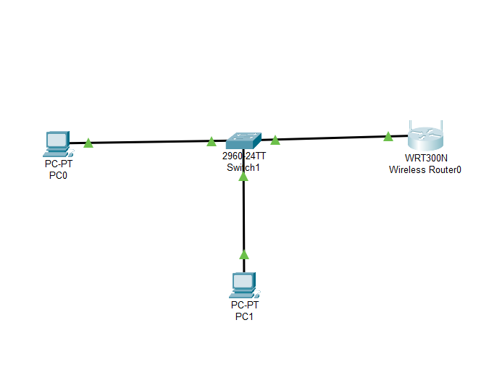
For this I will be using Cisco’s packet tracer software to build a simple home network that Che-Si employees would use in everyday life to connect to the database, and how simple it is for a hacker to employ a packet sniffer tool to intercept data between the user device and router.

Here is a simple network consisting of 2 PCs, connected to a switch which is then connected to a wireless router; for simplicity sake this can be viewed as a home network or a small LAN in the office. I have included a simple ping command to show the two PCs can communicate with one another, assigning static IP’s of PC 0: 192.168.1.11, and PC 1: 192.168.1.10.

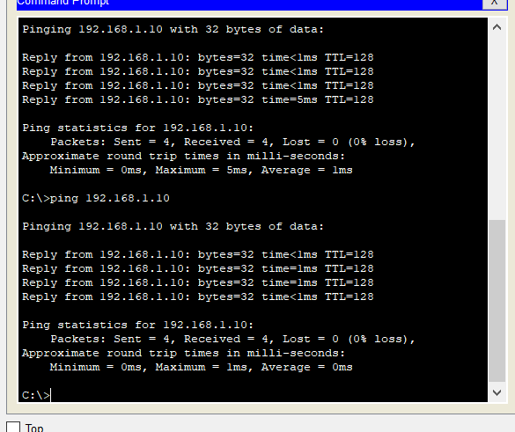
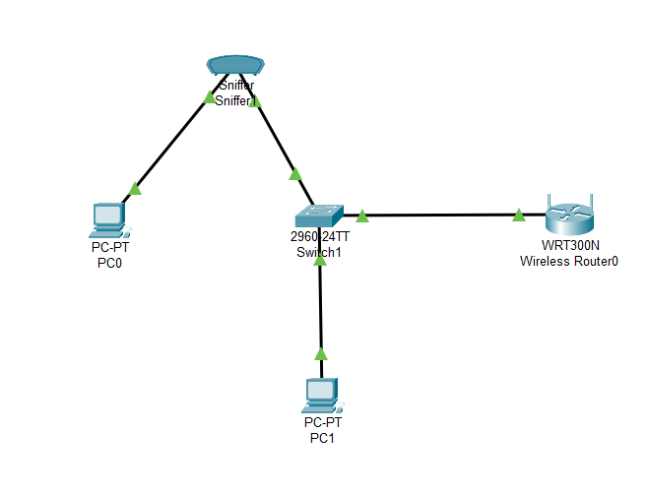
I have introduced a packet sniffing tool to intercept the connection between PC0 and the switch and sent another ping command to PC1 to ensure the connection between the 2 PCs still works, which it does (note the sniffing tool in this software is connected via ethernet but this also simulates a virtual hack into the network connection).
Now it’s a simple case of checking if the packet sniffer has picked up the command sent from PC0 to PC1.
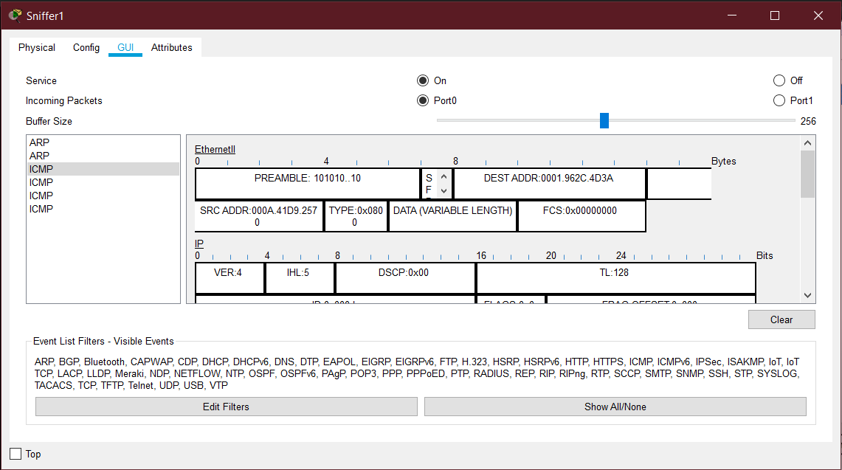
This here shows the packets intercepted by the packet sniffer, in this case we’re looking at the ICMP packets, if you notice, the DEST and SRC boxes show the destination and source MAC addresses, and these should match the two PCs.
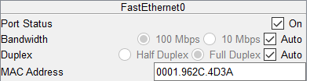
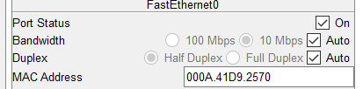
PC 0’s MAC address PC 1’s MAC address
The MAC addresses are correct, showing that the packet sniffer has successfully intercepted the packets on the network, a network this easily accessible is surprisingly common, as Dominion post showed in Newtown, a suburb in Auckland, NZ:
“NetSafe picked up 2643 wireless signals. Of those, 55 were open, or unprotected by a password. Ninety-six had "broken" security - they had security but it was not working, 1792 had "OK" security, and 15 were unknown. Only 685, or 25.9 per cent, of wireless connections in the suburb had state-of-the-art security [9]”.
This sort of security breach could allow hackers to access any part of the information sent between devices, confidential emails and personal data and now I’ve shown just how easy to is to gain access to an unprotected network.
I needn’t state that with the current COVID 19 pandemic that there’s an unprecedented number of employees working from home using their own home networks to connect to Che-Si infrastructure, and with this, ANZ banks risk officer Kevin Corbally stated:
“he believed the biggest threat to the financial sector during the coronavirus shutdown was heightened cyber-criminal activity [10]”.
This risk carries over to the construction industry, and as the international market grows for the business, it helps to be aware statistics showed from Microsoft, the cyber security threat costs Australian businesses roughly $29bn in losses annually [10], extrapolating this over the other countries Che-Si is involved in, coupled with unprecedented amounts of home working and a flawed cyber security policy, means it is more important than ever to have an updated security policy applied to every employee within Che-Si and to have an increased awareness of just how easy it is to have a breach of data from a simple unprotected network.
In conclusion, after identifying the basic flaws in the network of Che-Si, I recommend updating the security policy at the very least to implement and check every network connection, from corporate to home networks, has WPA2 encryption enabled to prevent packet sniffer tools finding easy access points to the databases.
Password policy also needs updating, the use of Password Authentication Modules for system users ensuring a stronger level of security, future work can most certainly be focused on this, as an improvement on my current findings in the failure of Che-Si cyber security policy.
With that being said, I would recommend taking on board my report and redistributing the key info via training sessions held by the cyber security department, with monthly reviews of user knowledge and using packet sniffer tools yourself to discover any breaches in encrypted data in networks you have access to.
This knowledge needs to implemented across all levels of the company, from trainees to the board of executives, as a breach can occur from any device.

References
[1] F. Hult, "What good cyber resilience looks like," Journal of Business Continuity & Emergency Planning, vol. 7, (2), pp. 112-126, 2013.
[2] Anonymous (). Cyber Attacks and Terrorism: A Twenty-First Century Conundrum - ProQuest. Available: https://www-proquest-com.ezproxy.uwtsd.ac.uk/docview/2262020444?OpenUrlRefId=info:xri/sid:primo&accountid=130472 [Accessed Dec 9, 2020].
[3] Anonymous (). What is a Network? - Definition from Techopedia. Available: http://www.techopedia.com/definition/5537/network [Accessed Dec 11, 2020].
[4] K. Curran and E. Smyth, "Demonstrating the Wired Equivalent Privacy (WEP) Weaknesses Inherent in Wi-Fi Networks," Information Systems Security, vol. 15, (4), pp. 17-38, 2006. Available: https://ezproxy.uwtsd.ac.uk/login?url=https://search.ebscohost.com/login.aspx?direct=true&db=bth&AN=22287937&site=ehost-live. DOI: 10.1201/1086.1065898X/46353.15.4.20060901/95121.3[AccessedDec 11, 20202020 ].
[5] Anonymous "Fortress' Sps Protocol Solves Wep Security Weaknesses," Computer Protocols, vol. 14, (4), pp. 1, 2001. Available: https://ezproxy.uwtsd.ac.uk/login?url=https://search.ebscohost.com/login.aspx?direct=true&db=bth&AN=4365856&site=ehost-live[AccessedDec 11, 20202020 ].
[6] Gliń, W., & Stasiak-Betlejewska, R., "Gliń, W., & Stasiak-Betlejewska, R. (2020). Threats in Cyber Safety - Outline of the Problem, System Safety: Human - Technical Facility - Environment, 2(1), 349-356. doi: https://doi.org/10.2478/czoto-2020-0043," pp. 349-356., 2020. Available: https://doi.org/10.2478/czoto-2020-0043.
[7] M. Ashley, "New practices in wireless security," Communications News, vol. 41, (6), pp. 30-33, 2004. Available: https://ezproxy.uwtsd.ac.uk/login?url=https://search.ebscohost.com/login.aspx?direct=true&db=aph&AN=13357150&site=ehost-live[AccessedDec 17, 20202020 ].
[8] Anonymous (). Metrics for Mitigating Cybersecurity Threats to Networks - ProQuest. Available: https://search-proquest-com.ezproxy.uwtsd.ac.uk/docview/197314576/fulltextPDF/DB0F5CAF818C4F97PQ/1?accountid=130472 [Accessed Dec 21, 2020].
[9] Anonymous (). Anyone in the world may be reading your e-mail Security programs can protect exchanges from interception or tampering: [All Edition] - ProQuest. Available: https://search-proquest-com.ezproxy.uwtsd.ac.uk/docview/260860834/fulltext/96F8B93DDEC24303PQ/1?accountid=130472 [Accessed Dec 23, 2020].
[10] Anonymous (). NetSafe raises alert over risks to unprotected wi-fi networks - ProQuest. Available: https://search-proquest-com.ezproxy.uwtsd.ac.uk/docview/1355953651?pq-origsite=primo&accountid=130472 [Accessed Dec 23, 2020].

