

Student name: Bruna Moraes Goncalves
Student ID: 2440011

Module name: Introduction to Health and Social Care
Module code: LCHS4003
Supervisor’s name: Jolly Nwankwo

  This Photo by Unknown Author is licensed under CC BY-NC-ND |  | COMMUNITY ANTENATAL MIDWIFERY SERVICES  Community midwives and maternity support workers look after you during your pregnancy (antenatal care) and after your baby is born (postnatal care). They work in local clinics, GP practices, children’s centres, and sometimes visit you at home. They are also on call for home births and help support the Birth Centres. Most women first meet the community midwifery team when their pregnancy is confirmed, so they are usually your first point of contact. |  | 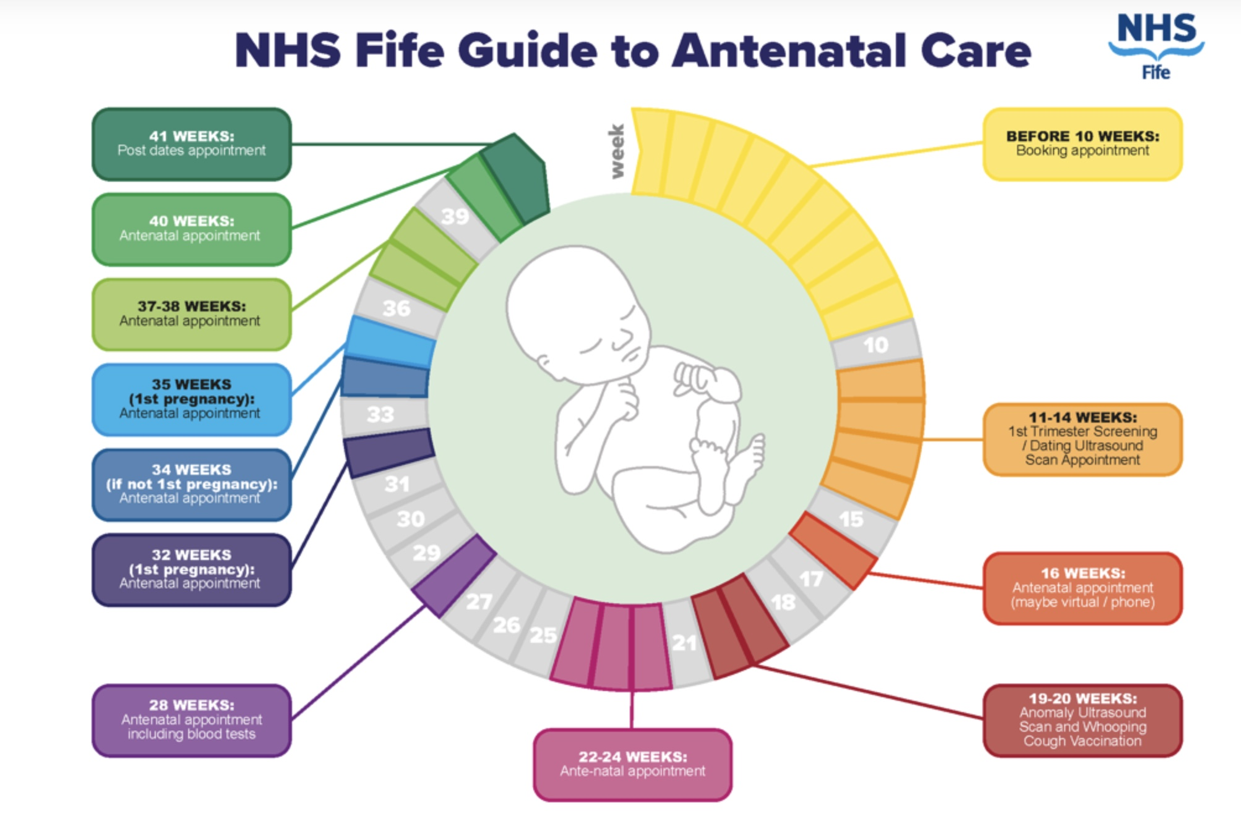
History  Midwifery became officially recognised in Britain in 1902 with the first Midwives Act. Even after this, many women were still supported by midwives who had no formal training. As Leap and Hunter (1993:1) explain, “Before the First World War and, in some areas, until the mid-1930s, most working-class women in Britain were attended in childbirth not by a professional but by a local woman. ”The Midwives Act allowed these lay midwives to keep working because there were very few trained midwives at that time (Heagerty 1997). However, there were deadlines: by 1905, all midwives had to register as “bona fide,” otherwise they could not call themselves midwives (Heagerty 1997). After 1910, bona fide midwives were no longer allowed to attend births on their own; they had to be supervised by a certified midwife or a doctor. |  |  |  | Current State  The Maternity Transformation Programme. The Maternity Transformation Programme aims to achieve the goals of the Better Births plan. It brings together many different organisations to lead and deliver work across 10 work streams. The programme is led by a Programme Board, which is supported by a group of stakeholders. This group helps to review, question, and challenge the decisions made by the Board. Local change, supported by national guidance, is essential to achieving the vision of Better Births. Providers and commissioners of maternity services have created Local Maternity Systems. These systems plan how maternity services will be designed and delivered for populations of between 500,000 and 1,500,000 people.
Harnessing digital technology:
NHS X is leading this work to develop and introduce digital maternity records that women can keep and use to manage their own care. By September 2019, 105,000 women had been offered access to their digital maternity record, and 60% of them used it. This progress is ahead of the original target date of April 2020. Reforming the payment system: NHS England has already made some small changes to the current tariff to help deliver the Better Births plan. Now they are working on a bigger change, using a blended payment model. Once this new model is confirmed, the aim will be to support Local Maternity Systems to make the best use of it.

References
NHS, C. (n.d.). CHFT website. Www.cht.nhs.uk. Retrieved November 12, 2025, from https://www.cht.nhs.uk/services/clinical-services/maternity-services/wards-and-services/community-midwifery

NHS England. (2021). NHS England Maternity Transformation Programme. England.nhs.uk; NHS England. https://www.england.nhs.uk/mat-transformation/
Fife, N. H. S. (2020, July 21). Antenatal care schedule. NHS Fife. https://www.nhsfife.org/services/all-services/maternity/antenatal-care/antenatal-care-schedule/

TASK 2
In July 1948, the National Health Service (NHS) was created, with the main purpose of providing free healthcare to all people in the United Kingdom, regardless of income, employment, or social class. Some doctors and dentists disagreed at first, because they worried about losing private income, but the plan was approved anyway, and society celebrated the chance to receive care without direct payment.
In the early 1950s, the government reduced health funding and introduced charges for prescriptions, glasses, and dental care, but even with these changes, the general level of public health improved, with a significant fall in infant mortality and the introduction of major vaccination programmes such as polio and diphtheria in 1958. The NHS faced long waiting lists, during the 1960s, staff salary problems, and continued financial pressures, but most people still supported the service because it represented fairness, equal access, and social justice. New district hospitals were built, social care services were reorganised, and student nurses were highly involved in direct patient care, showing how the nursing profession played a central role in delivering hands-on services. In 1969, nurses received a 20% pay rise, but in the 1970s, even with more funding available, disputes about salary continued, and complaints increased about growing administration and bureaucracy. The NHS was reorganised again in 1974, and following the Halsbury Review, many members of staff received large salary increases, especially nurses. In the 1980s, the government introduced important reforms, including “general management” and the creation of the Nurses Pay Review Body, designed to improve professional standards and salary fairness.
Another major change was Project 2000, which moved nursing education from hospitals to universities, helping to increase theoretical knowledge, academic development, and professional recognition. Towards the end of the decade, the internal market was introduced as a way to increase competition and improve efficiency in healthcare provision. Throughout the 1990s, new organisational structures continued, including the creation of NHS trusts and the start of NHS Direct, which offered telephone health advice to the public. Funding for new hospitals often came through Private Finance Initiatives (PFIs), but this raised concerns because many services, such as cleaning and catering, were outsourced to private companies, which some professionals believed could affect service quality and staff rights. In 1992, nurses finally obtained legal permission to prescribe some medicines, expanding their responsibilities and autonomy in patient care.
During the 2000s, the government introduced a ten-year plan to modernise the NHS and, in 2004, launched the Agenda for Change pay system designed to standardise salary bands, job roles, and progression. Other important organisations were created, such as foundation trusts, the Care Quality Commission, and the NHS Constitution, which helped structure responsibilities, accountability, and quality of care. In the 2010s, further reforms transformed nursing into a fully degree-level profession, increasing academic requirements and professional status. In 2017, the role of Nursing Associate was introduced to support healthcare delivery, help reduce staff shortages, and strengthen the workforce between healthcare assistants and registered nurses. In the 2020s, instead of celebrating the 200th anniversary of Florence Nightingale, the world faced the serious COVID-19 pandemic. The NHS created temporary Nightingale hospitals to increase capacity, but staff worked under very difficult conditions with lack of personal protective equipment, emotional pressure, staff shortages, and many losses. After the pandemic, strikes occurred among nurses and other professionals demanding better pay, working conditions, and safety.
Today, the NHS is a large and complex structure that works at national, regional, and local levels, including hospitals, GPs, mental health services, and community care. Public opinion shows mixed feelings: although 13% of people think care has improved, 38% think it has become worse, and expectations about the future are still mostly negative. People tend to be more satisfied with local services, where 46% say they receive good care, but only 32% believe the NHS provides good service nationally. Only 16% agree that the government has the right policies, which shows concern about long-term planning, staffing, and funding.

Memories of Nursing. (2017). Midwifery in Britain in the Twentieth Century - Memories of Nursing. Memoriesofnursing.uk. https://memoriesofnursing.uk/articles/midwifery-in-britain-in-the-twentieth-century

Mind the gap: public perceptions of the NHS and social care. (2023). The Health Foundation. https://www.health.org.uk/reports-and-analysis/briefings/mind-the-gap-public-perceptions-of-the-nhs-and-social-care

Royal College of Nursing. (2023, July 4). NHS 75: the history of our National Health Service | RCN Magazine | Royal College of Nursing. The Royal College of Nursing. https://www.rcn.org.uk/magazines/History/2023/July/NHS-75-anniversary-history-of-the-National-Health-Service

