

LEVEL 6

SEMESTER 2

MODULE CODE: SHSS6078
Assessment in Physical Education
aSSESSMENT TYPE: aSSIGNMENT
Assessment/Component: 1
COMPONENT WEIGHTING: 50%
WORD COUNT: 3000 WORDS
MODULE TUTOR: Dylan Blain

Assessment portfolio:
You are a Physical Education teacher and have been tasked with preparing a report for a pupil who is moving on from your school. As part of the process you are required to create and use an assessment rubric which is firmly based in the literature surrounding the valued outcomes for physical education. Once the assessment is complete and report written, you are required to reflect upon the effectiveness of the assessment process undertaken.
The portfolio should contain four parts:
- A detailed rationale underpinning the creation of the rubric. This should be firmly based on high quality and relevant literature form the field.
- An assessment rubric to assess outcomes within a physical education lesson (please include a copy of the completed assessment).
- Having used the rubric to assess a pupil, a report detailing the pupil’s current levels and their next stages of learning.
- A critical reflection on the effectiveness of the assessment process undertaken. Use relevant literature to support this.

SUBMISSION DETAILS: 12th of April 2019, 3pm.

School of Sport, Health & Outdoor Education

Assessment Feedback Sheet

Student No./Name:
Module:
Module Code:

Personal Evaluation – to support your academic progress please complete the section below BEFORE submitting your work.
What do you consider to be the best aspects of this work?
Which aspects do you consider could have been improved in this piece of work?
What have you found most satisfying whilst undertaking this submission?
ASSESSMENT CRITERIA | Learning  Outcomes |  | GRADE
ASSESSMENT CRITERIA |  |  | Poor  0-25% | Unsatisfactory  26-39% | Satisfactory  40 – 49% |  | Good  50 – 59% | Very Good  60 – 69% | Excellent  70 – 85% |  | Exceptional  86– 100% | %
Quality of rationale and detailed outline of assessment rubric | 1, 2, 3 |  |  |  |  |  |  |  |  |  |  | 50%
Pupil report | 2 |  |  |  |  |  |  |  |  |  |  | 25%
Reflections on the assessment process | 1, 2, 3 |  |  |  |  |  |  |  |  |  |  | 25%
It is expected that students will present work that is proof read, correctly referenced and adheres to the Assessment Checklist. Therefore a range of 0 – 10 marks will be deducted for non-completion of any of the points on the checklist below.
TUTOR COMMENTS:

Submission date:  via Turnitin |  | Return date:  (at least within 4 weeks) |  |  |  | Tutor: |  |  |  | Mark:

Rationale

Physical education can be a broad and complex subject. In order to create an assessment rubric, it is vital to first understand what physical education actually is, and what the aims of the subject are. Coultera and Ni Chroinin (2013) found that the terms “physical education” and “sport” are often interchangeable when in a school context. Physical education is often perceived to be a break from regular school activities – an opportunity for students to run off some steam. Often the purpose of physical education was to learn about sports and activities in order to stay fit and healthy. While the general public’s view of physical education may be that of only fun and enjoyment – Baily et al., (2009) found many advantages of physical education and school sport, in relation to the children’s relationship with sport and physical activity as well as their academic performance.
They found that positive engagement in PE led to the development of children’s movement skills and physical competence. While this may be obvious however, they also concluded that engagement in PE also led to numerous instances of emotional and psychological development. These are skills which are essential for a child to maintain a lifelong interest in sport and physical activity, which is a vital aspect of a healthy lifestyle. This paper also found that regular physical activity can lead to improved concentration and arousal – which in turn may benefit their academic performance. Bearing this in mind, it is trivial to assume physical education is nothing more than an extended break time – or a chance for the sports team to improve. Considering then the potential future benefits of a full and engaging physical education, the aims and objectives of physical education must be fully measured in order to design an appropriate and effective assessment rubric.
Whitehead (2000) closely examines both the need for understanding the aims of PE and the actual nature of those aims – specifically whether PE is an end in itself or rather a means to an end. Where you place PE as a subject can change what the aims are – if you identify PE as an end in itself, then the overall goal would be to develop the children’s physical skills. This then provides the children with the tools to engage in physical activity outside of a school setting. This is a valid aim – physical education must prepare children for a future of physical activity. By taking this approach, when children find themselves in an environment that requires competence in physical activity, they are well equipped and therefore prepared. However what if a child does not want to engage in physical activity? Yes their PE lessons has enabled them to take part, but that doesn’t mean they are necessarily more motivated to do so. Also, they may have an advanced set of physical skills, but that doesn’t necessarily enable them to communicate and work with their peers.
If PE lessons are a means to an end – the children will have an opportunity to develop their personal and social skills. This is also a valid aim – PE lessons should develop the children’s personal and social skills, in order for them to improve in other subjects. If this was the sole aim however then PE is not necessarily worth being a subject in itself. Clearly PE lesson should be both an end in itself and a means to an end. I.e. the aim physical education should be to develop a child’s physical, personal and social skills – for their immediate physical experiences as well as their wider academic and future experiences.
This idea can effectively be summed up with Whitehead’s (2006) idea of physical literacy. In that physical education lessons should allow the children to become physically literate. For a child to become physically literate – they are deemed able to not only “do” an activity, but they are also able read and environment and respond effectively. Physical literacy contains many components – not only to be physically able but to have a development of self-realisation, self-confidence and positive self-esteem. ‘Physical literacy can be described as the motivation, confidence, physical competence, knowledge and understanding to value and take responsibility for engagement in physical activities for life’ (IPLA, 2017). How can this be applied to assessing physical education however? If we agree the aim of PE lessons are for children to become physically literate, how do judge it?
A simple way to break down the components of physical literacy, is to consider the 4 domains of physical education (Baily et al., 2009). These domains are: Physical, social, cognitive and affective. Each of these domains are very different and if a child was to develop extensively in each of the four, then they can consider themselves to be fully physically educated – or physically literate. So what does each domain involve? First the physical. This domain is essentially about physical competence - this includes fundamental movement skills, object control and general physical skills. This domain is very important because this is the starting point of any physical activity. Take football for example, the physical domain will cover running, dribbling the ball and shooting. These are essential skills to take part in the sport. This is then paired up with the cognitive domain – this involves knowledge and understanding of the game, rules and more importantly tactics. A child will know how to run, dribble and shoot through developing the physical domain however by developing the cognitive domain then they will gain an understanding and feeling of when to shoot, when to pass, i.e. they can institute tactics to improve their game.
The social domain involves leadership, communication and cooperation. This can improve your relationship with your teammates, peers and even your coach/teacher. Also, while it is important to become a better player – in relation to your physical ability and knowledge of the game and tactics – it is equally important to have good sportsmanship. Especially seeing as this is a relatable skill. I.e. in other academic areas. The fourth and final domain is often overlooked, however it holds great importance for sport and physical activity. The affective domain involves motivation, confidence and self-esteem. This can be arguably be the most important domain in terms of physical literacy. Being physically literate is the key to maintaining lifelong physical involvement. Therefore it is vital for children to have positive self-esteem towards physical activity and to be self-determined, seeing as when they leave school they won’t have a teacher telling them to exercise and take part.
The individual importance of each domain is clear to see. It can be widely agreed then that the purpose of physical education if to develop children’s physical literacy in order for them to maintain lifelong participation of physical activity. Therefore, in order to assess physical education, the children must be assessed against each of the four domains.

Pupil report
(For the purposes of the report, the pupil being assessed will be referred to as “child A”)

Child A is very enthusiastic when it comes to physical education. Be it during the warm up, main activities or cool down, child A gives their full attention to the task at hand. During explanations and demonstrations they give their undivided attention to the teacher or their peers and when it is time to take part, they do so without hesitation. Child A embraces a positive attitude towards sport and physical activity – while they don’t appear to prioritise physical activity in their personal life, during lessons they seem very engaged and make an effort to get involved and do their best.
Child A demonstrates a very advanced ability in javelin - they possessed a very firm foundation of skill prior to the lesson and they developed their skills throughout the session. Child A responded very maturely to the teacher’s constructive criticism and took their advice on board to further develop their skills. As well as correct technique, child A demonstrated good accuracy – consistently hitting targets. In order to further develop, child A should continue practising using targets – gradually decreasing the size. Also, when appropriate introduce a run up, this will increase power and therefore distance.
Child A demonstrates maturity and distinguished social skills in relation to other pupils. Particularly during javelin, when other pupils were struggling, child A would offer help and advice. They appeared to respect the other pupils’ ability – both in instances where others were better or worse – and never hesitated to assist where they could. Child A possesses good communication skills: when offering help or advice they use constructive and appropriate language. During activities they consistently voice any concerns with their peers or teacher and engage in appropriate discussions during cooperative tasks.
Despite being helpful towards other pupils and offering advice, child A struggles with receiving constructive criticism from their peers. They appear to be fine with receiving feedback from the teacher however. Child A is a very confident pupil and is often eager to take the leadership role in group role however the aversion to receiving feedback from their peers could present issues in their future activities. Therefore future interventions could include placing child A in more cooperative based environments where another pupil takes the lead roles. Seeing as child A shows enthusiasm towards all of their tasks – this intervention may assist in developing this specific social skill.
For future development, child A should look towards improving their basic fitness and coordination. What child A lacks in physical ability, they appear to more than make up for in their attitude and effort levels. Therefore more focus on improving health and fitness should lead to future development of their fitness. It appears a lack of fitness is holding back their development in the physical domain. Interventions could include a focus on educating health, fitness and well-being.

Reflections

Assessment is a key aspect of education - ‘how do you know your students have learned what you intended them to learn?’ (Metzler, 2011). Seeing as assessing pupils is important, possessing the appropriate tools for good assessment is vital – and so this assessment opportunity was very useful. It was very important to design an appropriate assessment rubric, therefore it was important to understand why assessment is important. According to Lockwood & Newton (2004) assessment can help indicate strengths and weaknesses, this directly allows you to identify the individual needs of the pupil. Assessment can also go both ways, an assessment can not only be a reflection on the pupil’s development but also on the effectiveness of the teaching. The teacher can identify the aspects of their teaching which are successful and which require improvement. Taking this into account, the assessment rubric must reflect these aspects. A good rubric should aim to identify the positive and negative aspects of a child’s development. It was important for the rubric to have clear purposes and performance needs to be measured against clear criteria (Lockwood & Bowler, 2013).
Keeping this in mind, I ensured the rubric would be simple to read and understand with clear information. In order to have a broad understanding of a child’s ability the rubric would be split up into 4 sections – each with more specific titles. This way the rubric will provide information both broadly and specifically. For example, a quick look the rubric will tell you this child is level 3 in the physical and cognitive domains, level 4 in the social domain and level 5 in the affective domain – overall they are level 4. This information can be understood relatively quickly and will give a clear indication of the child’s current ability, the rubric will then give more specific scores within each of the domains. I opted to use both a level system (i.e. level 1-5) and an achievement scale (i.e. very limited – excellent). This is to accommodate the children in the assessment process. This particular assessment is summative and so the children aren’t necessarily going to see it, however should this be used as a formative assessment – the child may see the rubric. Levels may seem irrelevant to a child and they may not fully understand what that means about their performance – by using terms such as limited and accomplished however, it suddenly becomes easier to understand.
This assessment did lack in some areas however. During the lesson I was not able to observe the child carrying out any problem solving or reflective tasks. This meant I couldn’t calculate a clear score for the cognitive domain. Likewise, I couldn’t assess the child’s motivation or their approach towards fair play, so this effected their affective domain score. This is because the lesson was not planned with the assessment in mind – I created the rubric but I didn’t plan the lesson, this meant some of the things I intended to assess didn’t get covered in the lesson. Assessment must go hand in hand with the lesson – it is unfair to assess and draw judgement on a child without giving them the best possible opportunity to prove their performance. For example, to assess the social domain – they should be given a cooperative task where they have more time and opportunity to show their social skills. Cooperative learning would allow the assessor to observe the child’s social skills. Cooperative learning is also a very useful tool for developing not only social skills but can be very effective at developing motor skills. Cooperative learning also allows children to take responsibility for their own learning. (Dyson and Rubin, 2003).
As well as integrating lesson planning and assessment, for future assessments I would pay more attention to the work of Dudley (2015) regarding observations of physical literacy. The SOLO taxonomy seems to provide a form of assessment without fault. The progressive aspect of it ensures both the learner and the assessor knows exactly what they need to do to improve. The need to fulfil all criteria in a section before moving on also ensures that the grading is valid and reliable. With my rubric, there it the potential that the learner could be assessed wrong by chance. For example – balance. A child may walk across a balance beam perfectly one time and so they would achieve a perfect score, but there isn’t a guarantee that they maintain balance while sprinting or after jumping. Potentially the criteria in my rubric is subjective, therefore it is not valid for assessment. The solo taxonomy however is very detailed in its criteria and because you have to fulfil the criteria in each section, there can be no suggestion of getting a high mark through luck. The solo taxonomy appears to produce valid and reliable assessments.
Finally, for future assessments I would prefer to assess children over a number of sessions – potentially carrying out 4 periods of assessment to target each of the domains. This would eliminate the risk of brushing over certain areas. Also, physical activity can be subjective and contextual. If a child isn’t feeling 100% they cannot hope to perform at their regular ability. Physical education is unique as a subject because of the obvious physical aspect – therefore when assessing children they should ideally be feeling fully healthy in order to give an assessment reflecting their actual abilities.

Word count 2820

Domain | Grade | Level 1  Very limited  (0-20%) | Level 2  Limited  (21-40%) | Level 3  Accomplished  (41-60%) | Level 4  Strong  (61-80%) | Level 5  Excellent  (81-100%) | Notes | Total
Physical | Movement skills |  | X |  |  |  | The child had very limited physical ability. The child became very out of breath during the warm up and throughout the session they needed to take regular breaks. Alternatively they showed very ability when throwing javelin – they showed very good technique and excellent accuracy. | 14 /30  47%  Level 3
Physical | Fitness | X |  |  |  |  |  | 14 /30  47%  Level 3
Physical | Coordination | X |  |  |  |  |  | 14 /30  47%  Level 3
Physical | Development of skills |  |  | X |  |  |  | 14 /30  47%  Level 3
Physical | Objet control |  |  |  |  | X |  | 14 /30  47%  Level 3
Physical | Balance |  | X |  |  |  |  | 14 /30  47%  Level 3
Social | Leadership |  |  |  |  | X | The child was briefly given the chance to show leadership during the warm up however on the whole this lesson wasn’t catered to show leadership skills. The child was consistently ready to offer help and advice where they felt appropriate – for example during the javelin. On the other hand however they struggled to accept help from their peers. Alternatively they were happy to receive help from the teacher. | 20 / 30  67%  Level 4
Social | Working with others |  |  | X |  |  |  | 20 / 30  67%  Level 4
Social | Communication |  |  | X |  |  |  | 20 / 30  67%  Level 4
Social | Offers help and advice to peers |  |  |  | X |  |  | 20 / 30  67%  Level 4
Social | Response to help and advice from peers | X |  |  |  |  |  | 20 / 30  67%  Level 4
Social | Sportsmanship |  |  |  | X |  |  | 20 / 30  67%  Level 4
Cognitive | Knowledge and understanding |  |  | X |  |  | The child was not given the opportunity to show their problem solving skills or reflective skills – therefore they have not been given a mark for these two. | 10 / 20  50%  Level 3
Cognitive | Awareness | X |  |  |  |  |  | 10 / 20  50%  Level 3
Cognitive | Tactics |  | X |  |  |  |  | 10 / 20  50%  Level 3
Cognitive | Follows the rules and instructions |  |  |  | X |  |  | 10 / 20  50%  Level 3
Cognitive | Problem solving | N/A |  |  |  |  |  | 10 / 20  50%  Level 3
Cognitive | Reflection | N/A |  |  |  |  |  | 10 / 20  50%  Level 3
Affective | Motivation | N/A |  |  |  |  | The child’s motivation could not be identified in this lesson and they were not given the opportunity to demonstrate fair play. Therefore they have not been given a mark for these two. | 19 / 20  95%  Level 5
Affective | Effort |  |  |  |  | X |  | 19 / 20  95%  Level 5
Affective | Fair play | N/A |  |  |  |  |  | 19 / 20  95%  Level 5
Affective | Attitude |  |  |  |  | X |  | 19 / 20  95%  Level 5
Affective | Engagement |  |  |  | X |  |  | 19 / 20  95%  Level 5
Affective | Confidence |  |  |  |  | X |  | 19 / 20  95%  Level 5
Total = 65% level 4

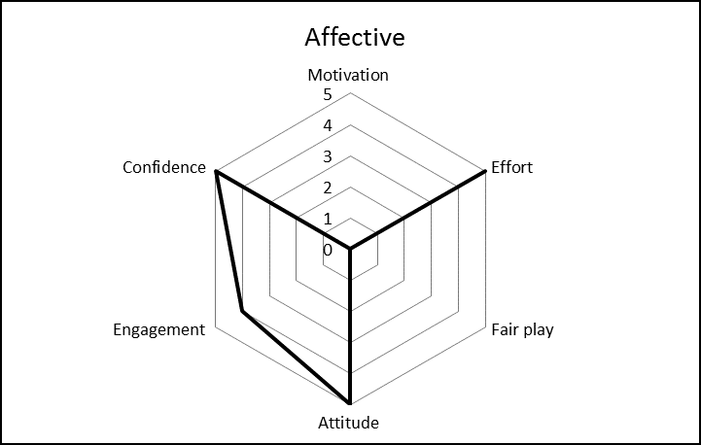
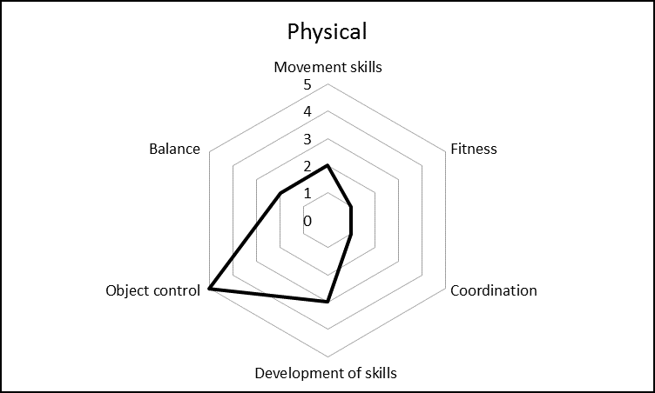

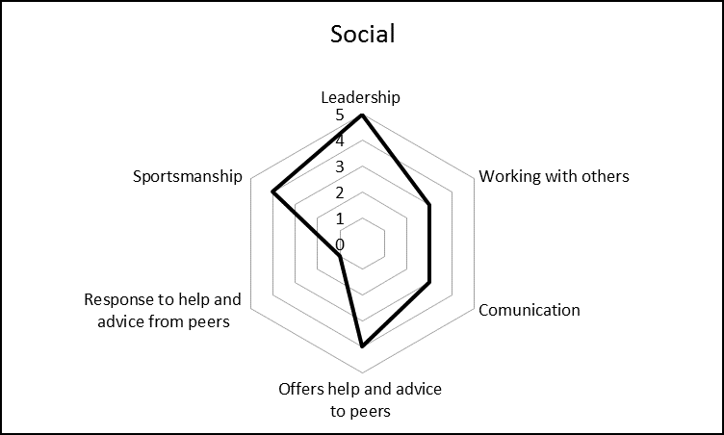
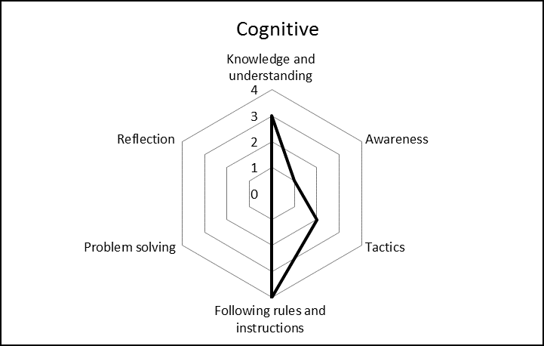

Referencing

Bailey, R., Armour, K., Kirk, D., Jess, M., Pickup, I., Sandford, R. and BERA Physical Education and Sport P (2009). The educational benefits claimed for physical education and school sport: an academic review. Research Papers in Education, 24(1), pp.1-27.
Coulter, M. and Ní Chróinín, D. (2013). What is PE?. Sport, Education and Society, 18(6), pp.825-841.
Dudley, D. (2015). A Conceptual Model of Observed Physical Literacy. The Physical Educator.
Dyson, B. and Rubin, A. (2003). Implementing Cooperative Learning in Elementary Physical Education. Journal of Physical Education, Recreation & Dance, 74(1), pp.48-55.
IPLA. (2017). International Physical Literacy Association. [online] Available at: https://www.physical-literacy.org.uk/ [Accessed 8 Apr. 2019].
Lockwood, A. & Bowler, M. (2013) ‘Assessment for and of learning’ in Capel, S. & Whitehead, M (Eds). Learning to teach physical education in the secondary school. London: Routledge.
Lockwood, A. & Bowler, M. (2013) ‘Assessment for and of learning’ in Capel, S. & Whitehead, M (Eds). Learning to teach physical education in the secondary school. London: Routledge.
Metzler, M.W. (2011). Instructional models for physical education (third edition). Scotsdale, Arizona: Holcomb Hathaway.
Whitehead, M. (2000) ‘Aims as an issue in physical education’, in Capel, S & Piotrwosky, S Issues in Physical Education Lewes: Falmer Press.

