
Skills for the Workplace
Module Assignment Submission
Student Name: | Sara Jayne Griffiths
Student Number: | 1302902
Module No: | BMSK4006
Module Title: | Part 2 Reflection

Statement of Confirmation of Authenticity
By the act of making this submission, the student declares that this is the work of the student named above. The work has not, in whole or in part, been knowingly presented elsewhere for assessment, or where assessment has been built on a previous assessment, this has been identified. Where materials have been used from other sources it has been properly acknowledged. If this statement is untrue, the student acknowledges that an assessment offence has been committed.
Attention is drawn to the plagiarism and unfair practice policies of both the University and of ILM.

Table of Contents
Part 2: Reflection on Skills developed during the Business Plan Project 2
2.1 Description 3
2.2 Feelings 3
2.3 Evaluation 3
2.4 Analysis 3
2.5 Conclusion 4
2.6 Action Plan 4
References 4

Part 2: Reflection on Skills developed during the Business Plan Project


Gibbs (1988)

2.1 Description
Sara’s Signature Glamour is a new business supplying all aspects of cosmetics and beauty products on an online platform. Utilising our unique buying power we can offer massive discounts on the high-street prices therefore offering you the customer a “Signature “discount.
Having looked at various businesses I looked at what I know best and that’s make up and beauty products. The high-street market was a good start but looking further down the line and having first-hand knowledge of purchasing from the internet I thought it was a more viable prospect to start an online shop. This took a lot of planning in the form of securing premises and funding let alone stock.

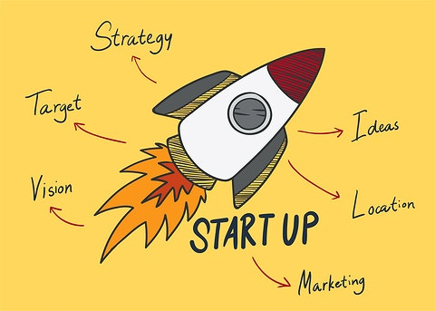

2.2 Feelings

I spent hours and hours trolling through the internet for ideas on how I proposed to make this work and had a gut feeling I was doing the right thing but needed that little bit of encouragement to settle my mind. Having looked at the competition I found that the general feeling was there wasn’t much difference in pricing compared to the likes of BOOTS and DEBENHAMS etc. so I decided to look for suppliers that could allow me to keep prices to a minimum but still make a profit. Feelings were divided on which way the business should go as regards do we promote one line or all? Do we specialise in just a couple of brands or go for many? These things were all put in place by following my gut feeling and go big or go home way of thinking.

2.3 Evaluation

The good thing I found about the plan was that I had to research my competition and by doing this I could look at their strengths and weaknesses and by doing this I managed to evaluate how we could structure the business in a way we would out strip the competition and push our profits up. I would ring up and pretend to be a customer to see what discounts were being offered and look at our stock lines to beat the competition. By evaluating your competition you can assess how to run yours and by gaining the knowledge of how ruthless some businesses are in their strive to make money. We wanted to make a profit and keep overheads at a minimum at all times so utilised our own property as a warehouse and ordered just enough stock to run but as things developed we had to move to bigger premises. So when putting this plan together we had to research and evaluate our competition, Pricing, Stock etc. Research is everything when starting a business and your business plan becomes your life line to funding.

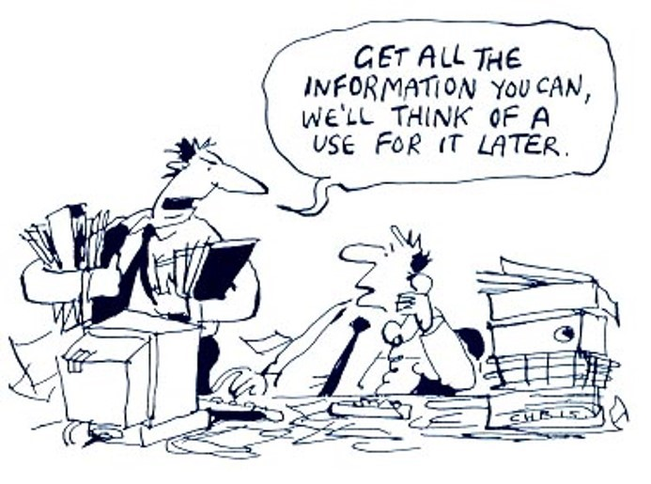

2.4 Analysis

My study concluded that business plans are not very predictive, but they are preparatory and get you in good stead for your business future. If the proper method is used, the business plan process combines the knowledge of the industry into the management and structure of your chosen business, so that they have a solid information base when faced with changes in the business environment, In other words, the business planning product is not as important as the business planning process because without the proper planning in place the structure of the final product will be poor.
Top Management Strategy, by Tregoe and Zimmerman
- Has top management determined the nature and direction of the business over the next few years?
- Do you know the specifics of the organization's strategy?
- Do the key managers share the same vision of the strategic direction?
- Is the strategy sufficiently clear so you and the key manaers can readily agree upon what new products and markets your current strategy would include and exclude?
- Is the statement of strategy used for making future product and market choices?
- Are strategic deliberations held separately form your long-range planning efforts?
- Is the strategy determining what you plan, project, and budget?
- Are assumptions about the environment used for setting strategy?
- Is future strategy determining decisions relating to capital improvements?
- Does each department have a clear stated strategy?
- Do the department strategies clearly support the overall cooperative's strategy?
- Is overall performance reviewed on both strategic accomplishment and operating results?

This is a strategy I used to for my plan or at least some of it giving a few tweaks here and there, it was most helpful in the respect of making decisions within the plan and making it clear as to what I wanted to achieve.
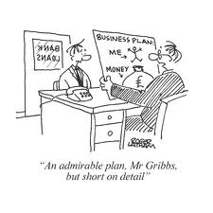

2.5 Conclusion

The conclusion to my plan is that having felt I had covered most bases I still feel I could have researched more about the funding and pricing, but that’s not to say that my pricing was inadequate but maybe could have been more structured in some respects. I have found that no matter how much research you put in there will always be something there you have missed. Having said that the plan is a guideline and can be adjusted at any time and therefore you can make amendments along the way to allow you to restructure or re finance but always keep it to hand as it will provide the core to your business.

2.6 Action Plan

Have a plan and stick to it. I had an idea of what I wanted and I ran with it making few changes along the way but that’s not to say there are things there I wouldn’t change now but at the time I didn’t want to rock the boat. Check and double check things like financial forecasts before going to your bank along with double check your competition. My personal view is make a plan over time do not rush it do your research and forecasts check completion check out suppliers and then and only then put your plan together, don’t be afraid to ask people to look at it or criticize it as this will only make a stronger plan.
Like I said “HAVE A PLAN AND STICK TO IT”.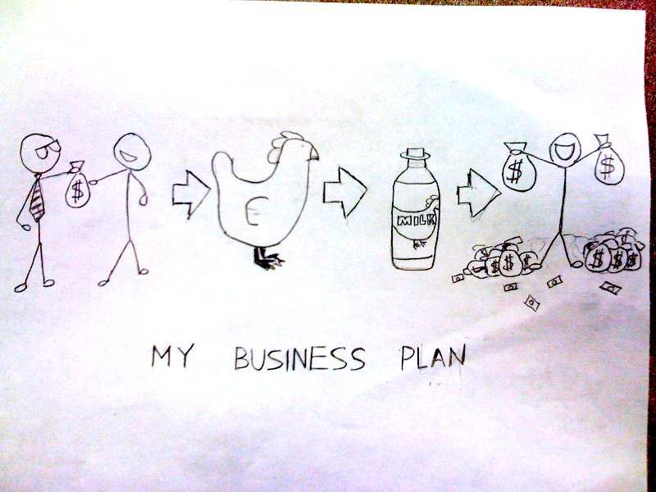

References

Gibbs, G. (1988) Learning by doing; A guide to teaching and learning methods. London: FEU

https://www.thebalancesmb.com/best-business-plan-books-2890050
http://leeds-faculty.colorado.edu/moyes/bplan/References/references.htm
Barney, J. B. (1997). Gaining and sustaining competitive advantage. Reading, MA: Addison-Wesley.
Strategic management and competitive advantage: Concepts and cases. Upper Saddle River, NJ: Pearson/Prentice Hall. Business Development Bank of Canada.
https://openpress.usask.ca/businessplandevelopmentguide/back-matter/references/

