Dishes and their allergen content
(Note – Please state the name of the cereal(s) containing gluten* and/or the name of the nut(s)†)

Dishes | 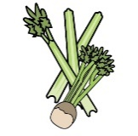 | 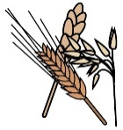 | 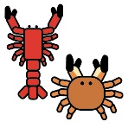 | 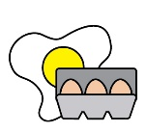 |  | 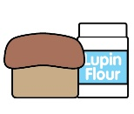 | 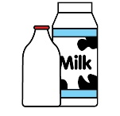 |  | 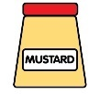 | 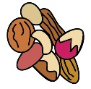 | 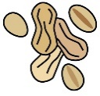 | 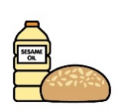 |  | 
 | Celery | Cereals containing gluten* | Crustaceans | Eggs | Fish | Lupin | Milk | Mollusc | Mustard | Nuts† | Peanuts | Sesame seeds | Soya | Sulphur Dioxide
Tuna Salad [example] | ✓ |  |  | ✓ | ✓ |  | ✓ |  | ✓

Review date: |  | Reviewed by: |  |  |  |  | You can find this template, including more information at www.food.gov.uk/allergy-guidance

