Problem Solving and Decision making

Name: Evdokiya Stefanova Stefanova
Student Number: 2018698
Module: BMSW 4004 Problem Solving and Decision Making
Lecturer: Chijioke Uba

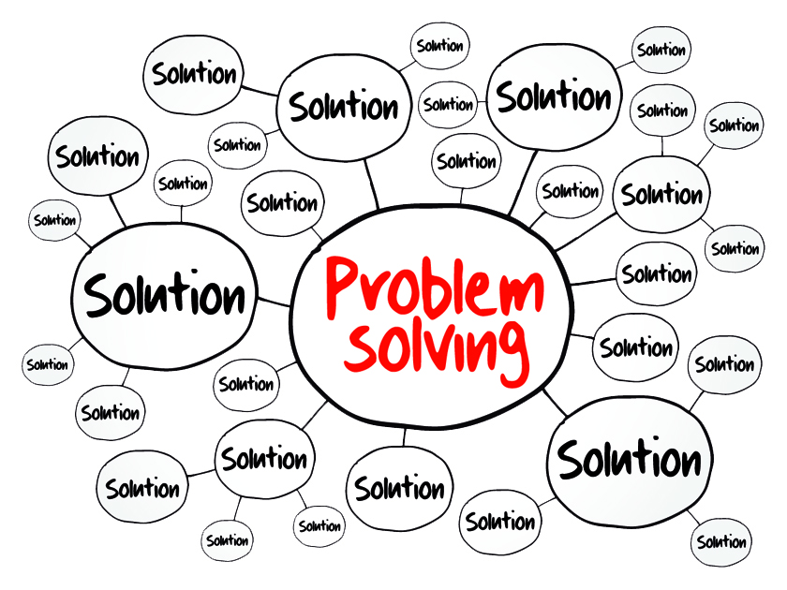

Table of Contents
Introduction 3
3
4 steps 3
Nature of the problem 4
Remuneration 4
Changing Duties 4
Valuing of the staff 4
Impact of the staff shortage in healthcare 5
Waiting lists 5
Unsustainable services 5
Deteriorating care quality 5
Pestel analysis 6
What is pestel? 6
Political 6
Economical 6
Legal 6
Environmental 6
Sociological 6
Fishbone Diagram 7
What is a fishbone diagram? 7
Work conditions 7
Sickness 7
Relationships 7
Financial 8
Governmental 8
Solutions to the problem 9
International recruitment allowing immigration 9
Funding Visa Costs 9
Set new development plans & Training programmes 9
Funding further education 9
My chosen solution and how to implement it 10
References 11

Introduction

Any group of people working towards a goal is bound to run in issues, the way organizations are equipped to handle and deal with these issues, will decide their future.
The essential skills for tackling these problems are problem solving and decision-making, ASQ (2022) gives a four step guide to this; ‘defining a problem; determining the cause of the problem; identifying, prioritizing, and selecting alternatives for a solution; and implementing a solution.’

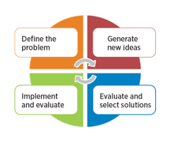

4 steps

First is to diagnose and make sure the problem is being focused, this can be done through a few helpful techniques like flowcharts and cause-and-effect diagrams to picture everything clearer.
Secondly we should look for various solutions and avoid implementing any of them until we have a good variety of choices, this is because comparing different points of view can help highlight and enhance the pros and cons of each solution. This is also to avoid the issue of accepting the first ‘acceptable’ solution and truly finding the best method.
Thirdly, it is time to evaluate the potential problems and complications of applying the proposed solutions, considering the widespread acceptance of the changes, and if the solution can be implemented in time.
Fourth and lastly, it is time to implement the chosen solution and very importantly, set up feedback pathways to monitor and modify the plan as necessary to ensure the desired result.

This is the structure I will be using in my report for my proposed solution, but first we need to understand the nature of the problem.

Nature of the problem

The current economy has been hit hard by recent worldwide events such as COVID and political instability, the UK government (2022) mentions this stating that ‘restrictions are affecting some businesses' ability to trade’.
Though for healthcare it is more about being overworked and understaffed for the sudden increase in patients that they were underequipped to deal with. Some research by Marć, et al. (2019) suggests that the nursing shortage causes are ‘multifaceted with no single global or local measure of its nature’.
The NHS is facing issues with staff retention and recruiting as well as low spirits and energy of remaining staff, the government is facing the crisis, but it is a big task to modernise the whole system, and a lot of the responsibility is falling on the staff being willing to burn themselves for the system, which is not proving very effective, new rewards and methods are needed.
A few of the identified problems include remuneration, the changing duties of the role, the valuing of the staff, and better employment elsewhere.

Remuneration
Money is a very good motivator to push people to work harder, Furnham (2012) says ‘money is an effective, powerful and simple motivator’, it is argued that promotion and recognition cannot be given equally to all workers, this is a spot where money shines as it can be given freely to any staff member as a reward.

Changing Duties
Many nurses and medical staff had set expectations of what their roles would be like and how their balance of work and life would be, either from years of their own experience or as new workers, from stories of their mentors.
However due to the decreased NHS funding and the increased demand through the pandemic, many workers have found themselves with a completely broken balance, and putting in too many hours to the point where their well-being is not a priority. At first a lot of them want to try and push through but every person has a limit, even the most kind-hearted of us, which leads to burnout and subsequent retirement from the position.

Valuing of the staff
We all have been deeply affected by changing circumstances, and a lot of pressure and expectations were unduly placed on healthcare workers, who in turn might have not received as much appreciation and encouragement as they deserve, this can lead to feelings of worthlessness and make healthcare staff feel as if their career isn’t fulfilling anymore, leading to second thoughts and changes in profession.

Impact of the staff shortage in healthcare

The understaffing problem is having a negative impact on both employees as well as organizations and the quality of their work. The growing gap between demand for services is also leading to staff dissatisfaction.
‘‘Pressures on staff were reported to be leading to higher levels of stress and, in some cases, increasing absence due to sickness’’ says Robertson (2017)
There are many worries surrounding the staff shortage and the impacts it will have on society, burnout is a big one which will lead to negative effects on patients. Along with it there are increasing waiting lists, unsustainable services, and deteriorating care quality.

Waiting lists
Due to the ever-growing shortage of medical staff, waiting lists are growing longer and longer, leading to crucial check-ups and operations being delayed, potentially impacting the health and well-being of patients.

Unsustainable services
Providing free health-care requires funding and continuous treatment, which might not be possible to provide efficiently with a lack of staff.

Deteriorating care quality
Medical staff are still people, when they are over-worked and burned out, they can and tend to fail, however in their profession this can lead to disastrous consequences like misdiagnosis, and delayed treatment which causes undue suffering on patients, and gives public healthcare a bad image.

We can better identify the causes that lead to this impact through a PESTLE analysis.

Pestel analysis

What is pestel?
Pestel is a tool utilized to track the macro – environmental factors that contribute to a problem in an organization, as it helps to understand the risks, threats and opportunities that lie within. Pestle is specially useful in staffing issues because ‘it can identify skill gaps, new job roles, job reductions or displacements’ says CIPD (2022).

Political
Brexit has impacted staff shortages due to immigrant staff who have now gone back to their home countries, leaving the NHS no time to train new recruits to replace them.
Governmental policy surrounding training and development as well as healthcare standards also impacts the staff shortage.

Economical
Low remuneration for the job and the current situation of healthcare workers does not make it an appealing profession to young people, many will opt for higher paid jobs which can afford better quality of life.

Legal
Patient complaints and claims due to unsatisfaction and claims of medical negligence, can affect medical organizations and with the growing lack of resources, more and more patients will be unsatisfied.

Sociological
Age, culture and attitude can have an impact in the interrelations of staff and patients.
Understanding this helps us analyse the cause-and-effect of the problem, we will do this through a Fishbone Diagram.
Mental health has been declining through the pandemic and the recent years, this affects both patients which will have less patience, and medical workers which will be more prone to burnout and mistakes.

Now that we’ve evaluated the external issues we can look more in-depth at the causes and direct effects of the problem.

Fishbone Diagram

What is a fishbone diagram?
Cause and effect diagram is ‘‘a tool so called because its structure is similar to the toa fish skeleton’’, Arsovski (2015).
It is used to identify potential and real causes, enabling to discover the root of a problem occurring internally in an organization.
The effect is staff shortage, and we can see the many causes and sub-causes clarifying what relates

Work conditions
Work conditions include overload, long hours which disbalance the personal life of workers, and a lack or extreme difficulty to advance in position as not everyone can be promoted, leading to feelings of being unvalued or giving out pointless effort.

Sickness
Mental health is affected greatly by being overworked and by the immense stress that the pandemic has caused both in staff’s work and personal lives. The long hours and mental pressure can even lead to physical sickness, as well as catching COVID themselves while taking care of patients, which forces staff to quarantine and quit their position for a set amount of time.

Relationships
Networking is an important part of growing in any job, as well as to be comfortable in the workplace and have helping hands when needed, manager favouritism and partiality to certain staff members while disregarding others who work equally hard, can and does cause staff to reconsider their role and leads them to finding different positions or switching careers. Stress due to being overworked also makes people more irritable and can create tensions between peers, creating a bad environment to work on which adds yet another reason to switching jobs.

Financial
Low rewards and payments are yet another reason why staff might consider quitting, feeling as if their skills which are vital, are unnecessary or not appreciated enough,

Governmental
Policy action, or lack of it through slow response and support of the NHS leads to more stress and a heavier burden for healthcare staff, which can push people over the edge of quitting through feelings of hopelessness.
Now that we understand the problems and impact we can better understand which solutions would work best and why.

Solutions to the problem

My proposed solutions to the problem are;
- International recruitment allowing immigration
- Funding Visa Costs
- Set new development plans & Training programmes
- Funding further education

International recruitment allowing immigration
Looking for talent outside the UK to fill the positions

Funding Visa Costs
Helping talent immigrate in exchange for their skills

Set new development plans & Training programmes
Develop new plans and goals to train existing staff in order to increase efficiency, investing in training programmes to better prepare staff and help upcoming staff develop faster.

Funding further education
‘Educational development has long been aligned with organizational development’ says Weston (2017). Investing in increasing knowledge of your staff exponentially grows the development of any organization.

My chosen solution and how to implement it

Chosen solution
I consider setting new development plans and training programmes as the most efficient one to solve the current problem of staff shortage across Proper Care UK.
Though the time to set a new framework is longer in my chosen solution, it will result in long lasting results and improvements because every new worker will undergo the adequate training. This should also lead to higher staff retention rate as people will be better prepared and with a broader range of options in their healthcare career paths, better suited to their individual skills.
Through the program early students can be introduced to practical situations where they’ll gain a deeper insight into the work and the problems that may arise, more experience staff can also mentor the new workers and support them to ensure things run smoothly.

Implementation
I would do this by sending different groups of staff to two week long workshops around the year, in working hours, this would add to the problem of lack of staff but I believe we would see a positive impact as well due to helping people out from burnout, and preparing them better for when they come back.

Success measurement
To measure the impact I would monitor the thoughts of the staff that underwent training in the following weeks, having them rate the techniques they learnt and their feelings of stress and pressure before and after the workshops.
I would also have patient satisfaction surveys and compare them before and after my staff has been trained, expecting to see positive results.

References

Arsovski, S. (2015) ‘Fishbone Diagram’, Encyclopedia of Quality and the Service Economy.
Available at:Fishbone Diagram - University of Wales Trinity Saint David (uwtsd.ac.uk)
(Accessed: 3 August 2022).

Changing trends and recent shortages in the labour market, UK - Office for National Statistics (2022). Available at: https://www.ons.gov.uk/employmentandlabourmarket/peopleinwork/employmentandemployeetypes/articles/changingtrendsandrecentshortagesinthelabourmarketuk/2016to2021 (Accessed: 5 August 2022).

Furnham, A. (2012). Money as a motivator. In: The Talented Manager. Palgrave Macmillan, London. (Accessed: 5 August 2022).

Marć, M., Bartosiewicz, A., Burzyńska, J., Chmiel, Z. & Januszewicz, P. (2019) A nursing shortage – a prospect of global and local policies. International Nursing Review 66, 9– 16
(Accessed: 5 August 2022).

PESTLE Analysis | Factsheets | CIPD (2022). Available at: https://www.cipd.co.uk/knowledge/strategy/organisational-development/pestle-analysis-factsheet#gref (Accessed: 3 August 2022).

Robertson, R., Wenzel, L., Thompson, J. and Charles, A., 2017. Understanding NHS financial pressures. How are they affecting patient care. Available at: kf-understanding-nhs-financial-pressures-full-report.pdf (abhi.org.uk) (Accessed: 3 August 2022).

Weston, C., Ferries, J. and Finkelstein A. (2017) Leading Change: An Organizational Development Role for Educational Developers, ‘International Journal of Teaching and Learning in Higher Education’, 29, 270-280. (Accessed: 3 August 2022).

What is Problem Solving? Steps, Process & Techniques | ASQ (2022). Available at: https://asq.org/quality-resources/problem-solving (Accessed: 5 August 2022).

