ACMA 4013 Reflective Journal
ASSIGNMENT 1

Table of Contents
Introduction 3
Topic 1: Addressing Sustainability 3
Session 1: What is the problem? 4
Session 2: Sustainability Changemakers 5
Session 3: Be the changemaker 5
Topic 2 Identifying new ideas 6
Session 1: Scoping 6
Session 2: Finding Meanings 7
Session 3:Identifying attributes 7
Session 4: Theories 8
Topic 3 Funding My Idea 9
Session 1: Sources of Funding 9
Session 2: Creating a Crowdfunding Campaign 10
Session 3: Understanding Social Enterprise 11
Topic 4 Personal Evaluation 12
Session 1: My Project Success 12
Session 2: Me, My Project and Others 13
Session 3: Success Through Teamwork 13
Conclusion 14
References 15

Introduction
The present assignment is in the form of a reflective journal. The primary aim of the reflective journal is to reflect on the crucial tropics selected from the four units. The four units provide a vivid description and account of the topic and its impact on our daily activities. The first topic of the unit deals with sustainability, which is recognised as a global issue facing the world. The first section offers an account of the problem and emphasises the individuals' influential role in positively contributing to protecting biodiversity. The second topic addresses recognising new ideas and how it helps the entrepreneur adapt to innovative and distinctive ideas. The third section highlights our idea of generating an effective funding process. Finally, the last section deals with the topic of personal evaluation and the way it has brought success through teamwork.

Topic 1: Addressing Sustainability
Sustainability has gained effective prominence in the present decades as the world faces global challenges. Sustainability means establishing an idea of meeting our own needs without compromising the needs of future generations. The prime principle of sustainability is to conserve and protect our environment, promote social equity and enhance economic prosperity. I have chosen this topic as the world is facing constant climate change and has been affected by the sun's harmful ultraviolet radiation. By adopting sustainable practices, we can mitigate our environment's negative impacts because of human activities [1].
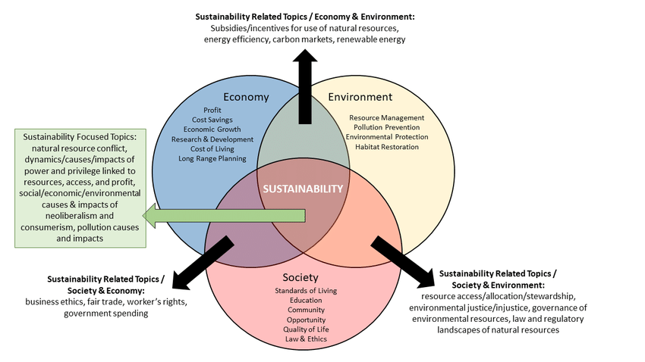
Figure: Sustainability dimensions
Source: (ADIGÜZEL, 2020)[2]

Session 1: What is the problem?
According to my perception, the problem associated with sustainability is that the excessive release of greenhouse gasses has been the major factor that has led to a change in the climatic conditions. Thus these gasses are trapped in the atmosphere, thereby resulting in global warming. The main sources of greenhouse gas emissions may lead to the burning of fossil fuels, deforestation, clearing the forest land to provide residential places to the rising population, industrial activities and agricultural processes. In my opinion, another vital aspect related to the issue of sustainability is that with the tremendous increase in the population, the forest is getting cleared, which has resulted in deforestation, land conservation for increasing agricultural production, and the increase in industrial activities have posed a negative impact on the environment that has led to increase in the global warming and a constant change in climatic conditions [3]. Deforestation has not only resulted in decreasing oxygen for human consumption but has increased the release of carbon dioxide into the atmosphere, which deteriorates the health of human beings. Both biodiversity and the ecosystem comprise the two most essential elements that have resulted in climate change and carbon sequestration. With the decline of biodiversity, the ecosystem becomes less resilient, making the factors more effective in promoting global climate change [4].

Session 2: Sustainability Changemakers
The notable sustainability changemakers in the fight against climate change are the efforts made by Bill McKibben, an American environmentalist and the co-founder of grassroots climate campaign 350. org. Based on my knowledge and information, I can reveal that he depicted a strong message in spreading awareness about the urgent need to address climate change through his writings and activities. He has played an active and significant role in addressing the issues and enhanced the principles of sustainability by promoting the objectives of sustainable practices in the environment. Even Swedish environmentalist Greta Thunberg has earned international recognition and reputation because of her tremendous efforts in raising awareness about climate change and inspiring the young generations to take effective actions that would create a positive impact on the environment and effectively promote the goals of sustainability. She even mobilised and brought together millions of students so that they could take immediate actions to safeguard and protect the environment. I am also aware of Elon Musk, that stands at the forefront of the clean energy revolution. I have discovered that Elon Musk focuses on establishing electric vehicles and promoting the use of renewable sources of energy, thereby aiming to decrease the emission of harmful greenhouse gasses and carbon and promoting a transformation towards a safe and sustainable future [5].

Session 3: Be the changemaker
Being a conscious and responsible individual, I am quite aware of the global climatic changes and how they affect our life. I think it's very crucial and a major aspect that all the community's individuals are bound to uphold the principles and promote sustainability in their daily activities. With the rise in population that has resulted in clearing forest lands for increasing agricultural production and building residential complexes simultaneously, concepts like afforestation and reforestation should make individuals more aware of their suits and responsible towards the environment. The community should actively promote sustainability and make individuals more aware and conscious of the need and importance of protecting the environment. It can be possible if the community conducts small projects and workshops that tend to implement the strategies and approaches that would positively impact the environment. The emission of carbon should be reduced effectively, as of my knowledge; otherwise, it would create health issues among individuals as there is an increase in suffering from breathing problems, asthma and other respiratory issues. Being an active and conscious individual, I would like to teach the community the need for recycling and reusing by promoting the principles of the 3Rs and the need to follow a waste management system that would create a positive contribution to promoting sustainability. Everyone should plant trees, eradicate plastic goods, and use brown eco-friendly bags [6].

Topic 2 Identifying new ideas
Innovation and creativity are the two most essential components that have played a vital role in promoting and formulating new ideas, concepts and terminologies that have led to innovation in the business activities of entrepreneurs. Innovations are helping entrepreneurs develop innovative ideas to identify the business trends and desires of their clients and how they can work accordingly to improve the satisfaction of their customers. I have gained valuable insights and information about innovation's influential role in shaping entrepreneurs' business activities that tend to mitigate their business risks and promote their business growth and success. I believe innovation plays a pivotal role and helps the individual adapt to changing times [7].

Session 1: Scoping
Scoping plays a significant role in shaping the focus, goals, directions and principles that can promote success in the new business setup of an organisation. I observed that scoping helps define and shape the boundaries and principles of a business idea or project essential in fostering significant innovation and entrepreneurship. I am quite aware that scoping helps entrepreneurs recognise opportunities by clearly defining the business gaps and problems and helps entrepreneurs develop innovative and unique ideas that aim to solve the issue related to the business problem. Entrepreneurs can optimise their business activities by scoping their ideas of the business project to establish a link with their vision and help them recognise the elements or aspects that help them develop objectives related to innovation and entrepreneurship [8]. I have gained a relevant understanding of how scoping helps entrepreneurs increase their innovative thinking capabilities that helps them reduce business challenges and risks by developing strategies to efficiently seek challenges. I have an idea of the way scoping helps entrepreneurs in conducting thorough market research that helps them to get an idea about the prevailing business scenario and gain an understanding of the business conditions [9].

Session 2: Finding Meanings
Innovation is the process of establishing and implementing new ideas, concepts, products and services that create value and generate a positive outcome. It involves developing and formulating new solutions to the problems, new methods and approaches that effectively mitigate the challenges and improve and increase efficiency to meet the effective results.
Based on my knowledge, entrepreneurship refers to those individuals who are willing to start their own business and can bear the risks they may face in promoting their business activities. An entrepreneur is a person who employs the resources that are needed for production and hires labour and manpower to establish innovation and creativity to develop stability and sustainability in business activities [10].

Session 3:Identifying attributes
The attributes I know related to entrepreneurship are that entrepreneurs should possess a clear vision and a positive mindset to flourish their business activities. They have the capability of predicting future challenges and also have some idea of their business outcomes. Based on my learning, an entrepreneur is a person who bears the risk-taking activity in their business to pursue new ventures. Entrepreneurs should learn lessons from their failures and try to gain inspiration to reduce the chance of business failure. A good entrepreneur should also have the qualities of good leadership and can be a source of inspiration to the workforce and motivate them to seek challenges so that they can effectively work towards it and thereby would reduce the chance of business failure. Present-day entrepreneurs must develop critical thinking abilities to establish innovation and creativity in promoting their business activities.
I have learnt the attribute of innovation that plays a vital role in an efficient entrepreneur is creativity. Innovation helps an entrepreneur to think differently in a unique way that makes his ideas and concepts new and different from the others. Innovation makes entrepreneurs more curious and increases their willingness to discover and explore new possibilities and outcomes to help them sustain their businesses in the competitive business world [11].

Session 4: Theories
Effectuation theory seeks to challenge entrepreneurship's traditional concepts and notions, often focused on planning and predictions. I have observed that this theory suggests that entrepreneurs can shape their future by effectively allocating those resources that are in demand and would meet the present business trends. The theory also offers valuable information and reliable insights that help entrepreneurs to develop a positive presence of mind and help them to take spontaneous actions and decisions that would reduce the risks of the business activities. Thus it makes an individual capable enough to navigate uncertainties and prosper in the dynamic business world [12].
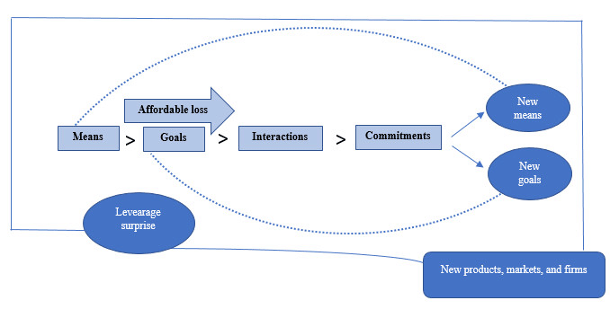
Figure: Effectual cycle and principles
Source: (Ghorbel et al. 2021)[13]

Conclusion
In conclusion, this reflective journal of my business idea provides valuable insights into the effective significance of sustainability in the business. It helps in addressing the issues of sustainability and adopting and implementing effective strategies. It also focuses on the responsibilities and duties of individuals in promoting sustainable practices. The second topic depicts the importance of innovation and creative idea that helps in identifying attributes.

References
[1] Norström, A.V., Cvitanovic, C., Löf, M.F., West, S., Wyborn, C., Balvanera, P., Bednarek, A.T., Bennett, E.M., Biggs, R., de Bremond, A. and Campbell, B.M., 2020. Principles for knowledge co-production in sustainability research. Nature Sustainability, 3(3), pp.182-190.Available at: https://dspace.library.uu.nl/bitstream/handle/1874/410045/s41893_019_0448_2.pdf?sequence=1

[2] ADIGÜZEL, S., 2020.An Investigation on the Social Economic Environmental Dimensions of Sustainability Efforts Logistics Managers in Turkey.Available at: https://www.researchgate.net/profile/Selminaz-Adiguezel/publication/343774992_An_Investigation_on_the_Social_Economic_Environmental_Dimensions_of_Sustainability_Efforts_Logistics_Company_Managers_in_Turkey/links/5f44215c458515b7294ca10a/An-Investigation-on-the-Social-Economic-Environmental-Dimensions-of-Sustainability-Efforts-Logistics-Company-Managers-in-Turkey.pdf
[3] Ramakrishna, S. and Jose, R., 2022. Addressing sustainability gaps. Science of The Total Environment, 806, p.151208.Available at: https://www.sciencedirect.com/science/article/pii/S0048969721062860
[4] Schaltegger, S., Christ, K.L., Wenzig, J. and Burritt, R.L., 2022. Corporate sustainability management accounting and multi‐level links for sustainability–A systematic review. International journal of management reviews, 24(4), pp.480-500.Available at: https://onlinelibrary.wiley.com/doi/pdfdirect/10.1111/ijmr.12288
[5] Skivko, M., Gerasimov, K. and Morozova, E., 2022, June. Commitment to Sustainability: Innovations, Drivers, and Changemakers in the Times of Digitalization in the Post-COVID Era. In PRIZK International Conference-Novel Insights in the Leadership in Business and Economics After the COVID-19 Pandemic (pp. 449-463). Cham: Springer Nature Switzerland.Available at: https://link.springer.com/chapter/10.1007/978-3-031-28131-0_31
[6] Schmitz, M., Saltevo, E., Bustamante, S. and Martinovic, M., 2022, December. Looking Ahead–Sustainability and Responsibility in Management Education. In Shaping a Sustainable Future (p. 449). Nomos Verlagsgesellschaft mbH & Co. KG.Available at: DOIhttps://doi.org/10.5771/9783748933090
[7] Escobar, O., Schiavone, F., Khvatova, T. and Maalaoui, A., 2023. Lead user innovation and entrepreneurship: Analysing the current state of research. Journal of Small Business Management, 61(3), pp.1174-1191.Available at: https://doi.org/10.1080/00472778.2021.1955126
[8] Sedera, D., Tan, C.W. and Xu, D., 2022. Digital business transformation in innovation and entrepreneurship. Information & Management, 59(3), p.103620.Available at: doi: 10.1016/j.im.2022.103620
[9] Kitsios, F. and Kamariotou, M., 2023. Digital innovation and entrepreneurship transformation through open data hackathons: Design strategies for successful startup settings. International Journal of Information Management, 69, p.102472.Available at: https://www.researchgate.net/profile/Fotis-Kitsios/publication/357908349_Digital_innovation_and_entrepreneurship_transformation_through_open_data_hackathons_Design_strategies_for_successful_start-up_settings/links/621b7075b1bace0083a0927a/Digital-innovation-and-entrepreneurship-transformation-through-open-data-hackathons-Design-strategies-for-successful-start-up-settings.pdf
[10] Stephan, U., 2022. Cross-cultural innovation and entrepreneurship. Annual Review of Organizational Psychology and Organizational Behavior, 9, pp.277-308.Available at: https://www.annualreviews.org/doi/abs/10.1146/annurev-orgpsych-012420-091040
[11] Ismail, I.J., 2022. Entrepreneurs’ competencies and sustainability of small and medium enterprises in Tanzania. A mediating effect of entrepreneurial innovations. Cogent Business & Management, 9(1), p.2111036.Available at: https://doi.org/10.1080/23311975.2022.2111036
[12] Klenner, N.F., Gemser, G. and Karpen, I.O., 2022. Entrepreneurial ways of designing and designerly ways of entrepreneurs: Exploring the relationship between design thinking and effectuation theory. Journal of Product Innovation Management, 39(1), pp.66-94.Available at: https://onlinelibrary.wiley.com/doi/pdf/10.1111/jpim.12587
[13] Ghorbel, F., Hachicha, W., Boujelbene, Y. and Aljuaid, A.M., 2021. Linking entrepreneurial innovation to effectual logic. Sustainability, 13(5), p.2626.Available at:https://www.mdpi.com/2071-1050/13/5/2626/pdf

