UWTSD
Managing Enterprise BMSW4011_CARD
Business Plan
Tutor: Melanie Squire
Irina Kitley 2219546
7/2/2023

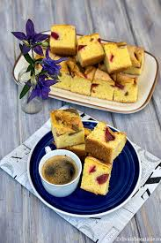

.

Contents

Part A Business Plan
Introduction 3
Service description 4
Legal Status 5
Mission statement, aim and objectives 6
Proposed location/equipment 7
Human Resources 8
Marketing activities 9
Financial resources 10
SWOT analysis and conversion strategy 11
12 month cash forecast 12
Conclusion 13
References 14
Appendix 1 15
Appendix 2 16
Appendix 3 19
Part B Reflection 20

Part A – Business Plan

Introduction

A constant in most books about entrepreneurship is the necessity of a business plan when starting a new business. There are debates about how useful they are, since successful businesses have been started without one (Steve Jobs or Bill Gates never wrote a business plan) and if they are only written in an attempt to gain legitimacy. In most of the educational literature on entrepreneurship, a business plan enhances the company’s performance (Karlsson & Honig, 2009).
This is the business plan for my future business, a coffee shop called ‘Coffee Break’.



Service description

Coffee is a beverage enjoyed all over the world and most coffee drinkers have almost an instinct of what a good cup of coffee should be like. It has also been discovered that caffeine dulls the receptors that detect sweetness and makes us crave something sweet to go with it (Morris, 2018).
Serving good quality, organic coffee and delicious homemade cakes, along breakfast items, sandwiches, paninis and drinks is exactly what we are planning to offer in our coffee shop, called Coffee Break.

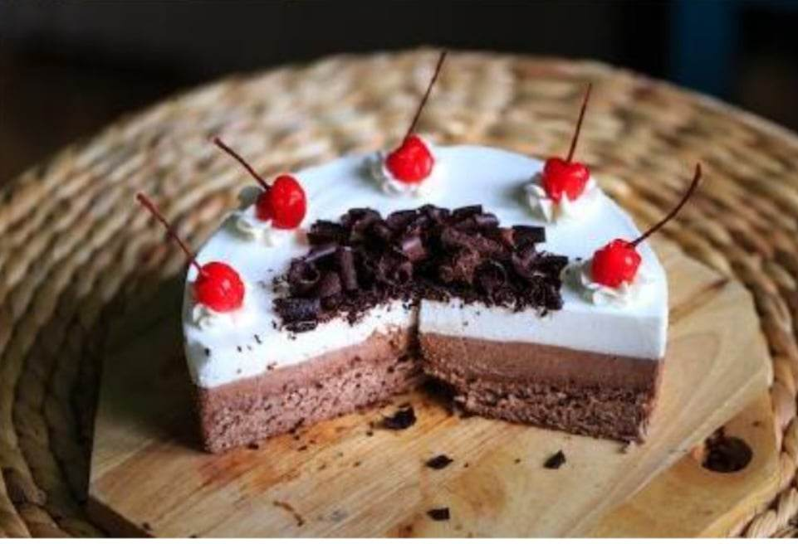

Legal Status

The legal status of the business is a partnership.
Partnerships can be risky, which is why a partnership agreement will be drawn up by a solicitor (Limited Liability Partnership) (Morris, 2011).
My business partner is a Romanian lady who shares my passion for baking and preparing sweets and pastries. I prefer a partnership because I am not an experience entrepreneur and I would feel safer if I had a business partner to help me with the new venture. I also prefer a partnership because I would not be able to come up with all the funds needed to open the new business.
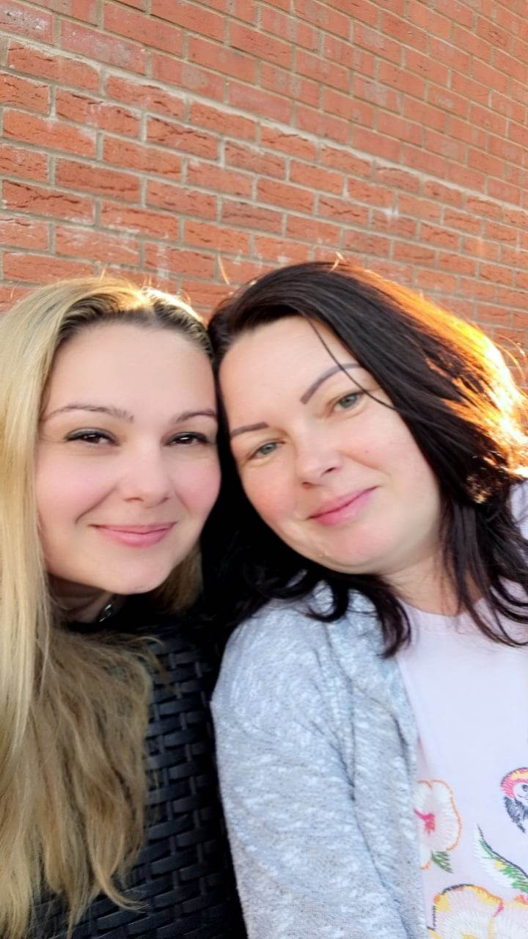

Mission statement, aim and objectives

Mission statement
Our mission is to offer our customers an amazing experience every time they visit us: new flavours, organic ingredients and a reading corner. As Maya Angelou (2022) said that ‘people will forget what you said, people will forget what you did, but people will never forget how you made them feel’.

Aim
Our aim is to become the number one choice café for our customers and to break even in the first year.

Objectives

According to Chavda K. N. (2007), ‘the central objective of a company must be to maximise the long-term return on the resources it employs. Planning for profit must be done in the context of a critical analysis of the company’s strengths, weaknesses, threats and opportunities arising from the external environment in which it operates, and of the expectations of the owners, employees and customers’.

- The café to be fully open and operational by the end of August 2023.​
- To register profit or, at the minimum, break even, by the end of August 2024.​
- The business to be present on the main social media platforms and have the website ready by end of July 2023.​
- To have supplier contracts signed by end of June 2023.​
- To employ 2 members of staff on a seasonal contract basis for June-August 2024, advertise by May 2024 (gov.uk, 2023).​

Proposed location/equipment

Our café will be located on the main road in Rhoose, taking over from the old café, Coffee Time. The location is convenient, it is easily accessible and it even has a few parking spaces available on the road. The equipment is still there, stored away : fridges, display fridges, tables, chairs, counter, grill etc (Locale Online,2023).
We will have to invest in new coffee machines, register, new serving equipment. We will also invest in ovens, so we can bake the cakes on site instead of baking them at home.

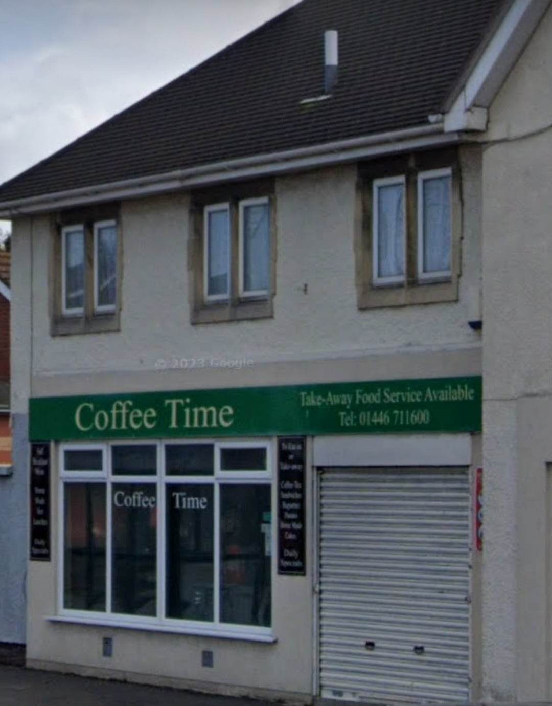 | 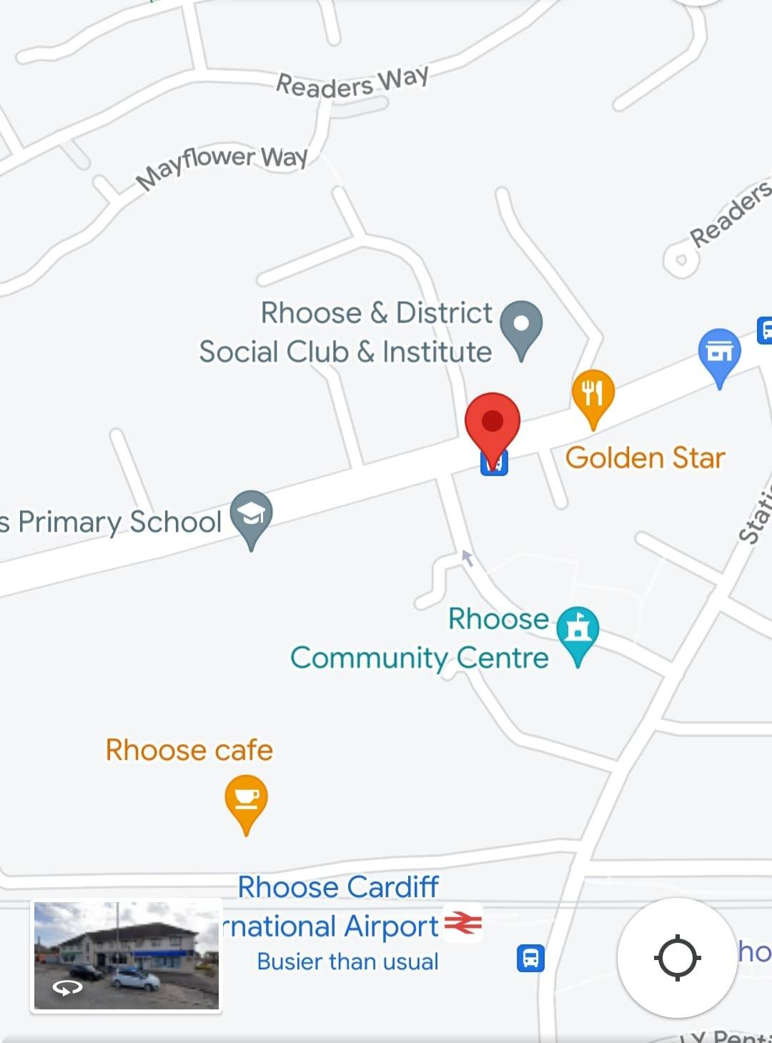
(Vale Life, 2020) (Google Maps, 2023)

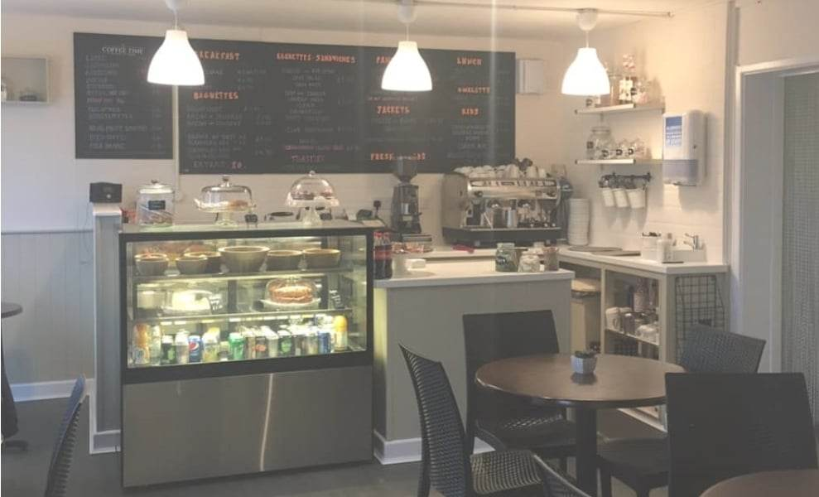

Human Resources

When recruiting for a new business, it is very important to make sure that the company is compliant with employment laws. In small businesses where there won’t be a HR team, the entrepreneurs need to know how to recruit the perfect candidates as quickly as possible. They need to know where it’s best to advertise, how to behave in an interview, which checks are needed. HR can be the key to a company’s success (Michie & Sheehan, 2005).
My business partner and I will be the only ones working in the beginning. We will also employ a team member on a temporary contract basis to cover the busy summer period next year, as mentioned above. I am familiar with the checks necessary for European Union members, checking for their residency status (gov.uk, 2023).


Marketing activities

Market research
There is only one café in the village (part of the Leisure Centre), to 6782 people (City Population, 2023). We have seen posts on the village social media group, from people asking if the old café would be re-opened.
We started asking our groups of close friends and family, neighbours. We then offered samples to the same groups and the feedback was very encouraging. We have also distributed questionnaires to bigger audiences.
Please see the questionnaire in Appendix 2.

Marketing ideas and strategy
A well defined marketing strategy can increase revenue and can help attract new customers. It is a very powerful tool that can help reach the business’ objectives and it can help choose the tactics needed within the business (Fangfang, et al., 2021).
We will post on social media, on the Rhoose Community Facebook page. We are also going to distribute our leaflets, containing business information, menu, prices and special offers. We will ask permission from the other businesses in the village to display posters with the details of the business and the proposed opening date, along with offers for first customers. We would also offer free samples a few days before and after opening.
Please see our marketing ideas in Appendix 3.

Financial resources

We will invest £40.000 of our own money into this business. This should help us in the first 12 months, but should the need arise for more finances, we will consider a bank loan. This business plan should help with obtaining one. We have researched the bank’s requirements (HSBC, 2023) but if we will decide to go ahead with applying, we will do more research into other banks as well.

SWOT analysis and conversion strategy

STRENGTHS  - F&B experience  - Customer service experience  - Organic, affordable products  - Reading corner  - Partnership | WEAKNESSES  - Time management  - Perfectionism  - Small space  - Partnership  - Limited business experience
OPPORTUNITIES  - Gap in the market  - Online orders  - Takeaway options  - Private orders for parties and birthday cakes  - Collaborate with B&B, decorating companies (balloons, florists) | THREATS  - Competitor  - Cost of living  - People’s preferences  - Unpredictable situations  - Family life

According to Covey S.R (2004), ‘Balance and peace of mind follow the person who develops a clear sense of his or her highest priorities and who lives with focus and integrity toward them’.
I think of the partnership both as a strength and a weakness. In the ‘Legal status’ I explained what the benefits of a partnership are. The weaknesses are: difference of opinions, the partner who invests more might think that they have the right to make the decisions, disagreements around days off/holidays, etc.

Conversion strategy

Our biggest threat is the competitor. Having been their customer on numerous occasions, I can say with confidence that our exceptional customer service and the quality products will convert this threat into an opportunity.

12 month cash forecast

Understanding how to read and create a cash flow forecast is very important for the new business, because it clearly shows and understanding of said business: projected sales, expenses, if there will be enough funds to run the business or expand it. It helps identify red flags and react to them in time (Senay & Abon, 2017).
Please see the detailed cash flow in Appendix 1.

Conclusion

A business plan is not an easy task. A lot of information is needed in order to come up with a realistic outcome. A business plan needs to be revisited and updated, because circumstances change and this needs to be reflected in it (DeFond & Hung, 2003).

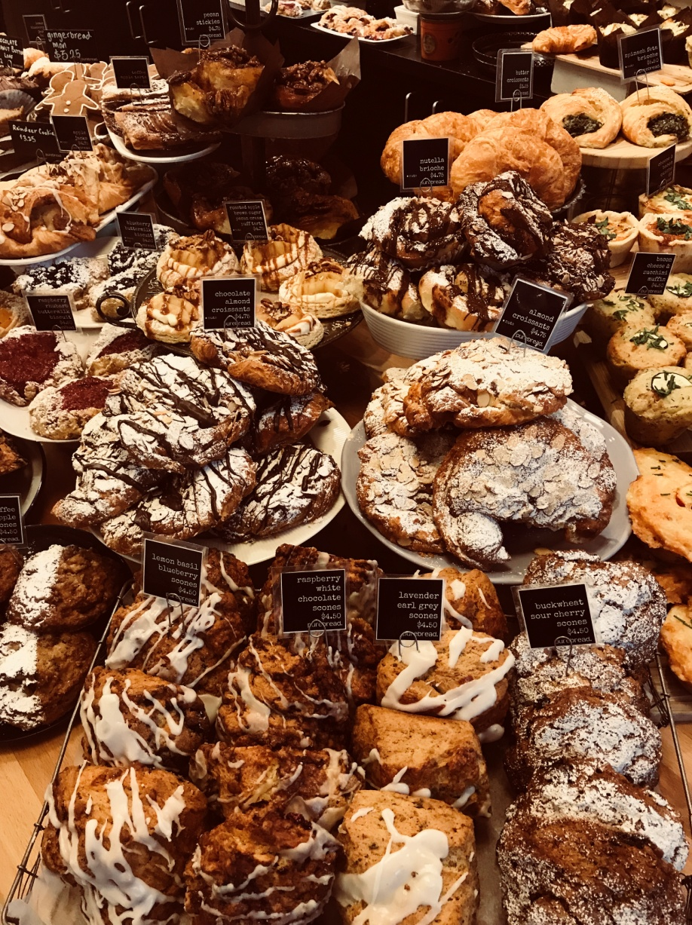

References

Angelou, M., 2022. Quotes by Maya Angelou. [Online]
Available at: http://www.thesuccessfulspirit.com
[Accessed 06 June 2023].
Chavda, K., 2007. Objectives Management. 1 ed. s.l.:ABD Publishers.
City Population, 2023. Rhoose. [Online]
Available at: https://www.citypopulation.de
[Accessed 07 June 2023].
Covey, S., 2004. The 7 habits of highly effective people. 2 ed. London: Simon&Schuster.
DeFond, M. L. & Hung, M., 2003. An empirical analysis of analysts' cash flow forecasts. Journal of accounting and economics, 35(1), pp. 73-100.
Fangfang, L., Jorma, L. & Leonidas, L. C., 2021. Social media marketing strategy: definition, conceptualization,taxonomy,validation, and future agenda. Journal of the Academy of Marketing Science, 49(1), pp. 51-70.
Google Maps, 2023. Coffee Time Rhoose. [Online]
Available at: https://maps.google.com
[Accessed 12 June 2023].
gov.uk, 2023. Right to work checks for employing EU, EEA and Swiss citizens. [Online]
Available at: https://www.gov.co.uk
[Accessed 13 June 2023].
HSBC, 2023. Small Business Loan. [Online]
Available at: https://www.business.hsbc.uk
[Accessed 07 June 2023].
Karlsson, T. & Honig, B., 2009. Judging a business by its cover: An institutional perspective on new ventures and the business plan. Journal of Business Venturing, 24(1), pp. 27-45.
Locale Online, 2023. Coffee Time Rhoose. [Online]
Available at: https://uk.locale.online
[Accessed 06 June 2023].
Michie, J. & Sheehan, M., 2005. Business strategy, human resources, labour market flexibility and competitive advantage. International journal of human resource management, 16(3), pp. 445-464.
Morris, J., 2018. Coffee: a global history. 1 ed. s.l.:Reaktion Books.
Morris, M. J., 2011. Starting a successful business. 1 ed. s.l.:Kogan Page.
Senay, A. & Abon, M., 2017. Investment-Cash Flow Sensitivity: Fact or Fiction?. Journal of financial and quantitative analysis, 52(3), pp. 1111-1141.
Vale Life, 2020. Directory: Coffee Time, Cafe & Takeaway, Rhoose. [Online]
Available at: https://www.valelife.co.uk
[Accessed 12 June 2023].

Appendix 1

 | 1 | 2 | 3 | 4 | 5 | 6 | 7 | 8 | 9 | 10 | 11 | 12 | total
Income
Sales | 2500 | 2700 | 3000 | 3300 | 3500 | 3800 | 4000 | 4200 | 4500 | 6000 | 6000 | 6000
Loans
Investment | 40.000
Total | 42500 | 2700 | 3000 | 3300 | 3500 | 3800 | 4000 | 4200 | 4500 | 6000 | 6500 | 6800 | 90800
Expenditure
Wages |  |  |  |  | 200 | 200 | 200 | 200 | 200 | 400 | 400 | 400
Drawings |  |  |  |  | 2000 | 2000 | 2000 | 2000 | 2000 | 2000 | 2000 | 2000
Rent | 750 | 750 | 750 | 750 | 750 | 750 | 750 | 750 | 750 | 750 | 750 | 750
Utilities | 300 | 300 | 300 | 300 | 300 | 300 | 300 | 300 | 300 | 300 | 300 | 300
Phone | 80 | 80 | 80 | 80 | 80 | 80 | 80 | 80 | 80 | 80 | 80 | 80
Loans
Stock | 2000 | 2000 | 2200 | 2200 | 2500 | 2500 | 2500 | 2500 | 2800 | 2800 | 2800 | 2800
NINO | 40 | 40 | 40 | 40 | 40 | 40 | 40 | 40 | 40 | 40 | 40 | 40
Adverts | 500 |  |  |  | 500 |  |  |  | 500
Petrol
Pension | 100 | 100 | 100 | 100 | 100 | 100 | 100 | 100 | 100 | 100 | 100 | 100
Insurances | 50 | 50 | 50 | 50 | 50 | 50 | 50 | 50 | 50 | 50 | 50 | 50
Capital spend | 10.000
Total | 13820 | 3320 | 3520 | 3520 | 6520 | 6020 | 6020 | 6020 | 6820 | 6520 | 6520 | 6520 | 75140
Net Cash Flow | 28680 | -620 | -520 | -220 | -3020 | -2220 | -2020 | -1820 | -2320 | -520 | -20 | 280
Opening balance | 0 | 28680 | 28060 | 27540 | 27320 | 24300 | 22080 | 20060 | 18240 | 15920 | 15400 | 15380
Closing balance | 28680 | 28060 | 27540 | 27320 | 24300 | 22080 | 20060 | 18240 | 15920 | 15400 | 15380 | 15660 | 15660

Appendix 2

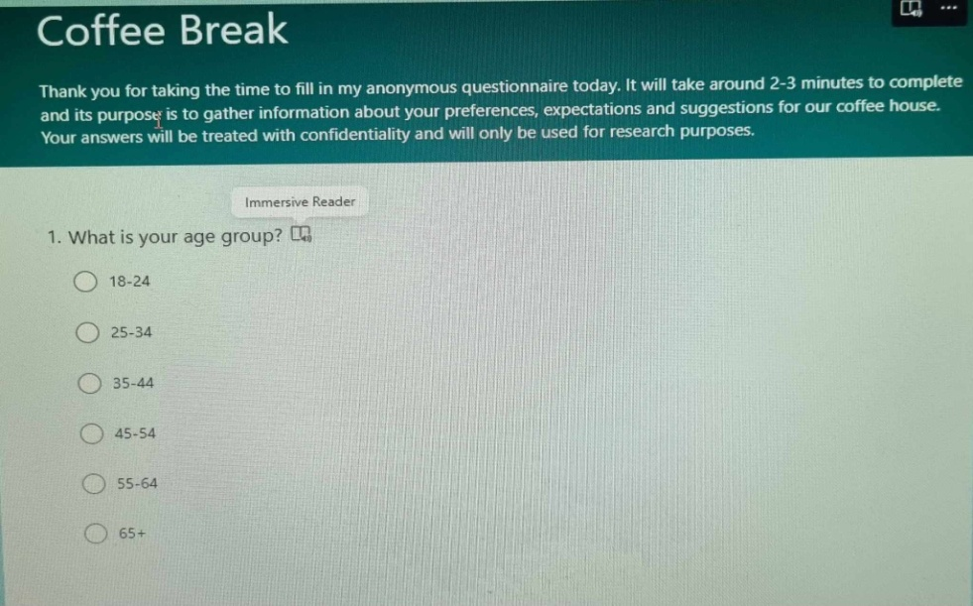
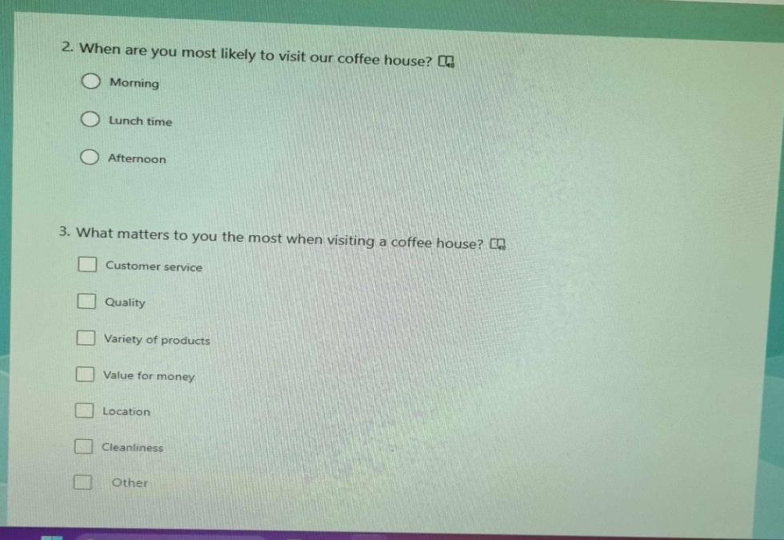
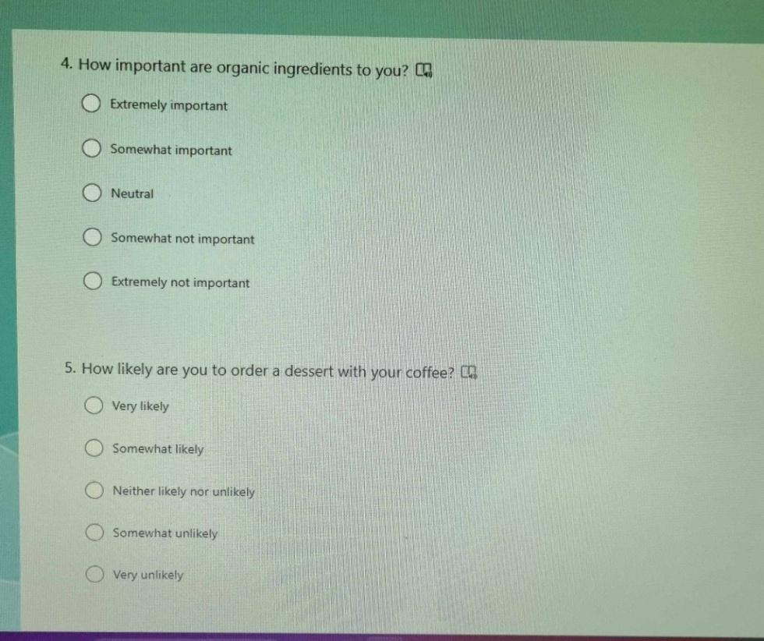

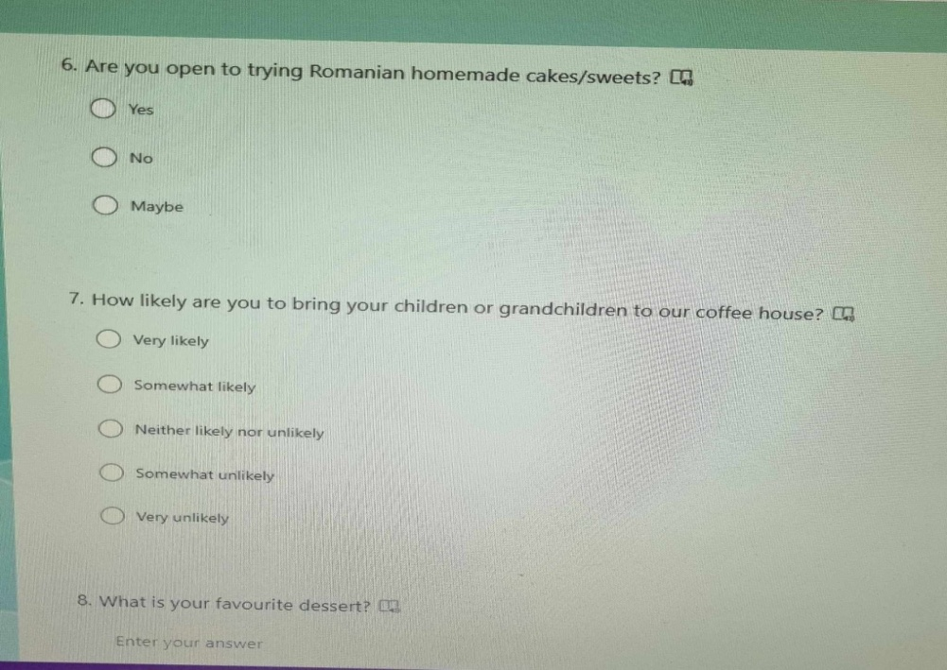
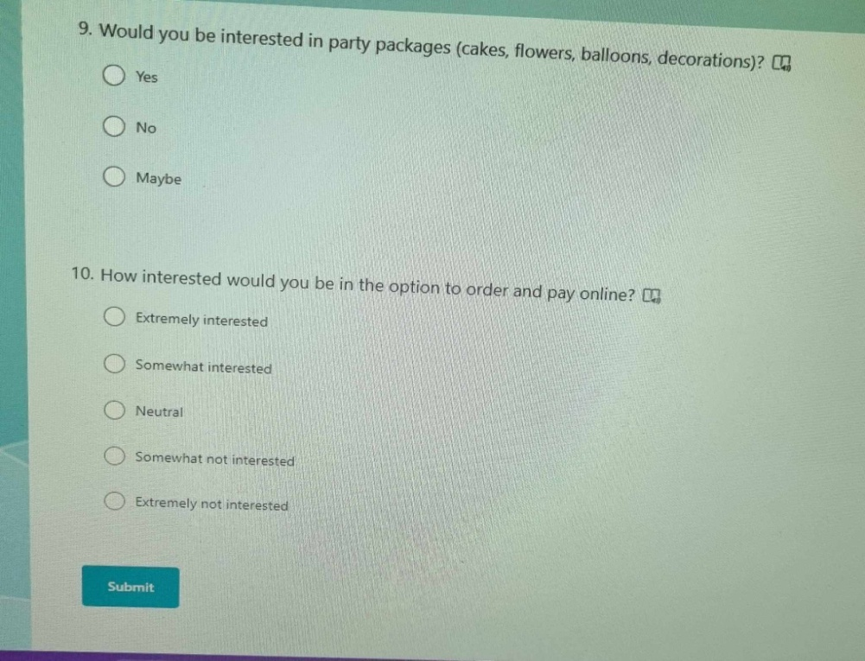

Appendix 3
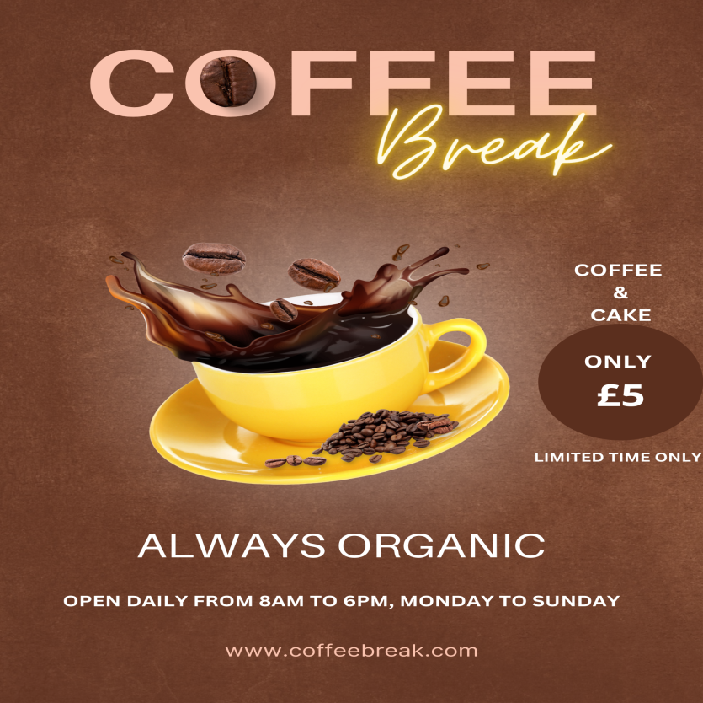


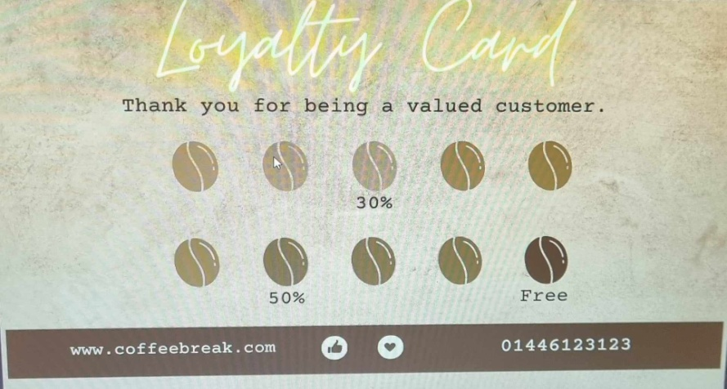

Part B - Reflection

Entrepreneurship always seemed to be for brave people in my eyes and I never saw myself as one of them. The financial insecurity, not being able to take time off, all the problems and worries seemed too much to handle. If we add to that my lack of experience in the business field, it was quite clear to me that this path was not one for me to take. I was happy in my employment.
Last year I had to step out of my comfort zone, when I (quite suddenly) decided to quit my job and become self-employed as a public service interpreter. While it’s not the same as opening a brand new business, it is definitely a step in that direction. I also started this year in University and slowly but surely discovered that I am very interested in becoming an entrepreneur at some point.
I have prepared this business plan and the presentation thinking that, at some point in the future, the café dream will become reality. However, the time is not right now. I will go through some of the reasons below.
My potential business partner and I have discussed the possibility of opening a café in our village if at some point we realise that our profession is not profitable anymore (we are both public service interpreters). At the moment, qualified interpreters are in demand, but coming out of the EU has had a big impact on it and will continue to impact it long term. Also, progress with AI might eventually deem us not useful. Therefore, going through the details of the business plan will be very useful for the future.
At the moment, the rising cost of living is a big problem for many families. I am not sure this is the right time to invest all our savings – or worse, get into debt.
I resigned from my management position because I wasn’t spending enough time with my young son and my husband. Opening a business would send me back to that routine, but on top of that, it would minimise our holiday time as well.
The positive feedback we got from the small group of friends and family is real, this is another reason we started thinking about opening this business. But even if the figures on the cash flow forecast are not accurate, the outcome still doesn’t make me feel like I am ready to take this chance. From the limited research I have done, the profit of a small coffee shop is unlikely to go over £6000 per month, but the expenses are probably higher than what I put on the cash flow forecast. Adding to that the fact that 2 business partners can’t survive long term off £1000 a month, it just doesn’t make me very confident in the success of the business long term.
To summarise, the business idea is only benched at the moment, I feel like I need to do some more research before making an informed decision.

