University of Wales Trinity Saint David

Programme: CertHE Computing Skills for Workplace

Database Coursework Submission

Name: Hifza Nasir

Student ID: 2524550

Module: Introduction to Web and Database Concepts

Lecturer: Anum Paracha

Module Code: ACCA4023

Design and Implementation of a Relational Database System
Case Study: Auto Park Management System

Contents

Introduction 2
Task 1 – Data Implementation 2
Scenario Analysis 2
Entity Identification 3
Entity Relationship Diagram (ERD) 4
Data Structure Development 5
Normalisation (3NF) 9
Sample Data Population 10
Query Development 16
Validation and Testing 21
Forms 22
Testing 23
Task 2 – Course Work Written Elements 27
Screenshots of Database Development 27
Design Decisions 29
Challenges Faced 30
Future Improvements 30
Conclusion 30
References 31

Introduction
The AutoPark Management System currently uses a manual system to capture details of customers, vehicle, parking site, booking and payment transactions. Manual records become inefficient as volume grows and increase the chances of mistakes, duplicate records and missing records. A relational database system is an appropriate solution, since it can store the data in related tables, minimise data redundancies, ensure data integrity and retrieve data efficiently via queryable relationships.

This report contains the design and implementation of a relational Database for AutoPark Management System in Microsoft Access. The report provides analysis on the scenario, identification of entity and relationships, construction of conceptual and logical Entity Relationship Diagrams (ERDs), normalizing the database to Third Normal Form (3NF), implementing the database, inserting sample data, developing database queries, and validation and testing. The final database will be organized and reliable enough to manage the parking operations and help in accurate data storage and retrieval.

Task 1 – Data Implementation

Scenario Analysis

The AutoPark Management System currently uses manual methods to book and record customer information, vehicles, parking sites, and payment information. This can result in duplicate data, data entry errors, lost records, and delayed information retrieval, and can be time-consuming. With several parking sites to maintain, there must be an effective way to store and retrieve information.

A relational database is appropriate since it stores information in tables which are related to each other with primary and foreign keys. This helps in handling customer records efficiently, minimizing data redundancy, and improving data consistency, while also allowing for the efficient management of parking space allocation, bookings, and payment transactions. The database used was a relational database and was selected to be implemented in Microsoft Access as it was found to be capable of handling relational database design, referential integrity, queries, and reporting features appropriate for small to medium-sized information systems.

Entity Identification

Attributes of Each Entity

Relationship between each entity
After analyzing the business scenario 6 major entities were identified as key for the functioning of the Auto Park Management System:
- Customer
Attributes (CustomerID, FirstName, LastName, PhoneNumber, Email)
One Customer may have many Vehicles and each Vehicle may have only one Customer (One-to-Many).
- Vehicle
Attributes (Vehicle ID, Vehicle RegistrationNumber, Color, Make, Model)
A Vehicle can have more than one Booking in the time line, and each Booking has one Vehicle (One-to-Many).
- Parking Site
Attributes (SiteID (Primary Key), SiteName, Address)
One parking site may have more than one parking slot and one parking slot is required to belong to a parking site (One-to-Many).
- Parking Slot
Attributes (SlotID (Primary Key), SlotNumber, SlotType, AvailabilityStatus)
One parking site may have more than one parking slot and one parking slot is required to belong to a parking site (One-to-Many).
- Booking
Attributes (BookingID (Primary Key), EntryTime, ExitTime)
Booking is related to Payment (One-to-One).
- Payment
Attributes (PaymentID (Primary Key), PaymentDate, PaymentAmount, PaymentMethod)

Payment is related to Booking (One-to-One).

Entity Relationship Diagram (ERD)
A visual representation of the structure of the database was created using an Entity Relationship Diagram (ERD).
First Conceptual ERD (shows the main entities, attributes, and the relationship among them). Then Logical ERD (builds on conceptual one by adding primary and foreign keys, and complete table structure).
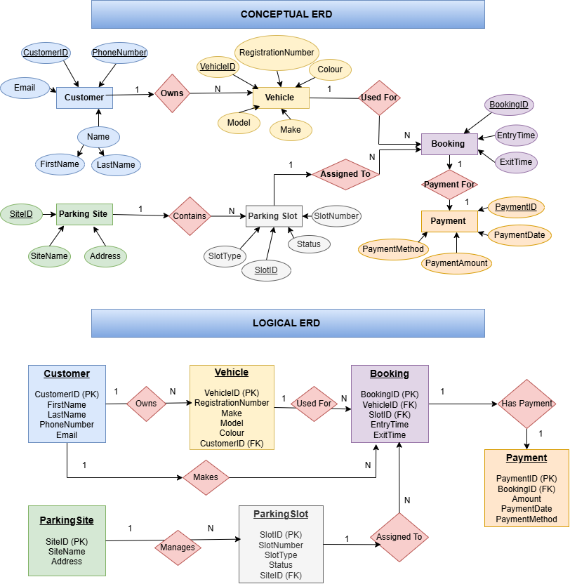

Data Structure Development
After completing the conceptual and logical ERD’s, the relational database was created in Microsoft Access. During the analysis phase, six tables were created to represent the key entities identified: Customer, Vehicle, Parking Site, Parking Slot, Booking, and Payment. Primary Keys (PK) were added to each table to ensure that each record is unique, and Foreign Keys (FK) were added to the tables to ensure that there is a relationship between tables. This structure ensures that data is organized efficiently, minimises redundancy and maintains consistency throughout the database.
Customer Table
The Customer table contains the information about customers utilising the parking management system. It includes details about customer including first name, last name, phone number, email handle. The CustomerID is the primary key which guarantees that any customer record can be uniquely identified.

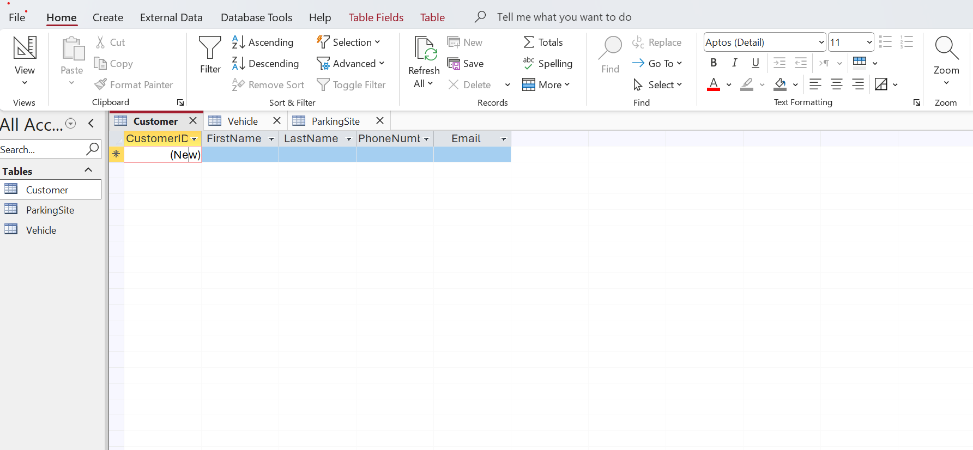
Vehicle Table
Vehicle table holds data about vehicles that are registered in the system. It includes make, model, colour, vehicle number. The CustomerID field is established as a foreign key, establishing a relation between every vehicle and its customer. This allows one customer to sign up for several vehiclesand keep the proper ownership details.
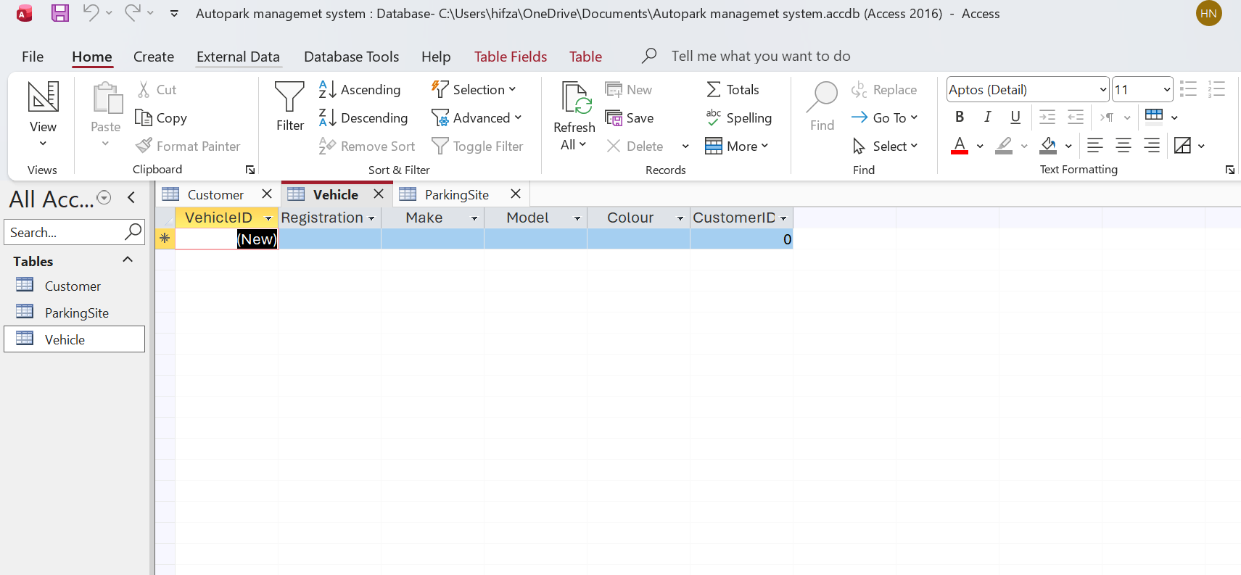
Parking Site Table
The table Parking site holds data for each parking area controlled by the organization. The SiteID field will be the primary key, uniquely identifying each parking site, with the site name and address stored in it.
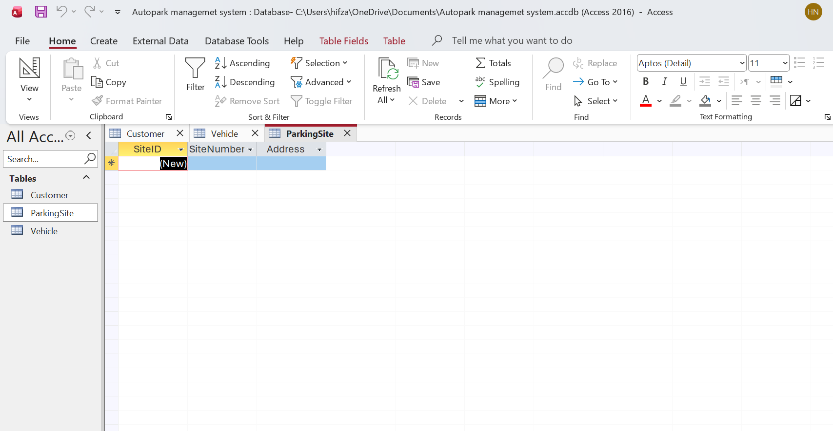
Parking Slot Table
The information about individual parking spaces in each parking site is kept in the table called Parking Slot. The SiteID field acts as a foreign key that associates each parking slot with a specific parking location (SiteID), allowing the management of multiple parking locations.
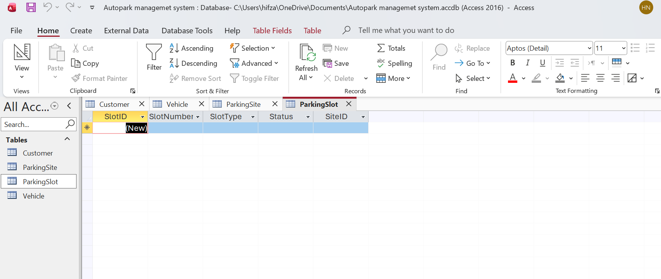
Booking Table
The Booking table contains all booking information processed by the system. It holds the allocated vehicle, the assigned parking slot and the entry/exit times. Each booking is tied to the VehicleID and SlotID fields, which act as foreign keys to ensure proper tracking of parking activities.
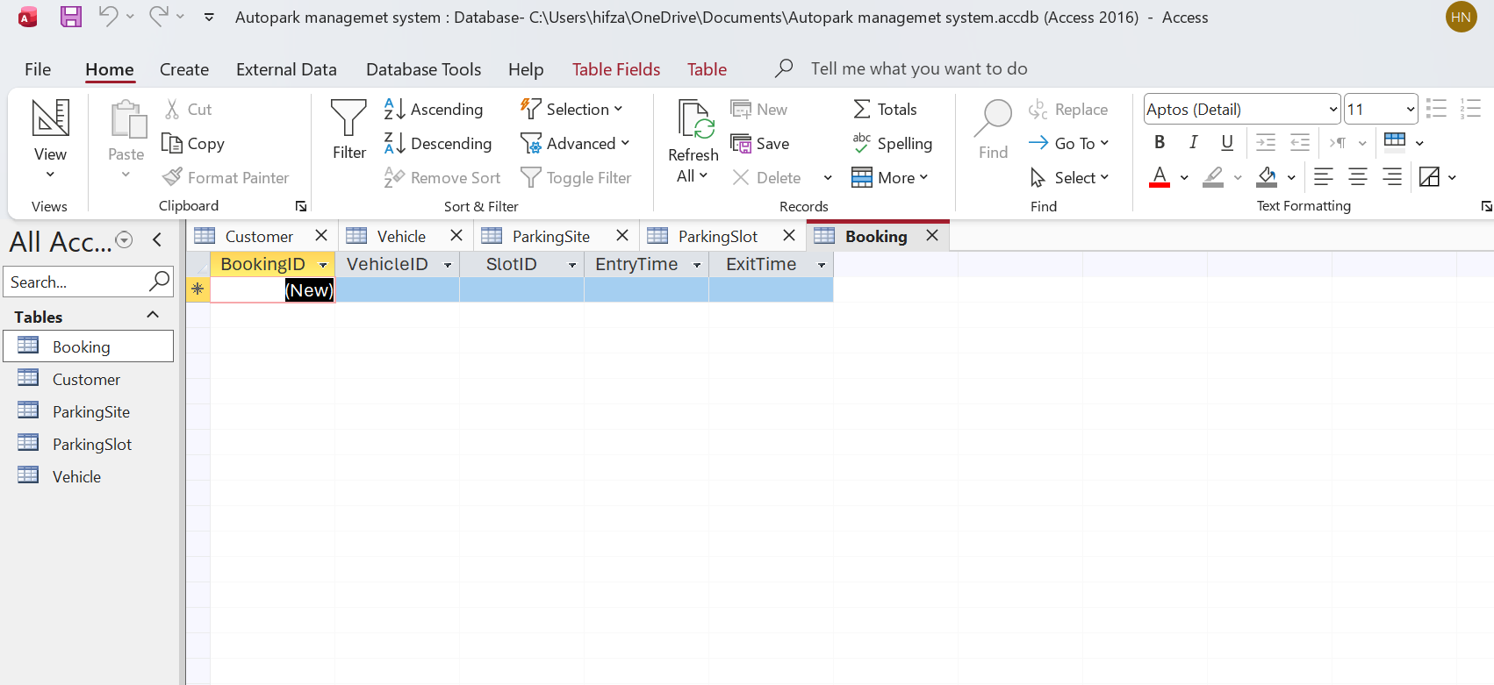
Payment Table
The Payment table holds financial data pertaining to each booking. It contains the quantity of payment, date of payment, and the mode of payment that the customer used. The BookingID field is a foreign key that connects each payment to a specific booking.

Table Relationships
All six tables were created and relationships were set up using the “Relationships” tool in Microsoft Access. Primary and foreign keys were set up appropriately based on the Entity Relationship Diagram.
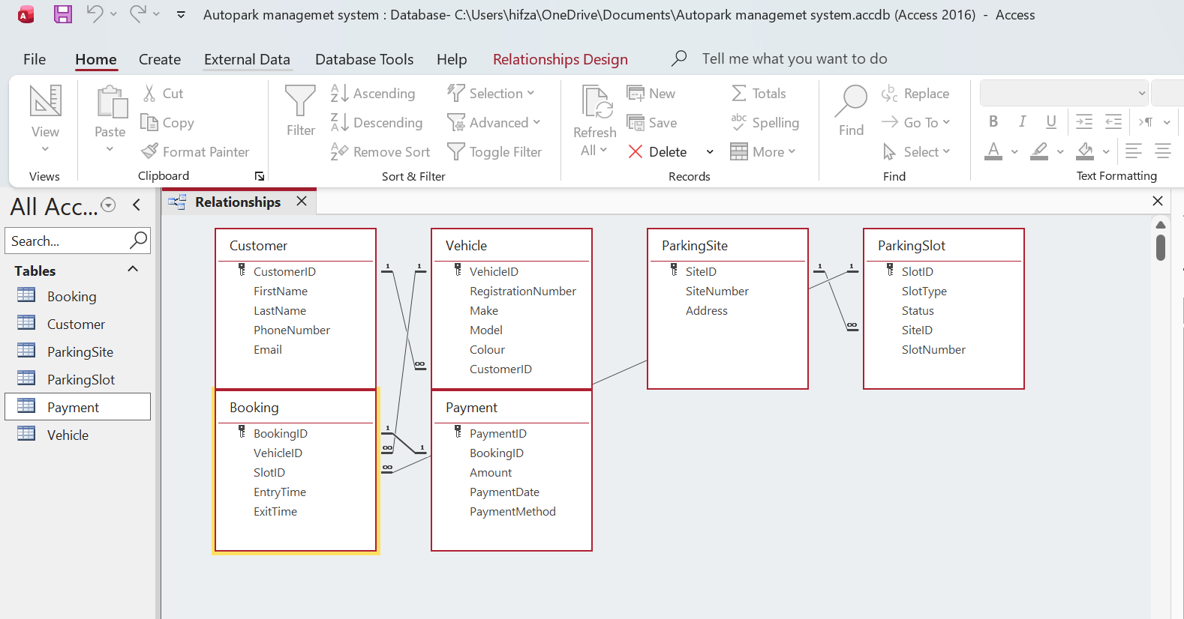

Normalisation (3NF)
Normalisation is a process of organising data in a database so as to reduce redundancy, consistency and ensure data integrity. The Auto Park Management System database was designed based on the Third Normal Form (3NF) principle, which ensures efficient storage of data and a well-defined relationship between tables
The database adheres to the First Normal Form (1NF) which ensures that each table has a primary key and no repeating, multiple values within an attribute.
The database is in 2NF where all non-key attributes depend completely on their corresponding primary key.
The database is in the Third Normal Form (3NF) as there are no transitive dependencies between non-key attributes. Use of separate tables, primary keys and foreign keys reduces redundancy, ensures data integrity and facilitates efficient data storage and retrieval.
The normalized design also has a clear basis for future extension of the Auto Park Management System while not impacting the current data.

Sample Data Population
Customer
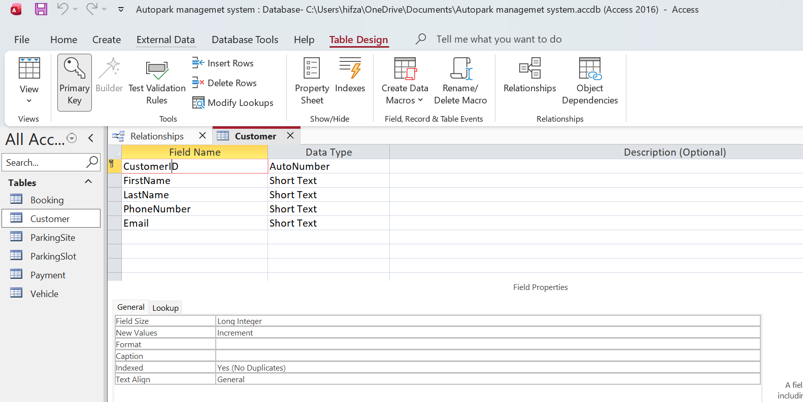
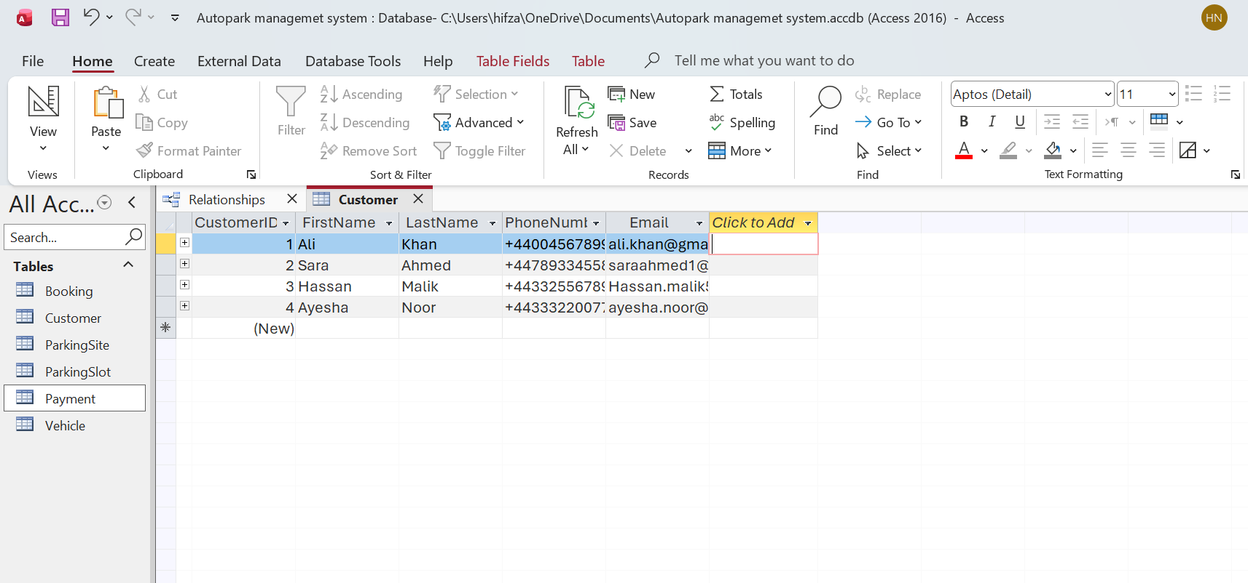
Vehicle
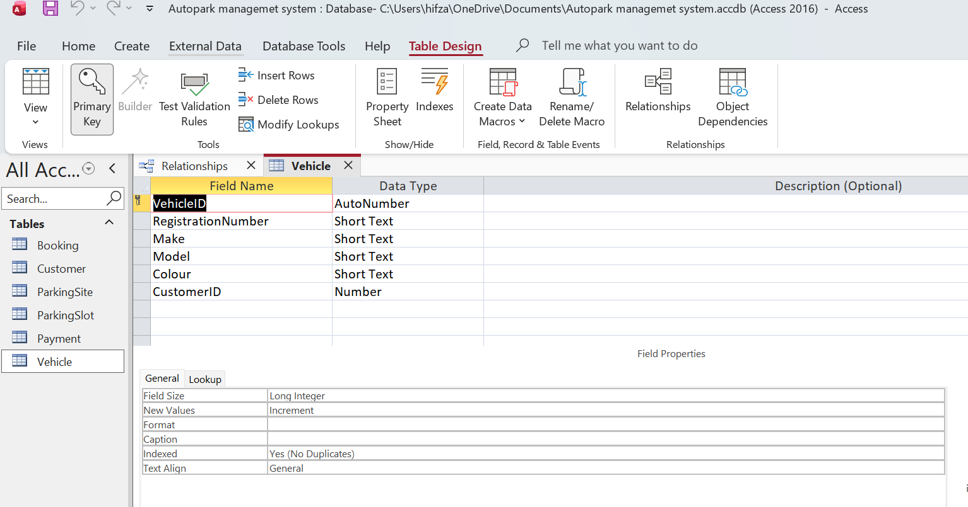
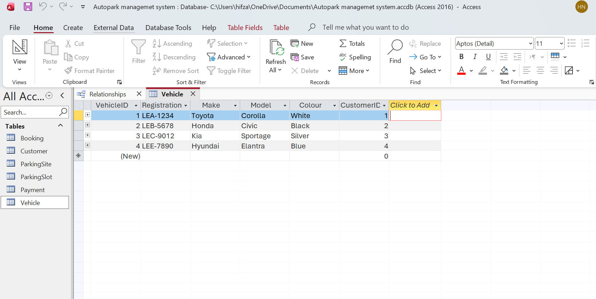
Parking Site
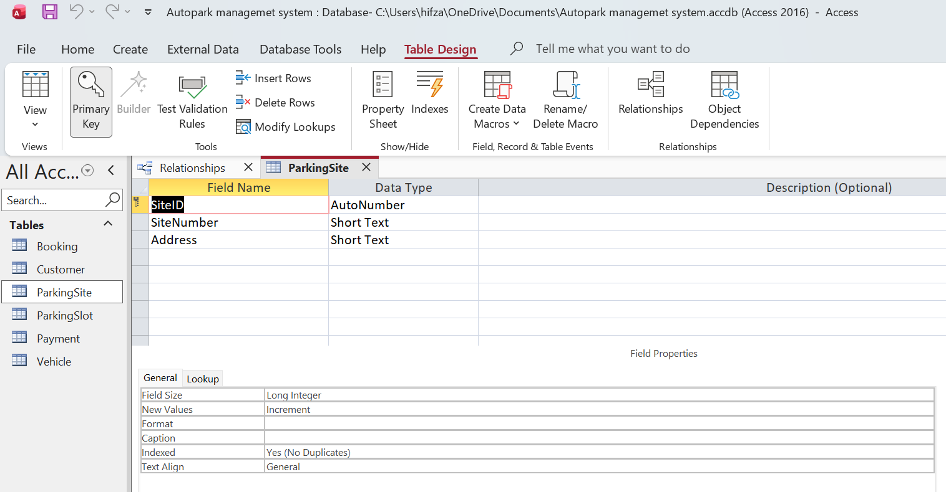
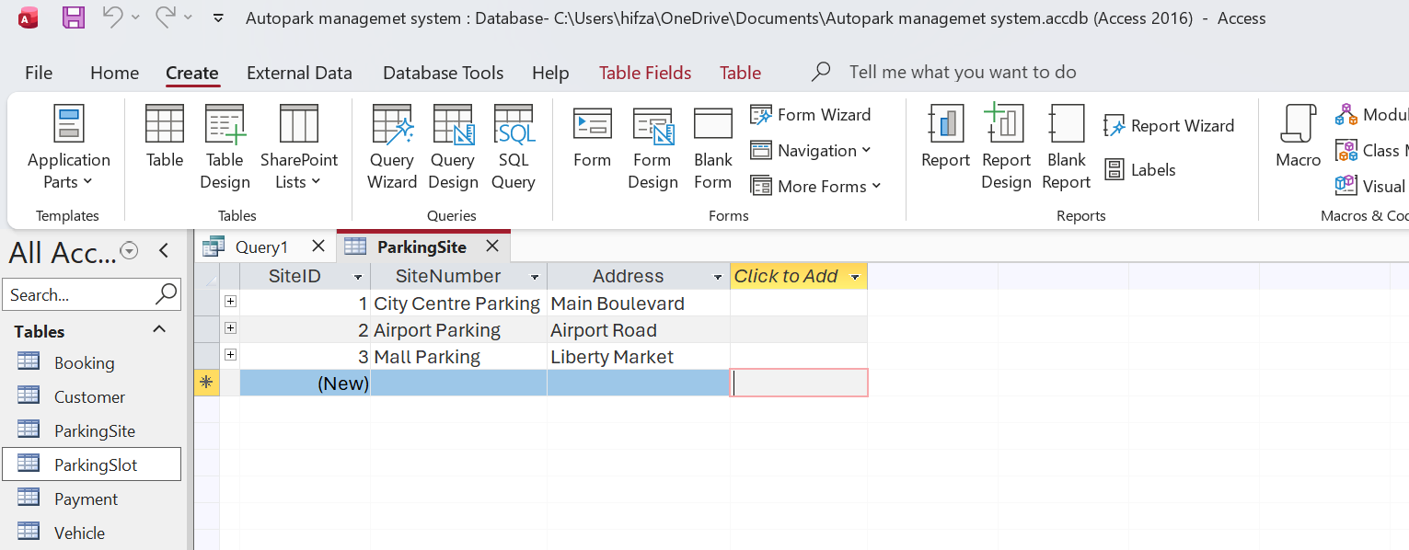
Parking Slot
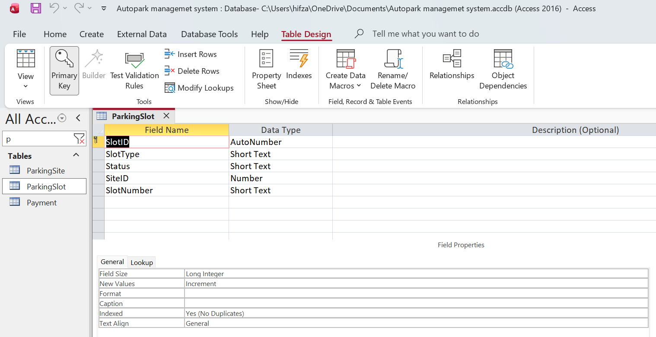
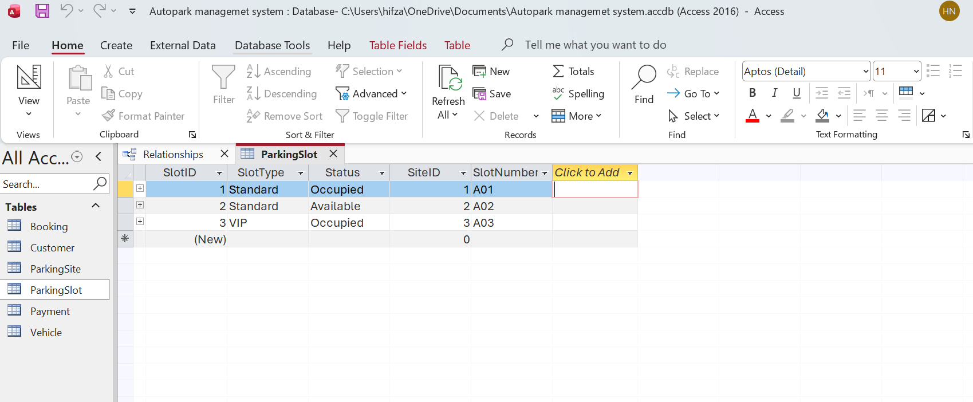
Booking
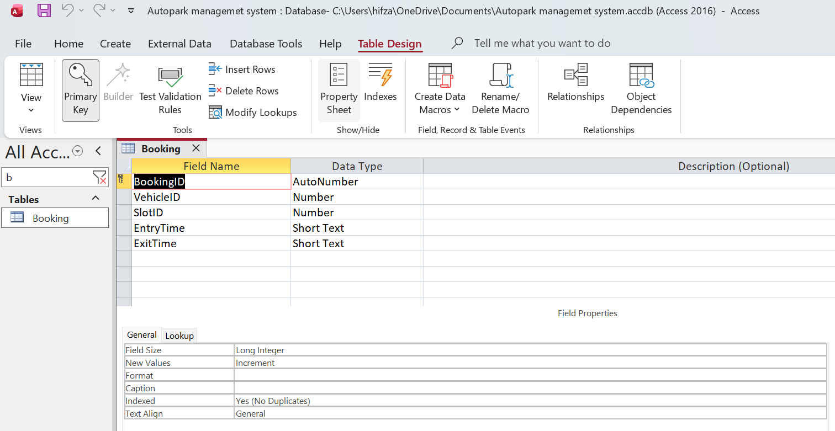
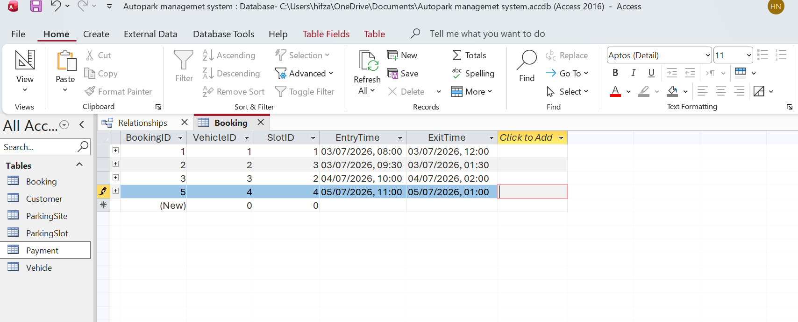
Payment
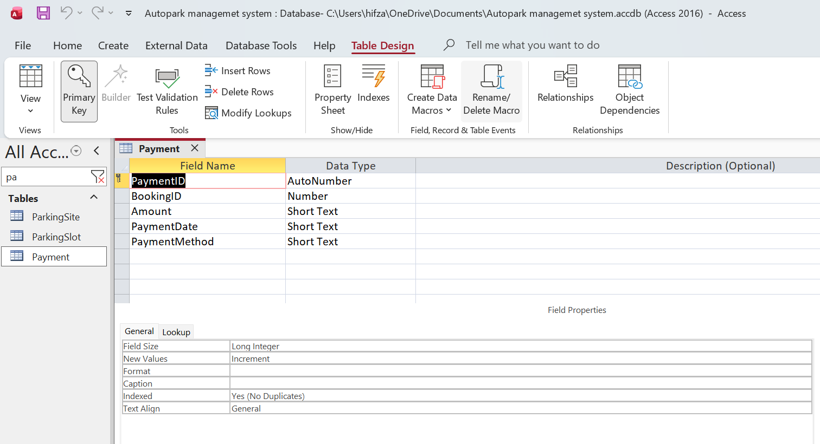
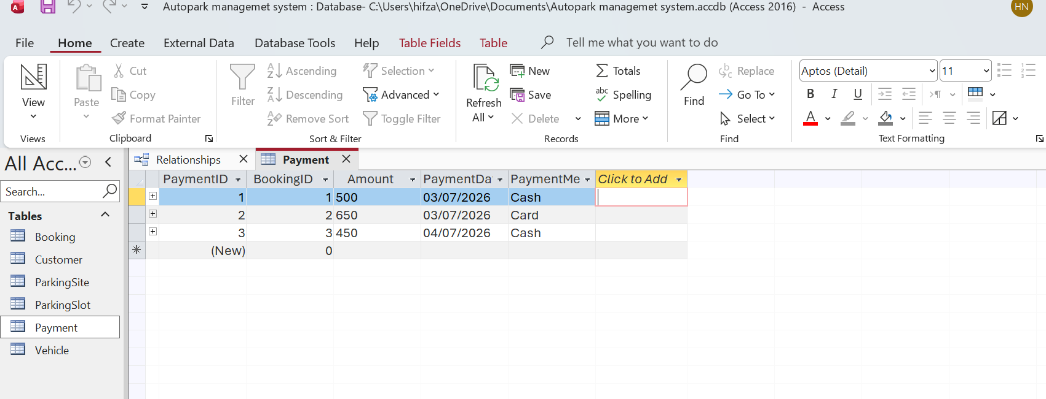

Query Development
Query 1 – All Customers
This query retrieves all customer records stored in the database. It allows staff to quickly view customer information without opening the Customer table.
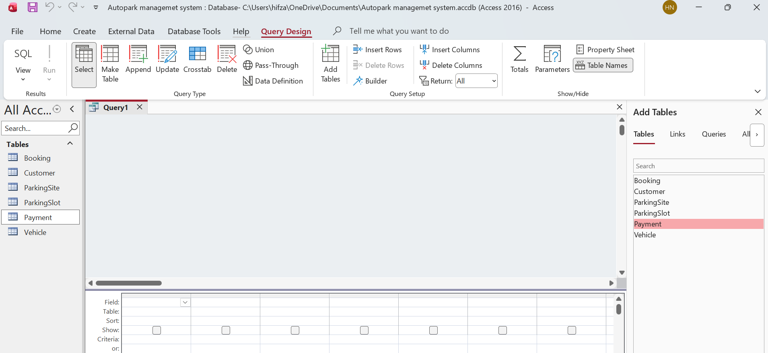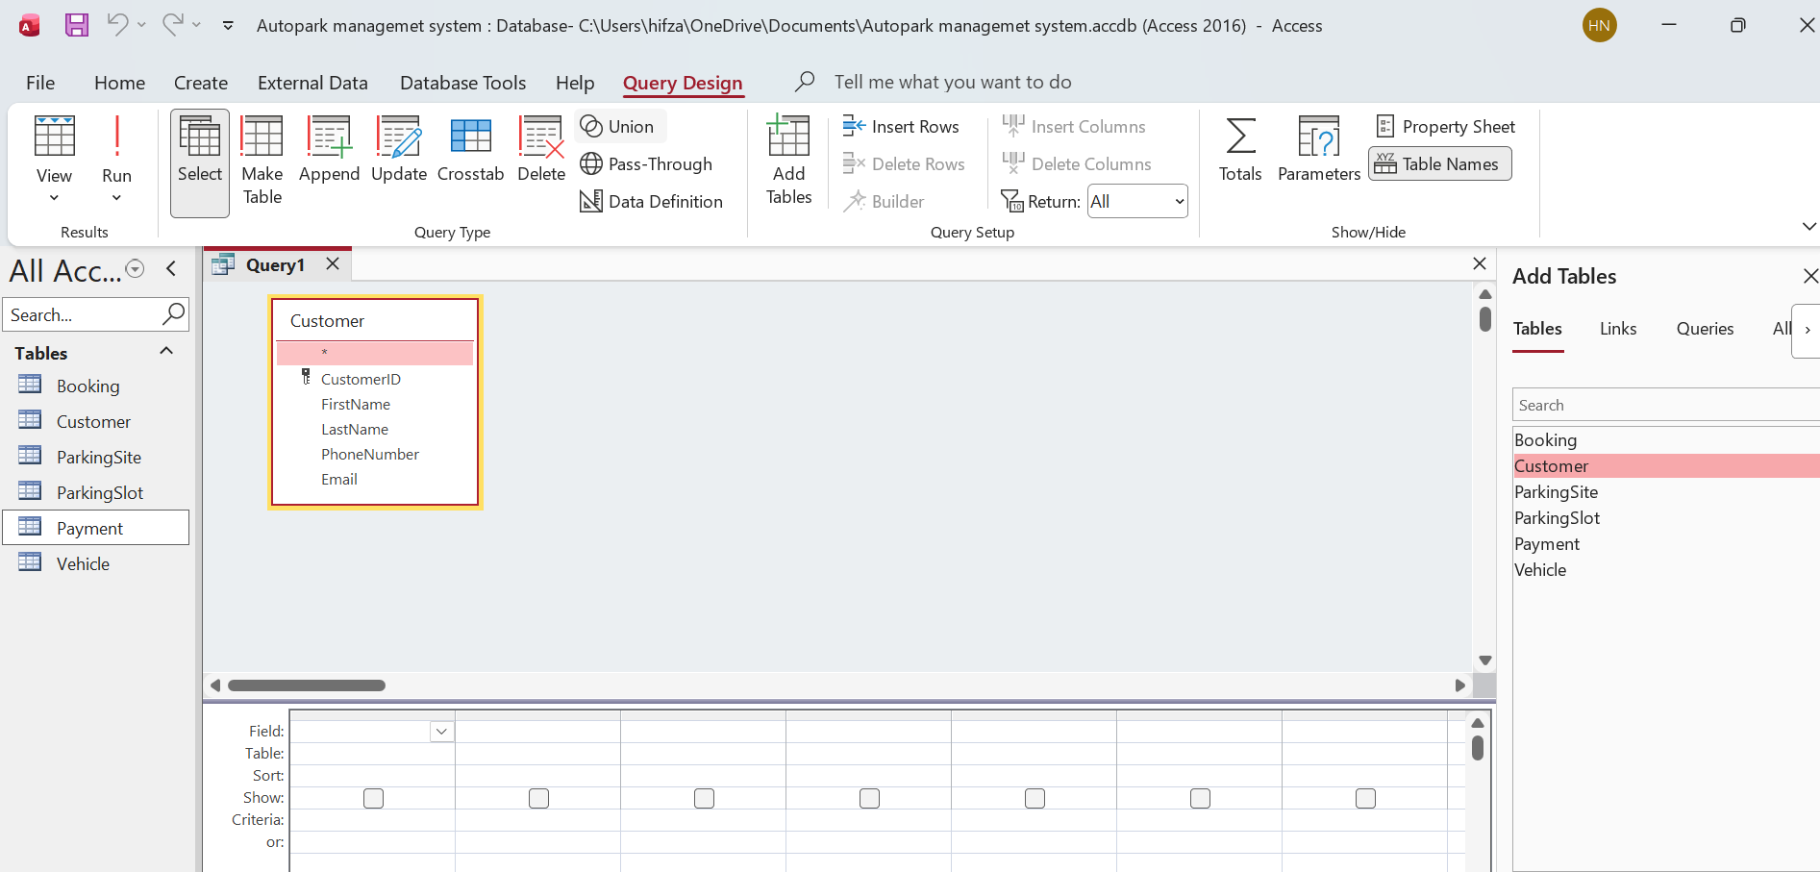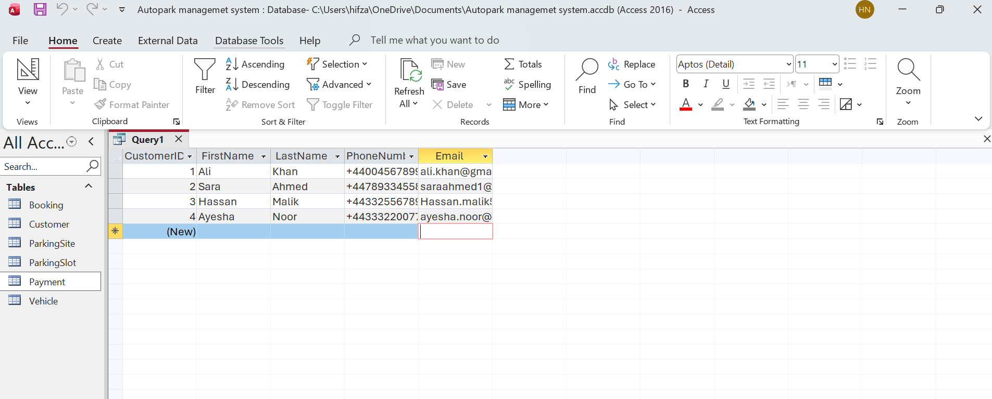

Query 2 – Vehicle Owners
This query combines data from Customer and Vehicle tables to display each vehicle together with its owner. It demonstrates the relationship between customers and their registered vehicles.
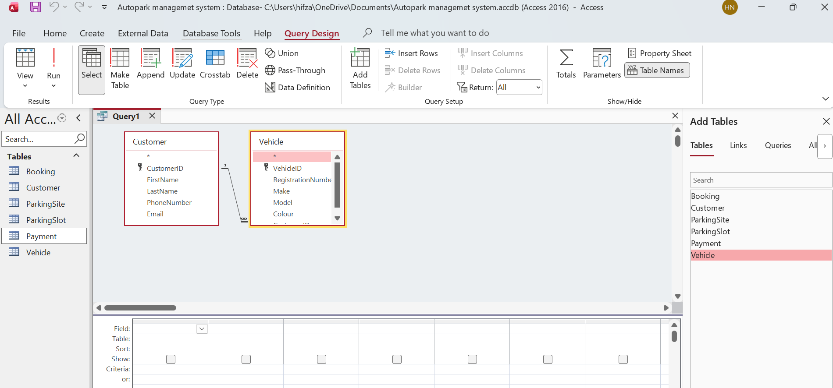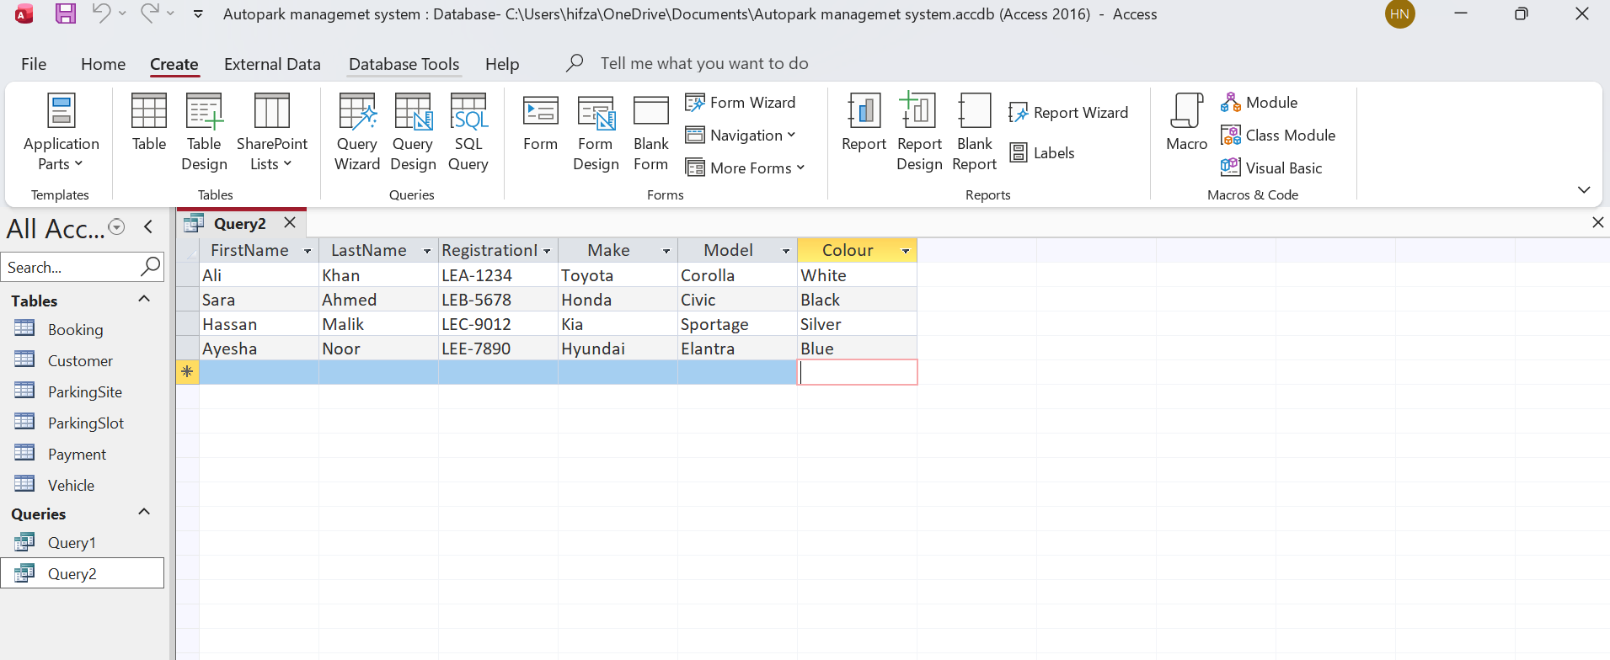

Query 3 – Available Parking Slots
This query displays only the parking slots that are currently available. It helps staff identify vacant spaces for new bookings.
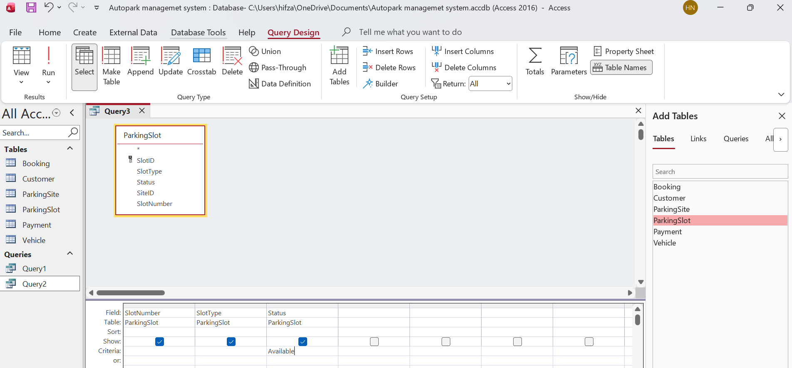
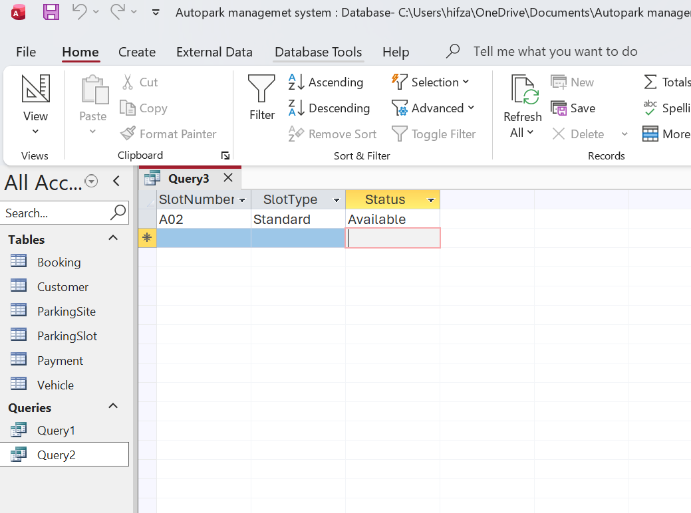

Query 4 – Booking Details
This query retrieves booking information together with the allocated vehicle and parking slot. It provides an overview of parking activities.
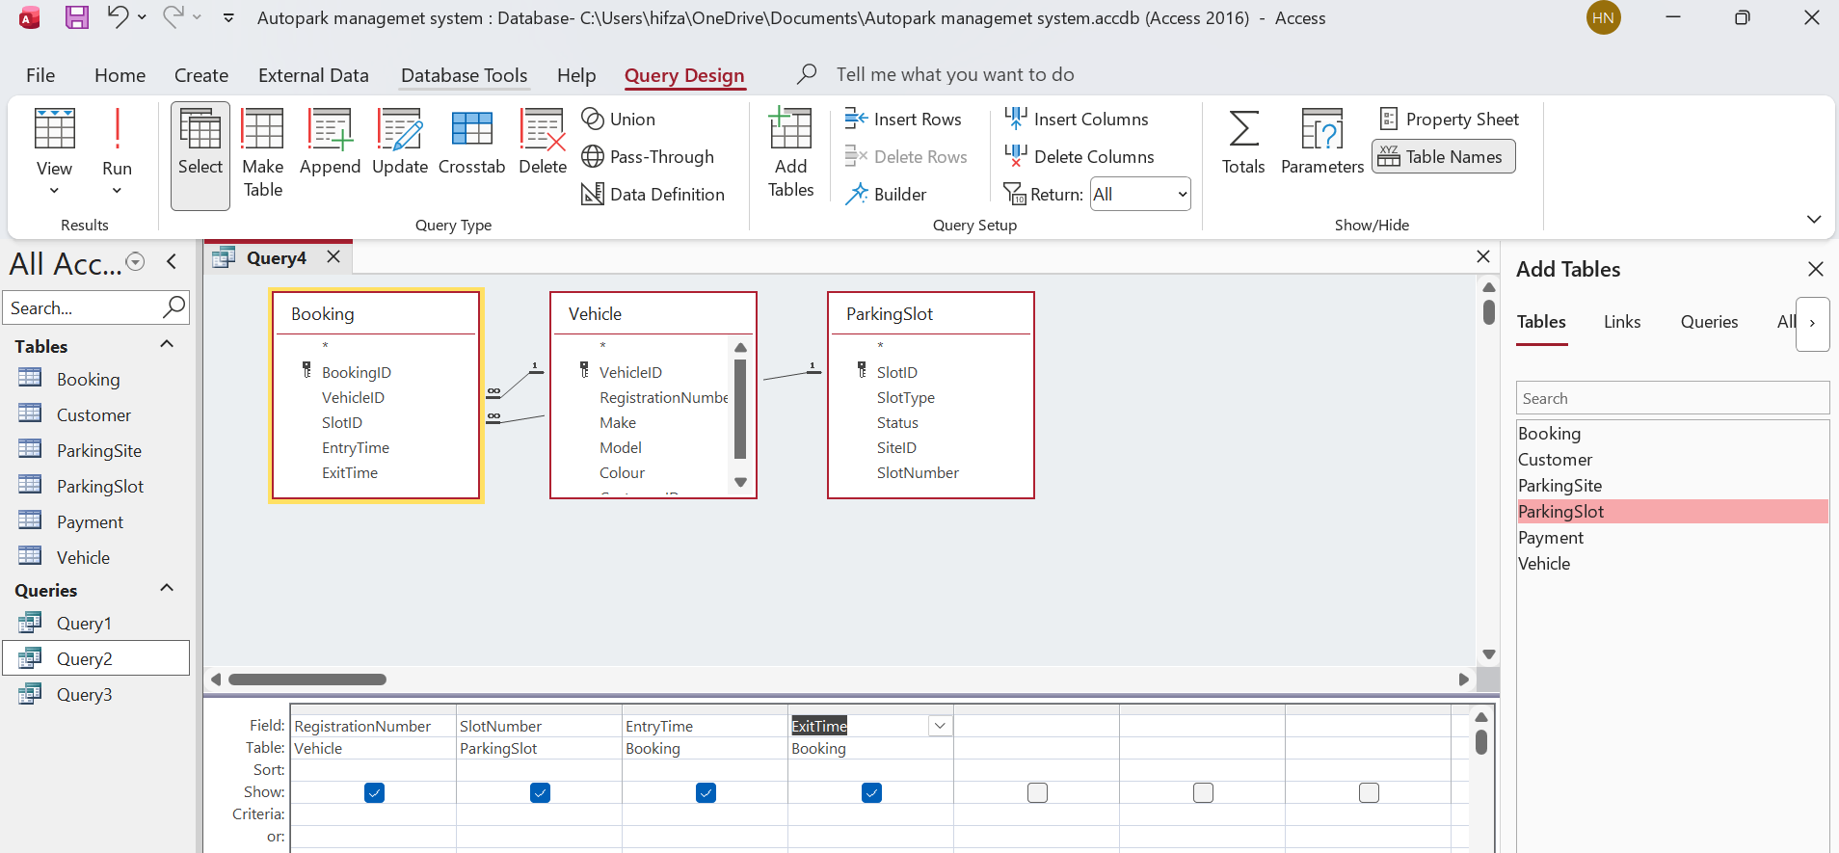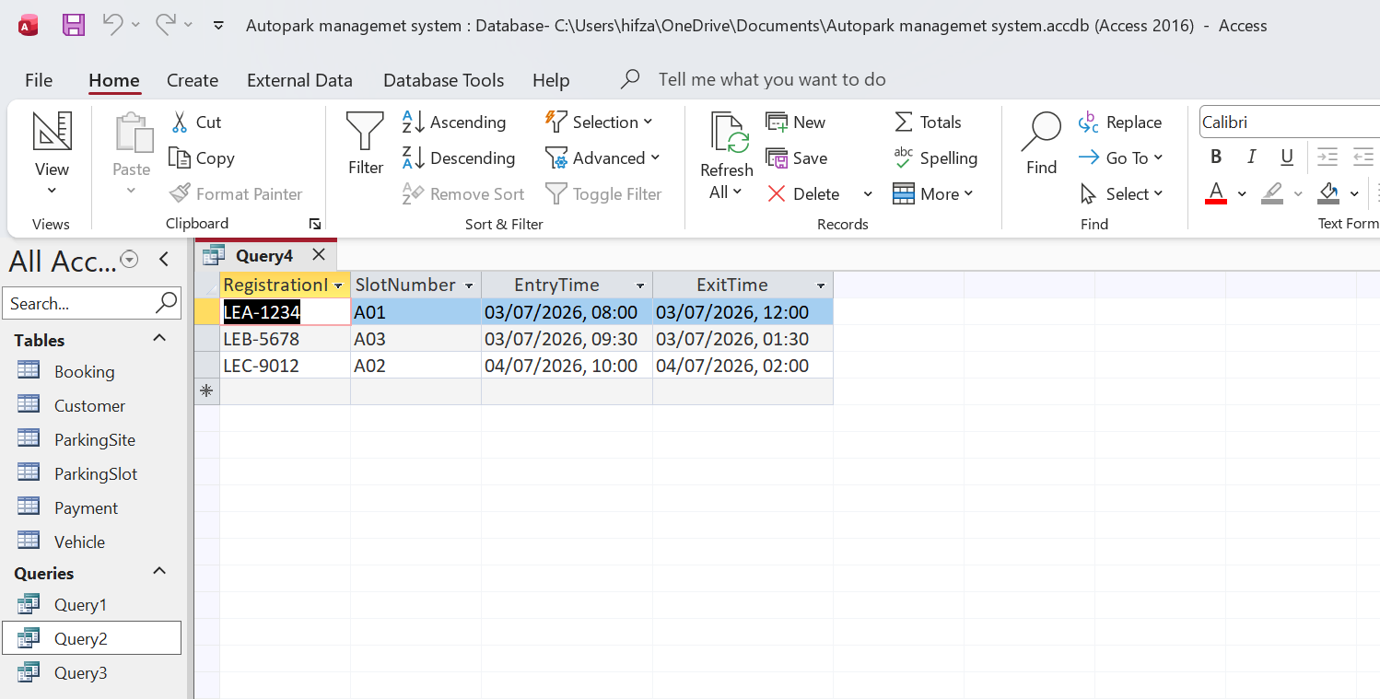

Query 5 – Payment Details
This query combines information from the Customer, Vehicle, Booking, and Payment tables to display customer names together with their vehicle registration numbers and payment details. It allows staff to review completed payment transactions and verify that each payment is linked to the correct booking and customer.
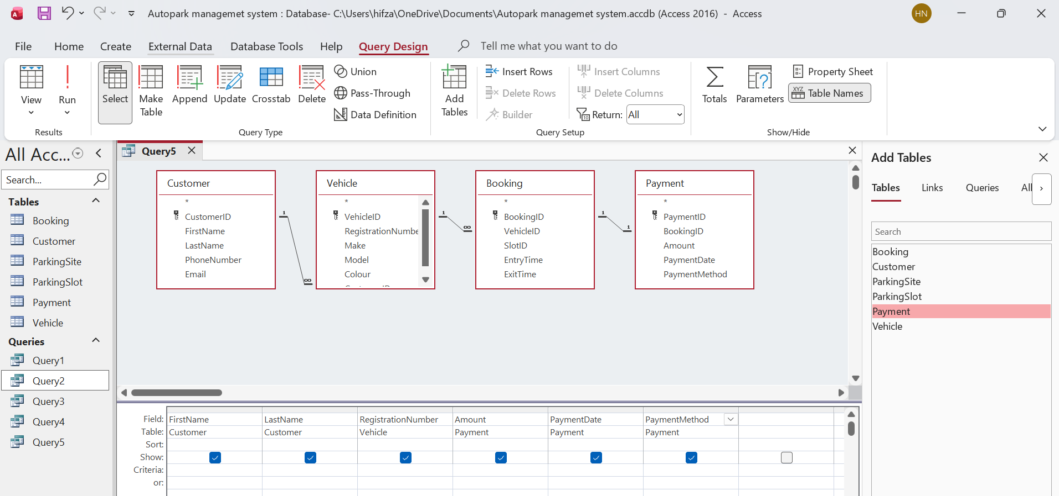
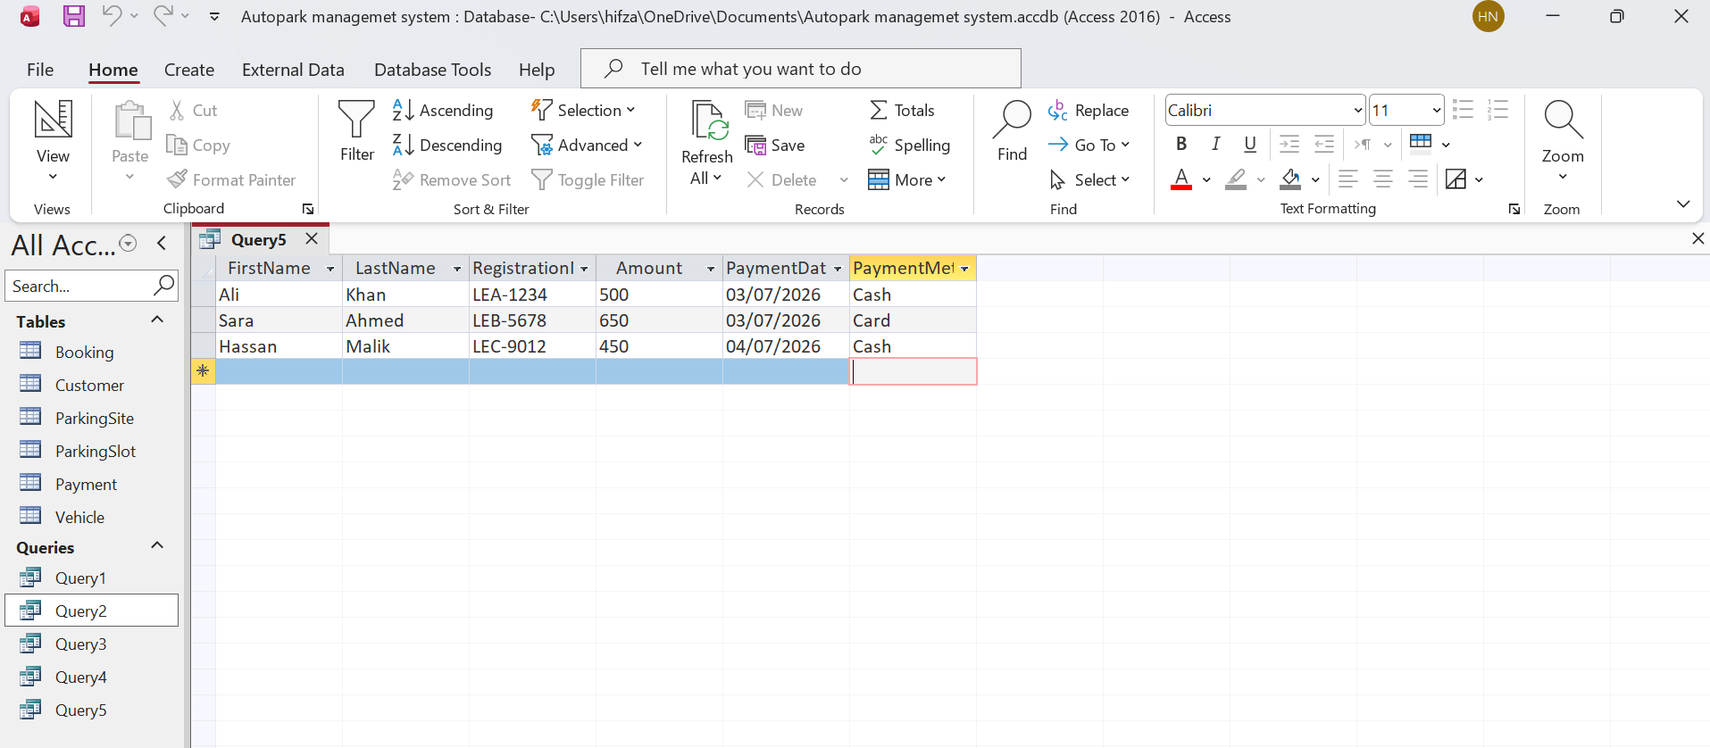

Validation and Testing
The Auro Park Management System database was tested for proper operation of all tables, relationships, queries and validation rules after implementing the system. The various scenarios were tested to ensure that the database contained correct data and that the data was properly integrated and the results were returned. The results showed that the identified functional requirements in the design phase were fulfilled by the outcomes of the database.

Forms
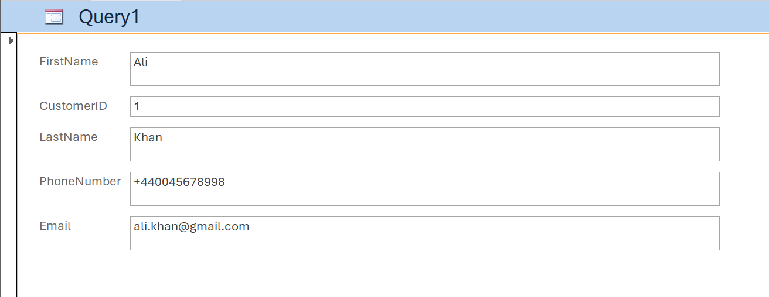
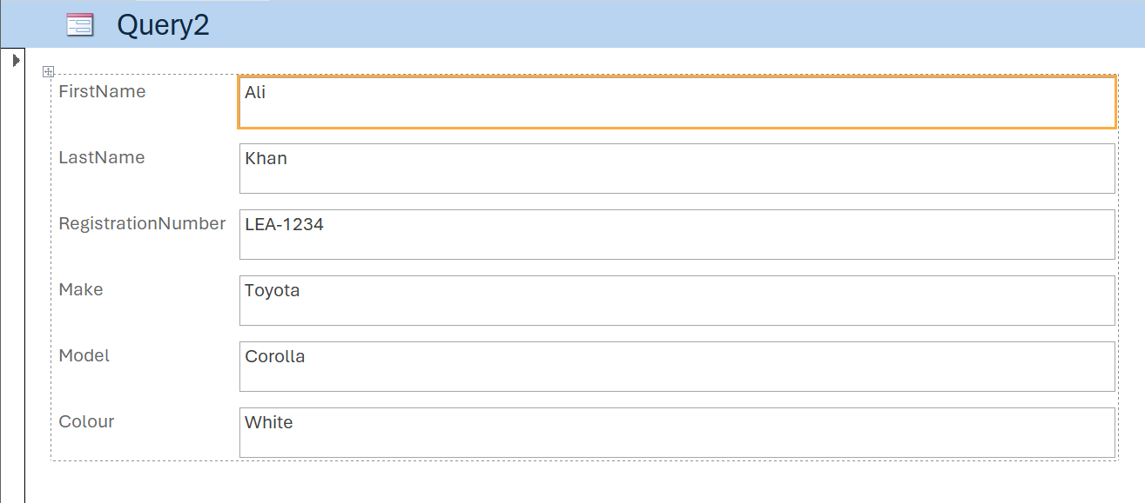
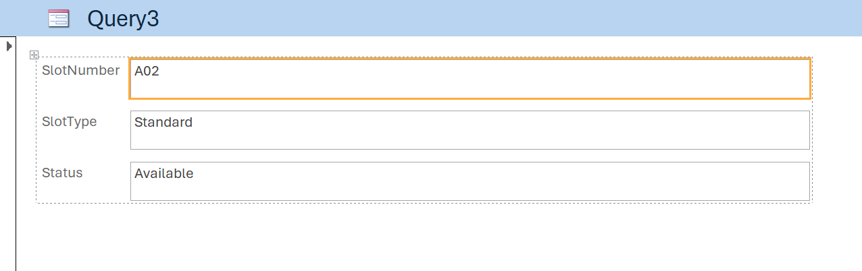
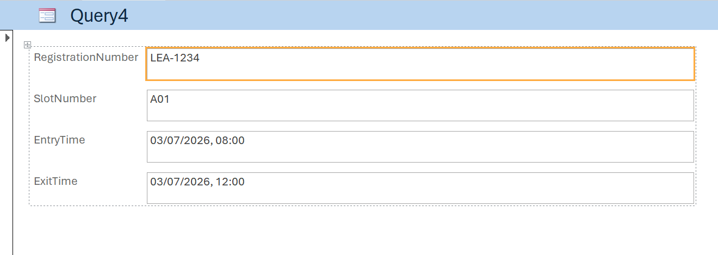
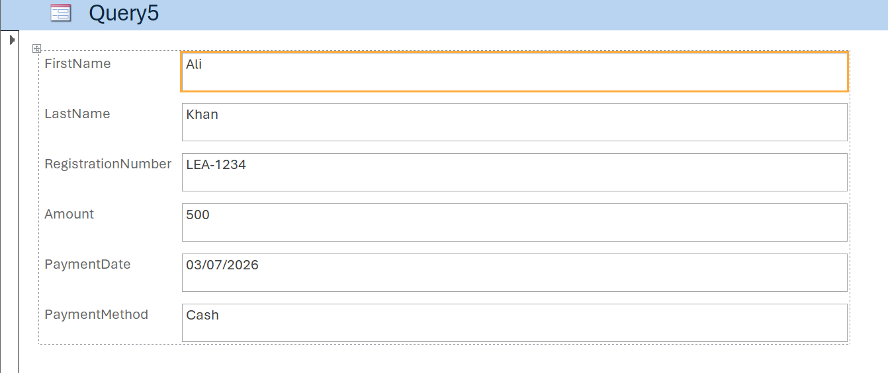

Testing
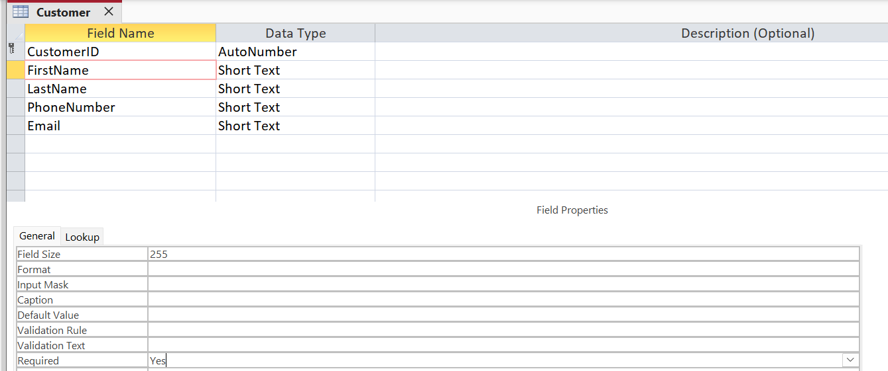
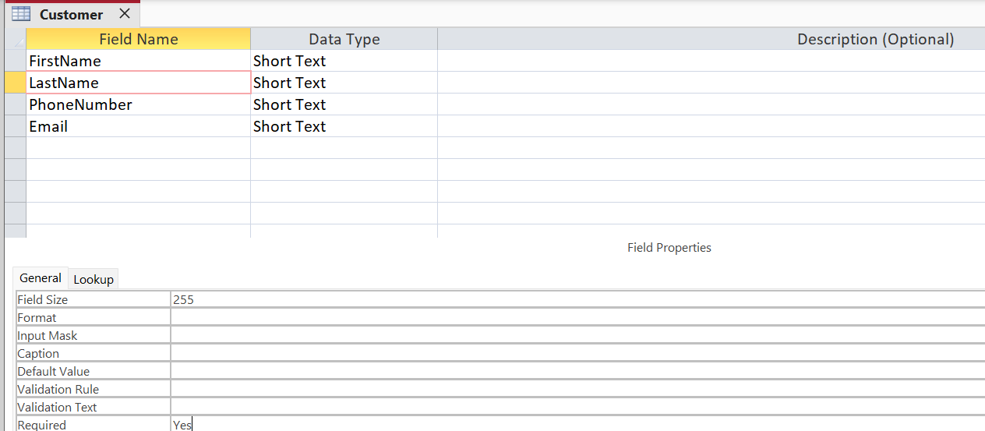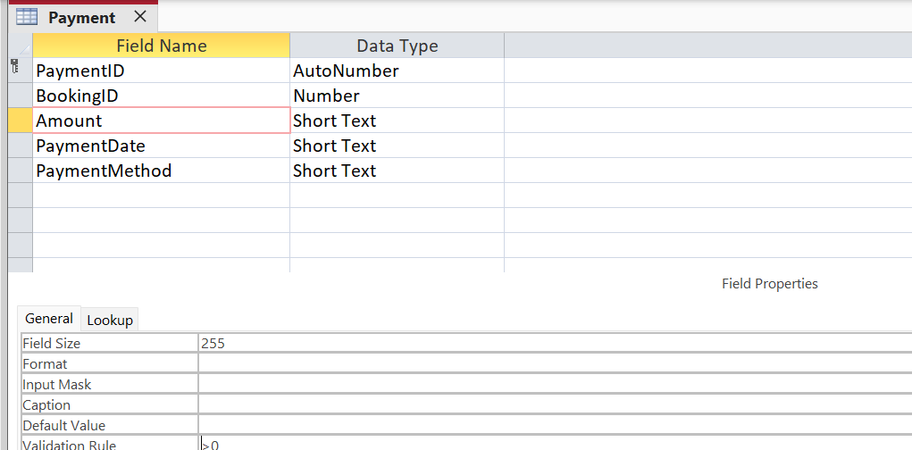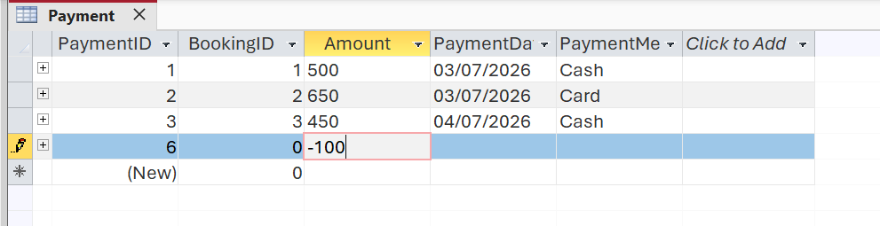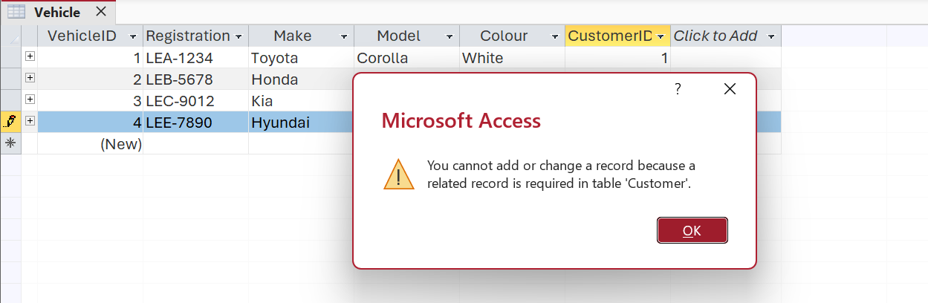
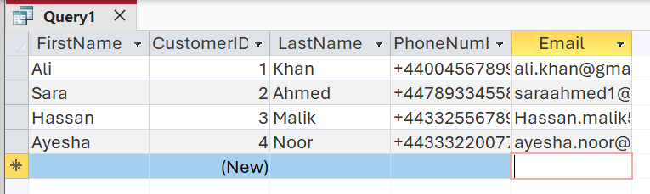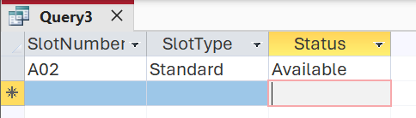
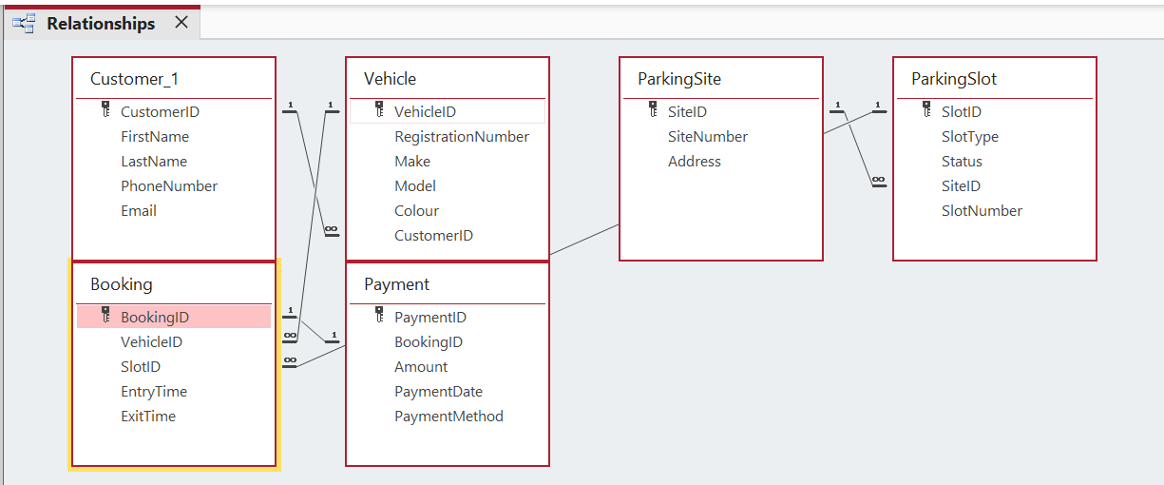

Task 2 – Course Work Written Elements

Screenshots of Database Development
Auto Park Management System was completed using Microsoft Access. Screenshots have been included to demonstrate the process of creating the tables, relationships, sample data, sample queries, and the testing. These screenshots are a proof of successful implementation of a database.
Figure 1: Customer table created in Microsoft Access.
Figure 2: Relationships established using Referential Integrity
Figure 3: Sample Data entered into the Customer table.
Figure 5: Query displaying available parking slots
Figure 6: Validation rule preventing invalid data entry.

Design Decisions
The database was designed in a relational model to minimise the magnitude of data duplication and data organisation in the database. This was achieved by adding unique identifiers (primary keys) to records and links (foreign keys) between tables. The database was also designed in Third Normal Form (3NF) to ensure data consistency and eliminate data duplication. Microsoft Access was selected because it is suitable for developing small relational databases.

Challenges Faced
The biggest problem was making the relationships in Microsoft Access properly and making sure that all the foreign keys would match with their primary keys. Other queries needed to be modified to yield the desired results. These were addressed by carefully examining the database design, and testing each relationship and query.

Future Improvements
Adding features such as user login, online booking and payment, auto parking slot allocation and management reports would enhance the system. The following improvements would result in a more efficient and appropriate system for larger organisations.

Conclusion
Microsoft Access was used to create a successful AutoPark Management System database. The database design had been done according to the principles of relational database design by identifying that what entities are required, how they are connected with one another through primary and foreign keys, and how the data can be normalised according to Third Normal Form (3NF). Sample data, queries, and validation procedures were shown to prove that the system can handle customer information, vehicle records, parking locations, bookings and payments in an efficient manner, maintain data integrity and minimise data redundancy.

In general, the adopted database meets the needs of the selected scenario, and offers a structured approach to optimizing the operations of parking management. There are potentially further improvements to the system that can be made in the future, including online booking, user authentication and automated reporting.

References
[1] C. Coronel and S. Morris, Database Systems: Design, Implementation, and Management, 14th ed. Boston, MA, USA: Cengage Learning, 2022.
[2] R. Elmasri and S. B. Navathe, Fundamentals of Database Systems, 7th ed. Harlow, U.K.: Pearson, 2021.
[3] A. Silberschatz, H. F. Korth and S. Sudarshan, Database System Concepts, 7th ed. New York, NY, USA: McGraw-Hill, 2020.
[4] T. Connolly and C. Begg, Database Systems: A Practical Approach to Design, Implementation and Management, 6th ed. Harlow, U.K.: Pearson, 2015.
[5] P. P. Chen, "The Entity-Relationship Model—Toward a Unified View of Data," ACM Transactions on Database Systems, vol. 1, no. 1, pp. 9–36, 1976.
[6] E. F. Codd, "A Relational Model of Data for Large Shared Data Banks," Communications of the ACM, vol. 13, no. 6, pp. 377–387, 1970.
[7] R. Agrawal, T. Imieliński and A. Swami, "Mining Association Rules Between Sets of Items in Large Databases," Proceedings of the ACM SIGMOD International Conference on Management of Data, pp. 207–216, 1993.
[8] Microsoft, "Microsoft Access Documentation." [Online]. Available: https://support.microsoft.com/access. [Accessed: Jul. 8, 2026].
[9] Microsoft Learn, "Create relationships between tables in Access." [Online]. Available: https://learn.microsoft.com/. [Accessed: Jul. 8, 2026].
[10] Microsoft Learn, "Create queries in Access." [Online]. Available: https://learn.microsoft.com/. [Accessed: Jul. 8, 2026].
[11] Microsoft Learn, "Introduction to relational databases." [Online]. Available: https://learn.microsoft.com/. [Accessed: Jul. 8, 2026].
[12] IBM, "Database Normalization." [Online]. Available: https://www.ibm.com/topics/database-normalization. [Accessed: Jul. 8, 2026].
[13] Oracle Corporation, "Database Design." [Online]. Available: https://docs.oracle.com/. [Accessed: Jul. 8, 2026].
[14] JGraph Ltd., "diagrams.net (draw.io)." [Online]. Available: https://www.diagrams.net/. [Accessed: Jul. 8, 2026].

