Module: Global Business Environment
Module Coordinator: Eric Osei
Module Code: LCBB4005-BIRM

Assignment Title: Individual project report


Student’s name:
Gabriela-Camelia Buliga(2114966)

Table of Contents

Introduction 3
PESTEL analysis of Pound-land shop 4
Porter's five forces model 9
Supermarket giants such as Asda compete against not only Tesco, Sainsbury's and Morrison's and but also with Nike, Primark, Superdrug, among others. 10
References 11

Introduction

An international company provides products or services to customers all over the world. One of the primary objectives of a worldwide corporation is to generate as much revenue as possible using various marketing techniques, such as advertising, promotion, and the internet. Small and medium-sized businesses like Poundland are typical in the United Kingdom. A British variety store chain called Poundland provides a wide range of goods for only one euro, including clearance items and brands owned by the company itself (Rullen, 2022). As per the PESTLE analysis, it will be exposed how Poundland's business environment get impacted in good and bad ways in macro environmental factors. Porter's five force study and how competitors affect the market are also explored.

PESTEL analysis of Pound-land shop

The PESTLE Analysis of Poundland looks at the company's macro environment. Poundland's PESTLE Analysis examines a wide range of external factors, including political, economic, social, and technological issues, as well as environmental and legal concerns, that impact its business. Using the PESTLE Analysis, it is possible to identify the various external factors that affect the brand's business (Akman, 2020). Poundland relies on PESTLE research to stay abreast of market changes and continuously improve its business. An alternative term for PESTLE analysis is referred to by the acronym PESTEL.

Figure 1: PESTLE Analysis (Karrabi and Mohammadi, 2018)
Political: Political factors are government rules that influence business function. Some factors influence the government's ability and willingness to step in and help the economy or a specific firm. In other words, here is where the government's impact on your business is classified. Overseas trade policy, fiscal policy, and labor laws are just a few examples of this. Trade limitations and import tariffs are also a part of it (Karrabi and Mohammadi, 2018).
- Political stability: This Poundland's advantage is that they often provide healthy options. A clear sociological trend toward eating healthy has arisen in the twenty-first century. As political stability increases, the likelihood of conducting business increases as well. The food and retail sectors are susceptible to a wide range of political consequences.
- Tax Policy: Taxes may restrict private consumption since they remove money from them and diminish their income. Consumers' less spending means less money for companies, which result in less employment and investment. Poundland's major political challenge would be to keep these people spending to maximize earnings. This will hurt Poundland. New EU regulation has raised expenses and lengthened delivery times. Up to 80% of UK food imports originate from the EU.
Economic: Economic factors are the essential data about the market and economy taken into attention when an investment or company value is calculated.
It is crucial to remember that a country's economy is influenced by its economic policies. Everything from economic growth to consumer disposable income to poverty rates has a role. Due to their impact on consumer purchasing power and the economy's demand and supply patterns, these factors may have a protracted effect on a company (Gheibi, 2020). Consequently, this affects the pricing of products and services.
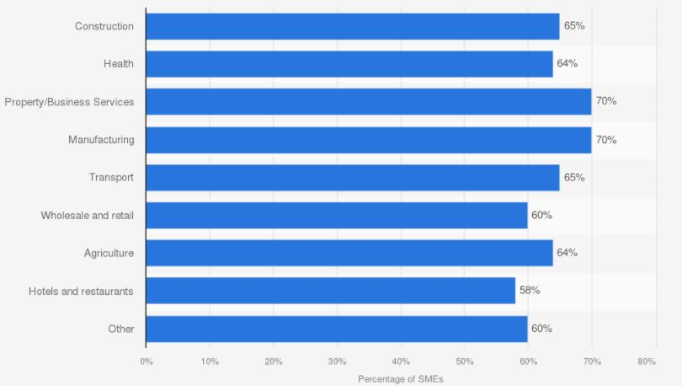
Figure 2: SME profit percentage in the UK in 2020 (Gheibi, 2020)
- Interest rates: Sales figures for retail and wholesale indicate that the margins are around 60 percent, which is exceptional. Small enterprises in the UK may add product interest rates to take advantage of these advantages. When it comes to generating interest rates, sales, distribution, and profit, Poundland must keep a careful eye on economic trends in the countries in which it operates.
- Supply and demand: To give the most significant value to customers, satisfy their needs, and improve sales, Poundland's management must consider both supply and demand. By doing so, they have a complete view of the situation. The downside is that Poundland has a bad reputation for being slow to purchase and sell products (Karrabi and Mohammadi, 2018). The trend must last for at least twice if Poundland's moving average to avoid losing money.
Social: As a whole, this element of the surrounding atmosphere represents the individuals who work at Poundland in terms of their characteristics, customs, habits and values. Consider population growth, age, income distribution, education levels, safety awareness, health awareness, lifestyle attitudes and cultural obstacles (Widya Yudha. Tjahjono and Kolios, 2018). If Poundland's trying to target specific customers, these factors are critical. This story also shows local employees' willingness to labor under harsh conditions.
- Income: To Poundland's advantage, people's hectic lifestyles mean they like to buy everything at once more than their income; therefore, the retailer-built store layouts to match this demand for convenience. The company is now selling food and non-food products. Social effect or societal influence is a factor in determining the products that a company's diverse clientele wants. Several cultural aspects might impact an individual's decision-making process (Widya Yudha. Tjahjono and Kolios, 2018). Poundland must examine these cultural shifts and their implications for future generations to serve its customers better.
- Employment: More employment always helps the country's economy. Negative characteristics of the social sector include unemployment percentage fluctuations and shifting staff expectations. Inside the United Kingdom, this same United States, and certain other countries, a growing number of enterprises are catering to customers from a wide range of ethnic origins.
Technological: In a market or industry context, technical factors consider the rate of technology innovation and development. New digital or mobile techniques, automation, or even R&D may have a role (Widya Yudha. Tjahjono and Kolios, 2018). A company's ability to connect with customers, vendors, and competitors and gather information about these entities is influenced by these factors. Technology has a significant influence on business operations. Poundland will benefit from both physical and intangible benefits of technology, no matter how big or little their firm maybe. There is a direct correlation between a new goal, efficiency, and ties to its technology infrastructure (Achinas and Euverink, 2019). In the face of technological advancement, businesses are faced with risks, possibilities, and problems. To improve their products and processes or even create whole new ones, some companies might take advantage of the ever-changing technological landscape.
- E-Platform Technologies: Shopping online, digital marketing and other related operations all play a part in influencing clients since they provide several technological benefits to the customer base. Forty-three percent of its consumers now prefer to shop online and deliver their items directly to their homes regarding shopping habits. The most recent news from Poundland. Customer wait times will be reduced due to the elimination of complex billing procedures.
- Production: There are also drawbacks to technology innovation, such as how supermarkets operate their production. Automated checkouts have replaced human checkouts in many retail establishments. Most businesses now utilize electronic loyalty cards and have long used computers to track their inventories as fast as their production makes possible (Achinas and Euverink, 2019).
Legal: Legal factors may intersect with political considerations in discrimination and antitrust legislation, as well as other specialized areas like consumer protection laws, intellectual property laws, and health and safety standards. Poundland must know what is and isn't legal to do business ethically and successfully. Since each county does have its own set of rules and regulations, this becomes considerably more difficult for Poundland when it trades abroad. For Poundland, being abreast of potential legal developments and how they might influence the firm in the future, is a top priority as well. If Poundland needs assistance with legal concerns, they should seek the advice of a lawyer.
- Laws and Employment Safety: Employees at Poundland have recently benefited from this legal aspect of their work. The firm was recently sued for gender wage disparity. To keep the city's status, it must thoroughly examine and follow all regulations and laws. Restoring a company's reputation is difficult and expensive. On the legal system's flat side, changes in government laws immediately affect corporate operations. To run smoothly, the firm must follow local and international market laws. Organizations like the Grocery Retailing Commission have set rules that all retail members must follow.
- Goods labeling and safety regulations must be addressed: There are several advantages to doing so, including the fact that it provides information like the product name, manufacturer's name, components of the product, end date, manufacturing date, guide the reader, and so on; however, there are several disadvantages, including those labels seem to focus on damage and may encourage children to see the cognitive deficits rather than the child.
Environmental: For strategic planning, Lumen Learning recommends addressing environmental variables, which are external factors that a corporation has limited influence over yet must address. The importance of environmental factors has just recently increased. They have become more critical because of escalating raw material shortages, environmental regulations, and carbon footprint goals than ever (Yüksel, 2012). Some ecological and environmental aspects may influence many industries, such as tourism, agribusiness, agriculture, and insurance, including weather and climate (ADEKOLA, 2017). Companies like Poundland, which sell low-cost items, are adapting to the growing public concern about climate change.
- Pollutants: Poundland also took steps to reduce the amount of non-recyclable material used more than possible. One of these steps has been to investigate innovative ways to make more use of residual material which is still in use. Because of this, the amount of rubbish disposed of in landfills is expected to drop by a substantial amount. It has been more than a century since more than 800 goods have indeed been rebuilt, and more than 4500 tonnes of rigid plastic have been removed from the environment (Horjus, 2020).
- Water & Food Activity: Another threat is food and water shortages caused by extreme weather. The risks to public health were likely to outweigh any economic benefits that may result from this decision. There is the potential for a wide range of environmental concerns to influence human health and well-being negatively.

Porter's five forces model

Porter's Five Forces is a framework for assessing a company's competitive landscape. An organization's profitability is affected by the number and strength of its rivals, new market entrants, suppliers, customers, and replacement items.
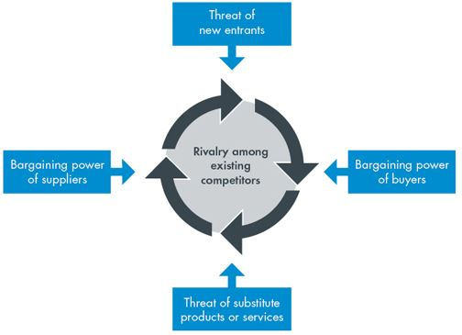
Figure 3: Most essential forces (Asad, 2020)
Applying Porter's five forces could assist Poundland in identifying who has the most extraordinary power. This approach may examine an organization's existing and prospective competitive positions. To better understand their competitors, Poundland may use Porter's five forces of competition. It's a basic plan that works. Understanding the factors impacting Poundland's store will assist them in improving profitability and remaining competitive. Poundland, for example, may fully use a favorable situation or accentuate a negative one (Arar and Yurdakul, 2017).
New Entrants Threats: It will cost a lot of money to get started. Marketing and sales techniques must be similar to Poundland's. Other retailers may establish their scale economies and discount packages (Arar and Yurdakul, 2017). Due to their inexperience, a new firm cannot provide significant discounts. It will be harder to access large firms' supply chains. Nike and Primark, for example, sway small local firms.
Substitute Threats: Affordability is another. People purchase from low-cost merchants because they need everyday products (Hove and Masocha, 2014). Morrison and Tesco have followed suit. Poundland must thus consider Nike or Primark. Replacement danger is reduced. Poundland, therefore, enjoys a competitive advantage. So, replacements won't affect Poundland operations.
Customer Bargaining Power: Tesco, Sainsbury's, and Morrison's are known. It must so dazzle customers to win. Customers may have little say in pricing. Devotion to products isn't intended. It is cheaper to switch to Poundland than other stores.
Suppliers Bargaining Power: Supplier networks aren't only for Nike and Primark. Poundland's supply strategy. Consequently, only merchants may negotiate and decide the product's price. Suppliers vary by shop. In this case, retailers may value price above quality (Hove and Masocha, 2014). Poundland's actions weaken supplier leverage.
Competitive Rivalry: Poundland has come far in marketing. Businesses use several marketing strategies to stand out. They may gain from scale efficiencies owing to pricing competition. Since commodities are supposed to meet fundamental requirements, price battles are vital. Enemies will constantly mimic your techniques (Asad, 2020).

Supermarket giants such as Asda compete against not only Tesco, Sainsbury's and Morrison's and but also with Nike, Primark, Superdrug, among others.
The presence of competition in the grocery sector is undeniable. There are minimal restrictions on the establishment of a new superstore. Because of the move from supermarkets to smaller, community convenience shops, it has become simpler to open new nearby supermarkets. Asda must compete not only with Tesco, Sainsbury's, plus Morrison's, and even though also with Nike, Primark, and Superdrug, to name a few major competitors. Supermarkets that take advantage of their scale to save money will be penalized as part of an attempt to promote customer choice and competition. The Competitive Commission is set to release suggestions to prevent large corporations from forming local monopolies and driving small businesses out of business in their communities (Galli-Debicella, 2021). As well as being a clothes shop, Asda also manufactures its apparel. According to a spokeswoman for Primark, Asda competes indirectly with the retailer because of the terrible working conditions at Asda. Employees from Primark are also employed at the businesses in question. Workers at Asda, Tesco, and other Primark factories said that lots of people work up to 84 hours per week, they were unable to provide for their families due to the poor earnings they received in return. This holds even during their conflict. Although Nike is a very well-known brand, supermarkets today have more alternatives than only Tesco, Sainsbury's, Asda, or Sainsbury's and Tesco, among others (Galli-Debicella, 2021).

References
Achinas, V. and Euverink, G., 2019. A PESTLE Analysis of Local Shop in Europe. Sustainability, 11(21), p.5981.
ADEKOLA, A., 2017. GLOBAL BUSINESS MANAGEMENT. [Place of publication not identified]: ROUTLEDGE.
Akman, M., 2020. Management and PESTLE Analysis. Ante Portas - Studia nad bezpieczeństwem, 1(14)/2020(1(14)/2020), pp.93-102.
Arar, T. and Yurdakul, G., 2017. Developing Competitive Strategies Analysis in Porter s Five Forces Model by DANP. Journal of Business Research - Turk, 9(2), pp.511-528.
Asad, M., 2020. Porter Five Forces vs. Resource-Based View - A Comparison. SSRN Electronic Journal.
Galli-Debicella, A., 2021. How SMEs Compete Against Global Giants Through Sustainable Competitive Advantages. Journal of Small Business Strategy,
Gheibi, M., 2020. A perspective from SOAR-PESTLE analysis. Integrated Environmental Assessment and Management, 14(4), pp.480-490.
Horjus, J., 2020. A PESTLE Analysis of Retail Company in Europe. Sustainability, 11(21), p.5981.
Hove, P. and Masocha, R., 2014. Interaction of Technological Marketing and Porter's Five Competitive Forces on SME Competitiveness in the UK. Mediterranean Journal of Social Sciences.
Karrabi, M. and Mohammadi, A., 2018. PESTLE analysis. Integrated Environmental Assessment and Management, 14(4), pp.480-488.
Rullen, A., 2022. Home page. [online] Poundland.co.uk. Available at: <https://www.poundland.co.uk/> [Accessed 26 February 2022].
Widya Yudha, S., Tjahjono, B. and Kolios, A., 2018. A PESTLE Policy Mapping. Energies, 11(5), p.1272.
Yüksel, I., 2012. Developing a Multi-Criteria Decision Making Model for PESTEL Analysis. International Journal of Business and Management, 7(24).

