
Applied Leadership and Management in the Workplace
Module Assignment Submission
Student Name: | Callum mason
Student Number: | 2236886
Module No: | BMSK4011
Module Title: | Continous Professional Development

Statement of Confirmation of Authenticity
By the act of making this submission, the student declares that this is the work of the student named above. The work has not, in whole or in part, been knowingly presented elsewhere for assessment, or where assessment has been built on a previous assessment, this has been identified. Where materials have been used from other sources it has been properly acknowledged. If this statement is untrue, the student acknowledges that an assessment offence has been committed.
Attention is drawn to the plagiarism and unfair practice policies of both the University and of ILM.

Table of Contents
Section 1: Know how to identify development needs 3
1.1 Identify learning styles for self and another 3
1.2 Use a simple technique for identifying development needs for self & another 4
1.3 Identify potential barriers to learning for self and another. 5
1.4 Explain how these barriers to learning can be overcome. 5
Section 2: Know how to develop self & others to achieve organisational objectives 6
2.1 Analyse learning/development options to meet needs of self & another. 6
2.2 Identify support mechanisms for the development of self & another 6
2.4 Method used to monitor the development of self & another. 8
References 10
Appendix A Curriculum Vitae 11
Appendix B Continuous Professional Development Record 12

Section 1: Know how to identify development needs What are the options – basic
On the job training – shadowing/mentoring
Off the job – your current course, any other courses
Self-directed learning – Reading, conferences, zooms

Shadowing/mentoring – shadowing is an important part of developing your learning needs as you mentor and learn from the candidate who is already at the position I want to be in and has many years of experience.

Self-directed learning – self-directed learning describes a process in which individuals take the initiative, with or without help of others, in diagnosing their learning needs, formulating learning goals, identifying human and material resources for learning , choosing and implementing appropriate learning stage ties and evaluating learning outcomes.

Off the job – off the job courses I currently attend are applied leadership and management course but I do have an option to attend other courses if need be.

Firstly, it is important to understand my company plans and priorities going for forward, its priorities is to hit target every week and to do with professionalism and quality. Understanding its back-end work done from administration to help policies stick is also important to understand as out company receives a 4-year claw back. I’ll need to understand the roles of agents on the sales floor as it is a mixture of different jobs being done to reach our daily goals.

1.1 Identify learning styles for self and another

These are examples of learning styles and I’ve selected the style that best suits me in my leaning. I’m going to be use Mumford and honey and VARK. Mumford and honey are the four different ways in which people prefer to learn that honey have identified, relate to a different stage in the learning cycle. These are activist, reflector, theorist and pragmatist . in this model Mumford and honey describe the learning styles as a continuum that one moves through over time. Named the vark model of learning, Fleming theorised that we are all one of four main types of learners :visual ,auditory reading/writing and kinasetic. Understanding our brains psychology and how we best process information is one of the most crucial building blocks for educational success
Learning styles
- Visual
- Kinesethic
- Auditory
- Reading
- Writing

The learning style that shows my strength is visual learning. Imaging information helps me understand better by reading or seeing pictures. I like to see what I’m learning and using methods that are primarily visual. For example, I was listening to information in a meeting or a lesson I would right down key aspects of information for me to remember in future reference while also looking at lecturers when doing their class to understand it visually.
The learning style I have best identified for my team worker would be writing style as again finds it all better to gain the ability to learn by writing information after receiving it. Formal learning is best suited to me to learn by attending classes or online zooms. It has clear objectives and goals that are defined by an instructor or tutor. Formal learning allows you to be prepared for the task in hand as it is a planned process. Barriers that could affect learning could be culture, peer pressure , lack of goals or fear.

1.2 Use a simple technique for identifying development needs for self & another
Strategic entrepreneurs and leaders find the greatest insights behind SWOT.

This is about your strengths and weaknesses in the workplace – you are thinking about the role you are aiming for in the workplace- strengths I have now – weaknesses I have
SWOT Person 1

STRENGTHS  10 year’s experience in the company product (life insurance)- experience in understanding which new staff will be able to stick the job out mentally.  An understanding with the insurances companies that we broker for is important as you need to know there standards and what they pay per policy and what the except for the customer and what they cant. | WEAKNESSES  Conflict of interest with members of staff being friends of mine. When you build up 8 years of friendship with staff its hard to then being the the person to watch them and driving them to do their job
OPPORTUNITIES  Sales manager role at I quote online.  Sales advisor roles  Administration roles  HR roles | THREATS  Other team members applying for the managers role of have same experiamce as me and have worked at the company just has long as me.  A threat could be not passing the exam set out my our authorised company to make sure they can honour the position and to feel comfortable themselves.
Tom .
SWOT Person 2

STRENGTHS  Happy upbeat personnel  Brings character to the floor  Over achieves on the amount revenue generated for the company  Has the ability to coach new members of staff product knowledge and how to speak to customers over the phone | WEAKNESSES  Struggles to attend work on time or even to attend the day at all due to the amount of sales done in a short period of time. Makes other staff feel outsiders and they don’t have as many privileges as this college. To add to this I could also mention that this colleague can be a weakness for the company even tho the revenue generated is high it can upset other staff and effect there results which in turn effects over all targets.
OPPORTUNITIES  To be come and insurance advisor and to be able to sell the customer the product in instead of being on the lead generation side which ultimately is more draining | THREATS  Threats to this role would be our authorising company not being willing to authorise this agent to be an advisor. Threats are also the target its self if this agent isn’t in work its thousands down the drain on revenue and also taking into consideration dialler costs and data.
Once I know my strengths and weaknesses I can complete a gap analysis to identify how I can reduce my weaknesses. What is gap analysis ? gap analysis is the means its current state -by measuring time, money and labour -and compare it with its target state. By defining and analysing these gaps the management team can create an action plan to move the organization forward and fill in the performance gaps.
Gap Analysis person 1
Conflict management is a key area to improve on as working in the company for ten years I have built up good friendships and relationships with colleagues and to be come manager of the floor you need to find the right balance between friendship and management. If I don’t find that balance it can become harder to bring the right result for the company and cause aggravation for me which in turn is conflict management.

Gap Analysis person 2
An area to focus on for a colleague of mine would be punctuality as attending work on time isn’t his strongest tool. Reason why he gets away with is due to the amount of revenue generated and the importance of that revenue. When your high end earner in my work places it means you have abillty to generate leads from small amounts of data which can lead you to earning lots of money. If you missed work for one day but you could generate enough money in 4 days ?

1.3 Identify potential barriers to learning for self and another.

What are barriers to learning ?
barriers to learning are considered as the lack of access to the classroom environment and lesson goal the learner may be struggling with one or more types of learning barriers , there for the tutor should be dealing with the student according to their individual differences to ensure an effective learning process. Students who have disability may be facing many different types of learning barriers.

A brief description on barriers to learning for me and my colleague. For me the biggest barrier to me learning would be the demand of my job and how heavily relied on I am which in turn reaps big rewards financially. To include having a social life and family life. For my colleague the biggest barrier to him learning or attending work would family life and not having a car to attend.

1.4 Explain how these barriers to learning can be overcome.

To overcome our barriers, I can use my student finance to potentially to eliminate being in work to be able to study more or even apply for bank loans to give me that buffer and peace of mind. As for my colleague being in work on time will increase pay hugely and in return will help towards getting a car. And a much better social life and family life. How ever for that to happen time management much be an area to focus on and improve over time.

Section 2: Know how to develop self & others to achieve organisational objectives

My company is a results driven job so achieving organisational objectives is something we have to do on a daily and weekly basis. How I would do that is to break down the company’s targets session by session. Track my progress, and commit myself to work and target week in week out. By setting comprehensive, realistic goals its easier path to achieve and understand the vision of the organization. Goal setting, and attaining these weekly goals, can also help my organization achieve increased efficiency, productivity and profitability.

2.1 Analyse learning/development options to meet needs of self & another.

The learning and developing options I have to meet my needs are on the job training, so mentoring or shadowing current managers. Off the job I have my current course applied leadership and management and also other courses I can attend. With self directed learning I can apply reading into my life and join conference calls in work or even zooms.

2.2 Identify support mechanisms for the development of self & another

The support I have identified as support mechanisms for the development of me and my colleague are managers, work colleagues’ tutors and most importantly family without family its hard to accomplish much. As for managers its good to ask managers for advice and guidance as we operate under them mostly every day along with work colleagues as you build a good relationship with them. Tutors can also provide feedback which can help understanding and learning.

2.3 Prepare development plans for yourself and another person

What is a PDP? Personal development plan is an ongoing process that drives you to improve your knowledge, skills and experience, so that you can achieve your goals. A personal development plan or (PDP) is a method of focusing on your goals into achievable steps, which helps you keep track of your personal development. Your plan may be aimed your education, career or personal goal, or a mixture of all three.
Person 1
What do I want to learn? | What do I have to do? | What support and resources will I need? | How will I measure success? | Target Date for Review
Cert HE Applied Management and Leadership in the Workplace | Complete final assignment | Tutor | Review grade and read feedback | 2 months
Conflict management | Research on the internet or books how to deal with conflict management | My current C E O | Try to take on board advice while shadow mentoring | 6 months
How to make the right managerial decisions | Shadow learning on current floor | Current manager | Watch the decisions that are currently being done and take on aboard weather them decisions are making a diffrence | 2-3 years

Personal Objectives

Short Term Goals (next 12 months)
Complete Cert HE Management and Leadership in the Workplace
On the job objectives is to have the ability to learn more about conflict management ready for being offered the role.
Medium Term Goals (2-3 years)
Become current floor manager for my current company I quote online

Long Term Goals (3-5 years)
Complete Degree in Management and Leadership in the Workplace
On the job id like to be able to sustain results on a weekly basis and have good balance between manager and friendship.

Person 2
What do I want to learn? | What do I have to do? | What support and resources will I need? | How will I measure success? | Target Date for Review
How to understand how important it is to the company and other staff to be mindful of time management | Seak advice from manager and current staff | Family to make sure there are lifts to and from work on time | My college will measure success my making sure to receive attendance bonus ever week | 3 months
How to become an insurance advisor for I quote online | Express interest and motivation to become an advisor | 7 years experience in the product that’s being sold by current advisors | I will measure success by asking higher members of staff for an interview for the role | 3-6 months

Personal Objectives

Short Term Goals (next 12 months)
To have the ability to deal with conflict management as it would play is massive part in being floor ,manager in my company as most of the staff are my friends and colleagues who could want the same goals as me.
Medium Term Goals (2-3 years)
To be giving the role of sales manager for my company i quote online

Long Term Goals (3-5 years)
The long term goal for me is the a sustainable manager hitting great results for my organisation and to watch current staff becoming high earners in work. Id like to complete my agree in management after 5 year period.

2.4 Method used to monitor the development of self & another.

My main method to monitor development will be a Gantt chart here’s why. A Gantt chart is a project management tool assisting in the planning and scheduling of projects of all sizes; they are particularly useful for visualising projects. A Gantt chart is defined as a graphical representation of activity against time; it helps project professionals monitor progress. I can also use lists , diary markers, reflection and appraisals to use monitoring skills.

References

www.techchart.com
www.apm.org.uk
www.godreads.com
www.investopedia.com
www.structural-learning.com
www.betterup.com

Appendix A Curriculum Vitamer

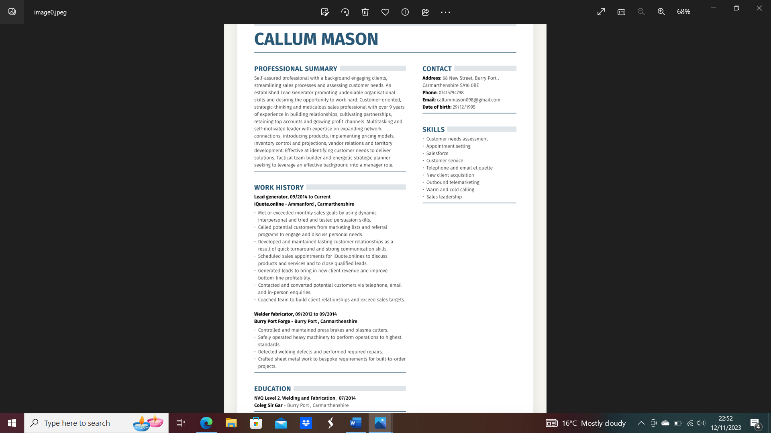

Appendix B Continuous Professional Development Record

CPD

