Question 2: Define skill in the context of your own practice and the work of two artists/makers/designers from the lecture series.

Within Art and Design a practitioner needs to exercise and become proficient in a number of core skills that can then be applied and developed through the process of creating artwork. Within surface pattern design, there are several core skills used to carry out a range of creative pattern-based tasks. There are also technical skills required to follow the processes involved in designing and making. This essay explores the role of specific skills that are used by surface pattern designers in relation to the textile screen printing process. In particular, it will focus on the skill of combining fabrics, screen weave, pigments, and pastes in screen printing to create the desired colour, intensity, and overall effect. The essay will then focus on the skill set of two different pattern designers: Lucienne Day and Zandra Rhodes. By means of analysing their process, I will evaluate and compare the differences in skills, as well as comparing them to what I am learning as a surface pattern designer in my practice.

Skill can be defined as the ‘ability to do something well’ (Oxford Learners Dictionaries, 2022). An artist goes through a process of learning and developing one’s practices before any skill becomes proficient and can be classed as completing a task with skill. Within screen printing, to create the desired colour, intensity and effect the artist needs to understand, practice, and apply the right equipment, techniques, and inks. Screen printing as a ‘highly specialised skill represents not just a laundry list of procedures, but a culture formed around these actions’ (Sennett, 2008, pg. 107). The reasons and thought processes behind one’s practice follows through into everyday life, allowing for more care, observation, and playfulness. Core to these skills, is to understand what you want the desired outcome to be. For example, when creating a printed cotton shirt with a repeated pattern, the artist has to apply the right skill combinations for the desired outcome in a way that meets the needs of the fabric itself, and the end user, i.e. comfortable, washable, and long-lasting.

First, the artist needs to choose the best method of getting a repeat pattern artwork onto the correct silk screen, see Figure one.
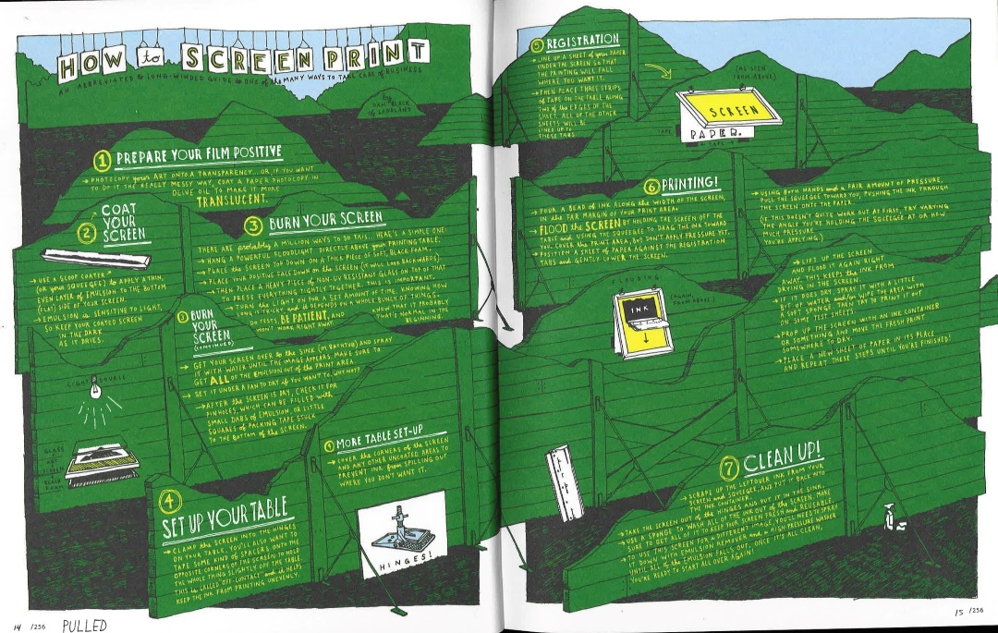
Figure 1: Illustrated diagram of a screen-printing process, (Perry, 2011, pg. 14-15).
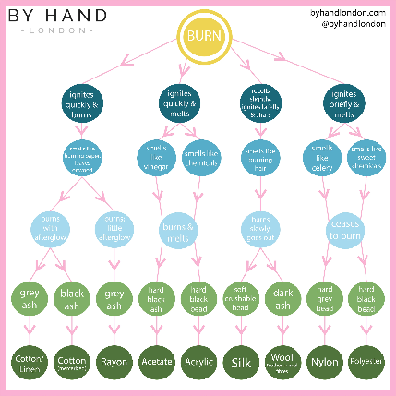
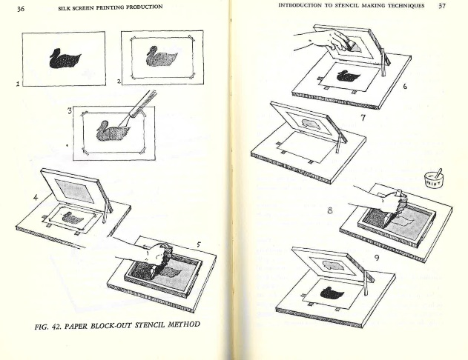
For a cotton shirt the artwork could be exposed on the screen via UV light, see Figure one. Another example would be for making a one-off design that could be in the form of a high-end designer scarf. In this case the artist could choose to create a stencil to block out parts of the screen, see Figure two. This method would only produce one clean print as the inks would slowly seep into the stencil edges after each re-print, leaving an untidy finish to the print making this method unsuitable for a cotton shirt.
Figure 3: Fabric Burn Test Flow Chart (Peake, 2021)
Figure 2: Paper Block Out Stencil Method, (Biegeleisen, 1963, pg. 36).

For the next steps for a successful print, surface pattern designers need to have practised and experimented with different skills in order to know what questions to ask oneself in order to continue. For example, the task of identifying the fibres of a cloth is needed to know what colours will ‘take’ the best and which dye will react with the fibres e.g. the burn test, see Figure three. With all these underlying skills, the artist can then make an educated decision to choose the right colour pigment and print paste depending on the fabric being used, see Figure four.
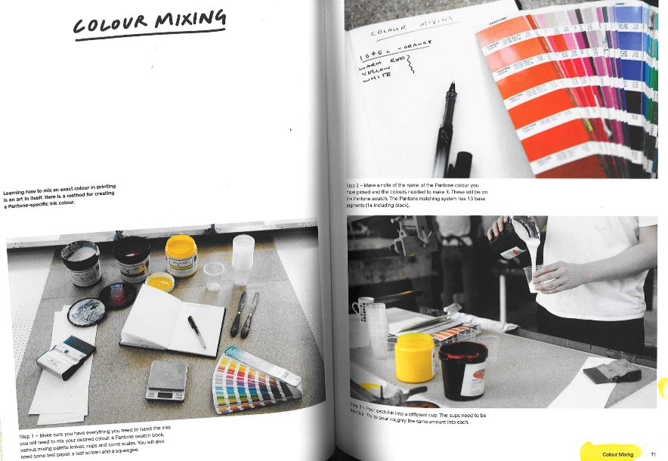
Figure 4:Picture Guide to Colour Mixing, (Print Club London, 2017, pg. 16-17).
For a shirt, cellulose fibre cotton-mix fabrics are commonly used. The design needs to sit into the weave of the fabric, so the chosen paste or binder must allow the colour to permanently seep into the warp and weft. A reactive print paste with Procion dye pigments would work well for this outcome.

Finally, the artist needs to choose the right method of fixation. For a cotton fibre fabric with reactive dyes, a steaming process in an atmospheric steamer is needed, and only then is the paste rinsed out and the fabric washed. The method of fixing for other types of fabric depends on the type of paste.

As can be seen above, many of the skills described in screen printing could be seen as logical, and the decisions an artist has to make screen printing work are mostly clear but, as Sir Terence Conran, says: “Design is 98 per cent common sense and 2 per cent that mystical ingredient that you might call creativity. But it's that thing that makes a perfectly decent object into something really special, really desirable that people want as much as they might want a Picasso on the wall” (Cooper and Press, 1995, as cited in Studd, 2002). The underlying hidden skills needed to produce a successful screen print could be found in that 2 per cent of the artists skill set that the untrained eye would call mystical. This suggests that anyone could produce a successful screen print and ‘magic’ makes it seem like it comes about by chance. Arguably, skill is formed by repetition, dedication, and experimental play, leading to informed decision-making, and hours of work, that is not shown to an audience. These imperfections and learnings are the making of one’s unique skill set. Nothing about that is coincidental or ‘magic’ but ‘the conscious effort to impose meaningful order’, (Walker, 1983, pg. 31). By understanding one’s practice to an nth degree, the decision-making and planning starts to become natural and second nature. When a skilful artist teaches one’s practice, they may think it is common sense but underlying all of one’s knowledge is years of learning and perfecting.
These skills for screen printing have been used by Zandra Rhodes and Lucienne Day for years. They both have worked in the textile industry and have been able to bring together design, forward thinking ideas and technology to deliver stunning and iconic fabrics.
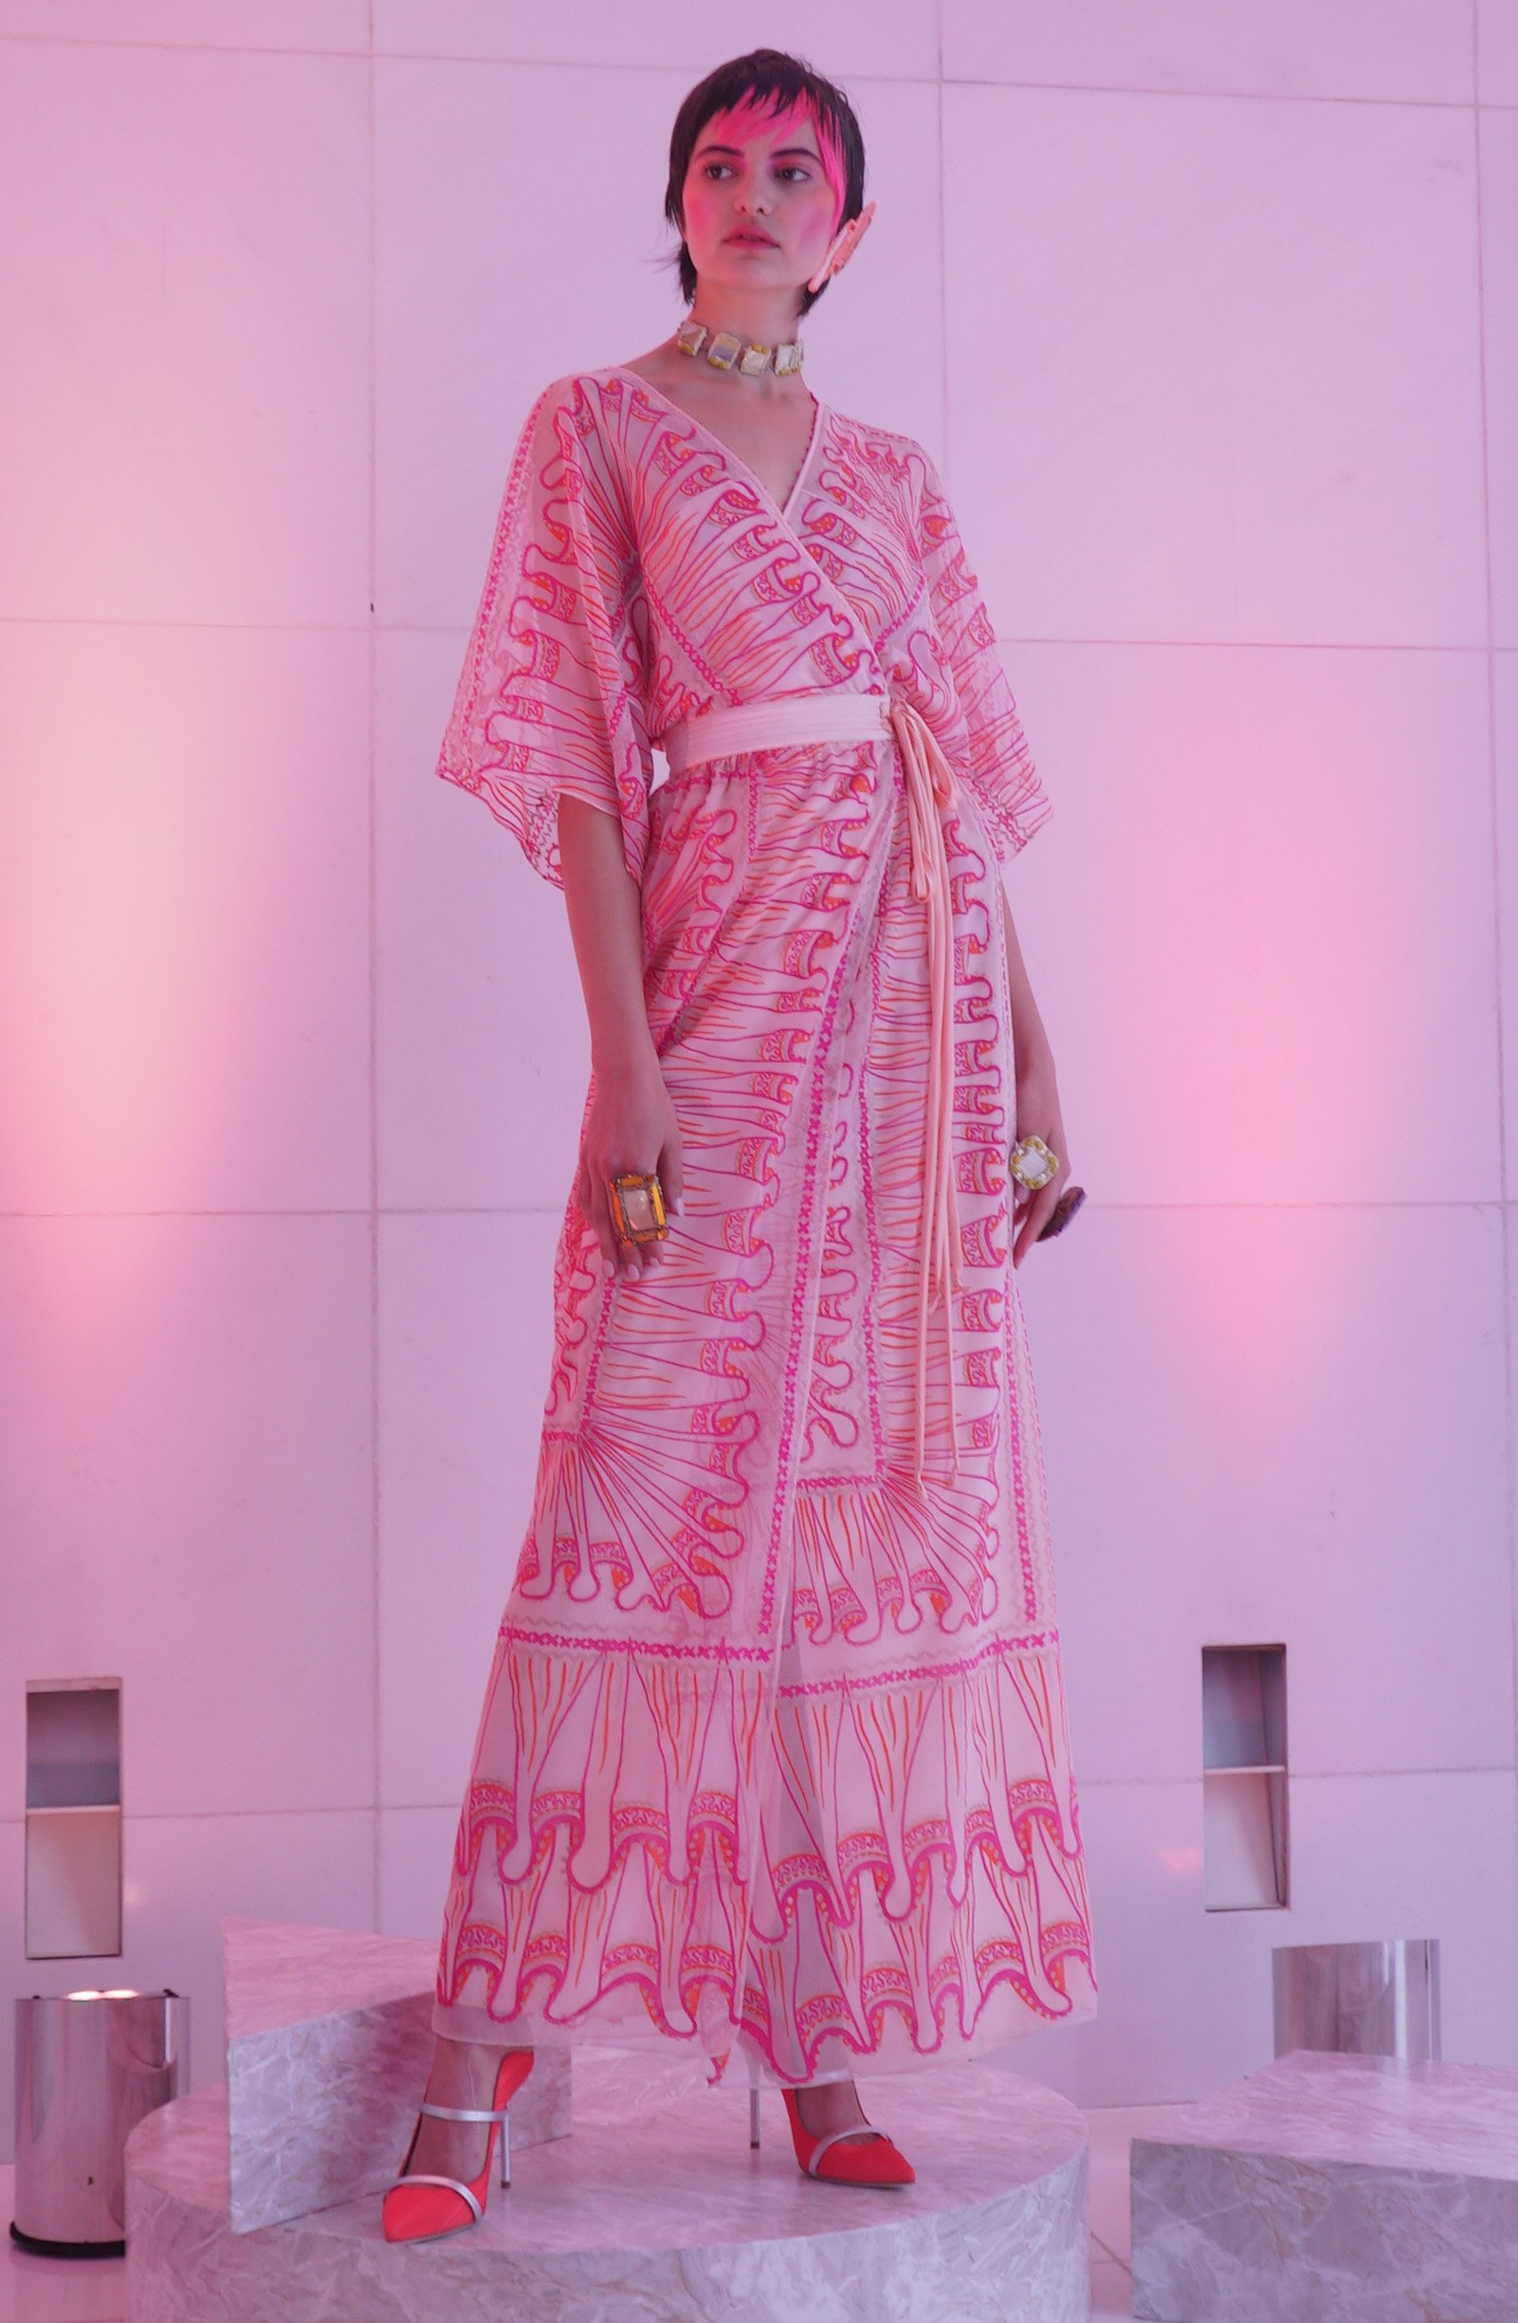
Zandra Rhodes:
Figure 5: Looking back, looking forward. Using screen print designs from 1969, Chiffon (Rhodes, 2019)
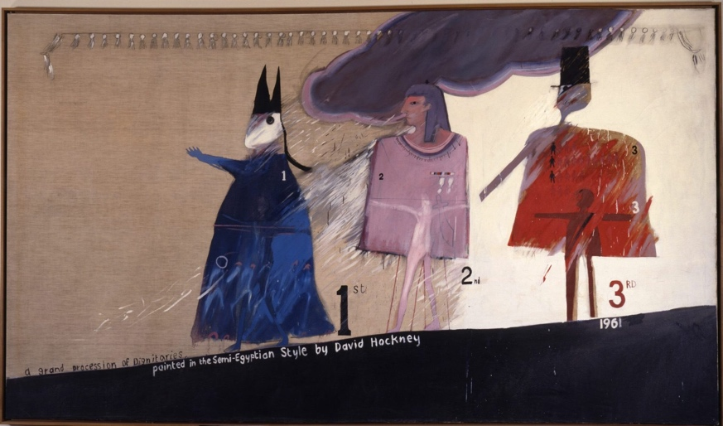
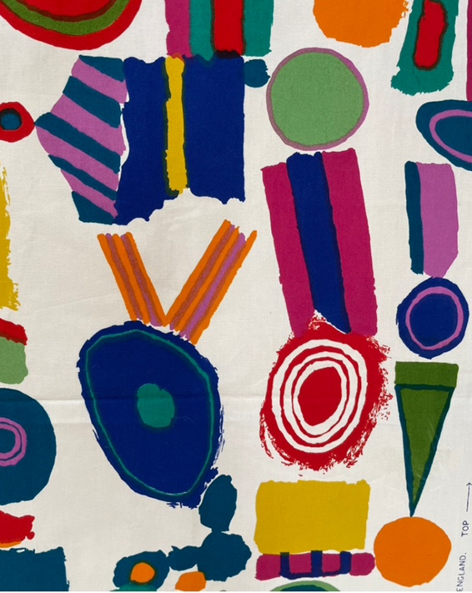
Dame Zandra Rhodes was born in Cheltenham, Kent in 1940. Her mother was in the textiles industry as a fitter for the House of Worth in Paris and became one of Rhodes biggest influences because she was always sewing (Greenstreet, 2021, pg. 244-264). This would suggest Rhodes has a rich cultural upbringing overseas and exposure to luxurious goods may have influenced her loud, perhaps obnoxious, colour pallet. Rhodes was taught by artists like Barbra Brown and Roger Nicholson. Brown worked in a similar time and fashion to Lucienne Day, selling designs to companies like Heal’s of London for interiors. Brown’s colour schemes were more suited to an older generation than Rhodes’, but Brown’s style could have been perceived as new and garish in the 1950s. Rhodes attended the Royal College of Art (RCA) from 1961- 64, with Roger Nickolson as head of department, (Kellogg, 2002). In her final degree project Rhodes looked at a painting by David (see Figure six) who, at the time was a third-year student at the RAC. The painting was of officials in the forces adorned with their medals, this could have influenced her later work in the semi-Egyptian style that she’s known for, (Royal College of Art, 2012). After this successful print (Figure seven) was brought and produced by Heal’s of London, Zandra’s career continued to progress.
Figure 6: A Grand Procession of Dignitaries in the semi-Egyptian style, (Hockney, 1961).
Figure 7: Top Brass, Screen Printed on Cotton, (Rhodes, 1964).
In the 1970’s she moved her eccentric, elegant style to America where her exuberant designs were warmly welcomed by Vogue and many others to follow. ‘With her own distinctive look of theatrical make-up and trademark bob, dyed hot pink since the Eighties, she is the embodiment of her label’s designs – larger than life and impossible to ignore…” (Rhodes, 2019). In Figure five you can see her trademark style really showing through in her colour, garment style but also in the original screen-printed artworks that she chooses to reuse. Having practised for many years, she now recycles ideas which she knows will sell and are true to her style and brand. This brings fluidity to her collections and an aesthetic which has seen progression but ultimately, her continuing unique use of chiffon flouncy fabrics, tonal colour combinations and other-worldly style is what people remember her for. Now days, Figure five alludes to the 1970s hippy music venue, flouncy upper-class elegant attire which is well received. However, I am wondering if this may have been too obnoxious for her peers and those already in the fashion industry of the 1960s. Still reeling from the Second World War at the time, England’s fashion was still budget, with mending and plain fabrics still being used. In the Sixties, “Womenswear followed three broad trends: a continuation of the previous decade’s ladylike elegance, the youthful styles of Mary Quant and the Space Age influence, and the late 1960s ‘hippie’ style” (Reddy, 2019). Rhodes work does not pay any attention to the post-war motion of her parents’ generation, almost a rebellion of ‘plain and boring’ bringing in the new ideas of consumerism and loud personal style with expensive colour and all things synthetic. “By 1979 Rhodes was well established and internationally renowned for her colourful hand screen-printed silk chiffon crinoline dresses,” (Gramstadt, 2016) suggesting that Rhodes has honed her skill set down from the broad spectrum of processed discussed above, into choosing processes that work best for her chic fashion garments. One of Rhodes’ preferred fabrics for this look is silk chiffon which is notoriously hard to work with due to its large woven nature and the lightweight touch making it very easy to rip, slip and for the pigment to bleed through losing the delicate detailed designs.

Along with founding the British design and textiles museum in 2003, she has set up the Zandra Rhodes Foundation which aims to see her work and designs live on for the use of students and other artists in the form of a material library/catalogue digitally. This will ensure her skill set is made accessible for students and the public to learn from her practices. Her encouragement towards future designers and artists helps bring a community of makers who learn from each other, and can enjoy history through the language of fabrics, prints, sketchbooks, and designs whist focusing on the present and future of textiles.

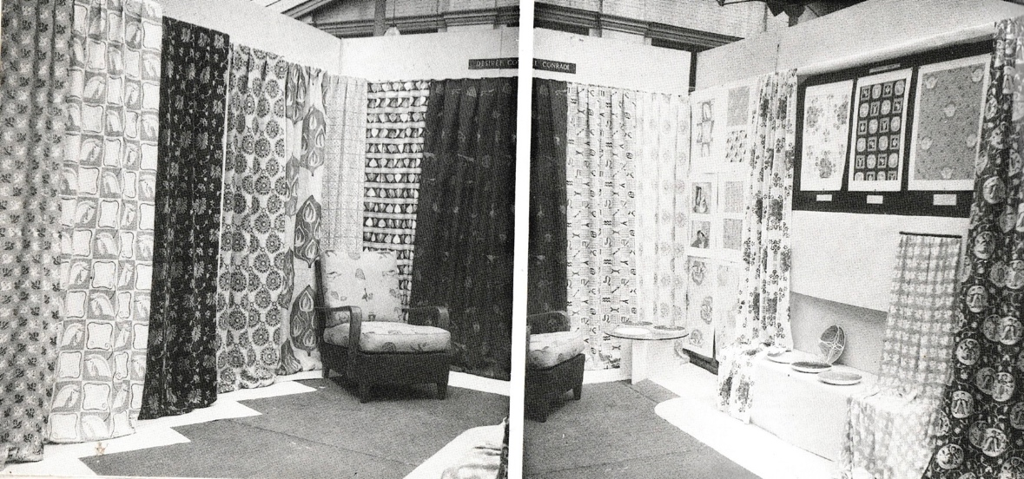
Lucienne Day was born in 1917 to a Belgian father and English mother. Day also attended the Royal College of Art however Day graduated 24 years earlier than Rhodes in 1940. Her final collection for her degree show was focused on repeat pattern designs on fabric for curtains and soft furnishings with bright and colourful hues (Figure eight).
Figure 8:Lucienne Day’s Diploma collection from Royal college of Art 1940, (Harris, 1993).
This attracted immediate attention from the likes of the V&A museum and Edinburgh Weavers, a large commercial fabric screen print company. Day’s style focused on delicate line-work with a hand drawn look and bright Fifties colours. This created a free and playful feel whilst bringing through complex detail in her compositions. Over her career her style evolved, starting with more hand drawn elements and simple repeats, for example brick, block and half drop repeat systems (Figure nine is block repeat and Figure ten is a brick repeat). Then later, by the Sixties her focus was on more commercial designs with geometric shapes, even brighter colours with stronger contrasts and more complex repeat systems (Figure 12).
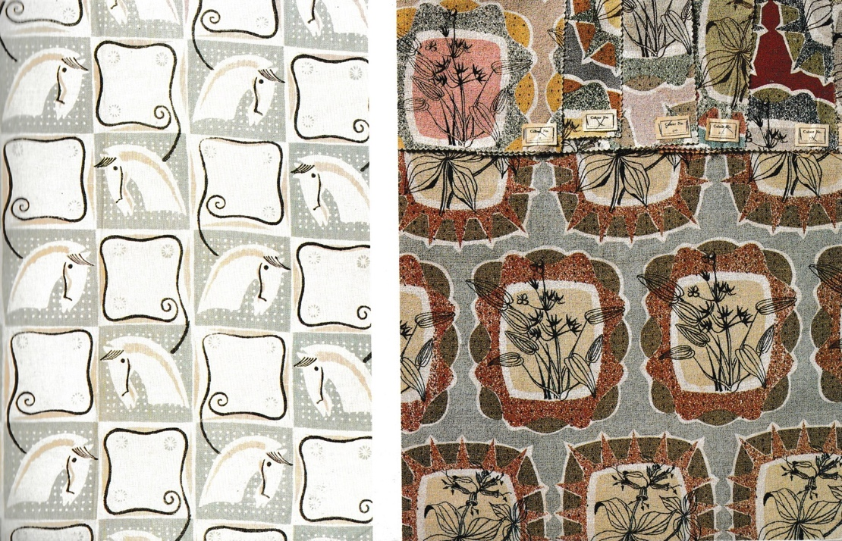
Figure 9: Hand screen printed from Diploma collection brought by the V&A, 1940. (Harris, 1993).
Figure 10: Elysian, hand screen printed linen, 1949, (Harris, 1993).

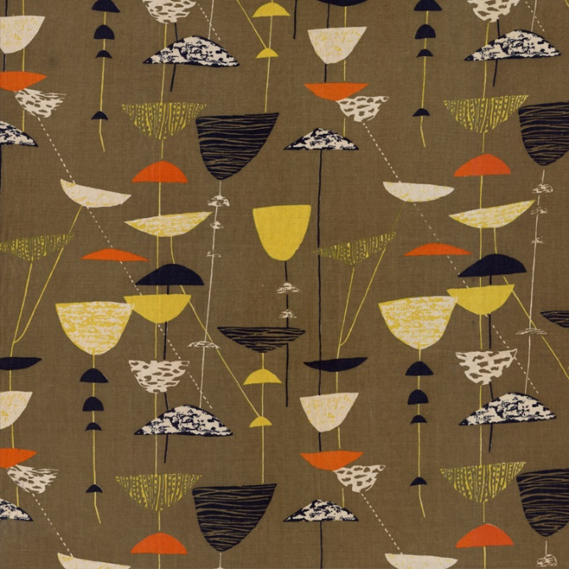
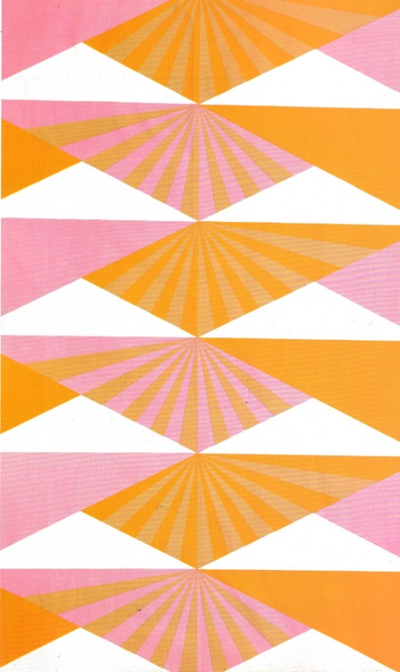
Day worked extensively with Heals’ of London, Edinburgh Weavers and British Celanese Ltd, each commissioning from her for multiple design per year. In particular, Celanese gave her a completely free hand in the style, colourways, and did not impose any technical limitations.
Figure 11: Calyx, screen-printed furnishing fabric, (Day, 1951)
Figure 12: Sunrise, an Abstract landscape design screen printed onto cotton, Heal's, 1969, (Harris, 1993).

This brave move allowed Day to bridge the gap between the historical and the contemporary, making her designs iconic for the era (Harris, 1993). An example of Day’s work which split her customers was her hand screen-printed design Calyx (figure 11), designed for the festival of Britain in 1951. Like Rhodes’ style, it was called highly original and a landmark design in the 20th century (Harris, 1993). In contrast, Day kept a wide range of processes in her work in order to keep generating new and exciting interiors for her clients, rather than honing into one or two skills like Rhodes’ collections.
Day’s design process may have started similarly to Rhodes by finding inspiration either from found objects, plants or man-made items, the environment or from an arts movement or political ideas. In this case, for Figure 11, Day has drawn from her love of plants, Joan Miró and the Bauhaus art movement.

The Bauhaus movement that started at the Bauhaus school of art in Germany in 1919 typically featured balanced form and abstract shapes with little ornamentation (Richman-Abdou, 2021). The design follows natural shapes and forms, creating a simplified motif of unidentified flowers. Previous designers like William Morris took traditional realist approaches to creating floral repeats however, “good designers can create normalcy out of chaos” (Jeff Veen, 2000) and Day changed it up by extracting small, exciting details from plants added depth to her work. Her abstract designs are arguably just as complex as an all-over floral ditsy pattern like Morris’, yet just as pleasing to the eye. Each element, though playful looking, would have been carefully woven together, (like Rhodes) in quiet rebellion against designers who came before. Even down to the identification of which colour has to be printed first. From looking at the layers in Figure 11, the yellow pigment probably was pulled through first on top of undyed linen, brown must have come next as the red overlaps the brown, and black is the top colour. With each artist creating differently and a fractured history of screen printing as a process (Lengwiler, 2013, pg. 10) it is difficult to know exactly how Day came to produce her original screen prints. It can be assumed that in 1951 this was a small-scale hand-made process with little automation, making the skill more impressive.

As an interiors artist and designer in the 1950s, Day typically used cellulose fibres such as cotton and linen which are more robust and heavy duty as this suited her practice. Although wool is heavy fabric, this is not something she would have worked with because it wears down easily and the bigger weave means that it does not hold colour as well because the pigment would bleed, making it a less defined pattern. This is something she would have learned through experimentation and practising her craft.

By contrast, Rhodes favoured materials such as silk and chiffon. These are hard to work with because they are slippery and delicate, resulting in a less intricate design in terms of colours. Rhodes often used one colour of screenprint on a dyed fabric, which is how her process is different from Day’s. Where they are similar, they both followed their method by hand without the use of the digital technology available to designers today. Furthermore, as her chosen fabric is so difficult to work with, it shows an impressive skill level that she became a master in using this material.

As we have seen in this essay, in order to produce exceptional screen-printed artwork and fabrics, an artist needs to not only to understand the practical steps of screen-printing but be able to apply these with extreme technical skill combined with an artist’s influences, eye for colour and design with personality and flare. In Lucienne Day and Zandra Rhodes, we have seen two artists who have not only achieved this, but their artwork has inspired and influenced many artists who have followed with their iconic designs, use of colour and screen-printing techniques.

As with Rhodes and Day, I have gained a lot of my knowledge about screen printing through experimenting with different fabrics and processes, and deciphering what works and what does not. My practice is always evolving and changing how I perceive my own skills. As a student I am still learning, and I realise that whenever I feel I have mastered a skill, there is always more to learn. This understanding redefines my practice. Redefining is a skill in itself as it allows me to progress in my artwork as I understand that I can always add more, develop further, and gain better skills by learning from people in the profession.

Artistic skills are passed down through teachers and other artists. Everyone has their own way of working and takes something different from the skills learned, so each artist will produce a different outcome even when learning from the same teachers.

Reference list
Biegeleisen, J.I. (1963). The Complete Book of Silk Screen Printing Production. New York: Dover Publications, 198.
Day, R. and Day, L. (1951). Calyx, screen-printed Furnishing Fabric. www.robinandluciennedayfoundation.org. Available at: https://www.robinandluciennedayfoundation.org/lives-and-designs/festival-of-britain/calyx-screenprinted-furnishing-fabric-lucienne-day [Accessed 13 Oct. 2023].
Gramstadt, M.-T. (2016). Zandra Rhodes’ ‘Works of Art’ (1979–1988): From Feminine Frills to Goddess Saris. Costume, [online] 50(2). doi:https://doi.org/10.1080/05908876.2016.1165954.
Greenstreet, R. (2021). Zandra Rhodes: ‘A secret? My hair isn’t naturally pink’. [online] the Guardian. Available at: https://www.theguardian.com/lifeandstyle/2021/jul/24/zandra-rhodes-a-secret-my-hair-isnt-naturally-pink [Accessed 12 Oct. 2023].
Guido Lengwiler. (2013). A History of Screen Printing : How an Art Evolved into an Industry. Fairfax, Va: Specialty Graphic Imaging Association.
Harris, J. and Whitworth Art Gallery. (1993). Lucienne Day : a Career in Design. Manchester: Whitworth Art Gallery.
Hockney, D. (1961). The David Hockney Foundation: A Grand Procession of Dignitaries in the Semi-Egyptian Style. [online] www.thedavidhockneyfoundation.org. Available at: https://www.thedavidhockneyfoundation.org/artwork/3570 [Accessed 16 Dec. 2023].
Kellogg, A.T. (2002). In an Influential Fashion : an Encyclopedia of nineteenth-and twentieth-century Fashion Designers and Retailers Who Transformed Dress. Westport, Conn.: Greenwood Press.
Oxfordlearnersdictionaries.com. (2022). Skill Noun - Definition, pictures, pronunciation and usage notes | Oxford Advanced Learner’s Dictionary at OxfordLearnersDictionaries.com. [online] Available at: https://www.oxfordlearnersdictionaries.com/definition/english/skill.
Peake, E.D.C. (2021). The Burn Test - How to Identify the Fibres in Your Mystery Fabric. [online] By Hand London. Available at: https://byhandlondon.com/blogs/by-hand-london/the-burn-test-how-to-identify-the-fibres-in-your-mystery-fabric [Accessed 16 Dec. 2023].
Perry, M. (2011). Pulled : a Catalog of Screen Printing. New York: Princeton Architectural Press.
Print Club London. (2018). Screen-printing : the Ultimate Studio guide, from Sketchbook to Squeegee. New York: Princeton Architectural Press.
Reddy, K. (2019). 1960-1969. [online] Fashion History Timeline. Available at: https://fashionhistory.fitnyc.edu/1960-1969/.
Rhodes, Z. (2019). Bio | Zandra Rhodes. [online] Zandrarhodes.com. Available at: https://zandrarhodes.com/bio/ [Accessed 13 Oct. 2023].
Rhodes, Z. (2019). SS 2019 ‘Looking Back, Looking Forward’ | Zandra Rhodes. [Online] Zandra Rhodes. Available at: https://zandrarhodes.com/ss-2019-looking-back-looking-forward/.
Rhodes, Z. (1964). Top Brass, Screen Printed onto cotton. Meg-andrews.com. Available at: https://www.meg-andrews.com/item-details/Zandra-Rhodes-Top-Brass/9520 [Accessed 16 Dec. 2023].
Richman-Abdou, K. (2021). Bauhaus: How the Avant-Garde Movement Transformed Modern Art. [online] My Modern Met. Available at: https://mymodernmet.com/what-is-bauhaus-art-movement/ [Accessed 1 Dec. 2023].
Royal College of Art. (2012). Zandra Rhodes. [online] RCA Website. Available at: https://www.rca.ac.uk/news-and-events/news/zandra-rhodes/ [Accessed 12 Oct. 2023].
Sennett, R. (2008). The Craftsman. London: Penguin.
Studd, R. (2002). The Textile Design Process. The Design Journal, 5(1). doi:https://doi.org/10.2752/146069202790718567.
Veen, J. (2000). Art and Science of Web Design. Indianapolis: New Riders Press.
Walker, J.A. (1989). Design History and the History of Design. London: Pluto Press (UK).

