Further Solid Modelling Exercises

Automotive Brackets:
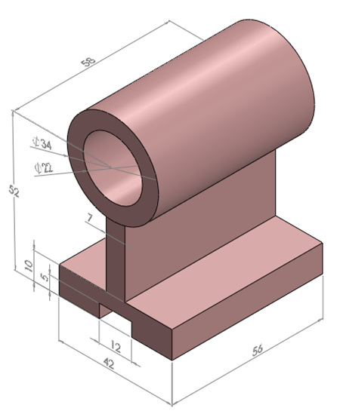
Automotive brackets come in all shapes and sizes for all types of uses. These axle brackets made up of malleable cast iron. These brackets features machined bores, bosses and mounting faces. The brackets are slotted through one mounting hole, allowing the bracket to be positioned laterally before being clamped by tightening the bolt through the slotted side. Here the front axle is installed between the left and right wheel. It have the function which transfers the power of engine to the wheels. Especially it transfers the high power to the front wheels when driving four wheel.

Axle Bracket or Spindle Bracket or Shaft Bracket:
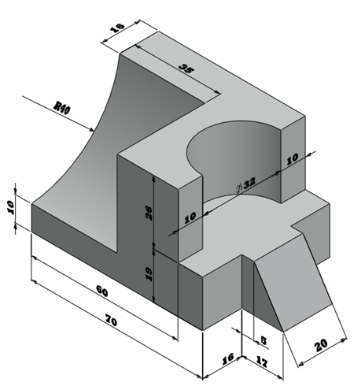
The spindle shaft is the essential element for transmitting power in mills and workshops. An axle is a stationary shaft on which pulleys and other members rotate. The part of the shaft within the bearing is known as journal. A spindle is a machine shaft that drives and supports either a cutting tool or the work on which machining and other operations are performed.

Sliding Frame:
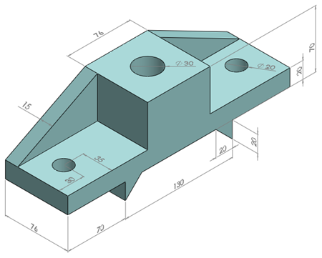
A sliding frame is an extremely efficient extraction system that allows non free flowing materials to be discharged from the flat bottom. The sliding frame is a simple machine consisting of either one or two hydraulic cylinders driving a frame that reciprocates across the floor. These sliding frames which are used in automobiles, power plants and lathe machineries etc. Here the conventional pressed steel frame to which all the mechanical units are attached and on which the body is superimposed.

Slotted Block or Clapper Block:
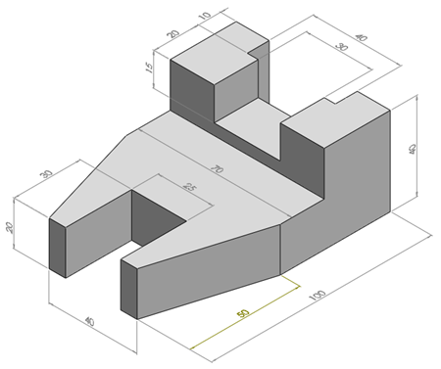
This clapper block is used in shaper, planer and slotting machines. The clapper easily swings up. It flops back down with a slight push. The clapper box hinges a tool block already fitted with apron. The tool block holds a tool post to mount the tool. During cutting stroke, the tool block fits inside the clapper box rigidly. During the return stroke, the tool block lifts out of clapper to avoid rubbing of the tool on the job.

Adjustable Arm:
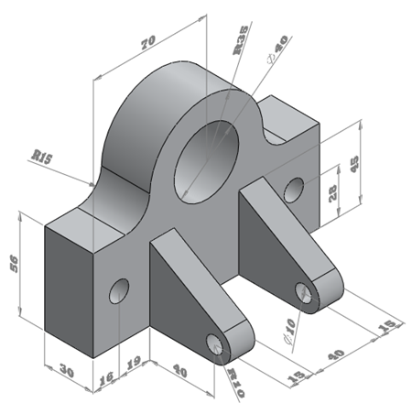
The adjustable arm was designed to improve access to devices by having a wider range of access angles. An adjustable arm controlling an automatic feed of a lathe to position its cutting tool. This adjustable arm including a flat base member, upstanding member having at least a partially circumferential edge, a pair of bar members, and having a straight working edge.

