
MASTER OF BUSINESS ADMINISTRATION (MBA)

HUMAN CAPITAL MANAGEMENT
LCMB7023

ASSESSMENT COMPONENT 1: INDIVIDUAL REPORT – HR STRATEGY

INTEGRATED HUMAN CAPITAL BLUEPRINT: RE-ENGINEERING PERFORMANCE & JOB DESIGN AT AETHER INNOVATIONS

Lecturer(s): Gladius Kulothungan, Ejike Udeogu

Student Name: Arpit kantibhai khatra
Student ID: 2526504

Word Count: 2603

Date of submission: 20/03/2026
Executive Summary

This report is a comprehensive HR plan of Aether Innovations, a mid-sized tech company of mid-size, with high employee turnover, stagnant growth, and decreased customer satisfaction issues. It is a critical assessment of existing weaknesses in performance management and job design, and the suggestion of a contemporary system that would integrate Objectives and Key Results (OKRs), 360-degree feedback, and continuous performance management. As well, job positions are reorganised in accordance with the Job Characteristics Model to increase motivation, autonomy, and innovation. These practices will be combined so that employee engagement will be enhanced, individual and organisational goals will be aligned, and sustainable organisational performance will be promoted. The report also produces learning outcomes, future relevance in a workplace that is being AI-driven.

Table of Contents

Part 1: Report 4
1. Introduction 4
2. Current Practices 4
2.1 Performance Appraisal Issues 4
2.2 Job Design Issues 6
3. Modern Performance System 6
3.1 Objectives And Key Results (Okrs) 6
3.2 360-Degree Feedback 7
3.3 Continuous Performance Management 7
4. Job Design & Job Analysis 7
4.1 Job Characteristics Model 7
4.2 Job Analysis 9
4.3 Job Descriptions And Specifications 9
4.4 Skills-Based Job Design 9
5. Integration: Aligning Performance And Job Design 10
6. Conclusion 10
Part 2: Reflection 11
1. Gibbs reflective cycle 11
2. AI and Future Professional Relevance 13
References 14

Part 1: Report

1. Introduction
Aether Innovations is a mid-sized technology company with around 300 employees, and it is presently experiencing serious organisational issues, such as excessive employee attrition, sluggish growth, and decreased customer satisfaction (Aether, 2025). These problems suggest the existence of efficiency loopholes in its human resource practices, especially in performance management and job design. Ineffective appraisal systems and role definitions in high-technological culture may act as a serious impediment to innovations and the motivation of employees. Through this report, the challenges are expected to be solved by re-engineering job roles to boost organisational performance and productivity, alongside the redesign of the performance management system in a way that will encourage motivation and overall organisational performance. The targeted strategy aims at aligning the personal performance with the organisation's objectives to ensure high performance culture is sustainable.

2. Current Practices

2.1 Performance Appraisal Issues
Modern technology companies have been finding themselves with constraints in respect to the old performance appraisal systems, especially the annual review systems, which are ineffective in reflecting on the contributions of the employees in real time. According to recent industry evidence, there has been an increasingly disproportionate employee performance rating to actual performance. As an example, cases of performance-based layoffs in leading companies showed that workers who are now declared underperformers were given good performance ratings (Herzlich, 2025). These practices deter trust, perceived fairness and engagement with employees.
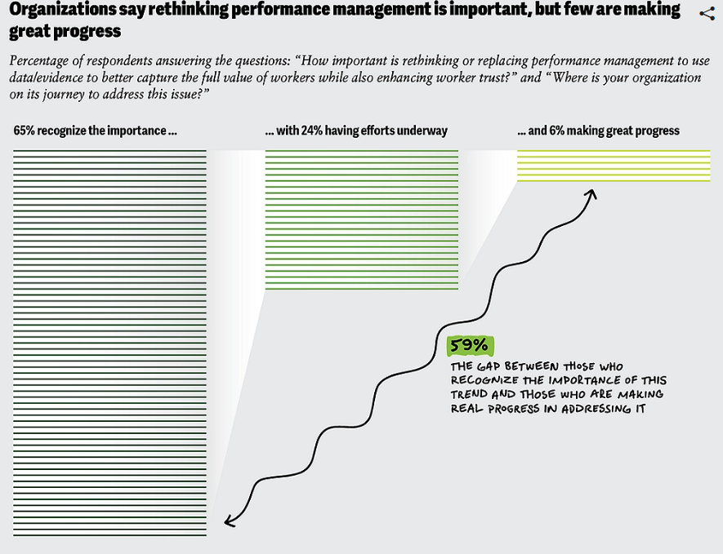
Figure 1: Performance Management Processes
(Source: Deloitte, 2025)
In addition, the lack of continuous feedback mechanisms is also a major problem. Recent HR intelligence shows that most organisations are failing to align their performance management with the changing working environments because old systems lack the ability to cater to the agile and innovation-based sectors. This above figure shows that there is a wide gap, and even though 65% of organisations identify the need to reform performance management, only 6% have made any meaningful improvement (Deloitte, 2025). This serves to depict the ineffectiveness of performance management implementation and outdated appraisal practices. These problems also seem to increase productivity reduction and dissatisfaction among the employees in the situation of Aether Innovations, supporting the pattern of turnover.

2.2 Job Design Issues
Simultaneously, job design in most of the technology organisations is not sufficiently geared towards emerging employee demands. Staff want to be given autonomy, meaningful work, and a chance to utilise their skills, but strict and ill-organised jobs tend to disappoint. According to Smite et al. (2023), after the pandemic, the work changes have changed the priorities of employees greatly, and they want to be recognised, gain flexibility, and have purposeful work. Moreover, swift digitalisation and the implementation of AI have brought ambiguity in roles and the lack of proper skills to jobs, which has exacerbated dissatisfaction. Through evidence, it has been found that low-quality job structuring is the cause of burnout, disengagement and higher turnover in the software-related jobs (Ribeiro, 2022). In the case of Aether Innovations, such shortcomings are likely to limit the ability to innovate and the adaptability of the organisation, which eventually impacts customer satisfaction and long-term growth.

3. Modern Performance System
In order to resolve the limitations found in Aether Innovations, a contemporary performance management platform combining Objectives and Key Results (OKRs), 360-degree reviews, and endless performance control is suggested to create a greater level of alignment, equity, and responsiveness.

3.1 Objectives And Key Results (Okrs)
OKRs offer a goal-setting structure that can ensure impersonal performance and organisational goals are aligned based on well-defined and attainable results (Zierock et al. 2024). Each goal is justified by 3-5 measurable key outcomes, which allow for monitoring the progress and responsibility on a regular basis. Empirical studies have proven that organisations that use OKRs record much greater levels of engagement and performance outcomes. Allowing goal harmony between employees and leaders will reduce work absenteeism in businesses by 41% and increase customer satisfaction by 24%, among other good outcomes (Magali Cicujano, 2025). This is concurrent with the Goal-Setting Theory by Locke and Latham, which focuses on the fact that particular and difficult goals improve motivation and performance. In the case of Aether Innovations, the use of OKRs would make employees have a clear focus on expectations, hence creating less ambiguity and enhancing productivity.

3.2 360-Degree Feedback
The introduction of the 360-degree feedback results in a multi-source assessment tool, where the feedback provided by peers, managers, and subordinates is used. This minimises the bias of the evaluators and increases the reliability of the performance evaluation. Theoretically, the performance management model specifies priority on equity, quality of feedback, and staff growth to enhance the results in terms of performance (Aguinis and Burgi-Tian, 2021). With the inclusion of other points of view, Aether Innovations can help facilitate transparency and foster trust and encourage the constant development of its employees, which will address the dissatisfaction mentioned above.

3.3 Continuous Performance Management
Existing traditional annual reviews are substituted with ongoing and real-time input as well as agile performance dialogues. According to Bristol-Alagbariya et al. (2022), implementing continuous feedback mechanisms in performance management systems helps positive behaviour change and better outcomes. Similarly, the performance challenges can be handled before arising, which allows flexibility in the dynamism of the technology setting. In the case of Aether Innovations, responsiveness, innovation, or agility of the organisation as a whole would be improved through continuous performance management.

4. Job Design & Job Analysis

4.1 Job Characteristics Model
Job roles can be redesigned based on the Job Characteristics Model (JCM) by Hackman and Oldham to improve the motivation and performance of employees at Aether Innovations. The model determines five fundamentals: skill variety, task identity, task significance, autonomy, and feedback, which altogether contribute to intrinsic motivation and job satisfaction (Ullah et al. 2022).
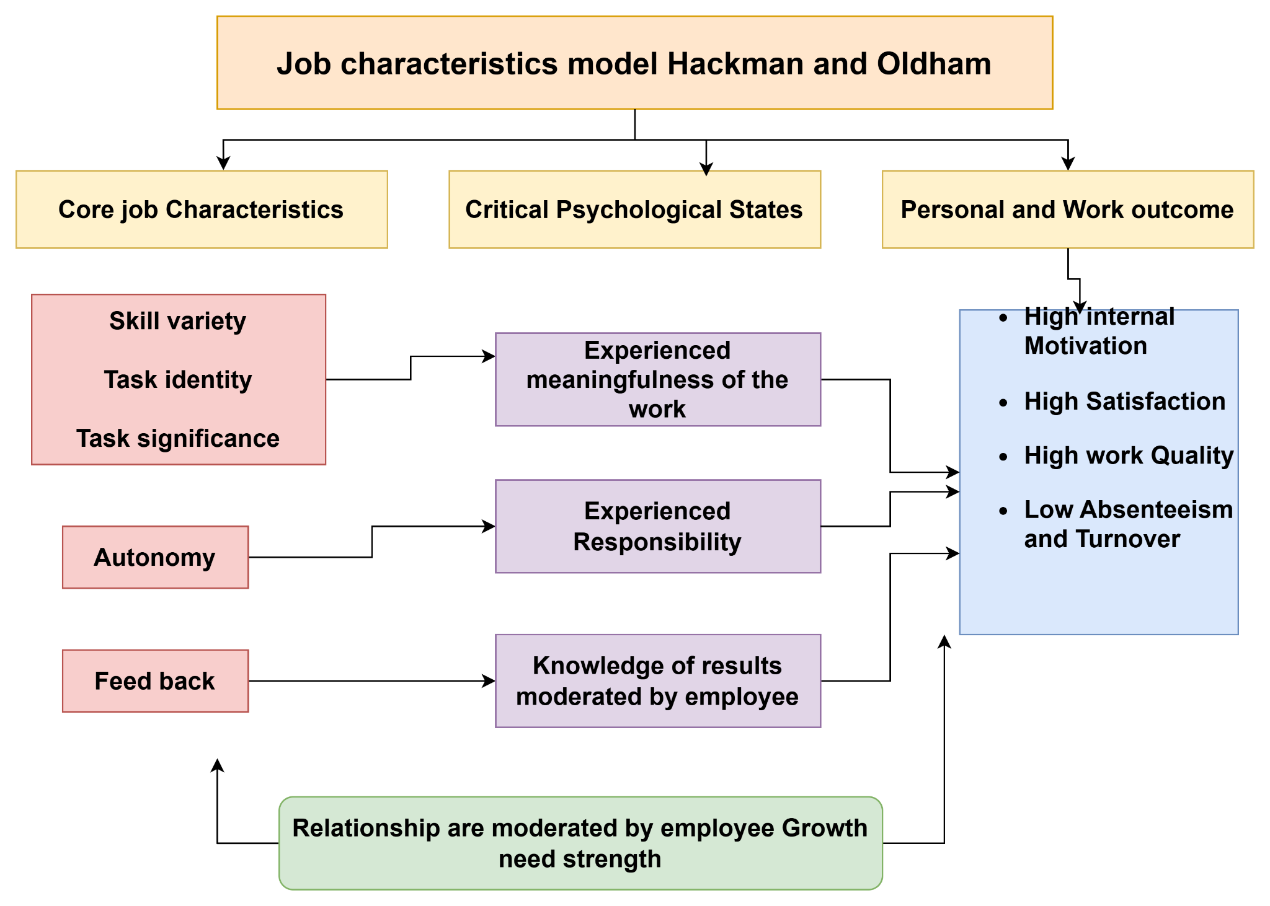
Figure 2: Job Characteristics Model
(Source: Self-developed)
The variety in the skills used by the employees will ease the workload, make it less monotonous, and enhance the level of involvement. Task identity and task significance allow employees to view the meaningfulness of their work, which has been observed to increase their organisational commitment. Knowledge-intensive industries demand significant independence in employees, which makes them innovate and be accountable as autonomous staff. Lastly, constant feedback will enable employees to know their performance and improve as soon as possible. The empirical studies have confirmed that enriched job design is a significant factor in making a difference in the performance of an individual and an organisation (Knight and Parker, 2021). Application of JCM in the case of Aether Innovations would deal directly with disengagement and poor innovation by designing meaningful yet empowering roles.

4.2 Job Analysis
Job analysis is a structured process of defining the role, duties, responsibilities and needs; it forms the basis of proper HR practices, including recruitment, job training and performance appraisal. Khatoon et al. (2025) stated that in organisations that are technology-focused and roles change very quickly, proper job analysis is necessary to facilitate a match between the needs of organisations and the ability of employees. Role ambiguity and inefficiencies are caused by poorly defined roles, especially in the digital context. In the case of Aether Innovations, a thorough job analysis would help the organisation establish clear expectations, eliminate duplication, and also to make sure that employee skills are neither too little nor too much. This is especially significant in the face of the current high turnover and dwindling performance experienced in the firm.

4.3 Job Descriptions And Specifications
Role | Key Responsibilities | Skills | Autonomy
CEO | Strategic direction, organisational leadership | Vision, decision-making, leadership | High
CFO | Financial planning, risk management | Financial analysis, strategic thinking | High
CTO | Technology strategy, system innovation | Technical expertise, problem-solving | High
CIO | Innovation leadership, digital transformation | Creativity, change management | High
HR Director | Talent strategy, employee engagement | HR expertise, communication | Medium
Head of R&D | Product development, research leadership | Innovation, analytical skills | High
Table 1: Job Descriptions And Specifications
(Source: Self-developed)

4.4 Skills-Based Job Design
Besides role redesign, skills-based job design can be adopted that helps employees to acquire and utilise several competencies in various functions. It improves workforce flexibility, the desire to engage in ongoing learning, and flexibility in dynamic settings (Zhang et al. 2025). In the case of Aether innovations, this would ease the skills disengagement, encourage innovation, and overall long-term organisational robustness.

5. Integration: Aligning Performance And Job Design
Implementation of the modern performance management system in conjunction with enhanced job design is essential in the formation of a sustainable performance-based culture at Aether Innovations. By harnessing the deployment of OKRs, the employees are working under transparent, quantifiable achievements that are replaced by the organisational strategy, whereas 360-degree feedback promotes balance and developmental acumen (Shetye, 2025). At the same time, the use of the Job Characteristics Model boosts the power of intrinsic motivation through augmenting autonomy, skill diversity, and assertiveness of work (Cotič et al. 2025).
When used together, these systems form a positive feed-forward loop where the performance is guided by distinctly set goals and the functions are established in such a way that the employees can easily attain the set goals. According to Hamraaia (2024), HR practices match greatly with the outcomes of employee engagement, innovation and organisational performance. In the case of Aether Innovations, this combination would respond directly to the existing challenges through the increase in motivation, turnover level, and customer satisfaction. Finally, performance management and richer job design have a harmonised system that facilitates continuous improvement and organisational efficiency in the long term.

6. Conclusion
Aether Innovations has critical challenges, namely high employee turnover, lack of growth, and depreciating customer satisfaction, and this is mainly due to inefficient performance management and job design. In this report, the combination of an integrated HR strategy with the use of OKRs, 360-degree feedback, and enriched job roles according to the Job Characteristics Model was proposed. Together, these interventions lead to greater alignment, motivation, and innovation, which ultimately increase the performance of organisations, increase employee engagement and enable businesses to endure in the long-term.

Part 2: Reflection

1. Gibbs reflective cycle
Description
This module of human capital management has offered me in-depth insights into the major HR concepts, such as HR strategy, performance management and job design. The learning process has been designed based on a synthesis of theoretical framework and case applications that allowed exploring real organisational issues in the real world. Such topics as performance appraisal schemes, employee motivation and strategic HR alignment were analysed in detail. Practical scenario and the case of Aether innovative provided an opportunity to outline the theoretical models into practical context of business, and hence the paper strengthened the comprehension of how HR practices affect the results of organisations.
Feelings
In the first half of the module, I found the topic highly difficult and complicated, mainly because of the combination of various HR theories and their application to actual organisational challenges. Performance management systems and job design are some of the concepts that were initially abstract and seemed very hard to implement. However, as the course went on, I got more confident because I gained a better idea of how these concepts come together in the field. I started to value the significance of HR and the role that proper people management can play in organisational success, and this greatly increased my interest in the topic.
Evaluation
The practical application was among the strengths of this module. The real-world case studies corroborated the gap between theory and practice, enabling me to learn how HR strategies would be applied to the organisational context. Additionally, such learning models as the Job Characteristics Model and the latest performance management models were helpful in analysing business issues. Nonetheless, there were also difficulties presented in the module. The assessment of the theoretical concepts was vital to be applied not descriptively but critically, which needed a higher level of thought and analysis.
Analysis
This module has improved my insight considerably about the strategic role of HR in driving organisational performance. It is also obvious that HR practices are not just administrative activities but are important factors that determine the motivation of employees, their performance and innovation. An example of this is the Job Characteristics Model, which shows how autonomy, skill variety, and feedback are some of the elements that allow employees to be intrinsically motivated and enhance their job performance (Zhao et al. 2024).
Shawn et al. (2023) revealed that effective performance management systems, including continual feedback and goal alignment, would help employees to a greater degree. The studies also suggest that organisations where HR practices are well integrated record advanced degrees of innovation and overall performance (Gahan et al. 2021). On the contrary, incompetent HR systems may result in disengagement, low productivity, and high turnover because employees might feel undervalued or not offered their roles. This shows the relevance of ensuring that the HR strategies are aligned to the organisational objectives. The enhancement of job design and performance management brings about a synergistic effect where motivational employees are in a better position to meet organisational objectives.
Conclusion
Comprehensively, this module has altered my perception of HR from a conventional administrative to a strategic tool of organisational success. Another lesson that I have gained is that employees are an important organisational resource and their performance is closely correlated to good HR practices. The need to incorporate performance management systems and job design has become specifically critical, as gearing will improve motivation, engagement, and productivity.
Action Plan
In the future, I will continue learning and acquiring new skills in the field of human resource management to improve my professional competencies. I plan to have an ongoing learning process through taking courses on advanced HR and management. I will also read academic journals often to keep up with the current trends and research. I am also hoping to develop my analytical and strategic thought skills by using theoretical concepts in practical scenarios, i.e. case studies and internships.

2. AI and Future Professional Relevance
Included among the fields where the nature of work is being radically altered by the rising introduction of artificial intelligence (AI) is the area of human resource management. The routine processes of the recruitment process, such as filtering of resumes, screening of candidates, and analysing their data, are becoming more and more automated by using AI technologies, which contributes to better efficiency and decreased workload. Also, chatbots supported by AI are being deployed to address questions of employees and go through HR procedures. As inspired from the ideas of Olan et al. (2022), AI reduces organisational productivity because it allows making decisions quicker and more based on facts. Nonetheless, this change also has issues with job displacement and changing skills in organisations.
The key to staying relevant in a work environment dominated by AI requires the abilities that cannot be automated by machines to be learned. These are critical thinking, creativity, emotional intelligence and complex decision making. These are essential human-centred capabilities of interpreting data, people management and innovation. Moreover, the ability to learn continuously and be adaptable would also be vital in adopting the changes in technology and the shift of job descriptions (Sony and Mekoth, 2022). Thus, the creation of these competencies will be essential towards becoming career-relevant in the long term.
Though AI has a great number of benefits, the system should be considered not as a replacement for human ability but as a form of it. I would like to use AI to assist in research, data analysis, and the enhancement of efficiency in regular processes. Nevertheless, I will make sure that such vital parts of work as strategic decision-making, solving problems, and creativity will be left to humans. It could be that over-dependence on AI would impair critical thinking and creativity.

References
Aether, (2023). ANNUAL REPORT 2023. Available at: https://aether.co.in/wp-content/uploads/2023/05/Annual%20Report%20FY%202022-23.pdf [Accessed on: 10.03.2026]
Aguinis, H. and Burgi-Tian, J., 2021. Talent management challenges during COVID-19 and beyond: Performance management to the rescue. BRQ Business Research Quarterly, 24(3), pp.233-240. https://journals.sagepub.com/doi/pdf/10.1177/23409444211009528
Bristol-Alagbariya, B., Ayanponle, O.L. and Ogedengbe, D.E., 2022. Developing and implementing advanced performance management systems for enhanced organizational productivity. World Journal of Advanced Science and Technology, 2(1), pp.39-46. https://www.researchgate.net/profile/Latifat-Ayanponle/publication/386348208_Developing_and_implementing_advanced_performance_management_systems_for_enhanced_organizational_productivity/links/67a1c97a645ef274a46662dc/Developing-and-implementing-advanced-performance-management-systems-for-enhanced-organizational-productivity.pdf
Cotič, L.P., Man, M.M.K., Soga, L.R., Konstantopoulou, A. and Lodorfos, G., 2025. Job characteristics for work engagement: autonomy, feedback, skill variety, task identity, and task significance. Global Business and Organizational Excellence, 44(5), pp.75-85. https://onlinelibrary.wiley.com/doi/pdf/10.1002/joe.22295
Deloitte, (2025). Reinventing performance management processes won’t unlock human performance. Here’s what will. Available at: https://www.deloitte.com/us/en/insights/topics/talent/human-capital-trends/2025/employee-performance-management-optimization-effective-strategy.html [Accessed on: 08.03.2026]
Gahan, P., Theilacker, M., Adamovic, M., Choi, D., Harley, B., Healy, J. and Olsen, J.E., 2021. Between fit and flexibility? The benefits of high‐performance work practices and leadership capability for innovation outcomes. Human Resource Management Journal, 31(2), pp.414-437. https://onlinelibrary.wiley.com/doi/pdf/10.1111/1748-8583.12316?casa_token=7azzwuOY8kkAAAAA:HcVQVAaYXydEJDEz9XBDEf4DG1lqhBspBechYFk1u3Y1cXYi-8BOOC-ovsOgkVtiwnpuID3mrwrmPA
Hamraaia, M.Y., 2024. Transforming HR Practices: Integrating Employee Engagement and Analytics for Organizational Success. Educ. Adm. Theory Pract, 30, pp.1717-1725. https://www.researchgate.net/profile/Ravi-Agrawal-12/publication/384268899_Transforming_HR_Practices_Integrating_Employee_Engagement_and_Analytics_for_Organizational_Success_Educational_Administration_Theory_and_Practice/links/66f24053fc6cc464897232f8/Transforming-HR-Practices-Integrating-Employee-Engagement-and-Analytics-for-Organizational-Success-Educational-Administration-Theory-and-Practice.pdf
Khatoon, U.T., Babgi, M., Hadi, N.T., Mir, R.N. and Velidandi, A., 2025. Technology-driven change in human resource management: Reshaping talent management and organizational design. Administrative Sciences, 15(11), p.452. https://www.mdpi.com/2076-3387/15/11/452
Knight, C. and Parker, S.K., 2021. How work redesign interventions affect performance: An evidence-based model from a systematic review. Human relations, 74(1), pp.69-104. https://journals.sagepub.com/doi/pdf/10.1177/0018726719865604?casa_token=bH4ojLGWOb0AAAAA:i6iShIpt5wnLJmXG5HiLixnbxOnl-COrcwb--YP03DU0bY1vi59rgp4eTDQRY7c3p_TzcbBvU60
Magali Cicujano, (2025). Aligning Leadership Goals with Employee Objectives. Available at: https://www.linkedin.com/pulse/aligning-leadership-goals-employee-objectives-magali-cicujano-eqjve [Accessed on: 10.03.2026]
Olan, F., Arakpogun, E.O., Suklan, J., Nakpodia, F., Damij, N. and Jayawickrama, U., 2022. Artificial intelligence and knowledge sharing: Contributing factors to organizational performance. Journal of Business Research, 145, pp.605-615. https://www.sciencedirect.com/science/article/pii/S0148296322002387
Ribeiro, D.M., 2022, October. Understanding the relationships between the perceptions of burnout and instability in Software Engineering. In Proceedings of the XXXVI Brazilian Symposium on Software Engineering (pp. 58-67). https://dl.acm.org/doi/pdf/10.1145/3555228.3555251
Shawn, E., 2023. Efficacy of performance appraisal systems in enhancing employee engagement. International Journal of Human Resource, 1(1), pp.24-35. https://forthworthjournals.org/journals/index.php/IJHR/article/download/78/75
Shetye, M.K., 2025. RETHINKING APPRAISALS: EMERGING TRENDS AND STRATEGIC TRAJECTORIES IN PERFORMANCE MANAGEMENT. Evolving Practices, Emerging Trends, and Future Trajectories Across All Academic Streams, p.123. https://www.researchgate.net/profile/Eknath-Mundhe/publication/395298237_Evolving_Practices_Emerging_Trends_and_Future_Trajectories_Across_All_Academic_Streams/links/68baeb01fe2bdc5ae9a2426b/Evolving-Practices-Emerging-Trends-and-Future-Trajectories-Across-All-Academic-Streams.pdf#page=137
Smite, D., Moe, N.B., Hildrum, J., Gonzalez-Huerta, J. and Mendez, D., 2023. Work-from-home is here to stay: Call for flexibility in post-pandemic work policies. Journal of Systems and Software, 195, p.111552. https://www.sciencedirect.com/science/article/pii/S016412122200228X
Sony, M. and Mekoth, N., 2022. Employee adaptability skills for Industry 4.0 success: a road map. Production & Manufacturing Research, 10(1), pp.24-41. https://www.tandfonline.com/doi/pdf/10.1080/21693277.2022.2035281
Herzlich, T. (2025). Meta lays off 4K workers in performance-based spree — as some claim they received glowing reviews just last year: report. Available at: https://nypost.com/2025/02/11/business/meta-lays-off-4k-workers-as-some-claim-they-received-glowing-reviews-just-last-year-report [Accessed on: 12.03.2026]
Ullah, M.A., Khattak, S. and Naqvi, S.K.R., 2022. Job Characteristics and Employees’ Organizational Citizenship Behavior in Healthcare Sector of Pakistan. Open Access Public Health and Health Administration Review, 1(1), pp.1-8. https://journal.mdpip.com/index.php/oapr/article/download/12/15
Zhang, Y., Liu, X., Yan, Q. and Na, M., 2025. Empowering workforces in AI-driven environments: co-skilling, organizational support, and mitigating job insecurity. Frontiers in Psychology, 16, p.1700129. https://www.frontiersin.org/journals/psychology/articles/10.3389/fpsyg.2025.1700129/pdf
Zhao, S., Ping, J., Zhu, H., Ji, W., Wang, Y. and Wang, Y., 2024. Job characteristics model-based study of the intrinsic motivations for primary care practitioners. Chinese General Practice Journal, 1(1), pp.3-10. https://www.sciencedirect.com/science/article/pii/S295055932400004X
Zierock, B., Blatz, M. and Karcher, K., 2024. Team-centric innovation: The role of objectives and key results (OKRs) in managing complex and challenging projects. In Proceedings of the 15th International Conference on Applied Human Factors and Ergonomics (AHFE 2024). https://www.researchgate.net/profile/Benjamin-Zierock/publication/381349032_Team-Centric_Innovation_The_Role_of_Objectives_and_Key_Results_OKRs_in_Managing_Complex_and_Challenging_Projects/links/6682541d2aa57f3b8264314a/Team-Centric-Innovation-The-Role-of-Objectives-and-Key-Results-OKRs-in-Managing-Complex-and-Challenging-Projects.pdf

