Task 1
clc
clear
close all
IT=input('The thickness of ice you require in meters is : ');

figure(1);
plotcube ([0.22+2*IT 0.20+2*IT 0.22+2*IT],[0 0 0],0.1,[1 1 0]) %Plotcube function gives a 3 dimensional display of the box
plotcube ([0.18+2*IT 0.16+2*IT 0.18+2*IT],[0.02 0.02 0.02],0.3,[0 1 0])
plotcube ([0.18 0.16 0.18],[IT+0.02 IT+0.02 IT+0.02],0.5,[1 0 0])
plotcube ([0.14 0.12 0.14],[IT+0.04 IT+0.04 IT+0.04],0.7,[0 0 1])
hold;
figure(2);
rectangle('Position',[0 0 0.22+2*IT 0.2+2*IT],'FaceColor',[0 .5 .5],'EdgeColor','b'); % The rectangle function gives a 2 dimensional display of the box
rectangle('Position',[0.02 0.02 0.18+2*IT 0.16+2*IT],'FaceColor',[0.6 1 .7],'EdgeColor','b');
rectangle('Position',[0.02+IT 0.02+IT 0.18 0.16],'FaceColor',[1 0.3 0.3],'EdgeColor','g');
rectangle('Position',[0.04+IT 0.04+IT 0.14 0.12],'FaceColor',[0.7 0.7 1],'EdgeColor','g');

d1=[0.22+2*IT,0.20+2*IT,0.22+2*IT]; %Dimension of the box2
d2=[0.18,0.16,0.18]; %Dimensions of the inside of the box2
disp(['The dimensions of the Outer box in meters is : ' num2str(d1)])
disp(['The dimensions of the Inner box in meters is : ' num2str(d2)])

v1a=0.14*0.12*0.14; %Volume of middle of box1
v1b=0.18*0.16*0.18-v1a; %Volume of EPS box1
v1c=0.18*0.16*0.18; % Total volume of box1
v2a=(0.18+2*IT)*(0.16+2*IT)*(0.18+2*IT); %Volume of inside of box2
v2b=(0.22+2*IT)*(0.20+2*IT)*(0.22+2*IT)-v2a; %Volume of EPS box2
vIT=v2a-v1c; %Volume of ice
deps= 23; %Density of EPS
da=1.3; %Density of air
a0=916.50;
a1=157.556;
a2=0.2779;
a3=0.008854;
a4=0.0001778;
T=-20; %Box temperature
di=a0*(1-(10^-6*T*((a1+a2*T)+(a3*T^2)+(a4*T^3)))); %Density of ice
mvials=0.18*9;
mEPS1=v1b*23; %Mass of EPS box1
mEPS2=v2b*23; %Mass of EPS box2
mIT=vIT*di; %Mass of ice
ma=v1a*da; %Mass of air
TM=mEPS1+mEPS2+mIT+ma+mvials; %Total mass
fprintf('The total mass of box 1 plus box 2 with an ice thickness %g m is \n %g Kg ',IT,TM)

if IT>0.07
disp('Box will be too heavy')
end
if IT<=0.02
disp('Ice will melt too quickly')
end
The equation for volume is $V=l×w×$h
Where V = volume (m³), l = length (m), w = width (m), h = height (m) (“Solids - Volumes and Surfaces,” 2008)
The density of ice ($ρ)$ in kg/m³ between -30⁰C and 0⁰C (T) can be calculated using
$$ρ(T)=a0×[1-{10}^{-6}.T. \left(a1+ a2.T+a3.T+a4.T^{3}\right)]$$
Where a0 = 916.5, a1= 157.556, a2= 0.2779, a3=0.008854, a4=0.0001778 (Bader, 1964)
The equation for Mass is $M=V×ρ$
Where M= mass (Kg), V = volume (m³), $ρ$= density (kg/m³) (Hussain Ather, 2020)
The volume of the outer box is dependent on the variable IT (ice thickness) that is a user input into the code.
To calculate the total mass of the box, first the volume of EPS, ice and air is required.
The densities of air and EPS are given while the density of the ice is calculated using the polynomial calculation above.
Once density and volume are known then the mass of each material inside the box can be calculated using the mass equation and the results added to find the total mass of the box materials.
The mass of the vials is given and added to find the total mass.

Task 2
clc
clear
h = 0.02; %Node spacing
t = 6.539; %timestep

T= zeros(18,18);% Temperature Matrix at start
T(:,:)=-20;
T(:,1)=12;
T(1,:)=12;
T(end,:)=12;
T(:,end)=12; %

deps= 23; %Density of EPS
da=1.3; %Density of air
TD_EPS = 0.0345/((deps)*(1.28*10^3)); % Thermal diffusivity EPS
TD_air = 0.02/((da)*(1006)); % Thermal diffusivity air
Fo_EPS= TD_EPS*t/h^2; %Fourier EPS
Fo_air= TD_air*t/h^2; %Fouruer air

M= zeros(18,18); %Material Matrix
NT=T; %new temp matrix
i=0;
figure('Name','Heat distrubution map','NumberTitle','off');
[~,val]=contourf(NT, 'ShowText','on'); %draw heat map
set(gca,'ydir','reverse', 'xtick',[0],'ytick',[]);
title('Boundary condition 12C');
xlabel('Box length 340 cm')
ylabel('Box width 340 cm')
while NT(7:12,7:12)<=0
T=NT;
i=i+1;
for r=1:18 % Boundary
for c=1:18
if r==1 || r==18 || r==2 || r==17%EPS outer rows
M(r,c)=7;
if r~=1 && r~=18 && c~=1 && c~=18 % Stops calculation at boundary
NT(r,c)=Fo_EPS*(T(r-1,c)+T(r+1,c)+T(r,c-1)+T(r,c+1)-(4-1/Fo_EPS)*T(r,c)); %calc temp change
end
end
if c==1 || c==18 || c==2 || c==17 %EPS outer coloumns
M(r,c)=7;
if r~=1 && r~=18 && c~=1 && c~=18
NT(r,c)=Fo_EPS*(T(r-1,c)+T(r+1,c)+T(r,c-1)+T(r,c+1)-(4-1/Fo_EPS)*T(r,c)); %calc temp change
end
end
end
end
for r=3:16 %air gap
for c=3:16 %air gap
if r==3 || r==4 || r==15 || r==16
M(r,c)=19;
NT(r,c)=Fo_air*(T(r-1,c)+T(r+1,c)+T(r,c-1)+T(r,c+1)-(4-1/Fo_air)*T(r,c)); %calc temp change
end
if c==3 || c==4 || c==15 || c==16
M(r,c)=19;
NT(r,c)=Fo_air*(T(r-1,c)+T(r+1,c)+T(r,c-1)+T(r,c+1)-(4-1/Fo_air)*T(r,c)); %calc temp change
end
end
end
for r=5:14 %inner box EPS
for c=5:14 %inner box EPS
if r==5 || r==6 || r==13 || r==14
M(r,c)=7;
NT(r,c)=Fo_EPS*(T(r-1,c)+T(r+1,c)+T(r,c-1)+T(r,c+1)-(4-1/Fo_EPS)*T(r,c)); %calc temp change
end
if c==5 || c==6 || c==13 || c==14
M(r,c)=7;
NT(r,c)=Fo_EPS*(T(r-1,c)+T(r+1,c)+T(r,c-1)+T(r,c+1)-(4-1/Fo_EPS)*T(r,c));
end
end
end
for r=7:12 %inner box air
for c=7:12 %inner box air
if r==7||r==8||r==9||r==10||r==11||r==12
M(r,c)=19;
NT(r,c)=Fo_air*(T(r-1,c)+T(r+1,c)+T(r,c-1)+T(r,c+1)-(4-1/Fo_air)*T(r,c)); %calc temp change
end
if c==7||c==8||c==9||c==10||c==11||c==12
M(r,c)=19;
end
end
end
if (mod(i,10)==0) % number of iterations 10, until temp reaches 0
val.ZData=NT;
drawnow
end
end

finaltime= i*t/60; %time to get to 0
fprintf('The time the inner box takes to reach 0 degree Celcius with an ice thickness of 6 cm is \n %g mins', finaltime)

The equation for thermal diffusivity in m2/s $α=\frac{k}{ρ cp}$ , where k is thermal conductivity (W.m⁻¹.s⁻¹), ρ is density (Kg.m³), c_{p} is the specific heat capacity (J.Kg⁻¹.K⁻¹).
Thermal diffusivity describes the speed at which heat diffuses or spreads throughout a material (Conner, 2019). This equation is needed to calculate the speed at which heat will travel through the EPS and air in the vaccine container.
Solutions to problems such as heat transfer through materials are made complex by nonlinearities such as complicated geometries and complex boundary conditions and require partial differential equations to solve. The development of powerful modern computers means such problems can now be solved quickly and without great cost. Solving differential equations using computers can become problematic due to the vast number of calculations required to solve the problem.
Discretization only considers the values of the unknown variables at a finite number of nodal points rather than at every point within the boundary under consideration. By doing so the problem of solving the differential equation becomes linear and can solved using algebraic equations. A commonly used approach to discretise partial differential equations when trying to resolve heat transfer problems is the Taylor series expansion usually referred to as the finite difference method (Özis¸ik et al., 2017).
The conduction of heat through solids can be described by the differential equation:
$$∇2T=1α.\frac{∂T}{∂t}$$
Where ∇² is the Laplacian operator, a three-dimensional vector operator, t is time (s), T is temperature (⁰C), α is thermal diffusivity.
To apply the finite difference technique is to substitute the derivatives with spatial co-ordinates around a point.
The explicit finite difference discretised formular for heat conduction is:
$$\frac{1}{F0}{TP}^{n+1}={TO}^{n}+{TI}^{n}+{TE}^{n}+{TW}^{n}-(4-\frac{1}{F0}).{TP}^{n}+\frac{h^{2}.Q}{k}$$
Where T is time (s), Fo is the Fourier number:
$$F0=\frac{α.∆t}{h^{2}}$$
Where α is density, $∆t$ is the time step, h is the node spacing in the grid used to represent the finite points in the area under consideration.
The explicit finite method is limited by the stability criterion, the solution of the equation should stay stable. The value of Fo should be restricted to
$0<Fo≤ \frac{1}{4}$
The stability criterion specifies that for any given values of h – the node spacing and α – thermal diffusivity, then Δt – the time step cannot exceed the limit stated in the equation above. Once the stability criterion is violated Fo >$\frac{1}{4}$ then the solution begins to oscillate and diverge. While the results that meet the stability criterion are stable and very close to the true value of the equation (Özis¸ik et al., 2017). For this reason, a timestep of 6.539s and a node distance of 0.2m has been chosen to keep solution modelling stable.
This method is restricted by the maximum time step allowed by the stability criterion, calculations over a large period of time are prohibited by the large number of calculations required.
Another method developed to help resolve this problem is the implicit method, for this method the space derivative is discretised at the n + 1 time step –
$${\frac{∂^{2}T}{∂x^{2}}}_{ i,n + 1} = \frac{T_{i-1}^{n+1}- 2T_{i}^{n+1}+ T_{i+1}^{n+1}}{{Δx}^{2}}+ 0 [{\left(Δx\right)}^{2}]$$
While the time derivative is discretised from the n+1 time step
$${\frac{∂T }{∂t}}_{i,n + 1} = \frac{T_{i}^{n+1} - T_{i }^{n}}{Δt } + 0(Δt)$$
By integrating these equations, you obtain the implicit finite difference equation
$$\frac{T_{i}^{n+1}- T_{i }^{n }}{Δt} = α \frac{T_{i-1}^{n+1} - 2T_{i}^{n+1} +T_{i+1}^{n+1}}{{(Δx)}^{2}}$$
Which is accurate to 0[(Δx)2, Δt] and unconditionally stable. This is called the implicit scheme because at each time step the equations need to be solved simultaneously to be able to solve the node temperatures. However, if an unknown number of node temperatures requires solving the equations at each time step becomes more complex than that of the explicit method.
Other possible methods include the Crank -Nicolson method, this method retains the left-hand side of the implicit method but modifies the right hand side by using the average of the right hand side of the explicit method. The Crank – Nicolson method is second order accurate in both time and space and has no restriction on the time step (Özis¸ik et al., 2017).

Task 3
clc
clear
close all
h = 0.005; %Node spacing
t = 0.408; %timestep

T= zeros(69,69);% Temperature Matrix at start
T(:,:)=-20; %All
T(:,1)=12; %left column
T(1,:)=12; %Top row
T(end,:)=12; %right column
T(:,end)=12; %bottom row

a0=916.50;
a1=157.556;
a2=0.2779;
a3=0.008854;
a4=0.0001778;

w0=999.83952;
w1=16.945176;
w2=-7.9870401*10^-3;
w3=-46.170461*10^-6;
w4=105.56302*10^-9;
w5=-280.54253*10^-12;
w6=16.897850*10^-3;

x0=999.85308;
x1=6.32693*10^-2;
x2=-8.523829*10^-3;
x3=6.9432488*10^-5;
x4=-3.821216*10^-7;

deps= 23; %Density of EPS
da=1.3; %Density of air
TD_EPS = 0.0345/((deps)*(1.28*10^3)); % Thermal diffusivity EPS
TD_air = 0.02/((da)*(1006)); % Thermal diffusivity air
Fo_EPS= (TD_EPS*t)/(h^2); %Fourier EPS
Fo_air= (TD_air*t)/(h^2); %Fouruer air

% Fo_Mushy Calculations
km=(2*2.3*0.56)/(2.3+0.56);%conductivity mushy zone
dm=(916.5721+999.84)/2; %density mushy zone
cm=(((2*10^3)+(4.2*10^3))/2)+(334*10^3/0.51);%specific heat mushy zone
TD_mushy= km/(dm*cm);% Thermal diffusivity mushy
Fo_mushy= (TD_mushy*t)/(h^2); %Fourier mushy

M= zeros(69,69); %Material Matrix
NT=T; %new temp matrix
i=0;

figure('Name','Heat distrubution map','NumberTitle','off');
[~,val]=contourf(NT, 'ShowText','on'); %draw heat map
set(gca,'ydir','reverse', 'xtick',[0],'ytick',[]);
title('Boundary condition 12C');
xlabel('Box length 340 cm')
ylabel('Box width 340 cm')

while NT(22:48,22:48)<=0
% for z=1:2
T=NT;
i=i+1;
for r=1:69 % Boundary
for c=1:69
if r>=1||r<=15 || r<=69 ||r>=65 %EPS outer rows
M(r,c)=7;
if r~=1 && r~=69 && c~=1 && c~=69 % Stops calculation at boundary
NT(r,c)=Fo_EPS*(T(r-1,c)+T(r+1,c)+T(r,c-1)+T(r,c+1)-(4-1/Fo_EPS)*T(r,c)); %calc temp change
end
end
if c>=1||c<=15 || c<=69 ||c>=65 %EPS outer coloumns
M(r,c)=7;
if r~=1 && r~=69 && c~=1 && c~=69
NT(r,c)=Fo_EPS*(T(r-1,c)+T(r+1,c)+T(r,c-1)+T(r,c+1)-(4-1/Fo_EPS)*T(r,c)); %calc temp change
end
end
end
end
for r=6:64
for c=6:64
if r>=6||r<=16 || r<=64 ||r>=54 %ice boundary rows
M(r,c)=17;
if T(r,c)<= -0.5% calculate Fo_ice for changing temps %
di=a0*(1-(10^-6*T(r,c)*((a1+a2*T(r,c))+(a3*T(r,c)^2)+(a4*T(r,c)^3))));% Density of ice
TD_ice = 2.3/((di)*(2*10^3));% Thermal diffusivity of ice
Fo_ice= (TD_ice*t)/(h^2); %Fourier ice
NT(r,c)=Fo_ice*(T(r-1,c)+T(r+1,c)+T(r,c-1)+T(r,c+1)-(4-1/Fo_ice)*T(r,c));% ice zone temp calc
end
if T(r,c)>-0.5 && T(r,c)<=0.01
NT(r,c)=Fo_mushy*(T(r-1,c)+T(r+1,c)+T(r,c-1)+T(r,c+1)-(4-1/Fo_mushy)*T(r,c)); %mushy zone remp calc
end
if T(r,c)>0.01 % calculate Fo_water for changing temps %
dw=(w0+(w1*T(r,c))+(w2*T(r,c)^2)+(w3*T(r,c)^3)+(w4*T(r,c)^4)+(w5*T(r,c)^5))/(1+w6*T(r,c));% water density
TD_water = 0.56/((dw)*(4.2*10^3));% Thermal diffusivity of water
Fo_water= (TD_water*t)/(h^2); %Fourier water
NT(r,c)=Fo_water*(T(r-1,c)+T(r+1,c)+T(r,c-1)+T(r,c+1)-(4-1/Fo_water)*T(r,c));% water zone temp calc
end
end
if c>=6||c<=16 || c<=64 || c>=54 %ice boundary columns
M(r,c)=17;
if T(r,c)<= -0.5
NT(r,c)=Fo_ice*(T(r-1,c)+T(r+1,c)+T(r,c-1)+T(r,c+1)-(4-1/Fo_ice)*T(r,c));% ice zone
end
if T(r,c)>-0.5 && T(r,c)<= 0.01
NT(r,c)=Fo_mushy*(T(r-1,c)+T(r+1,c)+T(r,c-1)+T(r,c+1)-(4-1/Fo_mushy)*T(r,c));%mushy zone
end
if T(r,c)>0.01
NT(r,c)=Fo_water*(T(r-1,c)+T(r+1,c)+T(r,c-1)+T(r,c+1)-(4-1/Fo_water)*T(r,c));% water zone
end
end
end
end
for r=17:53
for c=17:53
if r>=17||r<=21 || r<=53 ||r>=49 %EPS inner box boundary
M(r,c)=7;
NT(r,c)=Fo_EPS*(T(r-1,c)+T(r+1,c)+T(r,c-1)+T(r,c+1)-(4-1/Fo_EPS)*T(r,c));
end
if c>=17||c<=21 || c<=53 ||c>=49
M(r,c)=7;
NT(r,c)=Fo_EPS*(T(r-1,c)+T(r+1,c)+T(r,c-1)+T(r,c+1)-(4-1/Fo_EPS)*T(r,c));
end
end
end
for r=21:49
for c=21:49 % Air inside inner box
if r~=21 && r~=49 && c~=21 && c~=49
M(r,c)=27;
NT(r,c)=Fo_air*(T(r-1,c)+T(r+1,c)+T(r,c-1)+T(r,c+1)-(4-1/Fo_air)*T(r,c));
end
end
end
if (mod(i,100)==0) % number of iterations 10000, until temp reaches 0
val.ZData=NT;
drawnow
end
end

finaltime= i*t/3600; %time to get to 0
fprintf('The time the inner box takes to reach 0 degree Celcius with an ice thickness of 20 mm is \n %g hours', finaltime)
figure(3) % Figure showing material
S = size(M);
[R,C] = meshgrid(1:S(2),1:S(1));
scatter(R(:),C(:),5,M(:),'filled')
colormap(jet)
zlabel('z')
caxis([0 30])
xlim([1 69])
ylim([1 69])
set(gca,'xtick',[])
set(gca,'xticklabel',[])
set(gca,'ytick',[])
set(gca,'yticklabel',[])

Heat conduction through a solid and a liquid can be given by the equations –
$\frac{∂^{2} T_{s}}{∂x^{2}} = \frac{1}{α_{s}} \frac{∂T_{s}}{ ∂t}$ for the solid phase
$\frac{∂^{2} T_{l}}{∂x^{2}} = \frac{1}{α_{l}} \frac{∂T_{l}}{ ∂t}$ for the liquid phase
where Ts(x,t) and Tl(x,t) are the temperatures in the solid and liquid regions. These equations are joined at the solid - liquid interface, the mushy zone (Özis¸ik et al., 2017).
Balancing the equation for the mushy zone
$ks \frac{∂{Ts}_{s} }{∂x}= k_{l} \frac{∂T_{l} }{∂x }+ ρ_{s}L \frac{dS(t)}{dt}$
where L is the latent heat of the ice melting J/kg; ks and kl are the thermal conductivities of the solid and liquid phase. ρ_{s} is the density of the solid phase and S(t) is the location of the mushy zone.
The Conductivity of the mushy zone is given by $km=\frac{2∙ks∙kl}{ks+kl}$
The Density of the mushy zone is given by $ρm=\frac{ρs@-0.5°C+ρl@0.01°C}{2}$
The Specific Heat of the mushy zone is given by $cm=\frac{cs+cl}{2}+L∆T$
𝑤ℎ𝑒𝑟𝑒
∆𝑇 = (0.01 + 273) −(−0.5 + 273) = 0.51𝐾
𝑘𝑠 is the thermal conductivity of ice,
𝑘𝑙 is the thermal conductivity of water,
𝜌𝑠 is the density of ice,
𝜌𝑙 is the density of water,
𝑐𝑠 is the specific heat of ice,
𝑐𝑙 is the specific heat of water,
𝐿 is the latent heat of fusion (ice to water)
(Scanlon M., 2000, Zeneli M. et al., 2020)
The density of ice in 𝑘𝑔𝑚3⁄ for −30°C<𝑇<0 can be given by the equation, (Bader, H., 1964),
$$ρs(T)=a0∙[1-{10}^{-6}∙T∙(a1+a2∙T+a3∙T^{2}+a4∙T^{3})]$$
Where,
𝑎0 = 916.50
𝑎1 = 157.556
𝑎2 = 0.2779
𝑎3 = 0.008854
𝑎4 = 0.0001778
The density of water in 𝑘𝑔𝑚3 ⁄ for 0 < 𝑇 < 150°C is shown by: (Jones, F.E.et al., 1992)
$$\frac{ρl(T)=a0+a1∙T+a2∙T^{2}+a3∙T^{3}+a4∙T^{4}+a5∙T^{5}}{1+b×T}$$
Where,
𝑎0 = 999.83952
𝑎1 = 16.945176
𝑎2 = −7.9870401×10⁻³
𝑎3= −46.170461×10⁻⁶
𝑎4= 105.56302×10⁻⁹
𝑎5=−280.54253×10⁻¹²
𝑏=16.897850×10⁻³
The finite explicit method is used to track the mushy zone through the phase change.
There are three categories that can be used to model phase change behaviour: Sharp interface models, enthalpy models and phase field models. Sharp interface models assume that the solid and liquid phases are separated by a sharp interface. This results in a step change across the interface. There are individual models for the liquid and solid phases. These were derived by J. Stefan. The enthalpy models include the apparent heat capacity and linearisation method which are based on the solid- liquid interface or mushy zone. The third approach are the phase field models and the sharp interface and mushy zone are replaced by a smooth interface between the liquid and solid interface and relies on the specification of the free energy density function. This method is limited as it is unable to simulate the initiation of the solid liquid interface. Making the use of the model widely impracticable (Truex, 2010).
A smaller node spacing 0.005m and smaller time step 0.408 has been used to track the more complex mushy zone while still fulfilling the stability criterion.

Transportation Container for Medicine
Jamie Waters (P148170)

Table of Contents
Introduction 14
Concurrent Engineering 16
Design for X 17
Design for Assembly 18
Design for Manufacture 19
Kano Model 21
Quality Function Deployment 22
Benchmarking 27
Container Concept 28
Process and Material selection 29
Injection Moulding 33
Blow Moulding 35
Container insulation. 36
Tolerancing 36
Failure mode effect analysis (FMEA) 38
Final Part and decisions 42
Summary of decisions made 42
Reference list 45

Table of Figures

Figure 1 Traditional vs Concurrent product design product development schematic (Ficalora and Cohen, 2010) 14
Figure 2 The effect of design phase on cost and impact to customer (Yang and El-Haik, 2009). 15
Figure 3 The redesign of a motor drive assembly following DFA analysis (New design on the right) (Boothroyd et al., 2011). 17
Figure 4 How DFM integrates into the design process (Ferrer et al., 2010) 18
Figure 5 Kano's model (Ficalora and Cohen, 2010) 19
Figure 6 The House of Quality layout (Sartor and Orzes, 2019) 22
Figure 7 The House of Quality for the Vaccine Storage Container 23
Figure 8 The QFD four phase approach (Ficalora and Cohen, 2010) 25
Figure 9 Vaccine container concept (Waters., 2021) 26
Figure 10 Material classification (Swift and Booker, 2003). 28
Figure 11 Material property charts Density vs strength and Relative cost vs Strength (“Material property charts,” 2021) 28
Figure 12 Manufacturing selection matrix (Swift and Booker, 2003) 29
Figure 13Commonly used injection moulding materials (Boothroyd et al., 2011). 30
Figure 14 The Injection moulding machine (Mech4study, 2018) 31
Figure 15 Injection moulding. Sprues, runners, gates and cavities (Harper, 1999) 31
Figure 16 Extrusion and infection blow moulding (Sinotech, 2021) 33
Figure 17 Taguchi's loss function compared with the traditional view (Dagman, 2005) 35
Figure 18 Injection moulding process capability chart for PE & PP (Swift and Booker, 2003) 36
Figure 19 FMEA for the vaccine container 39
Figure 20 Front view of vaccine container assembly 40
Figure 21 Side view of vaccine container assembly. 41

Table 1 A voice of the customer table for a vaccine storage container 11

Introduction

In January 2020 the Chinese media reported that researchers had identified that a recent mysterious outbreak of pneumonia in the Chinese city of Wuhan was caused by a novel coronavirus now identified as SARS-CoV-2 (Williams, 2020). The virus causes a respiratory disease call COVID 19, most people infected with COVID 19 will experience mild to moderate respiratory illness, recover quickly and not require hospital treatment. People with underlaying medical problems and older people are more likely to develop serious illness (WHO 2021). The virus quickly spread around the globe becoming a global pandemic. At the time of writing 147,170,817 people have caught COVID 19 resulting in 3,115,268 deaths (“COVID Live Update,” 2021).
Scientists around the world scrambled to find a vaccination to try help slow the spread of the virus. Within twelve months of the beginning of the pandemic several research teams announced that they had developed vaccines that could protect from the SARS-CoV-2 virus, an outstanding scientific achievement. By early December 2020 vaccinations administration started and approx. 7% of the population have been vaccinated so far with varying degree of success, country dependant (OurWorldinData 2021).
To allow everyday life to return to some degree of normality, it is important that as many people as possible receive a vaccine. This raises several challenges, the manufacture, storage and distribution of such a large number of vaccines to the population is a significant logistical problem. Many of the vaccines require specific conditions for storage, most require refrigeration and some need to be kept frozen. They also have a limited shelf life (sps.nhs.uk 2021).
The objective of this report is to develop a design and manufacture proposal for a vaccine transportation system that meets the conditions outlined in task 3 of this project. The design must also meet the following end user requirements:
- The container should be reusable (as far as is possible).
- The integrity of the storage containers should be maintained over multiple uses.
- The containers should be stackable, to at least 3 high.
- The process of preparing, filling, and using the storage containers should be as efficient and free from potential error as possible.
- Provision or allowances for carrying and handling the storage containers should be incorporated.
The report will recommend suitable component manufacturing processes, and materials. The tools, processes and decisions made during design and development will be justified and explained. The final product and drawings will be displayed using the CAD program - Solidworks. To start some of the design methods and processes that will be used for the design of the container will be discussed.

Concurrent Engineering

Global markets are becoming increasingly competitive and demanding. Customers now demand high quality products at low cost. Shortening product lifecycles are forcing manufacturers to try and cut the time to market and increase flexibility. The result is increasingly variable products with complex processes. Product designers must now consider cost, quality, reliability, recyclability and consider how the implication of their decisions affect all stages of product development and manufacture. They also need to consider how the processes and materials used may impact the environment, the ability to disassemble, dispose and recycle the product must be considered. Developed in 1989, concurrent engineering is an approach that considers the manufacture, assembly, sustainability, supply chain, environment and other factors in the design phase to help designers throughout the new product development process (Holt and Barnes, 2010).
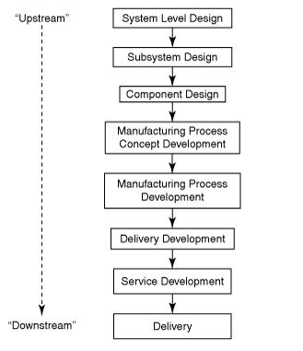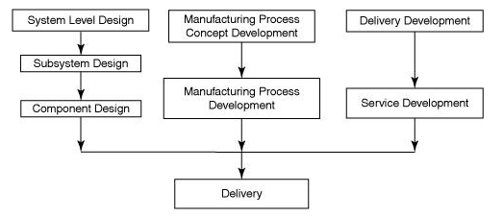
Figure 1 Traditional vs Concurrent product design product development schematic (Ficalora and Cohen, 2010)
A traditional product development process (shown in figure 1 on the left) follows a bottom down approach where each step, such as component design must be finished before the next step can start. The assumption is that time is wasted starting steps along the line as plans have already been formulated for their delivery. The issue with this system is that mistakes made early in the process may not be realised until late in the process and could be costly to rectify. A more efficient approach would be for all functions involved in the design process to work collaboratively to achieve the best possible results for each function. The concurrent engineering approach aims to start each process almost simultaneously with each function interacting throughout the product development process. Such an approach results in a faster product development lead time, lower production and delivery costs and an lower overall product delivery cost (Ficalora and Cohen, 2010).

Design for X

The design for x (DFX) principles originate from studies by (Boothroyd et al., 2011), the aim of the study was to try and reduce the cost of product assembly, they did this by reducing the number of operations used to make the part. This was achieved by reducing the number of necessary parts during the design phase. By eliminating unnecessary parts and combining others, then simplifying the part design for ease of assembly, the cost of assembly could be greatly reduced. The name given for this design approach was design for assembly (DFA). This concept was developed further to include the manufacturing process, design for manufacture (DFM) aims to reduce the manufacturing costs required to produce a product by eliminating expensive processes and materials (O’Driscoll, 2002). Design for manufacture and assembly (DFMA) became an important tool for manufacturers seeking to maintain high quality while reducing cost.
It is estimated that 80% of the total cost of a product is committed during the concept and design phase (see figure 2) while design costs only consume approximately 10% of the budget, costs increase as the design process matures, production machines and facilities are purchased, and staff hired etc. As soon as the product reaches the consumer, any faults or defects increase costs almost exponentially, design changes at this stage are very costly due to the tangible costs such as product recall and litigation costs and intangible costs such as customer dissatisfaction and brand damage (Yang and El-Haik, 2009).
There are now more demands than ever for product designers’, consumers now demand that products are safer and more environmentally friendly, leading to design approaches such as design for safety (DFS), design for recyclability (DFR) and design for sustainability (DFS). Collectively these approaches make up DFX. According to (Benabdellah et al., 2019) there are over 75 different DFX techniques including design for quality (DFQ), design for supply chain and design for cost (DFC).
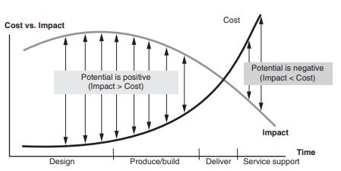
Figure 2 The effect of design phase on cost and impact to customer (Yang and El-Haik, 2009).

Design for Assembly

DFA practices try to simplify products by reducing the part count through the integration and elimination of parts and by reducing part variation. Thereby improving product quality and reducing problems during assembly. A lower number of parts reduces the assembly and manufacturing costs. Less parts can mean a smaller production facility and standardised parts and components speeds up assembly times and reduces tooling and storage costs. Using DFA results in a simpler product with fewer parts which is easier and faster to assemble and fabricate (Selvaraj et al., 2009).
(Moultrie and Maier, 2014) describe the basic method used in DFA:
- Functional analysis – Ask these questions, 1. Are all the components essential? This is often assessed by motion, does the component move relative to other assembled parts? Only large movements should be considered. Small movements can be adapted using elastic materials. 2. Is it necessary that the part is made of a different material? Only fundamental parts with material differences should be considered. 3. Consider position, is it necessary the part is separated from those already assembled? Would assembly or disassembly be impossible without it? If any components are found to be non-critical to the function of the part, then they can be considered redundant and have the potential for elimination.
- Handling/Feeding analysis – Each part is assessed for its handling difficulty or feeding difficulty. Very large or very small parts for example can be difficult to handle and feed. The components need to be assessed on how easy they are to position and orientate correctly for assembly.
- Fixing analysis - Once the part is ready for assembly, it must be determined how simple it is to insert into the assembly. Avoid fasteners that need physical manipulation.
Assess parts in order of assembly. Each part and assembly process are given a score which indicates the number of parts required and potential time and cost savings at assembly.
Figure 3 show an example of DFA in practice, an electric drive motor design was assessed using DFA principles. By redesigning motor and sensor subassemblies to snap into the base with a plastic snap on cover, the number of necessary parts was reduced from 19 to 4 (subassemblies are counted as parts). The old design had an assembly time of 160 seconds while the new design takes only 46 seconds. The screws for the motor base would have pilot points and it would be self-aligning. There would need to be an initial outlay for the tooling for the plastic cover, but the cost savings for the part and assembly time significantly outweigh this spend over time. The materials used in the initial DFA may be reviewed at the DFM stage as for example it may be decided to use a different material for the motor cover and there may be trade-offs as the best processes and materials are considered (Boothroyd et al., 2011).
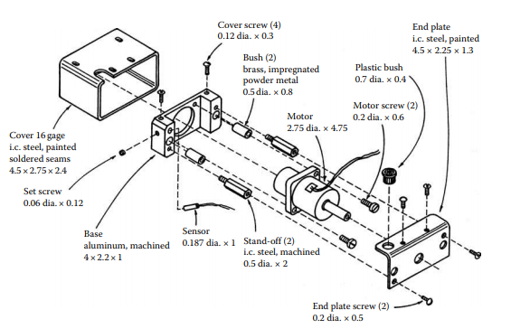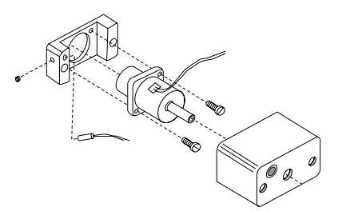
Figure 3 The redesign of a motor drive assembly following DFA analysis (New design on the right) (Boothroyd et al., 2011).

Design for Manufacture

DFM is a method for selecting the most cost-effective process and materials to be used to produce a product, used during the initial design phase. It is closely linked with DFA and they are typically applied together O’Driscoll (2002) and Anderson (2020) states that the manufacturing functions considered for DFM are:
- Fabrication
- Assembly
- Testing
- Procurement
- Shipping
- Service
- Repair.
He adds that DFM ensures that the product is produced at best:
- Cost
- Quality
- Reliability
- Safety
- Lead time
- Customer satisfaction.
DFM helps designers select the most suitable manufacturing process that is cost effective and meets all technical requirments. The design specifications are compared to process attributes and capabilites to select the best fit. There are computer aided design programs (CAD) that can aid this process. There are DFM design guidelines that help designers choose the best shape, material, dimensions and structure of the part. An manufacturing analysis is then carried out that identifies any potential manufacturing problems and assesses the manufacturing cost (Ferrer et al., 2010). Figure 4 shows the DFM steps and how they allign with the design process.
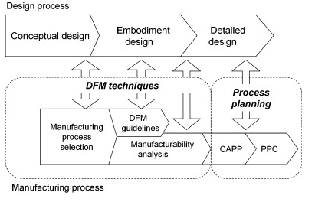
Figure 4 How DFM integrates into the design process (Ferrer et al., 2010)
Bogue (2012) summarises the DFMA guidelines as:
Guideline | Benefits
Minimise the part count | Simplified assembly, reduced costs, Improved reliability
Use standard/ off the shelf parts | Lower costs and lead times
Design for efficient joining and fastening, minimise the use of fasteners | Reduced costs, simplified assembly, improved reliability
Avoid the use of dissimilar materials if possible | Fewer manufacturing processes
Minimise the use of fragile parts | Fewer part failures(cost) easier handling and assembly
Do not over specify tolerances or surface finish | Reduced fabrication costs and easier manufacture
Use modular designs | Simplified assembly, reduced costs
Mistake proof designs (poka yoke) | Cost reductions, reduced rework
Design for simple part orientation and handling | Cost reduction, reduced time to manufacture
Design with predetermined assembly technique | Cost reductions from use of proven techniques
Design for automated assembly if possible | Cost reduction, reduced time to manufacture

In the following chapters using concurrent engineering and design for x techniques discussed above, a proposal for the design of a vaccine transportation device will be outlined, the reasoning behind the decisions will be explained and justified.
When designing a product, the needs of the end user, the customer are a critical factor that must be considered throughout all stages of the design process. The identification of the customer requirements (CR) is usually done through market research and by talking to the customers. These requirements must then be incorporated into the product design to satisfy the customer.

Kano Model
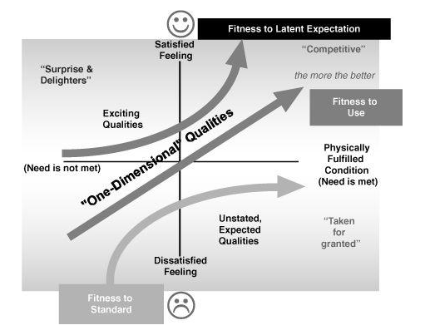
Figure 5 Kano's model (Ficalora and Cohen, 2010)
Ficalora and Cohen (2010) explain the kano model shown in figure 5, it illustrates how product characteristics can influence customer satisfaction. The model splits product and service characteristics into three categories, the fitness to standard characteristics are ‘must have’ or ‘basic’ features that the customer takes for granted. These features do not greatly satisfy the customer but can cause extreme dissatisfaction if they are not present. Examples include scratches on surfaces, missing parts and missing features that are provided by competitors. Meeting this standard alone is not enough for a product to thrive. Fitness to use characteristics are what the customers are asking for, what they desire. They cause dissatisfaction if not present and are expected to some level. Examples include lower cost, faster speed, and more reliability. Satisfying fitness to use characteristics keeps a product competitive. Fitness to latent expectation or delighters are features present that the customer did not expect but make them happy. Products missing delighters are not dissatisfied as they are unexpected. Delighters can make products and services market leaders and providing them is the goal for product designers. The Apple I pod with I tunes is an example of a product and service which satisfied a customer need that had previously gone unfulfilled.

Quality Function Deployment

Quality function deployment (QFD) is a tool widely used to translate CR’s into engineering characteristics which can then be used to design, develop and deliver the product (Ji et al., 2014). Using QFD can reduce product development time and decrease the number of unexpected start up issues. As a result, the production start-up costs are lower. Using QFD has also found to reduce customer complaints with products thereby reducing warranty costs (Stamatis, 2003).
The first step in QFD is to gather the voice of the customer (VOC), to understand the needs of the customer. The customers are questioned on product requirements and their feedback is put into a table, called the voice of the customer table (VOCT), the needs can then be prioritised before attempting to translate the CR’s into quality characteristics. Once the CR are collected the customer is asked to prioritise these requirements and they are given a score (Ficalora and Cohen, 2010).
It has been identified that there is a requirement for a vaccine transportation container, QFD will be applied for the design of the container. Some of the CR are identified in the assignment brief and some other requirements that users of such a container might wish for, have been suggested in the VOCT shown in table 1. For the importance rating, a score of 1 - 9 has been used, with 9 being the highest, importance ratings have been assigned to the CR by the author, using assumptions on how the customer would have rated them.
The CR (often referred to as the What’s) are then translated into substitute quality characteristics (SQC’s) or the How’s, the SQC is a technical feature that must be measurable, they are the designer’s response to the customer’s needs (Sartor and Orzes, 2019a).
The assumption has been made that the customer is most likely a medical organisation, and that the product reusability would be highest on their priority as this would significantly reduce costs, when compared to a single use container, or one which does not last more than a couple of uses. The SQC’s assigned to this requirement are all related to material properties, for the container to be reusable, it must be made of a durable, watertight material.
As the vaccine needs to be kept below 0⁰C the assumption has been made that it would be desirable for the container to stay cool for as long as possible to allow the vaccine to be transported for longer

Table 1 A voice of the customer table for a vaccine storage container
Customer requirement | Importance score | Substitute quality characteristics
The container should be reusable | 9 | Permeability  Toughness  Compressive strength  Fatigue  Yield strength
The integrity of the storage containers should be maintained over multiple uses | 7 | Toughness  Permeability  Number of parts  Fatigue
The containers should be stackable | 1 | Compressive strength  Toughness  Yield strength
The process of preparing, filling, and using the storage containers should be as efficient and free from potential error as possible. | 3 | Number of steps need to fill and use the container  Number of parts
Provision or allowances for carrying and handling the storage containers should be incorporated | 6 | Number of different materials  Tensile strength  Number of parts
The inner box in the container should stay cold for as long as possible | 8 | Thermal Conductivity  Container volume  Temperature
The container should be light enough to carry when full | 5 | Container volume  Container Dimensions  Material density
The container should be robust | 2 | Tensile strength  Yield strength  Toughness  Number of parts
The cost of the container should be relatively low | 4 | Cost of material  Cost of parts  Cost of manufacture

distances, the SQC’s for this CR are related to the dimensions of the product and the material it is made of.
The container would need to be manually handled and carried during vaccine transportation, therefore allowance for carrying the container is next. The SQC for this CR is related to the strength of material used number of parts and number of materials used. According to DFMA principles the number of parts and materials need to be kept to a minimum. Similarly, the weight of the container is an important factor, although there will be some trade off against the time the container stays cool. The more ice that can be fitted into the container the longer the vaccine is kept below 0⁰C but the weight will also increase, there will be a limit to what weight is acceptable for a person to carry. Again, the SQC for this CR are product dimension and material related.
The cost is given a medium priority, the vaccine is life saving and vital to ending the pandemic, therefore although cost needs to be considered there may be a trade-off to ensure the container is off a high quality and meets all the CR.
The process of preparing the container for use should be as simple as possible as all the time used in preparation is essentially a cost, so should be kept as low as possible. The SQC metric assigned is number of process steps and number of parts, which both should be kept to a minimum. The robustness of the container is linked to its reusability and the SQC are material properties related, similarly for the ability to stack the container which has been given the lowest priority.
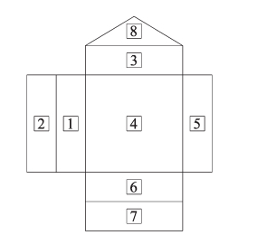
Figure 6 The House of Quality layout (Sartor and Orzes, 2019)
For the next step in QFD as explained by Sartor and Orzes (2019), the information gathered in the VOCT is displayed in a matrix form called the house of quality (HOQ) shown in Figure 6.
The CR are listed in a vertical column while the SQC are then listed horizontally in a perpendicular row. Zones 1 and 3. The relative importance of the CR are listed in zone 2. Zone 4 is called the relationship matrix and provides a metric on the strength of any relationships between the CR and the SQC, the what’s and the how’s. The relationships are designated symbols indicating a strong, moderate or weak relationship, the absence of a symbol indicates no relationship. A strong relationship is given a score of 9, a moderate relationship is scored 3 and a weak relationship 1. Zone 5 includes a competitor comparison and benchmarking. Zone 6 shows the target values for the SQT’s. In zone 7 the SQC are weighted according to their relationship with the CR. This allows product designers to prioritise which SQC would provide more customer satisfaction. The roof of the HOQ is the correlation matrix, zone 8, it shows which SQC have any correlation, they may be positively correlated, when a change in one SQC results in a coinciding change in the other or negatively correlated when a change in one SQC results in a conflicting change in the other. These correlations can help when there may be trade off decisions for the SQC.
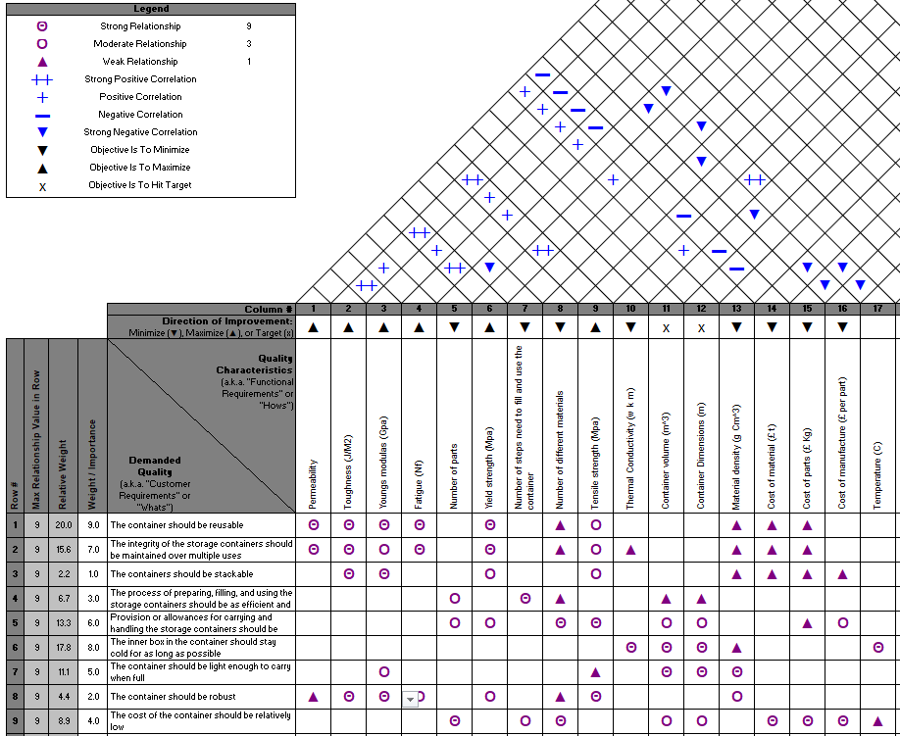
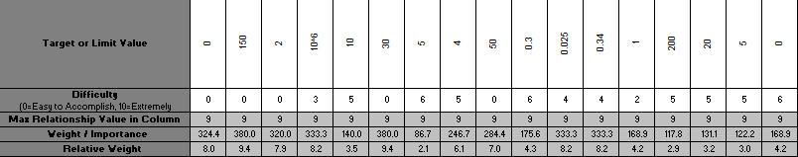
Figure 7 The House of Quality for the Vaccine Storage Container
The HOQ for the storage container shows that the SQC with the highest priority are for yield strength and toughness. This indicates that it is important that the container is manufactured with a material with high specifications in these properties.
There a three SQC with level weighting next on the priority list. Two of them are closely linked, the container volume and dimensions. There are conflicting CR for these SQC, the weight of the container (therefore the thickness of ice it contains) and the length of time it stays cool. The third SQC is fatigue, the container will be subjected to cyclic strain as the ice freezes and melts and so this needs to be considered when choosing the container material.
The next SQT on the priority list is permeability, to enable to maintain the integrity of the container over multiple uses the container needs to be watertight. The young’s modulus relates to the stiffness of the material which is linked to the ability of the container to be stacked and it robustness. The following SQT relates to the ability of the container to be carried, by straps or handles, the material used will need high tensile strength.
As already discussed, DFMA principles maintain that the least materials used the better as this will keep manufacturing costs down.
An insulting material will help keep the container cooler for longer and so the thermal conductivity of the material used should be considered. The density of the material will help keep the weight of the container down. The temperature of the inner box is relatively important, so the user knows when the vaccine has reached its temperature limit, a means of displaying temperature would be beneficial.
The next three SQC near the bottom relate to cost and the ease of preparing the container has the lowest priority for the customer.
The correlation matrix shows positive correlations for the material properties, yield strength, tensile strength, toughness, young’s modulus, fatigue, and density which is to be expected as they are all material properties. There are negative correlations with the cost of manufacture with number of parts, size of the container and number of materials and negative correlation with the cost of the material with the different material properties, size of the container and temperature measurement.
There are several different QFD approaches, for the four-phase approach for example the HOQ process is repeated four times. The second HOQ help define part characteristics from the performance measures defined in the first HOQ from there manufacturing processes and then production operation planning is defined in the last HOQ. For the purpose of this report only the first HOQ is used.
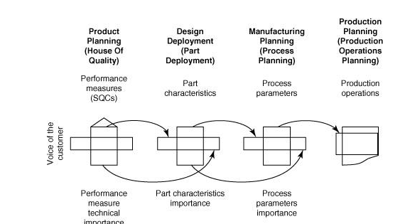
Figure 8 The QFD four phase approach (Ficalora and Cohen, 2010)

Benchmarking

Many authors Dale (2003), Ficalora and Cohen (2010), Sartor and Orzes (2019) and Stamatis (2003) recommend the use of benchmarking, the study of competitors including their design, manufacture, administrative and management processes. Benchmarking helps organisations discover best practices and improve performance and can lead to customer satisfaction and reduced costs.
To obtain ideas from similar products on the market several leading online stores were searched using search terms such as ‘cool box’, ‘cooler’, search engines were also used to find ‘vaccine storage’ and ‘vaccine container’. The results of these searches found several types of insulating storage containers meeting many of the requirements for the vaccine storage container. There were some of the picnic cooler box type, a hard, hollow thermoplastic shell with insulating material inside the hollow. There were bags made of soft thermoplastic, also insulated. Some medical storage containers used plastic coated cardboard as the box material. While many of the storage devices were refrigerated.
While a full benchmarking was not possible, a market comparison was made to gather design ideas.

Container Concept

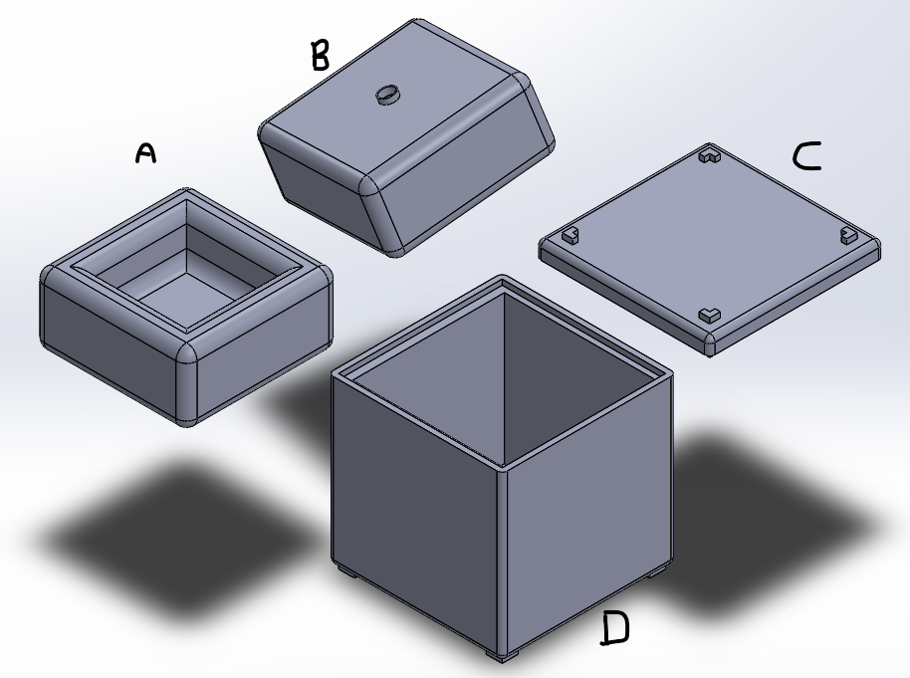
Figure 9 Vaccine container concept (Waters., 2021)
The initial idea for the storage container shown in figure 9 is based on the some of the containers seen while benchmarking. From the assignment brief it is known that the container is a hollow walled box (D). The lid for the box is shown in figure 9 (C). To keep the vaccine at the centre of the box and surrounded by ice, it is proposed that hollow moulds (A + B) filled with water and then frozen, are placed inside the container to hold the vaccine box. Moulds A and B are identical, but B is shown inverted.
Using the MATLAB coding in task 1, if the thickness of ice is 0.06m, the weight of the container would be 20.36 Kg. The HSE (2020) recommend that for weights close to the body, a man should not be required to lift more than 25 Kg at work, and a women 16 Kg. They state that these are not safe limits for lifting and carrying, and that they are based on assumptions and generalisations, but if met the risk of injury is low. Therefore, it is recommended that the ice thickness be limited to 0.051m, resulting in a container weight of 16 Kg and container dimensions of 0.328 length 0.308 height 0.328 width. The final total weight will be dependent on the materials used.
The following sections will discuss what materials and processes will be used to manufacture the box and what design considerations are required.

Process and Material selection

Boothroyd et al. (2011) state that the product and the manufacturing process are very closely linked, so much so that the manufacturing process must be considered from the start and that many design considerations cannot be defined until the process has been decided. The following considerations can help decide on the most suitable process:
- Expected number of parts to be manufactured
- Part shape and complexity
- Appearance factors
- Tolerance requirements
- Tooling costs
- Part Technical requirements
Most of a product’s components and parts are not produced by the same process but require several different processes, such as finishing processes that are often needed once the part has been produced. A simple process of elimination can be used to help narrow down the possibilities. Certain materials and processes are not compatible and certain combinations of processes are not possible. Cost also has a large influence on all decisions, but the overall cost must be considered not individual costs.
When selecting the material, the SQC from the HOQ must be considered. A classification of materials is shown in fig 9. The SQC require a strong, light, watertight, heat insulating, tough material that can be produced at low cost.
Metals can be excluded as they are dense, heavy materials that conduct heat. Ceramics are generally hard, brittle materials and so would be unsuitable. Natural materials would be difficult to form or machine into the required shapes in mass quantities. The most suitable candidates are polymers, thermosets are mostly hard and rigid and are used where high temperature resistance and low creep properties are required. Some like rubber can be soft. Thermosets cannot be recycled and so are environmentally unfriendly (Farag, 2021).

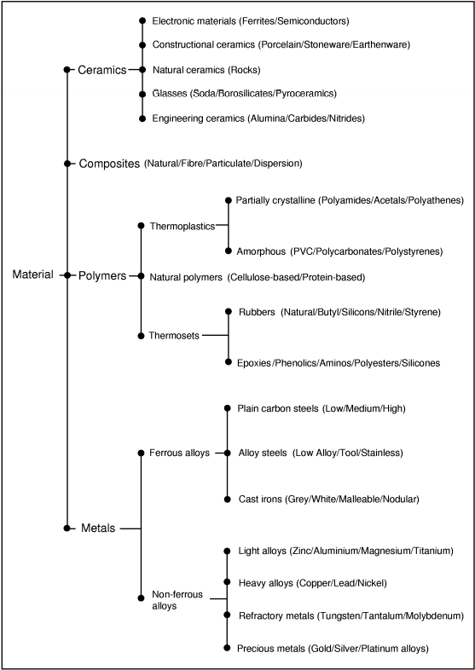
Figure 10 Material classification (Swift and Booker, 2003).
This leaves the best candidate as thermoplastics, Ashby and Johnson (2014) infer that they are among the best insulating materials, they are resistant to chemical attack, they can be strong and tough materials and they are light and flexible see figure 10. They can be made into complex shapes cheaply using moulds, shapes that would be expensive to manufacture using other materials. They can be blended to meet specific design requirements for stiffness, strength and processability. They are mainly cheap to purchase and manufacture (figure 11). Thermoplastics are also nontoxic and recyclable.
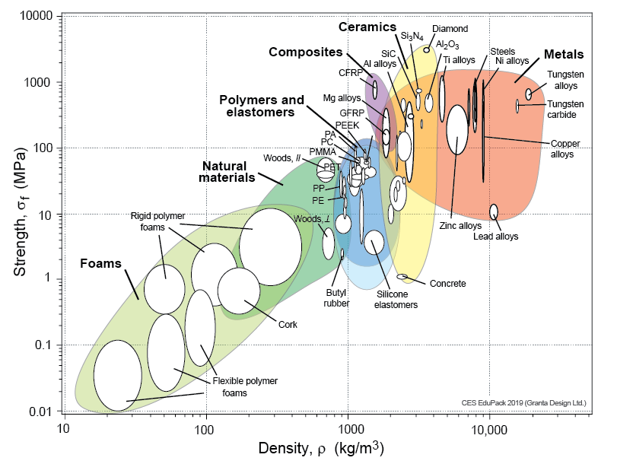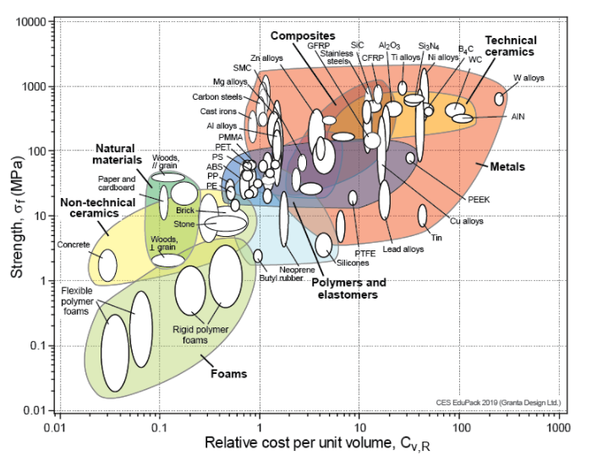
Figure 11 Material property charts Density vs strength and Relative cost vs Strength (“Material property charts,” 2021)
Drawbacks of polymers include sensitivity to UV light and strongly oxidising environments , they are highly responsive to temperature, many can creep under load at room temperature and become brittle when cooled (Ashby and Johnson, 2014).
Swift and Booker (2003) suggest a checklist for choosing the manufacturing process as follows:
- Estimate annual production of part
- Choose material type using quality characteristics
- Refer to Figure 11 to find suitable processes
- Assess each process against the product for
  - Material compatibility
  - Product geometry capabilities
  - Tolerance and surface finish capabilities
  - Conformance of process with design rules
An estimate on annual production of the container would be high 100,000 plus, distribution of a vaccine is vitally important and so there will be a large market for such a product.
Using figure 12, Swift and Booker (2003) advise that suitable processes for an annual high production volume are: Injection moulding, blow moulding and continuous extrusion.
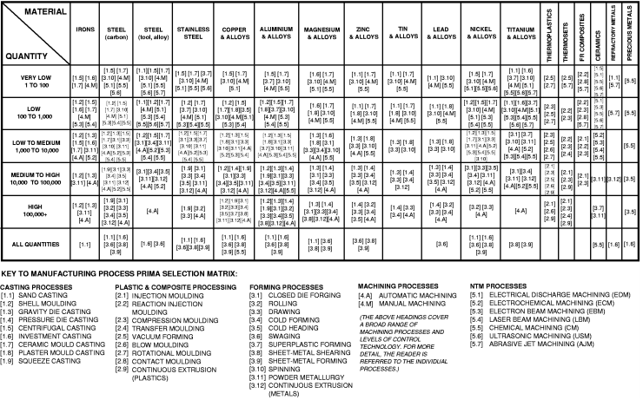
Figure 12 Manufacturing selection matrix (Swift and Booker, 2003)
As the container is a thin-walled hollow box, continuous extrusion can be ruled out, as this process produces products such as tubing, pipe and window frames (Goodship et al., 2016).
Commonly used materials for injection moulding are shown in figure 13 below
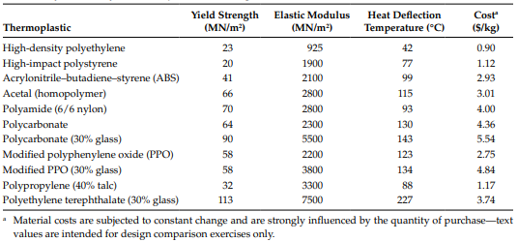
Figure 13 Commonly used injection moulding materials (Boothroyd et al., 2011).
While Ashby and Johnson (2014) declare that the materials commonly used with blow moulding are Polyethylene terephthalate (PET), Polycarbonate (PC), High and low Polyethylene (HDPE, LDPE), Polypropylene (PP), Acrylonitrile-butadiene-styrene (ABS), and Poly-vinyl-chloride (PVC).
Some property comparisons are made below. Where a range of values exist, averages are used.
Table 2 Thermoplastic properties (Ashby and Johnson, 2014; Harper, 1999)
Thermoplastic | Youngs modulus GPa | Density g/cm³ | Thermal conductivity w/m-k | FrToughness MPAM ^{1/2} | Cost $/Kg
HDPE | 0.78 | 0.96 | 0.42 | 3.5 | 0.9
LDPE | 1 | 0.93 | 0.5 | 1.55 | 0.9
ABS | 2.2 | 1.18 | 0.26 | 2.7 | 2.15
Polyamide (PA) (nylon6) | 2.76 | 1.13 | 0.27 | 4.31 | 7.2
PC | 2.3 | 1.2 | 0.21 | 3.35 | 4.05
PP | 1.6 | 0.9 | 0.28 | 3.75 | 0.95
PET | 8.96 | 1.56 | 0.15 | 5 | 1.9
PVC | 3.14 | 1.44 | 0.22 | 3.29 | 1.1
Acetal | 4.31 | 1.41 | 0.285 | 2.96 | 3.35

PC, Nylon, PPO, PET and Acetal are called engineering plastics are used in specialist applications and therefore are more expensive. PVC is a brittle material and would not be suitable. Both PP and PE has a low density, good thermal resistance, and are low cost. They also meet the requirements for strength, stiffness, and toughness. PP is the preferred material for the container as it is more easily moulded than PE, it is also less dense and stiffer (Ashby and Johnson, 2014).

Injection Moulding

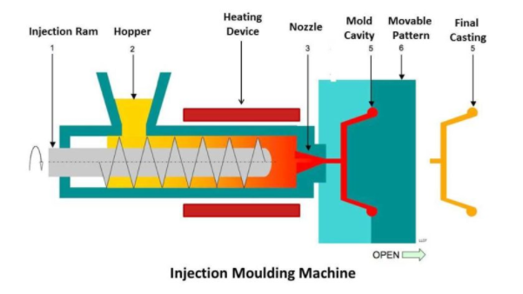
Figure 14 The Injection moulding machine (Mech4study, 2018)
This process can produce complex and intricate parts with a good surface finish at high volumes.
The thermoplastic material is feed into the hopper where it is heated until it melts. The melted plastic is forced into a steel mould using a screw fed injection ram. The plastic cools and solidifies inside the mould and then is ejected.
The tooling and initial set up costs are high, the complexity of the mould determines its cost, but these high costs can be made economic by the volume of product produced. The production rate is also high from 1 – 50 parts a minute depending on its size (Swift and Booker, 2003).
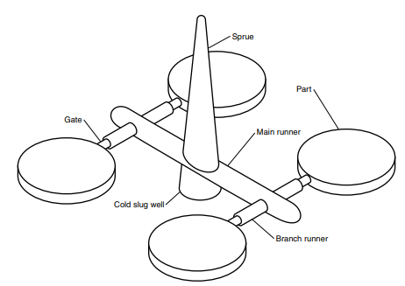
Figure 15 Injection moulding. Sprues, runners, gates and cavities (Harper, 1999)
Design considerations recommended by (Boothroyd et al., 2011; Bralla, 1999; Swift and Booker, 2003):
- The wall thickness must remain uniform.
- Holes, inserts, threads, lettering, colour, bosses, and minor undercuts possible.
- A draft is required for easy release from the mould.
- Decide on wall thickness and material with overall cost in mind, the cheapest material may not always be the best choice. A stronger material with thinner wall thickness may be more economical.
- The thickness of projections from the main wall should be half of the main wall thickness to avoid issues when cooling.
- Fillets should be as generous as possible, avoid sharp corners.
- Minimum wall thickness 0.4mm Maximum wall thickness 13mm
- Avoid placing parting line across critical dimensions.
- Design tolerances for the process capability
- Take care when deciding gate and ejector pin locations as they can impair surface finish (see figure 15)
- Use reinforcing ribs to prevent sink marks
The mould gives shape to the final part, its where the melted plastic cools and is ejected from. They must withstand the forces of injection and ejection. A standard mould has two halves and the division between these halves is known as the parting line. The cavity through which the plastic flows through the mould are called runners, the sprue allows the part to be pulled to the correct mould for ejection. When solidified ejector pins push the part from the mould. The sprue, runner and part are connected after connected after ejection (figure 15) (Harper, 1999).
Injection moulding will be used to produce parts D and C in figure 9, the container and its lid. Each part will be made in two halves which will then need to be joined to create the hollow. Ultrasonic welding joins plastic parts together by subjecting them to high frequency vibration, approximately 20 kHz. The process is relatively inexpensive and fast with welding taking only 2 seconds (Boothroyd et al., 2011).
When deciding on wall thickness it must be remembered that the material may cool and solidify in thin sections before the mould is filled. As the container has a uniform shape and walls, a wall thickness of 2 mm is recommended (Bralla, 1999).

Blow Moulding

Bralla (1999) explains the blow moulding process - thin walled, hollow parts are made by blowing hot air into a hot plastic hollow tube called a parison inside a mould. The plastic expands until it meets the cold surface of the mould. It is allowed to cool and then is ejected from the mould. In extrusion blow moulding the parison is drawn down and connected to a blow pin or needle. The mould is closed, and hot air blown in to form the part. Once cool the mould is opened and the part ejected. There is some surplus material at each end. Injection moulding is similar except that the parison is made by injection rather than extrusion. It is injection moulded over a mandrel to provide the hollow shape, the mandrel is then transferred over to the blowing die and hot air injected to form the part.

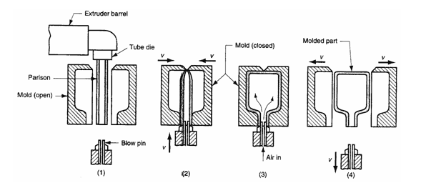
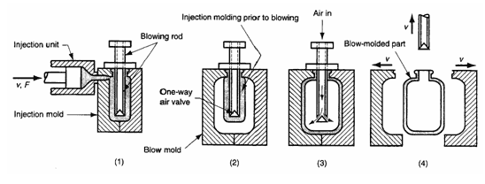
Figure 16 Extrusion and infection blow moulding (Sinotech, 2021)
Injection blow moulding is more suitable for smaller containers of tubular shape using more rigid materials. Extrusion blow moulding is more suited for producing larger containers with irregular shapes.
Blow moulding operations can be fully automated with short production cycles at relatively low cost, production rates of between 100 and 2500 parts an hour are possible depending on the size of the part. Tooling costs are moderate to high, but labour costs are low.
Design considerations recommended by (Bralla, 1999; Swift and Booker, 2003) are:
- Complexity of parts limited to thin walled, hollow rounded parts.
- Undercuts, bosses, ribs, lettering, inserts and threads possible.
- Corner fillets should be generous.
- Holes cannot be moulded in.
- Draft not required.
- Minimum wall thickness 0.25mm – Maximum wall thickness 6mm.
- Uniform wall thickness desirable.
Extrusion blow moulding will be used to produce part A (identical to part B) seen in figure 9. This part is to contain the ice for cooling the vaccine and hold the vaccine box central inside the storage container.

Container insulation.

The insulation inside the vaccine container is expanded polystyrene (EPS) which is made by subjecting styrene to suspension polymerisation in water which forms droplets of polystyrene these droplets are heated to start the polymerisation process. The result is polystyrene beads to produce the expanded foam the beads are subjected to steam or hot air to make them denser, here they are agitated to prevent fusing. They are then placed into the required mould and steamed again, fusing them together. The result is moulded EPS (Sulong et al., 2019). This material is used as an insulating material for many applications including cooling containers. EPS has been recommended as an insulation material for the vaccine container in task (1-3) although Paxton (2017) recommends using Polyurethane as a superior material for insulation, it advantages include, twice the thermal resistance, flexibility, fire retardation and chemical resistance. The insulation used for the vaccine container will be polyurethane foam.

Tolerancing

Yang and El-Haik (2009) describe Tolerance as the acceptable level of variation in a standard or measurement and can include part dimension, characteristic, or manufacturing process. Customers become unhappy if products fail to live up to their expectations. Minimising product variation will increase customer satisfaction and reduce costs. However, over tight tolerances increase process costs, so there needs to be a balance. Tolerance design must designate tolerances to all parts and processes based on acceptable variation of all customer quality requirements. Traditional tolerance design methods are: Worst-case tolerance analysis and statistical tolerance analysis. While another type of tolerance design are Taguchi tolerance design methods.
Worst case tolerance analysis only considers the maximum and minimum variation values. Theses extreme values are then added, the tolerance that leads to the most unfavourable outcome is used. This then guarantees 100 percent of the parts will fall within tolerance; however, this does not happen. Worst case tolerance analysis require tight tolerances as tolerances are over designed that drives up manufacturing costs (Schenkelberg, 2014).
Statistical analysis uses the normal distribution of the characteristic being measured and the three times standard deviation of the variance is used to calculate the maximum and minimum deviation from the mean. By varying the tolerance, an estimate of the scrap and defect rate can be made and a comparison of cost of failure and scrap vs tighter tolerances (Schenkelberg, 2014).
Dr Taguchi developed a cost-based tolerance design, where any deviation from the ideal is seen a quality loss to the customer where the larger the deviation, the greater the cost. Taguchi argued that manufacturer tolerances should be tighter than customer’s tolerance level. That if a product failure can be fixed before distributing to customer at a lower cost, then it will eliminate the costs incurred by customer dissatisfaction (Yang and El-Haik, 2009). The loss function as shown by (Kumar and Ragsdell, 2007) is represented by:
$L(x)=k(x-T)²$ where x = Quality characteristic; T = Target value; k= cost of repair
The quadratic loss curve is shown in figure 17.
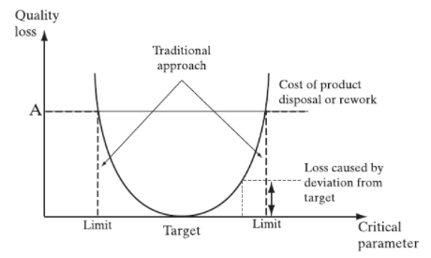
Figure 17 Taguchi's loss function compared with the traditional view (Dagman, 2005)
This only applies to characteristics with nominal targets. Some characteristics have ideal targets that aim for as low as possible or as high as possible. For ‘the smaller the better’ the loss function is:
L (x) = K x²
And for ‘the larger the better’
L (x) = K (1/x²)
According to Bralla (1999) injection moulding allows for reasonably tight tolerances although not as precise as with machined metal parts. Reasons for this include.
- Thermoplastics shrink when cooling, with some unpredictability.
- The thermal coefficient of plastics is high, they are reactive to heat changes.
- There is variation in the process, pressure, temperature, and time can vary slightly from cycle to cycle.
- Plastic is more flexible than metal.
Tight tolerances have significant cost implications, moulds with loose tolerances are much cheaper than those with tight tolerances. Tight tolerances also require tighter process controls, further raising the costs. The shrinkage level of the plastic will affect its tolerance capability.
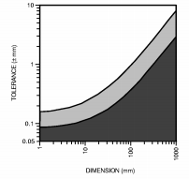
Figure 18 Injection moulding process capability chart for PE & PP (Swift and Booker, 2003)
As the dimension of the container is approx. 300mm then from using the chart in figure 18, a dimensional tolerance of +/- 1.5mm is recommended for any injection moulded parts.

Failure mode effect analysis (FMEA)

Dale (2003), Sartor and Orzes (2019) and Yang and El-Haik (2009) clarify the purpose of FMEA. To identify and correct potential modes of failure at the design stage before the product goes to manufacture. Using FMEA at the design stage prevents defects during production, failures in service, customer complaints, safety incidents and warranty claims. The idea is that for each functional requirement of the product, manufacturing and assembly process the design team need to ask, ‘what can go wrong?’. Considerations such as, how might the product fail while with the customer, potential process issues. The design team needs to then modify the design and processes to prevent these issues from happening. The steps for a design FMEA (DFMEA) are as follows.
- Select a function/process for the product.
- Identify potential failure modes.
- Assess the effects of each potential failure mode.
- Examine the root cause of the potential failure.
- Identify the controls in place for detection if the failure mode.
- Assign a risk priority number (RPN).
- Decide on an action to eliminate the failure mode.
- List the failure modes in order of RPN to help prioritise the order in which the failure modes should be addressed.
- Monitor and review.
The RPN is calculated by multiplying the following three rankings: The occurrence is an estimation of the probability that a failure mode will occur, scored from 1 – 10 with 10-very high (>10% failure rate) and 1-failure unlikely (< 0.001% failure rate). The detection ranks the likelihood that the failure mode will be detected before it reaches the customer with 10 meaning likelihood of detection almost nil and 10 meaning detection almost certain. The Severity scores the seriousness of its effect when it fails, 10 means hazardous without warning while 1 means very minor disruption.
Reducing the RPN is done by either lowering the likelihood of occurrence, for example by designing in a preventative measure, or increasing the chances of detection i.e implementing a quality control process.
Figure 19 shows an FMEA for the vaccine container. The highest RPN with a risk score of 400 is that without further consideration, the customer will have no way of knowing the temperature inside the container and they would not be able to identify when the temperature inside the box has reached 0⁰C and the vaccine is unusable. From the customers perspective this would be a big concern and a significant number of vaccines could be wasted or worse defective vaccines could be administered to people. Incorporating a thermometer into the design could be considered but this would raise costs considerably. Instead, it is proposed that using such modelling as used in task 3, that a guide is included with the vaccine containers instructions, or a sticker is placed on the container showing the approximate time taken for the centre to reach zero against a range of possible ambient temperatures.
The next highest RPN regards the customers need for the container to be stacked. If the stacking feature was not provided, then there would be a high chance that the containers would fall when stacked and the vaccine vials could break. To avoid this bosses that fit together on the bottom and top of the container have been designed in. In a similar fashion the next RPN is related to the material strength when stacking, if a strong material were not chosen then the weight of the stacked containers could break the containers or crush the vaccine vials. These issues had high severity and a high chance of occurrence if not detected during design.
The next four RPN’s on the priority list relate to the manufacturing process, if the correct material, and process parameters are not suitably selected, then process issues defects can occur. These can be prevented by following DMA principles.
The handle breaking while being carried is next on the priority list, this can be prevented by a suitable material and handle design being selected.
Difficulty in removing the ice box inserts would also be a concern, the customer has specified that the process of preparing and using the container be efficient and free from error. The ice box inserts have been designed so that only one design is needed for the top and bottom to ensure modularity. The insert has a hole in its back that would have a screw cap to make filling with water an easy task. Also, the cap would have a ring pull that could be used to make removal of the insert simple.
Water leaks would be prevented by selecting a watertight material with fatigue resistance and ensure there are no weaknesses in the design.
The following RPN’s relate to the container dimensions, the weight of the container and the length of time the temperature remains below 0⁰C (ice thickness). The model used in task 1 has been used to select the ideal dimensions that best meet customer requirements.
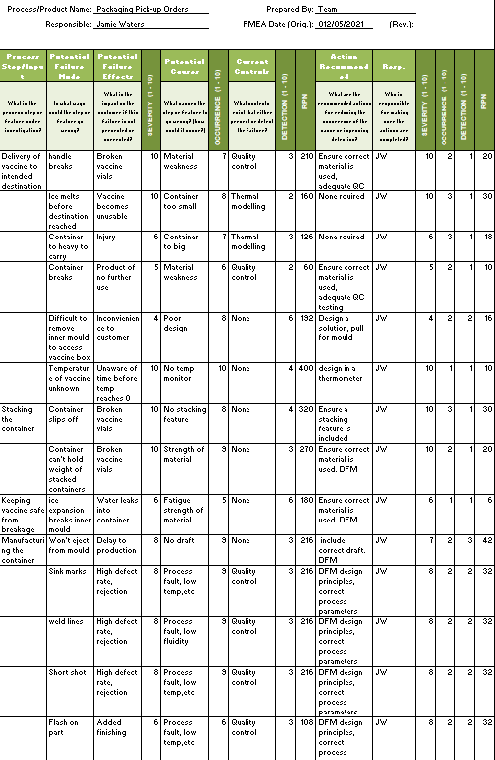
Figure 19 FMEA for the vaccine container

Final Part and decisions

Summary of decisions made

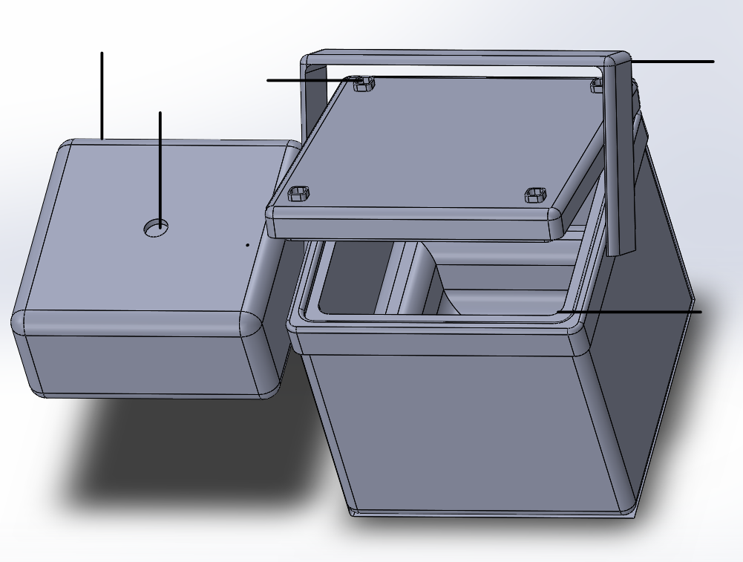
Bosses for stacking
Sharp corners filleted
Carry handle
Capped hole for easy filling of ice box
Ice box for vaccine
Figure 20 Front view of vaccine container assembly

Using DFMA and QFD principles discussed in the report and lessons learned from the FMEA the design decisions made are summarised below.
- Material - Vaccine container – Polypropylene, Inner container – Polypropylene, insulating material Polyurethane. DFM principles and QFD used to consider cost and required properties of the material chosen
- Process – Vaccine container – Injection moulding, Inner container – Blow moulding. Process chosen using DFM principles, geometry of shape, annual production and material used key factors. Ultrasonic welding used to join 2 parts of container together.
- Wall thickness of container – Using empirical data for process and material combination and size of product. 2mm is recommended (Bralla, 1999). Wall thickness of inner container also 2mm.
- Design considerations –
  - Vaccine container - Uniform wall thickness
  - Generous fillets
  - Drafted walls
  - Few components as possible
  - Ease of assembly
  - Bosses at bottom and top to enable stacking (thin walled, filleted)
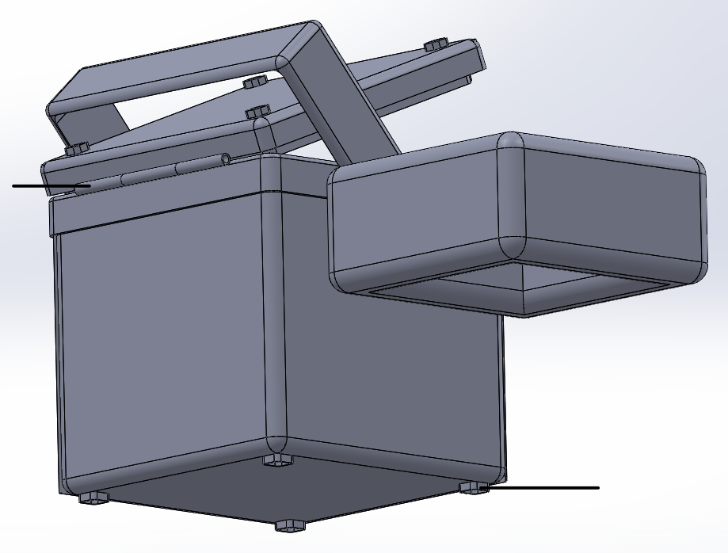
Hinged lid
Bosses that fit over bosses on the lid
Figure 21 Side view of vaccine container assembly.
  - Strong plastic handle to allow easy carrying of the container.
  - Hinged lid for easy use
  - Capped hole in ice box, only need to fill once. Can empty to reduce weight when not in use
  - Dimensional tolerance of +/- 1.5mm
  - Guide attached to advise the length of time for the inner box to reach 0⁰C at any given ambient temperature.
  - Optimum balance between low weight of container and ice thickness (container dimensions)
  - Simple design to make manufacture as easy as possible and to keep costs down.
  - Ice box made of two identical parts to keep inner vaccine box central. Easy to manufacture and replace if required. Modular.

Reference list

Anderson, D.M., 2020. Design For Manufacturability. Routledge/Productivity Press, Florida.
Ashby, M., Johnson, K., 2014. Materials and Design, Third. ed. Elsevier, Oxford.
Bader, H., 1964. Density of Ice as a Function of Temperature and Stress (Special report No. 64). U.S Army Cold Regions Research and Engineering Laboratory, Hanover, USA.
Benabdellah, A.C., Bouhaddou, I., Benghabrit, A., Benghabrit, O., 2019. A systematic review of design for X techniques from 1980 to 2018: concepts, applications, and perspectives. Int. J. Adv. Manuf. Technol. 102, 3473–3502.
Blow Molding [WWW Document], n.d. URL https://www.custompartnet.com/wu/blow-molding (accessed 5.8.21).
Bogue, R., 2012. Design for manufacture and assembly: background, capabilities, and applications. Assem. Autom. 32, 112–118.
Boothroyd, G., Dewhurst, P., Winston, Knight. A., 2011. Product Design for Manufacture and Assembly, Third. ed. CRC Press, Florida.
Bralla, James. G., 1999. Design For Manufacturability Handbook, Second. ed. Mc Graw Hill, New York.
Conner, N., 2019. What is Thermal Diffusivity - Definition [WWW Document]. URL https://www.thermal-engineering.org/what-is-thermal-diffusivity-definition/ (accessed 5.24.21).
Coronavirus (COVID-19) Vaccinations - Statistics and Research [WWW Document], n.d. Our World Data. URL https://ourworldindata.org/covid-vaccinations (accessed 4.25.21).
COVID Live Update: 147,170,817 Cases and 3,115,268 Deaths from the Coronavirus - Worldometer [WWW Document], n.d. URL https://www.worldometers.info/coronavirus/ (accessed 4.25.21).
Dagman, A., 2005. Increased Visual Quality through Robust Split-Line Design 4.
Dale, B.G., 2003. Managing Quality, Fourth. ed. Blackwell Publishing, UK.
Farag, M.M., 2021. Materials and Process Selection for Engineering Design, Fourth. ed. CRC Press, Florida.
Ferrer, I., Rios, J., Ciurana, J., Garcia-Romeu, M.L., 2010. Methodology for capturing and formalizing DFM Knowledge. Robot. Comput.-Integr. Manuf. 26, 420–429.
Ficalora, J.P., Cohen, L., 2010. Quality Function Deployment and Six Sigma A QFD Handbook, Second. ed. Prentice Hall, Boston.
Goodship, V., Middleton, B., Cherrington, R., 2016. Design and Manufacture of Plastic Components for Multifunctionality. Elsevier, Oxford.
Harper, C.A., 1999. Modern Plastics Handbook. Mc Graw Hill, New York.
Holt, R., Barnes, C., 2010. Towards an integrated approach to “Design for X”: an agenda for decision based DFX research. Res. Eng. Des. 21, 123–136.
HSE, 2020. Manual handling at work A brief guide. London.
Hussain Ather, S., 2020. How Are Density, Mass & Volume Related? [WWW Document]. Sciencing. URL https://sciencing.com/density-mass-volume-related-6399069.html (accessed 5.24.21).
Injection Molding Machine: Construction, Working, Application, Advantages and Disadvantages, 2018. mech4study. URL https://www.mech4study.com/2018/04/injection-molding-machine-construction-working-application-advantages-and-disadvantages.html (accessed 5.16.21).
Ji, P., Jin, J., Wang, T., Chen, Y., 2014. Quantification and integration of Kano’s model into QFD for optimising product design. Int. J. Prod. Res. 52, 6335–6348.
Kumar, N., Ragsdell, K., 2007. Quality Loss Function - Common Methodology for Nominal-The-Best, Smaller-The-Better, and Larger-The-Better Cases. SAE Tech. Pap.
Material property charts [WWW Document], 2021. Granta Des. URL https://www.grantadesign.com/education/students/charts/ (accessed 5.14.21).
Moultrie, J., Maier, A.M., 2014. A simplified approach to design for assembly. J. Eng. Des. 25, 44–63. https://doi.org/10.1080/09544828.2014.887059
O’Driscoll, M., 2002. Design for manufacture. J. Mater. Process. Technol. 122, 318–321. https://doi.org/10.1016/S0924-0136(01)01132-3
Özis¸ik, M.N., Orlande, H.R.B., Colaço, M.J., Cotta, R.M., 2017. Finite Difference Methods in Heat Transfer, Second. ed. CRC Press, Florida.
Paxton, R., 2017. Difference Between Polystyrene & Polyurethane [WWW Document]. Sciencing. URL https://sciencing.com/difference-between-polystyrene-polyurethane-8730934.html (accessed 5.21.21).
Sartor, M., Orzes, G., 2019. Quality Management Tools, Methods, and Standards. Emerald Publishing Limited, UK.
Schenkelberg, F., 2014. Worst Case Tolerance Analysis [WWW Document]. Accendo Reliab. URL https://accendoreliability.com/worst-case-tolerance-analysis/ (accessed 5.17.21).
Selvaraj, P., Radhakrishnan, P., Adithan, M., 2009. An integrated approach to design for manufacturing and assembly based on reduction of product development time and cost. Int. J. Adv. Manuf. Technol. 42, 13–29.
Solids - Volumes and Surfaces [WWW Document], 2008. URL https://www.engineeringtoolbox.com/surface-volume-solids-d_322.html (accessed 5.23.21).
Stamatis, D.H., 2003. Six Sigma and Beyond: Design for Six Sigma. St Lucie Press, Florida.
Storage requirements for each COVID-19 Vaccine [WWW Document], n.d. SPS - Spec. Pharm. Serv. URL https://www.sps.nhs.uk/articles/storage-requirements-for-each-covid-19-vaccine/ (accessed 4.25.21).
Sulong, N.H.R., Mustapa, S.A.S., Rashid, M.K.A., 2019. Application of expanded polystyrene (EPS) in buildings and constructions: A review. J. Appl. Polym. Sci. 136, 47529. https://doi.org/10.1002/app.47529
Swift, K.G., Booker, J.D., 2003. Process Selection from Design to Manufacture, Second. ed. Butterworth Heinmann, Oxford.
Truex, M., 2010. Numerical Simulation of Liquid-Solid, Solid-Liquid Phase Change Using Finite Element Method in h,p,k Framework with Space-Time Variationally Consistent Integral Forms (MSc). University of Kansas, USA.
Williams, S., 2020. A Brief History of Human Coronaviruses [WWW Document]. Sci. Mag. URL https://www.the-scientist.com/news-opinion/a-brief-history-of-human-coronaviruses-67600 (accessed 4.23.21).
Yang, K., El-Haik, B.S., 2009. Design For Six Sigma - A Roadmap for Product Development, Second. ed. Mc Graw Hill.

