Integrating project ACHA4008:
SERIOUS TOP 10 ISSUES COVID CAUSED


Mahdiyyah Hussain 2228656

TITLE- ANALYSE OF COVID ISSUES

TABLE OF CONTENTS
ABSTRACT
CHAPTER 1- Digital aim and objectives- covid issues
CHAPTER 2- Impact of pandemic
CHAPTER 3- Finding solutions to the problem
CHAPTER 4 - Results
REFERENCES



ABSTRACT
Covid led to many issues for the world's population including causing many infections. Research suggests that online learning has been shown to increase. This is by information, taking less time, which will mean the changes coronavirus have caused will remain consistent through a period. The infections were being addressed as the worst, as they came suddenly and no one knew about it, but as this disease developed, many people knew about the issues.

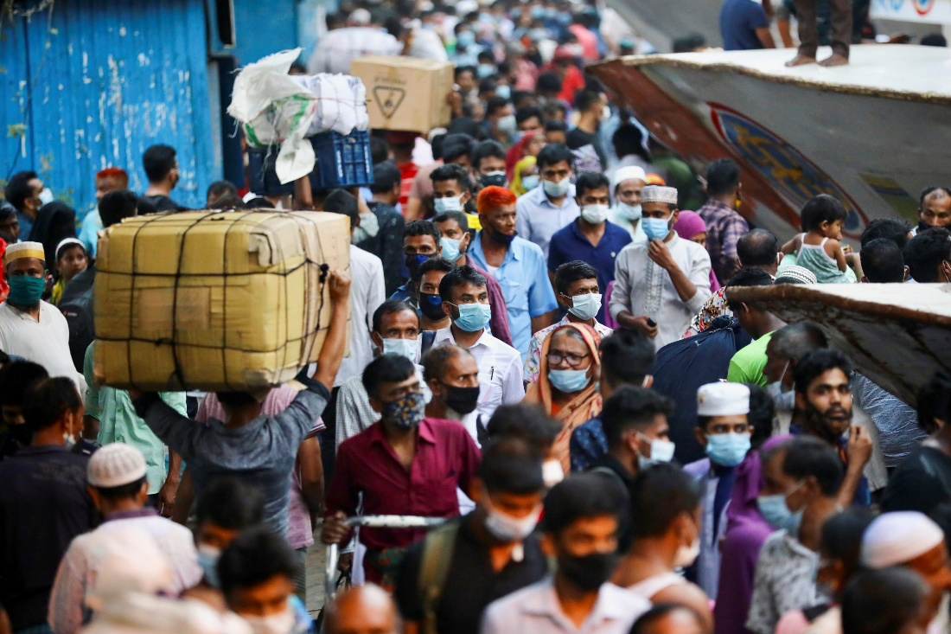

AIMS
Try to get the best, specialist equipment for this disease to prevent it from spreading. New ideas and innovations built and put into place. Cost-effective and reliable. I want to achieve the aspect and issues that arise, by this, measures will be put into place. Raise awareness through knowledge. Aims to prevent this from happening again. Stay home to reduce the chance of this spreading. Having a responsibility to carry out new developments and put them interaction to see how it would comprehend.
OBJECTIVE
New testing area for certain drugs, which will ensure how the drugs work differently. Support with funding from the government for this matter, to ensure better technology. The test might not be accurate. Managerial strategic. Interviewing people and medical staff, due to the perspective, improvements. To solve this problem, I will make a mobile/web application to warn others about the associated risks.

IMPACT OF THE PANDEMIC
The COVID-19 pandemic has led to a dramatic loss of human life worldwide and presents challenges to public health, food systems and the world of work. The economic and social disruption caused by the pandemic is devastating tens of millions of people are at risk of falling into extreme poverty, while the number of undernourished people, currently estimated at nearly 690 million, could increase by up to 132 million by the end of the year. Also, people not being able to go out and earn for a living is an issue because they would have to wear a mask, sometimes which can be difficult to cope with, especially if you've problems like asthma or breathing. This may end for a full year or on a short-term depending on how and who it travels to.
Millions of enterprises/businesses face an existential threat. Nearly half of the world’s 3.3 billion global workforce are at risk of losing their livelihoods. workers are particularly vulnerable because the majority lack social protection and access to quality health care and have lost access to productive assets produced will reduce rapidly in number. Without the means to earn an income during lockdowns, many are unable to feed themselves and their families, so this may result in their being poor.
The pandemic has been affecting the entire food system. Border closures, trade restrictions and confinement measures have been preventing farmers from accessing markets, including for buying inputs and selling their produce, and agricultural workers from harvesting crops. The pandemic has affected jobs and placed millions of livelihoods at risk. Below is a statistic on the percentage of the population that suffered from this deadly disease. This should be taken into further consideration because not enough food is being given out to people, especially the poor, so it will be difficult to survive and get energy to fight this. So, the support should carry on, people should protest about the way living conditions are gettingforthem and to raise awareness by campaigns and through social media, whilst expressing their thoughts.
Comparing schools with the same previous grade, the inspection outcomes for each group of schools have been more positive in 2022/23 than in 2021/22. In 2022/23, 75% of schools previously judged to require improvement have improved to good or outstanding, compared with 70% in 2021/22. 70% of good schools have also maintained their grade, higher than 57% last year.

FINDING SOLUTIONS TO THE PROBLEM
When the World Health Organization declared the Covid-19 outbreak a pandemic, the health crisis discovered a global effort to accelerate innovation and stop the virus’s spread. To help streamline that effort, the MIT Center for Collective Intelligence, MIT Media Lab’s Community Biotechnology Initiative, and Millipore Sigma, the life science business of Merck KGaA, Darmstadt, Germany, together convened more than 180 thought leaders from around the globe to collaborate asynchronously and rapidly identify solutions. This will ensure that the issues will be addressed further so that the remedies can do it’s job effectively.

RESULTS
If you get a positive result, it means it’s very likely you have COVID-19. Therefore, you should isolate for 3 days if you are under 18 years, 5 days if you are 18 or over. If you get a negative result, it means it's unlikely you have COVID-19. There's still a chance you could have the virus, so you should follow the advice on how to avoid catching and spreading COVID-19. If you’re eligible for COVID-19 treatments and you get a negative result, you must report your result as you may need to do another test.
If your test result could not be read (some tests may call this a void result), it’s not possible to say if you had COVID-19 when the test was done so you should conduct another test as soon as possible. If you’re eligible for COVID-19 treatments and you get a void result, you must report your result. You must report your free COVID-19 rapid lateral flow test results on GOV.UK.

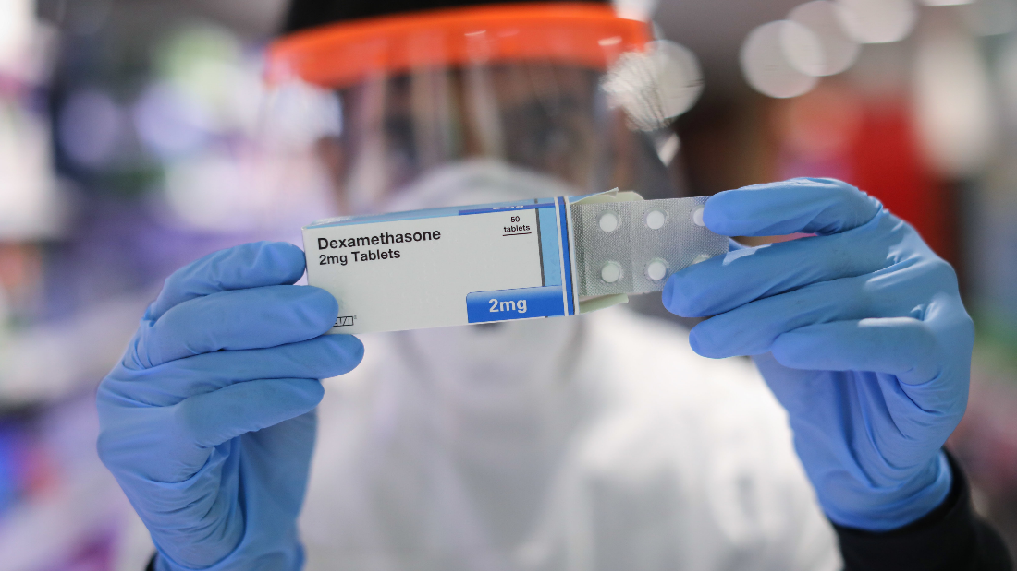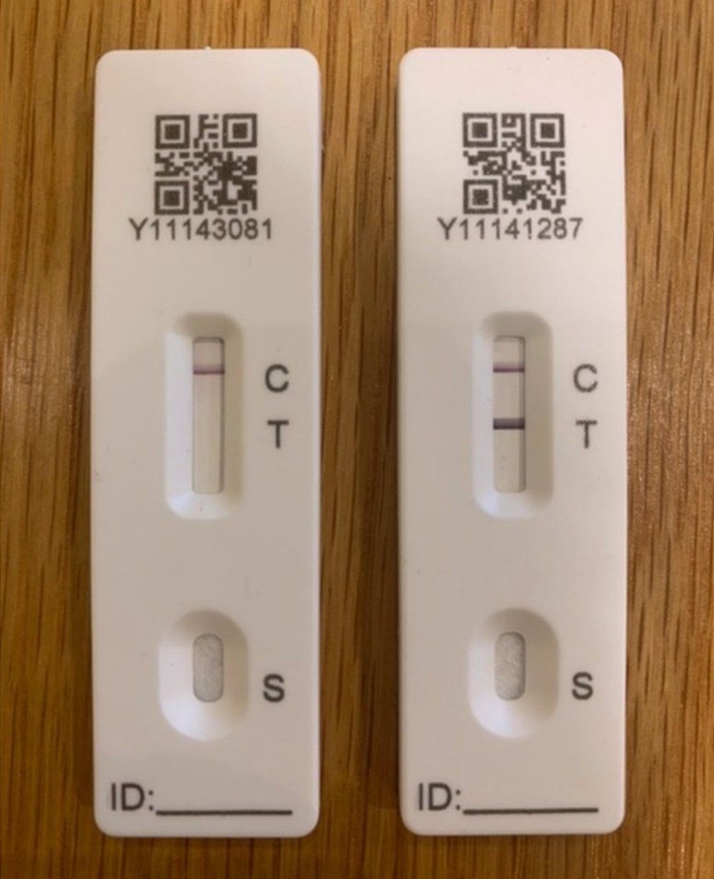

OVERVIEW OF THE BIGGEST PROBLEMS CAUSED
Due to many factors, there are many cuts for the public health service which means that the government is failing to provide health. The pandemic has affected the physical/mental health and access to care of the population. Also, some problems may be life-threatening, whilst some can be short-term depending on the type and implications linked to this.
Over half of the UK’s population has had COVID-19 since the start of the pandemic, and millions have developed long COVID, suffering long-term effects after infection. Sadly, over 200,000 people in the UK have lost their lives to COVID-19, and other factors, such as a delay in cancer diagnoses. This has then resulted in additional deaths. The main reason for death is not abiding by the rules and doing what people want, so this should be controlled for purposes.
The restrictions have affected us seriously in such a way that mental health has deteriorated over time, as well as accessing care has become difficult to tackle. Infection and mortality rates have been much higher, for example, among older people, people from certain ethnic backgrounds, and disabled people. There have been many risks of death and as the disease went on, more people died as there was no remedies put into place. ‘Studies suggest that, as pubs and restaurants closed their doors, home cooking became more popular and people in the UK improved their diets. As for diet improvements, these were more common in certain groups of people.

HOW COVID CHANGED TEACHING AND LEARNING AND PROMOTED MORE ONLINE BASED STUDIES
Beyond the immediate impact on the physical and mental health of the population, the pandemic has also affected many wider associations of health, including education and employment. This was a big role because it meant that this would be a loss, if not obliged, so this is why teaching got affected, many teachers can’t travel out due to covid, so isolation would have to be followed. Also, teachers may have to teach online, rather than face to face, or include a cover staff for the lesson, so children don’t miss out on learning.
Lockdowns have had a significant impact on early development in young children, causing a sharp rise in developmental issues. For example, fewer opportunities to interact with people outside of their household which has an impact on their psycho-social and language development. Unfortunately, the public services could have affected the negative impact of the pandemic on young children had been cut and, in some cases, of the pandemic. Some people have become so different and use to the situation as it is long term and currently rresearches looking for new inventories in researching new drugs to test what they are.
COVID led to the disruption seen to schooling and further education in the UK, while the amount is reducing the spread of the virus. The data represents a significant risk to the health of children and young people, the full extent of which remains to be seen. Most children missed out on in-person schooling for substantial periods, which led to a huge reduction in the time they spent on schoolwork every day. In total, UK pupils lost over 60 days of schooling on average. Some schools also would have an option to close down for the safety of children learning, and being in the environment where all this would be.

HEALTH IMPLCATIONS – LONG COVID
(THE WAY PEOPLE BEHAVE IN PUBLIC LIKE, WEARING MASKS AND HAND-CLEANING)
Long COVID is a condition that a part of the organs and the system. The symptoms of long COVID are fever and pain, chest painand palipilations, abdominal pain, nausea and vomiting, joint and muscle pain, skin rashes and hair loss. There are more infections around that are from covid, as some researchers haven’t found the solution to how it travels in humans and affects them in a way which can be serious.
‘‘The NICE review identified symptoms less commonly reported in children and young people. These included respiratory symptoms (shortness of breath, persistent cough, pain on breathing) and cardiovascular symptoms (palpitations, variations in heart rate, chest pain).
The NICE analysis also noted the high variability of symptoms between 4-12 weeks and 12 weeks+ : fatigue and concentration difficulties were reported consistently over time; cough, sleep disturbances, anxiety and depression were more common at 4-12 weeks rather than 12+ weeks, while hair loss was more common at 12+ weeks.’’ This has increased because the right drugs were not supplied, or people never took this to save themselves. Also, new drugs would have to be approved first from a professional doctor, to ensure what the potrntial risks can be and to see how it improves health compared to other vaccines, if applicable.
The challenges in the treatment and diagnosis against COVID are using clinical coding to test and record the use of resources that is used. Using equipment that will improve the results and improve the health service for the population to use and be assured of.
Also, this would ensure that team knows the main reason of covid, try to allow people to be calm about the issue because it will be published in the news so this can be one way in which grabs the audience's attention about the tremendous disease that has affected out population and cuased many people to become hospitalized, and/or even isolate for 7 days.

REFERENCES
1 Mehlmann-Wicks, J. (2023) The impact of the pandemic on Population Health and Health Inequalities, The British Medical Association is the trade union and professional body for doctors in the UK. Available at: https://www.bma.org.uk/advice-and-support/covid-19/what-the-bma-is-doing/the-impact-of-the-pandemic-on-population-health-and-health-inequalities (Accessed: 14 November 2023).
2 (No date a) Bing. Available at: https://www.bing.com/search?q=information%2Babout%2Bcovid%2B19%2Band%2Bstatistics&qs=n&sp=-1&ghc=1&lq=0&pq=information%2Babout%2Bcovid%2B19%2Band%2Bstatistics&sc=5-41&sk=&cvid=4FB0485400BF42578C571AAD08313561&ghsh=0&ghacc=0&ghpl=&FPIG=5808D549F1834C0C93D032E9F46945CA&first=10&FORM=PERE (Accessed: 21 November 2023).
3 (No date b) Long covid: What are the short- and long-term challenges? Available at: https://lordslibrary.parliament.uk/long-covid-what-are-the-short-and-long-term-challenges/ (Accessed: 21 November 2023).
4 (No date a) Autumn term 2020: How covid-19 affected England’s state-funded schools. Available at: https://commonslibrary.parliament.uk/autumn-term-2020-how-covid-19-affected-englands-state-funded-schools/ (Accessed: 21 November 2023).
5 Vizard, T. (no date) Exploring the changing impact of covid-19 on our lives, Office for National Statistics. Available at: https://blog.ons.gov.uk/2021/09/03/exploring-the-changing-impact-of-covid-19-on-our-lives/ (Accessed: 21 November 2023).

6 Intelligence, M.C. for C. (no date) Comprehensive report on pandemic response solutions developed by 180 leading experts, MIT News | Massachusetts Institute of Technology. Available at: https://news.mit.edu/2021/comprehensive-report-pandemic-response-solutions-0330 (Accessed: 21 November 2023).

7 Lockdown lifestyles: How has Covid changed lives in the UK? (no date) The Guardian. Available at: https://www.theguardian.com/lifeandstyle/ng-interactive/2022/feb/25/lockdown-lifestyles-how-lives-changed-covid-pandemic (Accessed: 21 November 2023).
8 (No date a) NHS choices. Available at: https://www.nhs.uk/nhs-services/covid-19-services/testing-for-covid-19/test-results-for-covid-19-and-how-to-report-them/ (Accessed: 21 November 2023).

