St. David’s Visit Report
Sofie Keddie
1600754
04/01/2019
Using One of the Establishments Visited; How easy is it to Gain a Sense of What Constitutes Welsh Culture?
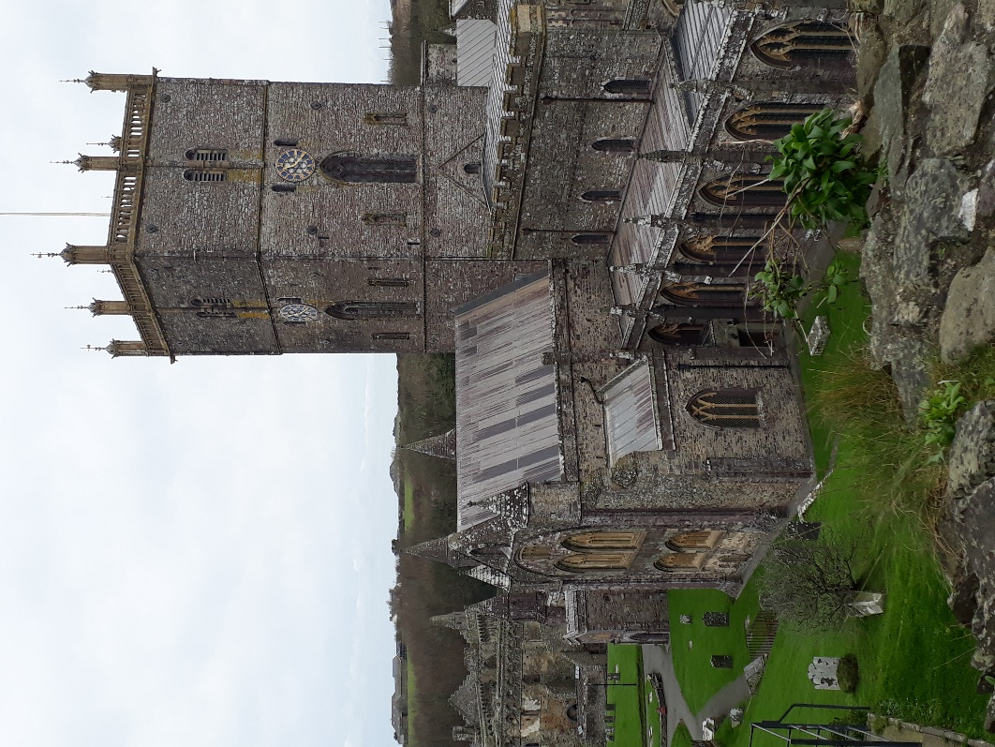
Contents:

- Introduction

- Welsh language in Welsh Culture

- Symbols of Welsh Culture

- History in Welsh Culture

- Conclusion

Introduction:
Culture in general is often defined as a nations or societies identity as a whole, although the term itself may have different definitions depending on the context that it is used in. when analysing any culture, it is said to be important to distinguish three levels that the culture manifests itself, these being; observable artefacts, values and underlying assumptions. this means that in order to analyse a place’s culture, observing individual factors within this is needed. This report focuses on what Welsh Culture is made up of, focusing on the St. David’s Cathedral and the area surrounding and bringing in some comparison of the National Museum of St. Fagans, both of which I have visited personally. Photographs that I took on my visits to these places will be discussed and analysed to form an idea of what Welsh culture is made up of and viewed as in the twenty-first century.

Welsh Language in Welsh Culture:
it is a widely known fact that Wales has two nationally spoken language, both English and Welsh. The language of Welsh, being a Celtic language, has been spoken for longer within the country of Britain than that of English, which is said to be a significant source of pride. The location of St. David’s does show this in the fact that on the signs within the cathedral and the areas surrounding it, show the Welsh translation before that of the English in multiple cases.

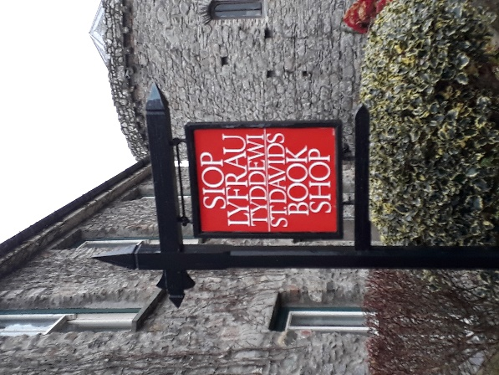
This is shown on this sign for a small book shop not far from the cathedral itself. The Welsh being presented first shows that the Welsh language is still remembered and spoken within the country despite its use declining over the past centuries. The use of the dual-language signs is also a clear indicator of the difference between Wales and the other countries in the UK because Welsh is not included on English, Scottish or northern Irish signs.

However, in other areas, it is English that is presented before the Welsh in the signage, or, in some cases not Welsh is not included at all (as shown in the photos below). This could be because of a variety of reasons, one being that it is because it has been calculated that Welsh is only spoken “by around 20% of the population”. In contrast, it could also be because the cathedral of St. David’s and the city surrounding it is known to be a prime location for tourism and it makes more commercial sense to have English first, so as to not confuse the visitors from outside Wales who possibly do not speak either language as their first. This is also evidenced by there being multiple other languages on the Cathedral welcome sign (the first image on the left).
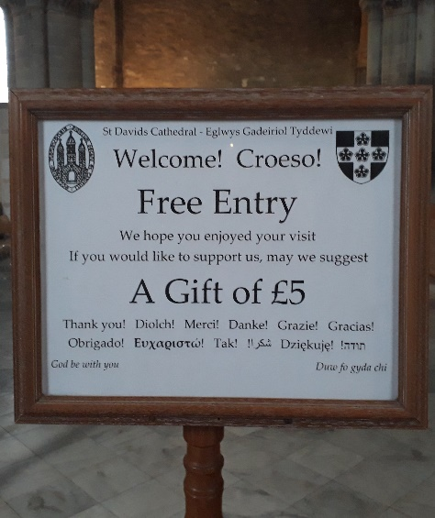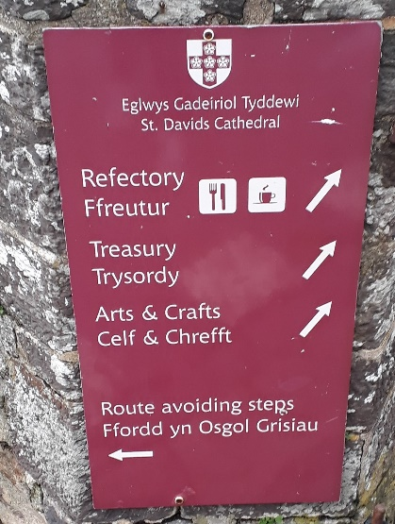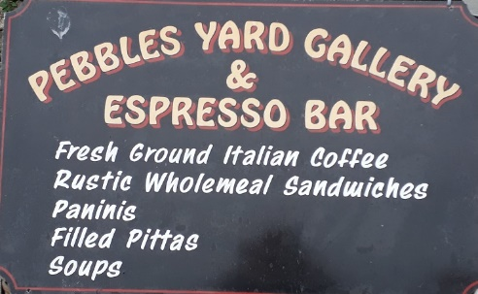
An example which shows the opposite of how the signs are set out at St. David’s is the signs at St. Fagans national Museum of Wales, which predominantly shows the Welsh first in the signage, regardless of the purpose of the area.
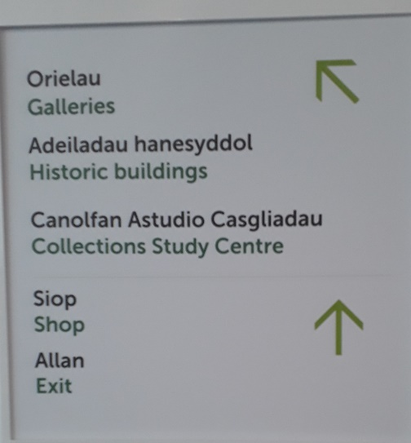
As the pictures above show, the Welsh is presented almost completely separately to the English, through the size and colour of the font on the signs. it has to be said that both sites are almost completely different from each other, with St. David’s being a very small city with its cathedral and St. Fagans being a museum of Welsh history specifically. This may be why the signs have a different order of the languages.

Symbols of Welsh Culture:
There are many symbols and images that are viewed as stereotypically Welsh, the main ones being the Welsh flag along with the Welsh dragon and daffodils. These things were featured significantly at St. David’s.
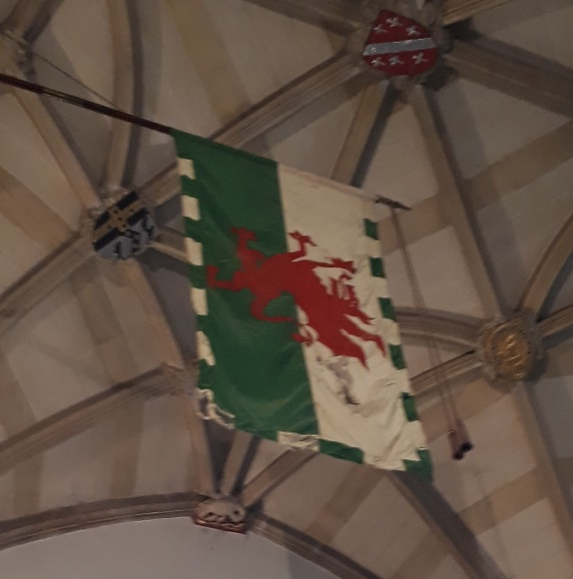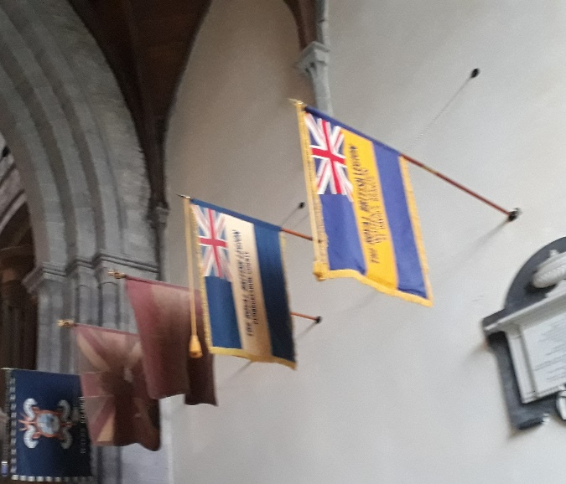
The welsh flag shown on the left in the above images can be seen everywhere around Wales. The flag and the dragon on it are almost the pinnacle of Welsh identity and it would be odd if it had not been included in the Cathedral. In addition to that though, there are flags that have the union jack included which could be said to indicate the part of the culture that is British rather than just Welsh alone.
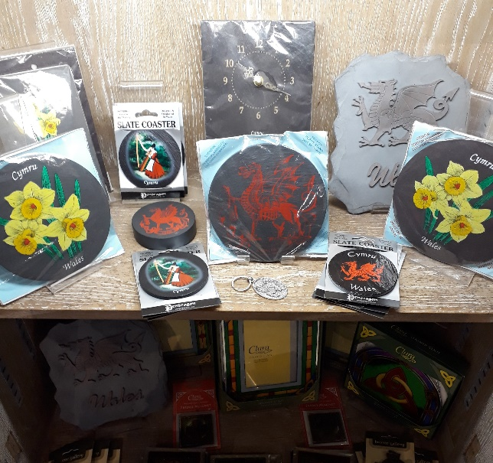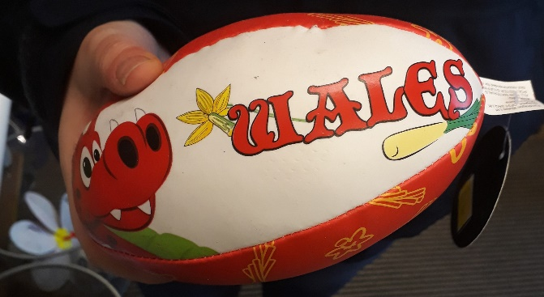
From the images above, it once again can be seen that the Welsh dragon featured prominently in all areas of St. David’s. The picture on the left showing the Cathedral gift shop and the one on the right showing a souvenir from a local shop from the surrounding area. The Daffodil is also shown in both instances, which is known to be the second emblem of Wales as well as this the souvenir rugby ball also has the image of what appears to be a leek which is a now lesser used emblem of the country. The use of such important symbols of welsh identity shows that traditional imagery is very important to the national identity of Wales which is often used in conjunction with the idea of culture of a place. As well as this the rugby ball being sold in St. David’s also shows another integral part of the welsh culture, that being the sport of rugby, which is very popular throughout the country. South Wales in particular.
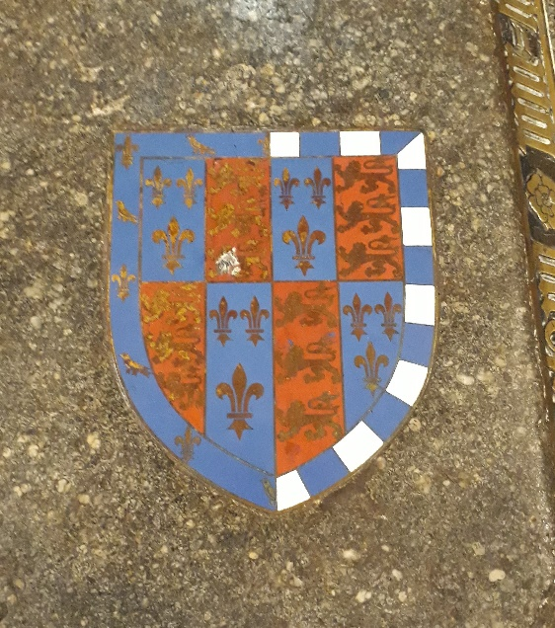
Another significant symbol that is featured on several decorations and grave slabs as shown in the picture above is the that of the ‘prince of wales feathers’ which is another traditional symbol used often throughout Wales.
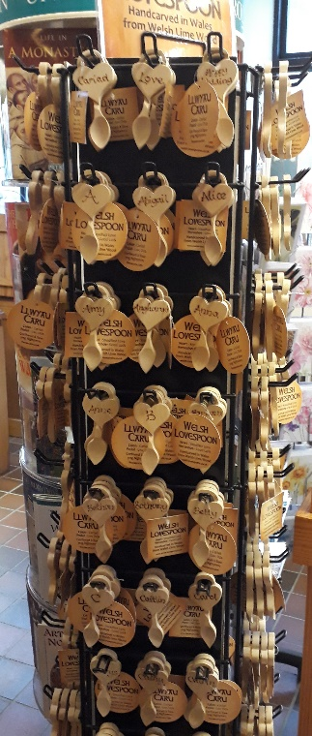
Multiple shops in also sold the welsh love spoon which is a traditional custom in Wales in which originally where an individual carved spoon was given by someone as a token at the beginning of courtship. However, as is shown in the photo image above, the custom has become quite commercialised and is likely now less of a traditional custom of the population and more of an opportunity to emphasise the cultural history of Wales as an independent country. Somewhat like the selling of objects with black cabs and double decker buses on around London, with the purpose of a person purchasing it in order to show they have been to this specific place.

In contrast to this, St. David’s also has clearly western twenty-first century means of shopping also, which is indicated by the clothing shop pictured above which shows that, while there are multiple traditions that places like the city of St. David’s, they are also operating within the modern way of living.

History in Welsh Culture:
The origin story of St. David’s Cathedral alone is able to represent Welsh culture in a way. As the information shown on the sign below states, the cathedral area itself was founded by saint David, Wales patron saint, originally as a monastery. The fact that such an important historical figure in Welsh history is known to have been there and began the building of the religious centre is very significant. It is thought that a factor that makes up a nations culture is the religion which would mean that St. David’s would be a place of a kind of pilgrimage for both the Welsh peoples and others of the same religion

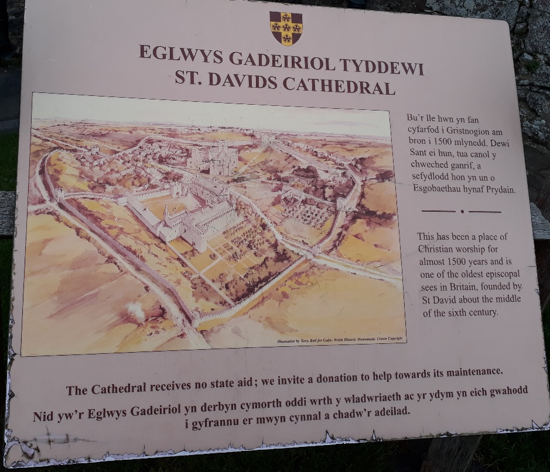

The Images below show that there was a museum aspect to the cathedral as well as a purely worship element. The small range of historical Welsh artefacts would show some of the cultural history of Wales because it shows objects like plates (as shown on the left) and some form of bronze art work (right). Showing the history of the culture is important because the history of a place more often than not plays a part in the cultural identity.
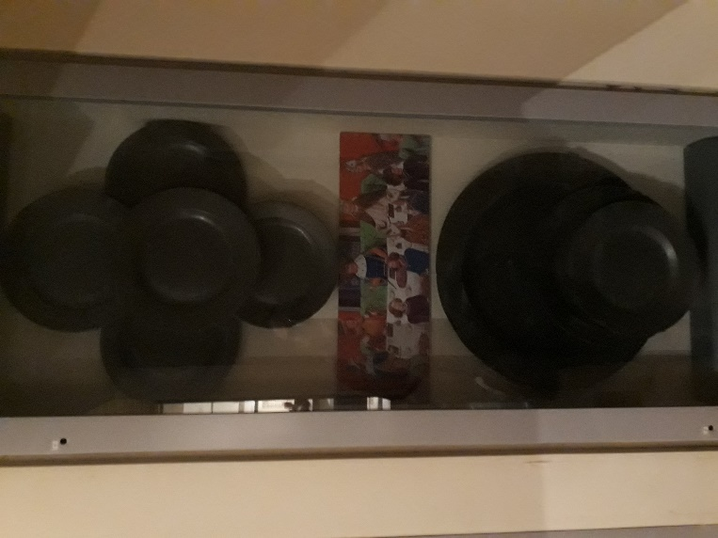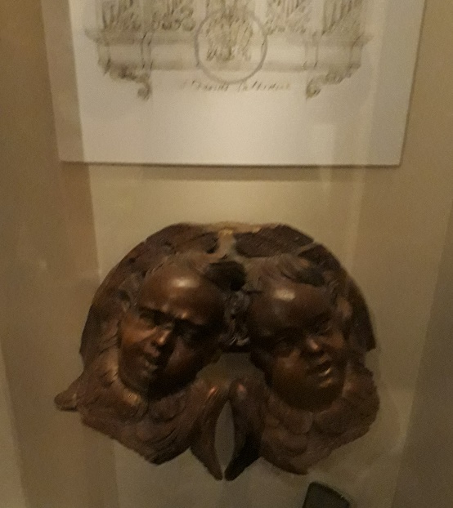

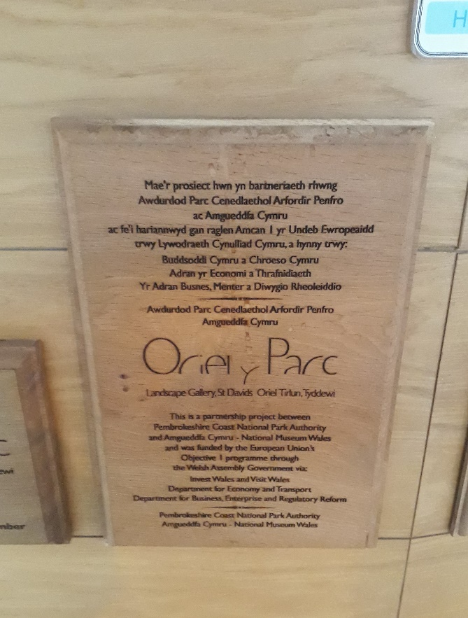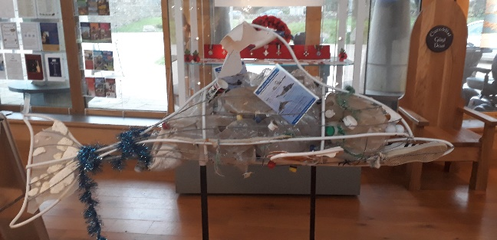
On the other side of the small city, there is the Oriel Parc landscape gallery which presents a very recent history of issues of not just Wales but internationally as well. It presents the impact of what pollution such as plastic has on the ocean through artworks, which is shown by the dolphin artwork above. The presence of this shows that, like many other western cultures, Wales is fighting against modern problems which will likely become important to the country’s history.

Conclusion:
Overall, it can be argued that the question of what constitutes Welsh culture is quite easy to identify by analysing places such as St. David’s as it is one of the main historical and religious landmarks in west Wales. In addition to this, the liberal use of the most ‘stereotypical’ symbols of the Welsh nation such as the red dragon, daffodil and prince of Wales feathers does present that St. David’s is showing the traditional features of the Welsh identity. It also has to be taken into account that the consistent use of the Welsh Language in the writing of the signs and information boards shows that despite it being stated that English is more widely spoken, the language is an important part of the Welsh identity and is the thing that sets them apart from England. However, despite there being a lot of traditional symbols and imagery being used around St. David’s, it also features many modern additions such as twenty-first century shops and a gallery focusing on modern environmental issues. This shows that the culture and its values have adapted to fit a more western scope alongside its individual features.

Bibliography

Journals:
Johnes, M (2015) ‘History and the Making and Remaking of Wales’ History, 100(343), pp.667-684 (Accessed: 01/01/2019) DOI-10.1111/1468-229X.12141
Schein (1990) ‘Organization Culture’ American Psychologist, 45(2): 109-119 in Spencer-oatey (2012) ‘What is Culture? A compilation of quotations.’ GlobalPAD Core Concepts. (Accessed: 01/01/2019) URL: http://www.warwick.ac.uk/globalpadintercultural

Websites:
BBC (2014) Wales Society and Culture. Available at: www.bbc.co.uk/wales/culture/sites/aboutwales/pages/culture.shtml
(Accessed: 30/12/2018)
BBC (2009) Saint David. Available at: http://www.bbc.co.uk/religion/religions/christianity/saints/david_1.shtml (Accessed: 30/12/2018)
Brittanica (1996) Wales on Brittanica. Available at: http://www.britannia.com/wales/culture2.html (Accessed: 01/01/2019)
Countries and their Cultures forum (Unknown) Culture of Wales. Available at: https://www.everyculture.com/To-Z/Wales.html (Accessed: 30/12/2018)
Wales.com (unknown) National Symbols of Wales. Available at: https://wales.com/national-symbols (Accessed: 01/01/2019)
St Davids Cathedral (unknown) a brief history of the Cathedral. Available at: http://www.stdavidscathedral.org.uk/index.php?id=685 (Accessed on 01/01/2019)

Photographs:
Keddie, S. (04/122018) St. Davids. (Accessed: 02/01/2019)
Keddie, S. (11/12/2018) National History Museum, St. Fagans. (Accessed: 02/01/2019)

Schein. (1990)
Johnes, M. (2015)
Countries and Their Cultures Forum. (Unknown)
Keddie, S. (04/12/2018)
BBC (2014)
Keddie, S. (04/12/2018)
Keddie, S. (11/12/2018)
Keddie, S. (04/12/2018)
Keddie, S. (04/12/20182018)
Keddie, S. (04/12/2018)
Wales.com. (Unknown)
BBC (2014)
Keddie, S. (04/12/2018)
Wales.com. (Unknown)
Keddie, S. (04/12/2018)
Brittanica. (1996)
Keddie, S. (04/12/2018)
St. Davids Cathedral. (unknown)
BBC (2009)
Keddie, S. (04/12/2018)
Keddie, S. (04/12/2018)
Keddie, S. (04/12/2018)

