My Screenshots/Photos

Screenshot 1 – Instagram

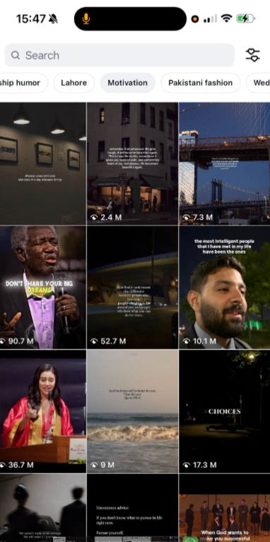
This screenshot shows Instagram. I use it to connect with friends, follow news and entertainment pages, and share photos and videos.

Screenshot 2 – Spotify

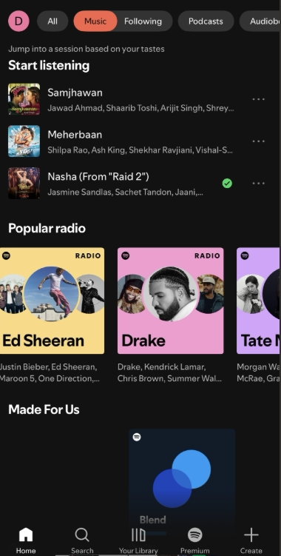
This screenshot shows Spotify. I use it to listen to music and podcasts for relaxation and entertainment.

Screenshot 3 – Google Chrome

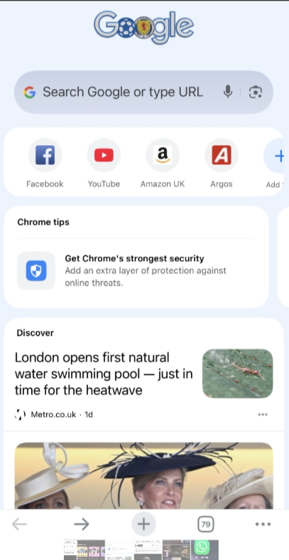
This screenshot shows Google Chrome. I use it to search for information, access online resources, and complete university work.

Screenshot 4 – Gmail

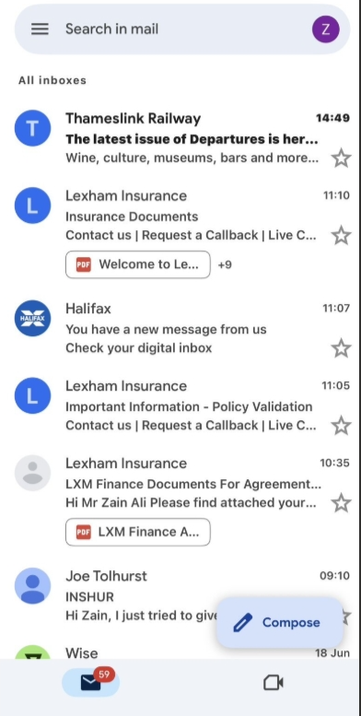
This screenshot shows Gmail. I use it to communicate with lecturers and receive important updates and messages.

Screenshot 5 – WhatsApp

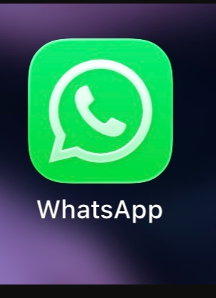
This screenshot shows WhatsApp. I use it to communicate with friends, family, and classmates and share information quickly.

Screenshot 6 – YouTube

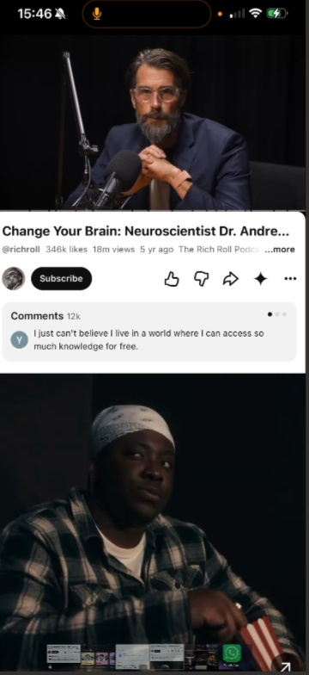
This screenshot shows YouTube. I use it to watch educational videos, tutorials, and entertainment content.

My Short Reflection
I use digital tools every day for studying, communication, and entertainment. I often use Instagram, Gmail, Google Chrome, WhatsApp, Spotify, and YouTube. I feel confident when using these tools because I have experience using them for university work and daily life. I would like to improve my digital skills, especially in using more advanced software. I sometimes worry about losing important files or dealing with technical problems. I hope this module will help me develop stronger digital skills and improve my confidence. Digital skills are important for me because they support my education and future career.

