
Entrepreneurship
Portfolio
Elements 1 to 4
Task 1
Submission Deadline
10/04/2026
Karibuni
Proptech and Fintech
Ltd

Name: Badru Keanene
Students Id: 2416450
Module code: LCBB5013
Module Name: Entrepreneurship
Lecture: Dr Toyin Adisa
Table of Contents

1. Element 1 Business Idea, Product or services, Objectives and USP 5
1.1. Introduction 5
1.2. Business Idea 5
1.3. How It will Work 6
1.4. Mission Statement 6
1.5. Business objectives 6
1.5.1. Formalise and Structure the Rental Market 7
1.5.2. Eliminate Hidden Fees and Promote Pricing Transparency 7
1.5.3. Provide Verified, Reliable Property Listings 7
1.5.4. Deliver Secure, Traceable, and Convenient Payment Systems 7
1.5.5. Digitise and Automate Rental Documentation 7
1.5.6. Strengthen Trust and Predictability in Tenant–Landlord Relationships 7
1.5.7. Improve Property Management Efficiency 7
1.6. Core Values 8
1.7. Unique selling point (USP) 8
1.7.1. Karibuni’s USP 8
2. Element 2: Business Environment and Competitor Analysis 9
2.1. SWOT Analysis 9
2.1.1. Strengths 10
2.1.2. Weaknesses 10
2.1.3. Opportunities 11
2.1.4. Threats 11
2.2. PESTLE Analysis 12
2.2.1. Political Factors 12
2.2.2. Economic Factors 12
2.2.3. Social Factors 13
2.2.4. Technological Factors 13
2.2.5. Legal Factors 13
2.2.6. Environmental Factors 13
2.3. Competitor Analysis 14
2.3.1. Direct Competitors 14
2.3.2. Indirect Competitors 14
2.3.3. Competitive Positioning 14
2.3.4. Barriers to Entry 14
2.3.5. Sustaining Competitive Advantage 14
3. Element 3: 4Ps, Market Segmentation, Marketing Mix and Online Marketing 15
3.1. Market Segmentation and Target Customers 15
3.2. Segmentation Approach 15
3.2.1. Demographic Segmentation 15
3.2.2. Geographic Segmentation 16
3.2.3. Behavioural Segmentation 16
3.2.4. Psychographic Segmentation 16
3.3. Target Customers 17
3.3.1. Primary Target Market 17
3.3.2. Secondary Target Market 17
3.4. The 4Ps of Marketing Framework 17
3.4.1. Product 18
3.4.2. Price 18
3.4.3. Place 19
3.4.4. Promotion 19
3.5. Online Marketing Strategies 19
3.5.1. Search Engine Optimisation (SEO) 20
3.5.2. Pay-Per-Click (PPC) Advertising 20
3.5.3. Social Media Marketing 20
3.5.4. Content Marketing 20
3.5.5. Referral and Incentive Programmes 21
3.5.6. Customer Retention Strategies 21
4. Element 4: Legal, Management, and Financial Planning 21
4.1. Definitions of Key Legal Structures (UK) 21
4.2. Legal Structure of Karibuni 22
4.3. Proposed Organisational Structure 22
4.4. Start-up Funding Requirements (Estimated) 24
4.5. Potential Funding Sources 24
5. Recommendation 25
6. Conclusion 25
7. References 27

Element 1 Business Idea, Product or services, Objectives and USP

KARIBUNI PROPTECH AND FINTECH LTD
Formalising and Modernising the Rental Market

1.1. Introduction
Karibuni Proptech (Property Technology) and Fintech (Financial Technology) is a mobile app and web-based platform that connects landlords and tenants directly in a secure, transparent, and broker-free way. It aims to solve common problems in the rental market like informal procedures, hidden agent fees, unreliable listings, and lack of secure digital payment options.
Based in the UK, and designed with international insight, Karibuni aims to modernise the rental experience by offering verified property listings, digital agreements, secure rent payments, and property management tools all in one easy-to-use app.

1.2. Business Idea
Karibuni Proptech and Fintech is a mobile and web app that enables users:
- Connect landlords and tenants directly
- Make rent payments digitally and securely
- Use legally recognised digital rental agreements
- Access verified property listings
- Manage properties through digital tools

The platform cutting out intermediaries and brokers, reducing unnecessary costs while increasing transparency and efficiency. By provide a secure digital platform that enables landlords to manage rent payments and tenants to rent properties seamlessly through verified listings, digital contracts, and secure payment systems.

1.3. How It will Work
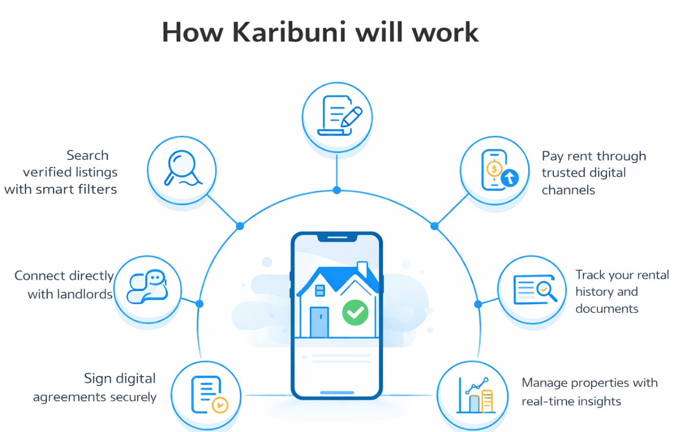
Source: Created by Learner
How it will Work
- Search verified properties using smart filters
- Connect tenants directly with landlords
- Sign digital agreements online securely
- Pay rent through trusted digital methods
- Keep track of your rental history and documents
- Manage properties with real‑time insights

1.4. Mission Statement
Rent Smarter Live Better.
Karibuni exists to modernise the rental market with this goal in mind.

1.5. Business objectives
Short term

1.5.1. Formalise and Structure the Rental Market
Karibuni wants to make the UK rental market more formal and modern by offering a clear, digital, and broker-free system. It plans to replace informal rental practices with standardised digital workflows, clear processes, and compliant documents to improve interactions between landlords and tenants.

1.5.2. Eliminate Hidden Fees and Promote Pricing Transparency
Build a fee transparent platform that removes unnecessary agent charges and ensures users understand all costs upfront. It aims for fair and predictable pricing to build trust and prevent exploitation.

1.5.3. Provide Verified, Reliable Property Listings
Karibuni will build a trusted database of verified properties, showing real-time availability and using digital verification tools to ensure accuracy and reduce misinformation and fraud in the rental market.

1.5.4. Deliver Secure, Traceable, and Convenient Payment Systems
The platform will use fintech solutions that enable safe rent collection, automated receipts, and secure digital transactions helping both landlords and tenants keep a reliable payment trail that supports accountability and financial planning.

1.5.5. Digitise and Automate Rental Documentation
Paperwork will be replaced with digital contracts, automatic renewals, and secure storage. reducing administrative burdens for landlords and tenants while improving compliance and record‑keeping.

1.5.6. Strengthen Trust and Predictability in Tenant–Landlord Relationships
Karibuni will provide tools for tenant verification, rental history checks, and landlord identity validation. It aims to build a reputation system that encourages responsible behaviour and reduces disputes.

1.5.7. Improve Property Management Efficiency
Landlords will get dashboards for rent tracking, maintenance requests, tenant communication, financial reporting, and enable data driven decision making to optimise property performance and reduce operational inefficiencies.

Long-Term
A future where renting is simple, secure, and dignified supported by verified data, smart tools, and trusted digital infrastructure. Karibuni plans to lead in Proptech (Ashton, 2024, Snisarenko, 2021) and Fintech (IBM, 2024) Innovation and develop scalable solutions for the UK and other emerging markets with potential for global expansion. The goal is to set new standards for transparency, security, and digital transformation in the rental sector.

1.6. Core Values
- Transparency Clear processes and honest pricing
- Trust Verified listings and secure systems
- Efficiency No intermediaries or unnecessary obstacles
- Community Empowering both tenants and landlords
- Innovation Building the digital foundation of UK rentals

1.7. Unique selling point (USP)
A product, service, or brand’s Unique Selling Point or Proposition (USP) refers to what makes a product, service, or brand different and attractive compared to competitors or the distinctive and attractive attribute that sets it apart in the marketplace. In essence, it is a marketing concept used to highlight what makes an offering stand out. A USP can be shaped by several elements, including product features, quality, price, performance, customer service, or any characteristic that differentiates it from competing options (GeeksforGeeks, 2023). This distinction might involve having the lowest price, superior quality, extensive experience, being the first of its kind, or any other advantage that positions it above competitors. Put simply, a USP represents “what you offer that others do not” (Sheldon, 2022).

1.7.1. Karibuni’s USP
For Tenants
- Broker-free renting
- Verified property listings
- Digital agreements
- Secure online payments
- Rental history tracking
- Direct communication with landlords
For Landlords
- Direct access to tenants
- Automated rent tracking
- Secure payment collection
- Digital agreement management
- Real-time property insights

2. Element 2: Business Environment and Competitor Analysis
Understanding the wider business environment is crucial for assessing whether Karibuni’s strategy is sustainable and likely to succeed. This section uses SWOT and PESTLE frameworks, along with current digital platform studies to evaluate internal strengths and outside influences. A competitor analysis further evaluates Karibuni’s strategic positioning within the UK rental market. Strategic analysis enables organisations to align internal strengths with external opportunities while mitigating risks (Johnson et al., 2020).

2.1. SWOT Analysis
SWOT analysis examines a firm’s internal strengths and weaknesses together with external opportunities and threats, helping organisations understand their current position and future prospects (Peterdy, 2024). In digital platform markets, competitive advantage increasingly stems from ecosystem management rather than asset ownership (Cennamo, 2021). Karibuni’s strategic logic reflects this shift through its integrated, broker-free rental lifecycle model.
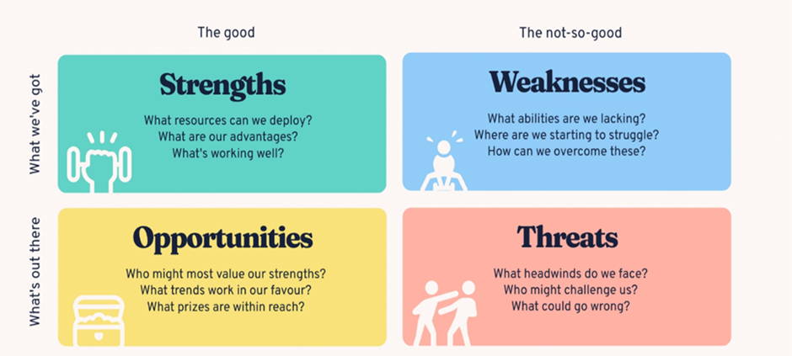
Source: (Bitesize, 2024)

2.1.1. Strengths
Karibuni’s primary strength lies in its broker-free digital model, reducing transaction costs while increasing transparency. This aligns with growing consumer demand for cost-efficient, transparent digital services (Deloitte, 2023).
The platform offers an end-to-end rental lifecycle integrating verified listings, digital contracts, and secure payment systems. Such integration enhances differentiation and value capture within digital ecosystems (Teece, 2017).
Its mobile App and Web platform infrastructure supports accessibility and scalability, particularly given rising UK smartphone penetration and fintech adoption (Ofcom, 2023).
Additionally, rental history tracking formalises tenant records and strengthens long-term customer value. This aligns with broader digitisation of financial identity systems (World Economic Forum, 2023).

2.1.2. Weaknesses
As a new entrant, Karibuni lacks brand recognition compared to established platforms. Trust is a critical success factor in digital marketplaces (Statista, 2024).
Significant investment is required in cybersecurity, regulatory compliance, and system development. High upfront digital infrastructure costs are common within fintech-enabled models (Pulse of Fintech H2’23, 2024).
Furthermore, the platform success relies on network effects where both landlords and tenants must join in large numbers to keep value high. Two-sided platforms must achieve critical mass to generate sustained value (Parker, Van Alstyne and Choudary, 2016).

2.1.3. Opportunities
The UK rental sector continues expanding due to housing shortages and affordability pressures (Office for National Statistics, 2024). Demand for flexible renting solutions remains strong. Accelerating digital transformation across service industries creates opportunities for platform-mediated transactions to replace traditional intermediaries (Trabucchi and Buganza, 2019). Karibuni can leverage data analytics to enhance tenant screening, risk assessment, and personalised services.
Geographic expansion across UK cities and potential international markets offers further growth potential.

2.1.4. Threats
Competitive intensity poses a major threat. Incumbents may replicate features or leverage scale advantages (Cennamo, 2021).
Rapid technological change necessitates continuous innovation (Teece, 2017).
Competition from established platforms such as Rightmove and Zoopla remains significant due to their high traffic and brand recognition (Statista, 2024).
Regulatory changes in housing and digital payments may increase compliance costs (Deloitte UK, 2025). Cybersecurity risks also threaten reputation, particularly amid rising digital fraud in property transactions (Pulse of Fintech H2’23, 2024). Macroeconomic instability, inflation, and interest rate fluctuations may reduce tenant affordability (Bank of England, 2024).
Therefore, SWOT’s strength lies in linking internal capabilities with external conditions, supporting strategic direction. However, it often produces broad or subjective insights and does not prioritise issues or prescribe action. It functions best as a diagnostic tool rather than a standalone strategy (Samson, 2017).

2.2. PESTLE Analysis
PESTLE evaluates macro-environmental forces shaping strategic decisions (Johnson et al., 2020). It examines Political, Economic, Social, Technological, Legal, and Environmental influences, enabling organisations to anticipate risks and identify opportunities (Makos, 2022).
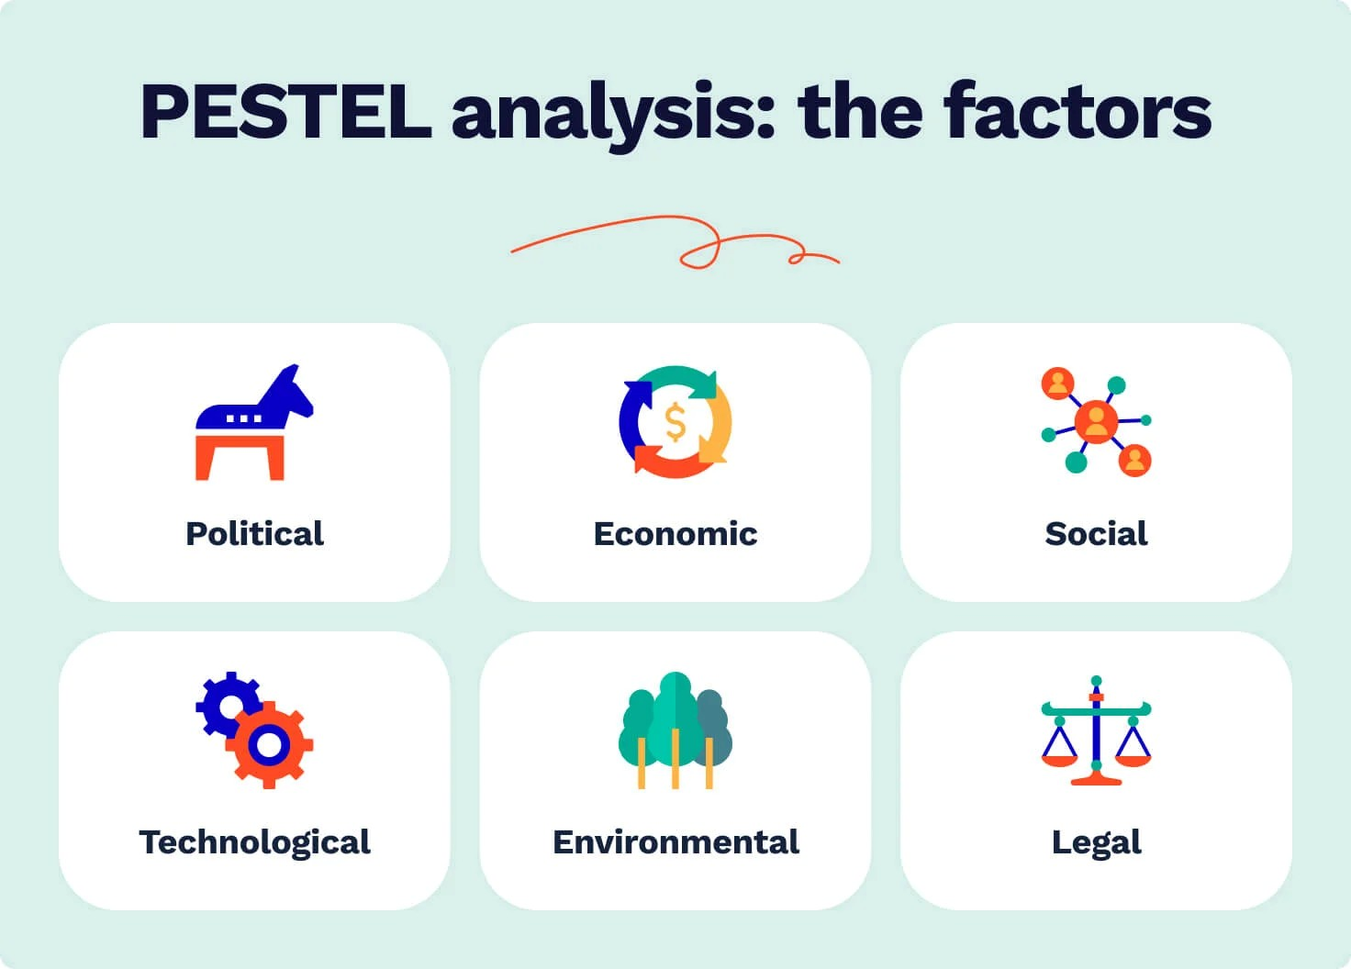Source:(Studycorgi.com, 2026)

2.2.1. Political Factors
Ongoing UK rental sector reforms, including tenant protection and landlord compliance measures, may influence platform demand (Martyn, 2025).
Government support for digital innovation and fintech development provides a favourable policy environment for digital property solutions.

2.2.2. Economic Factors
Inflation, wage growth, and housing affordability directly affect rental markets. High property prices continue to sustain rental demand (Office for National Statistics, 2024). However, economic downturns may reduce disposable income and payment reliability (Bank of England, 2024).

2.2.3. Social Factors
Urbanisation and demographic trends indicate sustained reliance on rental housing among younger populations. Digital-first expectations among Millennials and Generation Z favour app-based financial services (Deloitte, 2023).
Increasing demand for transparency and secure transactions aligns with Karibuni’s value proposition.

2.2.4. Technological Factors
Cloud computing, AI-driven verification, and secure digital payments enable integrated rental ecosystems (World Economic Forum, 2023).
However, rapid technological change requires ongoing investment and cybersecurity capability (Pulse of Fintech H2’23, 2024).

2.2.5. Legal Factors
Karibuni must comply with UK General Data Protection Regulation, tenancy regulations, and digital payment compliance frameworks. Regulatory enforcement in digital markets has intensified (Deloitte UK, 2025). Legal recognition of digital contracts strengthens the viability of e-signature integration.

2.2.6. Environmental Factors
Digital platforms reduce paper usage and administrative processes, supporting sustainability objectives. ESG (Environmental, Social, Governance) considerations increasingly influence investor decisions in Proptech ventures (PricewaterhouseCoopers, 2023).
Furthermore, PESTLE encourages outward-looking strategic thinking and supports early identification of threats and opportunities. However, it may oversimplify complex data or generate assumptions that quickly become outdated in volatile environments. Regular updates are therefore essential (CIPD, 2025).

2.3. Competitor Analysis
The UK Proptech market includes dominant property portals and emerging fintech-integrated platforms. Digital transformation and platform consolidation shape competitive intensity (PricewaterhouseCoopers, 2023).

2.3.1. Direct Competitors
Rightmove and Zoopla dominate listing traffic but primarily operate as advertising platforms rather than full lifecycle rental management systems (Statista, 2024).

2.3.2. Indirect Competitors
Traditional estate agents provide end-to-end services but with higher commission fees. Emerging fintech-enabled rental platforms are also entering niche segments.

2.3.3. Competitive Positioning
Karibuni adopts a differentiation strategy focused on managing the whole rental process digitally, rather than listing-only services. Platform-based ecosystem strategies enhance competitive advantage in digital markets (Teece, 2017).

2.3.4. Barriers to Entry
High technological development costs and complex compliance obligations create significant barriers to entry. Establishing user trust is particularly challenging where data security and transaction handling are central.
Network effects further reinforce barriers, as growth on one side of the platform attracts users on the other, creating self-reinforcing advantages for early movers (Kira et al., 2021; Fu, Avenyo and Ghauri, 2021).

2.3.5. Sustaining Competitive Advantage
Long-term competitiveness of Karibuni will depends on:
- Continuous technological innovation
- Robust cybersecurity systems
- Brand trust development
- Strategic fintech partnerships
Ecosystem-based digital value creation strengthens sustainability in platform markets (World Economic Forum, 2023).

3. Element 3: 4Ps, Market Segmentation, Marketing Mix and Online Marketing

3.1. Market Segmentation and Target Customers
Market segmentation involves dividing a broad market into distinct groups with similar needs, behaviours or characteristics to allow targeted marketing strategies (Kotler and Keller, 2016). For a digital rental platform such as Karibuni, segmentation is critical because it operates in a two-sided marketplace, serving both tenants and landlords simultaneously.

3.2. Segmentation Approach
Karibuni will use demographic, geographic, behavioural and psychographic segmentation.

3.2.1. Demographic Segmentation
For tenants, key demographic segments include:
- Students
- Young professionals (ages 20–40)
- Urban families
- Relocating workers
These groups typically have high rental dependency due to housing affordability constraints (ONS, 2024). Young professionals and students represent digitally literate users who are comfortable with mobile-based financial transactions (Smaje, LaBerge and Zemmel, 2022).
For landlords, segmentation includes:
- Individual private landlords
- Small-scale property investors
- Portfolio landlords managing multiple properties
These segments seek cost efficiency, payment security, and administrative convenience.

3.2.2. Geographic Segmentation
Initial targeting focuses on major UK urban centres with high rental demand such as London, Manchester, and Birmingham. Urban areas exhibit higher rental density and stronger digital adoption (ONS, 2023). Targeting these areas supports building the user base needed for network effects needed in the development of two-sided platforms (Eisenmann, Parker and Van Alstyne, 2006). (Trabucchi and Buganza, 2019).

3.2.3. Behavioural Segmentation
Karibuni targets:
- Tenants seeking broker-free rentals
- Price-sensitive renters
- Digitally active users preferring app-based services
- Landlords dissatisfied with agent commissions
Behavioural targeting aligns with cost-conscious and efficiency-oriented consumers.

3.2.4. Psychographic Segmentation
Karibuni appeals to users valuing:
- Transparency
- Financial control
- Convenience
- Technological innovation
This aligns with growing demand for frictionless digital experiences (PricewaterhouseCoopers, 2023).

3.3. Target Customers

3.3.1. Primary Target Market
The main focus is on urban young professionals and private landlords.
Young professionals:
- Rent frequently
- Move often
- Strong digital engagement
- Preference for mobile financial services
Private landlords:
- Cost-sensitive
- Interested in eliminating agent fees
- Seeking secure payment tracking
Targeting both groups is necessary since platform value grows with more participants on both sides (Trabucchi and Buganza, 2019).

3.3.2. Secondary Target Market
- Students
- Small property investors
- International renters relocating to the UK
These groups offer expansion potential once brand credibility is established.

3.4. The 4Ps of Marketing Framework
The 4Ps framework (Product, Price, Place, Promotion) provides a structured approach to marketing strategy (Kotler and Keller, 2016). This concept was introduced in the 1950s by Harvard advertising scholar Neil Borden, remain the core framework for shaping how any product or service is brought to market. They outline what is being offered (product), the amount charged (price), where it can be accessed (place), and the methods used to communicate and persuade (promotion). Effective marketing depends on the coordinated alignment of all four components; success cannot be achieved by focusing on promotion alone (Watson, 2026).

3.4.1. Product
Karibuni is a digital service product integrating:
- Verified property listings
- Digital rental agreements
- Secure rent payment processing
- Rental history tracking
- Landlord property management dashboard
The core benefit is trust and efficiency. The augmented product includes customer support, data security, and potential financial partnerships.
Critically, Karibuni’s differentiation lies in managing the entire rental lifecycle, not just property advertising. This supports a differentiation strategy (Key, 2023), (Kavitha, 2025)

3.4.2. Price
Karibuni will adopt a multi-stream pricing model:
- Subscription fees for landlords
- Small transaction fee on rent payments
- Premium listing options
Penetration pricing strategy may initially be adopted to accelerate platform adoption. It may start with low introductory fees to grow user numbers, vital for two-sided platforms (Kang et al., 2024).

3.4.3. Place
Karibuni operates through:
- Mobile application (iOS and Android)
- Web-based platform
Digital distribution ensures reaching users nationwide cheaply and expand quickly. Unlike traditional estate agencies reliant on physical offices, Karibuni’s digital place strategy reduces overhead costs and supports convenience.

3.4.4. Promotion
Promotion will focus primarily on digital channels, including:
- Social media advertising
- Search engine marketing
- Influencer partnerships
- Referral programmes
- University partnerships
Promotional messaging will emphasise:
- “Broker-free renting”
- “Secure digital payments”
- “Verified listings”

3.5. Online Marketing Strategies
Digital marketing is essential for platform-based businesses because user acquisition and retention directly affects profitability (Chaffey and Ellis-Chadwick, 2019).

3.5.1. Search Engine Optimisation (SEO)
SEO will target keywords such as:
- “No agent rental UK”
- “Direct landlord rental”
- “Secure rent payment app”
High search rankings lower ongoing acquisition costs and help sustainable growth compared to paid advertising alone.

3.5.2. Pay-Per-Click (PPC) Advertising
Google Ads and social media ads will target:
- Urban renters
- Property investors
- Students
Behavioural targeting increases conversion rates. However, Pay-Per-Click (PPC) (CFI, 2022) requires careful budget optimisation to maintain positive return on advertising spend (Chaffey and Ellis-Chadwick, 2019).

3.5.3. Social Media Marketing
Platforms such as Instagram, LinkedIn, and TikTok will be used to:
- Educate users about broker-free renting
- Share success stories
- Build brand trust
Social proof helps reduce user hesitation in digital platforms.

3.5.4. Content Marketing
Educational blogs and video content will address:
- Tenant rights
- Digital contracts
- Rental market trends
This builds authority and improves SEO performance.

3.5.5. Referral and Incentive Programmes
Referral programmes offering discounts or transaction fee reductions can accelerate user acquisition. Word-of-mouth marketing is highly effective in trust-based services (Kotler and Keller, 2016).

3.5.6. Customer Retention Strategies
Retention strategies include:
- Loyalty rewards
- Secure rental history records
- Seamless payment reminders
- Responsive customer support
Retention is more cost-effective than acquisition, particularly in digital marketplaces (Chaffey and Ellis-Chadwick, 2019).

4. Element 4: Legal, Management, and Financial Planning

4.1. Definitions of Key Legal Structures (UK)
- Limited company is a legally separate entity from its owners, where liability is limited to shareholders’ investment. It must register with Companies House and comply with the Companies Act 2006 (GOV.UK, 2022).
- Sole trader is an individual operating a business personally, retaining full control but bearing unlimited liability for debts (GOV.UK, 2024).
- Partnership involves two or more individuals sharing profits and liabilities. In a general partnership, liability is unlimited, whereas a Limited Liability Partnership (LLP) offers some protection (GOV.UK, 2022).
- Franchise is a business model in which a franchisor licenses its brand and operating system to a franchisee in return for fees and royalties (Martin, 2025).
- Online enterprise operates primarily through digital platforms, delivering products or services via the internet. Such firms must comply with UK e-commerce, data protection and consumer legislation (Group, 2023)
- Social enterprise is a business that reinvests profits primarily for social or environmental objectives rather than shareholder distribution (Social Enterprise UK, 2025).

4.2. Legal Structure of Karibuni
Karibuni should be registered as a private limited company (Ltd) because:
- Limited Liability Protects founders’ personal assets from business debts, critical for fintech-enabled rental platforms exposed to contractual and regulatory risks.
- Investor Attraction Venture capital and angel investors typically require equity structures only available within limited companies (Söderblom and Samuelsson, 2025)
- Scalability Platform-based ventures require future equity issuance for growth funding.
- Credibility and Compliance Formal registration builds trust among landlords and tenants, particularly where digital contracts and financial transactions are involved.

4.3. Proposed Organisational Structure
Karibuni should adopt a lean, functional structure in its early stage:

Founder/CEO
- Strategic direction
- Investor relations
- Partnerships
Chief Technology Officer
- Platform development
- Cybersecurity
- System scalability
Operations and Compliance Manager
- Regulatory compliance
- Customer onboarding
- Dispute resolution
Marketing and Growth Manager
- Digital marketing
- User acquisition
- Brand management
Finance and Administration Officer
- Budgeting
- Payroll
- Reporting
This structure supports agile decision-making while maintaining regulatory oversight, consistent with digital platform governance research (Cennamo, 2021).

4.4. Start-up Funding Requirements (Estimated)
Cost Category | Estimated Cost (£)
App & platform development | 20,000
Legal & compliance | 8,000
Marketing & launch campaign | 5,000
Cybersecurity & hosting | 7,000
Working capital (6 months) | 10,000
Total Estimated Start-up Cost | £50,000

4.5. Potential Funding Sources
- Founder Equity refers to the shares owned by founders or ownership stake granted to the founding members of a company, typically in the form of common shares issued at or shortly after incorporation. It establishes the initial ownership structure, aligns incentives among founders, and forms the basis for future dilution as the company raises external investment. (Guide, 2025). Equity-based funding is preferable due to Karibuni’s growth-oriented digital platform model, which may not generate immediate cash flow during user acquisition phases

- Angel Investment refers to a form of early‑stage equity financing in which wealthy individuals allocate personal capital to nascent ventures in exchange for an ownership stake or a convertible debt instrument that may subsequently be converted into equity. Such investors typically intervene at a developmental stage where firms have limited trading history and may not yet satisfy the eligibility criteria for bank lending or institutional venture capital. The term reflects the comparatively high levels of risk assumed by these individuals, who often base their investment decisions on the prospective growth potential of the enterprise rather than on established financial performance. This mode of financing is particularly relevant for technology‑oriented startups as Karibuni seeking seed‑stage capital to support initial development and market entry (Lennox, 2023).

5. Recommendation
Karibuni Proptech and Fintech Ltd should prioritise building a secure, user-friendly digital platform while focusing on rapid user acquisition to achieve the network effects required for marketplace success. Strategic partnerships with fintech providers, property investors, and universities can accelerate trust and adoption. Additionally, strong investment in cybersecurity, regulatory compliance, and brand credibility will be essential to differentiate the platform from established competitors and ensure sustainable long-term growth within the UK rental market.

6. Conclusion
Karibuni Proptech and Fintech Ltd offers an innovative solution to the inefficiencies and lack of transparency in the traditional rental market. By integrating verified property listings, digital contracts, and secure rent payment systems into a single platform, the business aims to simplify and modernise the renting experience for both tenants and landlords. Strategic analysis through SWOT, PESTLE, and competitor evaluation demonstrates that although the market is competitive and highly regulated, significant opportunities exist due to increasing digital adoption and rising rental demand. Through a clear marketing strategy, targeted segmentation, and a scalable digital platform model, Karibuni is well positioned to create value in the Proptech and Fintech sectors. With strong governance, effective funding strategies, and continuous innovation, the company has the potential to establish a trusted and sustainable presence in the evolving UK rental system.

7. References
Ashton, D. (2024). A guide to PropTech (and how it’s shaking up real estate). [online] University of the Built Environment. Available at: https://www.ube.ac.uk/whats-happening/articles/what-is-proptech/ [Accessed 23 Mar. 2026].

CFI (2022). Pay-Per-Click (PPC). [online] Corporate Finance Institute. Available at: https://corporatefinanceinstitute.com/resources/valuation/pay-per-click-ppc/ [Accessed 6 Mar. 2026].
Watson, N. (2026). The 4 P’s of the Marketing Mix Framework. [online] Salesforce. Available at: https://www.salesforce.com/blog/the-four-ps-of-marketing/ [Accessed 8 Mar. 2026].
Bank of England (2024). Monetary Policy Report - November 2024. [online] Bankofengland.co.uk. Available at: https://www.bankofengland.co.uk/monetary-policy-report/2024/november-2024 [Accessed 28 Feb. 2026]..
Bitesize (2024). How to Do a SWOT Analysis [with Examples & templates]. [online] BiteSize Learning. Available at: https://www.bitesizelearning.co.uk/resources/swot-analysis-explained-examples-templates [Accessed 24 Feb. 2026].
British business bank (2025). What are business grants? | British Business Bank. [online] www.british-business-bank.co.uk. Available at: https://www.british-business-bank.co.uk/business-guidance/guidance-articles/finance/grants-finance [Accessed 2 Mar. 2026].
Cennamo, C. (2021). COMPETING IN DIGITAL MARKETS: A PLATFORM-BASED PERSPECTIVE. Academy of Management Perspectives, 35(2) https://doi.org/10.5465/amp.2016.0048
Chaffey, D. and Ellis-Chadwick, F. (2019). Digital Marketing. [online] Google Books. Pearson UK. Available at: https://www.google.co.uk/books/edition/Digital_Marketing/-1yGDwAAQBAJ?hl=en [Accessed 2 Mar. 2026].
CIPD (2025). CIPD | PESTLE Analysis. [online] CIPD. Available at: https://www.cipd.org/uk/knowledge/factsheets/pestle-analysis-factsheet/#advantages-and-disadvantages-of-a-pestle-analysis [Accessed 24 Feb. 2026].
Deloitte (2023). Generative AI: Unleash Creativity with AI. [online] Deloitte United Kingdom. Available at: https://www.deloitte.com/uk/en/Industries/tmt/research/digital-consumer-trends-2023.html [Accessed 25 Feb. 2026].
Deloitte United Kingdom. (2025). Digital Regulatory Outlook 2025 | Deloitte UK. [online] Available at: https://www.deloitte.com/uk/en/Industries/financial-services/analysis/digital-regulatory-outlook-2025.html [Accessed 28 Feb. 2026].
Fu, X., Avenyo, E. and Ghauri, P. (2021). Digital platforms and development: a survey of the literature. Innovation and Development, 11(2-3), pp.1–19. https://doi.org/10.1080/2157930x.2021.1975361
GeeksforGeeks (2023b). Unique Selling Proposition (USP)| Meaning, Types and Example. [online] GeeksforGeeks. Available at: https://www.geeksforgeeks.org/marketing/unique-selling-proposition-full-form-of-usp-types-and-example/ [Accessed 17 Feb. 2026].
GOV.UK (2022). Incorporation and names. [online] GOV.UK. Available at: https://www.gov.uk/government/publications/incorporation-and-names/incorporation-and-names [Accessed 2 Mar. 2026].
GOV.UK (2024). Become a sole trader. [online] GOV.UK. Available at: https://www.gov.uk/become-sole-trader/register-sole-trader [Accessed 2 Mar. 2026].
Group, G.L. (2023). International Comparative Legal Guides. [online] International Comparative Legal Guides International Business Reports. Available at: https://iclg.com/practice-areas/digital-business-laws-and-regulations/united-kingdom [Accessed 2 Mar. 2026].
Guide, A. (2025). Founder equity Demystifying Founder Equity: A Guide for Entrepreneurs - FasterCapital. [online] FasterCapital. Available at: https://fastercapital.com/content/Founder-equity-Demystifying-Founder-Equity--A-Guide-for-Entrepreneurs.html [Accessed 2 Mar. 2026].
IBM (2024). Fintech. [online] Ibm.com. Available at: https://www.ibm.com/think/topics/fintech [Accessed 2 Mar. 2026].
Johnson, G., Whittington, R., Regnér, P., Angwin, D. and Scholes, K. (2020). Exploring Strategy. [online] Google Books. Pearson UK. Available at: https://www.google.co.uk/books/edition/Exploring_Strategy/ieksEAAAQBAJ?hl=en&gbpv=1 [Accessed 25 Feb. 2026].
Kang, J., Su, C., Lan, J. and Chen, L. (2024). Effects of the Subscription-Based Partitioned Pricing Strategy of Digital Content Platforms on User Willingness to Purchase. Journal of theoretical and applied electronic commerce research, 19(4), pp.3305–3330. https://doi.org/10.3390/jtaer19040160
Kavitha (2025). What Is Differentiated Marketing? Definition and Real Examples. [online] Intothecommerce. Available at: https://intothecommerce.com/marketing/what-is-differentiated-marketing/ [Accessed 2 Mar. 2026].
Key, K. (2023). What is Differentiated Marketing? - Marketing Advice Blog. [online] Lead Marketing Strategies. Available at: https://www.leadmarketingstrategies.com/what-is-differentiated-marketing/ [Accessed 2 Mar. 2026].
Kira, B., Sinha, V., & Srinivasan, S. (2021). Regulating digital ecosystems: bridging the gap between competition policy and data protection. Industrial and Corporate Change, 30(5), 1337–1360. https://doi.org/10.1093/icc/dtab053
Kopp, C. (2020). Understanding Seed Capital. [online] Investopedia. Available at: https://www.investopedia.com/terms/s/seedcapital.asp [Accessed 2 Mar. 2026].
Kotler, P. and Keller, K.L. (2016). Marketing Management. [online] Google Books. Pearson. Available at: https://www.google.co.uk/books/edition/Marketing_Management/UbfwtwEACAAJ?hl=en [Accessed 2 Mar. 2026].
Lennox, S. (2023). Angel Investment Explained & How to Attract Angel Investors. [online] Startups.co.uk. Available at: https://startups.co.uk/funding/investors/angel-investment-explained/ [Accessed 2 Mar. 2026].
Makos, J. (2022). PESTEL Framework: The 6 Factors of PESTEL Analysis. [online] PESTLE Analysis. Available at: https://pestleanalysis.com/pestel-framework/ [Accessed 28 Feb. 2026].
Martin (2025). Franchise Definition Business Model In The UK. [online] Martin Taggart. Available at: https://martintaggart.com/franchise-definition-business/ [Accessed 2 Mar. 2026].
Martyn, N. (2025). Renters’ Rights Act 2025: what’s changing and when? [online] Communities - The Law Society. Available at: https://communities.lawsociety.org.uk/property-commentary/renters-rights-act-2025-whats-changing-and-when/6003580.article [Accessed 28 Feb. 2026].
OFCOM (2023). Online Nation 2023 Report. [online] Available at: https://www.ofcom.org.uk/siteassets/resources/documents/research-and-data/online-research/online-nation/2023/online-nation-2023-report.pdf?v=368355 [Accessed 25 Feb. 2026].
Office for National Statistics (2024) Private rental affordability, England, Wales and Northern Ireland. [online] Ons.gov.uk. Available at: https://www.ons.gov.uk/peoplepopulationandcommunity/housing/bulletins/privaterentalaffordabilityengland/2024[Accessed 27 Feb. 2026].
ONS (2023). Private rental market summary statistics in England - Office for National Statistics. [online] www.ons.gov.uk. Available at: https://www.ons.gov.uk/peoplepopulationandcommunity/housing/datasets/privaterentalmarketsummarystatisticsinengland [Accessed 2 Mar. 2026].
ONS (2024). Private rental affordability, England and Wales. [online] Ons.gov.uk. Available at: https://www.ons.gov.uk/peoplepopulationandcommunity/housing/bulletins/privaterentalaffordabilityengland/2023 [Accessed 2 Mar. 2026].
Parker, G., Van Alstyne, M. and Choudary, S.P. (2016). Platform Revolution: How Networked Markets Are Transforming the Economy and How to Make Them Work for You. New York: W.W. Norton & Company. Platform Revolution. [online] Wwnorton.com. Available at: https://wwnorton.com/books/Platform-Revolution/ [Accessed 6 Mar. 2026].
Peterdy, K. (2024). SWOT analysis. [online] Corporate Finance Institute. Available at: https://corporatefinanceinstitute.com/resources/management/swot-analysis/ [Accessed 24 Feb. 2026].
PricewaterhouseCoopers (2023). Emerging Trends in Real Estate®: Europe 2023. [online] PwC. Available at: https://www.pwc.com/gx/en/industries/financial-services/real-estate/emerging-trends-real-estate/europe-2023.html [Accessed 28 Feb. 2026].
Pulse of Fintech H2’23 Global analysis of fintech funding. (2024). Available at: https://assets.kpmg.com/content/dam/kpmgsites/uk/pdf/2024/02/pulse-of-fintech-2024.pdf [Accessed 27 Feb. 2026].
Samson, R. (2017). The advantages and disadvantages of SWOT analysis | Profolus. [online] Profolus. Available at: https://www.profolus.com/topics/advantages-disadvantages-swot-analysis/ [Accessed 28 Feb. 2026].
Sheldon, R. (2022). What is unique selling point (USP)? [online] TechTarget. Available at: https://www.techtarget.com/whatis/definition/unique-selling-point-USP [Accessed 17 Feb. 2026].

Smaje, K., LaBerge, L. and Zemmel, R. (2022). Three new mandates for capturing a digital transformation’s full value. [online] McKinsey & Company. Available at: https://www.mckinsey.com/capabilities/tech-and-ai/our-insights/three-new-mandates-for-capturing-a-digital-transformations-full-value [Accessed 2 Mar. 2026].
Snisarenko, A. (2021). What Is Proptech and How It Changed the Real Estate Industry | Ascendix. [online] Ascendix Tech. Available at: https://ascendixtech.com/proptech-real-estate-definition/ [Accessed 23 Mar. 2026].
Social Enterprise UK (2025). All about Social Enterprise. [online] Social Enterprise UK. Available at: https://www.socialenterprise.org.uk/all-about-social-enterprise/ [Accessed 2 Mar. 2026].
Söderblom, A. and Samuelsson, M. (2025). Capital Structure in New Ventures. The Palgrave Encyclopedia of Private Equity, pp.131–138. https://doi.org/10.1007/978-3-031-81653-6_127
Statista (2024). Topic: Real estate market in the UK. [online] www.statista.com. Available at: https://www.statista.com/topics/6049/real-estate-market-in-the-uk/ [Accessed 25 Feb. 2026].
Studycorgi.com. (2026). Available at: https://studycorgi.com/wp-content/uploads/2024/08/pestel-components.webp [Accessed 1 Mar. 2026].
Teece, D.J. (2017b). Dynamic Capabilities and (Digital) Platform Lifecycles. Advances in Strategic Management, 37, pp.211–225. https://doi.org/10.1108/s0742-332220170000037008
Trabucchi, D. and Buganza, T. (2019). Fostering Digital Platform innovation: from Two to Multi‐sided Platforms. Creativity and Innovation Management, 29(2). https://doi.org/10.1111/caim.12320
World Economic Forum. (2023). Digital Transition Framework: An action plan for public-private collaboration. [online] Available at: https://www.weforum.org/publications/digital-transition-framework-an-action-plan-for-public-private-collaboration/ [Accessed 2 Mar. 2026].

