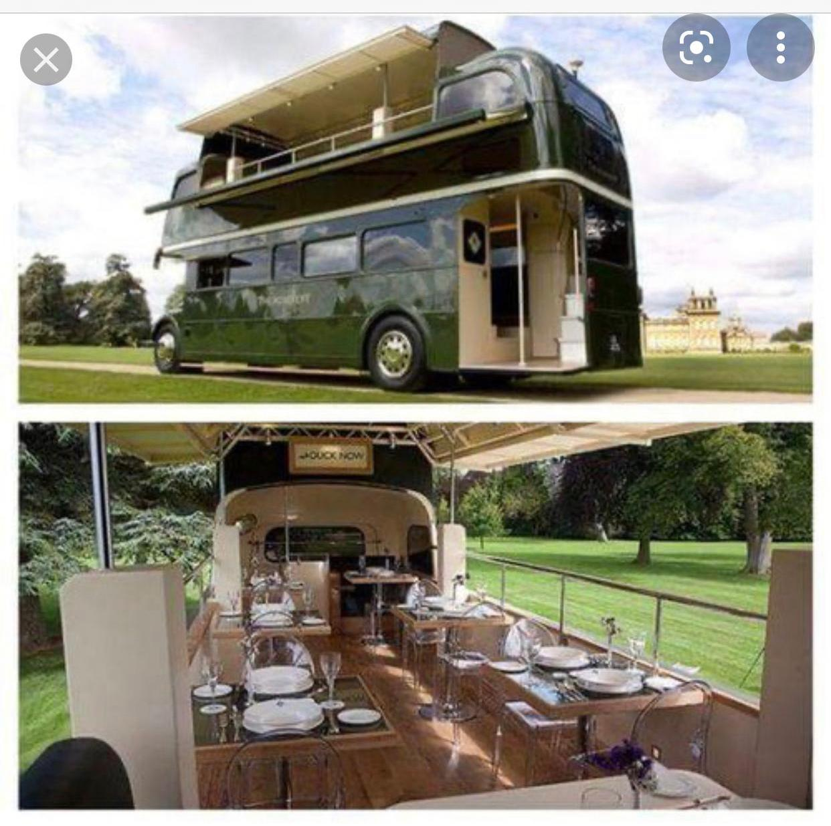


BMSW4006 Managing Enterprise in the 21st Century
Business plan
Mobile 10 salad restaurant IMADH LT

Group member names:
1. Maria Vitroroi - 2023024
2. Iosif Tcaciu - 2022775
3. Adrian Petrea - 2020066
4. Hadzher Shaban - 2023968
5. Dan Prisecaru - 2020834
Executive summary
The fact that one may locate a fully sanitary grocery shop that also acts as a live kitchen, as well as a very high-quality full cooking and serving service of the highest grade, in the United Kingdom is both satisfying and challenging (UK). Establishing an authentic and nutritious mobile restaurant in the United Kingdom while spending as little money as possible on costs and financing is the aim of the company's business strategy. Salads that are both healthy and tasty will be served on the premises, together with high-quality service in a comfortable, home-like environment. It will be owned and managed by a group of individuals who have come together to establish a partnership to create the mobile eatery. Thus, instead of being a single proprietorship, it will be transformed into a partnership in which many partners are participating. The responsibilities assigned to the partners will be split in order for everyone to be able to fulfil their various positions within the company effectively. For the task, more workers will be hired, including two chefs and two waiters, as well as other management staff working in other areas. They will be assigned to a variety of shifts over the course of the day. We will be serving the salads from this mobile restaurant, which will feature a total of ten different kinds of salad dinners in total. We will have a variety of different side drinks available for our customers to pick from when they come for their meals at the restaurant. People aged 20 to 29 as well as those between the ages of 30 and 39 are our primary target consumers. These include nationals as well as foreigners and visitors as well as those between the ages of 20 and 29. According to the findings of the researcher's study, the customers in the two age groups mentioned above are much more interested in health and nutrition than the general population, making this mobile restaurant an excellent choice for the intended clientele. Furthermore, in the event of a pandemic, the mobile restaurant will serve as the most convenient and safest option for everyone, guaranteeing that everyone is kept safe at all times, regardless of their location. In order to better serve our clients, we have chosen a site that is near to major cities and housing states. In light of the results of a poll performed to gauge public interest in potential sites, the researcher is looking at a number of other alternatives. The moving vehicle in which the mobile restaurant will be carried will be a moving van. A variety of marketing tactics will be used to reach out to prospective consumers, including mass media, a restaurant website, social media, word-of-mouth, and in-store advertising, among other methods.

Table of Contents
Task 1 – Business plan 6
Business description and planning 6
Mission, objectives and vision 7
Legal status and licenses 8
Management processes 10
Market situation 13
Market Strategy 16
Marketing Plan 17
Sales Targets and Objectives 19
Financial requirements and financial forecasts 26
Training needs 31
Business risk 32
PEST analysis 32
SWOT analysis 34
Conclusion 35
References 37
Task 2 – Online group presentation 40

List of figures
Figure 1 - Business planning 6
Figure 2 - Legal and licensing of business 8
Figure 3 - Management process 10
Figure 4 - Management chart for restaurant 11
Figure 5 - The business situation in COVID-19 13
Figure 6 - Competitor vs our campaign 15
Figure 7 - Market strategy cycle 17
Figure 8 - Mass media demonstration 18
Figure 9 - Meal 1 (Summer asisan slaw) 20
Figure 10 - Meal 2 (Easy Pasta Salad) 21
Figure 11 - Meal 3 (Rainbow Orzo Salad) 21
Figure 12 - Meal 4 (Taco Salad) 22
Figure 13 - Meal 5 (Kale Salad) 22
Figure 14 - Meal 6 (Greek Salad) 23
Figure 15 - Meal 7 (Egg and Tomato Faro Salad) 23
Figure 16 - Meal 8 (Corn Salad) 24
Figure 17 - Meal 9 (Creamy Potato Salad) 24
Figure 18 - Meal 10 (Watermelon Poke Bowls) 25

List of tables
Table 1 - Menu list of meals 20
Table 2 - Investment’s list 27
Table 3 - Working capital expenses 27
Table 4 - Asset depreciation costs 27
Table 5 - Salary statement any payout for the month 28
Table 6 - Income statement for 5 years 29
Table 7 - Balance sheet for 5 years 30
Table 8 - Cash flow statement for 5 years 31

Task 1 – Business plan

Business description and planning
Immediately after the study's findings, the study team came up with the idea for and ultimately executed a mobile restaurant concept in the United Kingdom. An undergraduate student at the University of Wales pursuing a degree in International Business performed the research that was utilized to assemble the information included within this report. Afterwards, the author hopes to do something to help the group become more self-sufficient and adaptive to new circumstances that may arise in their life in the future, according to the author's statements (Kirwan, 2009). The researcher is inspired to start their own mobile restaurant company after doing extensive market research and taking into consideration all other aspects. Customers will be given salads at the mobile restaurant, which will be the first of its kind in the United Kingdom. The salads will be both nutritious and sanitary (Greene, 2013). At some point in the near future, we want to create an even more fascinating mobile restaurant, one that will provide delicious ethnic cuisine that is nutritious, sanitary, and of excellent quality at a fair price while also being conscious of our environmental effect. We want our consumers to come to our business time and time again, bringing new customers with them each time they do so, in order to create a pleasant and enjoyable environment for them.

Figure 1 - Business planning
Source - (Govindasamy and Premraj, 2019)
Customers who want to eat healthy meals on a regular basis in order to maintain their health will benefit from the customized packages and exclusive special discounts provided by our mobile restaurant (Ford and Gioia, 2018). In addition, nights will be hosted in our mobile restaurant, which will provide a range of ethnic foods from across the world. This kind of event has the potential to bring in more customers to our restaurant in the future, and it is fair to expect this to happen. Customers may now make orders for their parties or events directly on our websites, which is a welcome addition. Our office will be open on weekdays from 11:00 a.m. to 10:00 p.m. and on Saturdays from 12:00 p.m. to 10:00 p.m., Monday through Friday. Sunday is a day of relaxation and rejuvenation for us. The restaurant is expected to be open for a total of 317 working days each year, which corresponds to a total of 317 days in a calendar year. Our meals cost £12 per person, which is a reasonable price. It is anticipated that the average meal price would be £12. After taking into consideration our expenses, revenue, and the food costs of our rivals, we arrived at our final pricing structure. When setting food costs, the findings of a consumer research study conducted with potential customers are also taken into consideration (DRABEK, 2011). The restaurant expects to sell an average of 25 breakfast units, 35 lunch units, 60 evening snacks, and 30 dinner units each day during its first year of operation. The restaurant will remain open for the foreseeable future 317 days a year, or 317 days a month, for the foreseeable future. Customers have the option of paying their bills using cash, debit card, or credit card, depending on their preferences.
Introduction of the entrepreneurs for this business –
- Partners Names – Maria Vitroroi, Iosif Tcaciu, Adrian Petrea, Hadzher Shaban, Dan Prisecaru
- Education qualification – Student of the business department
- Experience in other businesses – No
A summarized description of the business –
- Business name – IMADH LTD
- Business nature – Mobile restaurant
- Business industry – Foodservice
- Objective – To build a brand image with this unique 10 types of salad meals in the UK
- Business type – Partnership
- Opening days – Monday, Tuesday, Wednesday, Thursday, Friday and Saturday

Mission, objectives and vision
Mission
Our mission is to enhance a positive attitude towards healthy food and nutritious food via a range of salads created from different components in our customers. The main priority when it comes to servicing our customers is quality and smoothness. We offer our guests some excellent nutritious meals at a reasonable price, so that they may be eaten and viewed in our live kitchen products that are open to the public from all socioeconomic backgrounds. We also do a live performance in our shop in our kitchen, which is publicly accessible.
Objectives
- In order to provide your clients with a good first impression of our restaurant, we employ staff who have suitable expertise.
- A renowned and experienced chef (8 years) will be recruited to supervise the kitchen to ensure the best quality of cuisine is maintained.
- We will continue to improve our services in order to maintain excellent relationships with our consumers.
Vision
With our vision, we want to promote the idea of a mobile restaurant business in the United Kingdom and establish ourselves as the country's top-ranked restaurant.

Legal status and licenses
When a new business is established, an employer has a lot of tasks to do. Develop a business strategy and a financial plan, and then present your proposal to investors or seek financing if necessary. It is one of the most difficult jobs to guarantee that all legal requirements are met in full, a duty that is often overlooked despite the fact that it is very essential. Individuals who violate these rules may be subjected to fines or possibly judicial actions (Corbett, 2014). Despite the fact that the legal processes discussed here are unique to the United Kingdom, the major categories will most likely apply wherever your business is located in the world. It indicates that the business is managed by two or more people in a manner that has been agreed upon collectively, as shown by the fact that it is a partner company.

Figure 2 - Legal and licensing of business
Source - (Cady, 2010)
For example, the terms of our formal partnership agreement should describe the ways in which each member will participate in the business's capital, earnings, and losses, as well as the administration and decision-making procedures that will be followed by the company. The obligations and liabilities of the company are shared by everyone who is a corporate partner, which means that they are jointly and severally responsible. Each and every one of your accounts and information is treated with the utmost care and respect (Barnes, 2017). Due to the fact that we have chosen our company name, we are required to register a trademark with the United Kingdom Intellectual Patents Office in order to enhance the protection of our company name (www.ipo.gov.uk).
When it is taken into consideration that we engage individuals for shifting duty, UK law requires all employers to give each employee an employment agreement detailing all of the terms and circumstances of that work within two months on the day on which he or she begins a job contract (Balanko-Dickson, 2014). This section contains a comprehensive listing of all available positions, including their title and salary, working hours, holidays, and notice periods. In the event we are required to have extra conditions, we will be required to offer employment contracts to individuals who meet the requirements.
Always have a formal agreement in place with independent contractors to outline the services they offer, the rates they charge, and any other information that may be relevant. If our company sells goods or provides services, a standard set of commercial terms must be in place. A description of the goods or services we offer, pricing, payment methods, delivery dates, and wording intended to limit our liability in the event of a problem must be included in these terms and conditions (Williams, 2018). Order forms should be produced for each project in order to check the details of our work and to guarantee proper compliance with our business conditions. We are required to submit income tax documents in order to begin doing business in the United Kingdom since our firm has been proven to be critical to the country's taxation system.
Specifically, the Licensing Act 2003 stipulates that two kinds of licenses are needed in order to operate a restaurant facility in the United Kingdom: one for food businesses and another for entertainment establishments, respectively. A license for our business premises is required due to the location of our firm, and this license must cover the whole area in which we perform our activities. Our facility will most likely be examined and found to be in conformity with all current health and safety laws and fire rules before this license can be obtained. In addition, we offer a personal license as a backup option for our customers (Victoroff, 2013). With the signature of this agreement, we are granted the legal authority to own and operate the company on our own behalf. These permissions are accompanied by a great amount of accountability. We must make certain that our company does not violate any laws in order to maintain our licenses; otherwise, we face the risk of having our licenses withdrawn and our business location closed down.

Management processes
This section provides information on our management team, our employees, and the ownership and management structure of our company (Stutely, 2012). Not only will this part explain who belongs to our management team but also how the skills of every person contribute to our organisation's success. The individuals we recruit must be informed, honest and client-oriented. They must also be willing to work on behalf of all our stakeholders to establish a successful company.

Figure 3 - Management process
Source - (Paul, Cadle and Yeates, 2014)
Following business regulations and procedures, our management staff will be entitled, over a period of at least five years, to a marginal benefit arrangement which is decided by the firm's results (Richman, 2016). As our business is a partnership business and a team of 5 members, one of our most understandable members will be assigned as CEO and other 4 will take the roles of other departmental head i.e., Finance, HR, General Manager and Marketing and sales department respectively according to the skills and speciality. Other staff that will be included are shown in the management planning chart below and further descriptions are given.

Figure 4 - Management chart for restaurant
The roles of the employees in the hierarchy chart of management are discussed below –
CEO – Chief Executive Officer
Important tasks include the recruitment and selection of managers as well as advice and discipline. The other functions include communication of values and strategies to employees, assignment of accountabilities, planning, monitoring and evaluation of employment results, creation of incentives, creation of an information and opinion exchange environment and creation of a climate for opinion-sharing (Myers, 2011). It is its responsibility to establish price and perform commercial contracts, as well as to provide general guidance to the organisation, to create, convey, and implement the vision for the organisation, mission and general direction - that is, to supervise the development and implementation of an overarching strategy for the organisation.
Finance manager
It is the responsibility of this position to prepare financial reports, budgets, and financial statements for the business, among other things. Management can make well-informed decisions based on financial analyses, development budgets, and reporting (Muller, 2009). Specifically, this section is responsible for the financial forecasts and risk analysis associated with this work. This position is responsible for a variety of tasks, including cash management, general accounting, and financial reporting. As part of your role, you will be in charge of the development and administration of financial systems and policies. This is a job whose responsibilities include managing payroll and ensuring that tax regulations are followed.
HR Manager
To ensure effective implementation of all human resources and administrative duties throughout the company. It is responsible for the maintaining of office supplies which include, among other things, stock inspections, placement and shipment, and the evaluation of new goods. Identifies employment opportunities and monitors the interview and selection procedures to attract qualified individuals (Mintzer and Lynn, 2014). Promotes the knowledge of the business culture and operational procedures by new team members. Training, evaluation and appraisal of employees are the responsibilities of this job.
General Manager
The general manager's first and most important responsibilities are to ensure the well-being of all of the workers. Aside from that, the Manager will be responsible for developing the overall strategy of the company, managing workers, and putting in place corporate rules and procedures (Lynn, 2012). Our success depends on our ability to think strategically and make confident decisions. We must be committed to helping our employees in growing and being productive while also guaranteeing that our profits continue to rise over time.
Marketing and Sales Manager
Internal and external research is carried out, and all internal information sources are integrated in order to retain and attract the best customers of the company, while also attracting new users. To discover, prioritize, and contact potential new partners and business prospects, a systematic approach must be followed from start to finish (Lewis and Renn, 2010). Develop and implement strategies to identify, research, and investigate development possibilities, as well as maintain touch with leads and contacts. Responsible for installation monitoring, customer advocacy, and communication with customers and other stakeholders.
Trainee – Waiters
Employees in this role must provide consumers with fast, prompt and polite service, as well as the confidential protection and discretion of the customer. They also ensure that the presently empty tables are always prepared and arranged for visitors to take seats upon arrival. In fact, employees are accountable for the production of customer seats upon arrival and for any additional duties given to them by the dining manager (Howes, 2011). Additional tasks include providing food to all necessary tables and complying with all the laws and procedures governing cash processing.
Van’s Driver
The driver in charge will be responsible for taking us to our destination after we have arrived in our van, which will act as our mobile restaurant for the day. He will do so in accordance with the routes to different locations that will be followed during the day. Additional duties include minor vehicle repair and maintenance, keeping track of gasoline use, and ensuring that fuel is supplied properly and on time.
Cleaners and Dishwashers
Facility managers are responsible for ensuring the cleanliness of the facility at all times, as well as that their employees have frequent breaks. Maintenance of toilet items and supplies, as well as any other responsibilities that the supervisor or manager may be assigned, are just a few of their responsibilities (Fessenbecker, 2009). According to the regulations, it is the dishwasher's duty to clean the dishes once they have been returned from the serving table to the table and then to the kitchen. Additionally, the Management Team is responsible for completing any additional duties as soon as possible.

Market situation
The estimated population of the United Kingdom is about 66 million people, according to current estimates. The COVID-19 lock-downs and other limitations have resulted in a daily decrease in the number of foreign visitors to the United Kingdom, despite an increase in the overall number of international tourists across the world (Govindasamy and Premraj, 2019). Furthermore, there is an increase in the number of individuals from other nations, which is a positive development. Because of the hectic pace of metropolitan life, which has become all too common in recent years, more individuals are opting to dine outdoors when possible nowadays. As a side note, the advent of the virus COVID-19 has caused many individuals in today's modern society to be more concerned about their health and to take more precautions in their daily lives.

Figure 5 - The business situation in COVID-19
Source - (Cooper, Floody and McNeil, 2012)
A greater number of restaurants are required in the United Kingdom to meet the growing demand for high-quality cuisine among consumers across the nation. There is a growing demand for good food throughout the country, particularly in urban areas. There is a plethora of various kinds of restaurants available on the market nowadays, making it difficult to make a decision (Bolles, 2013). There are many different kinds of establishments that may be found in a restaurant company. Fast food restaurants, family-style restaurants, fine dining restaurants, ethnic restaurants, cafés, and coffeehouses are just a few examples. In this particular instance, the particular mobile restaurant will offer lunch and supper at reasonable rates while maintaining a high level of service in a nicely appointed environment. Restaurants in the United Kingdom are fiercely competitive with one another and with their customers.
As we focus more on nutritious meals, will distinguish us and it will be our competitive advantage if we go from place to place to spread words about our services and restaurants all across the UK. The demographics of our customers are also provided for visitors from other countries currently in the UK. We will work in cooperation with local hotels in the city centre to attract foreign tourists to our restaurant brochures (Yescombe, 2009).
As a result of the increasing awareness of health, the number of low-calorie options in grocery shops has risen in consumer expenditure. In recent years, this was one of the most apparent changes in salads. In addition, the high level of competition in the industry is expected to become even more serious in the coming years. If these days, when the internet society is continuously growing, we could create an online presence for our salad restaurant business, we would give our clients a fantastic service. In order to establish ourselves as experts in the sector, we discovered that blogging consistently about salad lunch and about our restaurant, which we often do. The campaign also utilizes social media websites such as Instagram, Facebook, and Twitter. Customers are able to place shopping from our store via a customer-facing online ordering platform we can develop on-site (Winer and Dhar, 2014). We also have to ensure that our distribution system is as effective as possible in order to succeed in our business enterprise. Second, developments in products that have shown that consumers are attracted enough to cope with the slow economic recovery while producing substantial revenue growth, have contributed to the continuing success of the sector.
Competitors and competitive advantages
Vendors get monetary remuneration in return for trading in their goods and services, and this is referred to as the "market." A number of additional factors, such as government limitations, taxes, and exchange laws, as well as consumer goals and other considerations, may cause the products or services offered on the market to differ from what is really available. The market may also vary based on where the seller is located on a map of the United States. Furthermore, when two or more parties are trying to get a competitive advantage or earn an advantage over one another, the phrase "competition" is the most important word to know and understand (Shapiro and Dolan, 2011). Understanding who our competitors are as well as what they have to offer may be helpful for the aim of differentiating our products and services as well as our marketing from those of our competitors.

Figure 6 - Competitor vs our campaign
Source - (Mohr, 2008)
As a result, we will be better able to establish competitive pricing and respond to rival marketing efforts with our own initiatives, which will ultimately benefit both of us in the long term. Some of the main competitors of this industry are mentioned below –
- The Detox Kitchen
- Good Life Eatery
- Ottolenghi
- Daylesford
- Aki Poke
Including a thorough study conducted by the restaurant sector, the market has grown much more competitive over the past decade (salad). It is imperative that we stay innovative, customer-focused, and aggressive if we are to succeed in this business. We are conscious of the competition and are prepared to compete with other eateries in the London, United Kingdom, marketplace. This allows us to compete with our competitors due to the unique market position we have, the cost-saving techniques we have implemented, and the potential to franchise our company. It is expected that the standard salad restaurant, which will be built by IMADH LTD in the near future and will open on time, will be popular with people of London, England, and will be successful (Lasher, 2015). There are many plazas in London, including one on a well-known street that is just across the street from one of the most opulent homes in the country. Every day, it is anticipated that there would be enough parking space for at least eight vehicles.
What we can guarantee is that the salads and beverages provided in our restaurant will be of the greatest quality and taste imaginable. Customers may find it difficult to visit our restaurant at this time owing to the health-care services that our staff are giving to our customers' families. Therefore, we have created our own website to give consumers the ability to make purchases, and our delivery team is now at your port to guarantee that all of our customers are pleased with their purchases. One of our company's objectives for the local community is the establishment of IMADH, an all-in-one salad restaurant. We've made tremendous steps ahead in the industry as a consequence of our excellent customer service culture, a wide range of payment methods, and a secure environment (Koop, 2014). Our staff is very conscientious and has one of the most important advantages in our industry in order to ensure that you will be more than eager to assist us in the development of your business and the achievement of our objectives.

Market Strategy
Extensive market research and feasibility studies were performed before choosing the most appropriate locations for the business to get a competitive edge and position ourselves as the preferred choice for residents of London, United Kingdom. The result of our extensive knowledge and data collection has enabled us to structure our business in such a way that we can attract the number of customers we want at any given moment (Friedlob and Schleifer, 2015). As part of our efforts to achieve our business aim of capturing a larger proportion of the available market, we sought the assistance of experts with significant experience in the food industry to assist us in creating marketing strategies that would enable us to achieve this goal.
In our efforts to recruit new workers, we were successful in our endeavours. The fact that our restaurant is in a busy location doesn't stop us from wanting to enhance the amount of publicity we create for the business, even if it is already very successful. Because we want to develop restaurant chains in a number of locations across London and other key cities in the United Kingdom as part of our long-term plan, we will carefully evaluate our brand's acceptability in the capital city before expanding our operations outside its boundaries (Bagozzi, 2011). While our public relations and advertising strategy are geared at gaining new customers, it is equally concerned with effectively communicating our brand to those who are interested in knowing more about what we have to offer.
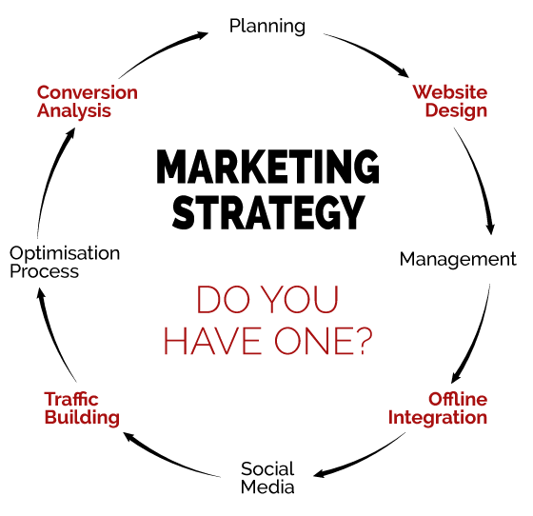
Figure 7 - Market strategy cycle
Source - (Albach and Weiser, 2012)
We plan to send introduction letters together with our brochure to the following organisations, corporate boards, schools, event planners, households, and other important stakeholder groups in order to promote our salad lunch for key stakeholder groups in London, the United Kingdom: We will do all in our power to ensure that our restaurants always provide a diverse selection of salads and drinks to our customers, regardless of the season. Use aesthetically pleasing hand lettering to promote awareness and provide help in raising awareness and advising on the preparation of our salad lunch (Zacharakis, Corbett and Bygrave, 2016). The posters and flexible banners will be placed in strategic locations across all of our facilities, and our welcome staff will be trained to greet potential customers. We will also develop a customer loyalty program that will allow us to reward returning customers, as well as participate in local trade fairs to raise awareness of our company.

Marketing Plan
A variety of promotional materials, including brochures and discount coupons, will be made available to prospective consumers in order to more effectively acquaint them with the company's products and services. Menus, pricing information, special deals, and information about the restaurants themselves will be included in the brochures, which will also contain photographs (Streibel, 2016). Our company will be marketed on the Internet in addition to conventional media such as television, print publications, social media platforms, and a variety of other media channels.
Mass Media
In addition to advertising, mass media techniques are employed to promote television publicity, radio advertisements, and airship ads in a variety of other ways. When it comes to commitment, just listening is adequate for the customer, and doing nothing more than that is also sufficient for the customer.

Figure 8 - Mass media demonstration
Source - (Reuvid, 2018)
Local newspapers, as well as television, are among the media outlets in which we would want to be included (Salter, 2010). Depending on our requirements, we may place advertisements in a broad variety of periodicals and television stations.
Social Media
Using social media platforms such as Facebook, Twitter, YouTube, Instagram, Google+ and LinkedIn to promote their goods and services is an option for restaurants to consider. In a short period of time, our restaurant may reach a large number of visitors, whether they are individuals or members of the restaurant's staff (Read, 2014). It may be necessary to build a separate Facebook page for a restaurant in order to reach a larger number of people and to educate customers about the activities and events hosted by the establishment. Before any of the company's operations can begin, we will create a Facebook page for the organisation. The information about upcoming events will be shared with you via our social media pages. We will also provide you with recopies of recipes, meals, and cooking videos that you request.
Word-of-Mouth
Using word-of-mouth (WOM) marketing techniques, we want to raise awareness of our restaurant. We can advertise our business, word-of-mouth is one of the most effective and least expensive methods available today (Razinkova, 2020). There are many significant events celebrated at our restaurant each year, including Valentine's Day, Easter Dinner, and New Year's Eve. If our current customers are satisfied with the food quality, pricing, and services provided by our restaurant, they are more likely to refer their friends and family to our establishment.
Local Store Marketing
The term "marketing plan for local shops" refers to a marketing strategy that is focused on a specific geographic region where the company operates. In certain areas, neighbourhood marketing or grassroots marketing is referred to as such, but in other groups, it is referred to as something else entirely (Pinson, 2008). We wish to distribute fliers from our restaurant to nearby hotels, tour agencies, and other businesses in order to raise awareness of our company. Each of the participating restaurants' advertising pamphlets includes a menu, pricing information, special offers, a map of their location, and contact information for all of the restaurants that are participating.

Sales Targets and Objectives
Target peoples
When it comes to our restaurant's fresh salad meals, there is one thing that is immediately apparent: we seldom come across anybody who does not really like them. The reason for this is because salad dinners are specifically designed for individuals who are worried about their diet and want to eat more healthfully. Individuals in London and abroad who visit our restaurants in major city centres across the United Kingdom will be the primary target market for the fruit salad bar that we have exclusively developed for them, according to our research (Overton, 2012). We have some thoughts about what our target market may anticipate from us in the months and years to come, based on the findings of our market research and our estimates about what they would expect. We believe that our primary goods, which are salads and non-alcoholic beverages, will be useful to a broad variety of consumers, including the following kinds of customers:
- Sports and athletics individuals
- Tourists
- Vegetarians
- Business People
- Corporate events
Product and Services (source of income)
IMADH Ltd. is a profitable salad food company, and we will work hard to provide our clients have access to a wide variety of salads and soft drinks. The following table lists our product and service offerings:
- Salads are made from two or more mixtures of fresh vegetables and sliced fruits (e.g., cucumbers, carrots, celery, olives, green or red bell peppers, Dragon Fruits, Grapes, Mango, Raspberry and other variety of components)
- Juices and smoothies will be offered
- Coffee
Our menu list –
S.I. | Items | Price
1 | Summer Asian Slaw + Drinks | £12
2 | Easy Pasta Salad | £8
3 | Rainbow Orzo Salad | £10
4 | Taco Salad + Drinks | £12
5 | Kale Salad + Drinks | £12
6 | Greek Salad | £9
7 | Egg and Tomato Faro Salad | £9
8 | Corn Salad + Drinks | £12
9 | Creamy Potato Salad | £6
10 | Watermelon Poke Bowls + Drinks | £12
Table 1 - Menu list of meals
1. Summer Asian Slaw + Drinks

Figure 9 - Meal 1 (Summer asisan slaw)
Source - (Oliver, 2014)
A creamy umami coating is provided by a tahini miso dressing, while juicy bursts of flavour are provided by peaches. For crunchy, usually, sprinkle toasted pepitas on top before serving.
2. Easy Pasta Salad
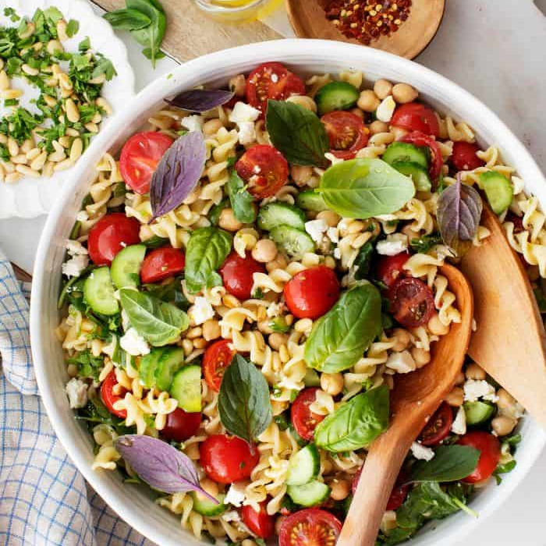
Figure 10 - Meal 2 (Easy Pasta Salad)
Source - (Oliver, 2014)
The name of this recipe implies that it is simple to prepare it. Combine the zippy lemon dressing and other ingredients in a large mixing bowl, then toss to combine a wonderful tangy/creamy/crunchy/fresh summer combination of textures and flavours.
3. Rainbow Orzo Salad
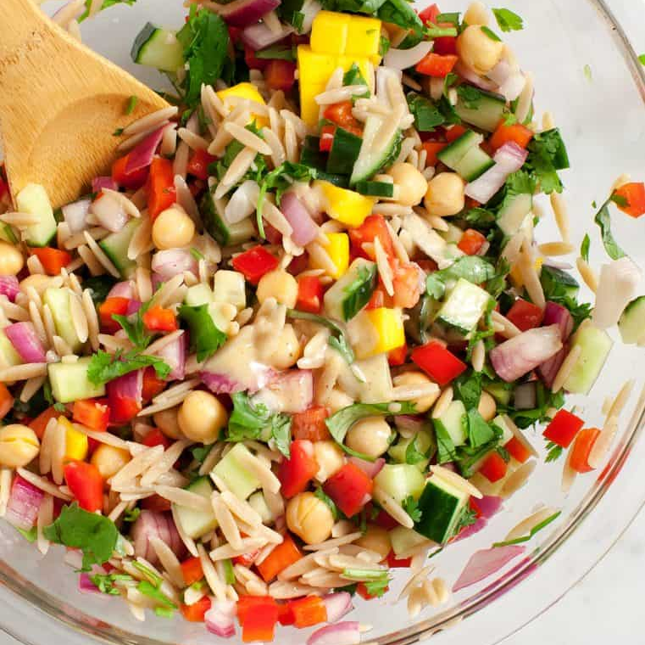
Figure 11 - Meal 3 (Rainbow Orzo Salad)
Source - (Oliver, 2014)
The addition of diced mango to this colourful orzo, diced carrot, red pepper, herb, and cucumber salad gives it a surprise sweet twist.
4. Taco Salad + Drinks
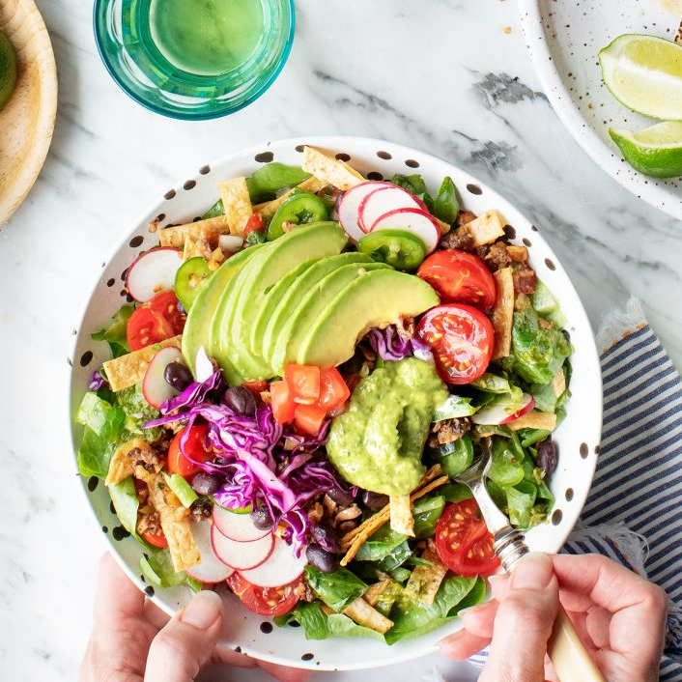
Figure 12 - Meal 4 (Taco Salad)
Source - (Oliver, 2014)
The centrepiece of this salad is the savoury shiitake walnut taco "meat," which is dressed with a zesty cilantro lime dressing for a burst of citrus flavour. This salad may be eaten as a complete meal on its own, or it can be served as a side dish with fajitas or tacos.
5. Kale Salad

Figure 13 - Meal 5 (Kale Salad)
Source - (Oliver, 2014)
This vibrant kale salad is a light and refreshing meal that can be enjoyed at any time of year. Before serving, I cover it with a rainbow of crisp veggies, toasted almonds, creamy avocado, and delicious roasted chickpeas to make it seem even more impressive. A spicy carrot ginger dressing gives it enough substance to stand on its own as a complete dinner course.
6. Greek Salad
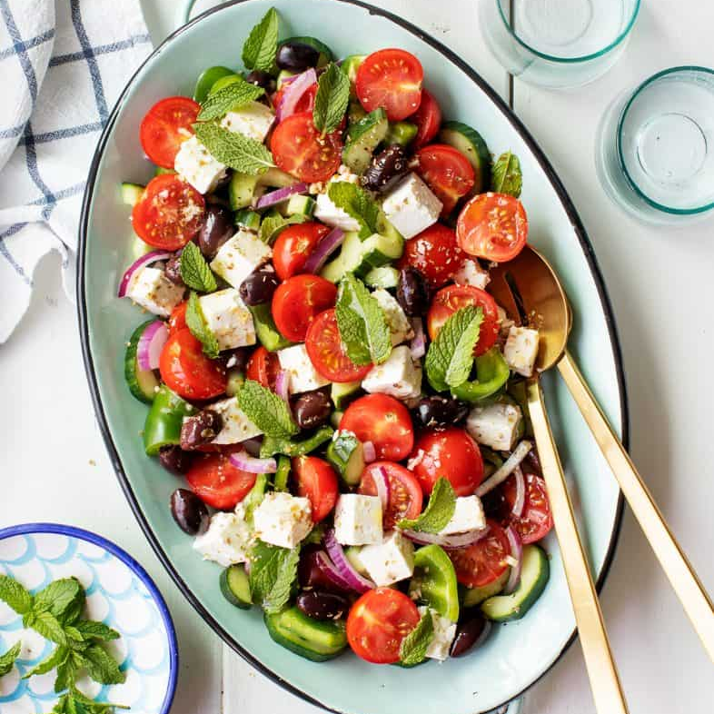
Figure 14 - Meal 6 (Greek Salad)
Source - (Oliver, 2014)
Large cubes of cheddar, juicy tomatoes, walnuts, mint, bell peppers, and cucumber are tossed together in a homemade Greek salad dressing to create a beautiful summer salad. This combination of juicy, crisp, acidic, and flavorful requires just seven ingredients and a few moments to put together.
7. Egg and Tomato Faro Salad

Figure 15 - Meal 7 (Egg and Tomato Faro Salad)
Source - (Oliver, 2014)
Roasting cherry tomatoes brings out their strong sweet and salty taste, which pairs well with eggplant, arugula, and nutty farro in this dish.
8. Corn Salad

Figure 16 - Meal 8 (Corn Salad)
Source - (Oliver, 2014)
Sweet corn, luscious apricots, and plenty of fresh herbs come together in this refreshing corn salad for summertime enjoyment. I garnish it with a spicy chile-lime dressing to bring out the crisp, fresh flavours of the ingredients.
9. Creamy Potato Salad
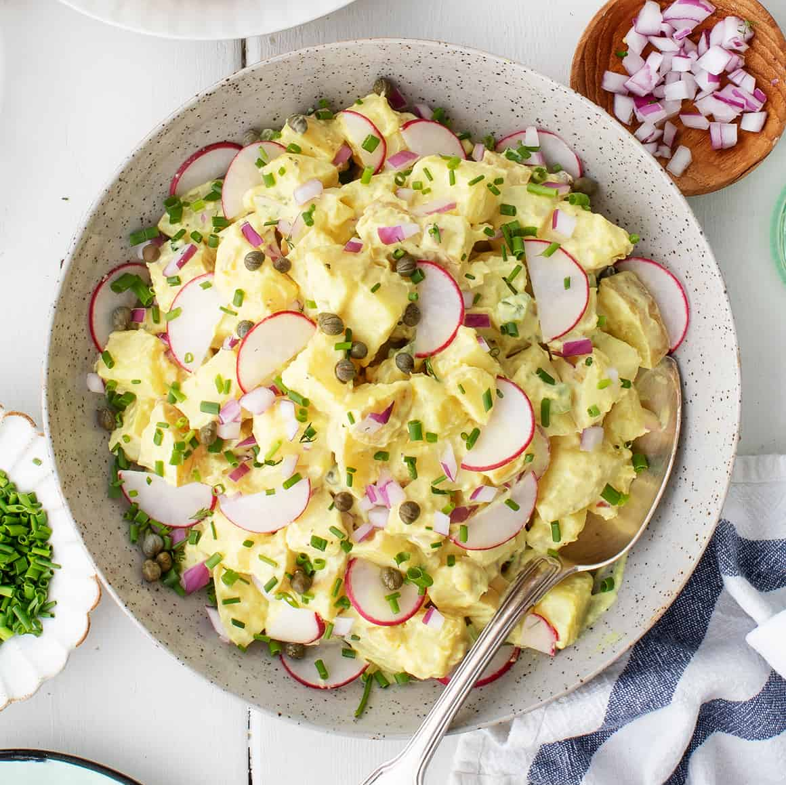
Figure 17 - Meal 9 (Creamy Potato Salad)
Source - (Oliver, 2014)
This plumped version of traditional potato salad is topped with a delicious Greek yoghurt dressing that contains just a little amount of mayonnaise. It's the ideal salad to prepare ahead of time since the flavours intensify as the salad rests in the fridge.
10. Watermelon Poke Bowls

Figure 18 - Meal 10 (Watermelon Poke Bowls)
Source - (Oliver, 2014)
Using watermelon cubes and crispy mixed nuts, this summer salad pays homage to the classic poke dish, which also includes traditional poke ingredients such as cucumber, pomegranate, and guacamole.
Sales Forecast
We can always rely on our fresh salad meals for business to attract clients and boost sales, which will result in a rise in income production for the company if our restaurants are strategically located across the community. With our strong presence in London, the United Kingdom, and our stated goal of producing adequate revenue during our first eight months of operation in order to expand the company and our client base, we believe we are well-positioned to take advantage of the opportunities in the city (Kirwan, 2009). Following our investigation into the food business, we were able to evaluate our possibilities of success in the market and develop sales forecasts, which are displayed in the following table. Information collected on the ground, as well as assumptions unique to startups in London, United Kingdom, have been used to create the sales estimates shown here. The sales forecasts for IMADH LTD are given in the table below. Those projections are based on the geographic location of our company as well as other variables that are important to the growth of fresh salad restaurants in the United Kingdom - for example, the number of people who eat a salad every day.
- The first year's income is expected to reach £350,000
- The second year’s income is expected to reach £400,000
- The third year’s income is expected to reach £650,000
- The fourth year’s income is expected to reach £850,000
The above values are only the estimated forecasts, these values are not the actual financial forecast values.

Financial requirements and financial forecasts
Investment
It is possible that initial funding may assist entrepreneurs in getting their businesses off the ground and will give them financial assistance and encouragement. Businesses that submit an application for employment and economic development assistance through their local Office, and that meet certain criteria, may be eligible for start-up funding (Greene, 2013). If a business concept is both attractive and possibly lucrative, it may be eligible for startup financing from a bank or other financial institution, according to the Small Business Administration. Furthermore, as previously said, the entrepreneur in a variety of situations has prior experience or has received appropriate business training. Candidates must commit to working full time in the location where their companies are based for the duration of the award period in order to be eligible for the prize consideration.
In the majority of cases, start-up assistance will be provided for a period of six months or longer, depending on the circumstances. It is possible that you will be eligible for this assistance for a total of up to 18 months if you meet specific requirements. In this regard, it is essential to note that start-up capital is subject to personal income tax rather than corporate income tax and that it is subject to personal income tax rather than other types of financing. When considering the establishment of an off-premise fresh salad eating business, we must be prepared to gather adequate money to cover some of the initial operational costs we will incur as a result of the procedure (Govindasamy and Premraj, 2019). To be completely honest, forming such a corporation does not come at a low cost.
To guarantee that the company makes enough money during this period to cover all of the expenditures of acquiring a standard facility in an appropriate location, purchasing an audio system and paying our employees, as well as covering the costs of the utilities. Before anything can be done, however, the project will require £30,000 in seed money to get things started. In addition, an additional £10,000 is given by the investor and £20,000 partners from their own personal resources.

Investment | Amount (£)
Start-up registration fee | 100
Van | 8000
Interior decoration | 3000
Furnitures | 3000
Kitchen equipment’s | 4000
Cash counter computers | 500
POS machines | 400
Website | 700
Printer | 200
Stationery | 100
Total | 20000
Table 2 - Investment’s list
Working capital for first 2 months
As our investment is in a total of £30,000, equipment’s and other purchases cost us £20,000 and the rest £10,000 we have kept for legal paper works and other miscellaneous expenses for the first two months.
Working capital | Amount (£)
Legal paper works | 8000
Miscellaneous expenses | 2000
Total | 10000
Table 3 - Working capital expenses
Assets Depreciation
Profits before taxes have been lowered by depreciation, which is an expenditure element used by firms to periodically recover and decrease their pre-tax profit from capital assets (Ford and Gioia, 2018). The assessment is often calculated by dividing the value of the asset by the lifetime of the item, which is not always the case. Furniture, culinary equipment and decorations for our restaurant will be available to buy. All our tangible assets will be assessed at the 10% depreciation rate.
Assets | Value (in £) | Depreciation (per year (£))
Furniture | 3000 | 300
Kitchen equipment’s | 4000 | 400
Van | 8000 | 800
Total | 15000 | 1500
Table 4 - Asset depreciation costs
Salary Statement
Detailed information on the income, wages, perks and circumstances of an employee is covered in an exhaustive wage plan (DRABEK, 2011). A pay plan contains information regarding the income, salary, beneficiaries and conditions of payment of an employee, and information on the financial situation of the employee. Included in the pay plan are methods to pay employees in the form of bonuses, incentives and commissions and the amount of compensation they get. Additional information on the planned raises and increases depending on service numbers, and projected bonuses and incentives may also be included in the compensation plans.
A chef manager is selected and a junior chef and an assistant worker support him on his duties, helping him with the daily operations of the kitchen. In addition to customer convenience, there are four attendants that work throughout the day to fulfil their requirements in a range of shifts (Corbett, 2014). Cooks are supported by cleaners and dishwashers to ensure plates and other servings are thoroughly cleaned before each meal is served. Van’s drivers pay at a rate similar to the school bus drivers on an hourly basis. Included in various financial statements are the yearly salary information that is computed and provided, including a return statement and an analysis of cash flows.
Employee Designation | Pay rate / hr. | Total hours/month in £ | Gross pay (monthly in £)
Chef Manager | 15 | 144 | 2160
Junior Chef | 10 | 168 | 1680
Assistant Staff (Kitchen) | 8 | 240 | 1920
Dining Manager | 12 | 150 | 1800
Waiter | 6 | 240 | 1440
Waiter | 6 | 240 | 1440
Waiter | 6 | 240 | 1440
Waiter | 6 | 240 | 1440
Van Driver | 7 | 180 | 1260
Facilities Manager | 11 | 150 | 1650
Cleaner | 6 | 230 | 1380
Cleaner | 6 | 230 | 1380
Dishwasher | 6 | 230 | 1380
Sales Executive | 9 | 100 | 900
Management Trainee | 18 | 180 | 3240
Bookkeeper | 12 | 90 | 1080
Total | 144 | 3052 | 25590
Table 5 - Salary statement any payout for the month
Forecast of the Income statement
We anticipate that revenues will grow by 15 per cent each year as a result of increasing knowledge of our business, our delicious salad meals, and our high-quality services. Each day at the spots, it is expected that 25 units for breakfast, 35 units for lunch, 60 units for evening snacks, and 30 units for supper would be sold, according to the forecasted sales figures. Because our meals are so cheaply priced, we are able to offer them to everyone who requests them (Cady, 2010). As a result of our calculations, the average cost of our meals ranges from £12 at the most expensive point to £6 at the most affordable. Our hours will be the same seven days a week, with the exception of Sundays, which will be different. The number of working days in a calendar year is about 317 on average. As a result, we expect to earn annual sales of £475,500, which is an increase over the previous year. We anticipate that revenues will grow by an average of 20% each year throughout the restaurant's second, third, and fourth years of operation, according to our estimates.
Particulars | 1st Year in (£) | 2nd Year in (£) | 3rd Year in (£) | 4th Year in (£) | 5th Year in (£)
Sales | 499275 | 599130 | 732270 | 865410 | 1031835
Cost of Goods sold (ingredients) | 309075 | 370890 | 453310 | 535730 | 638755
Contribution Margin | 190200 | 228240 | 278960 | 329680 | 393080
Operating Expenses
Salaries | 25590 | 25590 | 35000 | 35000 | 40000
Internet and telephone | 7200 | 7800 | 8400 | 8400 | 9000
Marketing | 30000 | 33600 | 21600 | 18000 | 14400
Depreciation | 1500 | 1500 | 1500 | 1500 | 1500
Insurance | 2400 | 2400 | 2400 | 2400 | 2400
Oil or petrol (van) | 6000 | 6000 | 4200 | 4800 | 7200
Other miscellaneous expense | 6000 | 6000 | 6000 | 6000 | 6000
Operating expense | 78690 | 82890 | 79100 | 76100 | 80500
Profit before income tax | 111510 | 145350 | 199860 | 253580 | 312580
Income tax (14%) | 15611.4 | 20349 | 27980.4 | 35501.2 | 43761.2
Net profit | 95898.6 | 125001 | 171879.6 | 218078.8 | 268818.8
Table 6 - Income statement for 5 years
The cost of the goods sold (inputs) may be calculated by subtracting 6.1 per cent of total sales from the total number of products sold (Barnes, 2017). A foundation for this estimate may be constructed on the basis of the restaurant finance manager's recommendations about sales charges and other expenses. On the basis of the sales statements above, it is possible to gauge our company's success in the first year after the establishment of our stores. In its first year of business, the company had a net profit of £9,5898.6 pounds. Our business, on the other hand, generates £12,5001 in revenue in its second year of existence. As can be seen in the preceding sales declaration, the profit of the company increases steadily over the course of many years.

Forecast of Balance sheet
 | 1st Year | 2nd Year | 3rd Year | 4th Year | 5th Year
Particulars | Amount in (£) | Amount in (£) | Amount in (£) | Amount in (£) | Amount in (£)
Assets
Cash | 125898.6 | 250899.6 | 422779.2 | 640858 | 909676.8
Depreciation - Furniture | 300 | 300 | 300 | 300 | 300
Depreciation - Kitchen equipment’s | 400 | 400 | 400 | 400 | 400
Depreciation - Van | 800 | 800 | 800 | 800 | 800
Total Assets | 127398.6 | 252399.6 | 424279.2 | 642358 | 911176.8
Liabilities
Capital | 10000 | 10000 | 10000 | 10000 | 10000
Retained earnings | 5888.6 | 97049.6 | 214419.2 | 378778 | 588596.8
Tax payable | 15611.4 | 20349 | 27980.4 | 35501.2 | 43761.2
Shareholders’ equity | 95898.6 | 125001 | 171879.6 | 218078.8 | 268818.8
Total Liabilities | 127398.6 | 252399.6 | 424279.2 | 642358 | 911176.8
Table 7 - Balance sheet for 5 years
The financial statement summing up our company's assets, liabilities, and equity, generally known as the statement of income, is shown in the above balance sheet. Although the balance sheet does not reveal any patterns, it does represent the financial position of a company at some time, which is useful information (Balanko-Dickson, 2014). Perhaps one of the most useful aspects of the balance sheet is its ability to alert us at an early stage about potential financial difficulties. In a wide variety of circumstances, it is a very helpful tool, even in the ones below. By checking our cash balance, we can determine how much money we owe and how much money we have in the bank (accounts payable). If our accounts payable outweigh the cash presently available, we either need to create a plan to increase the cash we have available, or we need to pay our bills slower with the number of accounts. The balances may offer a wealth of information for financial management reasons, which can be used to make the entire financial management process more efficient.

Forecast of Cash flow statement
Particulars | 1st Year | 2nd Year | 3rd Year | 4th Year | 5th Year
Cash inflows
Beginning cash balance | 30000 | 125898.6 | 250899.6 | 422779.2 | 640858
Sales | 499275 | 599130 | 732270 | 865410 | 1031835
Total cash inflows | 529275 | 725028.6 | 983169.6 | 1288189 | 1672693
Cash outflows
Ingredients | 309075 | 370890 | 453310 | 535730 | 638755
Salaries | 25590 | 25590 | 35000 | 35000 | 40000
Internet and telephone | 7200 | 7800 | 8400 | 8400 | 9000
Marketing | 30000 | 33600 | 21600 | 18000 | 14400
Depreciation | 1500 | 1500 | 1500 | 1500 | 1500
Insurance | 2400 | 2400 | 2400 | 2400 | 2400
Oil or petrol (van) | 6000 | 6000 | 4200 | 4800 | 7200
Other miscellaneous expense | 6000 | 6000 | 6000 | 6000 | 6000
Income tax | 15611.4 | 20349 | 27980.4 | 35501.2 | 43761.2
Total cash outflows | 403376.4 | 474129 | 560390.4 | 647331.2 | 763016.2
Closing balance | 125898.6 | 250899.6 | 422779.2 | 640858 | 909676.8
Table 8 - Cash flow statement for 5 years
In our firm, the cash flow statement depicts the movement of money into and out of the company. As a result, this statement contains information on the cash flow that happened during the previous quarter. Generally speaking, a cash flow forecast shows the amount of money that is expected to be produced or spent over a certain period of time in the future (Williams, 2018). This table shows that our restaurant has had positive cash flow from the beginning of the year and that this cash flow has increased gradually over time, as seen in the graph above.

Training needs
It is essential for us to guarantee that all of our employees are well-versed in the basics of food safety and hygiene before we can serve unpackaged food in our restaurant. Each and every person who works for our firm is required to complete a health and safety training course before beginning their employment with us. Businesses who get this certification will be able to handle perishable goods in a safe and efficient manner, as well as comply with all relevant safety laws and standards.
People who work in the food business should make sure that they get a certificate of occupational health and safety training within five months of starting their jobs in the industry. We must ensure that we have acquired all of the necessary certifications and licenses for each of our employees covered by this agreement (Victoroff, 2013). It is essential that the employees get enough training in order to ensure that the restaurant runs as smoothly and effectively as possible. A new employee orientation program will be developed to help new employees in becoming acquainted with their new workplace.
The participant is expected to contribute to a deeper understanding of the overall idea of the institution, its aims and objectives, as well as the institution's point of view on a variety of issues (Stutely, 2012). All of the employees at the restaurant must be aware of and supportive of the concept of the establishment, and we will offer them training on the company's culture as part of their employment. All workers get hands-on training and instruction in a variety of areas, including food safety, cleanliness, personal responsibility, menu knowledge, and service standards, to name a few.

Business risk
Obviously, there are dangers associated with operating a company. It is critical for the success of a restaurant company that risks be identified, evaluated, and minimized at every step of the process (Richman, 2016). The following is a summary of the most significant and critical hazards that our restaurant may encounter:
- It is difficult to predict how long it will take for consumers to accept and appreciate our unique approach to food and presentation decorations, as well as the amount of time it will take.
- A restaurant establishment may have an accident, such as a fire or an accident resulting in an injury.
- Changes in taxation and opening hours are two instances of government regulations that have been altered.
- Increases in the price of food components, as well as increases in the price of energy and gasoline, are examples of unexpected expenses.
- In light of the high level of taxes levied, it is possible that customers' discretionary money may be reduced.
- There is a shortage of food available for purchase on the market.

PEST analysis
PEST analysis is a technique for identifying external factors that have an impact on a company's business operations. It is of particular importance to us to understand how unique political, economic, social, and technological problems affect the food industry in this particular context.
Political factor
International political problems, particularly those affecting the United Kingdom, may have a major effect on restaurants throughout the globe. Tax reform, health and safety legislation, and other forms of political influence are only a few examples of the effect of politics (Paul, Cadle and Yeates, 2014). Following the discovery of regulations that may be detrimental to our company operations, we must take the appropriate steps to mitigate the consequences of these limitations. We are responsible for the food products throughout the food preparation process, from the time of purchase through the cooking and packing stages, and until the food items are delivered to our customers.
Economic factor
If the rate of inflation in the economy in which we operate rises, it will make it more costly for us to run our restaurant since it will have an impact on the price of the products and services that we use to create our meals. Due to the increasing cost of food, the majority of people will avoid dining at restaurants and shopping outside of their homes as a consequence of the increased cost of food on the menu. Another economic issue that may have an effect on the food business is the amount of money that customers have available to them, which is distinct from their discretionary income (Myers, 2011). More and more people, particularly those with more discretionary money, are choosing to spend their time with family and friends, as well as eating food from their own region.
Social factor
The profitability of our business may be influenced by a wide range of social factors, some of which are negative, others which are positive. People are becoming more conscious about their health as time goes on. This means that as a consequence of their effort’s individuals choose organic foods over processed foods. This social component will have a beneficial effect on the culinary options available at our restaurant. Consider the societal consequences of customers who are vegetarians, animal lovers, or transsexuals. Maintaining customer happiness across a wide range of demographics is very difficult to achieve.
Technology factor
The expansion of technical knowledge is the most dynamic aspect of PSET analysis. Rapid technological advancements and developments have the potential to adversely impact our restaurant sector. For the purpose of monitoring our employees and other activities, it is critical that we install closed-circuit television cameras that can be operated from our mobile phones. Manual registers are still in use by a small number of businesses to keep track of their restaurant and other transactions (Muller, 2009). There are several different types of restaurant management and accounting software options available, such as Toast POS and QuickBooks Online, that can perform a wide range of tasks and processes. As well as that, we have the option of choosing from among them our company's growth and profitability may be boosted by using one of the many useful software packages that are available.

SWOT analysis
For the first five years, we plan to operate just a fresh salad restaurant in London, United Kingdom, in order to evaluate whether or not we will invest more money and expand the business, and then build other locations around the city (Mintzer and Lynn, 2014). Our firm will be established in the city of London; however, we are fully aware that there are many salad restaurants and similar businesses in the area where we want to locate our company. Despite this, we will follow the necessary processes in order to establish our business. It is our strong belief that by doing a comprehensive SWOT analysis of our company, we will be able to position ourselves to maximize our strengths, take advantage of our opportunities, reduce our risk, and be better equipped to deal with our threats. We engaged IMADH LTD to assist us in conducting an in-depth SWOT analysis as well as developing an operational model that would assist us in achieving our business objectives (Lynn, 2012). The project was led by an experienced human resources and business analyst with a speciality in the restaurant industry, and the results were extremely positive. The next part gives a summary of the SWOT analysis carried out on behalf of IMADH LTD in more detail –
Strength
All of these factors, as well as our location, the business model we will be adopting, the diversity of payment options, the wide selection of fresh salads and drinks provided, our low meal pricing, and our excellent customer service culture, will be major advantages for IMADH LTD. Additional, we have a management team that is familiar with the challenges of transitioning from the inception of a new business to its first year of profitability in a short period of time.
Weakness
It is possible that we will be unable to compete against multi-million-dollar food franchises and restaurants owing to our lack of financial weaknesses due to our inexperience as a new food business. As a result of the fact that we are novices to the field of entrepreneurship, none of us has any previous experience in the administration of a business (Lewis and Renn, 2010).
Opportunities
Furthermore, the fact that we will be operating our mobile restaurant on one of London's busiest streets in the United Kingdom will provide us with an infinite number of opportunities to sell our salad lunches to a large number of individuals as a byproduct of this arrangement. Results of extensive feasibility studies and market research have helped us in determining the kind of goods that our potential consumers are likely to be looking for when they come into our business (Howes, 2011). As a result, we are well-positioned to capitalize on any opportunities that may arise in the near future. The capital city of England, London, is also a famous tourist destination for many foreign visitors to the country.
Threat
A downturn in the economy, like with any other business in a comparable situation, is one of the most important risks we will almost definitely confront in the foreseeable future. Furthermore, the building of a new restaurant with a concept that is similar to ours in the same location where ours is now located may pose a threat to the viability and profitability of our business in the future (Fessenbecker, 2009). Given that our meals are completely composed of vegetables and fruits coupled with other foods, rather than meat, it is probable that our competition will get fiercer as a consequence of this, and that the shortage of food components would have a detrimental effect on our business.

Conclusion
Everything that has been learned from all of the research methods covered in this chapter has been meticulously compiled for your convenience. Aiming to evaluate the feasibility of establishing a mobile salad restaurant in London that would only serve fresh salads and not provide other kinds of food, the researchers conducted their investigation. Furthermore, the results from each and every one of the study methods that were used are included in this part of the book. The new mobile restaurant in London, which is aimed at those who want to eat nutritious meals on the go while on the go, would be a handy alternative to eating in a conventional restaurant environment, according to the company (Ehrlich and Michael, 2009). A spokesperson for the establishment said that the "restaurant has a great home-cooked atmosphere that sets it apart from its competitors in the marketplace." In school, we put our ideas to the test via action research, and we seek new solutions to a specific problem. It was determined via this study that developing a realistic business plan that could be implemented was the main objective of the thesis (Daniels, 2011). It is fair to expect that the business will prosper and produce profits for its shareholders in the near future, given the comprehensive research that has been conducted so far. The ability to predict that a company would profit on the basis of financial calculations is available from the very beginning of its activities if the firm is successful.
However, during the second year of operation, it has begun to generate more profit and has continued to do so in subsequent years. It made a profit of £95898,6 for the year in its most recent financial year, which was the most recent available. The second-year results in an initial profit of £1250001, followed by a further profit of £171879,6 in the third year, a further profit of £218078,8 in the fourth year, and a further profit of £269818,8 in the fifth year. The third-year results in an initial profit of £1250001, followed by a further profit of £171879,6 in the third year, a further profit of £218078,8 in the fourth year, and a further profit for the business would progressively grow over the following few years as projected sales increased by 15% in the second year and 20% in the third year, resulting in an overall rise of the company's profit throughout the period. Another point to keep in mind is that, since London is the country's capital and geographic centre, the overwhelming majority of individuals who do so are foreigners, tourists, and business people who go to London for work-related reasons. With so many healthy salad meal options available in a large city like London, it may be difficult for healthy salad meal businesses to stand out from the crowd by offering something different to their customers (Cooper, Floody and McNeil, 2012).
In the beginning, all actions taken by its partners in the capacity of a partnership proprietorship company in accordance with the terms of the agreement would be held liable for the planned restaurant. Profitability and smooth operations, on the other hand, increase the likelihood of extending to other large cities in the near future, increasing the likelihood of earning more money. Obtaining accurate and private information from trustworthy sources proved to be the most difficult challenge throughout our investigation. The execution of this project proved to be a tough job, as did the creation of the restaurant's financial plan, which was itself a difficult task. Because we were unable to get a great deal of information from the restaurant's management, it was difficult to make an accurate assessment of what had happened. In order to create this mobile eating business, we needed the data and information that had been gathered during the research process (Bolles, 2013). The ability to gather data and information during the whole research procedure proved to be very beneficial. Finally, but by no means least, we think that our research will be beneficial to both readers and prospective partners in the long run.

References
Albach, H. and Weiser, C., 2012. Marketing - Management. Wiesbaden: Gabler.
Bagozzi, R., 2011. Marketing management. Upper Saddle River, N.J.: Prentice Hall.
Balanko-Dickson, G., 2014. Tips and traps for writing an effective business plan. New York: McGraw-Hill.
Barnes, J., 2017. A guide to business continuity planning. Chichester: J. Wiley.
Bolles, D., 2013. Building project management centers of excellence. New York: AMACOM.
Cady, D., 2010. Field guide to estate, employee, & business planning 2010. Erlanger, Kentucky: National Underwriter Company.
Cooper, B., Floody, B. and McNeil, G., 2012. Start & Run a Restaurant Business. Vancouver: Self-Counsel Press.
Corbett, A., 2014. Universities and the Europe of knowledge. New York, NY: Palgrave Macmillan.
Daniels, P., 2011. Restaurant business start-up guide. [Chino Hills, Calif.?]: Venture Marketing.
DRABEK, T., 2011. Disaster planning and response by tourist business executives. The Cornell Hotel and Restaurant Administration Quarterly, 36(3), pp.86-96.
Ehrlich, S. and Michael, D., 2009. Business planning. Newark, NJ: LexisNexis.
Fessenbecker, G., 2009. Licensing, registration, and regulations affecting construction contractors. Eugene, Ore.: Construction Contracting Press.
Ford, D. and Gioia, D., 2018. Creative Action in Organizations. Thousand Oaks: SAGE Publications.
Friedlob, G. and Schleifer, L., 2015. Essentials of financial analysis. Hoboken, N.J.: John Wiley.
Govindasamy, D. and Premraj, D., 2019. An Analytical Study On Financial Planning And Strategy Formulation. Restaurant Business, 118(9), pp.28-34.
Greene, C., 2013. Entrepreneurship. Cincinnati: South-Western Educational Pub.
Howes, N., 2011. Modern project management. New York: AMACOM.
Kirwan, J., 2009. Good small business planning guide. London: A. & C. Black.
Koop, G., 2014. Analysis of financial data. London.
Lasher, W., 2015. The perfect business plan made simple. New York: Broadway Books.
Lewis, J. and Renn, L., 2010. How to start & manage a restaurant business. Interlochen, Mich.: Lewis & Renn Associates.
Lynn, J., 2012. Start your own restaurant and more. [Irvine, Calif.]: Entrepreneur Press.
Mintzer, R. and Lynn, J., 2014. Start your own restaurant business and more. London.
Mohr, A., 2008. Finance & grow your new business. Bellingham, WA: Self-Counsel Press.
Muller, P., 2009. Show business law. New York: Quorum Books.
Myers, K., 2011. Total contingency planning for disasters. New York [N.Y.]: John Wiley.
Oliver, L., 2014. The cost management toolbox. 2nd ed. London.
Overton, R., 2012. Business planning. Parramatta, N.S.W.: Mertin Management Services in conjuction with Parramatta Business Centre.
Paul, D., Cadle, J. and Yeates, D., 2014. Business analysis. Swindon: BCS Learning & Development Limited.
Pinson, L., 2008. Anatomy of a Business Plan. Chicago: Dearborn Trade, A Kaplan Professional Company.
Razinkova, M., 2020. STAGES OF MARKETING PLANNING IN RESTAURANT BUSINESS. Ekonomika ta derzhava, (2), p.62.
Read, S., 2014. Effectual entrepreneurship. London.
Reuvid, J., 2018. The Business Guide. London: Legend Press.
Richman, L., 2016. Project management step-by-step. New York: Amacom.
Salter, B., 2010. The Essential Guide to Business Planning and Raising Finance. Thorogood Publishing.
Shapiro, B. and Dolan, R., 2011. Marketing management. Homewood Ill.: R.D. Irwin.
Streibel, B., 2016. The manager's guide to effective meetings. 1st ed. London, p.221.
Stutely, R., 2012. The definitive business plans. Harlow: Financial Times Prentice Hall.
Victoroff, G., 2013. The visual artist's business and legal guide. Englewood Cliffs, NJ: Prentice Hall.
Williams, J., 2018. Team Development for High Tech Project Managers. Norwood: Artech House.
Winer, R. and Dhar, R., 2014. Marketing management. Harlow, Essex: Prentice Hall.
Yescombe, E., 2009. Principles of project finance. Amsterdam: Acad. Press.
Zacharakis, A., Corbett, A. and Bygrave, W., 2016. Entrepreneurship. London, p.331.

Task 2 – Online group presentation
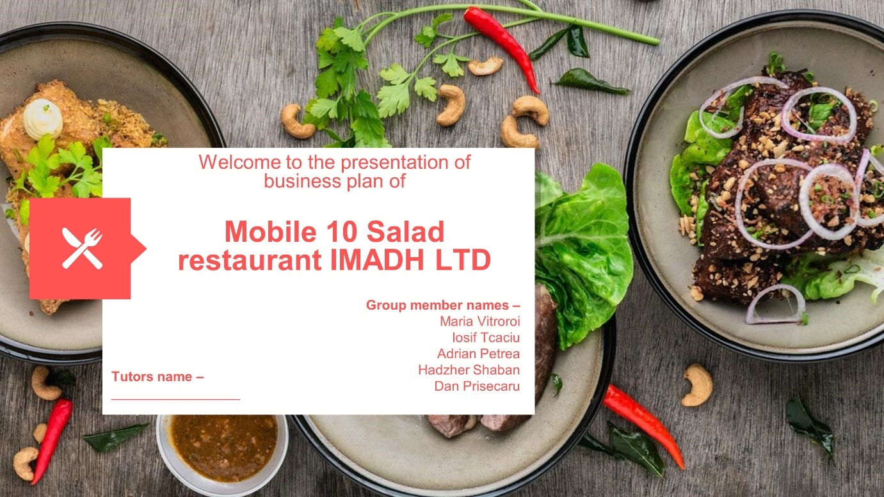
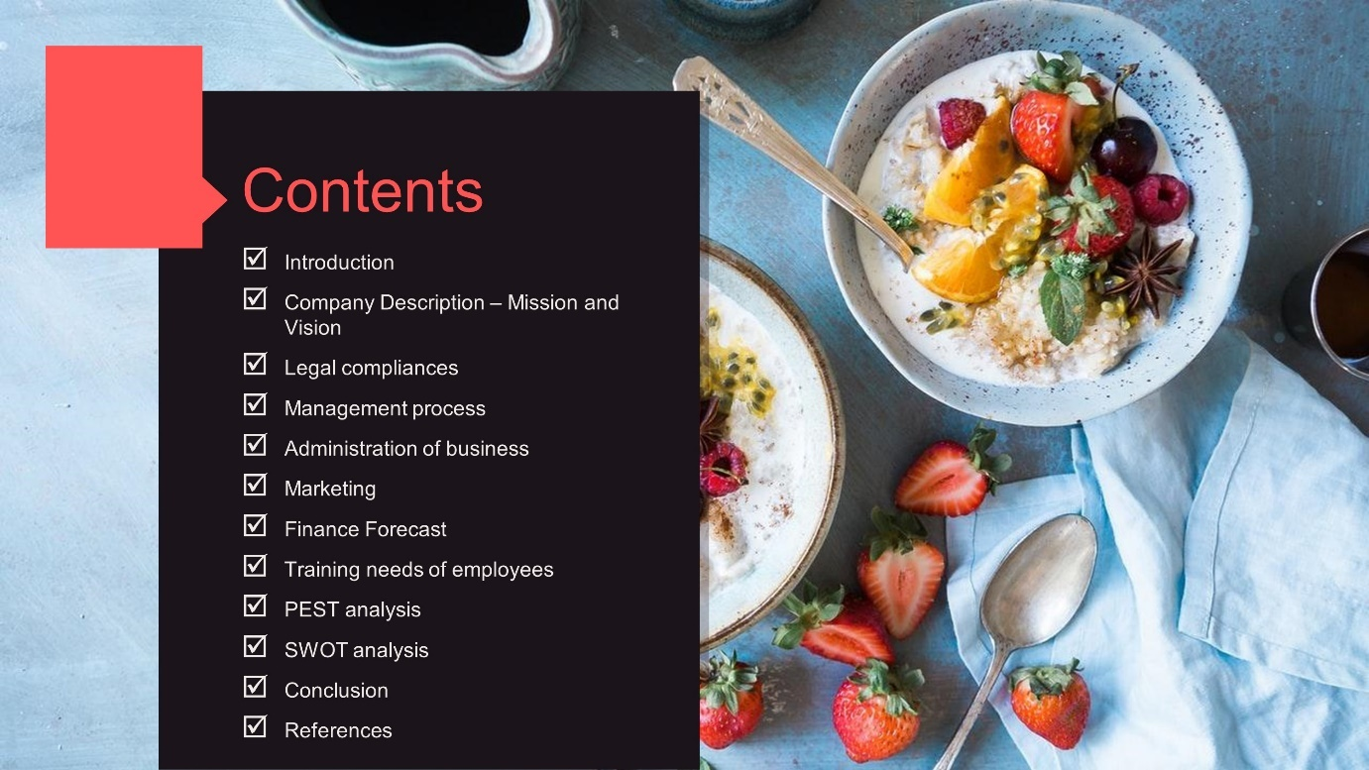
Introduction
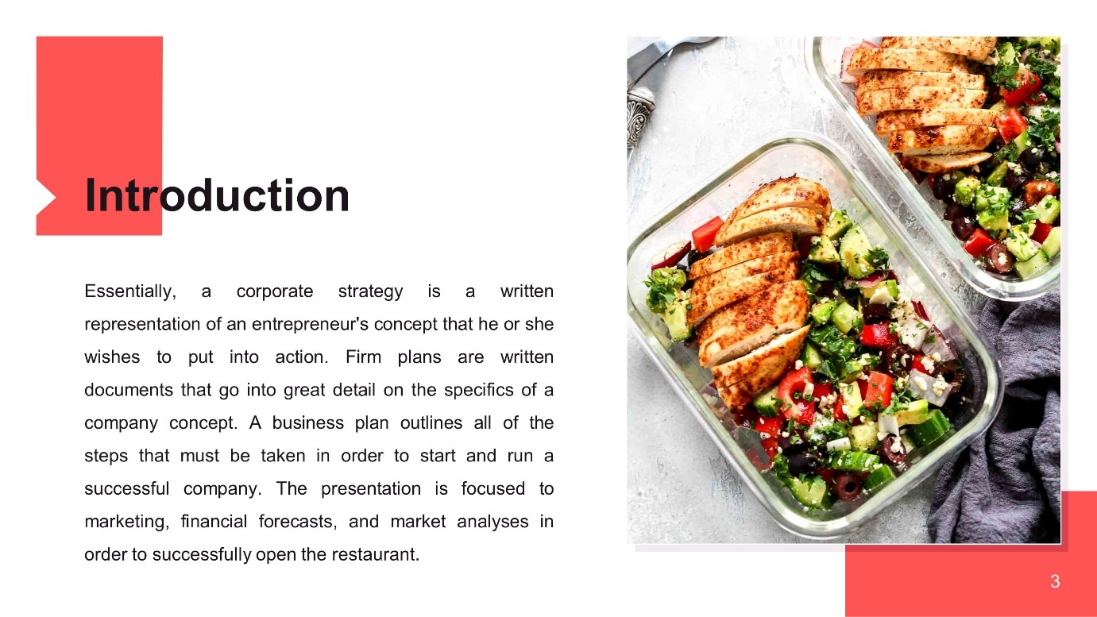
Essentially, a corporate strategy is a written representation of an entrepreneur's concept that he or she wishes to put into action. Firm plans are written documents that go into great detail on the specifics of a company concept. A business plan outlines all of the steps that must be taken in order to start and run a successful company. The business plans contain some attainable company objectives as well as road maps for achieving those objectives (Taylor and Jelen, 2008). When starting a company, it is critical to have a well-thought-out business strategy. This article discusses the procedures and tactics that must be followed in order to establish a successful restaurant. The paper is devoted to marketing, financial forecasts, and market analyses in order to successfully open the restaurant.
Company Description – Mission and Vision
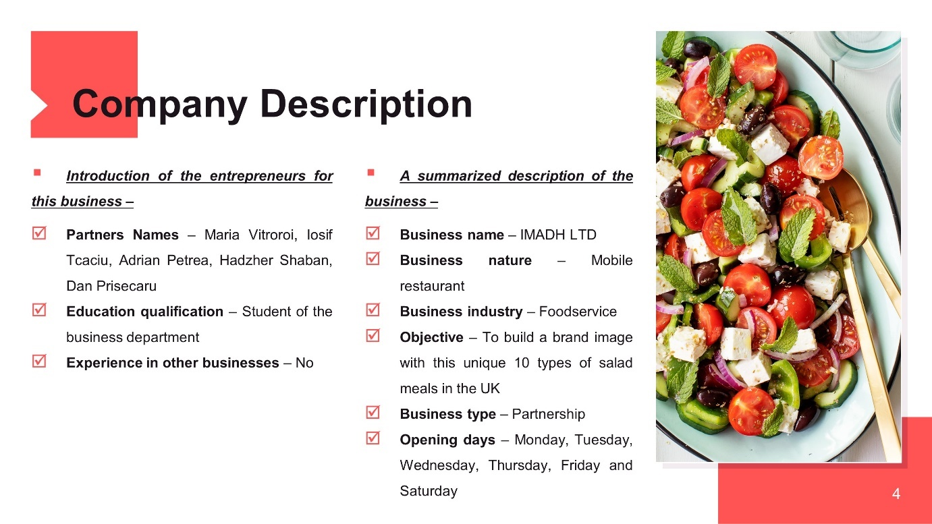
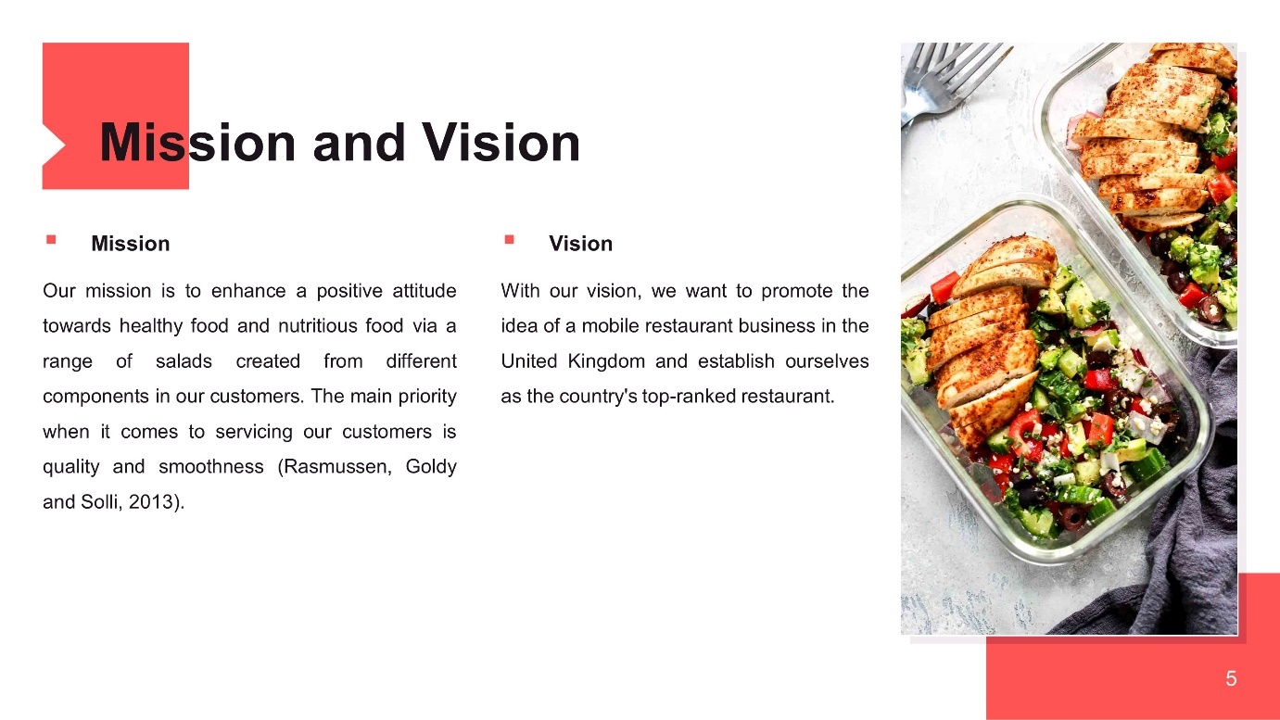
Introduction of the entrepreneurs for this business –
- Partners Names – Maria Vitroroi, Iosif Tcaciu, Adrian Petrea, Hadzher Shaban, Dan Prisecaru
- Education qualification – Student of the business department
- Experience in other businesses – No
A summarized description of the business –
- Business name – IMADH LTD
- Business nature – Mobile restaurant
- Business industry – Foodservice
- Objective – To build a brand image with this unique 10 types of salad meals in the UK
- Business type – Partnership
- Opening days – Monday, Tuesday, Wednesday, Thursday, Friday and Saturday
Mission
Our mission is to enhance a positive attitude towards healthy food and nutritious food via a range of salads created from different components in our customers. The main priority when it comes to servicing our customers is quality and smoothness (Rasmussen, Goldy and Solli, 2013). We offer our guests some excellent nutritious meals at a reasonable price, so that they may be eaten and viewed in our live kitchen products that are open to the public from all socioeconomic backgrounds. We also do a live performance in our shop in our kitchen, which is publicly accessible.
Vision
With our vision, we want to promote the idea of a mobile restaurant business in the United Kingdom and establish ourselves as the country's top-ranked restaurant.
Legal compliances
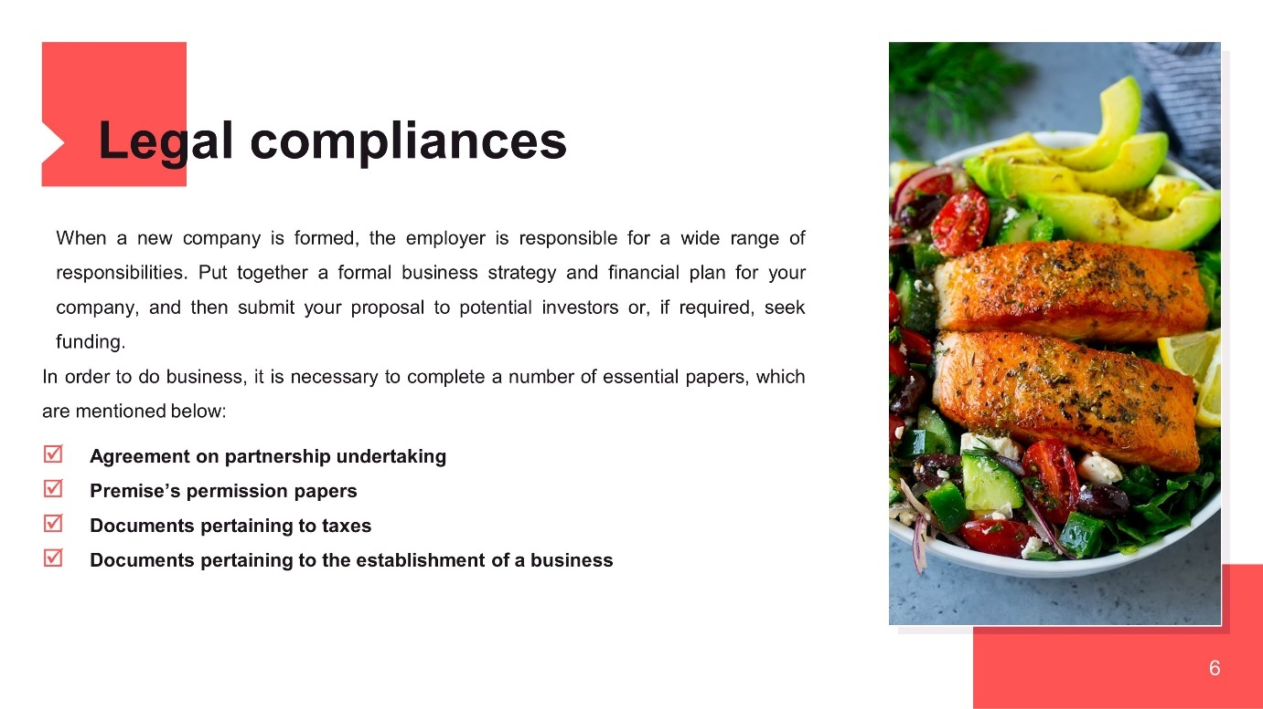
When a new company is formed, the employer is responsible for a wide range of responsibilities. Put together a formal business strategy and financial plan for your company, and then submit your proposal to potential investors or, if required, seek funding. Undoubtedly, one of the most challenging tasks is ensuring that all legal responsibilities are fully and completely fulfilled (Rachlin, Sweeny and Sweeny, 2014). Despite the fact that responsibility is very important, it is often neglected. Additionally, it is critical that the provisions of our formal partnership agreement specify the manner in which each Member will share in the company's capital, profit, and loss. In order to do business, it is necessary to complete a number of essential papers, which are mentioned below:
- Agreement on partnership undertaking
- Premise’s permission papers
- Documents pertaining to taxes
- Documents pertaining to the establishment of a business
Management process
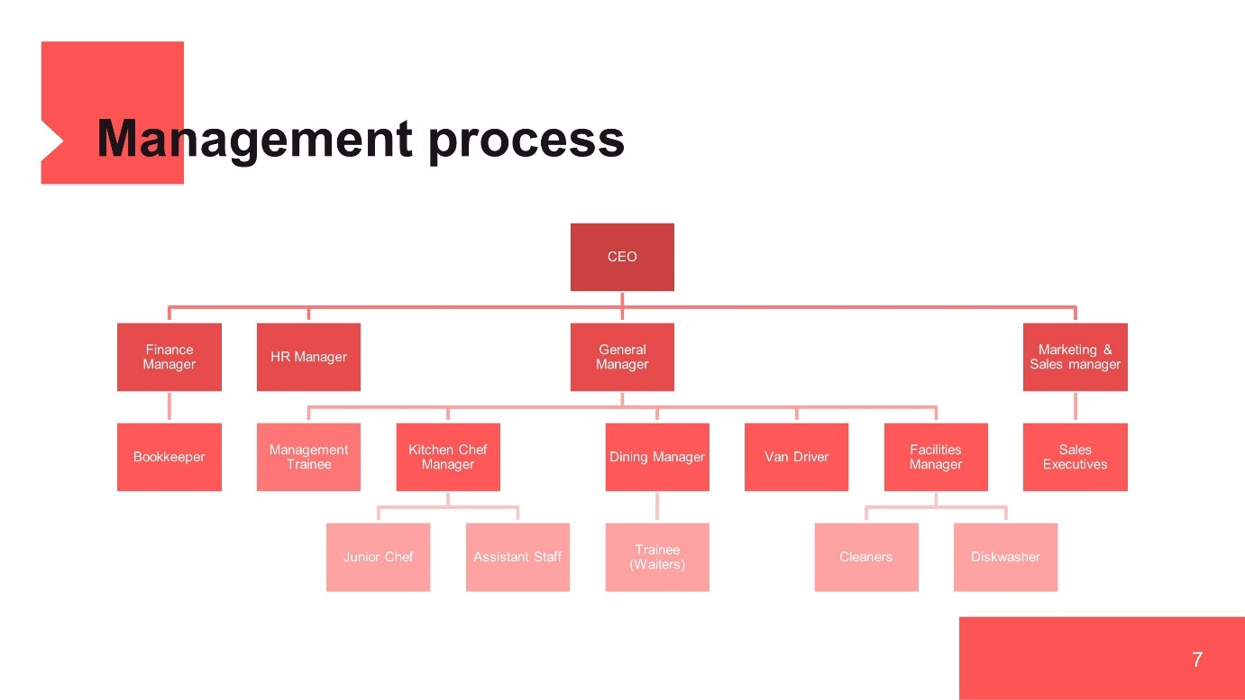
This portion provides information on our management team, our employees, as well as the ownership and management structure of our organization. Employees that are willing to work on behalf of all of our stakeholder groups are essential to the success of any business venture. The amount of a marginal benefit that our management personnel will receive will be determined by their performance over a period of at least five years, in compliance with business laws and regulations (Paul, Cadle and Yeates, 2017). Based on its collaboration with a group of five individuals, one of our most understandable members was chosen to serve as CEO, and four others will serve as Departmental Heads in various departments like finance, human resources, general management, and sales. Additional information about the engagement of other employees in the management planning process can be found in the management plan chart.
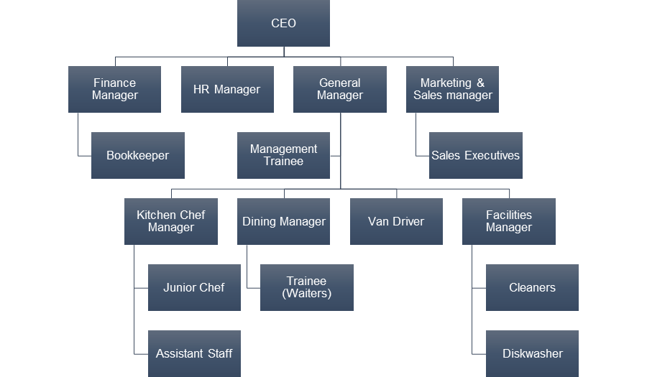
Administration of business
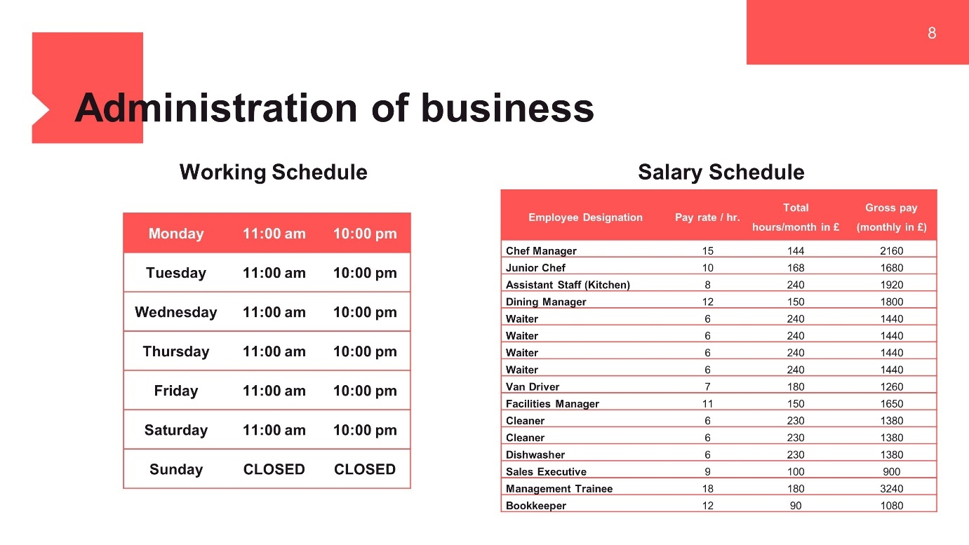
Working Schedule
The office will take place on weekdays from Monday to Friday between 11:00 am to 10:00 pm and from 12:00 am to 10:00 pm on Saturday. Sunday we will be closed. The entire opening days of the restaurant is anticipated to be 317 working days each year, or 317 days in one financial year.
Salary Schedule
Pay plans include information on an employee's income, salary, beneficiaries and payment arrangements, as well as the employee's financial status, among other things. A chef has been appointed, and a junior chef and an assistant worker aid him in the course of his daily job in the kitchen (Palepu et al., 2016). Four members of staff are available throughout the day to meet their needs via a variety of shifts, as well as to ensure that customers are comfortable in their surroundings. To guarantee that plates and other serving items are properly cleaned before each meal is served, cleaners and dishwashers work alongside the kitchen staff. Van’s driver is compensated at a rate per hour that is comparable to that of school bus drivers. The pay schedule chart is shown in the following manner on the presentation diagram:
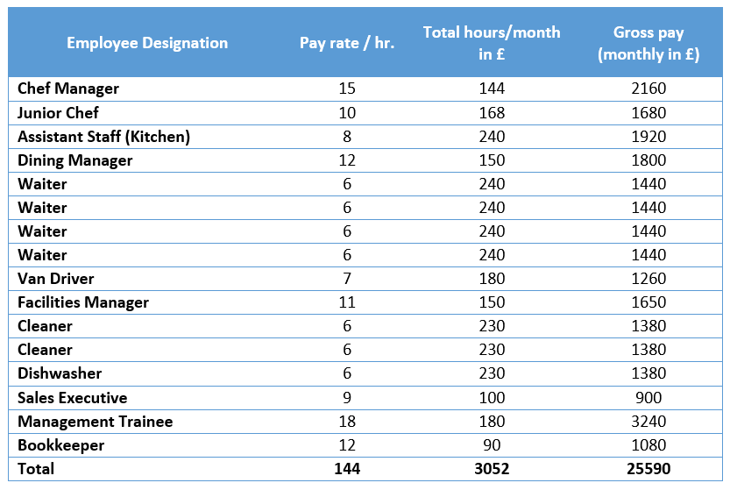
Marketing
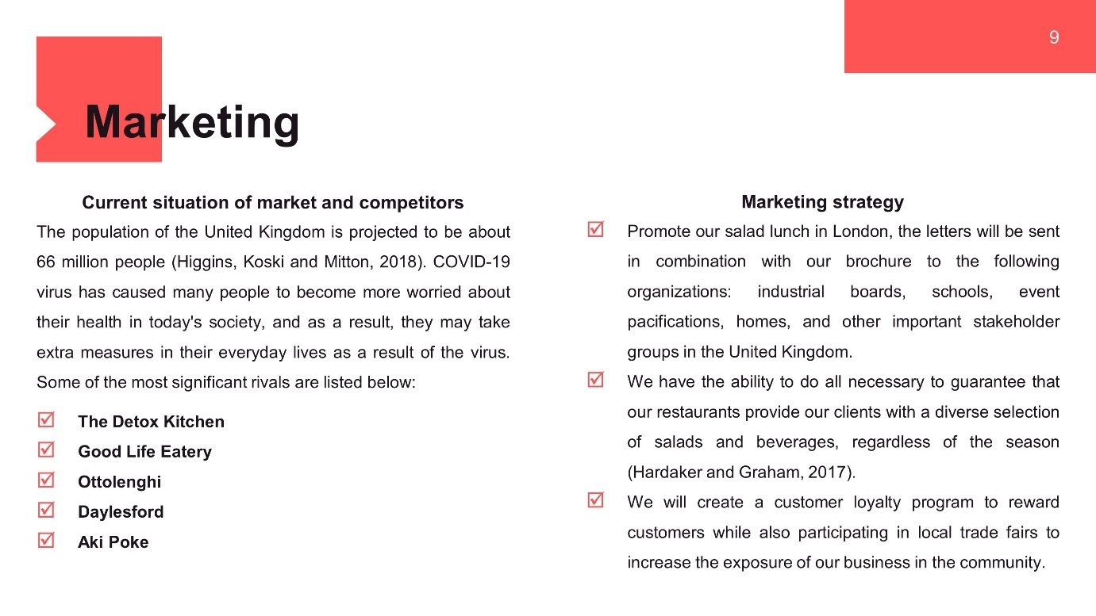
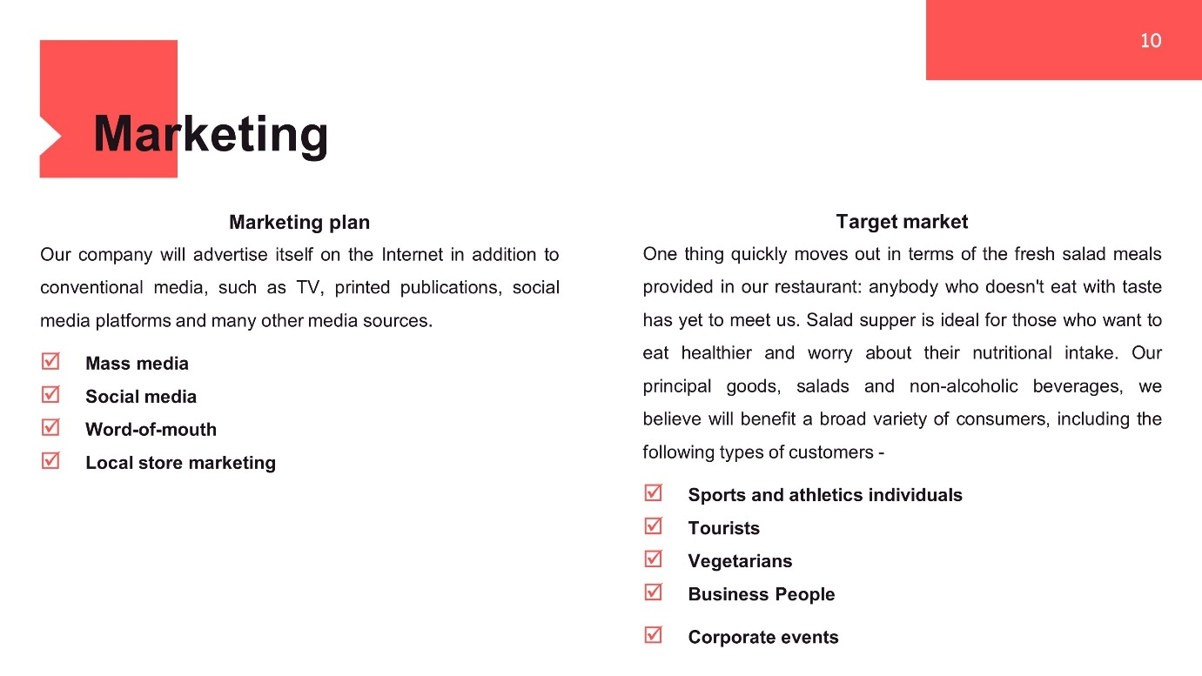
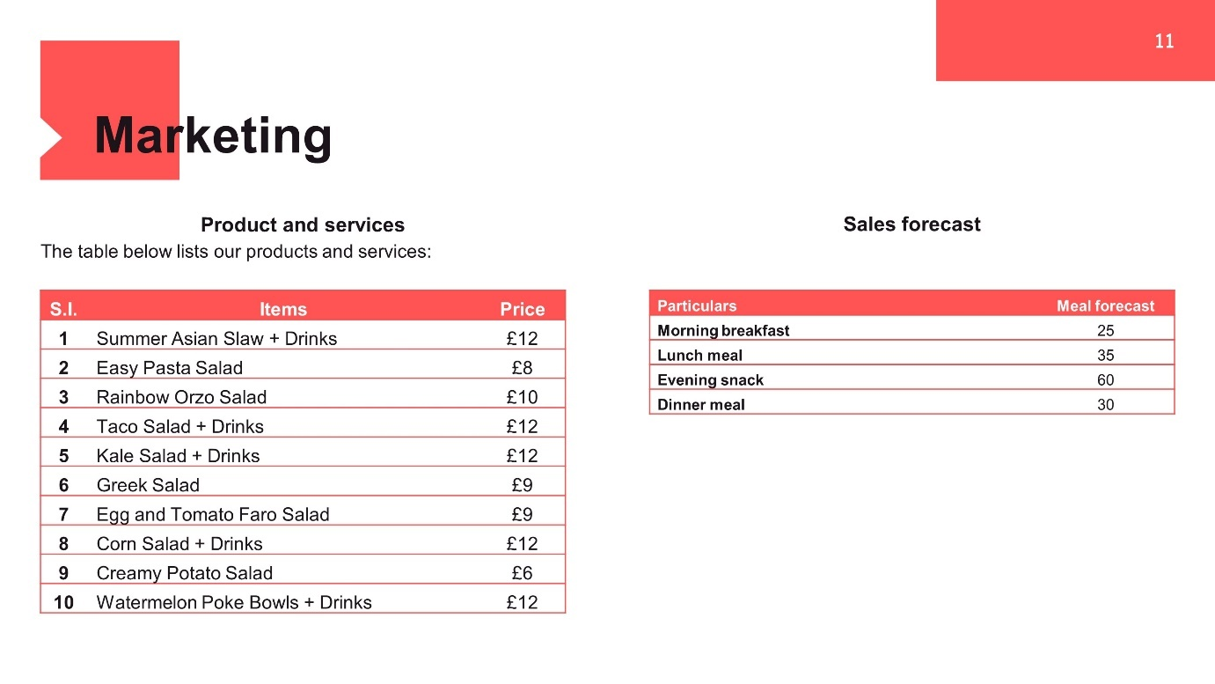
Current situation of market and competitors
The population of the United Kingdom is projected to be about 66 million people (Higgins, Koski and Mitton, 2018). Foreign visitors to the United Kingdom have been declining on a daily basis in recent months as a result of the COVID-19 locks and other restrictions. This is despite a rise in total international tourists entering the country from all around the globe during this period. Furthermore, the introduction of the COVID-19 virus has caused many people to become more worried about their health in today's society, and as a result, they may take extra measures in their everyday lives as a result of the virus. As a consequence, we will be better able to create competitive pricing and react to competitor marketing with our own efforts, which will ultimately benefit both of us in the long term. Some of the most significant rivals are listed below:
- The Detox Kitchen
- Good Life Eatery
- Ottolenghi
- Daylesford
- Aki Poke
Marketing strategy
- To further promote our salad lunch in London, the letters will be sent in combination with our brochure to the following organizations: industrial boards, schools, event pacifications, homes, and other important stakeholder groups in the United Kingdom.
- We have the ability to do all necessary to guarantee that our restaurants provide our clients with a diverse selection of salads and beverages, regardless of the season (Hardaker and Graham, 2017).
- We will create a customer loyalty program to reward customers while also participating in local trade fairs to increase the exposure of our business in the community.
Marketing plan
Our company will advertise itself on the Internet in addition to conventional media, such as TV, printed publications, social media platforms and many other media sources.
- Mass media
- Social media
- Word-of-mouth
- Local store marketing
Target market
One thing quickly moves out in terms of the fresh salad meals provided in our restaurant: anybody who doesn't eat with taste has yet to meet us. Salad supper is ideal for those who want to eat healthier and worry about their nutritional intake. We will start with London, the United Kingdom and will gradually extend our presence throughout the nation, including in the United States, as our business develops and is rented (Hamper and Baugh, 2018). Our principal goods, salads and non-alcoholic beverages, we believe will benefit a broad variety of consumers, including the following types of customers -
- Sports and athletics individuals
- Tourists
- Vegetarians
- Business People
- Corporate events
Product and services
We will work hard to provide our customers access to many different types of salads and soft drinks. IMAADH LTD. is a successful Salad Food business. The table below lists our products and services:
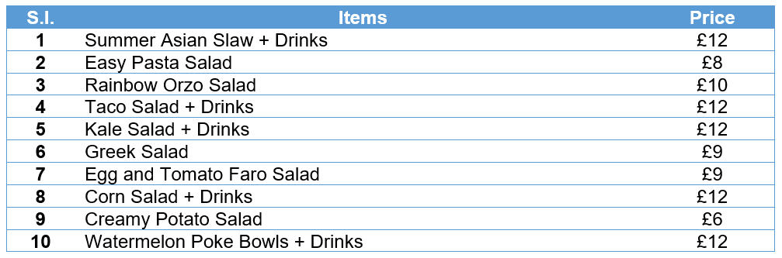
Sales forecast
Particulars | Meal forecast
Morning breakfast | 25
Lunch meal | 35
Evening snack | 60
Dinner meal | 30

Finance Forecast
Investment plan
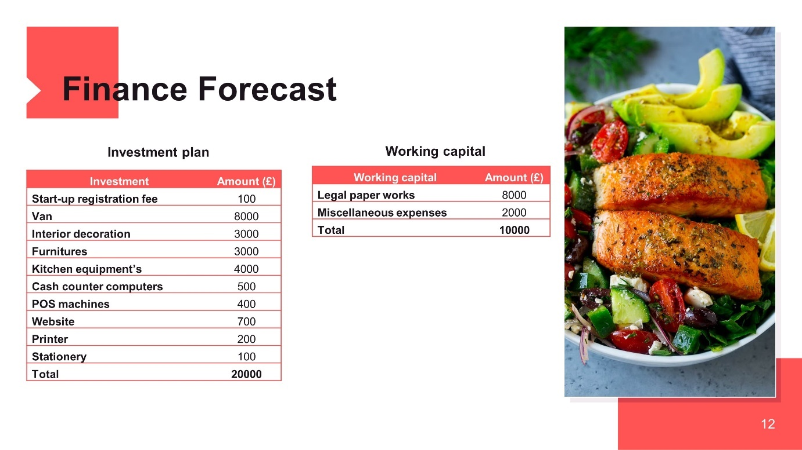
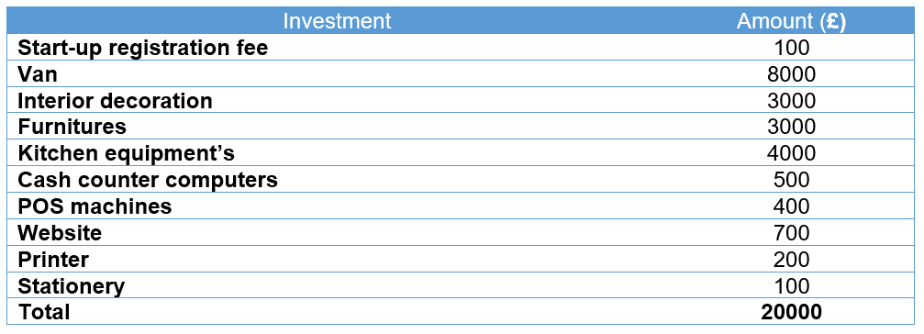
Ensure that, during this time, the business earns enough money to cover all the expenses of obtaining a basic installation in a suite location, buying an audio system, paying our staff and covering utilities' charges. The investor gives £10,000 and their own assets provide £20,000 partners.
Income statement forecast
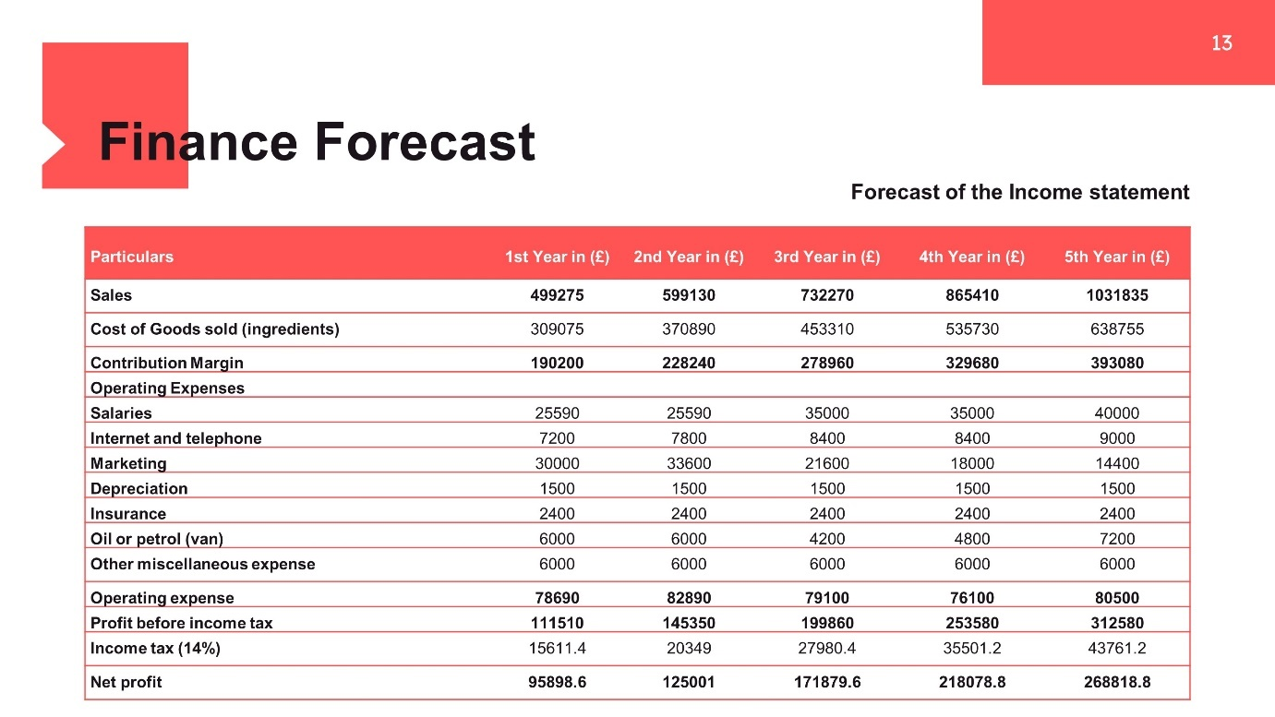
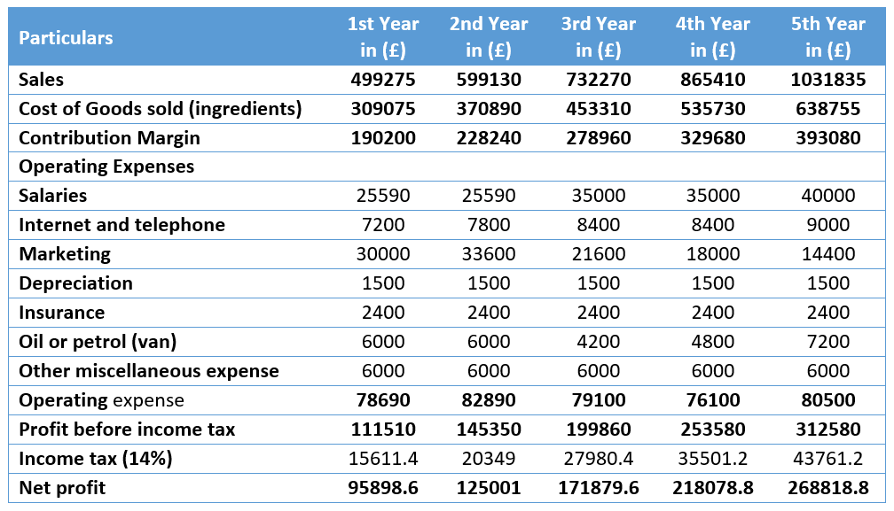
As a consequence, yearly revenues are expected to be £475,500, up from the previous year. According to our projections, sales in the second, third and fourth years of the restaurant are projected to increase an average of 20% per year.
Balance sheet forecast
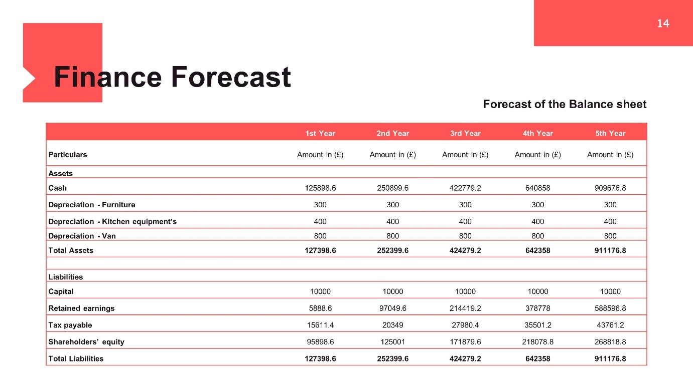
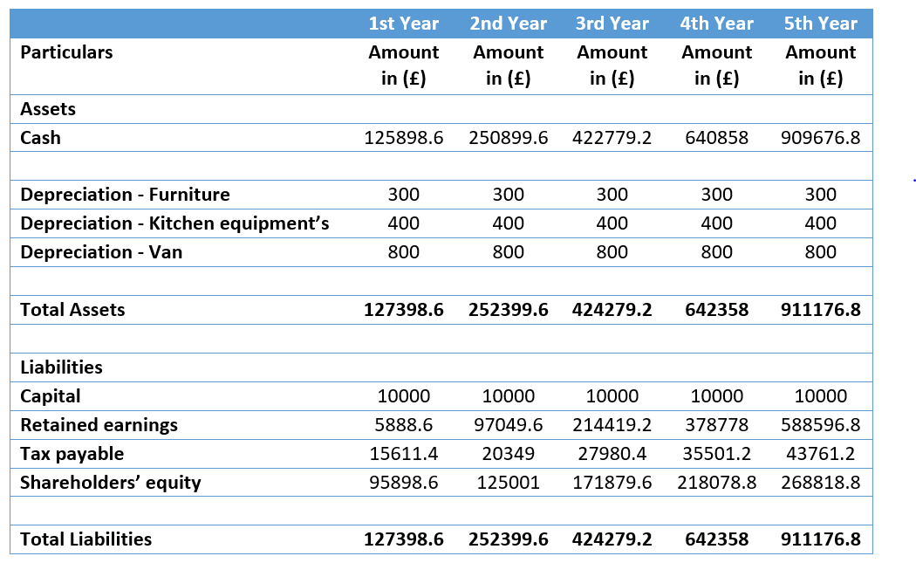
The capacity to warn us early on about possible financial problems is one of the most valuable features of the balance sheet. It is a very useful tool even in the following under a broad range of situations. We can establish how much money we owe and how much money we have in the bank by examining our cash balance.
Cash flow statement forecast
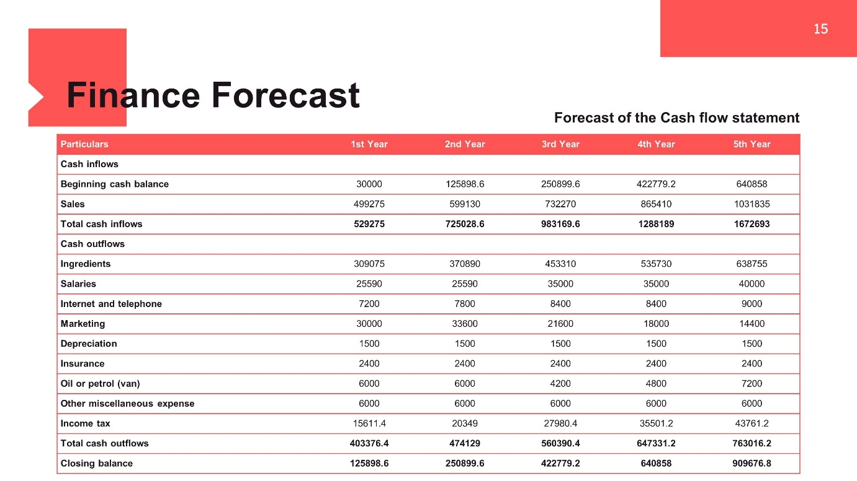
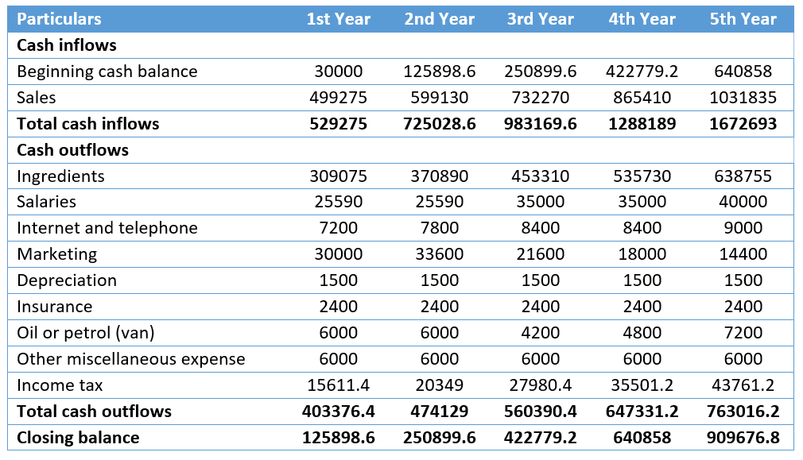
Our business shows the transfer of money into and out of the company in its cash flow statement. This statement thus provides information on the cash flow in the past quarter (Franses and Paap, 2014). In general, a cash flow estimate indicates how much money is anticipated to be generated or spent in the future during a given period.
Training needs of employees
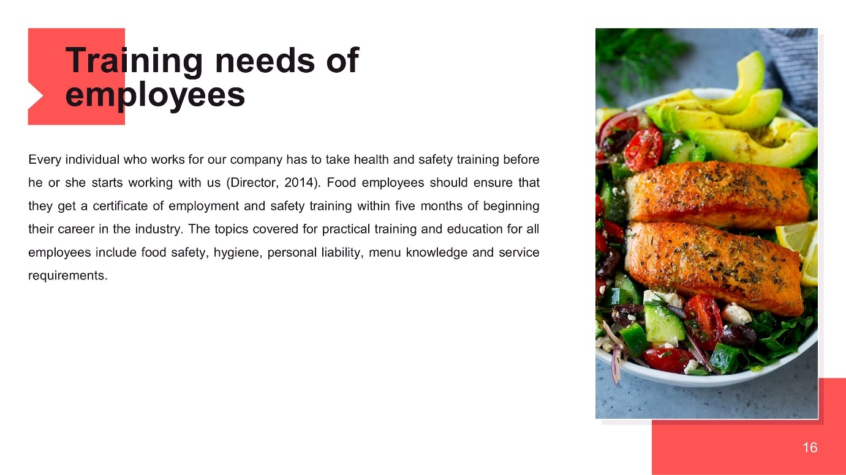
Every individual who works for our company has to take health and safety training before he or she starts working with us (Director, 2014). Food employees should ensure that they get a certificate of employment and safety training within five months of beginning their career in the industry. The topics covered for practical training and education for all employees include food safety, hygiene, personal liability, menu knowledge and service requirements.
PEST analysis
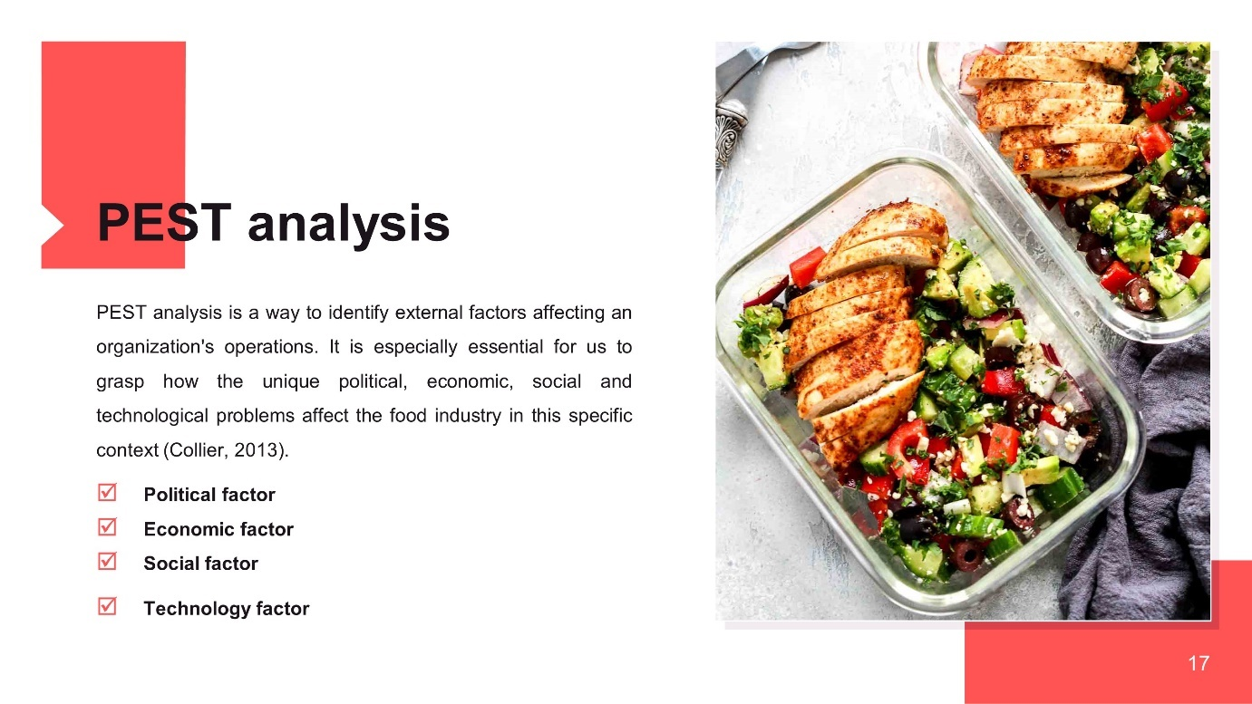
PEST analysis is a way to identify external factors affecting an organization's operations. It is especially essential for us to grasp how the unique political, economic, social and technological problems affect the food industry in this specific context (Collier, 2013).
Political factor
Some of politics' impacts include fiscal reform, health and security legislation and other types of political influence. We take care of the food throughout the whole process from the moment the ingredients were bought through the cooking and packing procedures until the food was delivered to our customers.
Economic factor
If the inflation of our economy rises, then running our restaurant will cost us more, since it will affect the price of the products and services, we use to manufacture our meals (Armstrong, Kotler and Opresnik, 2019).
Social factor
A number of social factors, some negative or others positive, may influence our profitability. People grow increasingly conscious of their health with the passing of time.
Technology factor
It is important that our mobile phones have a closed-circuit TV camera installed (Clay, 2015). Manual registers remain in use to control restaurant and other transactions for a small number of businesses.
SWOT analysis
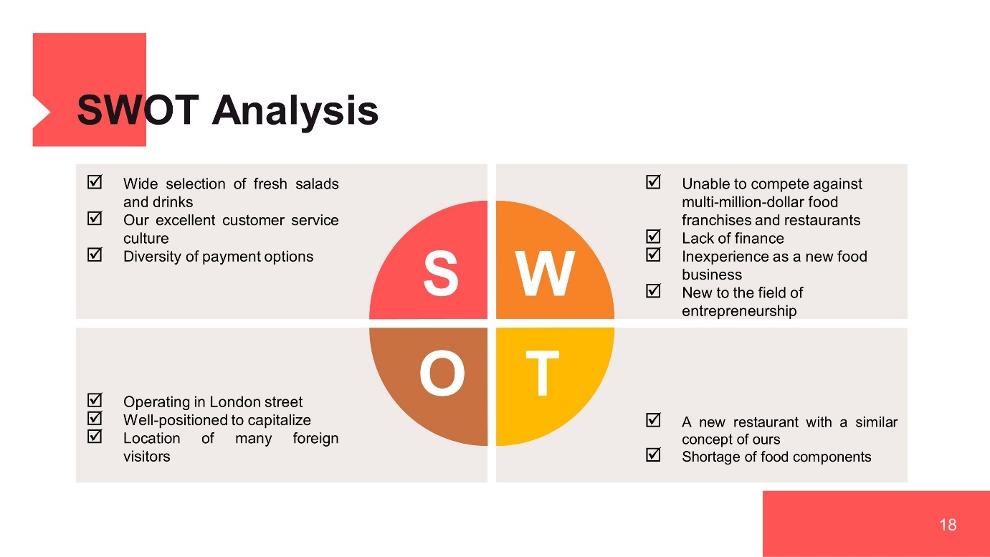
We intend on running a fresh salad restaurant in London, UK for the first five years simply to see whether we are spending more or not in growing the business and then constructing other locations throughout the city (Arkebauer and Miller, 2016). In the next part, the SWOT analysis on behalf of IMADH LTD is summarized in detail –
Strength
- Wide selection of fresh salads and drinks
- Our excellent customer service culture
- Diversity of payment options
Weakness
- Unable to compete against multi-million-dollar food franchises and restaurants
- Lack of finance
- Inexperience as a new food business
- New to the field of entrepreneurship
Opportunities
- Operating in London street
- Well-positioned to capitalize
- Location of many foreign visitors
Threat
- A new restaurant with a similar concept of ours
- Shortage of food components
Conclusion
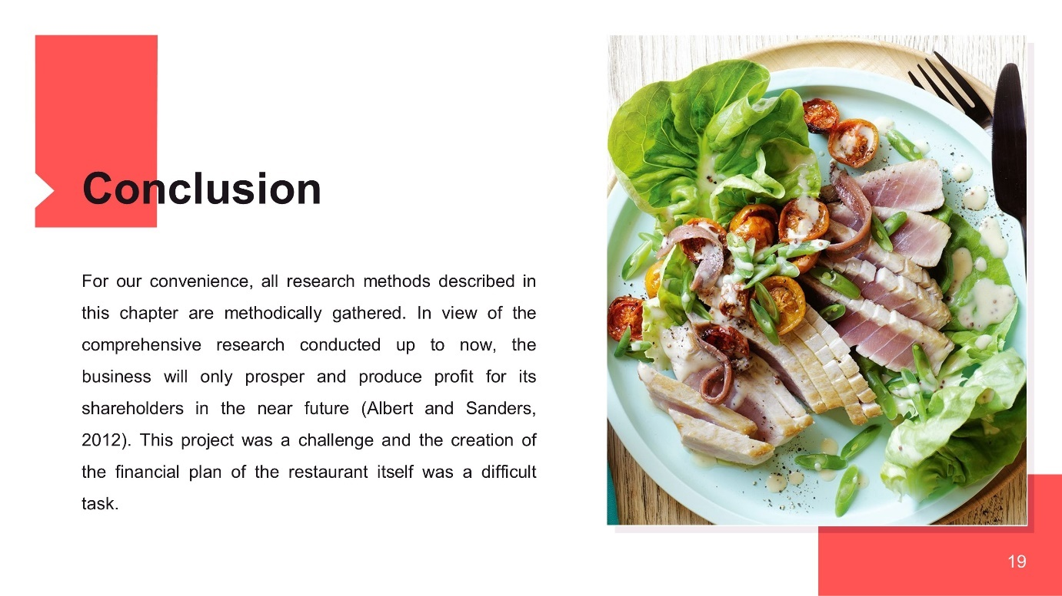
For our convenience, all research methods described in this chapter are methodically gathered. In view of the comprehensive research conducted up to now, the business will only prosper and produce profit for its shareholders in the near future (Albert and Sanders, 2012). If the firm succeeds, it can be expected from the very beginning of its operations that a company will profit from financial calculations. This project was a challenge and the creation of the financial plan of the restaurant itself was a difficult task. Because the restaurant management could not get much information, it was difficult to assess exactly what took occurred.
References
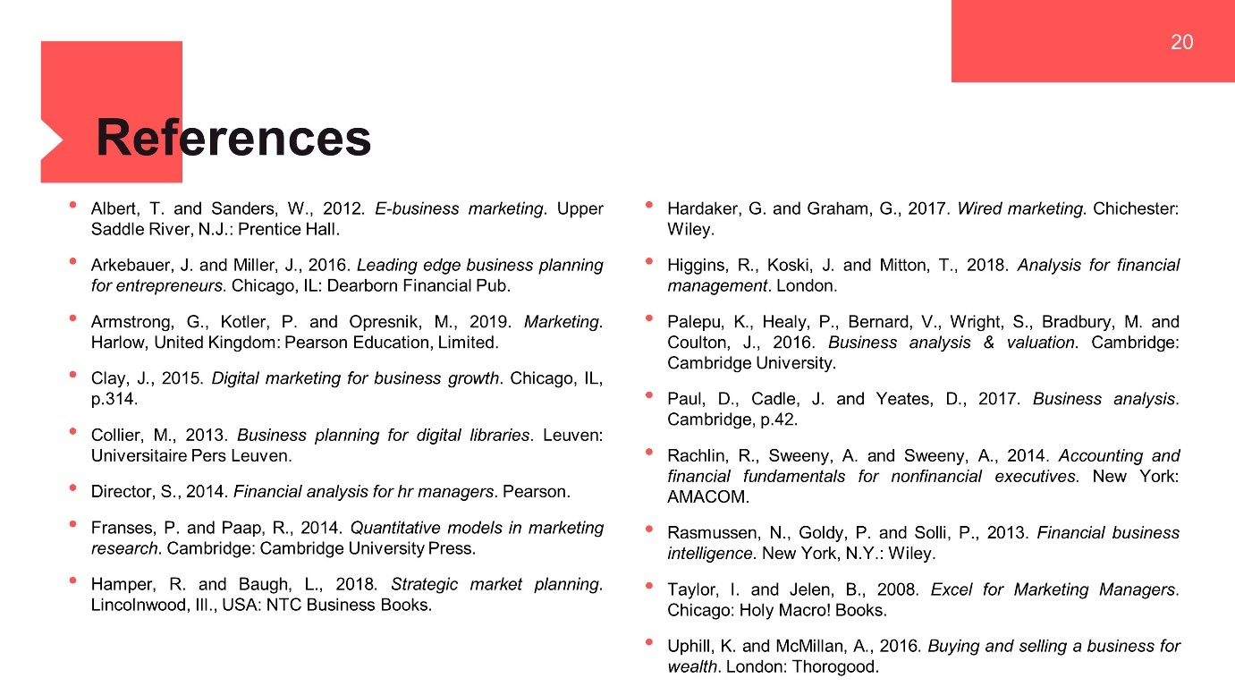

Albert, T. and Sanders, W., 2012. E-business marketing. Upper Saddle River, N.J.: Prentice Hall.
Arkebauer, J. and Miller, J., 2016. Leading edge business planning for entrepreneurs. Chicago, IL: Dearborn Financial Pub.
Armstrong, G., Kotler, P. and Opresnik, M., 2019. Marketing. Harlow, United Kingdom: Pearson Education, Limited.
Clay, J., 2015. Digital marketing for business growth. Chicago, IL, p.314.
Collier, M., 2013. Business planning for digital libraries. Leuven: Universitaire Pers Leuven.
Director, S., 2014. Financial analysis for hr managers. Pearson.
Franses, P. and Paap, R., 2014. Quantitative models in marketing research. Cambridge: Cambridge University Press.
Hamper, R. and Baugh, L., 2018. Strategic market planning. Lincolnwood, Ill., USA: NTC Business Books.
Hardaker, G. and Graham, G., 2017. Wired marketing. Chichester: Wiley.
Higgins, R., Koski, J. and Mitton, T., 2018. Analysis for financial management. London.
Palepu, K., Healy, P., Bernard, V., Wright, S., Bradbury, M. and Coulton, J., 2016. Business analysis & valuation. Cambridge: Cambridge University.
Paul, D., Cadle, J. and Yeates, D., 2017. Business analysis. Cambridge, p.42.
Rachlin, R., Sweeny, A. and Sweeny, A., 2014. Accounting and financial fundamentals for nonfinancial executives. New York: AMACOM.
Rasmussen, N., Goldy, P. and Solli, P., 2013. Financial business intelligence. New York, N.Y.: Wiley.
Taylor, I. and Jelen, B., 2008. Excel for Marketing Managers. Chicago: Holy Macro! Books.
Uphill, K. and McMillan, A., 2016. Buying and selling a business for wealth. London: Thorogood.

