Module : Effective Team-working and Communication

Presentation on Teamwork Theories and Models

Prepared By Salma Siddika
Student ID 2118578

The difference between groups and teams:

Definition of Group:

A group is formed when two or more people are together for a common or individual goal or cause either by the organization or for social reasons. For example, a study group.

Definition of Team:

Williams J defined team as a group of people with complementary abilities who are dedicated to a common goal and who work both individually and together to achieve certain goals( 2002, p.33). For example, we are a team of 4 members preparing a presentation.

The differences between teams and group are described below in terms of elements, Tuckman Theory and Belbin theory

Elements :

DuFour R described that a team has 3 elements,

Working interdependent
Mutually Accountable
Shared goals (2009, online)

For example our team has 4 members who are working codependently to prepare the project.

On the other hand group members work Independently, They are Individually accountable and work towards Individual or common goal. For example, a department in a office is a group where members working on their individual tasks.

Tuckman Theory:

Tuckman (1965, p.384–399) developed a theory of team development which has 5 stages.

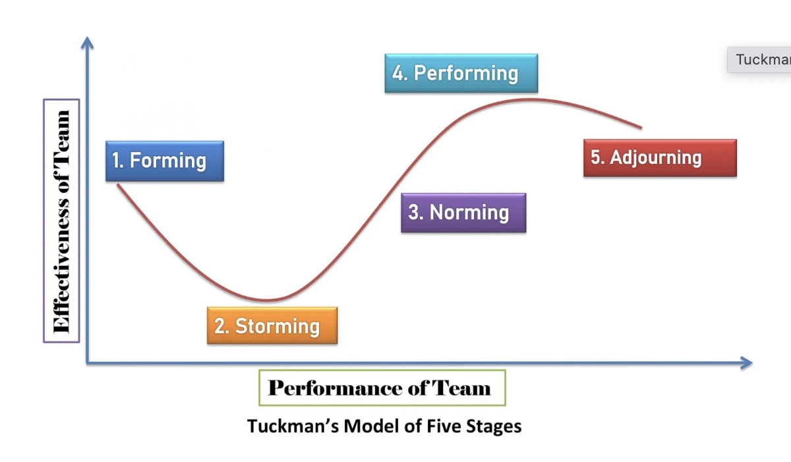
This theory describes that any team development goes through 5 key stages which are

- Forming:
- Initial communication.
- participants consider personal and group aims.
- Uncomfortable about working with a new group

- Storming:
- Group members initiate conflicting ideas
- Members compete for position

- Norming:
- Cooperation developed
- Conflicts are settled

- Performing:
- Teamwork achieved.
- Team role becomes flexible
- Adjourning:
- When team work finishes.
- Members may reluctant to the change
So as discussed above, a team development goes through these stages whereas a leader simply delegates work to the member and they work individually in a group.

Belbin theory:

According to Belbin, team members can be categorized in 9 roles (2010, p22)-

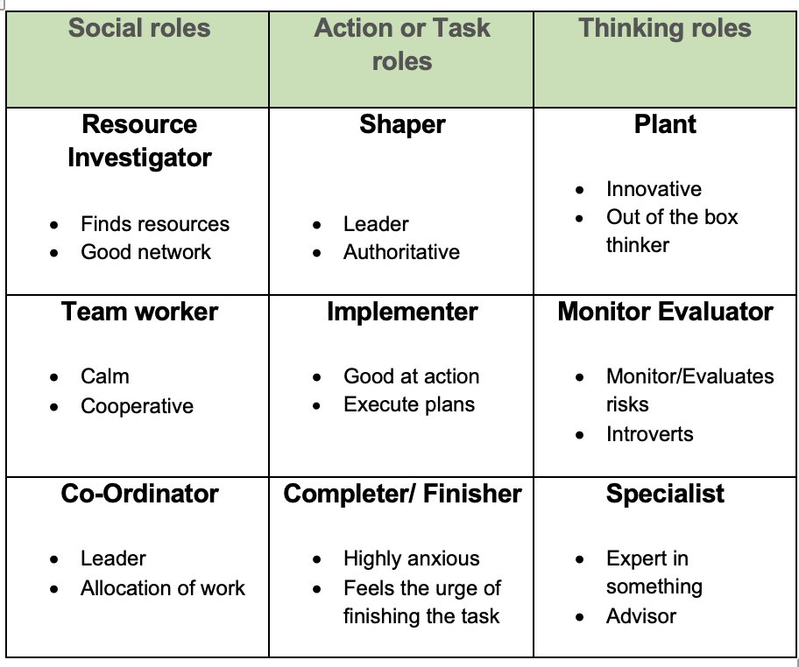

All roles should be present or compensated to become a successful team (Belbin.com, nd, online).

So it’s clear that team roles are more defined than group roles. Team can have more than one leader, Group doesn’t. For example we have 2 leaders in our group, Muhammad and Catalina.

The characteristics of effective teams

An effective team should-

- According to Tuckman, go through stages to form.

- Belbin describes that a top performing team should have the following characteristics:

- The attributes of the person in Leadership

- The existence of a good Plant

- Distribution in the responsibilities of members to match their different capabilities

- An adjustment to the realization of imbalance. (Belbin R M, 2010, p.90)

For example, We did not have any monitor evaluator in our team so we decided to use completer finisher role to compensate missing monitor evaluator role

According to Parker G, characteristics on an effective team are

Clear Purpose accepted by everyone.

There is an action plan.

Informality (working in an informal, comfortable environment)

Participation (2008, p.221)

The benefits of effective teams:
- Most important benefit of effective team is to achieve Synergy (2+2=5)
- An effective team can minimise the storming stage.
- Increased performance among members as they learn from each other's mistakes and achievements.
- When a team is selected, assembled, supported, and enabled, effectively and efficiently, the results can far outweigh those achievable by members acting individually.

Temelkovska R describes that an effective team would have following benefits:

1. It Boosts Creativity and Productivity
2. Network of Support
3. Effective Team Collaboration Attracts Talent and Builds Reputation
4. Enhances conflict Resolution Skills (AboutLeaders, nd, online)

Gersick's model of Group Development in Punctuated Equilibrium
shows that there are natural transition points in the team life when the group is receptive to change, and that one of these moments happens at the project's scheduled halfway. (1988, p.9-41)

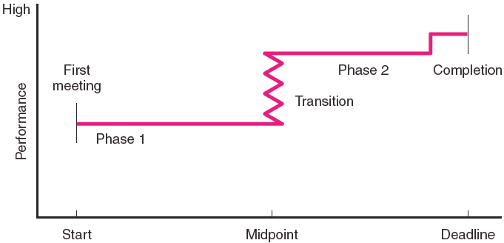

Gersick's model of Group Development

An effective team will establish many transition points for natural team development by imposing a series of deadlines connected with major milestones which would save resources and achieve more.

Reference:

Belbin R M(2010) Team Roles at Work. 9th edn. London: Routledge

Belbin R M (2010). Management Teams: Why They Succeed or Fail.3rd Ed. Oxford: Butterworth-Heinemann

Gersick, C. J. G. (1988). ‘Time an transition in work teams: Toward a new model of group development’. Academy of Management Journal, 31(1), 9-41

Parker, G M (2008) Team players and team work: new strategies for developing successful collaboration. California: Jossey-Bass

Puscasu A (2022). The Punctuated Equilibrium Model of Group Development. [Online]. Available at: http://apepm.co.uk/punctuated-equilibrium. [Accessed 8 June 2022]

Rogers K (nd) The Difference Between Groups and Teams: Definition & Contrasts. Available at: https://study.com/academy/lesson/the-difference-between-groups-and-teams-definition-contrasts.html [Accessed 8 June 2022]

Solution Tree: Rick DuFour on Groups vs. Teams (2009) Youtube Video, added by Solution Tree [Online]. Available at https://www.youtube.com/watch?v=0hV65KIItlE
[Accessed 10 June 2022]

Temelkovska R(nd).’4 Benefits of Effective Teamwork and Collaboration’.AboutLeaders.Available at: https://aboutleaders.com/benefits-effective-teamwork-and-collaboration/
[Accessed 10 June 2022]

“The Nine Belbin Team Roles”. Belbin.com, Available at: https://www.belbin.com/about/belbin-team-roles. [Accessed 10 June 2022]

Tuckman, B. (1965). ‘Developmental sequence in small groups’. Psychological Bulletin, 63. Available at: http://www.communicationcache.com/uploads/1/0/8/8/10887248/developmental_sequence_in_small_groups.pdf. [Accessed 11 June 2022]

Williams J (2002) Team Development for High-tech Project Managers. London: Artech House

