

Assessment 2: Written assignment

Programme: BA BUSINESS MANAGEMENT
Module name: MANAGING PEOPLE
Module code: LCBB5004
Student name: ALEXANDRA CREANGA
Student ID: 2113195

Table of Contents
PART ONE 3
Introduction 3
Figure 1: CIPD Professional Map 3
Importance of Core Behaviours for Effective HR Professionals Working in the UK 4
Usage of the map by HR professionals across sectors and company sizes 6
PART 2 8
Introduction 8
Skills shortages reason despite significant unemployment in the UK public sector 9
Figure 2: Skills shortages 9
Long-term labour market trends and skills shortages in UK healthcare 10
Figure 3: Long-term labour market trends and skills shortages 11
Conclusion 12
References 13

PART ONE

Introduction
For more than a century, the Chartered Institute of Personnel and Development (CIPD), which has 140,000 members across the globe, has been the organisation that establishes best practices for human resources and learning and development (Birkenhead, 2022). Core values, knowledge, and behaviours are only some of the topics covered by the CIPD Map, which tackles both mandated and elective aspects of human resource management. The CIPD Map identifies four degrees of effect, as well as the abilities and attitudes that are necessary to accomplish each level.
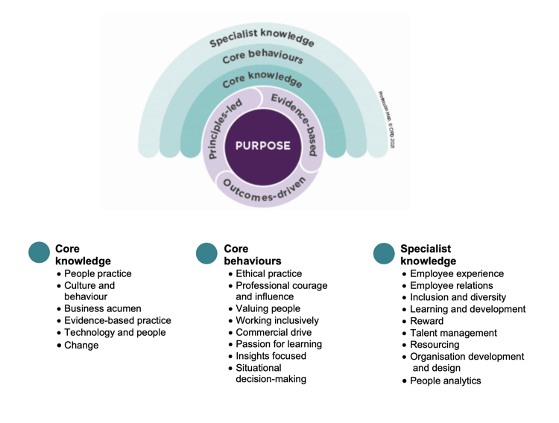

Figure 1: CIPD Professional Map
Source: (CIPD, 2021)

Importance of Core Behaviours for Effective HR Professionals Working in the UK
The eight basic behaviours outlined in the CIPD Profession map suggest a change for HR professionals. It can add value for individuals, organisations, society, and the profession by prioritising ethical and evidence-based decision-making (Gupta, 2020). These behaviours are necessary for successful human resources workers in the UK.
Ethical practice: Today, when everything is out in the open, more unpleasant things are happening. The HR department should serve as an example of moral conduct in the workplace and set the tone for the rest of the company. Having a consistent ethical framework provides professionals guidance as they make important decisions and avoid potential ethical pitfalls (Bratton & Gold, 2017). The morale of an ethical culture can be boosted and mitigate moral hazards mitigated by promoting an ethical culture. Ethical behaviour has a beneficial effect on macroeconomic performance and consumer interactions.
Professional courage and influence
When honesty, fairness, and "being right" are used as weapons, HR, OD, and L&D professionals are responsible for speaking out. Human resources professionals need the intestinal fortitude to stand up for what's right and advocate for the best possible outcomes (Gupta, 2020). The advent of innovative digital tools and economically, socially, and commercially viable business models have presented us with current issues that call for bold action.
Valuing people
For a team to succeed, shared ideals are essential. When dealing with employees, suppliers, CEOs, and other societal stakeholders, it helps to communicate kindness and humanity to lessen the potential for conflict (BRATTON, 2017). Human resource professionals should value and prioritise staff. It is essential to strike a balance between being judgmental and urging others to show empathy and justice.

Working inclusively
As more projects span national boundaries, geographic regions, and cultural traditions, it becomes increasingly important to recognise and equip workers with the skills they need to work together effectively. Human resources professionals affect a company's success by fostering transparency, encouraging cross-functional collaboration, building trust, and providing practical solutions to problems.
Commercial Drive
Financial metrics for employees and the company must be at the forefront of any human resources professional's mind. They resolve the most pressing issues, openings, and dangers associated with human resources in the organisation (Porter et al., 2017). This role entails talking to customers, understanding complex financial duties, providing evidence that the change is worthwhile, and carrying them out independently. Persons working in human resources need to take care of themselves to maintain their vitality and resilience.
Passion for learning
Professionalism is predicated on a commitment to lifelong learning, and this attitude centres on how individuals foster continuing professional development (CPD) in themselves and their peers (Trullen & Valverde, 2017). Education in HR must be comprehensive. Human resource professionals can learn a lot by asking others for their opinions on standard practices, exploring the interests of those in different fields, and having an open dialogue with those with more specialised knowledge.
Insights focused
In their expert roles, human resources professionals need to employ a systematic approach to problem identification and diagnosis, drawing on multiple sources of information to arrive at conclusions and recommendations of individuals (Rogers, 2019). It will assist Human Resources in obtaining fantastic success in their role.
Situational decision-making
Choices made using situational reasoning are more likely to be productive and pragmatic than those made using a "one size fits all" mentality. Indicating the merits, risks, and accepted practices of potential choices. Proficient experts know how to analyse each case individually and provide the optimal solution (Birkenhead, 2022). They have an insatiable appetite for learning new things and can adjust quickly to new situations. Contemporary desks allow for individualisation. Skill is required for the implementation of procedures and policies.

Usage of the map by HR professionals across sectors and company sizes
The Chartered Institute of Personnel and Development (CIPD) Profession Map is a dynamic set of standards created to aid HR professionals in enhancing working conditions worldwide. The purpose of the Profession Map is to encourage uniformity in HR practises by providing a common framework for measuring success and identifying areas for improvement. The map can assess one's strengths and areas for improvement, guiding professional development and planning one's or the team's future career steps (Porter et al., 2017). Individual, group and enterprise efficiency can all be improved with the help of Profession Map's standards because they provide a common ground for comparison.
To help those working in HR, the Chartered Institute of Personnel and Development has created the Profession Map. It is a resource that can be accessed online to aid personal growth, professional improvement, job preparation, and other similar endeavours. There are numerous advantages to the professional map, one of which is that businesses of any size in any field of expertise can use it (Rogers, 2019). One more benefit is that it covers all bases in terms of human resources and learning and development. Competency-based training can be designed because it is independent of factors like organisational hierarchy. This road map lays out the skills and practises that HR and L&D experts should have to meet our standards for expertise.
To keep a cohesive group identity, investing in the people who make that identity possible is essential. Professionals, in general, benefit from a standardised industry. Since the HR team shares its principles with the rest of the company, it is easier to build trust and promote positive change. The CIPD Profession Map categorises professional values as "principles-led," "evidence-based," and "outcome-driven." It was necessary to revise the CIPD map to account for the ever-changing nature of the working environment (Thomson, 2016). As a result of different priorities, tools, and methods of operation, human resources (HR) have seen a radical transformation in its role. Using the CIPD Profession Map will benefit businesses, HR experts, and, most of all, the workers who will benefit from the shift to a value-based decision-making approach.
As people's true worth becomes apparent after employing the map, previously inaccessible options become available. What is most important to remember from the new CIPD roadmap is that it may instil confidence that an HR professional and the company are doing everything necessary to ensure that the organisation conforms to the highest possible global industry standards (Trullen & Valverde, 2017). The map can assess one's strengths and areas for improvement, guiding professional development and planning one's or the team's future career steps. As a result of using Profession Map's benchmarks, operational efficiency can be improved at the individual, group, and organisational levels.

PART 2

Introduction
The unemployment rate in the United Kingdom is at a historic high. The OECD found that the United Kingdom had the highest rate of workers under qualification for their positions, at 40 per cent. The United Kingdom is severely weak in nearly all occupational skills and two-thirds of OECD knowledge areas. More businesses than in the previous quarter (46% this time) need help filling unoccupied positions. If we restrict our analysis to companies with openings, that percentage rises to 75%. Hard-to-fill parts were identified by 53% of for-profit organisations, 45% of NGOs, and 45% of private enterprises (Oosthuizen & van der Westhuizen, 2016). In particular, the healthcare industry (64%) and the building industry (51%) have many difficult positions to fill. Despite significant unemployment and long-term labour market dynamics, the paper will analyse public sector skill gaps to solve shortages in healthcare professions in the UK.

Skills shortages reason despite significant unemployment in the UK public sector
A skill shortage exists when businesses struggle to find qualified candidates for positions in a particular industry or specialised subject. The Industrial Strategy Council of the United Kingdom predicts that there will be a severe shortage of qualified workers in the field in the year 2027 (Kocór, 2019). The availability of people with the required skills is decreasing, making it more difficult for businesses to fill unfilled positions.
Last year, companies in the United Kingdom reportedly spent £4.4 billion on temporary workers, recruitment fees, and salary increases due to difficulties finding qualified workers to fill open positions. This trend has highlighted the significance of being available for professional growth, budgeting for adequate staff training, and actively seeking out talented new hires. Across 169 distinct professional fields, employers have reported just under 309,000 job openings. One hundred six thousand professional posts were hard to fill (Oosthuizen & van der Westhuizen, 2020). Of those jobs, just under 79,000 were deemed extremely difficult to serve due to a shortage of competent applicants. Most graduate employment openings are in nursing, computer programming, and human resources; nevertheless, there is a severe shortage of suitable applicants for these areas.
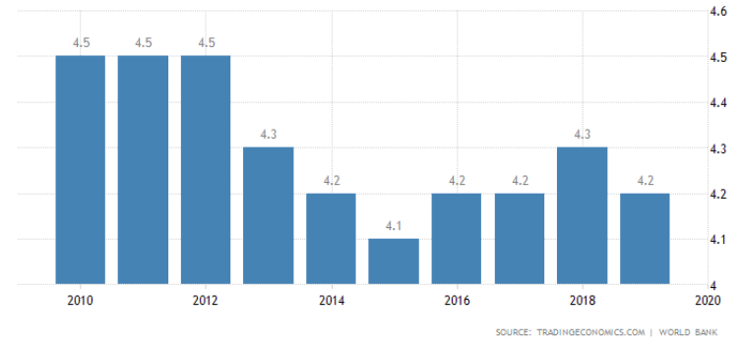

Figure 2: Skills shortages
Source: (Oosthuizen & van der Westhuizen, 2020)
Graduate skill shortages were experienced more frequently by smaller organisations than by larger ones. The labour market in the United Kingdom is not a monolith, and the jobs with the most significant skill gaps varied considerably from region to region. Most companies reported a "limited quantity of individuals with the required abilities" as the main reason openings were hard to fill. Due to a decrease in available workers from the EU, the United Kingdom has been experiencing a severe shortage of skilled professionals since Brexit. The COVID-19 epidemic exacerbated a precarious situation. As a result, there is an extreme shortage of qualified workers in particular areas. The retirement of many workers from occupations requiring specific skills has resulted in a skills gap (Oosthuizen & van der Westhuizen, 2020). Finding qualified workers with the requisite expertise is becoming increasingly complex. Introducing innovative technology or changes in the economy's structure may trigger sudden changes in demand for a particular occupation. This led to either an excessive number of unneeded workers or an insufficient number of needed ones.

Long-term labour market trends and skills shortages in UK healthcare
The Skills Shortage Bulletin released by the Edge Foundation in July 2019 reports that the National Health Service (NHS), the largest employer in the United Kingdom, has a vacancy rate of 11%. This overwhelmingly highlights the shortage of trained people in the UK's healthcare sector. Efforts are being made to improve the situation, and one strategy being explored is a shift in visa restrictions for healthcare personnel. But before we get to that, let us look at what this chasm implies.
With a decrease of 4% in nursing graduates, 41,000 open positions remain. The exact period has also seen the emergence of problems related to medical, social, and mental health. One can also point the finger at Brexit. Because of Brexit, many European medical professionals have left the continent. This crew is essential for keeping the system running smoothly. With the Health Foundation estimating a nursing shortage of about 70,000 in the next five years, immediate measures are needed. As part of a more significant national trend, British businesses need more qualified candidates to fill two-thirds of their open positions. The healthcare skills gap is a long-term socioeconomic risk, and it will likely develop due to an ageing population and growing demand for NHS services (Kocór, 2019). Staff shortages, rather than financial difficulties, pose the greatest threat to the English healthcare system, according to the Health Foundation, The King's Fund, and the Nuffield Trust. There is now a shortage of over 100,000 workers, which is expected to grow if international recruitment and newly qualified workers grow slowly (to 350,000 by 2030). NHS workers need help providing high-quality care to meet rising demand because of a lack of available resources. Treatment quality and staff retention are suffering due to the exodus of recently graduated professionals. A tenth of all social worker and care worker positions in adult social care are unfilled (about 110,000 opportunities). There is a threat to the public healthcare system.
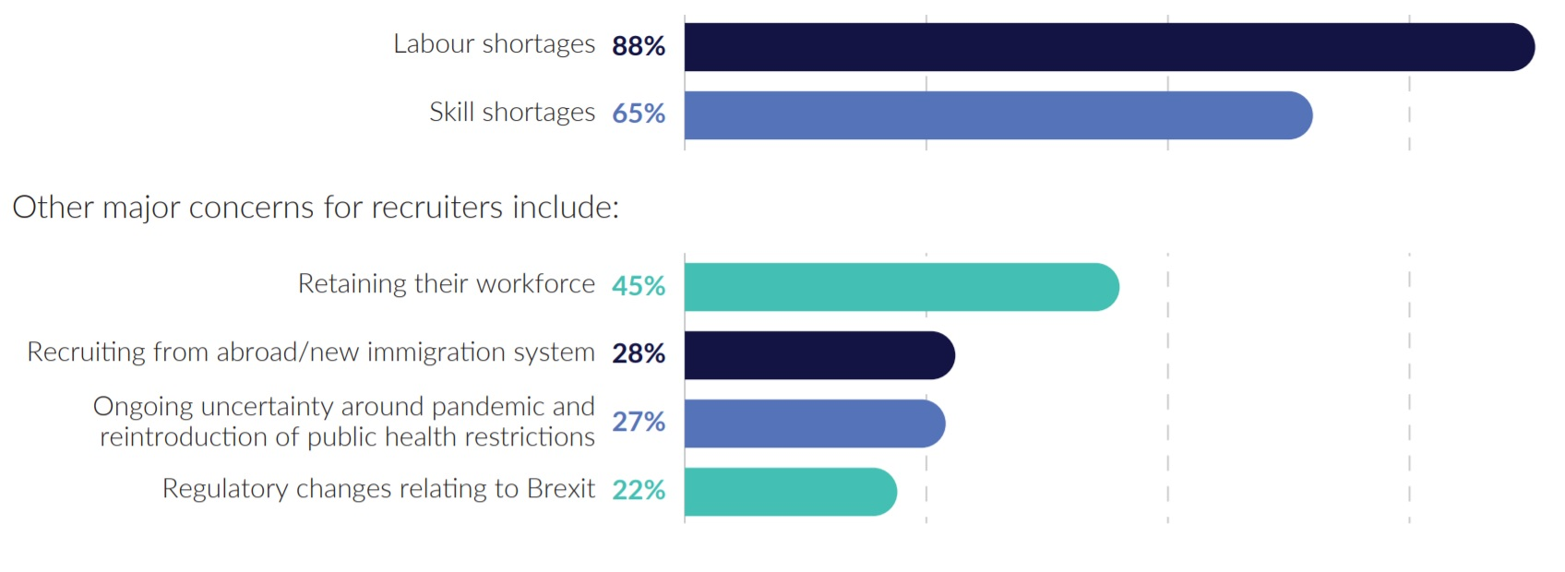

Figure 3: Long-term labour market trends and skills shortages
Source: (Kocór, 2019)

Conclusion
Employment issues are exacerbated by supply and demand. There is a substantial demand for workers, as evidenced by a record number of job postings and forward-looking indicators of recruitment intentions. Applicants are scarce due to several factors. First, fewer people are looking for jobs because unemployment is high, yet competent workers are few. In addition, fewer people are in the workforce than before the pandemic. This is due significantly to returning immigrants, although it is also true that many retirees are leaving the labour. According to the findings, businesses are making efforts to reduce employee turnover. The governments planned redundancy rates for the future are also lower than before the outbreak. The importance of keeping a good workforce is equal to that of bringing in new people.

References
Birkenhead, S. (2022). Managing people. London, UK: Penguin.
Bratton, J. and Gold, J. (2017). Human Resource Management: Theory and Practice. London: Macmillan Education.
BRATTON, J.O.H.N. (2017). Human Resource Management: Theory and Practice. London: Palgrave MacMillan.
Gupta, M. (2020) “HR analytics: Trend from data to predictive analysis for HR professionals,” International Journal of Psychosocial Rehabilitation, 24(5), pp. 2674–2682. Available at: https://doi.org/10.37200/ijpr/v24i5/pr201969.
Kocór, M. (2019) “Skills shortages and mismatches on the UK labour market and public policy recommendations,” Zarządzanie Publiczne, (4(42)/2017), pp. 38–52. Available at: https://doi.org/10.15678/zp.2017.42.4.03.
Oosthuizen, M. and van der Westhuizen, C. (2020) “Graduate unemployment in the face of skills shortages: A labour market paradox,” SSRN Electronic Journal [Preprint]. Available at: https://doi.org/10.2139/ssrn.964899.
Porter, K., Fagg, R. and Smith, P. (2017). Leadership and management for HR professionals: Covers the new CIPD Syllabus. Amsterdam: Elsevier Butterworth-Heinemann.
Rogers, P. (2019). Developing people and organisations. London: CIPD - Kogan Page.
Thomson, R. (2016). Managing people. Amsterdam: Elsevier.
Trullen, J. and Valverde, M. (2017) “HR professionals' use of influence in the effective implementation of HR practices,” European J. of International Management, 11(5), p. 537. Available at: https://doi.org/10.1504/ejim.2017.086695.

