
CHANGEMAKER: CREATIVITY AND VALUE CREATION


Name: Malika Ali
Student No: 2026355
Module Code: BMHP5014
Lecturer Name: Azora Hurd

Contents
Introduction 2
Blog 2
Kids Care: To end the cycle of abuse 2
Elevator Pitch 4
Conclusion 5
Reference list 5

Introduction
I have chosen to write a blog and elevator pitch for my e-portfolio. My idea to create a voluntary organization which would bring together a supportive community for adults who were abused as a child and children who have suffered from abuse. My perspective is developing a new project plan which is unique and helps fill a gap in a service.

Blog

Kids Care: To end the cycle of abuse
  - Providing support to children abuse
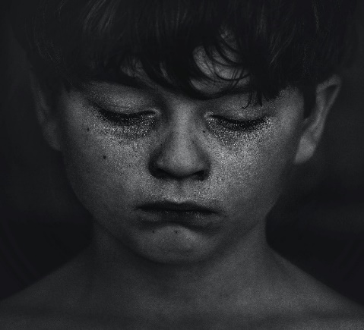
In my home country, Pakistan, I would often see parents abusing their children and no one would even bat an eyelash. Often, they would boast about discipling their kids with a hanger or a rod. The children that faced such abuse would put up a brave façade and pretend that it was hilarious when their mother threw a shoe at them, or when their father beat them with a bat, over something as insignificant as breaking a glass. I was fortunate enough to have parents who had the awareness to know this ‘casual abuse’ was still abuse. When my family moved to the UK, I did not expect that child abuse would be a common phenomenon here. One night as I was walking home, I heard a child crying. I found her standing outside her house, without any shoes, a bleeding lip, and a black eye. She was no more than eight years old. On being asked what happened, she said “I fell.” I was completely mortified. I immediately contacted the police. I realized that day that children of abuse are so used to covering up for their parents, or covering up the shame they feel, that they would rather lie than ever confess the truth. If they couldn’t even admit they have been abused, how can they ever learn to deal with the trauma associated with it? That day, I came up with the idea of KC, which stands for Kids Care.
(Limited, n.d.)
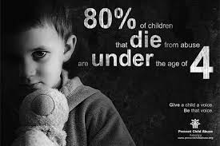
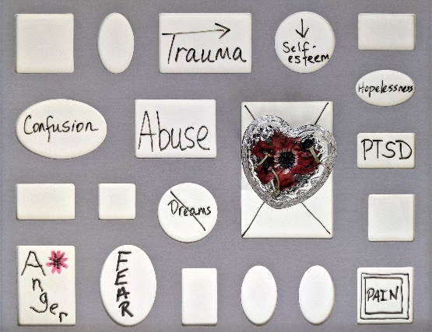
Around half a million children suffer abuse in the UK (NSPCC, 2022). Kids Care will be a support group for children of abuse. KC will work with the social services to provide recreational activities, personal therapy, and group therapy. Thousands of kids of abuse end up in the social system. These children require immediate and a unique form of support (Weich et al., 2009). Their caretakers have broken their trust which is exceedingly harmful to a child’s mental health. KC will ensure that these children receive the care they need. A therapist will be present in the group sessions to guide the therapy to help the children come to terms with their abuse. Every child will be paired with an adult that has grown up as a child of abuse. By doing so, we will help the child resonate with the adult and form a deep meaningful connection (Heckman, 2007). The children will also receive personal therapy so that the therapist is aware of their growth and current needs. We will hire psychologists as well psychiatrists that specialize in child and group therapy. Children of abuse are delicate, yet they act very strong (Zielinski and Bradshaw, 2006). Our mission is to help such children overcome their traumas so they can grow up to have full lives and they never end up inflicting the same pain on anyone else. Let’s break the cycle of abuse once and for all!
(Canopy Children’s Solutions, 2018)
(Secureteen.com, n.d.)
You can check out our website www.KidsCare.org for more details. To report child abuse, check out the website https://www.gov.uk/report-child-abuse You can reach out at our contact number + 447451656899 or visit our Head Office at 123 City Road, London, EC1V 2NX.

Elevator Pitch

Did you know that half a million children suffer abuse in the UK every year and this number is not even accurate since abuse is often hidden by adults (NSPCC, n.d.)? My name is Malika and I am honored to be presenting as a guest speaker today as an individual severely affected by the plight of these children. Today I welcome you all for coming to listen to me speak about how abuse has affected the life of children and consequently the adults they grow up to be and how it is a time that we bring a change to this. Abused children grow up to be emotionally scarred adults whose past hinders their growth (Canopy Children’s Solutions, 2018). I am going to explain what we aim to do and how you can help. Why do you want to help? Why are you sitting here?
KidsCare is a voluntary organization which hopes to bring together a supportive community for adults who were abused as a child and children who have suffered from abuse. KC is a registered charity that provides support for children of abuse. At KC we connect with non-abusing parents and caretakers to help provide practical support, therapy, and recreational activities in therapeutic settings. We offer group therapy as well as individual therapy for children of abuse as well as adults who have been abused as a child. KC acts in accordance with social services and a wide range of voluntary and paid therapists who have specialized to deal with cases of abuse.
KC also offers a Big Brother and Big Sister program, where adults who have been abused as a child are paired up with children of abuse under the guidance of their therapists. These adults can connect better with children who are feeling the same emotions they are and help guide them while creating a bond forged under common experiences (Ballenger, 2008). This will help children of abuse unwilling to interact with therapists connect with someone they feel is like them (Cirik, 2017). KC also works on providing support and safety sessions to children to allow them to respond to risks and foster a feeling of empowerment within them.
KC welcomes volunteers to come be a part of the community and brighten the life of children. The kids need you. You can also donate your time, supplies, and spread the message to help these children in need for a better tomorrow.
KC asks you to volunteer your time and become a voice For KC. Let’s get our stories out there, let the world cast a light on KC and the help it offers to survivors. If you are interested head over to our website www.KidsCare.org for more details, you can sign up as a volunteer and give dedicate yourself to helping these children. You can also donate and encourage others to as well by heading over to our website. You can reach to the HR team of KC if you have any queries or concerns. They will provide you with all the relevant details and help integrate you into the KC community. You can reach out at our contact number + 447451656899 or visit our Head Office at 123 City Road, London, EC1V 2NX.

Conclusion
Children of abuse are often neglected by the society at large. Due to this and their trauma, they have a strong possibility to grow up and be mentally unstable, become abusive, or find a partner that is abusive. In conclusion, Kids Care is needed to end the cycle of abuse and help these individuals live a healthy and happy life.

Reference list

Ballenger, J.C. (2008). A Prospective Investigation of Major Depressive Disorder and Comorbidity in Abused and Neglected Children Grown Up. Yearbook of Psychiatry and Applied Mental Health, 2008, pp.190–192. doi:10.1016/s0084-3970(08)70770-9.
Canopy Children’s Solutions. (2018). The Silent Cries of Child Abuse. [online] Available at: https://mycanopy.org/2018/03/cries-child-abuse/.
Cirik, V. (2017). Preventing child abuse and neglect. New Trends and Issues Proceedings on Humanities and Social Sciences, 4(2), pp.114–119. doi:10.18844/prosoc.v4i2.2472.
Currie, J. and Spatz Widom, C. (2010). Long-Term Consequences of Child Abuse and Neglect on Adult Economic Well-Being. Child Maltreatment, 15(2), pp.111–120. doi:10.1177/1077559509355316.
Heckman, J.J. (2007). The Economics, Technology and Neuroscience of Human Capability Formation. SSRN Electronic Journal. doi:10.2139/ssrn.999371.
Limited, A. (n.d.). Child abuse. Sad and lonely girl crying . Injured child posing as victim of domestic violence Stock Photo - Alamy. [online] www.alamy.com. Available at: https://www.alamy.com/child-abuse-sad-and-lonely-girl-crying-injured-child-posing-as-victim-of-domestic-violence-image188948028.html [Accessed 3 Jul. 2022].
NSPCC (n.d.). Half a million children suffer abuse in the UK every year. [online] NSPCC. Available at: https://www.nspcc.org.uk/about-us/news-opinion/2022/childhood-day/.
Secureteen.com. (n.d.). Parents Can Help Prevent Child Abuse. [online] Available at: https://www.secureteen.com/child-abuse-prevention/what-parents-can-do-to-prevent-child-abuse/.
Weich, S., Patterson, J., Shaw, R. and Stewart-Brown, S. (2009). Family relationships in childhood and common psychiatric disorders in later life: systematic review of prospective studies. British Journal of Psychiatry, [online] 194(5), pp.392–398. doi:10.1192/bjp.bp.107.042515.
Zielinski, D.S. and Bradshaw, C.P. (2006). Ecological Influences on the Sequelae of Child Maltreatment: A Review of the Literature. Child Maltreatment, 11(1), pp.49–62. doi:10.1177/1077559505283591.

