Lego Spike Prime Project

Drew Declan McClennon
University of Wales Trinity Saint David
ACHA4008 : Integrating Project
Divya Chidambaram
03/05/2024

- Introduction
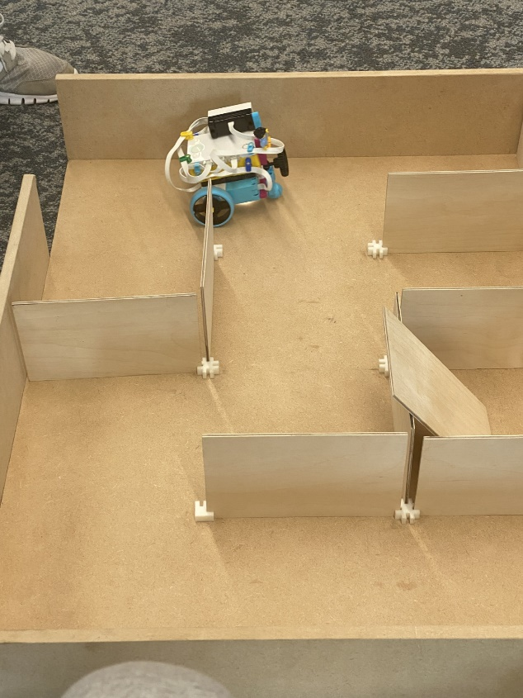
The Lego Spike Prime (set number 45678) is primarily targeted at an audience of key stage 3 students (years 7-9) in which it acts as a friendly and familiar introduction into STEM (or STEAM (Science, Technology, Engineering, and Mathematics)). Lego themselves describe it as an ‘easy to use hardware, and an intuitive drag and drop coding language based on scratch’. [1] As a product, its main objective is to spark ideas and form interests of the STEM industry within younger secondary school pupils. However, this product is an invaluable resource for anyone wanting to become familiar with STEM. Ourselves as foundation year students have been tasked with creating a self-driving robot with the ability to navigate obstacles based on colour, then also complete a maze of which the layout will be unknown to us up until the day we are to test our robot on the course.
This project that we have been working on proves invaluable to us as the Lego Spike Prime set has provided us with real time objectives, obstacles and problem solving in order to meet all targets. We have had to work as a team throughout all stages whether it be the design of the actual driving base itself or the code on which it uses in order to complete all of its objectives. In addition to my prior points, it is also very important to mention that robotics are quickly becoming a crucial factor when in comes to innovation and technological advancements. Many labour intensive tasks such as manufacturing are being replaced by automated robots. In order to fit in with this technological world, we will need to be acquainted with the basics of robotics and how they function.

- Background Research
A key part of our project was giving the driving base the ability to navigate the course and maze without any intervention. Following the line and avoiding any obstacles was easy however when it came to the maze, we had to research algorithms which would make this possible. After reviewing a couple of algorithms, including Trémaux’s algorithm [2] which involves marking the floor with lines to signify that the robot has already been there and the path did not lead to an exit. The algorithm that we chose to use for our project was the ‘Hand on wall’ rule [3]. This method requires the robot to always follow the left or right wall (we have chosen left) in order to find the exit. Whilst this method will take longer, it is more reliable and easier to incorporate into our robot due to not requiring to leave any waypoints unlike the aforementioned Trémaux’s algorithm.

- Project Plan
Throughout our project, my main area of leadership was the hardware design side of it. I was in control of ensuring our robots design would perform as intended. It was vital for our projects success that we created a detailed plan to follow in order to ensure that we were able to progress at a good rate yet also be able to deal with any issues or problems that we came across on our way.
Firstly, we had to come up with a basic design for our driving base to build upon and modify as and when it is needed for our benefit. For this first iteration of the robot, we allocated roughly 3 hours worth of lesson to get to the stage where we have a robot which drives on its own and also can detect colour and follow a line drawn on the ground.
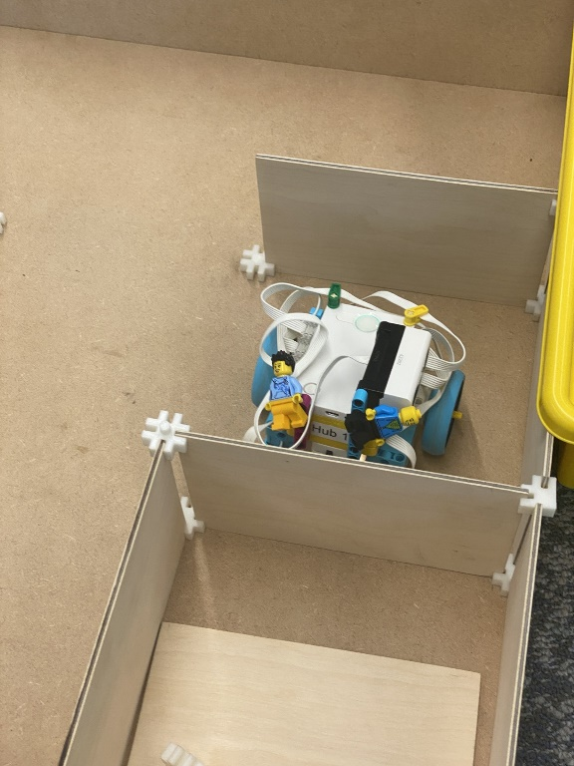
Second, we allocated ourselves a further 2 hours worth of lesson to modify the driving base in order to suit our needs, this involved testing different rollerball positions and heights, shortening the wheelbase in order to make tighter corners, and also testing different sensor positions in order to find the most efficient location for these sensors (colour and pressure) in order for them to work the best.
Third, we spent about 4 hours going through the code and making changes to how the driving base handles different scenarios. This mainly included focusing on its positioning. Throughout testing, we discovered that the wheels would sometimes get stuck on the corner pieces of the maze which are used to keep the walls in place leading it to drive off course and hit into walls prematurely, resulting in the robot not being able to find the end of the maze. To remedy this we played about with the yaw settings, instead of just setting yaw to 0 as it enters the maze, we attempted to make the robot reset its yaw position to 0 after each corner and head towards a predetermined value instead of just 90°. Imagine it as a sort of beacon which it could use for its positioning. Unfortunately, this did not end up being successful within the time allowance we had been given, this meant that in order to make all the other objectives within the given timeframe, we had to scrap this idea for the benefit of our other tasks.

- Design Process
As mentioned before, the design process for our robot went through many different iterations. We started off by building the ‘Driving Base 3’ [4] listed on the Lego Spike Prime website. This was a nice starting point for our robot however it didn’t fit all of our needs to how we wanted them to be. Whilst the wheel base remained the same, we decided to move the stabilising roller wheel (part 39370 & 52629) to the front of the driving base as we found that it would catch on the maze when at the back. We also decided to move the colour sensor from the original ‘Driving Base 3’ designs position on the front right, to the underside of the robot. This was decided on because it would mean that when following the lines, it would be central to the line and not off centre. Having it on the underside of the robot also allowed the sensor itself to be more accurate as there wasn’t as much distance between the ground and itself. In addition to this, we had to include a pressure sensor on the front of the robot. This is needed for obstacle detection and avoidance when in the maze. Our code is set up using the ‘Left hand on the wall’ method [3]. By following this algorithm, it ensures that the robot will not end up getting lost within the maze and will always find its way out to the exit. We also added a distance sensor to our modified version of the driving base. This works hand in hand with the pressure sensor and aids with following the left hand method. Due to it being positioned on the left side of the robot, it acts as our metaphorical hand. When it detects a change in distance as it passes a left turn, it will stop and turn into the corner. Whilst presenting some issues at the start and with lots of trial and error, as a team we have been able to solve its bugs and get it to operate just as we had envisioned.

- Evaluation and Results
Throughout this project we have faced many challenges which have proved invaluable for our problem-solving skills. Whether that be on the fly code adjustments, to complete redesigns of the driving base itself. It has taught us to work together as a team in order to overcome hurdles whilst also forcing us to collaborate ideas in which to face the tasks which lay in front of us. Our testing so far has been very important, feeding us with lots of valuable information of which we have used in order to fine tune and ready both ourselves and the robot for the final maze and obstacle course presentation. If I were to attempt the challenge again, I would focus more time on the motion sensor and its code, possibly having it on a rotating mount powered by a motor may allow it to ditch the ‘left hand on wall’ method which despite being reliable, does take more time to complete than it needs. I would also play about with the positioning code in order to allow the robot to move seamlessly and not have to stop before and after every movement it takes in order to make a more fluid visual experience.

References

[1] | Lego, “Lego Education : Spike Prime Set (45678),” Lego, [Online]. Available: https://education.lego.com/en-gb/products/lego-education-spike-prime-set/45678/. [Accessed 28 April 2024].
[2] | W. Contributors, “Wikipedia Maze Solving Algorithms : Tremaux's Algorithm,” Wikipedia, The Free Encyclopedia, 12 March 2024. [Online]. Available: https://en.wikipedia.org/wiki/Maze-solving_algorithm. [Accessed 28 April 2024].
[3] | W. Contributors, “Maze-solving algorithm - Hand on Wall,” Wikipedia, The Free Enyclopedia, 13 March 2024. [Online]. Available: https://en.wikipedia.org/wiki/Maze-solving_algorithm. [Accessed 28 April 2024].
[4] | Lego, “Lego Spike Prime Education : Driving Base 3,” Lego, [Online]. Available: https://spike.legoeducation.com/prime/models/blt9e7ffd6d4cc94c53. [Accessed 28 April 2024].

