

Smart and Connected Devices I
Visualisation of IoT data
Module Code: ACDA5005
Module Lecturer: Gaynor Thomas
Student Name: Mohamad Wael Baghdadi
Student Number: 1708309
Course: Software Engineering
Date: 13th May 2019

Table of Contents
Table of Contents 1
List of Figures: 2
1. Introduction 3
2. Implementation technicalities 3
2.1 Security technique 3
2.2 Transferring the data 4
2.3 Website features 5
1. First search option 5
2. Second search option 5
3. Third search option 5
2.4 Website style 6
➢ Header 6
➢ Design file (CSS) 6
2.5 Challenging part 7
3. Screenshot of the final website 8
Bibliography 10

List of Figures:
Figure 1: Log in page. 3
Figure 2: If the username or password was wrong. 3
Figure 3: If the login failure (PHP code). 3
Figure 4: Screenshot of the (users') accounts in the database 3
Figure 5: The database in (phpMyAdmin) 4
Figure 6: Screenshot showing the data inside the database. 4
Figure 7: Screenshot of the author's code while transferring the data to his database. 4
Figure 8: The first option in the website. 5
Figure 9: Screenshot of the first option code (sensor) 5
Figure 10: Second option in the website. 5
Figure 11: Screenshot of the second option code (date). 5
Figure 12: Third option in the website. 5
Figure 13: Screenshot of the third option code (graph). 5
Figure 14: Screenshot of the data view options. 5
Figure 15: Screenshot of the Header page file. 6
Figure 16: The link in other pages to link to the header page file. 6
Figure 17: Screenshot of the header in the website. 6
Figure 18: Screenshot of implementing the function file. 7
Figure 19: Screenshot of the index code while implementing the function method. 7
Figure 20: Screenshot of the first page to log in. 8
Figure 21: Screenshot of the second page for the data view’s options. 8
Figure 22: Screenshot of the data view by choosing the sensor option. 8
Figure 23: Screenshot of the data view by choosing the graph option. 9
Figure 24: Screenshot when the user logged out. 9
Figure 25: Screenshot if the user trying to go back after logged in. 9

Introduction
In this report, the author has included the technicalities of the implementation of his practical work to create suitable management and monitoring software which this software is about developing a website interface to allow a user to monitor data from the Internet of Things (IoT) devices. And this website will read the data from text files to insert the data into the database and then allow the user to view with data via a web interface, each file contains a series of temperature readings in Celsius and a date/time of the reading was taken which this data has been received from external sensors in different geographical location. So, the steps that included in the report are around the implementation technicalities like security, data transferring, website features, website design and a screenshot of the final implemented the website.

Implementation technicalities

2.1 Security technique
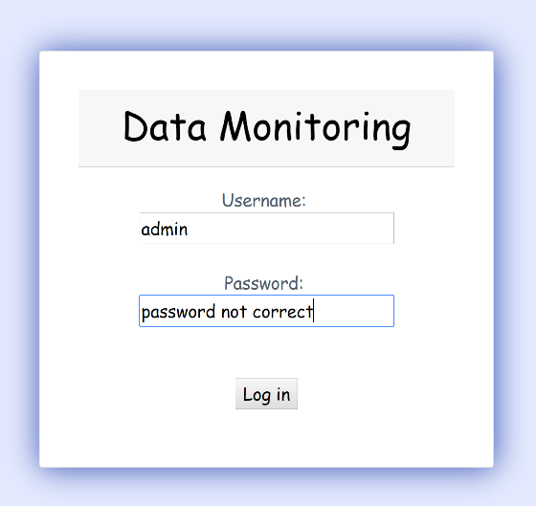
To implement this work the author has set the most important step to begin to create his website interface, which is the security side of the data inside the website, and the first step of implementing the security is to define the who is allowed to enter to the website by creating a username and password for each user and insert this data into the database, then by these data the user can log in to his account successfully. and if any of the username or the password was wrong a warning message will appear to the user saying that his account does not recognized and need to try again. so, with this way the security of the website will be against any user does not have the authorization to enter the website and view the data.
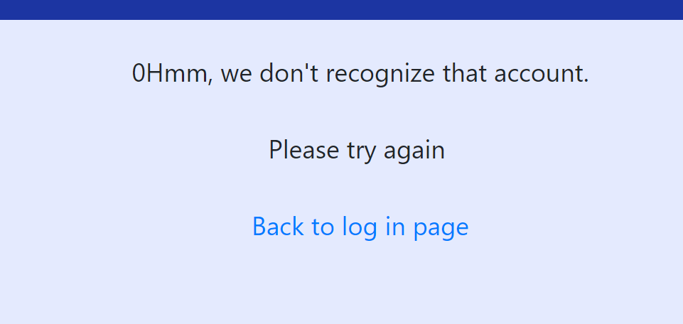
Figure 1: Log in page.
Figure 2: If the username or password was wrong.
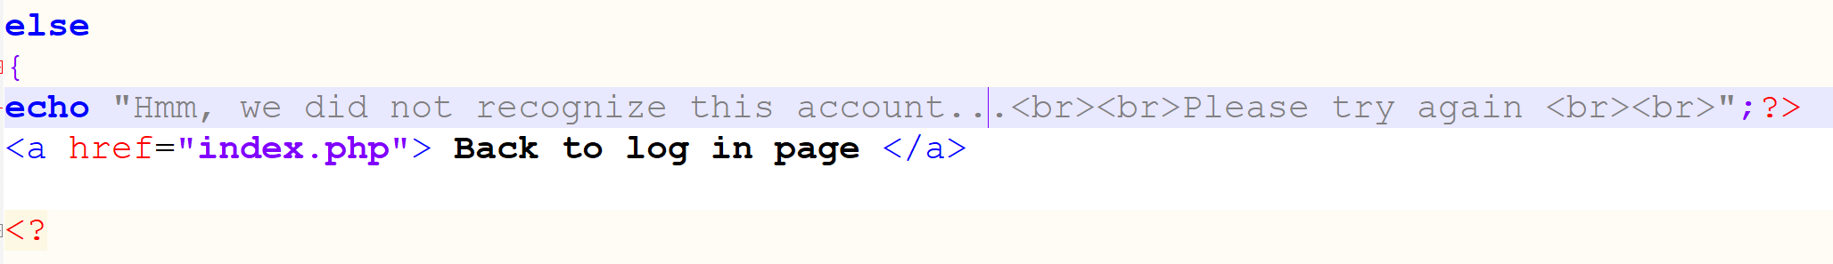
Figure 3: If the login failure (PHP code).
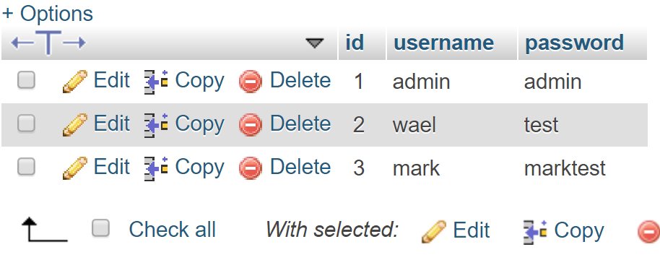
Figure 4: Screenshot of the (users') accounts in the database

2.2 Transferring the data
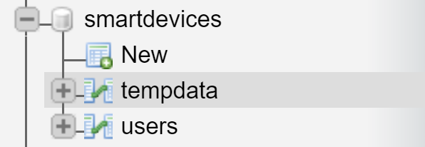
Surely, we need some data in the database to view for the user. So where the data come from and how these data will be transferred to be in the database file, how can the user view this data. the answer for those questions is the data coming in text files for each one of them and what the author did is creating PHP codes to transfer the data inside those text file to the database required and this code included by If statement to make sure the files are transferred. once the data transferred to our database the user can view this data successfully.
Figure 5: The database in (phpMyAdmin)
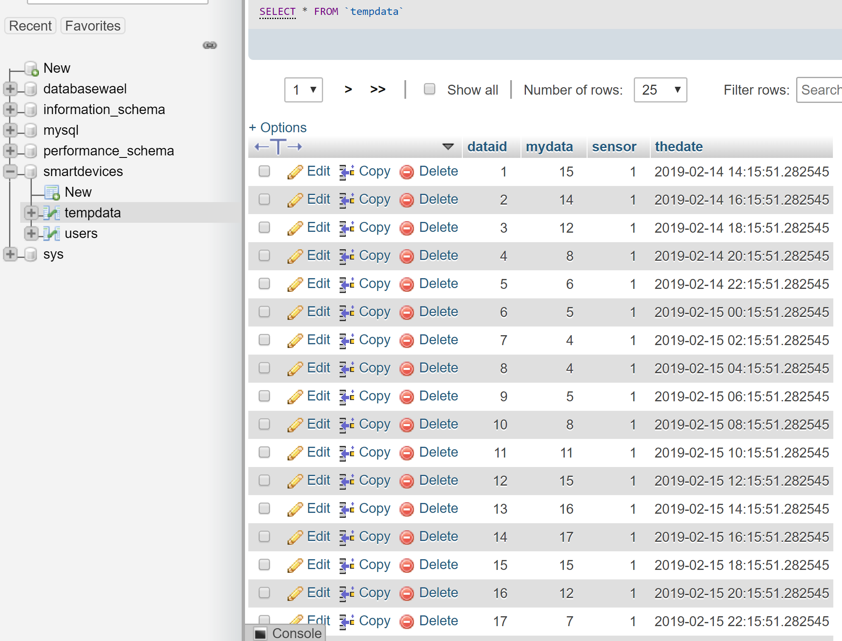
Figure 6: Screenshot showing the data inside the database.
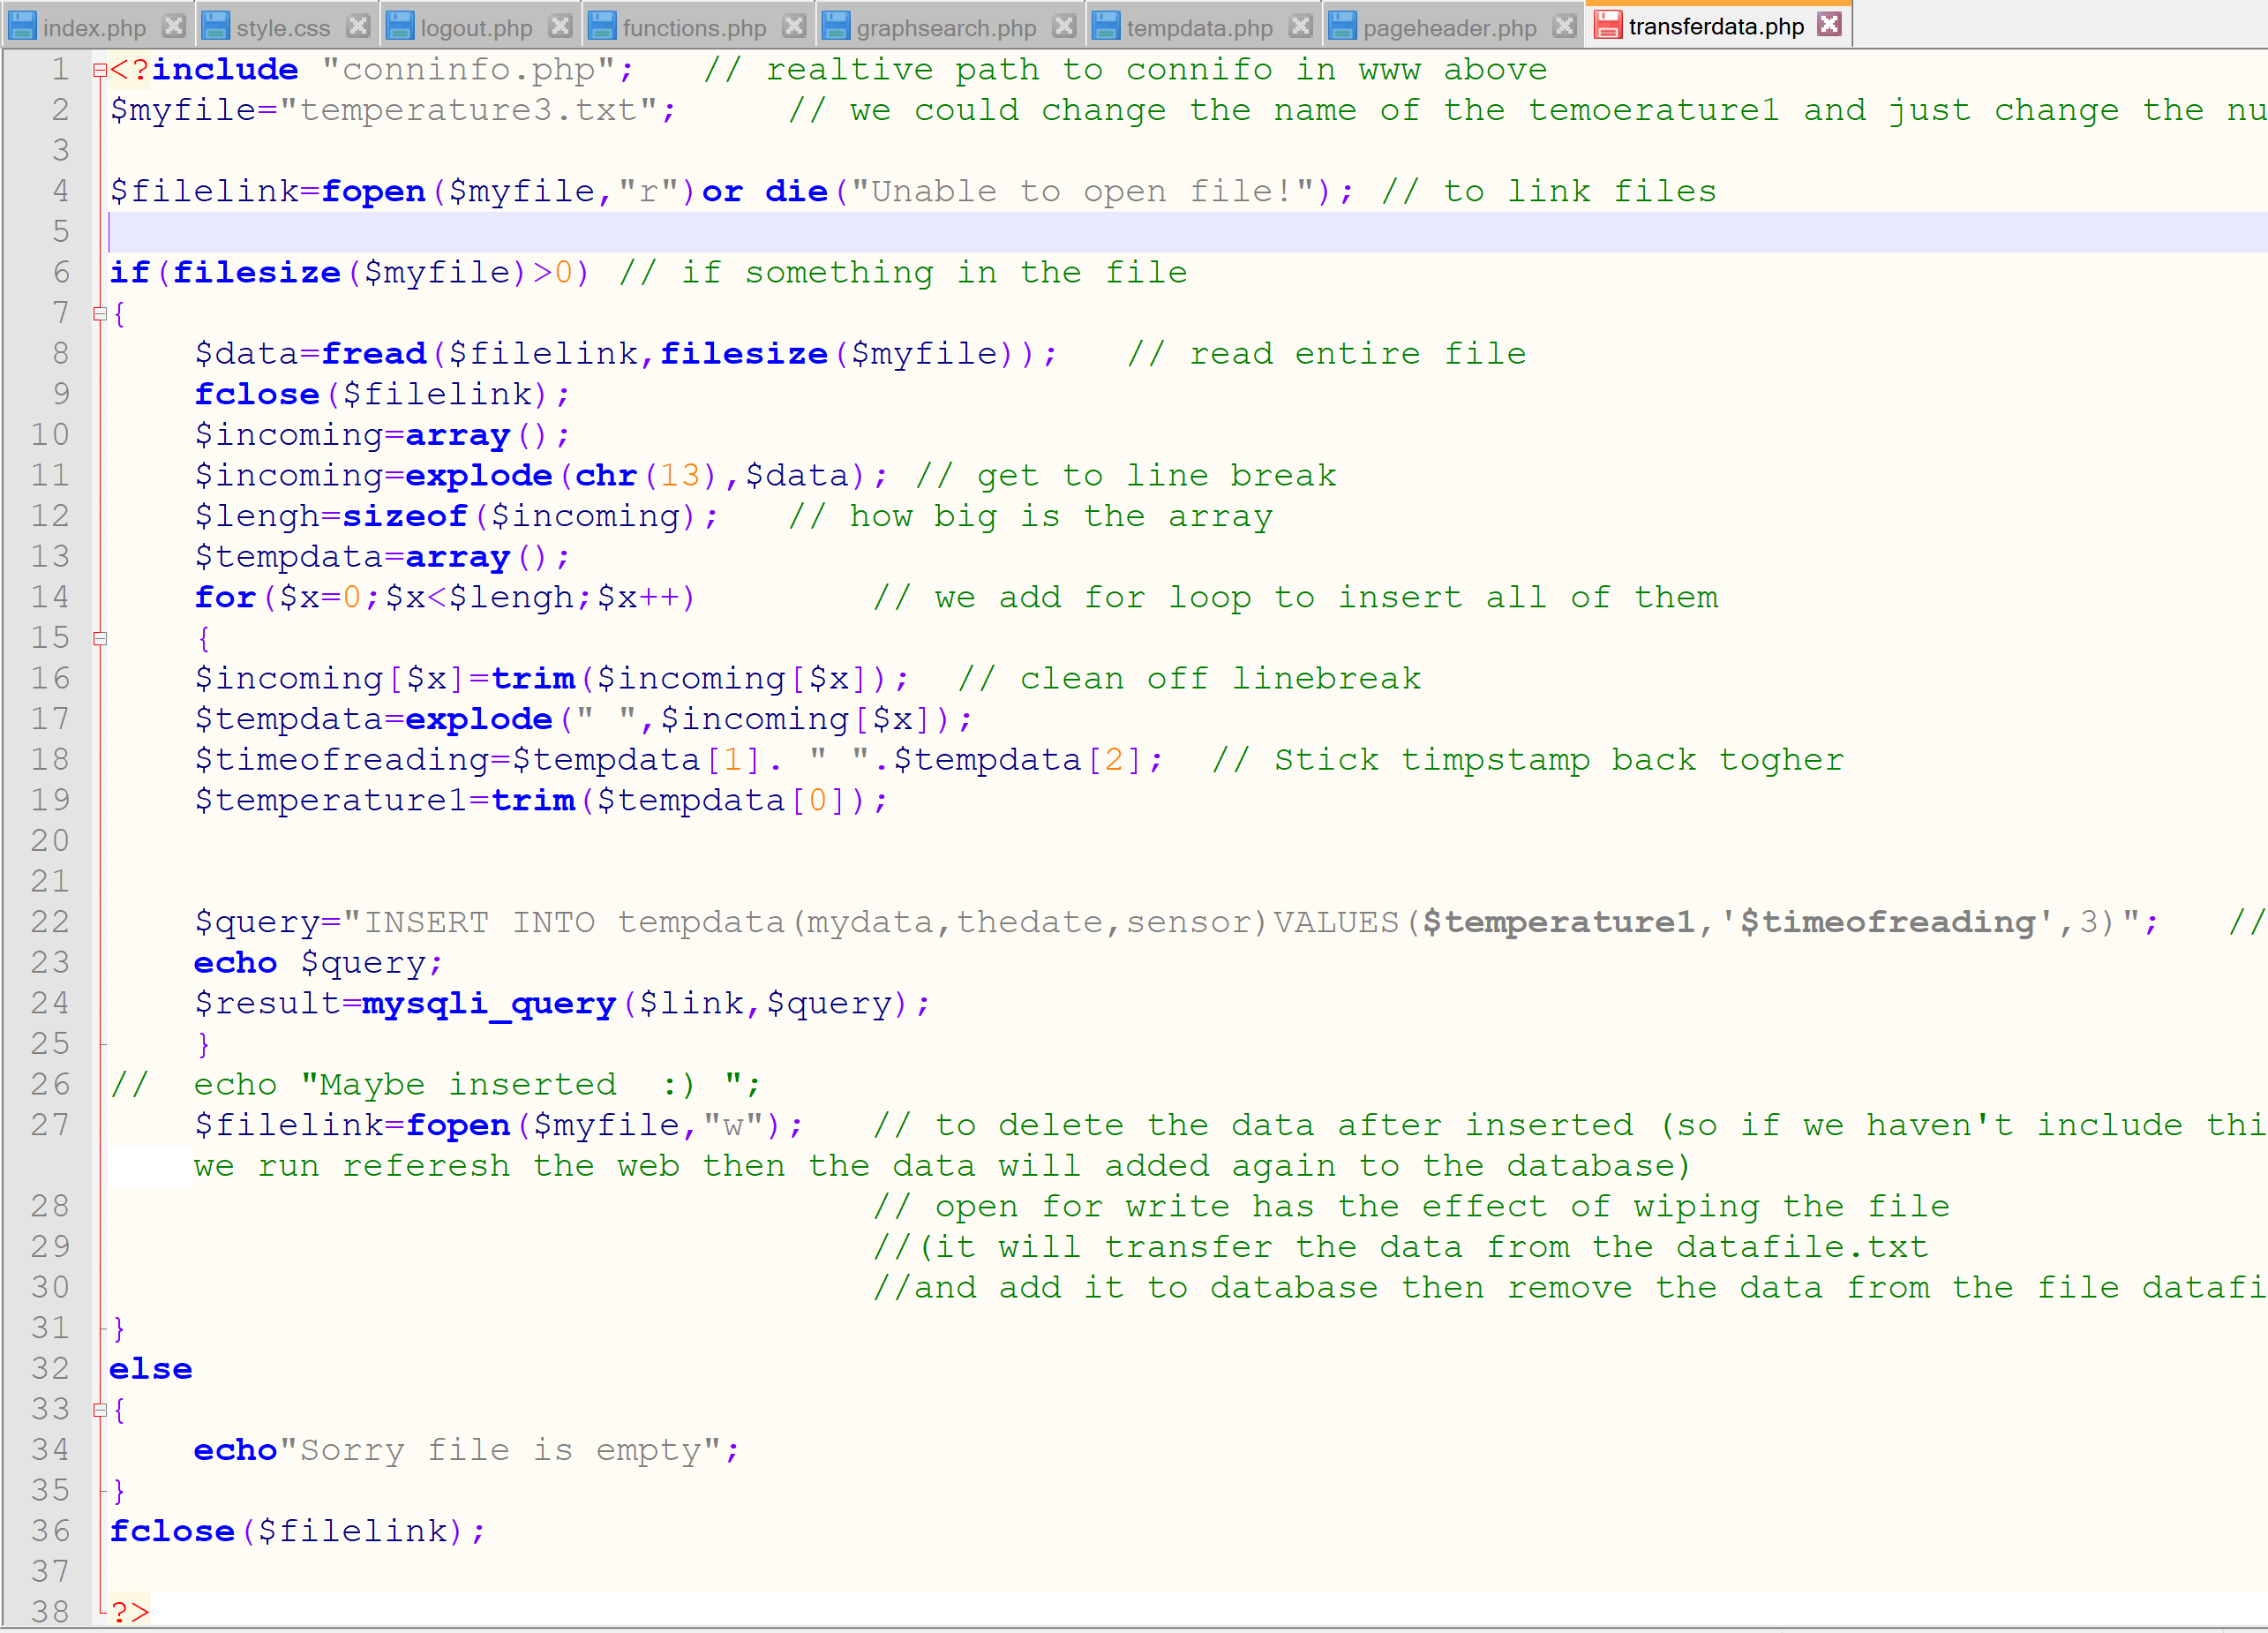
Figure 7: Screenshot of the author's code while transferring the data to his database.

2.3 Website features
In the website and once the user logged in successfully, there are three options available to view the database which all of them included in PHP file called (tempdata) and this file is the main file in the website to let the user choosing which way he would like to view the data.

First search option
(sensorsearch) is to search by a sensor as the database include three sensors, and the result will appear just with the required one.

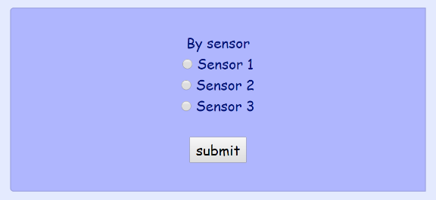
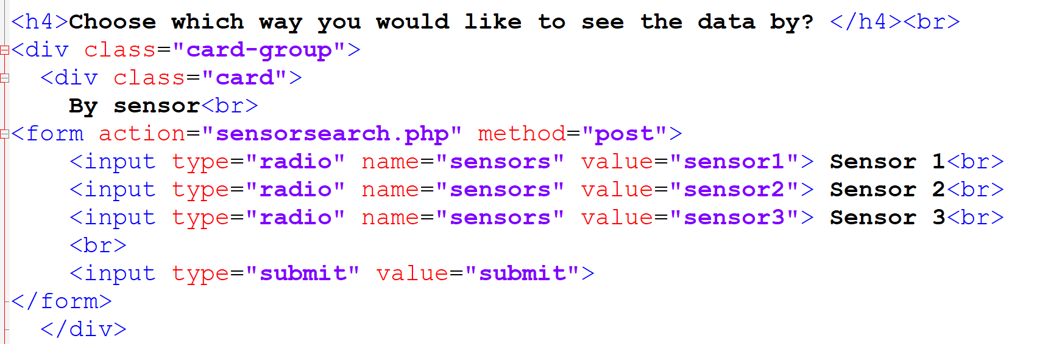
Figure 8: The first option in the website.
Figure 9: Screenshot of the first option code (sensor)

Second search option
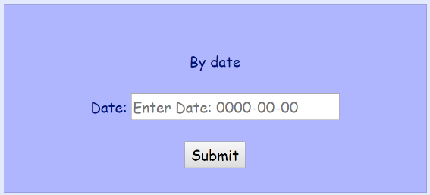
has been set (datesearch) is to search by date so the user can input which date he wants to view and the data will appear on another page with just the required date.
Figure 10: Second option in the website.
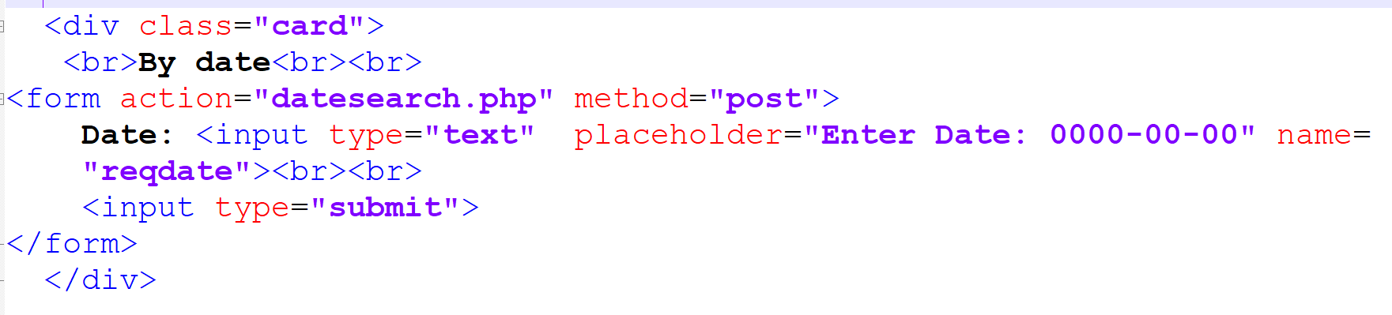
Figure 11: Screenshot of the second option code (date).

Third search option
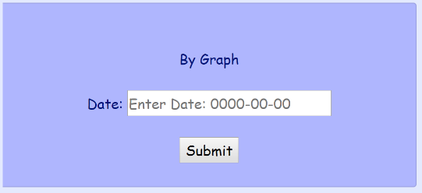
(graphsearch) is to view the database in (Vertical) graph image which this option allowed the user to choose by date or if empty will view all the dates with all sensors, and the library that used to show the graph is "phpmyGraph5.0.php"
Figure 12: Third option in the website.
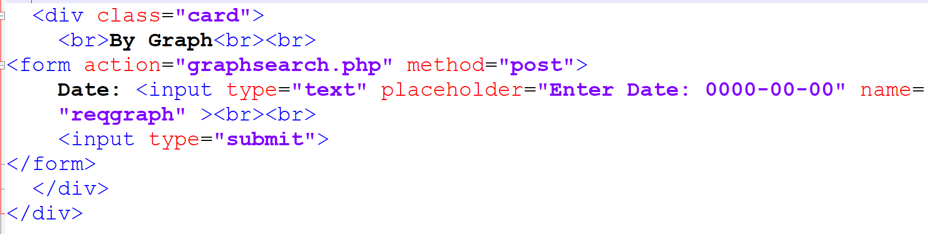
Figure 13: Screenshot of the third option code (graph).
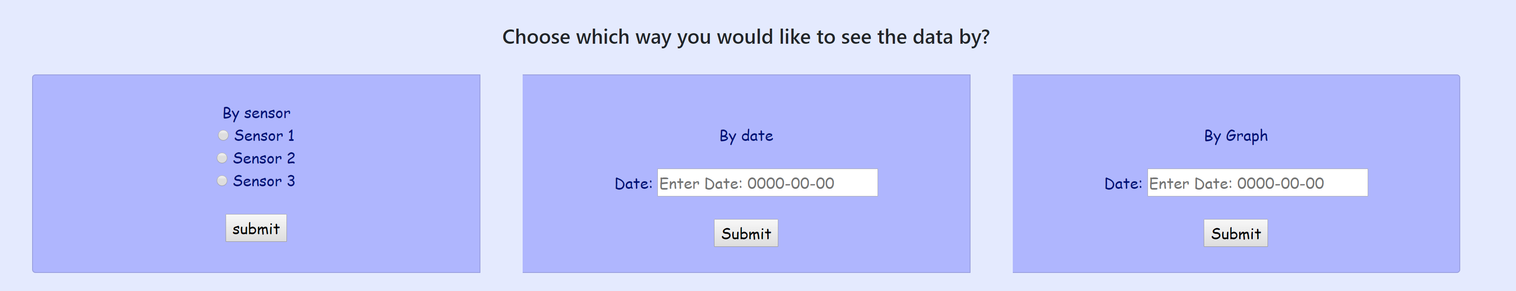
Figure 14: Screenshot of the data view options.

2.4 Website style

Header
Only one "header" file was implemented and included in other pages, to avoid repeating the code in each file which it takes too long to change or edit the header in next time and this file has included the Bootstrap framework to help the designs to be faster and easier.
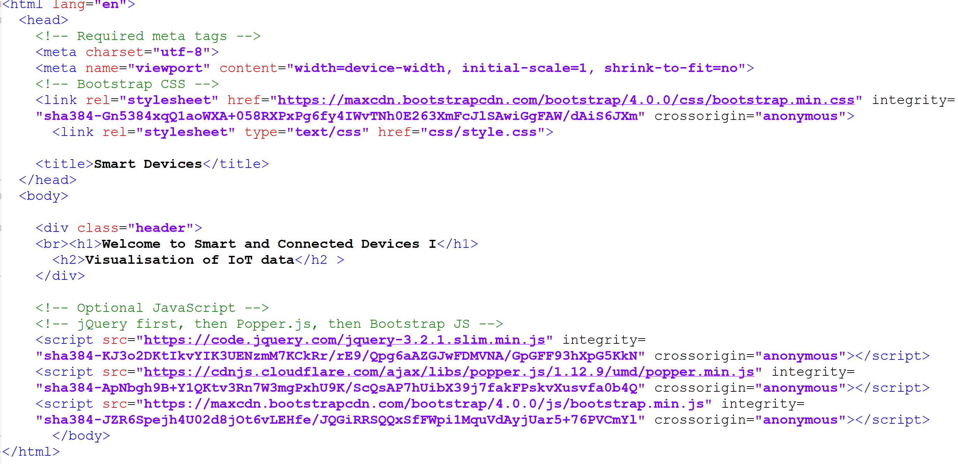
Figure 15: Screenshot of the Header page file.
Figure 16: The link in other pages to link to the header page file.

Figure 17: Screenshot of the header in the website.

Design file (CSS)
To implement the design of the website like colour, fonts, header, footer, cards and other design styles, a stylesheet (CSS) file has included in the work, which contains all the CSS codes for the all pages
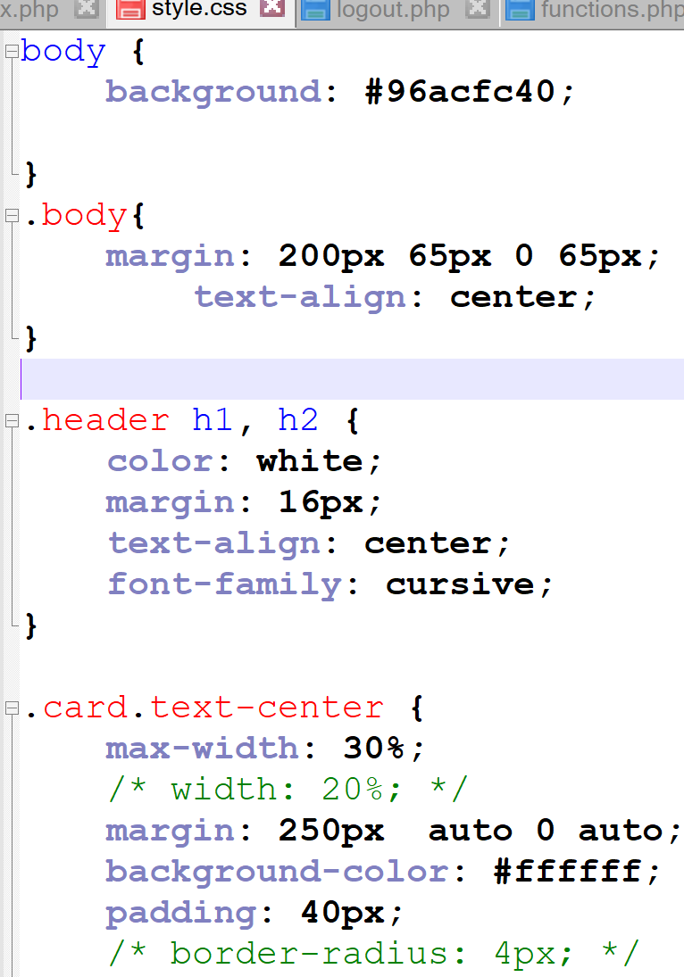

2.5 Challenging part
In this part of the study, the author has set a challenging work to do which is to implement all the pages in one page and make all the codes as functions for each one of them and call the required function when needed, but due to the deadline and other work for in the other assignments he just implemented the index page as functions, which he created a file called function and implemented the log in and log out in two separate functions, and in the index file the an If statement has been created and inside it we can call just the name of the function required.
Which by doing the function methods we can implement the work easier as well as we can call the same function at any time, we want without repeating the same code.
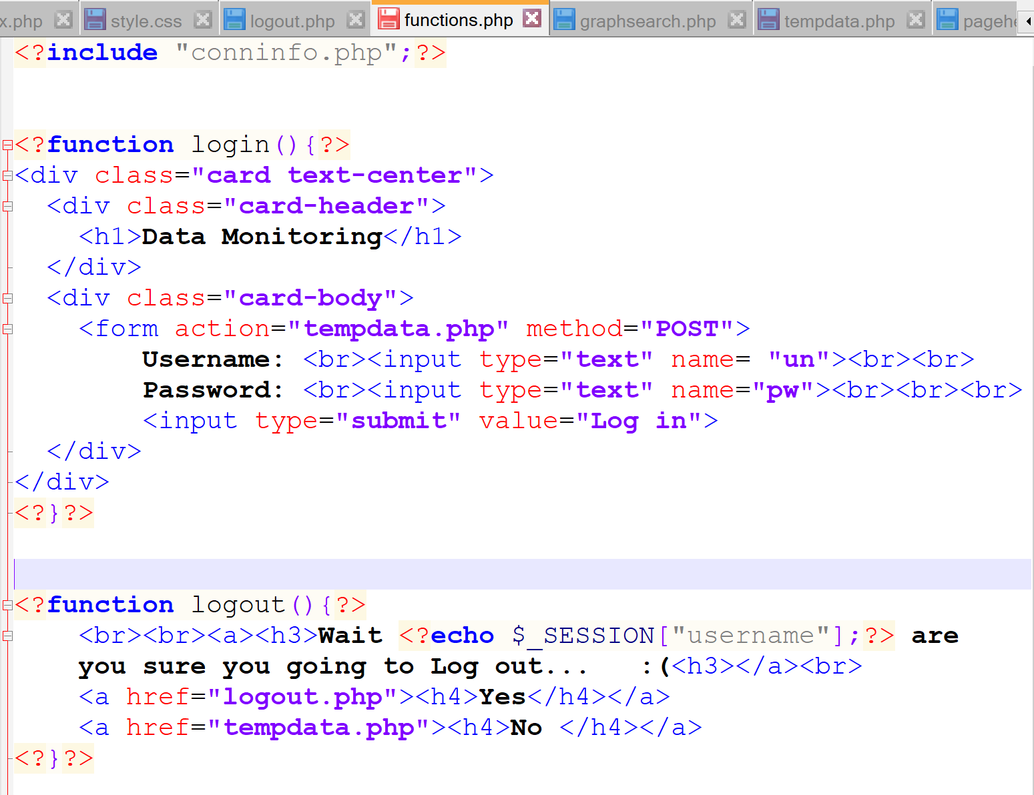
Figure 18: Screenshot of implementing the function file.
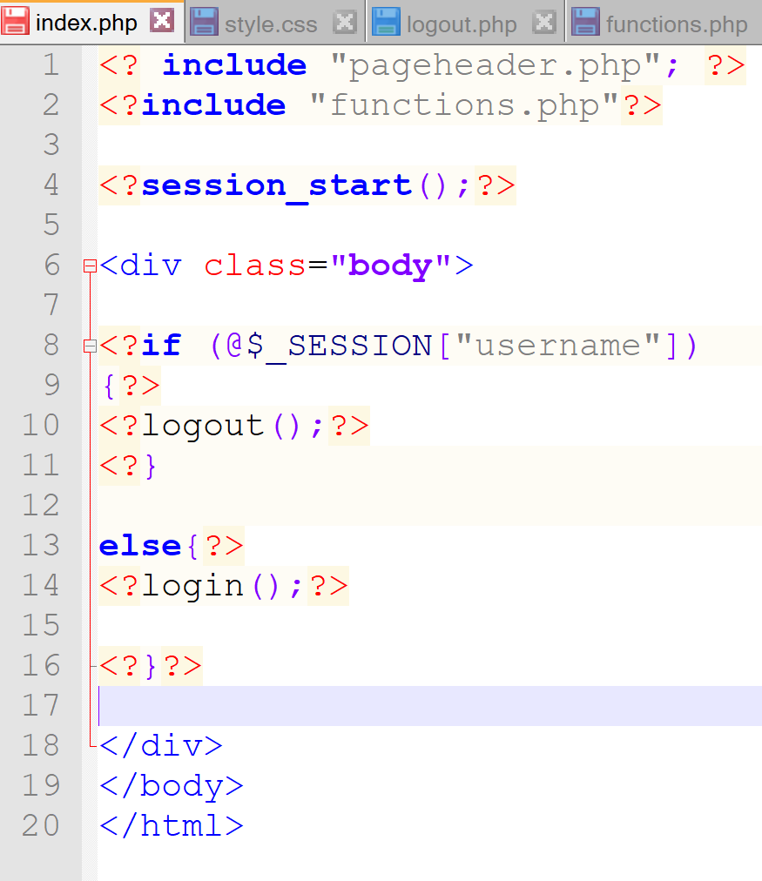
Figure 19: Screenshot of the index code while implementing the function method.

Screenshot of the final website
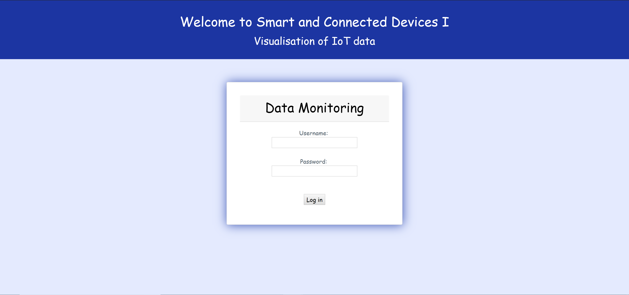
Figure 20: Screenshot of the first page to log in.
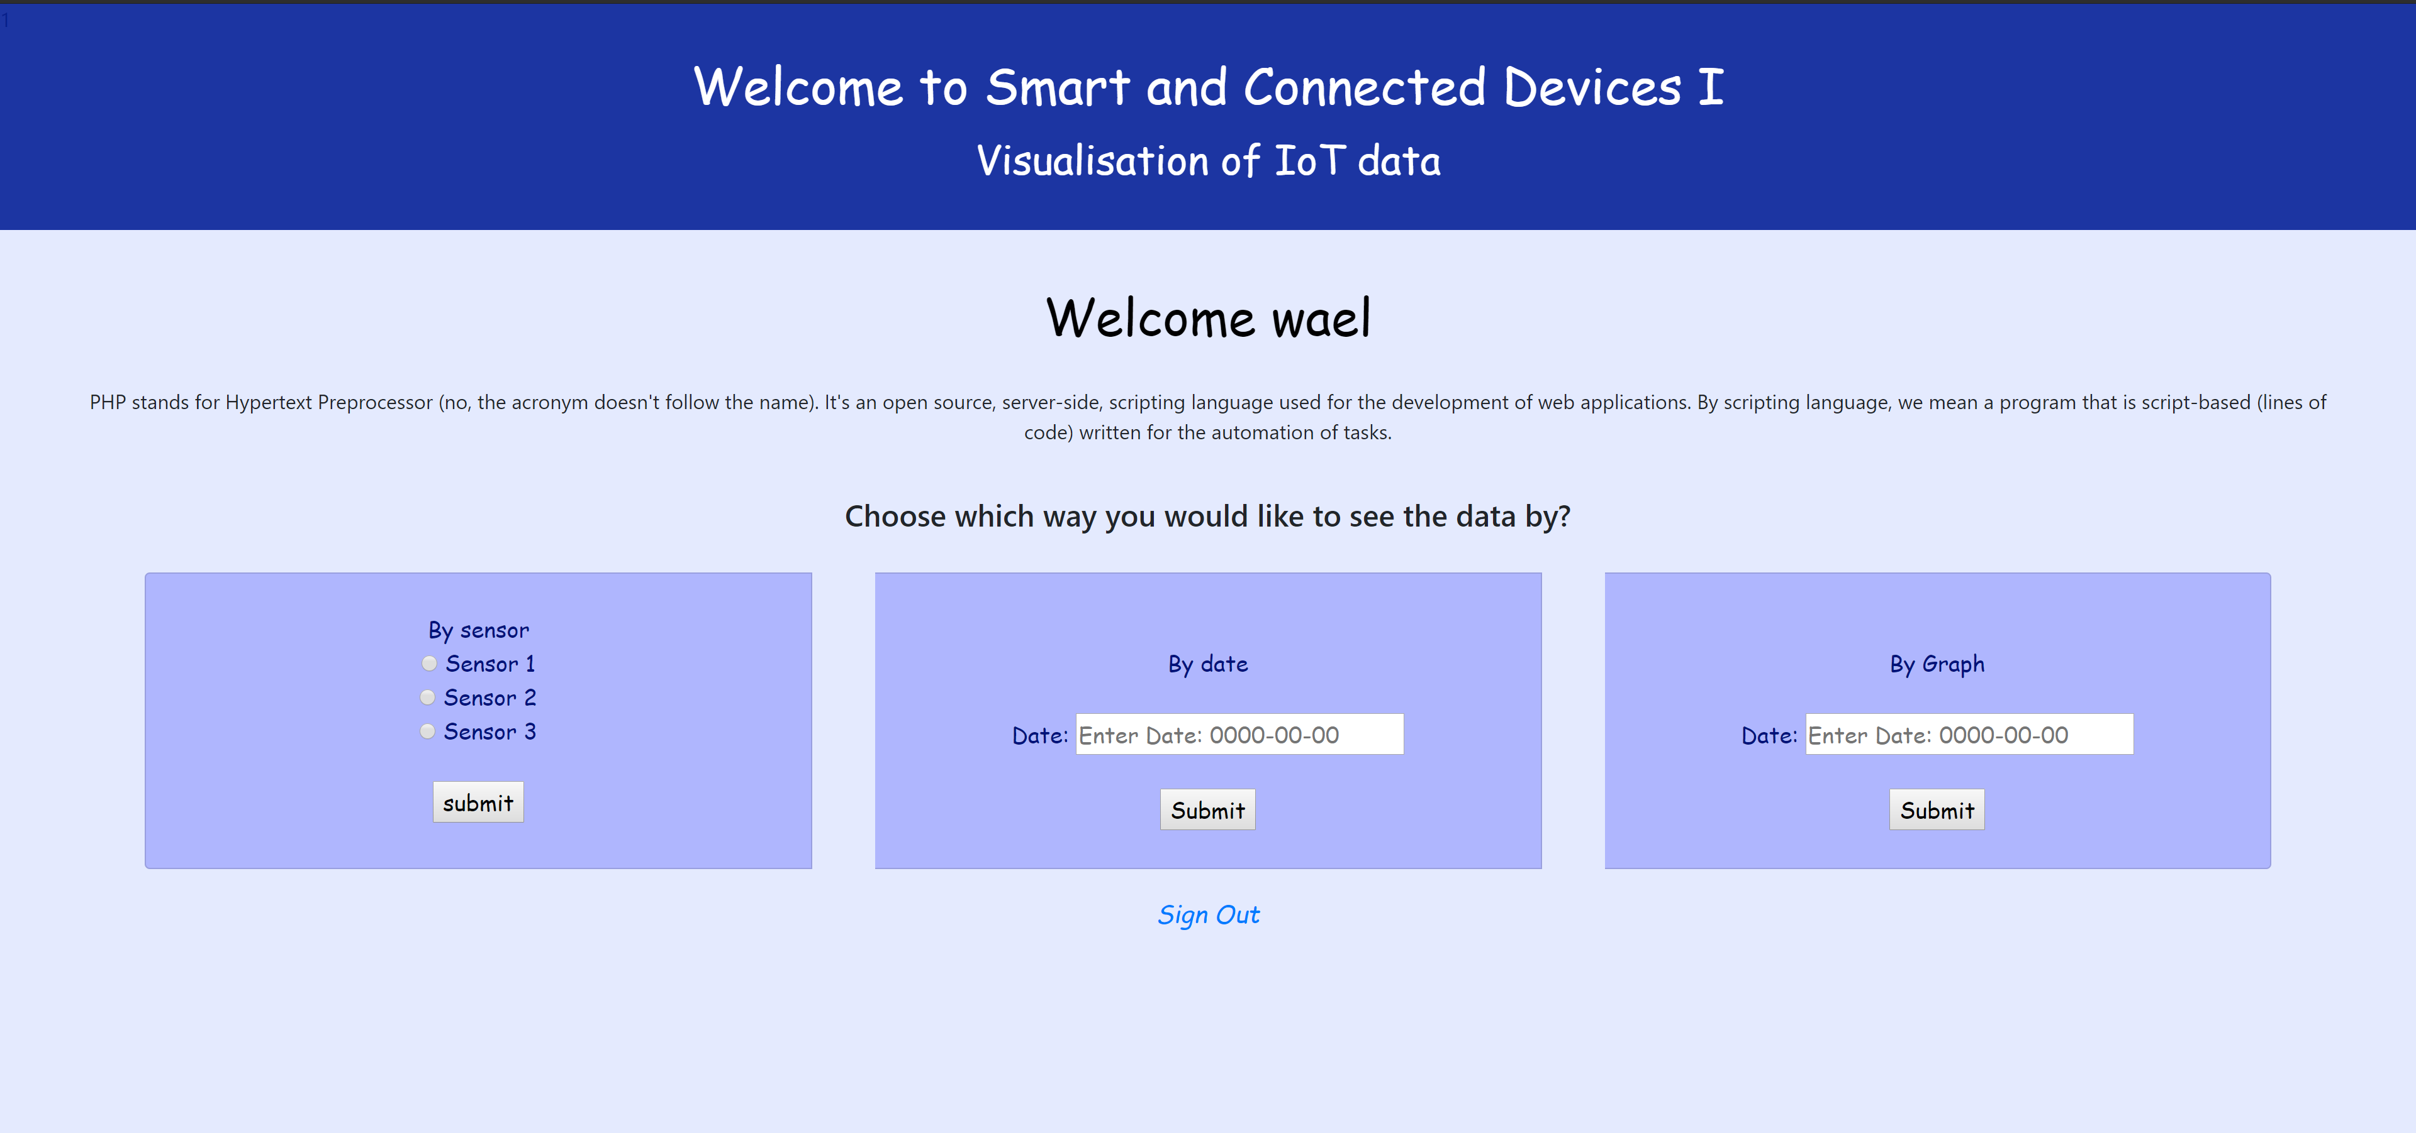
Figure 21: Screenshot of the second page for the data view’s options.
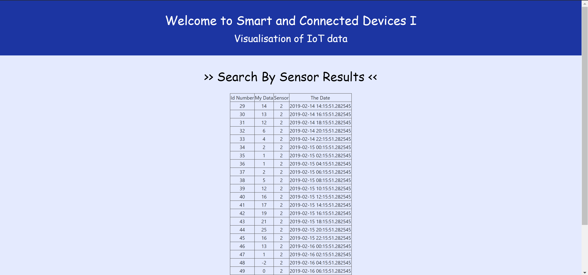
Figure 22: Screenshot of the data view by choosing the sensor option.
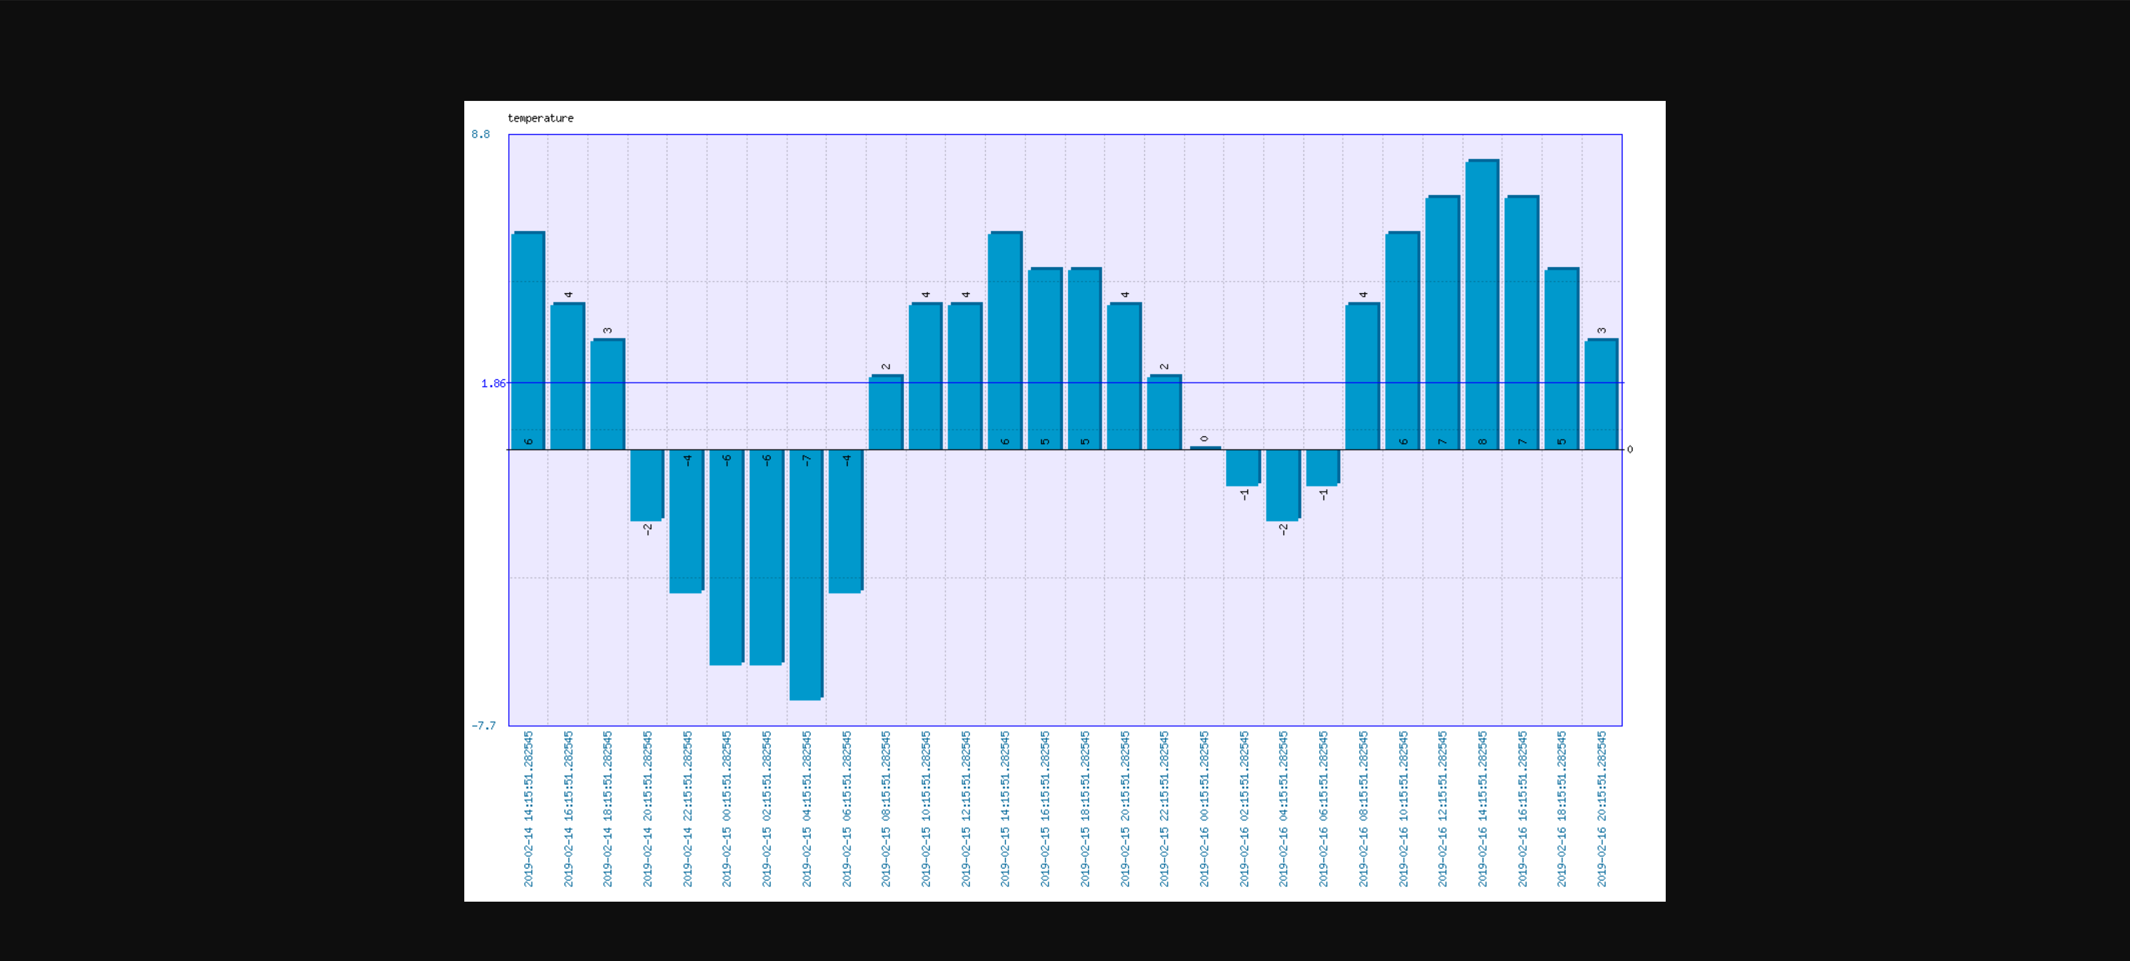
Figure 23: Screenshot of the data view by choosing the graph option.
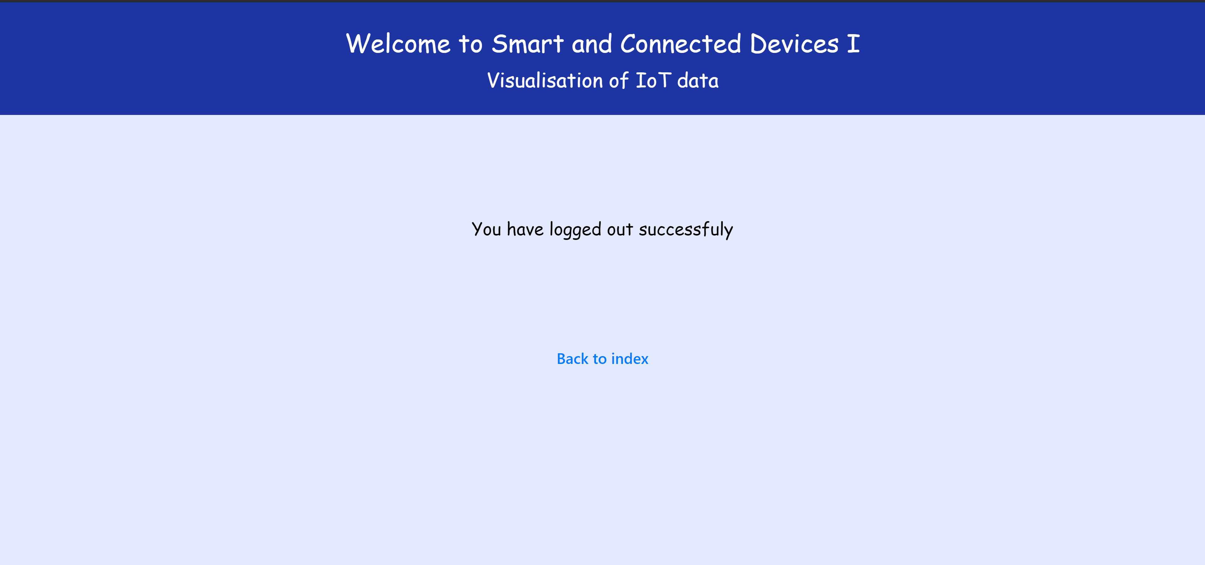
Figure 24: Screenshot when the user logged out.
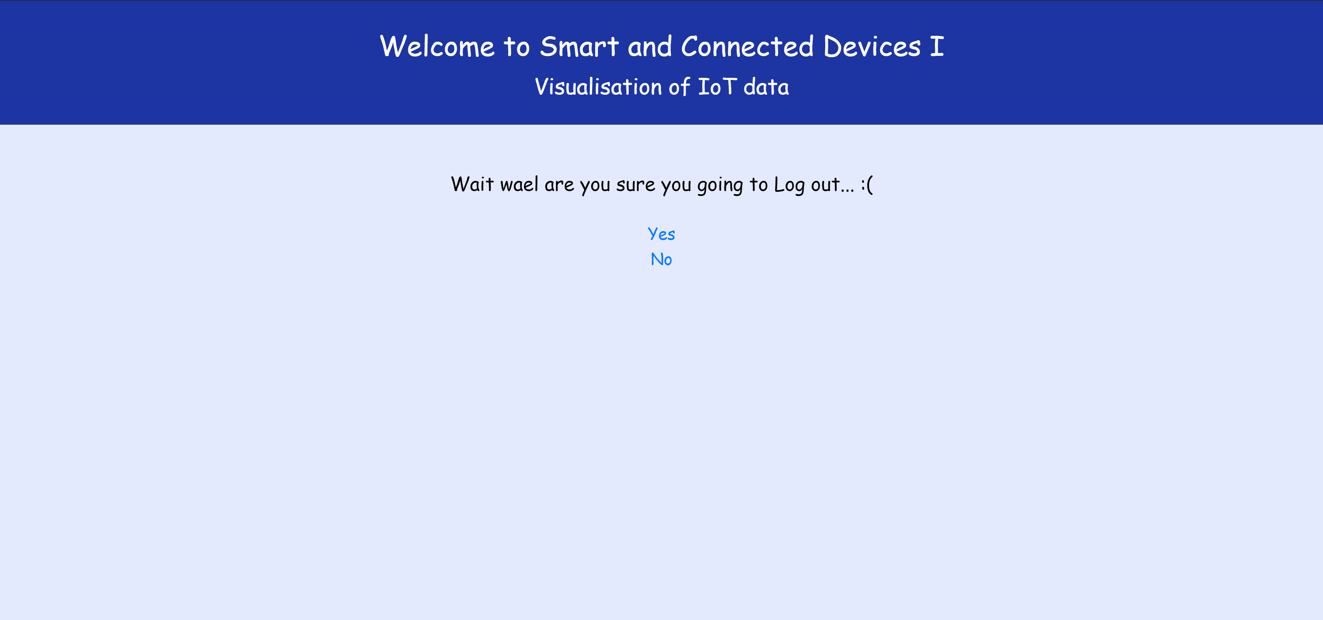
Figure 25: Screenshot if the user trying to go back after logged in.

Bibliography
The author has used many resources to help to implement his work[1][2][3][4][5]
[1] L. Wall, “PHP Tutorial,” TutorialsPoint, p. 148, 2015.
[2] w3schools, “PHP 5 Tutorial,” 2017. p. 100, 2017.
[3] “PHP Tutorial - Learn PHP.”
[4] The PHP Group, “PHP: What is PHP? - Manual,” my PHP.net, 2017. [Online]. Available: https://www.php.net/manual/en/intro-whatis.php. [Accessed: 13-May-2019].
[5] “PHP Tutorials - GeeksforGeeks.” [Online]. Available: https://www.geeksforgeeks.org/php/. [Accessed: 13-May-2019].

