

Community Engagement Assignment 2 – Reflective

Report

Student Name: Alexandru Mihai Ilie
Student ID: 2113107

Table of Contents
Introduction: 3
Display your knowledge and understanding on the purpose of reflective practice: 4
How can reflective practice help the development of effective self-management, communication, and interpersonal skills: 5
You are expected to analyse one reflective model in your report and the relationship between academic theories and your experience. 9
Conclusion: 12
References: 13

Introduction:
Reflective practice is one of the methods that can be used to learn new things through continuous learning. The reflective practice would help to understand the intentions as well as self-strengths and values of an individual which is very essential to work in a challenging situation. This report will help to understand the main purpose of reflective practice. To achieve personal as well as professional objectives every individual needs to develop various skills such as self-management skills, communication skills as well as interpersonal skills. This report will help to identify the ways that can be used to develop these skills by using reflective practice. At the end of the report, one reflective model will be analysed and its relationship with the academic theories and my practical experience will be discussed.

Display your knowledge and understanding on the purpose of reflective practice:
Reflective practice is one of the techniques that can be used to record experiences as well as observations of individuals. It would reflect the experiences as well as actions that can be taken to improve the knowledge and skills of an individual. This practice would help to recognize the paradigm along with the framework as well as assumptions and thinking patterns that influence the learning behaviour of an individual (Macbeth, 2022). With the help of reflective practice, an individual can explore paradigms along with assumptions as well as goals of an individual. The person can explore self-awareness along with developing imagination skills as well as the creative and systematic mode of thinking by practicing reflective practice. The reflective practice would help to understand the own intention along with self-values as well as visions which is very essential to complete challenging tasks. Management can use reflective practice to resolve the conflicts along with addressing the position-related issues as well as maintaining positive relationships within the organization.
In simple words, the reflective practice would help individuals to apply theoretical knowledge to solve practical problems. This concept is very similar to the performance assessment process. The only difference between the performance appraisal and reflective practice is that reflective practice would help to identify the self-achievement as well as failures and also helps to identify the areas of improvement which is very essential for the development of the person (Galutira, 2018). Apart from that, with the help of reflective practice person can learn from past blunders or mistakes.
Purpose of reflective practice:
- Understand the personality:
Reflective practice deal with the self-analysis of individuals this would help to understand personal strengths along with weaknesses as well as areas where improvement is needed (Slade et al., 2019). with the help of this practice, the person can understand own intentions along with self-values as well as ethics and vision which is very essential to complete the challenging task where the ethical values of an individual got tested. Apart from that reflective practice also help to understand the personality of people who are working in the organization which is very essential for human resource management.

- Self-development:
Reflective practice helps to identify the areas of improvement as well as weaknesses of the individuals. Every individual needs to identify their weaknesses before making plans for self-development. once you understand the areas where improvement is needed then you can easily take some actions to reduce your weaknesses or improvements. Apart from that this approach also helps to identify the methods which need to be used for individual development. The organization can use reflective practice to organize the development programs and improve the skills and knowledge of employees.

- Reduction of mistakes:
With the help of reflective practice, any individual can monitor as well as evaluate the past situation or decisions which are taken by them in past. This practice would help to understand the pros as well as cons of a particular action which is very essential to identify past mistakes. The person needs to identify his/her past mistakes to reduce them or not repeat them in the future.

- Management of workforce:
The reflective practice would help to understand the personality along with culture as well as values of an individual (Rogers et al., 2019). As we know there are a number of people are working in the organization and every individual has a unique personality. Hence HR managers need to identify the personality of employees to resolve conflicts between two people along with building and maintaining a positive relationship with the employees. HR managers can use reflective practice to conduct training programs for the employees and provide motivation to them.

How can reflective practice help the development of effective self-management, communication, and interpersonal skills:
Reflective practice play a very important role in the self-development of individuals. This practice would help to understand the thinking level or psychology of an individual which is very essential to identify the strengths or weaknesses of the person. Self-management along with communication as well as interpersonal skills plays a very important role in individual development. Hence every individual needs to develop these skills to achieve personal and professional goals. The person can use various strategies or practice such as developing reading habits along with self-discipline practice to improve these skills.

- Effective self-management:
Self-management is one of the important skills that help to achieve personal and professional goals as well as also helps to improve the performance of an individual (Vernon-Roberts et al., 2021). The reflective practice would help to improve productivity which is very essential to achieving professional objectives and career development. self-management is one of the skills that explains the ability of an individual to control their thoughts along with feelings as well as actions while working in the organization. Psychological factors would affect the performance of an employee on a large scale hence individuals need to manage and control those skills. Self-management skills play a very important role in different areas such as time management along with organization as well as accountability and stress management of an individual. Reflective practice is one of the powerful techniques that can be used to develop self-management skills. This tool helps to understand the self-strengths along with weaknesses as well as areas of improvement which is very essential to developing a strategic plan for developing self-management skills.
The reflective practice would help to focus on thoughts as well as help develop ideas and express the feelings of an individual. Apart from that with the help of reflective practice models individuals can improve their self-management skills. The reflective practice would help to identify self-awareness along with better time management as well as reduce the stress and increase the productivity of an individual.

- Communication skills:
Communication skills are one of the important skills which play a very important role in personal as well as professional development (Jabbarov, 2020). communication is an ability of an individual which helps to deliver important information from one person to another person. There are various skills such as listening, speaking as well as observing and sympathizing are involving ineffective communication. There are two types of communication one is formal and another is informal communication. Development of these skills is very important to achieve personal as well as professional goals. With the help of communication skills, individuals can influence, control and manage the emotions and behaviour of other people. Hence these skills can be considered essential to becoming an effective leader. To develop communication skills the person needs to develop listening skills along with teamwork skills as well as non-verbal communication skills and empathy.
The reflective practice would help to develop observation skills and understand the feelings of others which is very essential to developing communication skills. A reflective journal is one of the methods that can be used to develop communication skills among people. With the help of this method, the person can develop ideas along with feelings as well as observations and a vision for self-development. apart from that reflective journal would help to develop writing style as well as skills and helps to develop conversation skills which is one of the important parts of communication skills. To maintain the reflective journal the person needs to write on an everyday basis along with use diagrams and drawings. This practice would help to develop writing communication skills.

- Interpersonal skills:
Interpersonal skills are the combination of skills that can be used to interact along with communicating with others (Zhao and Chen, 2018). These skills play a very important role to become an effective leader and achieve professional objectives. interpersonal skills include a number of skills such as emotional intelligence, communication as well as leadership, and reliability which is very essential to developing a career in a particular area. It also includes teamwork skills along with conflict management skills as well as openness to feedback and empathy.
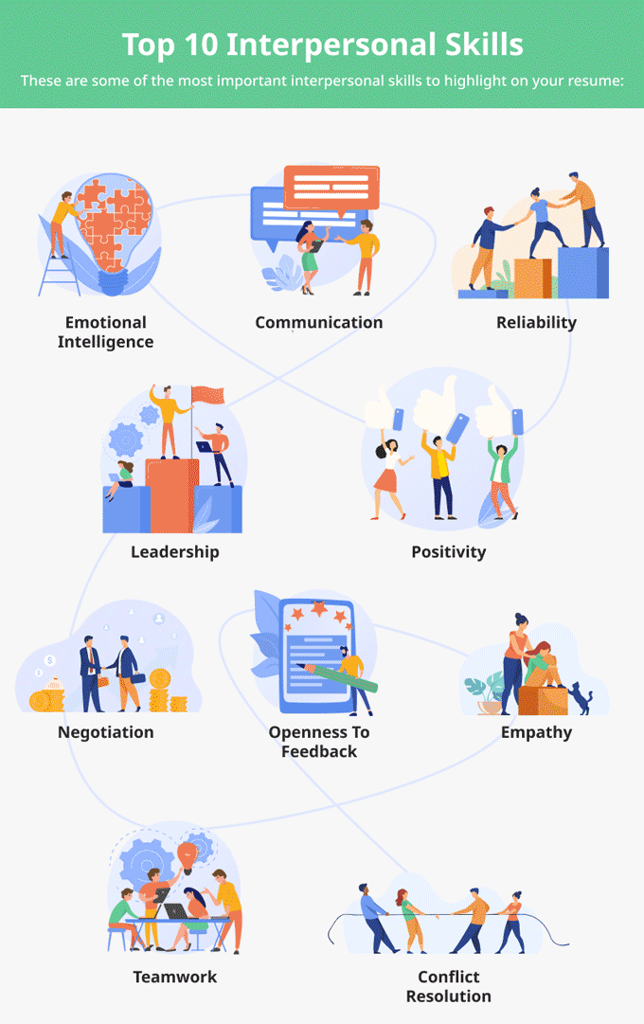
Figure 1Top 10 interpersonal skills
(Source: Peterson, 2022)
All these skills would create a positive impact on the resume or CV of an individual. Emotional intelligence is one of the most important skills that help to understand the feelings of other people. Qualities like self-awareness along with social awareness as well as perceptiveness and empathy contribute to emotional intelligence skills. The leader needs to understand the feelings as well as attitudes of other people while developing business strategies for the organization. Reflective skills would help to improve interpersonal skills. With the help of various models such as the Borton model, Gibbs model as well as Kolb and fry model individuals can improve their interpersonal skills. These reflective models would provide the framework to develop interpersonal skills.

You are expected to analyse one reflective model in your report and the relationship between academic theories and your experience.
The reflection model would provide guidance to implement the reflective practice in a practical manner. There are a number of models that can be used to learn while working in the organization. Gibbs’s reflective model is one of the reflective models that provide structure to learn from experience (Adeani et al., 2020). With the help of Gibbs’s model, you can understand as well as explore the situation which is very essential to making the appropriate decision. This model would help to provide guidance to implement the theoretical knowledge to solve practical problems. There are six stages are involving in this model:

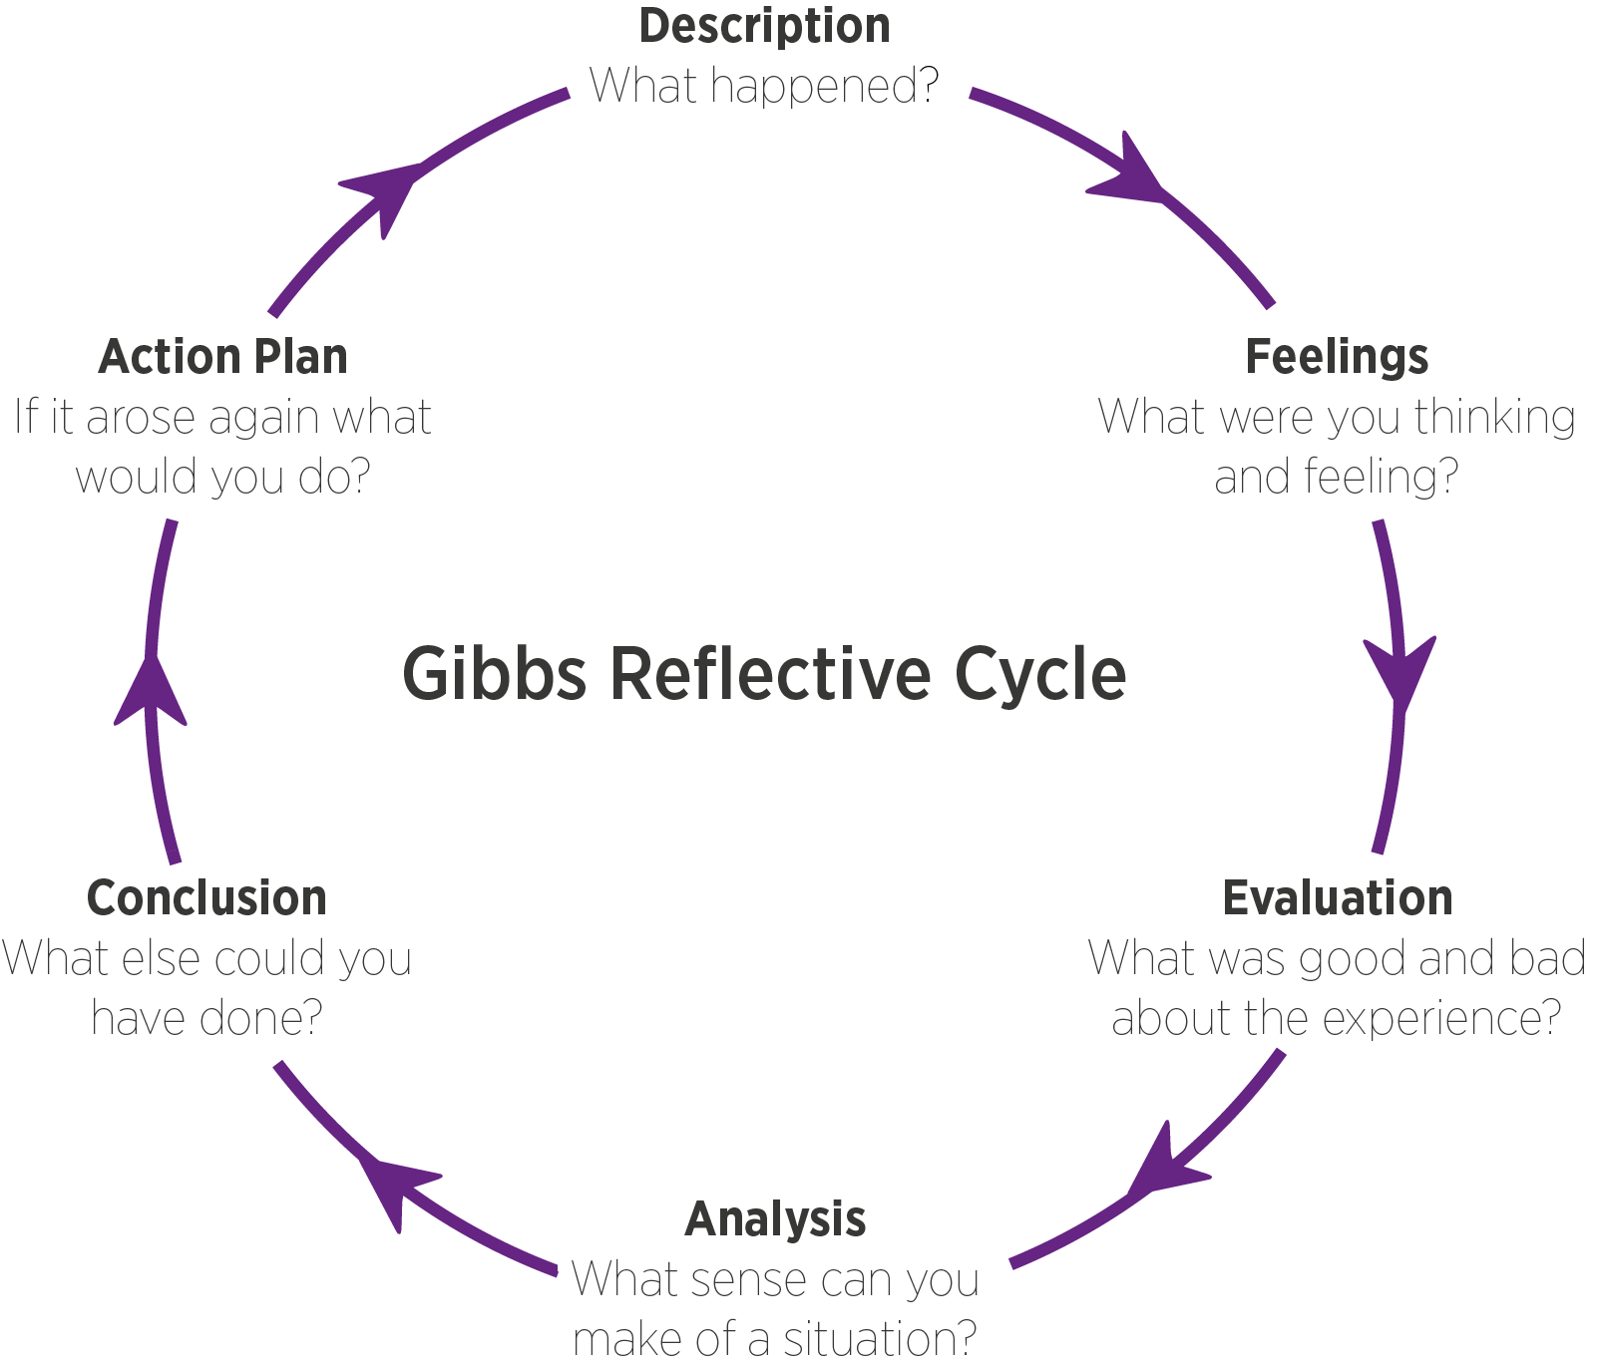
Figure 2Gibbs reflective cycle
(Source: Leaplikeasalmon.com, 2022)
- Description:
This is the first stage in which you need to describe the situation which is very essential to understand the seriousness of the situation. Before solving any problem or making any conclusion you need to understand the situation very well. This would help to design and develop strategies to deal with the situation. During academics, I have developed various skills to achieve my personal and professional objectives.

- Feelings:
This would be the second stage in which you can understand and explore the feelings of an individual (Tawanwongsri and Phenwan, 2019). Feelings or thoughts directly deal with the psychology of an individual which plays a very important role in the behaviour of an individual. I was a little nervous as well as excited to learn new skills.

- Evaluation:
This is the third stage in which a person can evaluate as well as examine the situation. This practice would help identify the factors which are working correctly or not working correctly. Here you can identify the positive as well as negative factors related to the particular situation. In this stage, I identified my strengths as well as weaknesses.

- Analysis:
In this stage, you can analyse the situation which is very essential to making a decision on a particular topic. Here person can use his/her knowledge along with expertise and experience to make a solution for the problem. During the analysis, I had identified strategies and practices which are essential to developing academics skills.

- Conclusion:
In this stage, a person can make a proper conclusion to resolve the problem. Here you need to consider all factors as well as challenges and needs to summarise the highlights (Hussein, 2018). In this stage, the person can learn various things from the situation along with present multiple ideas to solve the problem as well as present the skills which need to be developed to deal with the particular situation. In this stage, I was designed a plan by using the SMART tool to develop skills.

- Action plan:
This would be the last stage in which the person needs to prepare an action plan to handle the particular situation and solve the specific problem. The action plan is a combination of multiple practice that would practice in the future. An action plan would provide direction as well as guidance to solve a particular problem. In this stage, I had implemented the action plan which was previously developed.

Conclusion:
From the above analysis, it can be concluded that reflective practice would help to develop various skills to achieve the personal as well as professional objectives of an individual. HR managers can use reflective practice to understand the personality of their employees which is very essential to design the strategies for HR development. With the help of reflective practice, any individual can develop self-management skills along with communication skills as well as interpersonal skills. Gibbs’ reflective model would provide a framework to learn new things while working on a specific situation or problem.

References:
Adeani, I.S., Febriani, R.B. and Syafryadin, S., 2020. USING GIBBS’REFLECTIVE CYCLE IN MAKING REFLECTIONS OF LITERARY ANALYSIS. Indonesian EFL Journal, 6(2), pp.139-148.
Galutira, G.D., 2018. Theory of reflective practice in nursing. International Journal of Nursing Science, 8(3), pp.51-56.
Hussein, H., 2018. Examining the Effects of Reflective Journals on Students' Growth Mindset: A Case Study of Tertiary Level EFL Students in the United Arab Emirates. IAFOR Journal of Education, 6(2), pp.33-50.
Jabbarov, U., 2020. THE ROLE OF TRAININGS IN THE FORMATION AND DEVELOPMENT OF FUTURE FOREIGN LANGUAGE TEACHERS. Журнал иностранных языков и лингвистики, 1(1), pp.34-38.
Leaplikeasalmon.com. 2022. [online] Available at: <https://www.leaplikeasalmon.com/wp-content/uploads/2018/02/gibbs.png> [Accessed 31 March 2022].
Macbeth, S., 2022. Reflective Practice | Participatory Methods. [online] Participatorymethods.org. Available at: <https://www.participatorymethods.org/method/reflective-practice> [Accessed 31 March 2022].
Peterson, C., 2022. What are Interpersonal Skills? Definition & Examples. [online] Resume Genius. Available at: <https://resumegenius.com/blog/resume-help/interpersonal-skills> [Accessed 31 March 2022].
Rogers, S.L., Priddis, L.E., Michels, N., Tieman, M. and Van Winkle, L.J., 2019. Applications of the reflective practice questionnaire in medical education. BMC medical education, 19(1), pp.1-11.
Slade, M.L., Burnham, T.J., Catalana, S.M. and Waters, T., 2019. The Impact of Reflective Practice on Teacher Candidates' Learning. International Journal for the Scholarship of Teaching and Learning, 13(2), p.15.
Tawanwongsri, W. and Phenwan, T., 2019. Reflective and feedback performances on Thai medical students’ patient history-taking skills. BMC medical education, 19(1), pp.1-8.
Vernon-Roberts, A., Gearry, R.B. and Day, A.S., 2021. Overview of Self-Management Skills and Associated Assessment Tools for Children with Inflammatory Bowel Disease. Gastrointestinal Disorders, 3(2), pp.61-77.
Zhao, M. and Chen, S., 2018. The effects of structured physical activity program on social interaction and communication for children with autism. BioMed research international, 2018.

