Reflect and discuss how well you have developed skills during the module and your personal development needs, for example how developing these skills may assist in your future employment.

Throughout this reflective account, I will critically discuss how well I have developed skills during this module and personal development needs, for example how these skills may assist future employment. I will refer to relevant theories and literature throughout this reflective account, as well as completing the account using two reflective models. The module, Changemakers: Building your Personal Brand for Future Employment, entails building skills and competencies for career resilience and professional development for future employment. The learning outcomes included evaluating my own personal employability skills and their congruence with the skills required for professional practice in a real environment (Griffiths, 2022a). The reflective models I will be using are the Gibb’s Reflective Cycle (1988) and the Schön Reflective Model (1991). I have chosen two models as the Schön Reflective Model (1991) provides an additional element where it focuses on reflection during the event as well as reflection after the event (UOH, 2022). This reflective model is something I have identified as using daily within my work life, where I am sometimes faced with a challenge where I need to think quickly and maybe try something that is unexpected.

Gibbs’s Reflective Cycle provides a framework for examining experiences, with the cyclic structure allowing you to learn and plan from things that went well, things that did not go so well, and repeated experiences (University of Edinburgh, 2020). Gibb’s Reflective Cycle follows six stages with questions to guide you at each stage to help you to describe the situation in detail and to develop deeper reflections. Schön’s reflective model is not a circular one like Gibbs but is looked at over a timeline (Griffiths, 2022b). Schön (1991) believes that reflection begins in working environments, where the individual is confronted with unique experiences. Schön (1991) argues that it is in these situations where individuals develop their connections between theory and practice. He states that reflection-on-action is important to improve future decision making, but its reflection-in-action that he claimed is the core action for individuals to develop their skills, link theory to practice, and for thinking on their feet and improvising (Bates, 2019). As a result, our lecturer asked us to record our feelings during the lectures, and to explain why we feel that way and what we did about it in that moment. This provided me with something to reflect on after the action had finished.
My initial thoughts about the module were all negative. The title itself I feel has very little meaning to what the actual module entails, where the language suggests it involves business branding, rather than your own personal skills and qualities. After watching back the recorded lecture, I was left very confused and extremely stressed. I felt like I could not identify one academically enriched skill or quality that was relatively strong, or one that stood out from the rest. As I struggled to understand what the module was or what the assignments required me to do, I found it extremely hard to enjoy any aspect of the module. With the lack of enjoyment, I found that finding time to complete the work was forceful, and I always found something other to do instead of completing the assignments. This lack of understanding and enjoyment impacted the entire module. Whereas I usually aim for a high grade, I was happy enough to complete just enough work to gain a pass, or just happy to submit something.

In order to better understand what type of intelligence, skills or qualities I possess, I completed the three tests that were recommended by the lecturer. I also studied the skills inventory (see appendix 1) to identify skills that I feel are my strongest, but also to identify ones that I feel need improving. The first test I did was Howard Gardner’s Multiple Intelligence Test. Gardner (1943) developed the theory of Multiple Intelligences as he believed that people have different types of intelligences that form our intellectual potential (Cherry, 2022). Gardner claimed that an individual’s capacity in a type of intelligence will have a direct relation to how they learn (Bates, 2019). As a result, my results show that interpersonal intelligence and bodily-kinaesthetic intelligence were my strongest.

Bodily-kinaesthetic or “body smart” is the ability to use the body to communicate, process information through body movement and facial expressions (IDRLabs, 2022). Those identified as bodily-kinaesthetic intelligent are said to show strength in body movement, physical control and performing actions (Cherry, 2022). People with this type of intelligence occasionally learn better through movement, physically interacting with others, doing, and usually have great muscle memory (IDRLabs, 2022). They also have a great capacity to interpret and use expressive movement (Bates, 2019). On the other hand, “interpersonal intelligence or “people smart” is the ability to effectively interact with and understand other people” (IDRLabs, 2022). These people are highly skilled in communicating verbally and non-verbally, and have advanced skills in interacting, assessing emotions of others, intentions, and motivations of those around them. They are able to see situations from another perspective and are able to create positive relationships with those around them (Cherry, 2022).

The other test I completed was the Princeton Review test. This test asks you a series of questions where you choose one of two answers, to identify a list of career options suited for your interests and styles. Interests describe the types of activities that will need to be included in the career/job in order for you to stay motivated. Style describes the strengths that you will bring to that particular career when you are at your best. It states that being in a work environment where your skills are greatly appreciated is a larger part of job satisfaction (TPR Education, 2022). As a result, I fell under the red (expediting) category for interests and the green (communicating) category for style. The results show that individuals with red interests like hands on / problem solving responsibilities and like careers that involve practical and objective activities. My results then go onto state that those with green ‘styles’ prefer to work where they can perform their duties in an outgoing way. These people tend to be talkative, spontaneous, risk-taking and competitive, and usually thrive in a team-orientated environment (TPR Education, 2022).

The final test I did was the ‘Holland Code Career Quiz’, developed by John Holland. He created a system that was able to match personalities with work through a series of questions, where the results identify what career path(s) best suit you. There is a possibility of 6 personalities that matches a work environment. My test results show that I am best suited to a ‘social’ work environment, which includes cooperative, supporting, and helping environments. The test results provide you with a list of careers which matches your personality. My results included special education, which is my current profession, as well as various teaching roles, recreational therapists, behaviour workers, or social work. In comparison to my future employment, teaching in a special school or behaviour related environment is my end goal. Therefore, the Holland Code Career Quiz went exceptionally well for me.

Things started to go well after completing the three tests as I was able to make more sense of the skills and qualities that were identified as my strengths, weaknesses that need developing for future employment, but also was made aware that I was heading in the right direction with my career choice. I had more understanding of what the module involved, and how to start to complete the assignments. I was also able to make great connections between the skills the tests identified for myself, and the ones that I identified from the skills inventory to those of a teacher or individual working in special education. I was also fascinated that the Holland Code Career Quiz stated special education or behaviour management as a recommended career path. This is my current role within work, and I feel that working with the behaviour side of ALN is an enormous strength of mine. All results involved teaching or working in a social environment, or skills and qualities that are similar to those required to be a teacher.

Upon completing Gardner’s Multiple Intelligence Quiz, my results stated that I have an interpersonal intelligence, which is defined as ‘people smart’, and having an ability to effectively interact with other people (IDRLabs, 2022). People with strong interpersonal skills are able to create more positive relationships with a wide range of individuals, which is deemed as crucial for teachers who are wanting to be more approaching and attentive. This includes being adept at helping and understanding those with additional learning needs (Zambas, 2022). Communication is another skill that appeared in the results of the three tests, but also one which I chose from the skills inventory as a particular strength of mine. Communication is desired and is of top priority on a person specification form when applying for a teaching role. Communicating is considered one of the largest parts of teaching, which includes communicating with the students through learning, other staff members, therapists, and parents. This communication could be verbal, non-verbal, written or via any other route that gets your point across (Bright Network, 2022).

On the other hand, there were aspects of the module that did not go so well. Originally, for part A of Assignment 1 I chose to complete a professional CV and a Personal Development Plan (PDP). These two pieces of work were the ones I was drawn to the most, and I felt that they would be the easiest to complete. These thoughts came from the fact that I have recently created a CV for a recent job application, and that there was a whole lecture and PowerPoint based on CVs and PDPs with a guest lecturer (Hall, 2022). Although, the suggested structure that was provided to us in the lecture was an essay type structure. But after researching PDPs, they all seemed to be a table format. This created a lot of stress and I started to contemplate changing tasks. However, I realised that we would not have been provided this structure if it was incorrect. I decided to use my support network and emailed my lecturer to ask for some advice on whether to use the essay structure or the table structure. I used her response as an advantage and eventually decided to carry on with the PDP. Another part of the module that did not go well was my motivation and concentration levels. As previously stated, my initial thoughts about the module were negative, therefore I undoubtedly struggled to remain focused to complete work.

To conclude, the module Changemakers: Building Your Personal Brand for Future Employment has enhanced my knowledge and recognition of my own personal strengths and weaknesses. The three tests by Gardner (1943), Holland (1959), and the Princeton Review solidified that I am currently working in the right career, and that I am currently on the right path for the opportunities and career that is best suited to me. These tests also confirmed that the skills and qualities that I identified as my strengths, are in fact my strengths. Using the skills inventory, I was also able to identify skills to work on in order to better my opportunities. After completing this module, I feel some sense of achievement for the fact that I struggled with motivation and concentration for the whole module, but I was able to utilize my keep going skills in order to complete all parts of the assignments to a standard that I am happy with.

If I was to complete this module again, I would request the time off work in advance so I would be able to participate in the lectures and be present to ask questions. I would request a tutorial from the lecturer to gain a better understanding of the module and the individual parts to the assignments. To develop my motivation and concentration skills, I will start each study session by creating a list of things to complete during that session. This way, I will have a short-term goal to aim for, which can be easily achieved in small steps (Cottrell, 2019). I will plan to study away from work and home, in order to minimise distractions. I will also plan short breaks during the study times which I feel would help me concentrate fully until that time.

Reference List
Bates, B. (2019) Learning Theories Simplified. 2nd Ed. London: Sage

Bright Network (2022) How to develop the 10 key skills you need to work in Education. Available at: https://www.brightnetwork.co.uk/career-path-guides/education-teaching/key-skills/ (Accessed: 27th October 2022).

Cherry, K. (2022). Gardner’s Theory of Multiple Intelligences. Available at: https://www.verywellmind.com/gardners-theory-of-multiple-intelligences-2795161 (Accessed: 25th October 2022).

Cottrell, S. (2019) The Study Skills Handbook. 5th Ed. London: Red Globe Press

Griffiths, H. (2022a) Changemakers: Building Your Personal Brand For Sustainable Employment. [PowerPoint] (Accessed: 28th October 2022).

Griffiths, H. (2022b) Reflective Models and Reflective Writing. [PowerPoint]. (Accessed: 23rd October 2022).

Hall, M. (2022). CVs and PDP. [PowerPoint] (Accessed: 23rd October).

IDR Labs (2022) Multiple Intelligence Test: Based on the work of Howard Gardner, Ph.D. Available at: https://www.idrlabs.com/multiple-intelligences/test.php (Accessed: 09th October, 2022).

Johnston, J. (2007). Developing Teaching Skills in the Primary School. Berkshire: Open University Press.

TPR Education (2022). Career Quiz. Available at: https://www.princetonreview.com/quiz/career-quiz#!quizresult_7713728_quizResultsTab (Accessed: 25th October 2022).

University of Edinburgh (2020) Gibb’s Reflective Cycle. Available at: https://www.ed.ac.uk/reflection/reflectors-toolkit/reflecting-on-experience/gibbs-reflective-cycle (Accessed: 16th October 2022).

University of Hull (UoH) (2022) Reflective Writing: Schon. Available at: https://libguides.hull.ac.uk/reflectivewriting/schon (Accessed: 15th October 2022).

Zambas, J. (2022). The Top 25 Skills Needed to Be a Teacher. Available at: https://www.careeraddict.com/teacher-skills (Accessed: 20th October 2022).

Appendices

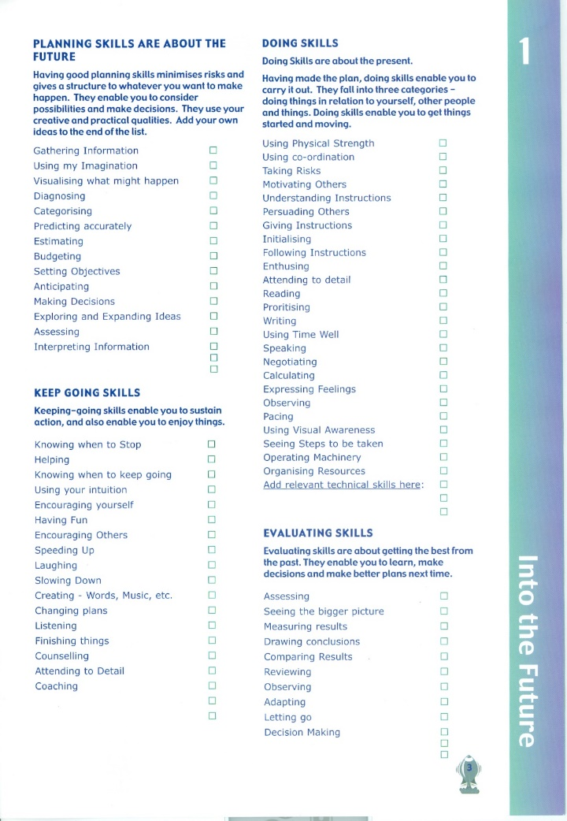
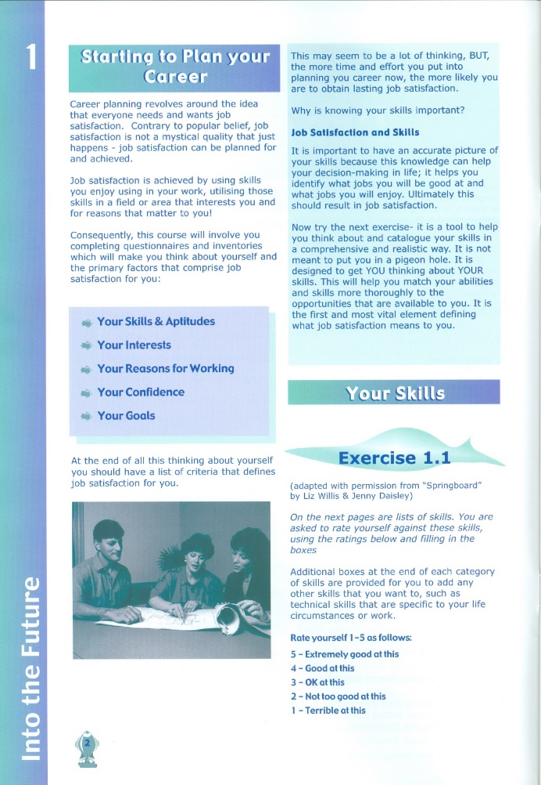
Appendix 1


