Dissertation Proposal

For my dissertation proposal, I will be researching a topic that I am very interested in called synaesthesia. Synaesthesia is a topic that is returning to the interests of researchers and artists alike with more research being done into how this neurological condition is caused. I plan to research synaesthesia, the senses, perception and the art world revolving these topics. I also plan to further delve into the technological side of the art world, to discover ways to perceive art and the artist’s mind. My own interest in synaesthesia lies within my own practice of trying to induce the interesting abilities of synaesthesia and working with visualisation sounds and sensations through painting and sculpting.
Synaesthesia, defined by Collins dictionary, is “a sensation experienced in a part of the body other than the part stimulated” (collinsdictionary.com) In other words, synaesthesia is a term collectively defines the cross-wiring of the neurological signal that perceive senses. Synaesthesia is used as an overall term for many variations of the condition. There are over 80 different variations, for example Chromesthesia, commonly known for sound being crossed wired with seeing colour, and Grapheme-Colour, seeing letters/ words in colour (Mächler, 2016). The working of synaesthesia is based upon an abnormality in the brain functions. According to David M. Eagleman (2010: 221), synaesthesia is a mixing of different perceptions of sense, being involuntary to the synaesthete, a person who has synaesthesia. When the brain of a synaesthete experiences the mixture of senses, the brain stimulates one area voluntarily and stimulates another area of the brain involuntarily.
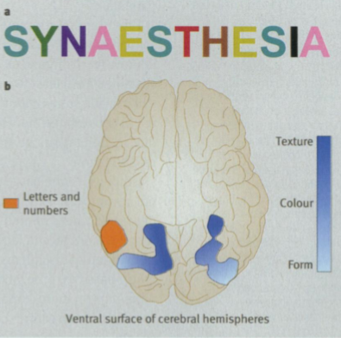[Figure 1]

In figure 1, there is a representation of the perception of a grapheme-colour synaesthete. Clearly show in the diagram, the word ‘SYNAESTHESIA’ has a different colour assigned to different letters, this is how this synesthete would view this word. The diagram also shows the parts of the brain that are affected when the synaesthete sees a word or letters, it makes an understanding of how the brain can be affected from one type of synaesthesia. (Eagleman, 2010: 221)
According to Bulat Galeyev (2001: 362), synaesthesia may not only be a condition in which the human brain involuntarily crosses senses causing unwilled senses to occur. The term synaesthesia has also been used for an experience that can be brought on by the intervention of human actions, such as taking a drug that may cause hallucinations or a similar sensation to a synaesthete’s. Another form of the condition may be linked to the thinking and perception abilities of creative people such as artists, writers and musicians. Galeyev believes that there is ‘art synaesthesia’ where it is based upon aesthetics, art theory and it is not caused by abnormalities of the brain such as synaesthesia. This form would be common in most creative people as it is something that can be developed if the psyche allows. It is as though a person voluntarily tries to stimulate multiple senses at once.
There are many different people that possess the synaesthetic ability which is usually portrayed through their work. An example of these people is modern abstract artist, Melissa McCracken. Using her ability of hearing colour, McCracken visualises music and then paints them onto canvas. McCracken paints her everyday life of the sounds she sees all around her as well as painting famous music. Her variation of the condition is a mixture of different ones compiled together. She can hear colour, see letters and words in colour as well as seeing days of the year float around the spaces next to her. As a result of her unique mind she began painting to record her own visuals from most songs (Zhang, 2017).
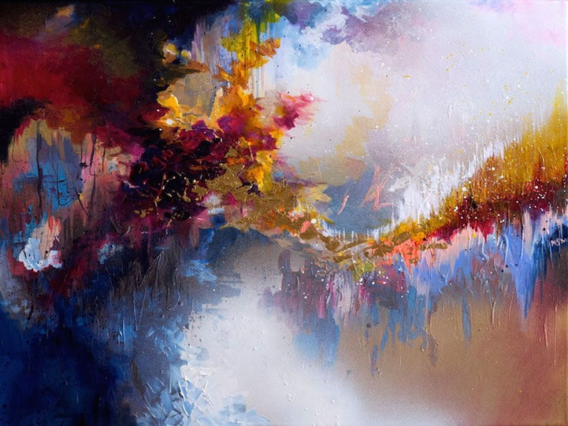
[Figure 2]

As an example of her work, the painting ‘Imagine- John Lennon’ (fig.2) is a great representation of her work and experiences. The painting shows great use of colour in an explosive and expressive way. There are contrasting dark and light areas within the painting, which allows for some parts to have a dark feeling and atmosphere. The rhythm of the song is portrayed through the waves and the pattern of tones. If listened to, the song ‘Imagine- John Lennon’ (Emi Records Italy, 2012) has an atmosphere that starts off quite dark to then proceed to jump to light then back to dark, which correlates with the patches of light and dark contrast in McCracken’s painting. The painting represents the atmosphere of the song. McCracken used her unique talent to portray sounds and songs into amazing visual abstract art.
Another creative person that experienced synaesthesia in the arts was Wassily Kandinsky. It is not entirely clear whether Kandinsky possessed involuntary synaesthesia, but he has clearly shown that he understood and had the capability to create visual arts to display sound in colour, shapes, forms and contrasts. It is believed that Kandinsky may have used the idea and knowledge of synaesthesia of his time to be able to further his abstract works. According to Ossian Ward (2006), Kandinsky had spent his life studying and creating his works based upon synaesthesia and sound in visual forms. The history of Kandinsky’s synaesthesia had been realised when he was at Moscow for a performance of Wagner’s opera, experiencing a multitude of colours appearing before him.
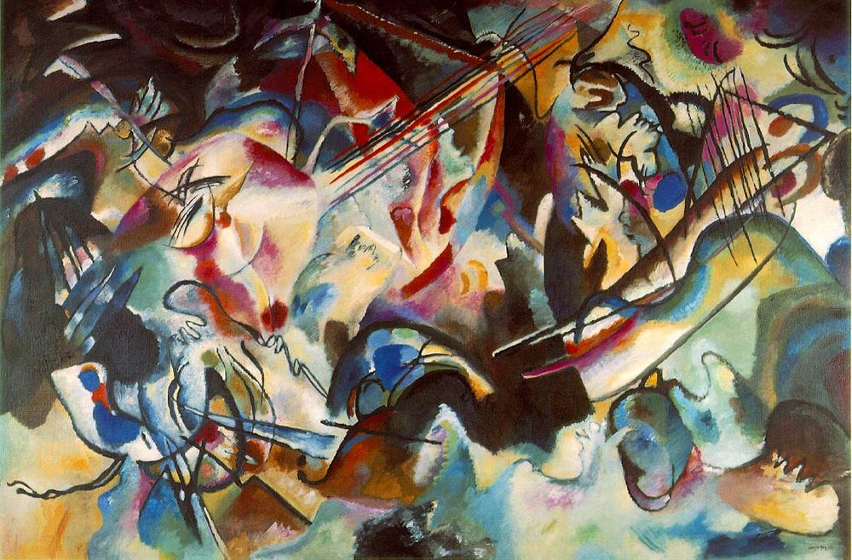
[Figure 3]

A works of Kandinsky’s “Composition VI” (1913) (Fig.3) has a very confused form and abstractly placed colours, which can be a representation of sound in visual form due to the upward motion of most of the lines and shapes. The colours contain some gradual gradients of colours from one to another, possibly indicating a smooth change from one note to another in the song. The colours can also be said to have an up and down motion that could be a representation of tone and tempo. In comparison to McCracken’s work, Kandinsky seems to have more form, lines and recognisable shapes whereas McCracken’s contains a more explosive visual of dispersing colours representing the music she listens to while working. Both artists use music and sound while working to create their pieces.
Returning to the ideas of Galeyev (2001:363), it is unsure if Kandinsky was fully a synaesthete, as it is only in newer technological advances that researchers can determine whether a person has abnormal activity in their brain functions while perceiving senses. In Kandinsky’s time synaesthesia could only be determined by description of symptoms. Galeyev has been studying synaesthesia for many decades to conclude what synaesthesia is and how it works.
Another artist that follows the ways of synaesthesia is Carol Steen, an artist that uses her abilities in a slightly different method. At first hiding her unique mind from others, Steen moved on to create artwork based with synaesthesia at its source. Synaesthesia was her inspiration. The senses that affiliate with her synaesthesia are taste, smell, sound and most interestingly, pain. Steen’s preferred sense to use for her paintings is pain, especially with the influence of an acupuncture session. The pain from these sessions allow for vivid colours and shapes, while she can fully concentrate on the imagery involuntarily shown to her.
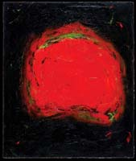 [Figure 4]

“Vision” by Steen (ATOA, 1996) (fig.4) is an interesting piece which depicts her synaesthesia as she has found it difficult to use words to fully represent what she has been seeing. Within her painting, the colours can reflect the sensation of pain through the colour red, even possibly conveying the emotion anger within the intensity. The colours in the painting, red and hints of green, seem to mix and blend into the black background. The feeling given is a representation of a sharp point/pain sensation elongating. Steen has many connections with creative people who share a form of synaesthesia, due to this Steen has found that there can be coinciding affects with the descriptions of other synaethetes’ experiences. (Steen, 2001: 203)
This brings the topic to how artists can use the idea and knowledge of synaesthesia in their practices. Unfortunately, not all creative people have the capabilities to bring on such a fascinating condition. There are, however, new technologies in which an artist may use to create their own visions in a synaesthetic manner. Google tiltbrush is a virtually reality drawing tool in which the user can stand in their own 3D drawings and experience a synaesthesia-like experience. Using this new technology, which is used alongside a VR (virtual reality) headset such as HTC Vive virtual reality system or Oculus Rift and the google tiltbrush, allows artists to create masterpieces or sketches of any size. This tiltbrush can be used in the whole area of a room, giving space and freedom to create whatever is needed. (Tiltbrush.com)
People that have worked with google tiltbrush are Karen Ingham. In a project called ‘Virtual Embodiments’ that ran in 2016-2017, Karen Ingham had worked with Dr Ann John of the Medical School, Swansea, to gain knowledge on the topic of mental health in the youth population. They had used this 3D resource to help research the negative feelings of the young participants using virtual reality and illustrate their inner thoughts through drawing. The project had ended in a show of film based on the 3D works as well as printed sculptures.
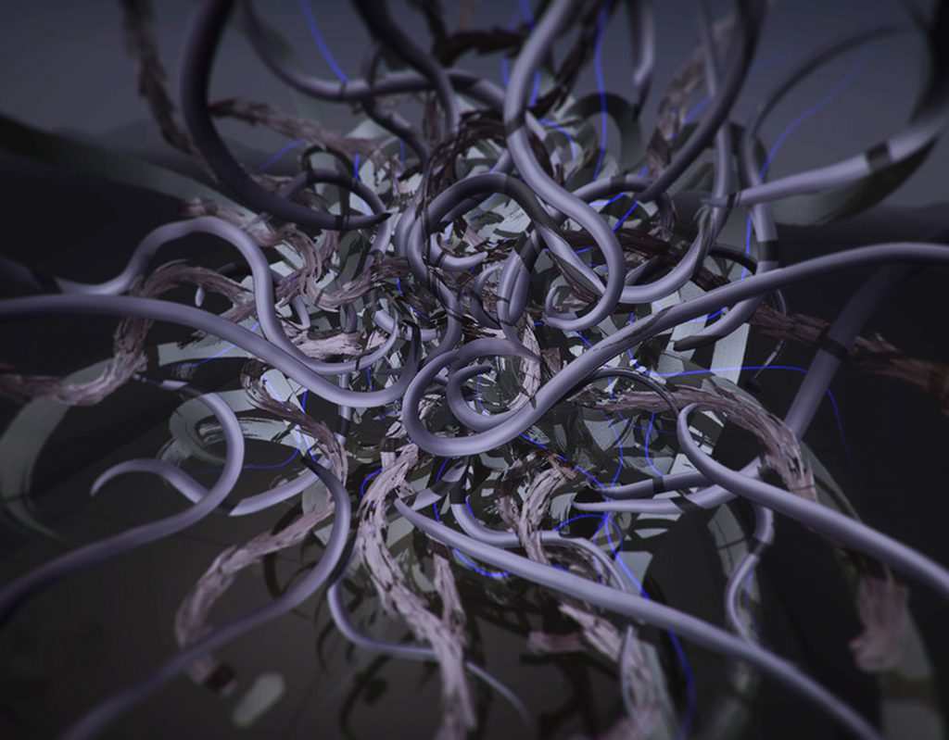
[Figure 5]

During the research, a 3D image of “Virtual Embodiments” (2017) (fig. 5) was created depicting a young person’s inner thoughts. The colours in the 3D drawing reflects a negative atmosphere with the use of dark colours and shading. The image creates a manifestation of swirling and intertwining lines, emphasising an emotion of confusion or a state of being overwhelmed. (Ingham, 2016-2017)
With knowledge of how the tiltbrush can be used, the previous research can be applied to using synaesthesia and the google tiltbrush combined as a new methodology for artists. The tiltbrush can be used to draw a variety of shapes and lines, in a variety of colours and textures. Some of these textures can also resemble a form of light, relating back to a variation of synaesthesia. An interesting feature included in this app, is that the user can incorporate sound and music to bring drawings to life, by animating a drawn line with a tune/beat. As shown the demonstration video, “Tiltbrush: Audio Reactive Brushes” (2016), the brush lines are fully animated to the beat of the song with some light spots reacting to only certain sounds within the music. This visualisation of music represented with this technology could lead to new insights for non-synaesthete to experience what it might be like to have the ability to hear colour. (Wilson,2016)
While researching synaesthesia and its connection to the art and technology fields, there is an idea union between them but for an artist with the neurological condition it is difficult to accomplish the same unique style of working as an artist with synaesthesia already possesses. With knowledge of the tiltbrush technology, there could be a possibility to unlock sections of the brain to experience a form of synaesthesia after the use of the google tiltbrush. This proposal concludes with the question, ‘Can the use of 3D technology activate synaesthesia in a non-synaesthete artist?’ Other questions that could be explored are ‘Can an artist cross their own senses?’ and ‘Will new technology open a path to allow artists to perceive senses differently and more creatively?

Bibliography

Collinsdictionary.com. (n.d.). Synaesthesia definition and meaning | Collins English Dictionary. [online] Available at: https://www.collinsdictionary.com/dictionary/english/synaesthesia [Accessed: 03-05-18]

Mächler, M. (2016). Types of Synesthesia - Become aware of your synesthetic abilities. [online] Synesthesia Meditation. Available at: https://synesthesia.com/blog/types-of-synesthesia/ [Accessed: 09-05-18]

Eagleman, D. (2010). Synaesthesia. BMJ: British Medical Journal, 340(7740), 221-222. Retrieved from http://www.jstor.org.ezproxy.uwtsd.ac.uk/stable/25673834 [Accessed: 03-05-18]

Galeyev, B. (2001). Open Letter on Synesthesia. Leonardo, 34(4), 362-363. Retrieved from http://www.jstor.org.ezproxy.uwtsd.ac.uk/stable/1577167 [Accessed: 03-05-18]

Zhang, J. (2017). Artist with Synesthesia Paints Music as Gorgeous Splashes of Color. [online] My Modern Met. Available at: https://mymodernmet.com/melissa-mccracken-synethesia-paintings/ [Accessed: 09-05-18]

Ward, O. (2006) The man who heard his paintbox hiss. [online] Telegraph.co.uk. Available at: https://www.telegraph.co.uk/culture/art/3653012/The-man-who-heard-his-paintbox-hiss.html [Accessed: 08-05-18]

Steen, C. (2001). Visions Shared: A Firsthand Look into Synesthesia and Art. Leonardo, 34(3), 203-208. Retrieved from http://www.jstor.org.ezproxy.uwtsd.ac.uk/stable/1576936 [Accessed: 03-05-18]

Tiltbrush.com. Tilt Brush by Google. [online] Available at: https://www.tiltbrush.com [Accessed: 09-05-18]

Ingham, K. (n.d.). Virtual Embodiments (2016-2017) – Karen Ingham. [online] Kareningham.org.uk. Available at: http://www.kareningham.org.uk/virtual-embodiments/ [Accessed: 09-05-18]

Wilson, M. (2016). Google’s New Tilt Brush App Makes You Feel Like A Synesthete. [online] Co.Design. Available at: https://www.fastcodesign.com/3062450/googles-new-tilt-brush-app-makes-you-feel-like-a-synesthete [Accessed: 09-05-18]
Videos/Images References

[Figure 1] Eagleman, D. (2010). [a] Representation of the colours evoked by individual letters in a word for a grapheme-colour synaesthete. [b] Synaesthesia seems to result from higher than normal crosstalk between neighbouring areas in the brain- in this case nearby by brain areas involved in graphemes (orange) and those involved in colour, texture, or form (shades of blue) Adapted from Eagleman and Goodale. [image] Available at: http://www.jstor.org.ezproxy.uwtsd.ac.uk/stable/25673834

[Figure 2] My Modern Met (2017). John Lennon- Imagine. [image] Available at: https://mymodernmet.com/wp/wp-content/uploads/2015/04/melissa-mccracken-synesthesia-examples-5.jpg [Accessed: 09-05-18]

Emi Records Italy (2012). John Lennon - Imagine. [video] Available at: https://www.youtube.com/watch?v=VOgFZfRVaww [Accessed: 09-05-18]

[Figure 3] Kandinsky, W. (1913). Composition VI. [Oil on Canvas] Saint Petersburg, Russia.: Hermitage Museum. Available at: http://www.wassilykandinsky.net/work-35.php [Accessed: 09-05-18]

[Figure 4] ATOA (2006). Carol Steen "Vision". [image] Available at: http://www.atoa.org/Fall2006/Steen_Vision.jpg [Accessed: 09-05-18]

[Figure5] Ingham, K. (2017). Virtual Embodiments. [image] Available at: http://www.kareningham.org.uk/wp-content/uploads/2017/01/Virtual-Embodiments3-1024x799.jpg [Accessed: 09-05-18]

Google VR (2016). Tilt Brush: Audio Reactive Brushes. [video] Available at: https://www.youtube.com/watch?v=uFzAB4mr3KI [Accessed: 09-05-18]

