Engine Performance Characteristics
Powertrain Technology (ACHA4029)



University of Wales Trinity Saint David
Motorsport Engineering Beng Hons

George Campling
2503449

Word Count: 1994
22/03/2026

Contents:

- Introduction…………………………………………………………………………………...1
- Testing Equipment and Methodology………………………………………………………2
  - Equipment Used…………………………………………………………………….2
  - Methodology…………………………………………………………………………2
- Collected and Calculated Data……………………………………………………………..4
- Data Graphs………………………………………………………………………………….9
- Conclusions from Test Results……………………………………………………………12
- Evaluation of Experience…………………………………………………………………..13
- Conclusion…………………………………………………………………………………..14
- Reference list……………………………………………………………………………….15

Figures:
- Figure 1, Specific Fuel Consumption vs Engine Speed Graph…………………………9
- Figure 2, Brake Power & Torque vs Engine Speed Graph…………………………….10

Tables:
- Table 1 – Important Information for Calculations…………………………………………5
- Table 2 – Collected/Calculated Data Pt.1…………………………………………………6
- Table 3 – Collected/Calculated Data Pt.2…………………………………………………7
- Table 4 – Collected/Calculated Data Pt.3…………………………………………………8

Equations:
- $T=F.L$………………………………………………………………………………………..4
- $P=\frac{\left(\frac{2⋅π⋅N⋅T}{60}\right)}{1000}$…………………………………………………………………………………….4
- $P_{s}= P⋅\frac{1.01325}{p_{a}}\sqrt{\frac{T_{a}}{27+273}}$………………………………………………………………………4
- $bhp=kW×1.34102$………………………………………………………………………..4
- $BMEP= \frac{\left(T⋅n⋅π\right)}{L}$……………………………………………………………………………….5
- $SFC=\frac{\left(V⋅0.74⋅60\right)}{kW}$………………………………………………………………………………5
- $OTE= \frac{BP}{m⋅CV}$…………………………………………………………………………………...5

Abbreviations:
- UWTSD – University of Wales Trinity Saint David
- Dyno – Dynamometer
- HP – Horsepower
- Pt – Part
- rpm – Rotations Per Minute
- bhp – Brake Horsepower
- BMEP – Brake Mean Effective Pressure
- SFC – Specific Fuel Consumption
- OTE – Overall Thermal Efficiency

Chapter 1 – Introduction:

This report aims to analyse the engine performance characteristics of a Honda D16 Vtec import engine, from around the years 2000 to 2001 (UWTSD WISA Workshops, 2020).
This shall be done by performing a dynamometer test (specifically the Schenck WS230 dyno (UWTSD WISA Workshops, 2020)) upon the engine. A spreadsheet containing factors such as load, dyno speed, fuel flow rate, and lambda (raw data) shall be drawn. Later calculations for further factors such as corrected power and torque shall also be conducted.
The methodology for performing the test shall be explained, and a series of graphs using both the raw and calculated data shall be drawn and evaluated, for the results of the test.
Finaly a brief evaluation of how the test and investigation could be improved shall be conducted.

1
Chapter 2 – Testing Equipment and Methodology:

2.1 - Equipment Used
As mentioned in the introduction, the engine that shall be having the dyno test performed on is a 1.6 litre Honda D16 Vtec, estimated to be from the years 2000 to 2001 (UWTSD WISA Workshops, 2020).
Over the years there have been multiple different iterations of the D16 engine, starting production in 1986 and finishing production in 2007, these engines from factory produced around 100 to 130 horsepower stock (Terrell, J. 2023).
Due to the number of iterations of the engine, it is hard to pinpoint which specific Honda model the engine came from. However, we do know that it is an import engine, so we can expect it to be on the lower end of the HP scale. It is a safe assumption to say that the engine came from a Jazz or a Civic CRX (UWTSD WISA Workshops, 2020).
Also as previously mentioned in the introduction the dynamometer itself is a Schenck WS230. The main specifications for this rig are as follows: (Dadt, H.J. 2001; UWTSD WISA Workshops, 2020)
- Power (kW): 230
- Rated Torque (Nm): 750
- Maximal Speed (rpm): 10000
- Torque Arm Length (mm): 815.776
- Measuring Accuracy Speed (rpm): ±1
- Measuring Accuracy Torque (%): 0.2

2.2 – Methodology
There are four main ways to perform a dyno test, manually, test sequencing, step testing and sweep testing (UWTSD WISA Workshops, 2020).
Manual testing consists of manually controlling the throttle and current input to the dyno, through two dials on the dyno control panel. From here the operator can target specific rpm and load measurements, to find torque. Both parameters are in direct correlation, if the load increases, the engine speed will decrease, and vice versa (UWTSD WISA Workshops, 2020).
2
Test sequencing is the process of letting the dyno system run itself. Using the test manager, the operator fills in a number of different parameters, such as ramp dyno (the rate at which an engines rpm increases (Darkside Developments, 2018)), ramp throttle, and step duration. The steps performed can also be looped, this allow for things such as drive cycles to be programmed in, alongside multiple other desired tests (UWTSD WISA Workshops, 2020).
Both step testing and sweep testing are two different types of Pico testing. “A step test tends to be for targeting specific areas… for example 3000 rpm.” (UWTSD WISA Workshops). The operator sets a start and finish rpm, a delta between rpm measurements to log data, ramp time, and some other parameters. Once the operator starts the test the system shall increment up through the start rpm to the finish rpm, by the set step rpm, logging the desired data, such as load, fuel flow rate, and lambda (multiple other parameters are also collected) at every step. At the end of the test a table of collected data is presented (UWTSD WISA Workshops, 2020).
Finaly sweep testing (the way our data shall be collected) is very similar to step testing. Rather than pausing at every step rpm, as a step test does, a sweep test takes the data at the given moment the engine hits the step rpm and doesn’t pause momentarily. This gives slightly less accurate results, but reduces the load on the engine, as well as producing less heat energy (UWTSD WISA Workshops, 2020).

3
Chapter 3 – Collected and Calculated Data:

Once the sweep test is complete, a table of measured parameters is drawn. As a bare minimum this table shall contain load (N), dyno speed (rpm), fuel flow rate (L/min), and Lambda (Lambda). Further parameters can be calculated on behalf of the operator by the dyno operating system, or they can be manually calculated. The further parameters that we’re interested in are power (kW), corrected power (kW), brake power (bhp), torque (N/m), BMEP (kPa), SFC (Kg/kWh) and OTE (no unit).

Torque can be calculated by using the equation: (Harrison, A, 2020).
$T=F.L$ (Equation 1)
Where: T = Torque (N/m), F = Force (N), L = Torque Arm Length (m)

Power can be calculated by using the equation: (Harrison, A, 2020).
$P=\frac{\left(\frac{2⋅π⋅N⋅T}{60}\right)}{1000}$ (Equation 2)
Where: P = Power (kW), N = Engine Speed (rpm), T = Torque (N/m)

Corrected power can be calculated by using the equation: (Harrison, A, 2020).
$$P_{s}= P⋅\frac{1.01325}{p_{a}}\sqrt{\frac{T_{a}}{27+273}} \left(Equasion 3\right)$$
Where: $P_{s}=corrected power \left(kW\right), P=Power \left(kW\right), p_{a}=ambient pressure \left(Bar\right), T_{a}=ambient tempriture \left(Deg C or Kevlin\right)$
Values for the ambient pressure and ambient temperature can be seen in table 1 below.

Brake power can be calculated by using the equation: (Blackcircles.com, 2026).
$$bhp=kW×1.34102 \left(Equaion 4\right)$$
Where: kW = Corrected Power (for at specific atmospheric conditions)
4
Brake mean effective pressure can be calculated by using the equation: (Harrison, A, 2020).
$$BMEP= \frac{\left(T⋅n⋅π\right)}{L} \left(Equasion 5\right)$$
Where: T = Torque (N/m), n = Number of Cylinders, L = Engine Capacity (L or cc)

Specific fuel consumption can be calculated by using the equation: (Harrison, A, 2020).
$$SFC=\frac{\left(V⋅0.74⋅60\right)}{kW} (Equasion 6)$$
Where: V = Fuel Flow Rate (l/min), 0.74 = Specific Gravity of Fuel (converts litres to kg), kW = Corrected Power (kW)

Overall thermal efficiency can be calculated by using the equation: (Kadhim, D.N.S. and Hassan, Q.H. 2017).
$$OTE= \frac{BP}{m⋅CV} (Equasion 7)$$
Where: BP = Brake Power (convert to kW), m = Mass Fuel Flow Rate (kg/s), CV = Calorific Value of Fuel (44000 kJ/kg) (The Engineering ToolBox, 2003).
The OTE value given at the end of this equation shall give the result as a decimal. To convert to a percentage multiply by 100.

All the final calculation results can be seen in tables 2 to 4 below.

Table 1 – Important Information for Calculations
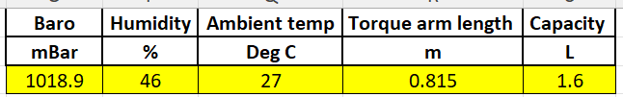

5

Table 2 – Collected/Calculated Data Pt.1
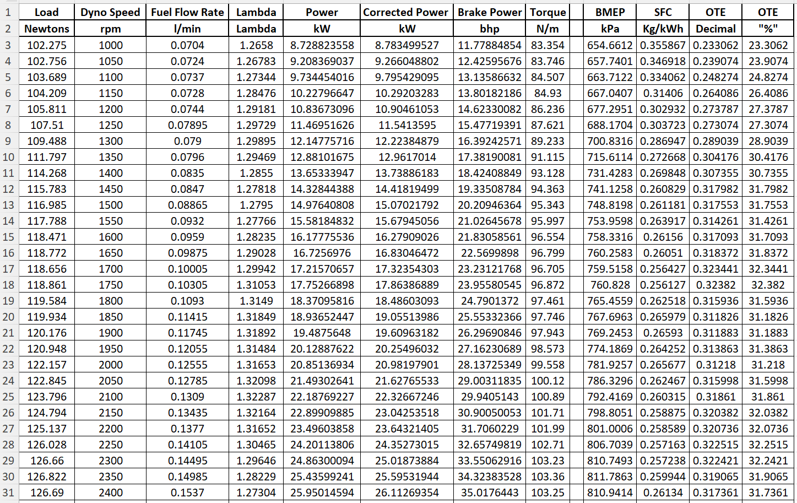
6
Table 3 – Collected/Calculated Data Pt.2
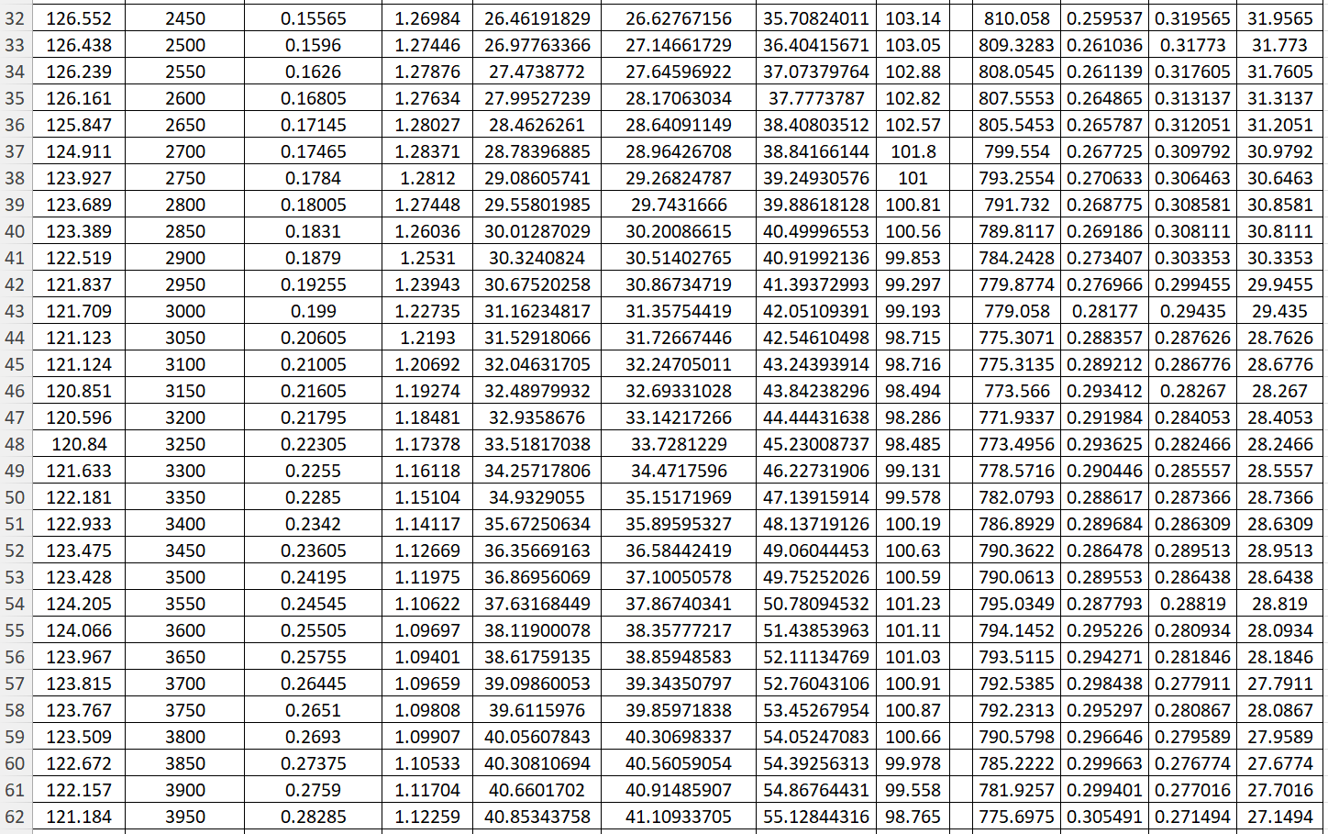
7
Table 4 – Collected/Calculated Data Pt.3
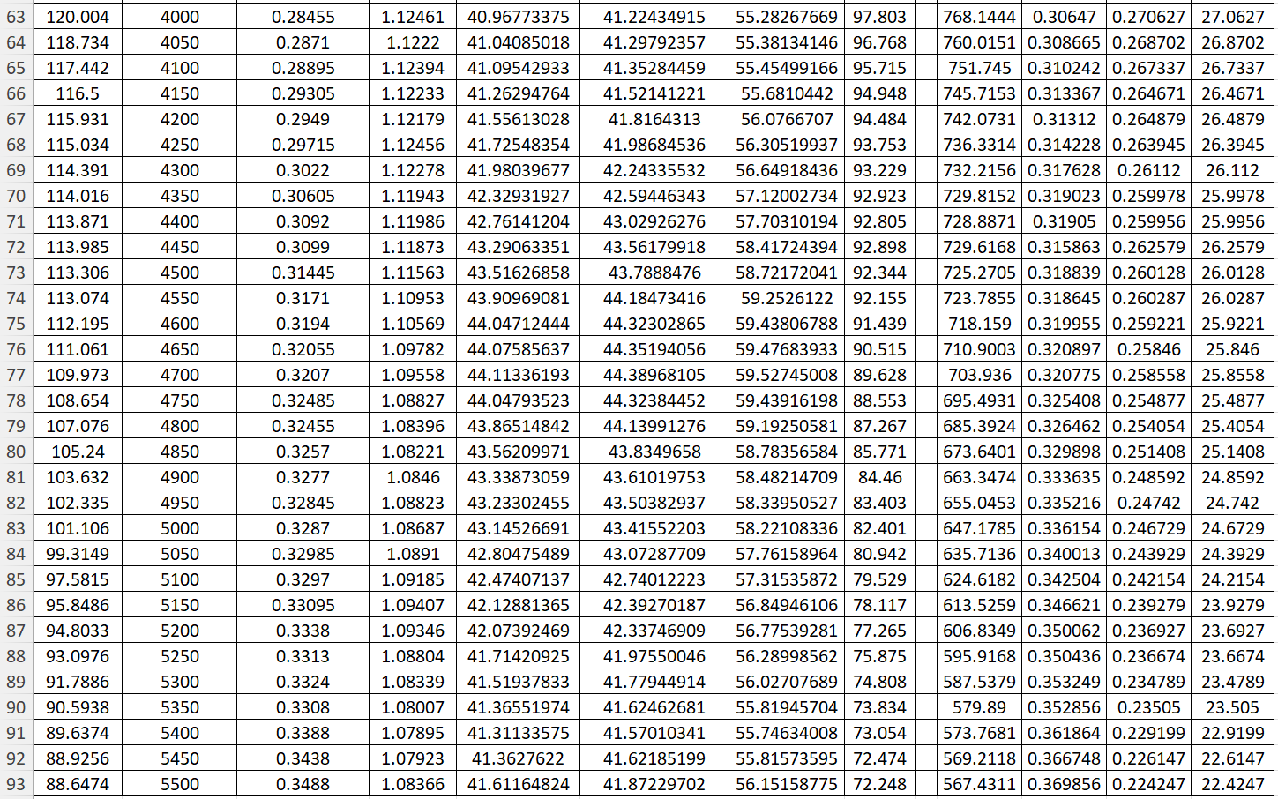
8
Chapter 4 – Data Graphs:

To best visualise and analyse the results of the test, one should draw a series of graphs. The three main results we are interested in, after performing this test are SFC, torque and brake power, against engine speed. Having gathered and calculated all the desired information (seen in the tables above), graphs can be generated.

Figure 1, Specific Fuel Consumption vs Engine Speed Graph

When looking at SFC against engine speed, one should not expect to see anything other than the fuel consumption rising as the engine speed rises (an upwards trend). As the rpm increases, more fuel is needed to be injected into the cylinder, to not only keep the engine running, but also to increase the rpm. This is the case with all internal combustion engines, whether they run on petrol, diesel, biofuels etc.
However, the most interesting part of this graph is at the lower rpm range. One can see that the fuel consumption at 1000 rpm is very similar to the fuel consumption at around 5250 rpm. This can be put down to over fuelling (running rich) on a cold start, similar to using a
9
choke on an older style engine. To generate heat in the engine quickly, the engine control unit (ECU) over fuels the cylinders, creating bigger explosions, meaning more heat energy produced. Cold engine oils also have a higher viscosity, meaning more friction, meaning there is more work for the engine to overcome, this increases the rpm.

Figure 2, Brake Power & Torque vs Engine Speed Graph

When looking at brake power and torque against engine speed, it is worth laying both parameters on the same graph, as they have some very interesting relationships.
One could be forgiven for thinking that torque and brake power should be a straight line, however in reality they are not, they are both curves. Both brake power and torque are dictated by piston speed, and how much air gets into the cylinder (driving 4 answers, 2022). As the piston moves down, it creates a vacuum, this pulls air from the throttle body, and through the intake valves, into the cylinder. As the rpm increases, the piston moves faster, creating a larger vacuum, therefor pulling in even more air. This is why brake power and torque are curves (driving 4 answers, 2022).
Once again one could be forgiven for thinking that peak torque and peak power would be at the same time, again this is not the case. The answer lies within the question, as “both torque and rpm are a multiplier for power” (driving 4 answers, 2022). Even in a situation where torque is flat, rpm is always increasing, thus power shall be increasing. This explains why peak torque is seen at a lower rpm than peak power. It also explains why torque can be falling off, while power is still increasing, provided the torque doesn’t fall off to dramatically (driving 4 answers, 2022).
10
The most obvious thing that relates brake power and torque, is that they both fall off at the higher end of the engine speed range.
There is no need for peak torque to be at a high rpm, as torque is needed to get a vehicle moving, therefore peak torque should be at a more accessible (lower) rpm (driving 4 answers, 2022). In this case on the tested engine, about 2500 rpm.
As the rpm reaches the top end of the power band, the cylinder has got to a point where the vacuum created by the piston, is so large it fills the entire usable volume of the cylinder and inlet devices with air. Here is the point where the engine can’t create any more power. Beyond this point the speed of the engine shall be trying to suck in more air than is actively available, where the power begins to drop (driving 4 answers, 2022).

11
Chapter 5 – Conclusions from Test Results:

Conclusions from test results:
- The engine appears to be under powered. We see the max bhp figure to be 59.52. As previously mentioned in chapter 2 these engines can be expected to reach power figures around 100 to 130 bhp (Terrell, J. 2023). It is mentioned in a UWTSD WISA Workshops video that there is a custom air filter that does have some restrictive properties, and the age of the engine itself will have resulted in some loss of power.
- Power increases with engine speed
- Torque trends downwards with engine speed
- Highest BMEP at highest torque value
- Highest load on engine at highest torque value
- Most fuel efficient as average at mid rpm
- When SFC increases OTE decreases and vice vera

12
Chapter 6 – Evaluation of Experience:

As an experience I have enjoyed evaluating engine performance characteristics, however I would have liked very much to have been able to physically use the dynamometer.
Unfortunately, during this assignment the dyno itself was broken, through nobody’s fault. We were given a set of previously collected data and told to continue the task as if we had used the dyno.
I feel that my understanding of the process of testing an engine, and my evaluation of the results, and the methodology could have been written in further detail, had I experienced performing and collecting the data myself.

13
Chapter 7 – Conclusion:

To conclude this report, it has detailed the process of dynamometer testing a Honda D16 Vtec engine. Listed how to manually calculate a number of engine parameters, and evaluated the results seen.
However, as an experience I feel there is some value and learning that has been missed by not being able to physically perform the test.

14
Reference List:

- Blackcircles.com (2026) Convert KW to BHP, Convert KW to BHP | Blackcircles.com. Available at: https://www.blackcircles.com/helpcentre/tyres/kw-to-bhp#:~:text=To%20convert%20power%20from%20kilowatts,0.7457%20kW%20in%201%20BHP. (Accessed: 22 March 2026).

- Dadt, H.J. (2001) Technical Specification Eddy-Current Dynamometer W Series, V4, Unpublished. (Accessed: 17 March 2026).

- Darkside Developments (2018) Reading a dyno graph, Darkside Developments. Available at: https://www.darksidedevelopments.co.uk/Blog/reading-a-dyno-graph/#:~:text=The%20ramp%20rate%20is%20the,to%20rev%20from%202000%2D5000rpm. (Accessed: 21 March 2026).

- driving 4 answers (2022) WHY are HORSEPOWER and TORQUE CURVED?, YouTube. Available at: https://www.youtube.com/watch?v=Nbev14oIH6I (Accessed: 22 March 2026).

- Harrison, A. (2020) Handout Master 2020 Part 1, Unpublished. (Accessed: 21 March 2026)

- Harrison, A. (2026) Powertrain Technology Level 4 Assignment. Unpublished. (Accessed: 22 March 2026)

- Honda Motor CO LTD (1987) Shop Manual Honda Coupe CRX Chassis Maintenance and Repair, hondacrx.co.uk. Available at: https://www.hondacrx.co.uk/FAQ/Manuals/CRX_Workshop_Manual.pdf (Accessed: 22 March 2026).
15
- Kadhim, D.N.S. and Hassan, Q.H. (2017) www.isorjournals.org. tech. Available at: https://www.iosrjournals.org/iosr-jmce/papers/vol14-issue6/Version-1/B1406010916.pdf (Accessed: 22 March 2026).

- Terrell, J. (2023) Honda D16 engine - everything you need to know - drifted, Drifted.com. Available at: https://www.drifted.com/d16-engine/ (Accessed: 17 March 2026).

- The Engineering ToolBox (2003). Higher Calorific Values of Common Fuels: Reference & Data. [online] Available at: https://www.engineeringtoolbox.com/fuels-higher-calorific-values-d_169.html (Accessed: 22 March 2026).

- UWTSD WISA Workshops (2020) Engine Dynamometer Overview, YouTube. Available at: https://www.youtube.com/watch?v=-WajOAp2LUE (Accessed: 17 March 2026).

- UWTSD WISA Workshops (2020b) Engine Dynamometer Testing, YouTube. Available at: https://www.youtube.com/watch?v=VD9OPoaAcJU (Accessed: 21 March 2026).

16

