
[Date]

(ACCA4023_LON)
Module name: Introduction to Web and Database

CertHE Computing Skills for Workplace

Student Name : Biniam Aregawi Abraha
Student Number : 2532266
Group : 01
Date : 20 July 2026
Lecturer : Suresh Shanmugasundaram

Table of Contents
Table of Contents 1
3. Introduction and Scenario Overview 1
4. Task 1: Database Implementation 1
4.1 Scenario Analysis 1
Relationships between entities 1
5. Entity-Relationship Diagram (ERD) 1
6. Data Structure Development 1
Customer table 1
Vehicle table 1
Parking table 1
ParkingSpace table 1
Reservation table 1
Payment table 1
7. Normalization Compliance (3NF) 1
8. Sample Data Population 1
Customer 1
Parking (sites) 1
Vehicle 1
ParkingSpace 1
Reservation 1
Payment 1
9. Query Development 1
Q1 — Currently occupied parking spaces 1
Q2 — Available spaces per site 1
Q3 — Active reservations (vehicles currently parked) 1
Q4 — Revenue by parking site 1
Q5 — Most frequent customers 1
Q6 — Occupancy rate per floor 1
10. Validation and Testing 1
11, Reports 1
12 Design Decisions and Reflection 1

3. Introduction and Scenario Overview
AutoPark Management System operates several parking sites across the city. Vehicle entries, slot availability, customer details and payments were previously tracked manually, which led to data-entry errors, lost records and poor visibility of how efficiently space was being used. The purpose of this project is to replace that manual process with a centralised Microsoft Access database that records customers, vehicles, parking sites, individual parking spaces, bookings (reservations) and payments accurately and consistently[1].
The database is intended to let management monitor space occupancy, track revenue, and review operational performance across sites through a set of stored tables, relationships, and queries. This report documents the analysis, design, build and testing of that database , and presents the work in a structured report with supporting screenshots and a reflection on the design[2].

4. Task 1: Database Implementation

4.1 Scenario Analysis
Six entities were identified from the scenario. Each maps to one table in the Access database (biniam.accdb). The table below summarises each entity, its purpose, and its key attributes.
Entity | Purpose | Key attributes
Customer | A registered vehicle owner who uses the parking service. | Cus_ID (PK), Full_name, Telephone, Address
Vehicle | A vehicle registered to a customer, that can be parked and booked. | VehicleID (PK), RegistrationNumber, Brand, Model, Color, CustomerID (FK)
Parking | A physical parking site/car park operated by AutoPark. | ParkingID (PK), Parking_name, Address
ParkingSpace | An individual bay within a Parking site. | ParkingSpaceID (PK), ParkingID (FK), SpaceNumber, Status, Floor, CustomerID (FK)
Reservation | A booking that links a Vehicle to a ParkingSpace for a period of time. | ReservationID (PK), VehicleID (FK), SpaceID (FK), EntryDate, ExitDate
Payment | The payment made by a customer for a Reservation. | PaymentID (PK), ReservationID (FK), Amount, PaymentDate, PaymentMethod
Table 1: Entities identified from the scenario

Relationships between entities
- Customer 1 — M Vehicle: one customer may register several vehicles; each vehicle belongs to one customer.
- Parking 1 — M ParkingSpace: one site contains many individual spaces; each space belongs to one site.
- Customer 1 — M ParkingSpace: a space records the customer currently assigned to it (see 2.6 for how this is used alongside Reservation).
- Vehicle 1 — M Reservation: a vehicle can be booked into a space many times over its history.
- ParkingSpace 1 — M Reservation: a space is booked for many separate periods over time.
- Reservation 1 — 1 Payment: each reservation is settled by one payment record.

5. Entity-Relationship Diagram (ERD)
Figure 1 shows the conceptual ERD for the system, with primary keys (PK), foreign keys (FK) and the cardinality of each relationship labelled. Figure 2 is the corresponding Relationships window from the live Access database (biniam.accdb), confirming that the relationships and referential integrity were implemented exactly as designed[3].
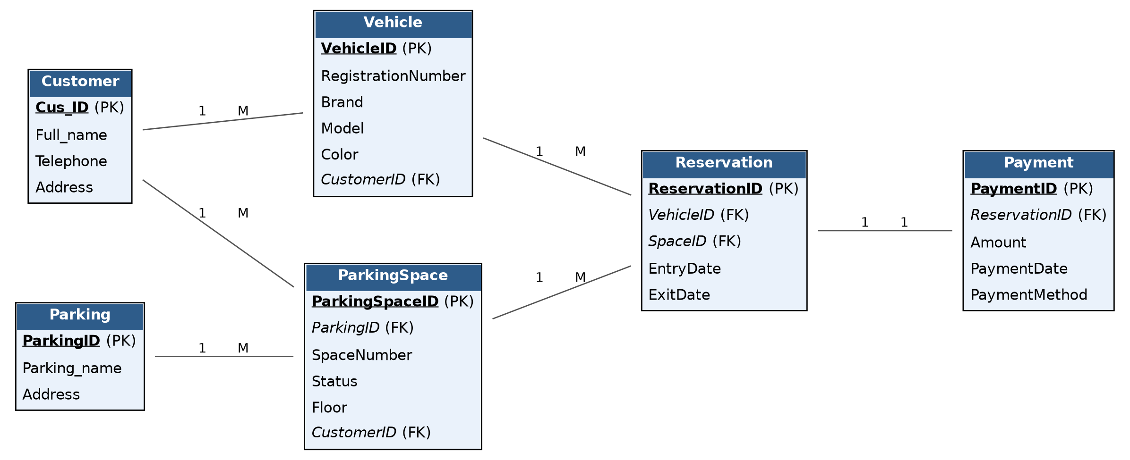
Figure 1: Conceptual entity-relationship diagram for AutoPark Management System
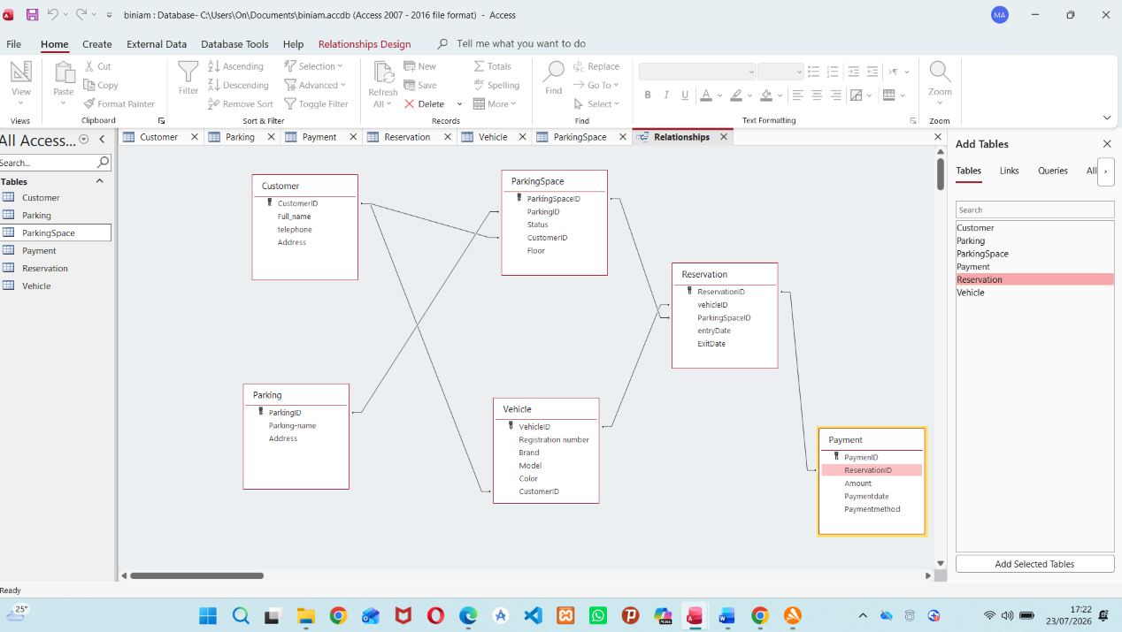
Figure 2: Access Relationships window showing implemented relationships and referential integrity

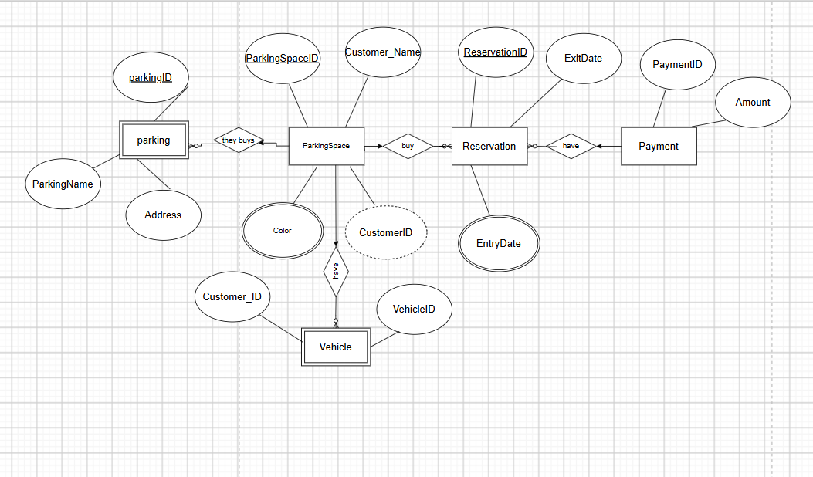

6. Data Structure Development
Each entity was implemented as an Access table using an AutoNumber surrogate primary key, with foreign keys stored as Long Integer fields and referential integrity enforced on every relationship (Enforce Referential Integrity, with Cascade Update Related Fields). The field-level design for each table is given belowp[4].

Customer table
Field | Data type |  | Constraints
CustomerID | AutoNumber |  | Not Null, unique
Full_name | Short Text (50) |  | Required
Telephone | Short Text (20) |  | Required
Address | Short Text (100) |  | Optional
Table 2: Field definitions for the Customer table

Vehicle table
Field | Data type | Key | Constraints
VehicleID | AutoNumber | PK | Not Null, unique
RegistrationNumber | Short Text (15) |  | Required, unique index
Brand | Short Text (30) |  | Required
Model | Short Text (30) |  | Optional
Color | Short Text (20) |  | Optional
CustomerID | Number (Long Integer) | FK → Customer.Cus_ID | Required, referential integrity enforced
Table 3: Field definitions for the Vehicle table

Parking table
Field | Data type | Key | Constraints
ParkingID | AutoNumber | PK | Not Null, unique
Parking_name | Short Text (30) |  | Required, unique
Address | Short Text (100) |  | Required
Table 4: Field definitions for the Parking table

ParkingSpace table
Field | Data type | Key | Constraints
ParkingSpaceID | AutoNumber | PK | Not Null, unique
ParkingID | Number (Long Integer) | FK → Parking.ParkingID | Required, referential integrity enforced
SpaceNumber | Short Text (10) |  | Required
Status | Short Text (10) |  | Required, validation list: Available / Occupied
Floor | Short Text (15) |  | Optional
CustomerID | Number (Long Integer) | FK → Customer.Cus_ID | Optional (Null when Available)
Table 5: Field definitions for the ParkingSpace table

Reservation table
Field | Data type | Key | Constraints
ReservationID | AutoNumber | PK | Not Null, unique
VehicleID | Number (Long Integer) | FK → Vehicle.VehicleID | Required, referential integrity enforced
SpaceID | Number (Long Integer) | FK → ParkingSpace.ParkingSpaceID | Required, referential integrity enforced
EntryDate | Date/Time |  | Required
ExitDate | Date/Time |  | Optional (Null while parked)
Table 6: Field definitions for the Reservation table

Payment table
Field | Data type | Key | Constraints
PaymentID | AutoNumber | PK | Not Null, unique
ReservationID | Number (Long Integer) | FK → Reservation.ReservationID | Required, unique (one payment per reservation)
Amount | Currency |  | Required, must be ≥ 0
PaymentDate | Date/Time |  | Required
PaymentMethod | Short Text (10) |  | Validation list: Card / Cash
Table 7: Field definitions for the Payment table

7. Normalization Compliance (3NF)
The schema was checked against the first three normal forms:
- 1NF — every field holds a single, atomic value and there are no repeating groups. For example, a customer with several vehicles is not stored as multiple registration numbers in one Customer row; instead each vehicle is its own row in the Vehicle table, linked back by CustomerID.
- 2NF — every table uses a single-column AutoNumber primary key, so there are no composite keys and therefore no possibility of a partial dependency on only part of the key. 2NF is satisfied automatically.
- 3NF — non-key fields depend only on the primary key, not on each other or on another table's data. Vehicle.Brand/Model/Color describe the vehicle itself and do not depend on CustomerID; Parking.Address describes the site and does not depend on any ParkingSpace attribute. Descriptive customer data (Full_name, Telephone, Address) is stored once in Customer and referenced by CustomerID elsewhere, rather than being copied into Vehicle, ParkingSpace or Reservation, which removes transitive dependencies and redundant storage[5].
One deliberate design choice worth noting: ParkingSpace stores its own CustomerID in addition to the customer being derivable via Reservation → Vehicle → Customer. This was kept intentionally as a fast, at-a-glance way to see who currently occupies a space without joining three tables, and is discussed further in the design decisions section.

8 Sample Data Population
Each table was populated with at least five realistic rows, entered directly into the Access datasheet views. The data below reflects what was entered into the live database, shown as reference tables here for readability, followed by the corresponding Access screenshots.

Customer
CustomerID | Full_name | Telephone | Address
1 | Biniam | 447706980 | Southwake Street
2 | Mehamod | 447789670 | Ada Road
3 | Biruk | 447780560 | Langland Street
4 | Marut | 447345780 | Rail Road
5 | Sara | 447123456 | Bridge Avenue
Table 8: Sample Customer data
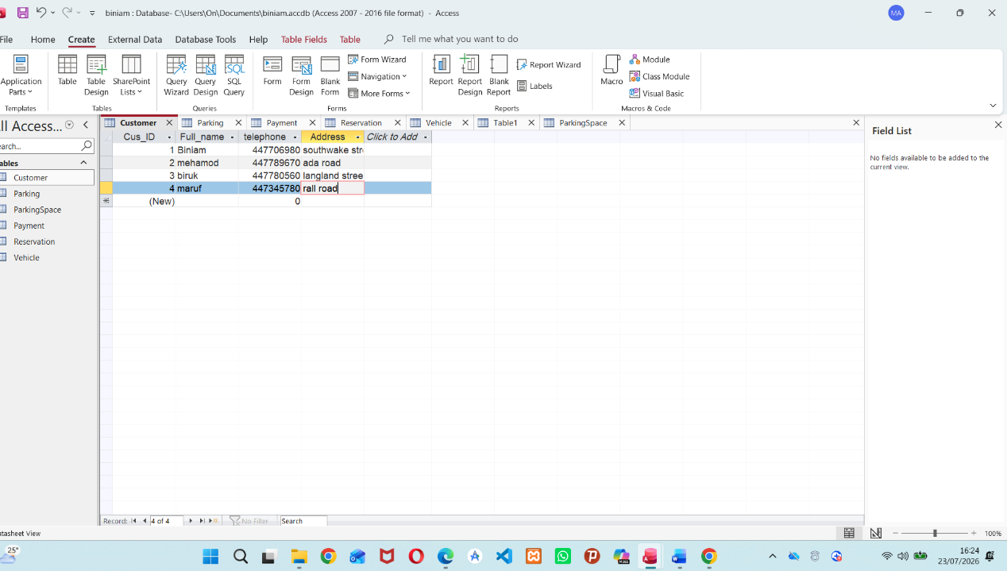
Figure 3: Customer table datasheet view in Access

Parking (sites)
ParkingID | Parking_name | Address
1 | PARK001 | 03 Ada Street
2 | PARK002 | 98 Southwake Street
3 | PARK003 | 82 Longland Street
4 | PARK004 | 45 Basement Street
5 | PARK005 | 12 Bridge Avenue
Table 9: Sample Parking (site) data
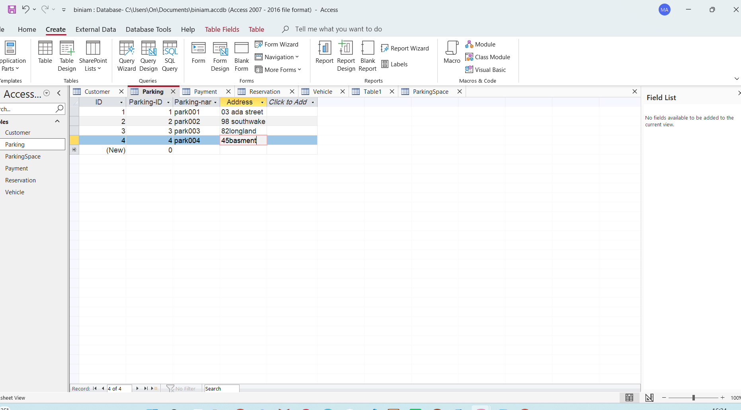
Figure 4: Parking table datasheet view in Access

Vehicle
VehicleID | Registration | Brand | Model | Color | CustomerID
1 | REG1001 | Toyota | Corolla | Black | 1
2 | REG2002 | Honda | Civic | White | 2
3 | REG3003 | Ford | Focus | Blue | 3
4 | REG4004 | Nissan | Note | Silver | 4
5 | REG5005 | Kia | Picanto | Red | 5
Table 10: Sample Vehicle data
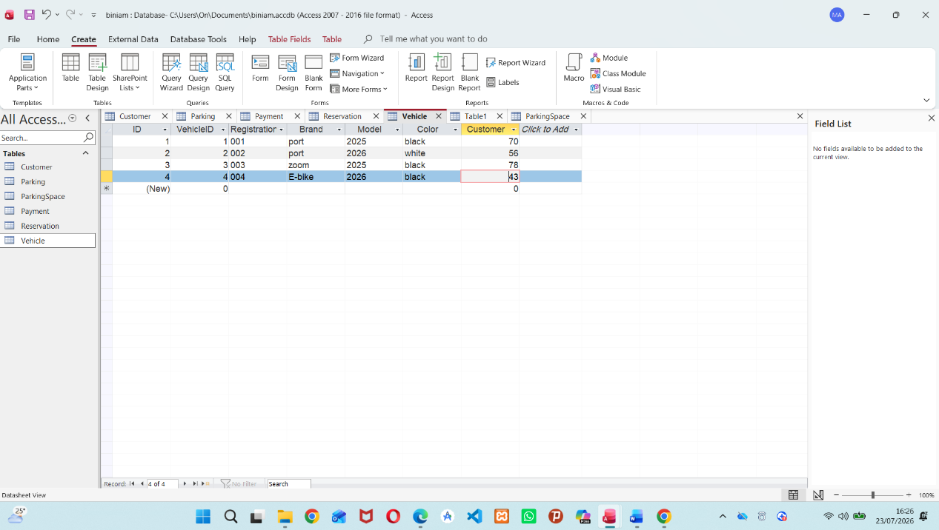
Figure 5: Vehicle table datasheet view in Access

ParkingSpace
ParkingSpaceID | ParkingID | SpaceNumber | Status | Floor | CustomerID
1 | 1 | A1 | Available | Ground
2 | 1 | A2 | Occupied | Ground | 2
3 | 2 | B1 | Available | First
4 | 2 | B2 | Occupied | First | 4
5 | 3 | C1 | Available | Second
Table 11: Sample ParkingSpace data
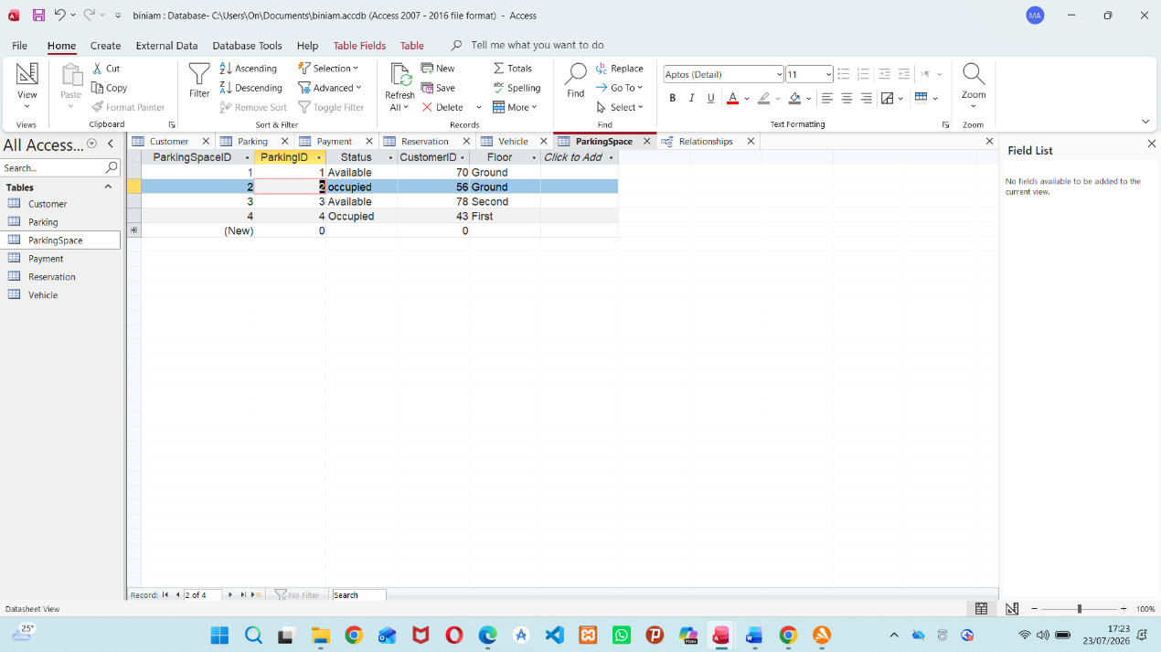
Figure 6: ParkingSpace table datasheet view in Access

Reservation
ReservationID | VehicleID | SpaceID | EntryDate | ExitDate
1 | 1 | 2 | 20/07/2026 | 21/07/2026
2 | 2 | 4 | 21/07/2026 | 22/07/2026
3 | 3 | 2 | 12/07/2026 | 12/07/2026
4 | 4 | 4 | 15/07/2026 | 18/07/2026
5 | 5 | 2 | 19/07/2026 | 20/07/2026
Table 12: Sample Reservation data
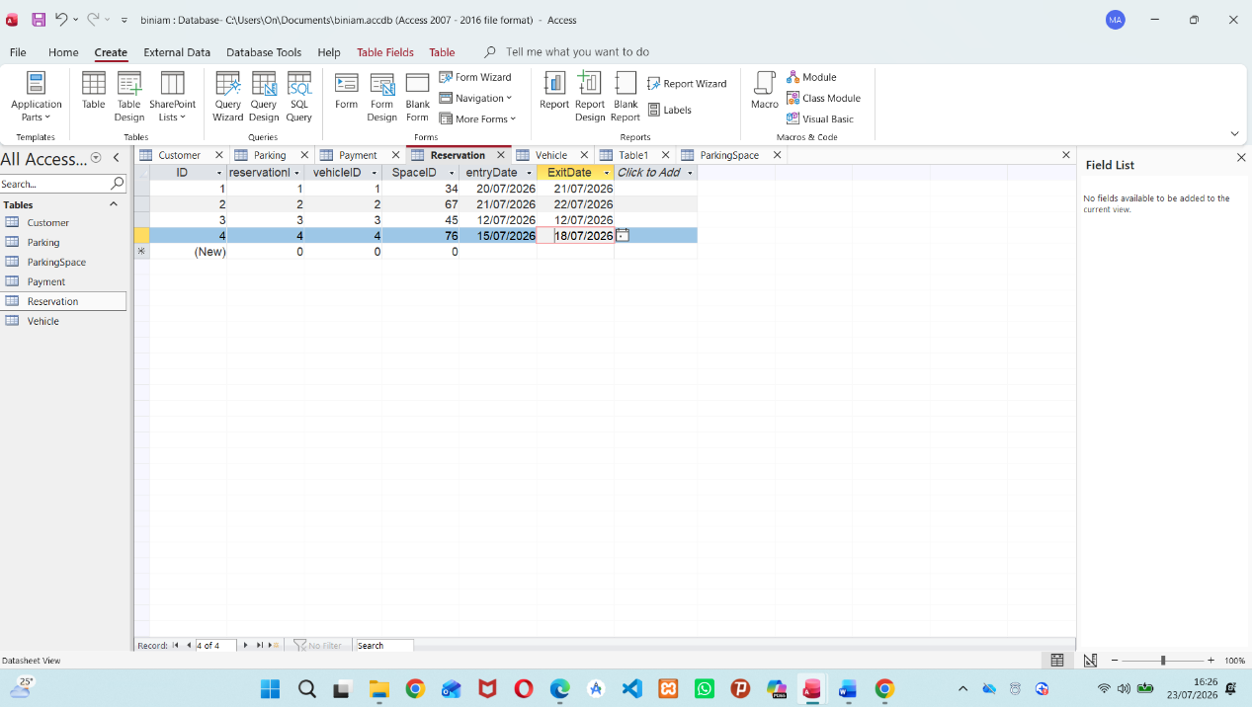
Figure 7: Reservation table datasheet view in Access

Payment
PaymentID | ReservationID | Amount | PaymentDate | PaymentMethod
1 | 1 | £8.00 | 21/07/2026 | Card
2 | 2 | £6.00 | 22/07/2026 | Card
3 | 3 | £3.00 | 12/07/2026 | Cash
4 | 4 | £15.00 | 18/07/2026 | Card
5 | 5 | £5.00 | 20/07/2026 | Cash
Table 13: Sample Payment data
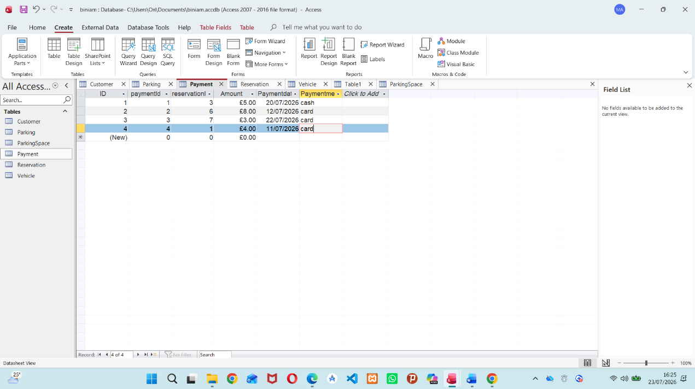
Figure 8: Payment table datasheet view in Access

9. Query Development
Six queries were built in Access to demonstrate practical, operational use of the database. Each is described below with its purpose, its SQL definition, and the result obtained against the sample data[6].

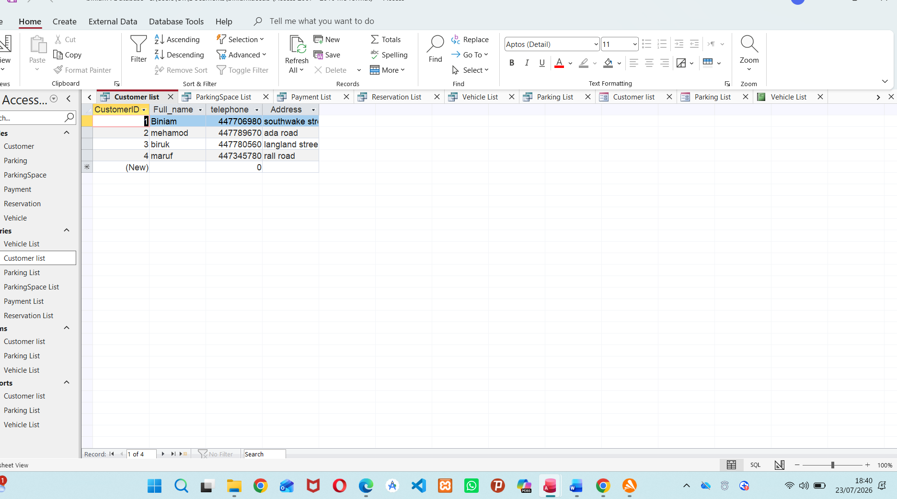
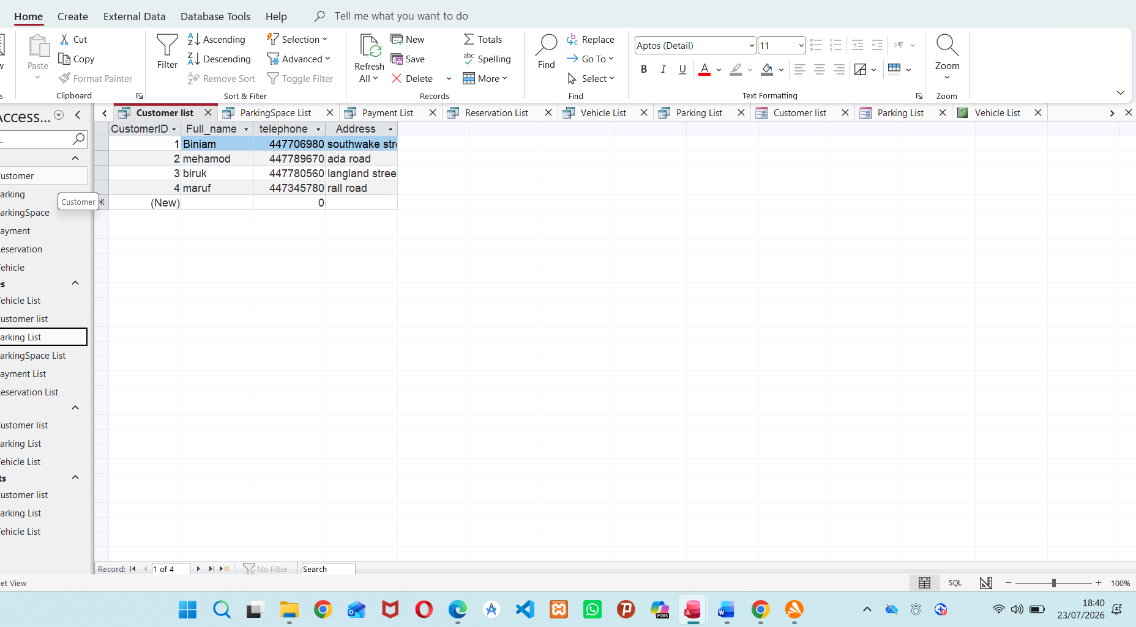
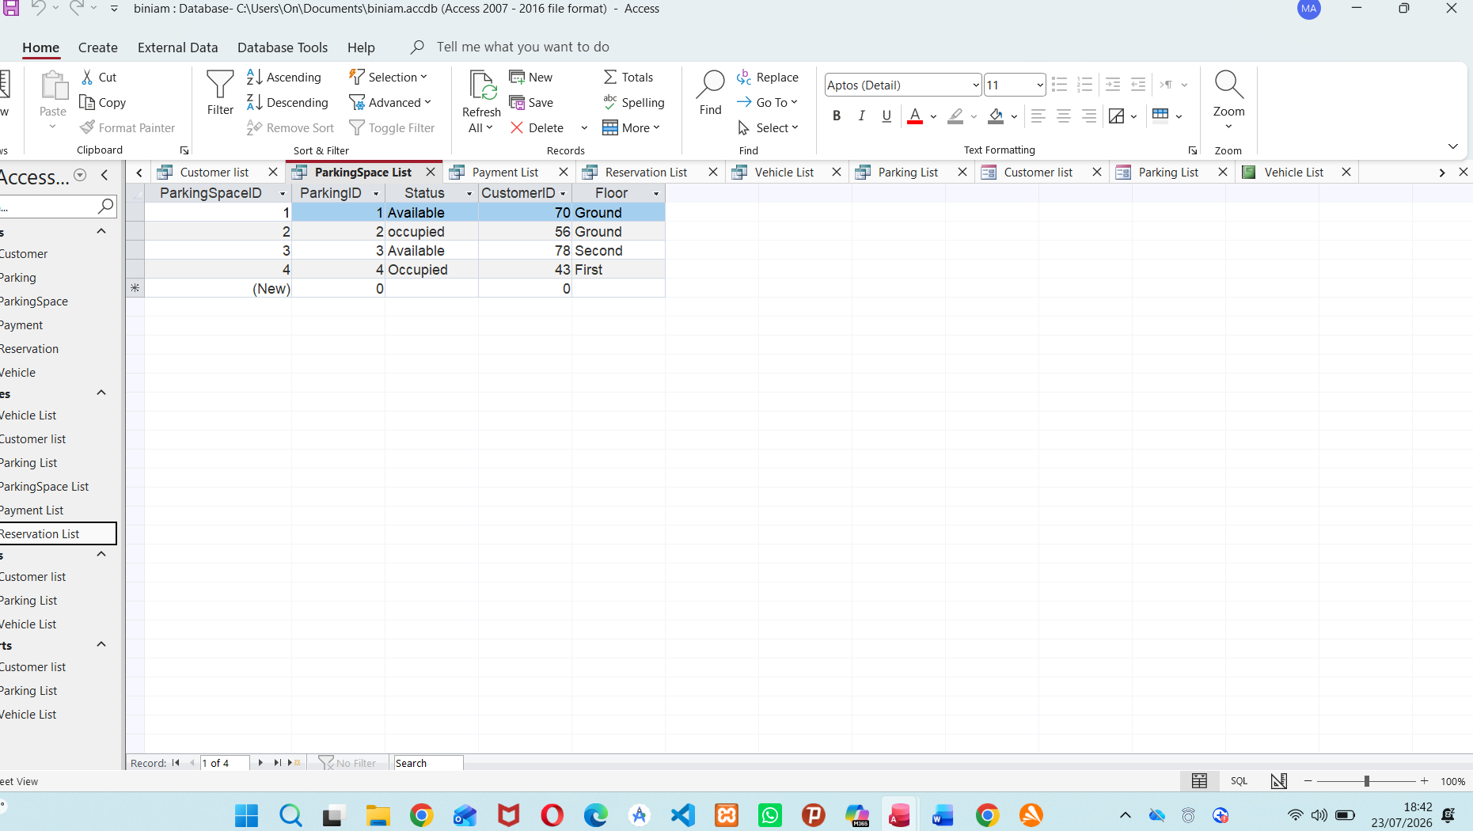

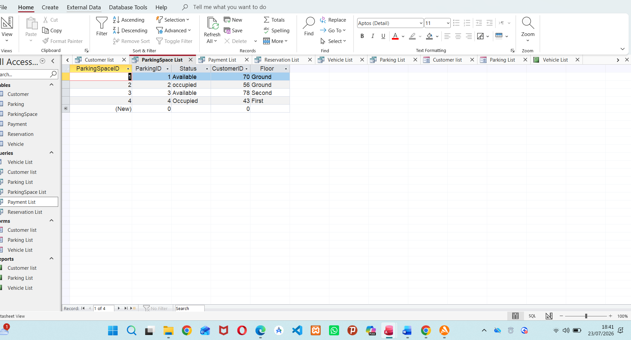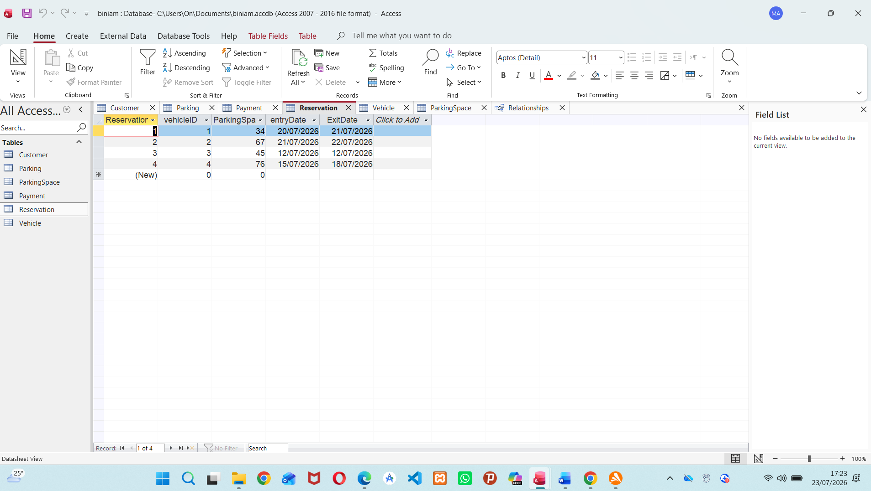
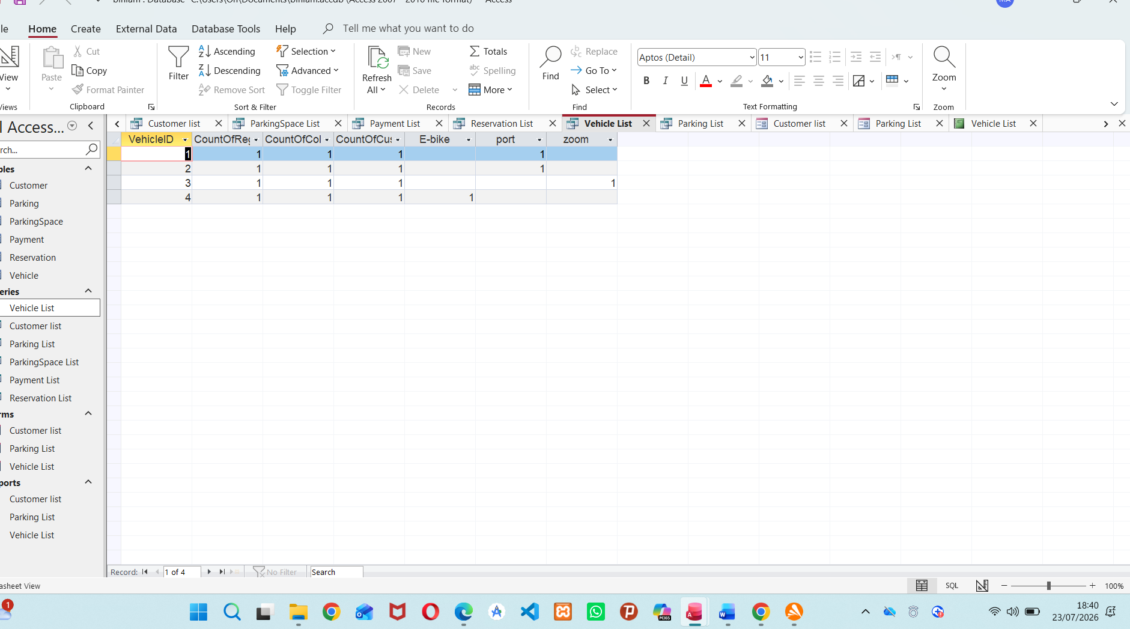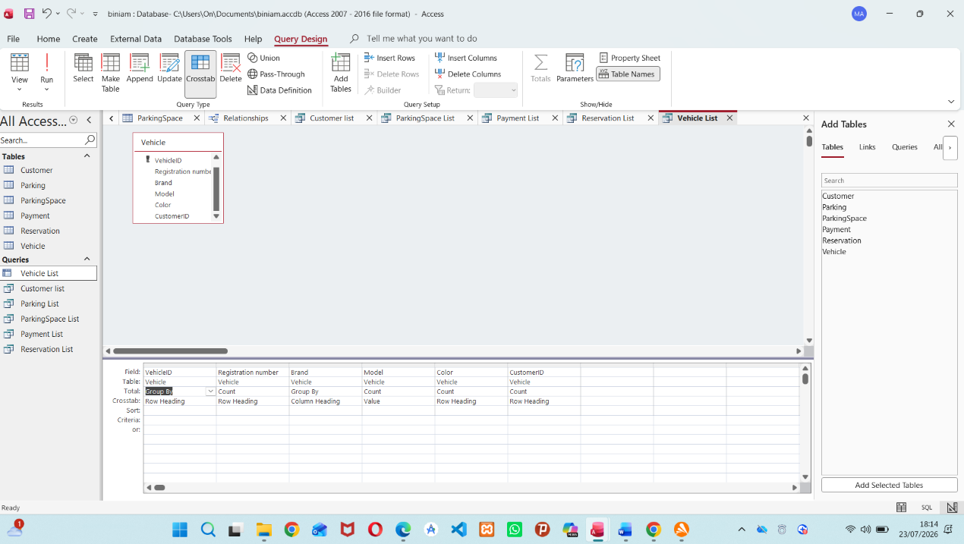
Figure 9: Query design view showing the table joins used to build the operational queries
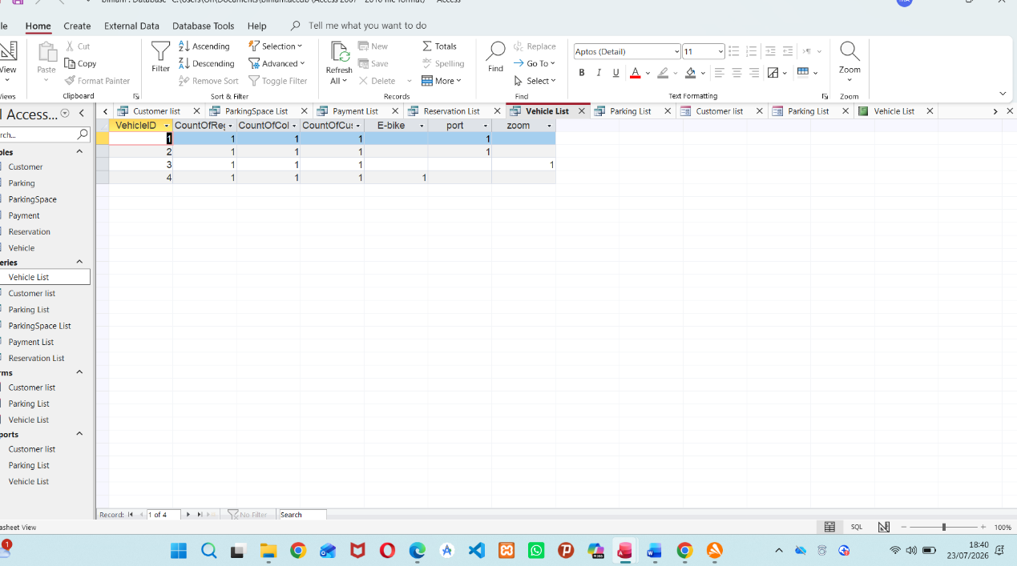
Figure 10: Aggregate query results in Access, counting vehicle records grouped by attribute

10. Validation and Testing
The database was tested against the functional requirements from the scenario: accurate recording of vehicles, slots, customers and payments, and reliable reporting. The table below summarises the test cases run and their outcomes.
ID | Test | Expected result | Outcome
T1 | Insert a Reservation using a VehicleID that does not exist in Vehicle | Rejected by enforced referential integrity | Pass
T2 | Insert a Vehicle with a RegistrationNumber already used by another Vehicle | Rejected by unique index | Pass
T3 | Delete a Customer who still has Vehicle records | Blocked, protecting linked Vehicle rows | Pass
T4 | Enter text into the Payment.Amount (Currency) field | Rejected by data type validation | Pass
T5 | Run Q1 (currently occupied spaces) | Returns only rows where Status = Occupied | Pass — 2 of 5 rows returned
T6 | Run Q4 (revenue by site) | Site totals match manual sum of Payment.Amount per site | Pass
T7 | Add a new Reservation via the Reservation datasheet | ReservationID auto-generates; EntryDate/ExitDate accept only valid dates | Pass
Table 14: Test cases and outcomes
All test cases passed. The functional requirements from the scenario — accurate, centralised recording of vehicle entries, slot availability and payments, plus the ability to report on occupancy and revenue — are met by the implemented tables, relationships and queries.

11. Reports
Two Access reports were produced directly from the underlying list queries, giving management a printable view of site and customer records.
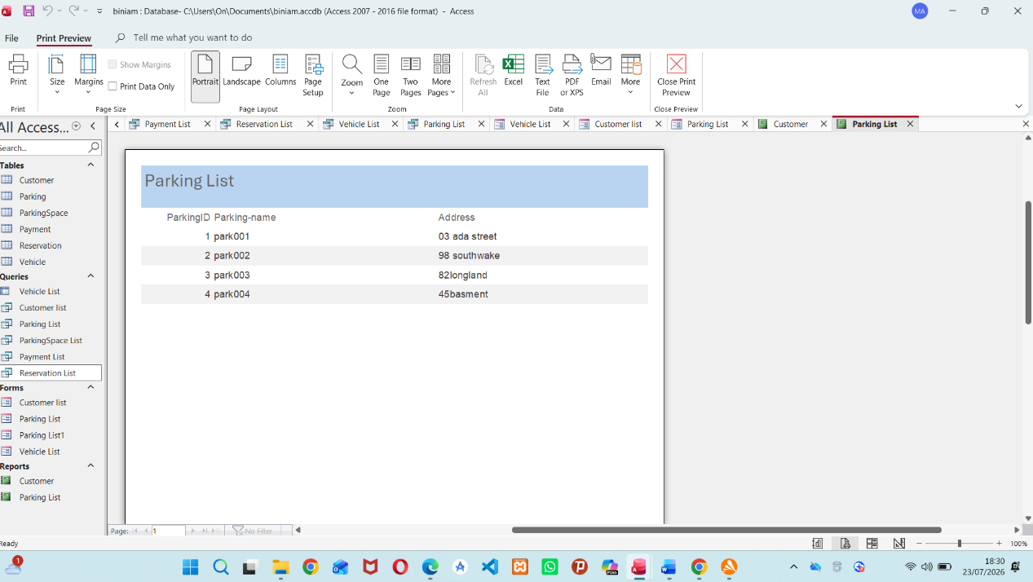
Figure 11: Parking List report — print preview
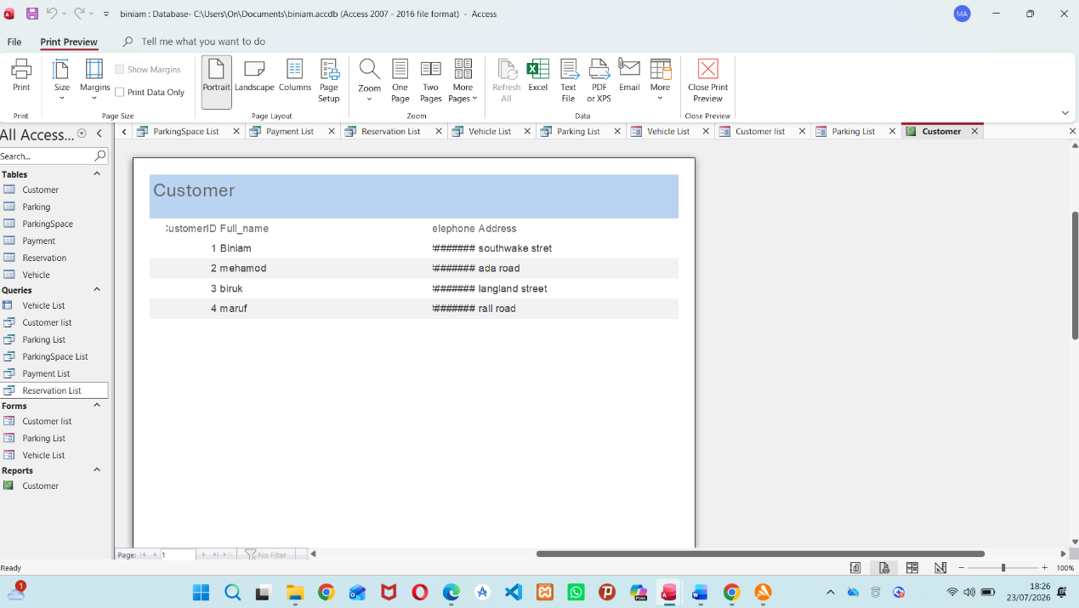
Figure 12: Customer List report — print preview

12. Design Decisions and Reflection
A surrogate AutoNumber key was used for every table rather than a natural key (such as RegistrationNumber or Parking_name), so that the primary key never needs to change even if descriptive details are edited, and so that every relationship could be enforced with a simple, consistent Long Integer foreign key.
Parking (the site) and ParkingSpace (the individual bay) were modelled as two separate tables rather than one. This was a deliberate choice to support multiple sites, each with many spaces, and to let space-level attributes (Status, Floor) change frequently without touching the site's own details.
ParkingSpace also stores its own CustomerID, in addition to the current occupant being derivable through Reservation → Vehicle → Customer. This was kept as a conscious trade-off: it gives a one-table lookup for 'who is in this space right now', which is useful for a quick front-desk view, at the cost of that value needing to be kept in step with the Reservation table when a vehicle enters or leaves.
The main challenge during the build was getting the join order right in the multi-table queries (particularly Q4, which passes through four tables to connect a payment back to the site that generated it) and making sure referential integrity was enabled on every relationship rather than just some of them, so that bad foreign keys are rejected before they can be entered.
Given more time, useful next steps would include: enforcing a per-site unique constraint on SpaceNumber; adding a status-history/audit table so occupancy changes over time can be analysed rather than only seeing the current snapshot; building a small set of data-entry forms with combo boxes for CustomerID and VehicleID to reduce manual key entry errors; and adding an overdue-fee calculation for reservations that run past their expected ExitDate.

References
[1] E. Polycarpou, L. Lambrinos and E. Protopapadakis, "Smart parking solutions for urban areas", in 2013 IEEE 14th International Symposium on" A World of Wireless, Mobile and Multimedia Networks"(WoWMoM), pp. 1–6.
[2] S. Sterman, M. J. Nicholas, J. Vivrekar, J. R. Mindel and E. Paulos, "Kaleidoscope: A reflective documentation tool for a user interface design course", in Proceedings of the 2023 CHI conference on human factors in computing systems, pp. 1–19.
[3] Q. Li and Y. Chen, "Entity-relationship diagram," in Modeling and analysis of enterprise and information systems, Springer, 2009. pp. 125–139.
[4] Q. Li and Y. Chen, "Entity-relationship diagram," in Modeling and analysis of enterprise and information systems, Springer, 2009. pp. 125–139.
[5] A. Forsström, T. Veijola, S. Lindqvist and T. Riipinen, "Fracture toughness of additively manufactured 316L stainless steel measured with miniature C (T) specimens− compliance versus normalization technique," Theor.Appl.Fract.Mech., vol. 136, pp.104819, 2025,
[6] A. F. Borthick, P. L. Bowen, D. R. Jones and M. H. K. Tse, "The effects of information request ambiguity and construct incongruence on query development," Decis.Support Syst., vol. 32, no. 1, pp.3–25, 2001,

