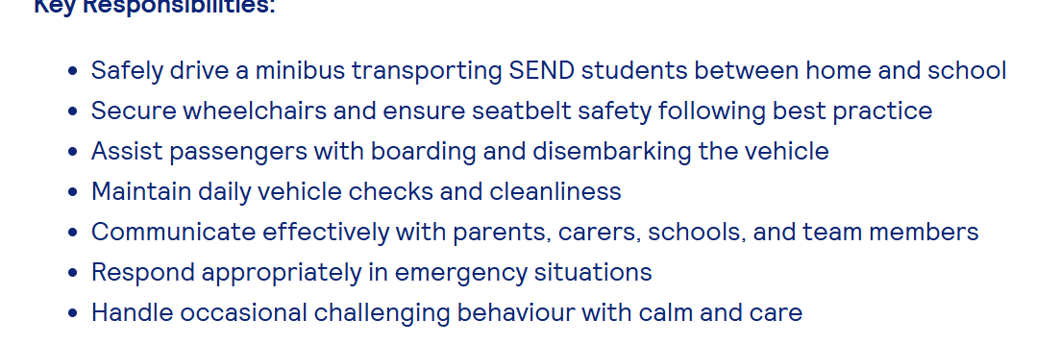

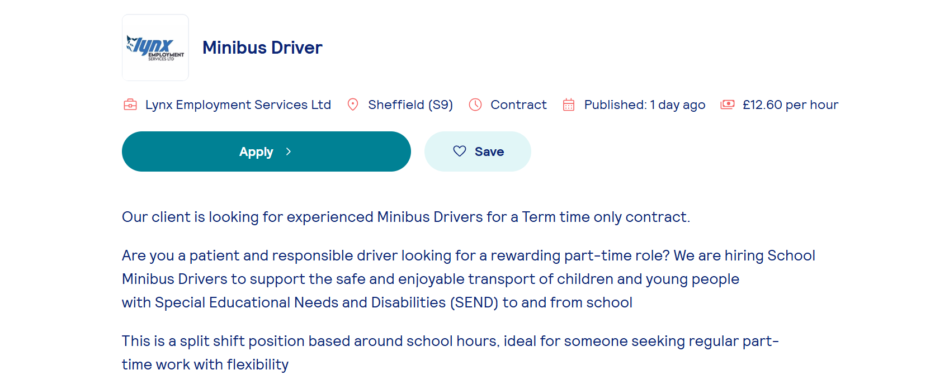
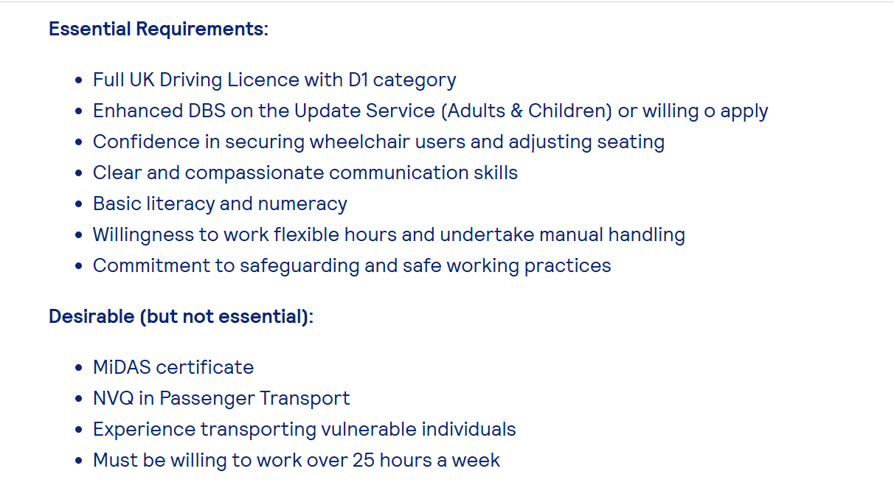

Waheed Azam
| 2421628@student.uwtsd.ac.uk
PROFILE
driving
EDUCATION & QUALIFICATIONS
Aston manor school - gsce MATHS A
ENGLISH C
PHYSICS C
WOODWORK B
COMPUTER STUDIES C 1989
WORK EXPERIENCE
TAXI DRIVER | UBER Dec 2024 to present
DRIVING FOR UBER
- WORKING AS A TAXI DRIVER TRANSPORTING PASSENGERS TO THEY DESTINATIONSD
- DISABILLTY AWARENESS COURSE
HOME TO SCHOOLL DRIVER | SANDWELL COUNCIAL Jan 2023 to Dec 2024
TRANSPORTING FORSDTER CHILDERN TO SCHOOL AND HOME
- TRANSPORTING FORSTER CHILDERN TO SCHOOL AND BACK TO THEY HOMES
- FIRST AID COURCE
TRANSPORT DRIVER | GREEN DESTINATIONS Sep 2018 to Dec 2020
TRANSPORTING KIDS TO SCHOOL AND BACK
- WORKING WITH SPEACIAL NEEDS KIDS WORKING WITH A GUIDE TRANSPORTING THERM TO SCHOOL AND BACK HOME
- DISABILITY AWARENESS COURSE
BAKER | HOVIS Dec 1999 to May 2018
BAKING BREAD
- DOWNLOADING ORDERS FOR THE SHIFT AND PRINTING THEM AND GIVING THEM TO THE WORKERS
- SUPERVISOR
- FIRST AIDER
- UNION REP
MACHINE OPERATOR | CADBURYS Feb 1993 to Jul 1995
MAKING CHOCOLATES
- MEASURING INGREDIENTS, CONTROLLING OVEN TEMPERATURES
ADDITIONAL INFORMATION
Languages – English; Punjabi; Urdu
Technical skills
INTERESTS
PLAYING FOOTBALL
GOINHG TO THE GYM
REFERENCES
Sujeewa Herath | ustad

WAHEED AZAM
3 ASTON LANE
B6 6HS

HIRING MANAGER
LYNX EMPLOYMENT SERVICES
SHEFFIELD S9
9/10//2025

Dear Sir/Madam
I wish to apply for the role of Minibus Driver, currently being advertised on your website. Please find enclosed my CV for your consideration.
As you can see from my attached CV, I have over 10 years’ experience in the driving industry, and I believe with the knowledge of road routes and working with disadvantage kids which makes me the right/perfect candidate for the role.
In my current role as a taxi driver at uber I have been responsible for taking passengers to and from work and transporting kids to and from school, I have a clean driving licence with no points; I have done a disability awareness course and am a qualified first aider.
All of this, coupled with my enthusiasm and dedication, and proven safety record and daily school runs, and routine vehicle checks makes me the perfect candidate for the role.
I am confident that I can bring this level of success with me to your organisation and help the company build upon their reputation as the leading transport company. With my previous experience and expertise, I am eager to bring my reliable driving and friendly service to your team,

Thank you for taking time to read my cv and cover note I look forward to hearing from you.

Yours sincerely
waheed azam

