Changemakers: Creativity and Value Creation (CW2)
ACCA5033
Rory Evans (2218702)
2024
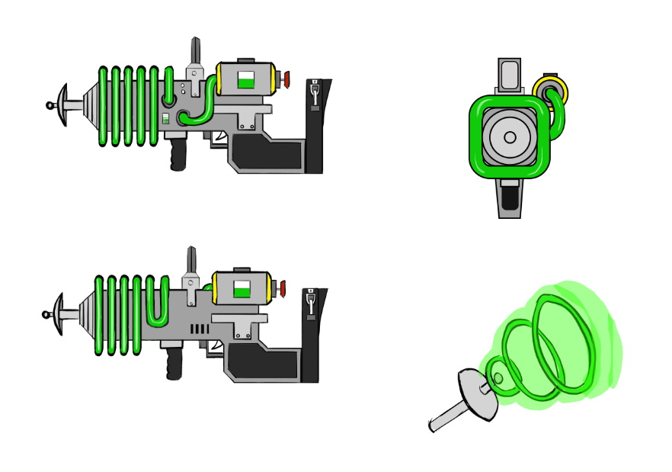
Industrial/Futuristic Design
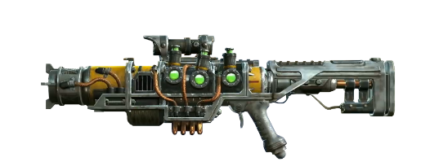


Introduction
This design would be most suited to being in a video game due to its visual style and to produce as a 3D model. Different variations were developed to consolidate the best way to develop my idea.
Video games were searched for similar demographics, starting with the video game Destroy All Humans[1], The visual aesthetics in the game resemble a similar style to my design.
[1]
[3]
[2]
Fallout 4 [2] had some great aesthetic examples of the sci-fi genre that were used to further improve my initial concept, including the Plasma Rifle [2] pictured above. Further research included Warhammer 40K the faction Necrons [3] was influential through the choice of having an industrial sci-fi theme. Additional research on guns with particular refences to the metallic materials included Wunderwaffe and Ray Gun from Call of Duty [4] which are more conceptual in design, however, was also intriguing due to their materiality with reference to yellow paint, copper pipes and green glow to add to the sci-fi appeal.
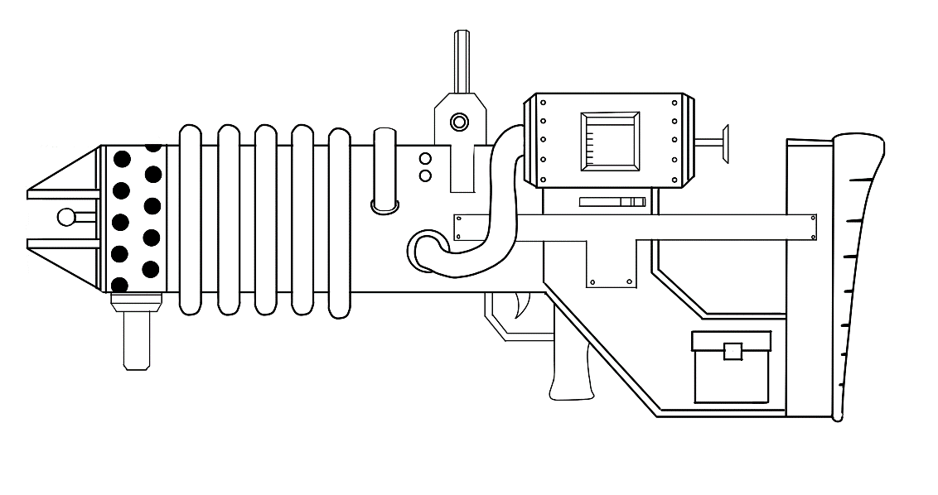 | Design 1
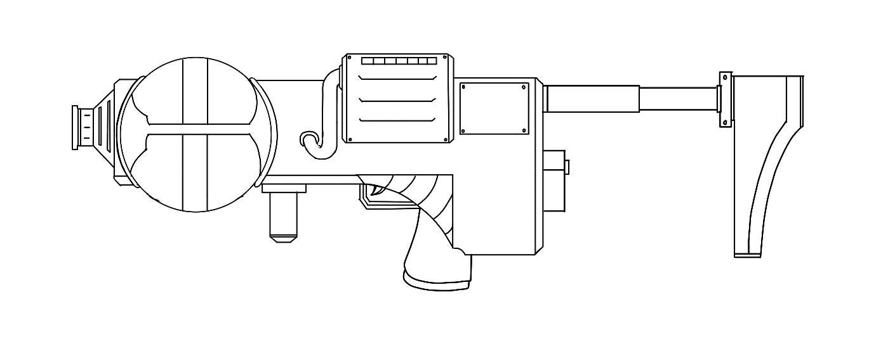 | Design 2
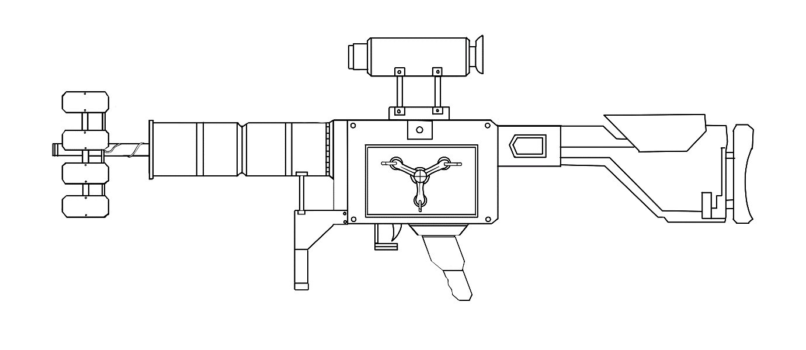 | Design 3
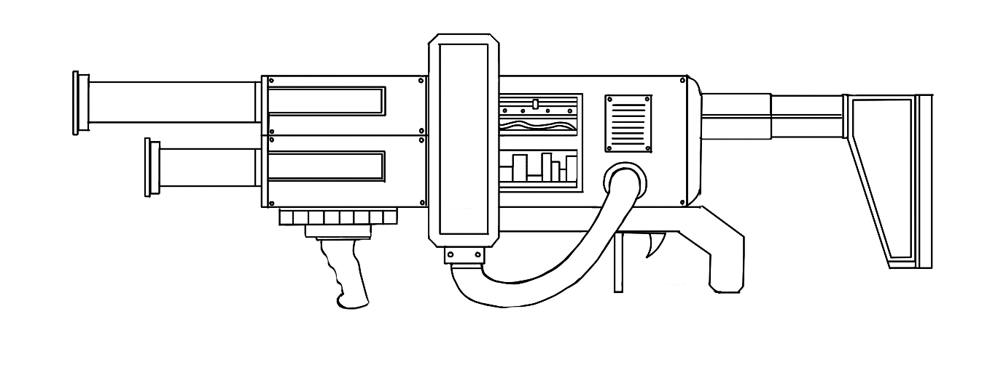 | Design 4
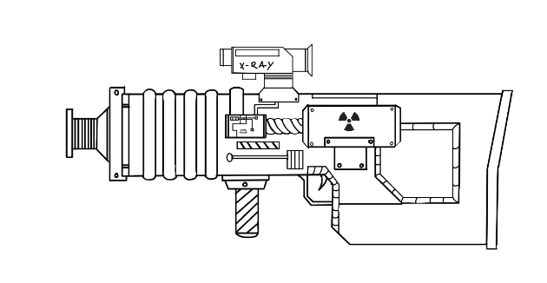 | Design 5
Once the iterative concepts were completed, number 5 was selected. This design still incorporated elements of the original and also added the necessary amendments to achieve a better end product. Planning was conducted of the best way to 3D model this by using Maya, firstly inspecting the overall geometry of the design, and breaking it down into basic individual shapes. This made the creation process more efficient for the best outcome.

Whilst 3D modelling the gun, I tried and tested different methods for modelling complex shapes into my creation. For example, below shows different iterations of the coil that would be around the barrel of the gun.
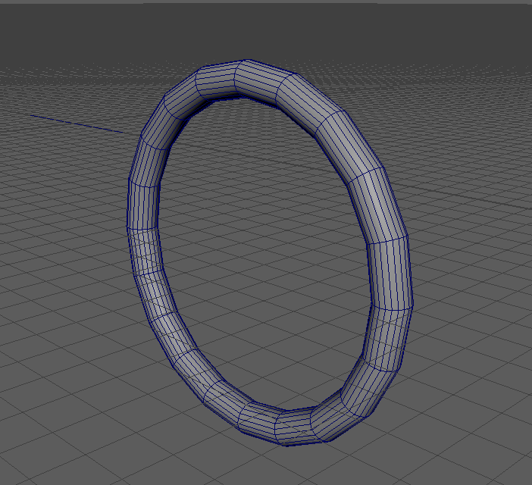 | 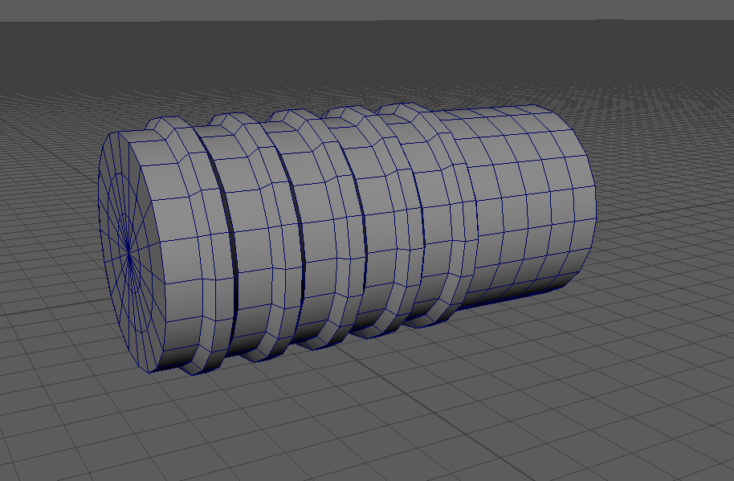
First idea, using a torus shape | Using the poly faces to extrude into the desired effect
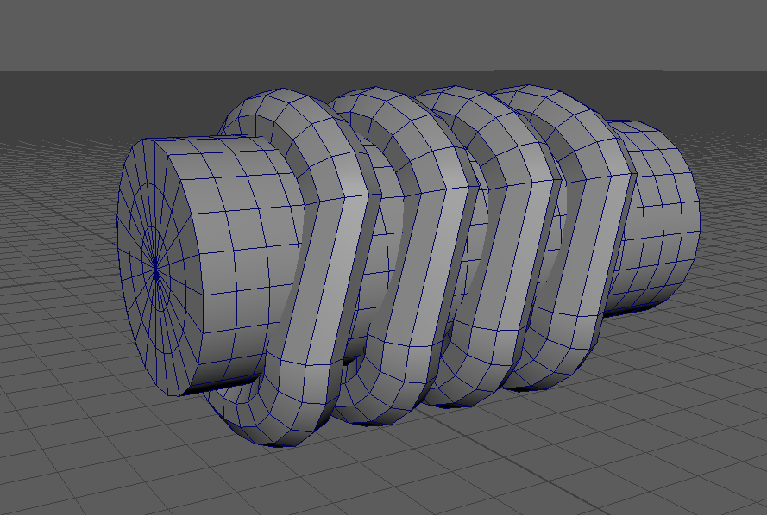 | 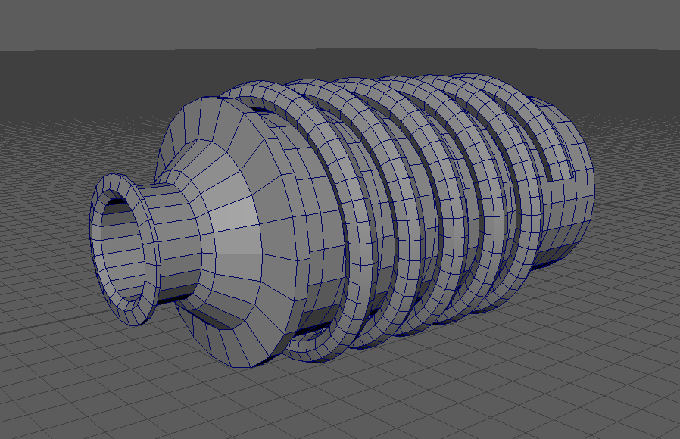
Using tori and cutting them into one continuous shape | Upon further research [5] I discovered how to make a helix by using one of the standard Maya shapes. This turned out the most efficient and most aesthetically pleasing outcome.

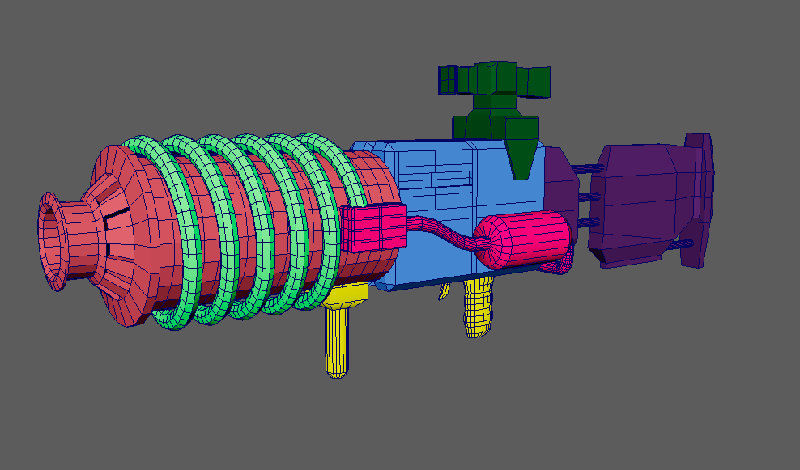
Finished 3D model in MAYA Autodesk

Orthographic Viewpoints
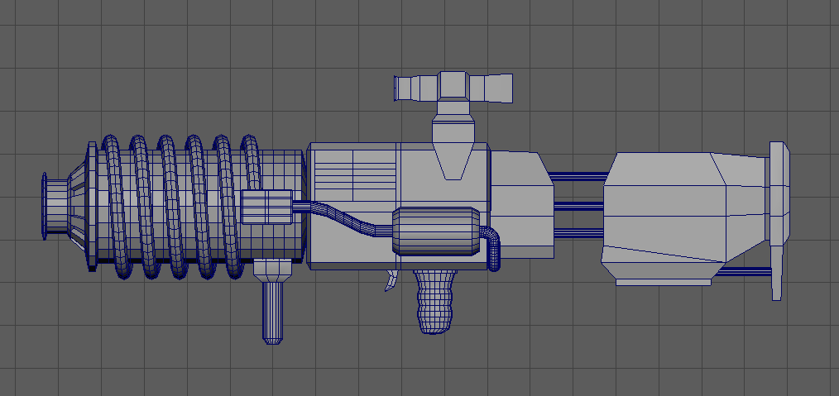
Side View
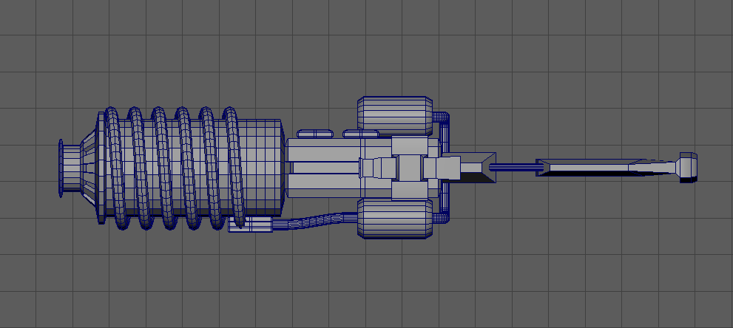
Top View
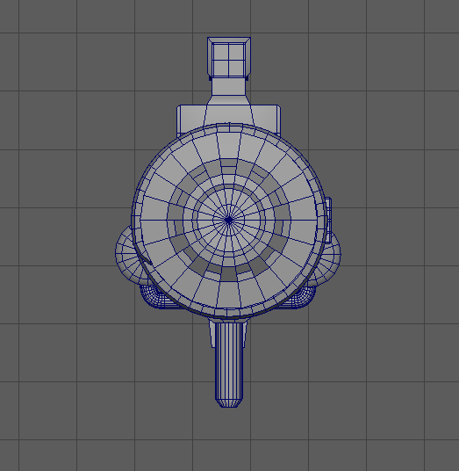
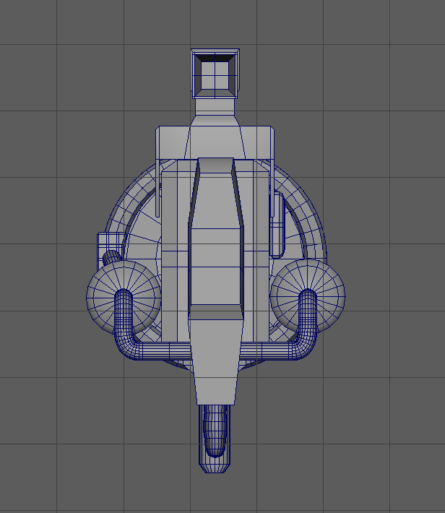
Back View/ Front View

Texturing in Substance Painter 3D
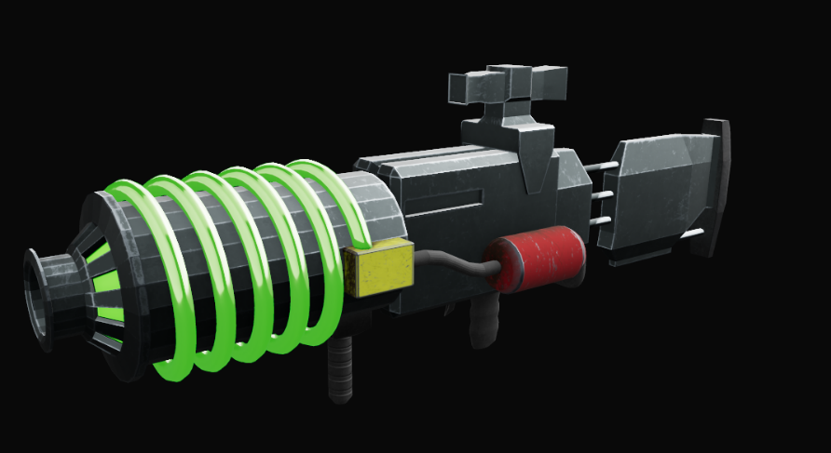 | Simple base textures to establish an overall design outcome
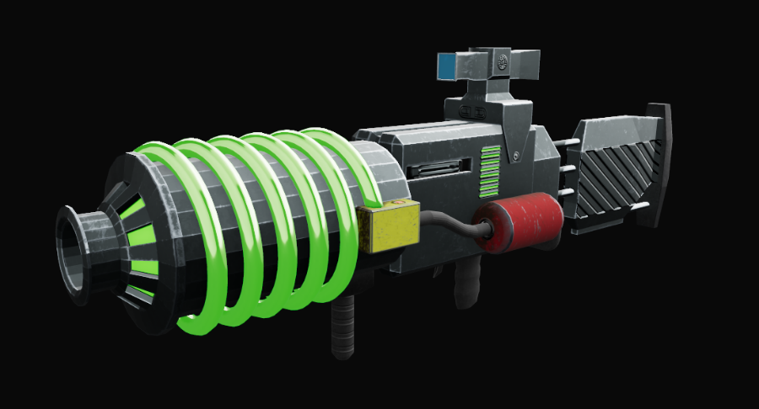 | Adding normal and height textures to give added detail to the mode

Texturing iterations
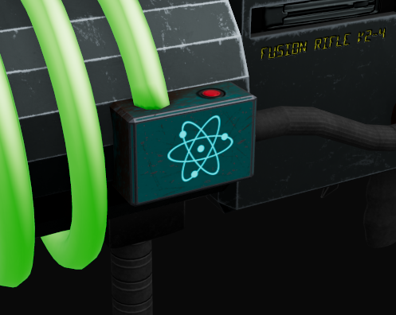 | 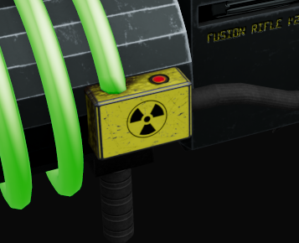
Blue atom | Yellow nuclear
 | 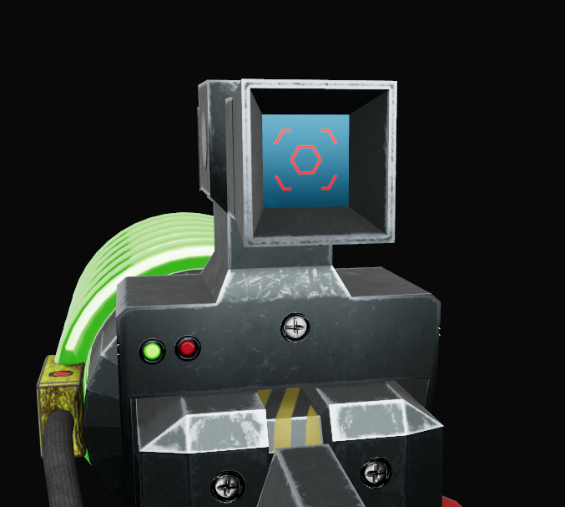
No scope reticle | With scope reticle

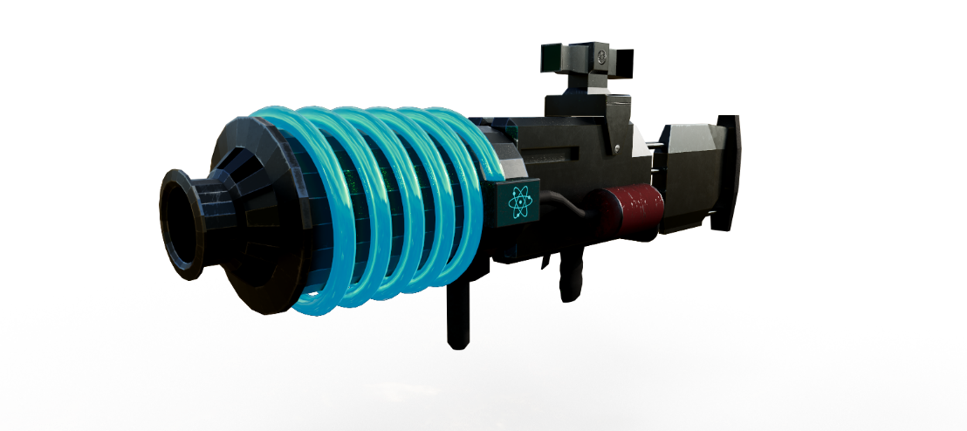
Blue plasma coil
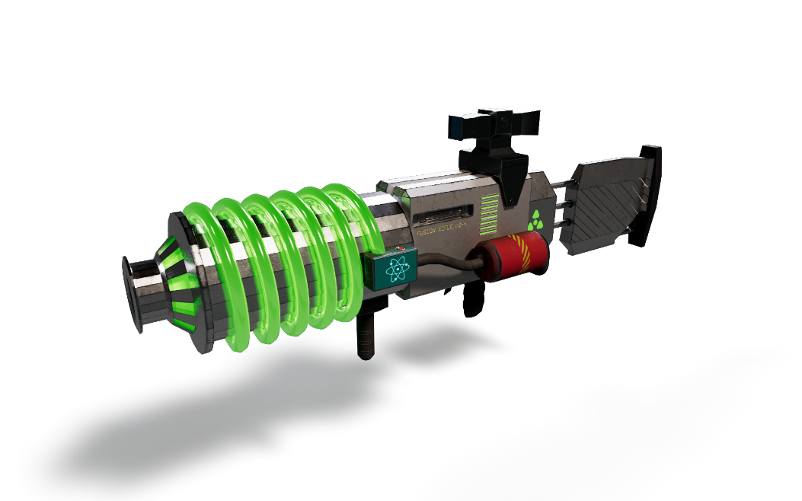
Green coil and Silver base colour
Deciding to go with the green coil as it is synonymous with nuclear waste and uranium, from sources such as The Simpsons [6], Call of Duty: Black Ops Cold War [7] Ratchet and Clank: Rift Apart [8] and Mars Attacks [9]

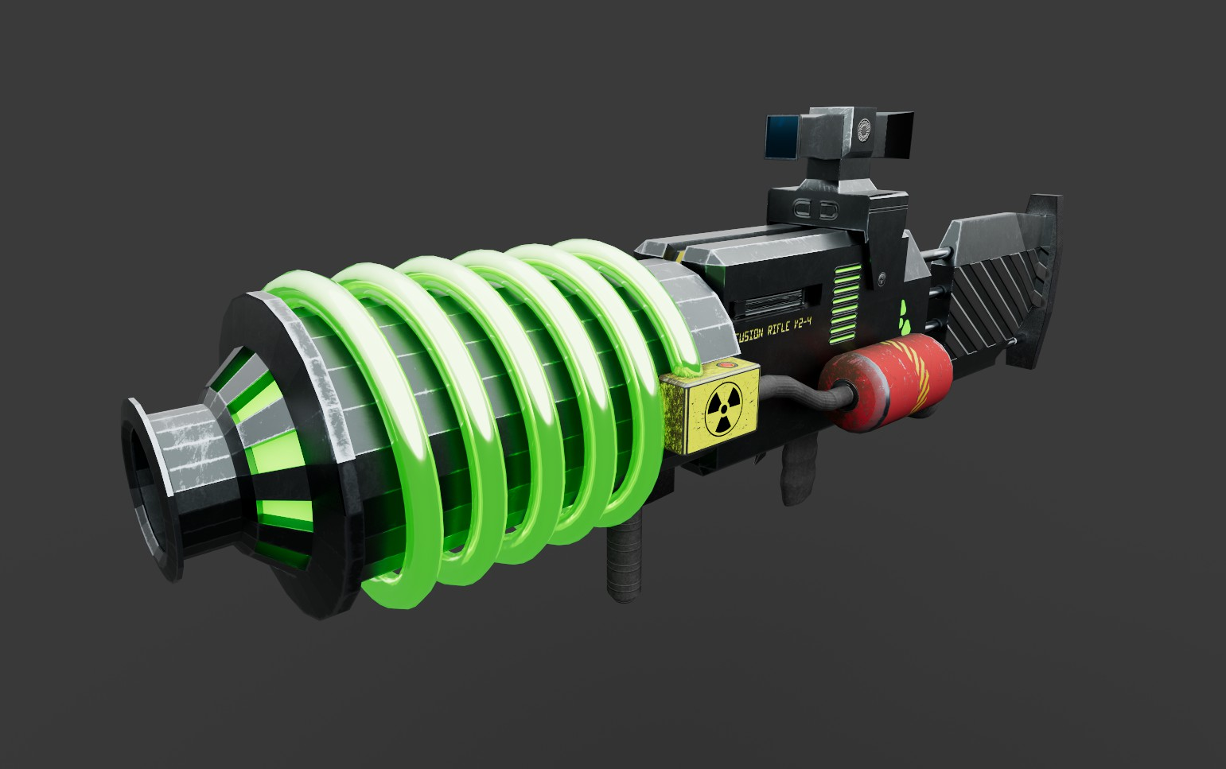
Finished 3D Model

I am happy with the outcome, being able to achieve the desired style and theme fits with the 3D model being in a video game as intended. There could be improvements made with the overall texture of the design to fine tune the final outcome including the base material which is quite stark in contrast to the bright green element. I would also like to animate the gun such as liquid going around the coil and firing with a smoke plume following to help capture the emissive glow for the weapon.

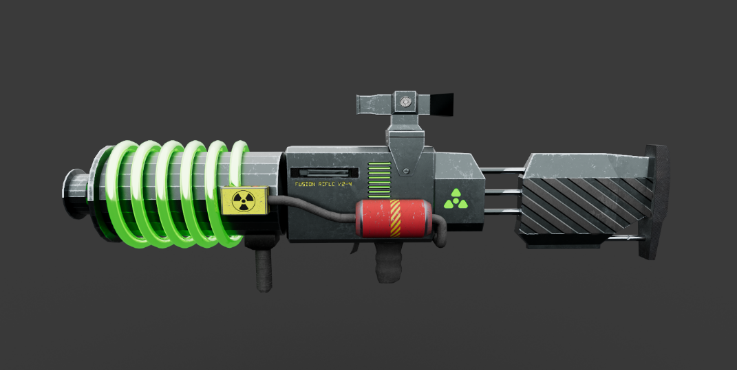  Side View 1 | 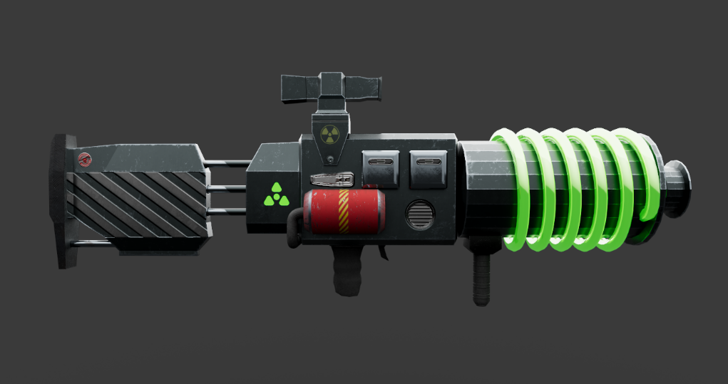  Side View 2
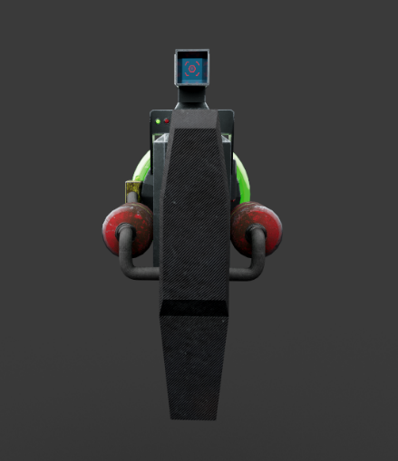    Front and Back view | 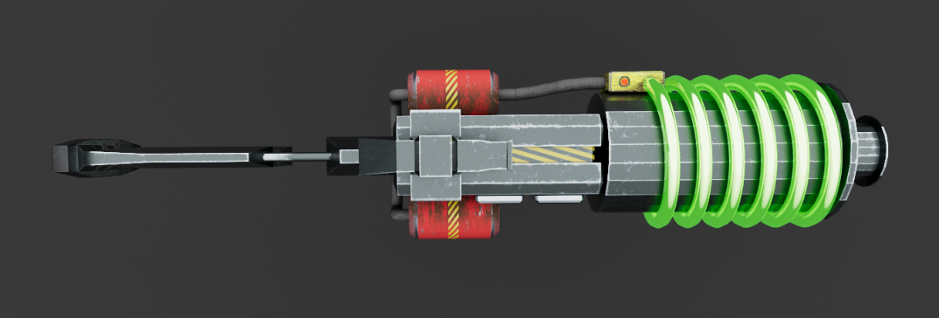  Top view

Reference List
[1] Black Forest Games and Pandemic Studios. Destroy All Humans! (2020). THQ Nordic. Accessed: May 1, 2024. [Online]. Available: https://store.steampowered.com/app/803330/Destroy_All_Humans/
[2] Bethesda Game Studios. Fallout 4. (2015). Bethesda Softworks. Accessed: May 1, 2024. [Online]. Available: https://store.steampowered.com/app/377160/Fallout_4/
[3] Owlcat Games. Warhammer 40,000: Rogue Trader. (2023). Owlcat Games. Accessed: May 1, 2024. [Online]. Available: https://store.steampowered.com/app/2186680/Warhammer_40000_Rogue_Trader/
[4] Contributors to Call of Duty Wiki. “Wonder Weapons.” Call of Duty Wiki. Accessed: May 14, 2024. [Online]. Available: https://callofduty.fandom.com/wiki/Wonder_Weapons#Wunderwaffe_DG-2
[5] “Maya: How to Create Spiral Geometry Along the Curve (Works for Wires, Chains and More).” World of Level Design - Tutorials for Becoming the Best Level Designer and Game Environment Artist. Accessed: May 14, 2024. [Online]. Available: https://worldofleveldesign.com/categories/3d-game-modeling/spiral-geometry-along-curve.php
[6] The Simpsons , vol. 1, no. 1, Fox , Dec. 17, 1989
[7] Treyarch, Raven Software, High Moon Studios, Beenox, Activision Shanghai, and Sledgehammer Games. Call of Duty®: Black Ops Cold War. (2023). Activision. Accessed: May 4, 2024. [Online]. Available: https://store.steampowered.com/app/1985810/Call_of_Duty_Black_Ops_Cold_War/
[8] Insomniac Games and Nixxes Software. Ratchet & Clank: Rift Apart. (2023). PlayStation PC LLC. Accessed: May 4, 2024. [Online]. Available: https://store.steampowered.com/app/1895880/Ratchet__Clank_Rift_Apart/
[9] Mars Attacks! United States : Warner home video, 1998.

Additional Reading List
https://www.pinterest.co.uk/pin/520376931942741813/
https://www.pinterest.co.uk/pin/520376931942741813/
https://www.turbosquid.com/3d-model/weapon-foregrip
https://forums.dayz.com/topic/189992-foregrips-what-should-they-do-and-how-should-they-do-it/
https://www.youtube.com/watch?v=6gGAG1xFB7w
https://www.fire-support.co.uk/product/ics-uksr-abs-adjustable-m4m16-sniper-stock
https://www.youtube.com/watch?v=Iupd4MMAKKo
https://www.dictionary.com/e/fictional-characters/flux-capacitor/
https://gamerant.com/destroy-all-humans-best-weapon-upgrades/
https://destroyallhumans2.thqnordic.com
https://fallout.fandom.com/wiki/Plasma_gun_(Fallout_4)
https://callofduty.fandom.com/wiki/Wonder_Weapons#Wunderwaffe_DG-2
https://eziil.artstation.com/projects/8EYwq
Black Forest Games and Pandemic Studios. Destroy All Humans! (2020). THQ Nordic. Accessed: May 1, 2024. [Online]. Available: https://store.steampowered.com/app/803330/Destroy_All_Humans/
Bethesda Game Studios. Fallout 4. (2015). Bethesda Softworks. Accessed: May 1, 2024. [Online]. Available: https://store.steampowered.com/app/377160/Fallout_4/
Owlcat Games. Warhammer 40,000: Rogue Trader. (2023). Owlcat Games. Accessed: May 1, 2024. [Online]. Available: https://store.steampowered.com/app/2186680/Warhammer_40000_Rogue_Trader/
https://destroyallhumans2.thqnordic.com

