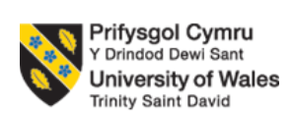

Programme: Master of Business Administration
Module: Human Capital Management
Module code: LCMB7023
Assignment Title: Assessment component 1: Individual report
Topic: Innovating New Working Practices and Breeding an Environment Where Talent May Grow
Student name: RANA NAGA MODHAVADIYA
ID: 2532684
Word count: 2598
Date of submission:15/10/2026
Table of Contents
Task A: Work Design and Organisational Innovation 3
1.1 Critical Evaluation: Traditional Work Design vs. Contemporary Working Practices 3
1.2 Proposed Integrated Framework and Recommendations 6
Task B: Talent Growth and Organisational Environment 9
2.1 Theoretical Foundations 9
2.2 Strategic Talent development in organisation 10
2.3 Implementation and Metrics for introducing talent growth strategy 12
Task C: Reflective Analysis and Capability Development 14
3.1 Introduction 14
3.2 Discussion: Reflective Analysis via Kolb’s Experiential Learning Cycle 14
3.3 Conclusion 17
References 18

Task A: Work Design and Organisational Innovation

1.1 Critical Evaluation: Traditional Work Design vs. Contemporary Working Practices
The traditional work design paradigm is based on classical bureaucratic management and Taylor's principles of scientific management. As mentioned by Munawaroh et al. (2026), traditional models are organised functionally, with strict vertical management, standardised task execution, and hierarchical chains of command. Traditional work design is well suited to manufacturing environments that are static and have a high degree of predictability, but can create important friction in rapidly moving, knowledge-driven sectors such as digital health technology. At NexSpace Health Systems (NHSX), a traditional organisation has caused operational delays, decreased cross-border agility, frequent product iteration cycles, and functional silos in clinical, engineering and artificial intelligence (AI) departments.
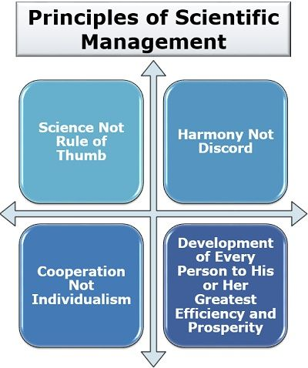
Figure 1: Principles of scientific management
(Source: Priya C, 2022)
Modern work design concepts respond to a non-mechanistic view of organisations based on the Socio-technical Systems Theory, which does not use a vertical approach. Socio-technical theory suggests that an organisation's effectiveness is determined by co-optimising the social subsystems (human relations, culture, communication, autonomy) and technical subsystems (technology, tools, workflow, and task structure) (He and Wang, 2026). If an organisation uses technology assets (such as NHSX's health algorithms) without implementing the corresponding social design, then there are operational bottlenecks.
Structural Dimension | Traditional Work Design Paradigm | Contemporary Innovative Practices | Theoretical Foundation
Organizational Architecture | - Top-down functional hierarchies  - Centralised authority. | - Flat, networked matrix structures  - Distributed leadership. | Socio-technical Systems Theory
Task Design and Discretion | - High task specialisation  - Repetitive micro-tasks  - Low decision-making discretion. | - Broadened job role  - High task variety  - Structural worker autonomy | High-Involvement Work Systems (HIWS)
Work Cadence | - Co-located presence  - Fixed working hours | - Asynchronous hybrid cadences  - Output-based performance metrics | Flexible and Hybrid Working Models
Team Operations | - Departmental isolation  - Delayed feedback loops | - Iterative multi-disciplinary teams  - Continuous feedback | Agile Working and HPWS
Table 1: Differences between Traditional Work Designs vs. Contemporary Working Practices
(Source: Self-created)
In addition to socio-technical theory, High-Performance Work Systems (HPWS) and High-Involvement Work Systems (HIWS) highlight the importance of work being defined and dependent on sets of mutually reinforcing human capital practices. The delegation of information, knowledge, rewards and decision-making power to the operational frontline is a specific way of involving the workers in HIWS (Nguyen et al. 2024). Employees feel ownership, have higher job satisfaction and are able to solve problems faster when they have autonomy to make local decisions, which is what HIWS enables them to do. The principles of socio-technical working are operationalised through agile working frameworks which break sequential workflows into iterative multi-disciplinary teams and customer feedback. In addition, today's Hybrid Working Models and Flexible Working Practices separate productivity from the physical workspace and rely on digital tools for collaboration to support continuous work in different geographies (Epizitone and Moyane, 2026).
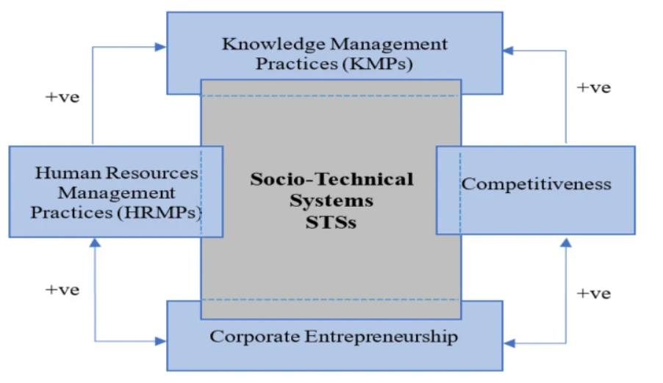
Figure 2: Principles of high-performance working
(Source: Elashry et al. 2024)
The figure highlights that the socio-technical system is greatly aligned with the knowledge management process and the HRM practices in an organisation. In terms of the given case scenario, it is seen that one of the main issues in NexSpace is that traditional hierarchical working practices have slowed innovation and decision-making and Hybrid working has weakened collaboration and knowledge sharing across international teams. Therefore, it is mentioned that following the principles of this theory can be crucial to develop manpower competitiveness and introducing effective knowledge management practices in the organisation (Rodriguez Perez and Ordóñez de Pablos, 2023).
Operational Friction and Trade-offs at NHSX
An examination of these paradigms shows important operational trade-offs and tensions in NHSX's work in the UK, India and the UAE:
Control vs. Velocity: Conventional management relies on a multi-layered approval sign-off process to exercise control. But during NHSX, having to get approvals from executives in different time zones slows down updates to clinical AI, which is delaying time-to-market.
Co-location vs. Global Flexibility: Co-location is an informal form of alignment and it limits talent sourcing (Lavoratori et al. 2025). Fixed office rules cause coordination problems with multi-time-zone teams (UK GMT/BST, UAE GST, India IST).
Specialisation vs. Integration: traditional functional separation results in clinical experts, software devs and business strategists working in silos. It leads to misaligned product designs and rework.

1.2 Proposed Integrated Framework and Recommendations
NHSX should implement the Agile Socio-Technical Framework (ASTF) to avoid the creation of an unnecessary ‘flux of friction' and increase organisational performance. This framework incorporates 5 key working recommendations:
- Multi-disciplinary “Health-Tech Pods”
Moving away from traditional functional teams to 8-10 member teams that include AI developers, clinical managers and product leads and operate in 2-week sprint cycles.
- Dynamic Hybrid and Asynchronous Cadences
Establishment of a “3:2 Flexible Hybrid Model” with an asynchronous-first communication protocol. Synchronous meetings will be limited to a required 3-hour overlap window across the globe (10:00 AM – 1:00 PM GMT) to work around teams in the UK, UAE and India.
- Structural Employee Autonomy
Giving employees autonomy in making local decisions about the execution of projects, and an “80/20 Innovation Rule”, which allows 20% of work time for cross-departmental research and problem-solving.
- Digital Collaboration Technologies
Centralising documentation and ensuring transparency with an integrated, open-access enterprise technology stack (e.g., Slack/Teams with Notion/Confluence and Miro) across different locations around the globe. The figure shows that the growth for using team communication software through cloud and others in UK will capture 85.2 billion market share within 2033 (Grand View Research, 2026).
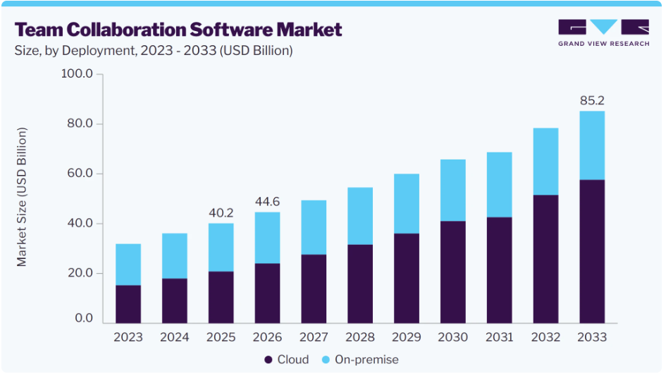
Figure 3: Digital collaboration market forecast
(Source: Grand View Research, 2026)
- Performance Measures
Measure teams based on key outcomes to move performance measures from hours logged to release speed, software stability and clinical efficacy.
Justification of the Performance Outcomes
The direct linkage of implementing the ASTF with key performance improvements is:
- Cross-functional pods shorten hand-off delays and shorten software development cycles, resulting in faster time to market.
- More Innovation Output: 20% innovation time results in proprietary software features and AI solutions.
- Higher Retention and Engagement: Across global locations, delegating autonomy and providing flexible working options improves job satisfaction (Hariani and Mardikaningsih, 2025) and minimises the risk of high-performer turnover.

Task B: Talent Growth and Organisational Environment

2.1 Theoretical Foundations
Increasing talent turnover and limited career development opportunities at NexSpace Health Systems (NHSX) require a shift in human capital management strategy from transactional administrative management to one where talent is nurtured in a systematic way. The three theories of psychology and organisation that need to be combined to create an architecture for continuous growth are:
- Self-Determination Theory (SDT)
Deci and Ryan claim that three psychological needs (Autonomy, mastering complex skills (Competence), and having relationships with others (Relatedness)) are necessary for optimal human development and intrinsic motivation (Slemp et al. 2024). The rigidities at NHSX have demanded greater autonomy from its employees, resulting in a lot of frustration and employee turnover among top-tier clinical engineers and software specialists.
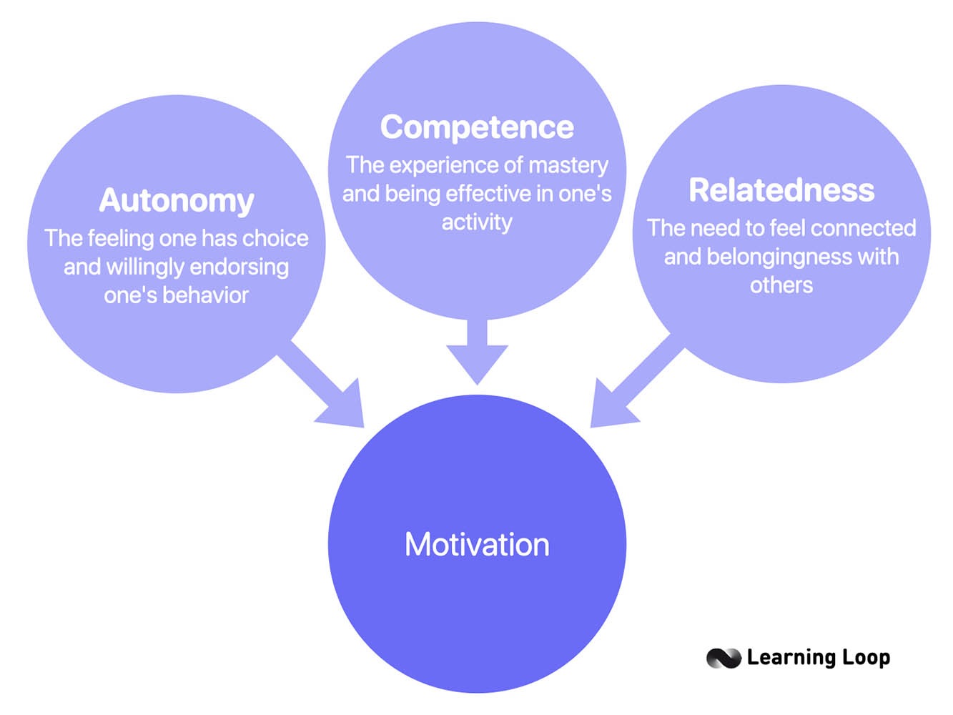
Figure 4: Self-determination theory
(Source: Toxboe, 2024)
- Psychological Safety and Growth Mindset
Psychological Safety is a team culture in which people can take interpersonal risks without being marginalised, voice ideas and make mistakes without fear. Failure is recast as a necessary element of capacity building when combined with Carol Dweck's Growth Mindset, that is, a belief that professional capacity is malleable through perseverance, explicit feedback and work (Dweck, 2024). Psychological safety in NHSX, a high-stakes digital health landscape, is about making mistakes and learning, rather than a culture based on risk aversion that can be harmful.
- Job Crafting and The Learning Organisation
The Job Crafting Theory of Wrzesniewski and Dutton focuses on how workers actively mould their task dimensions, social relationships and mental experiences to make them more similar to their own capacities (Demerouti, 2026). Peter Senge's framework for the learning organisation organises these individual behaviours under five heads: Systems Thinking, Personal Mastery, Mental Models, Shared Vision and Team Learning (Vesudevan and Abdullah, 2025). These theories together provide the foundations for individual motivation to be translated into cross-border organisational agility within NHSX's global workforce.

2.2 Strategic Talent development in organisation
Talent development process in an organisation is directly based on how manpower is managed and the ways through which the authority is focused on sustaining manpower efficiency. Therefore, introducing effective talent development strategies is essential for organisations to maintain a thorough rate of productivity (Wesonga and Van Der Westhuizen, 2024). Turning these theoretical concepts into an action plan is about implementing the NexSpace Ecosystem for Continuous Talent Advancement (NECTA) for NHSX in the UK, India and the UAE:
Dual-Career Pathway Matrix and Structural Job Crafting
NHSX needs to implement a concurrent Dual Career Progression structure (Adithyan RK, 2026) to address the lack of growth opportunities that leads to technical staff leaving the profession. Senior data scientists and clinical leads can get promoted up to the executive level without being forced into administrative people management positions to earn the executive-level pay grades and prestige as an "Individual Contributor. The figure below shows that the levels of senior staff and junior staff can be diversified and, finally, developed into business management and technological professions. Managers and employees will be able to flex 15–20% of roles according to the interest areas that come to light during formalised quarterly “Job Crafting Reviews”.
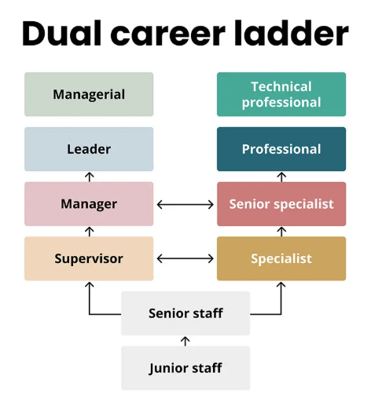
Figure 5: Dual career pathway
(Source: Test Gorilla, 2026)
Internal Talent Mobility and Gig Marketplace
Implementation of an intranet talent marketplace for NHSX staff will be effective to spend 10–15% of their time on cross-departmental projects or cross-border innovation sprints. For example, a software developer from India can participate in a clinical deployment project in the UK, leading to knowledge sharing and addressing internal growth and diversity requirements (Singh, 2024).

Blameless Post-Mortems and Innovation Failure Grants
Implementation of a post-mortem approach to operationalise the concept of psychological safety, instead of punitive performance reviews, when downtimes occur during AI product iterations or software deployments. The sessions are centred on the breakdown in the process, not the fault of a person. Additionally, create quarterly "Innovation Failure Grants" that would recognise well-structured experimental projects with commercial viability which have still generated actionable organisational learning.
Cross-Border Mobility and Global Experience Platform
Breaking geographical barriers between the UK, India and the UAE by institutionalising 3–6–month international rotation programmes. The international assignments of short-term staff can help to foster a sense of shared purpose, social networks and a sense of belonging within NHSX's international staff.

2.3 Implementation and Metrics for introducing talent growth strategy
In order to manage the transition in NexSpace Health Systems from a rigid hierarchical system to an agile talent-based ecosystem across India, the UK and UAE, the NexSpace ecosystem for continuous talent advancement can be implemented. It will follow a 12-month deployment program that will be helpful for tracking progress by balancing leading indicators, along with structural metrics within the organisation.
Implementation Phase | Operational Milestones | Target Metrics and Benchmarks
Phase 1: Foundation (Months 1–3) | - Establish Dual-Career Progression Tracks  - Roll out Blameless Post-Mortem protocols for clinical AI teams  - Train global managers on psychological safety and coaching. | - eNPS Baseline Shift: Increase score by +15 points (target > +20)  - Leadership Completion: 100% executive training compliance.
Phase 2: Integration  (Months 4–8) | - Deploy digital Internal Gig Marketplace  - Institutionalise quarterly Job Crafting reviews  - Activate 80/20 Innovation Time allocations. | - Internal Mobility Rate: Exceed 25% internal role transitions.  - Gig Participation: Minimum 2 cross-departmental projects completed per pod.
Phase 3: Scaling  (Months 9–12) | - Launch 3- 6 month cross-border mobility secondments between the UK, UAE, and India.  - Conduct annual NECTA Talent Ecosystem Audit. | - Voluntary Turnover Rate: Reduce high-performer attrition below 7%.  - Learning Transfer Rate: >85% continuous capability adoption.
Table 2: Implementation and Metrics for introducing talent growth strategy
(Source: Self-developed)
Based on the above table, it is clear that foundation, integration and scaling- all are necessary in managing a stable and productive base of manpower in NexSpace. Moreover, the implementation plan has mentioned that the operational milestones must be set in such a manner that they can easily fulfil the Target Metrics and Benchmarks. As a result of this, the concerned organisation can manage stability in its talent development base.

Task C: Reflective Analysis and Capability Development

3.1 Introduction
The reflective report is based on analysing my personal ability and developmental scopes through the strategic evaluation of NHSX. For this purpose, Kolb’s experiential learning cycle was implemented and three basic learning incidents are encountered in the discussion.

3.2 Discussion: Reflective Analysis via Kolb’s Experiential Learning Cycle
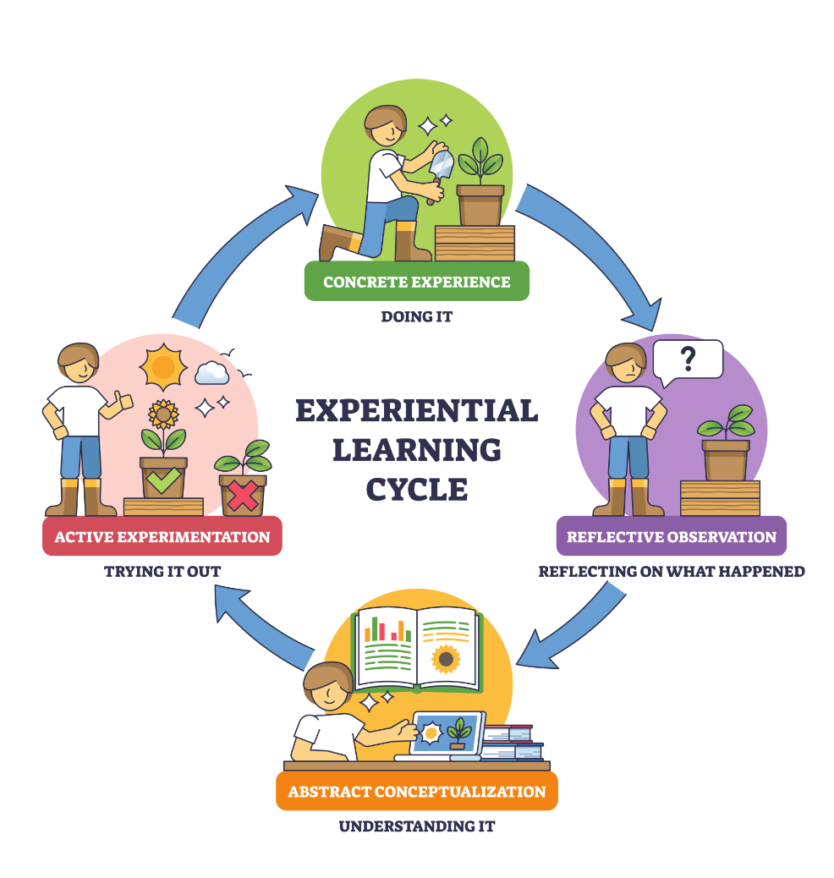
Figure 6: Kolb’s Learning Cycle
(Source: Mcleod, 2025)
Incident 1: Theoretical mapping
For the analysis of Task A, I used Generative AI prompts to synthesise the literature about the comparison between the traditional Taylorist approaches and the High-Performance Work Systems (HPWS) and Socio-technical Systems Theory.
AI-generated summaries were able to give broad conceptual definitions in Stage 2, but were lacking in depth of understanding of how to apply them in complex, multi-site health-tech environments. They also overlooked important operational compromises between nations, as well.
I linked this observation to academic literature and found that AI tools are great at aggregating data, but strategic HCM demands critical analysis and contextual adaptation. Automated outputs only can lead to shallow strategic planning (Abdeljaber et al. 2025).
I undertook independent research to check information about sources in primary and peer-reviewed journal articles, making sure that the theory was grounded in the context of NHSX's operations.
Incident 2: Designing Cross-Border Hybrid Work Frameworks
In the early stages of the hybrid working recommendations being considered for NHSX, I challenged AI with a task to create some health-tech scheduling models for teams working internationally and remotely.
The AI gave standard hybrid templates (such as rigid 3-day office mandates), which did not account for any time-zone differences between the UK (GMT), UAE (GST) and India (IST).
This revealed one of the biggest drawbacks of using AI for decision-making – the lack of cultural sensitivity, customer empathy and spatial awareness (Rezaei et al. 2025). No single HCM strategy can be replicated and they need human judgment to link social systems with the technical workflow.
I manually restructured the proposal to the Agile Socio-Technical Framework (ASTF) by creating a 3-hour synchronous communication window across the globe and an asynchronous communication stack for multi-time-zone teams.
Incident 3: Academic Voice and Structural Refinement
I used an AI assistant during the refinement of the Task B talent growth recommendations to help improve the recommendations' grammatical structure.
The analysis replaced direct, evidence-based sentences with overly complex and florid sentences that made the main arguments less clear.
Thinking about professional communication standards, the communication must be clear, concise and transparent, and not needlessly complex to be effective in the leadership of HCM. Human oversight is crucial to ensure authenticity and clarity in communication (Hayes and Burrell, 2026).
I took the liberty of editing it myself to have its voice sound like a real academic report, rejecting the AI's complicated wording.
Personal Capability Development Action Plan (CIPD Aligned)
Focus Area | CIPD Core Competency | Action Steps and Learning Activities | Target Metrics and Timeline
People Analytics and AI Governance | Digital Emergence and Analytics: Leveraging HR data and AI ethically for talent forecasting. | - Completing a certified module in HR Data Analytics  - Building predictive turnover models in R/Python. | March 2027.
Cross-Cultural Leadership | Global Mindset and Inclusivity: Navigating international employment laws and cross-border teams. | - Attending international labour law workshops (UK, UAE, India)  - Establishing a global HCM mentorship. | By June 2027.
Ethical Practice and Change Management | Ethical Value Creation: Leading agile organisational change with psychological safety. | - Shadowing a Senior HR Business Partner during organisational redesigns.  - Joining CIPD ethical practice forums. | By September 2027.
Table 3: Personal development plan
(Source: Self-created)

3.3 Conclusion
The reflective report has highlighted that AI may act as a decision support mechanism in Human Capital Management, but it is unable to replace the human evaluation process, centring ethical oversight.

References
Abdeljaber, O., Al-Masaeed, S., Al-Mu′ ani, L.A., Yaseen, H. and Alhnaity, B., 2025. Strategic intelligence: The power of AI in planning efficiency. Human Behavior and Emerging Technologies, 2025(1), p.5383054. https://onlinelibrary.wiley.com/doi/pdf/10.1155/hbe2/5383054
Adithyan RK (2026). What is a dual career ladder? Definition and guide. [online] Hyring. Available at: https://hyring.com/free-hr-toolkit/hr-glossary/dual-career-ladder [Accessed 24 Sept. 2026]
Demerouti, E., 2026. Job crafting revisited: current insights, emerging challenges, and future directions. Annual review of organizational psychology and organizational behavior, 13. https://www.annualreviews.org/content/journals/10.1146/annurev-orgpsych-020924-064242?crawler=true&mimetype=application/pdf
Dweck, C.S., 2024. Personal perspectives on mindsets, motivation, and psychology. Motivation Science, 10(1), p.1. https://psycnet.apa.org/journals/mot/10/1/1/
Elashry, M.M., Kortam, W.A.E. and Ali, T.M., 2024. High-performance work systems and organisational ambidexterity: the mediating role of knowledge management systems—evidence from the Egyptian public telecommunications sector. Future Business Journal, 10(1), p.45. https://link.springer.com/content/pdf/10.1186/s43093-024-00331-7.pdf
Epizitone, A. and Moyane, S.P., 2026, March. Reimagining Traditional Workspaces Through Digitalisation and Hybrid Perspective: A Systematic Review. In Informatics (Vol. 13, No. 4, p. 46). MDPI. https://www.mdpi.com/2227-9709/13/4/46
Grandview Research (2026). Team collaboration software market size report, 2021-2028. [Online] www.grandviewresearch.com. Available at: https://www.grandviewresearch.com/industry-analysis/team-collaboration-software-market [Accessed 24 Sept. 2026]
Hariani, M. and Mardikaningsih, R., 2025. Work Schedule Flexibility and Job Satisfaction in a Global Corporate Environment. International Journal of Service Science, Management, Engineering, and Technology, 7(1), pp.12-16. http://ejournalisse.com/index.php/isse/article/download/143/196
Hayes, R.D. and Burrell, D.N., 2026. Reasonable oversight of the practical, legal, and ethical boundaries impacting human factors trust in automated decision-making. Public Governance, Regulation and Law, 2(1), pp.33-50. https://armgpublishing.com/wp-content/uploads/2026/02/PGRL_1_2026_3.pdf
He, Y. and Wang, H., 2026. Effective quality management in Industry 4.0: a social-technical systems perspective from China's automotive industry. International Journal of Automotive Technology and Management, 26(2), pp.115-137. https://www.inderscienceonline.com/doi/abs/10.1504/IJATM.2026.155606
Lavoratori, K., Wu, Y. and Zhang, F., 2025. In the flexible working era: the micro-location choices of co-working spaces. Regional Studies, 59(1), p.2352525. https://www.tandfonline.com/doi/pdf/10.1080/00343404.2024.2352525
Mcleod, S. (2025). Kolb’s learning styles and experiential learning cycle. [online] Simply Psychology. Available at: https://www.simplypsychology.org/learning-kolb.html [Accessed 24 Sept. 2026]
Munawaroh, M., Irianti, D., Utama, F.S., Herdiansyah, H. and Saroh, S., 2026. Beyond Hierarchy: A Systematic Review of Organisational Transformation Through Agile, Network and Platform-Based Models. International Journal of Science and Environment (IJSE), 6(1), pp.584-591. https://ijsenet.com/index.php/IJSE/article/download/375/375
Nguyen, M., Pontes, N., Malik, A., Gupta, J. and Gugnani, R., 2024. Impact of high involvement work systems in shaping power, knowledge sharing, rewards and knowledge perception of employees. Journal of Knowledge Management, 28(6), pp.1771-1792. https://research-repository.griffith.edu.au/bitstreams/7f145be2-cd0a-42b3-b387-7931d5d14b11/download
Priya C (2022). What is scientific management? F.W. Taylor, principles, techniques - the investors book. [Online] The Investors Book. Available at: https://theinvestorsbook.com/scientific-management.html [Accessed 24 Sept. 2026].
Rezaei, M., Pironti, M. and Quaglia, R., 2025. AI in knowledge sharing, which ethical challenges are raised in decision-making processes for organisations?. Management Decision, 63(10), pp.3369-3388. https://iris.unito.it/bitstream/2318/2038630/5/MD%20pironti%20post%20print.pdf
Rodriguez Perez, J. and Ordóñez de Pablos, P., 2023. Knowledge management and organisational competitiveness: a framework for human capital analysis. Journal of Knowledge Management, 7(3), pp.82-91. https://hrmkeys.wordpress.com/wp-content/uploads/2010/11/knowledge_management.pdf
Singh, S., 2024. Knowledge sharing key to assured success: continuous learning, innovating, integrating, validating, networking and sharing knowledge are the keys to assured success. Notion Press. https://www.akgec.ac.in/wp-content/uploads/2024/09/5-Knowledge-Sharing-is-Key-to-Assured-Success-Dr-Sarbjit-Singh.pdf
Slemp, G.R., Field, J.G., Ryan, R.M., Forner, V.W., Van den Broeck, A. and Lewis, K.J., 2024. Interpersonal supports for basic psychological needs and their relations with motivation, well-being, and performance: A meta-analysis. Journal of Personality and Social Psychology, 127(5), p.1012. https://psycnet.apa.org/journals/psp/127/5/1012.pdf
Test Gorilla (2026). How to implement career pathing at your organization - TG. [online] www.testgorilla.com. Available at: https://www.testgorilla.com/blog/career-pathing/ [Accessed 24 Sept. 2026]
Toxboe, A. (2024). Self-determination theory. [Online] Learning Loop. Available at: https://learningloop.io/glossary/self-determination-theory-sdt [Accessed 24 Sept. 2026].
Vesudevan, M. and Abdullah, Z., 2025. Role of sustainable faculty leadership in shaping learning organisations in Malaysian higher education institutions. Environment-Behaviour Proceedings Journal, 10(SI33), pp.157-161. https://ebpj.e-iph.co.uk/index.php/EBProceedings/article/download/7080/4295
Wesonga, J.N. and Van Der Westhuizen, J., 2024. Effect of talent development on organizational performance. EUREKA: Social and Humanities, (2), pp.25-37. https://www.journal.eu-jr.eu/social/article/download/3374/2458

